ANALYSTLAB AFRICA — HEALTHCONNECT EXPERIENCE LAB

Week 5: Initial HealthConnect Analytics Report — Data Analytics Track
Prepared by: Omolade

Part 1: Review of Week 4 Foundation
In Week 4, the problem defined was understanding which factors in the HealthConnect appointment data are associated with patient no-shows. The proposed approach was to calculate five KPIs (overall no-show rate, no-show rate by reminder status/channel, average distance/waiting time by outcome, and repeat no-show rate), each linked to one of three business questions on reminders, access factors, and repeat no-show behaviour. Key assumptions were that the dataset is representative of real clinic patterns and that missing distance/waiting-time values (1.8% and 1.2%) would not materially affect analysis. Week 5 builds directly on this foundation by calculating and interpreting those KPIs.

Part 2: Data Preparation
The dataset (5,000 rows, 18 columns) was re-inspected before analysis:
- No duplicate rows or appointment_ids were found.
- reminder_channel is recorded as the text value "None" (not a blank) for the 1,366 patients who received no reminder — this is a deliberate data value, not missing data.
- distance_to_clinic_km has 90 missing values (1.8%) and waiting_time_minutes has 60 missing values (1.2%); these rows were excluded only from the specific averages that use those columns, and were not removed from the dataset.
- All categorical values (gender, appointment_type, appointment_outcome, reminder_channel) were checked and found consistent, with no unexpected categories.
A derived field, repeat_offender, was created from previous_no_shows: patients with previous_no_shows > 0 were labelled "Has previous no-shows", and all others "No previous no-shows", to support KPI 5.

Part 3: Exploratory Data Analysis & KPI Development

KPI 1 — Overall No-Show Rate
Definition: The percentage of all scheduled appointments that ended in a no-show.
Calculation: 2,423 of 5,000 appointments = 48.5%.
Business question: Central project question — how big is the missed-appointment problem?
Interpretation: Almost half of all appointments are missed. This confirms the scale of HealthConnect's problem and sets the baseline against which every other KPI below is compared.

KPI 2 — No-Show Rate by Reminder Channel
Definition: No-show rate broken down by which reminder channel (or none) the patient received.
Calculation: None 51.4%, WhatsApp 49.8%, Email 48.4%, SMS 45.75%.
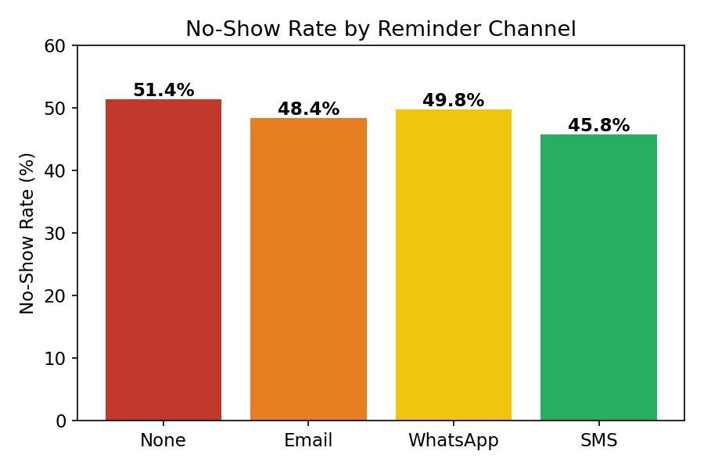
Business question: Does sending a reminder, and the channel used, reduce no-shows?
Interpretation: Any reminder is better than none, but the effect is modest — the best channel (SMS) is only about 5.7 percentage points better than sending nothing. SMS is the most effective channel tested, followed by Email, then WhatsApp.

KPI 3 — No-Show Rate by Booking Lead Time
Definition: No-show rate grouped by how far in advance the appointment was booked (same-day, 1–7 days, 8+ days).
Calculation: Same-day 24.7%, 1–7 days 28.3%, 8+ days 51.5%.
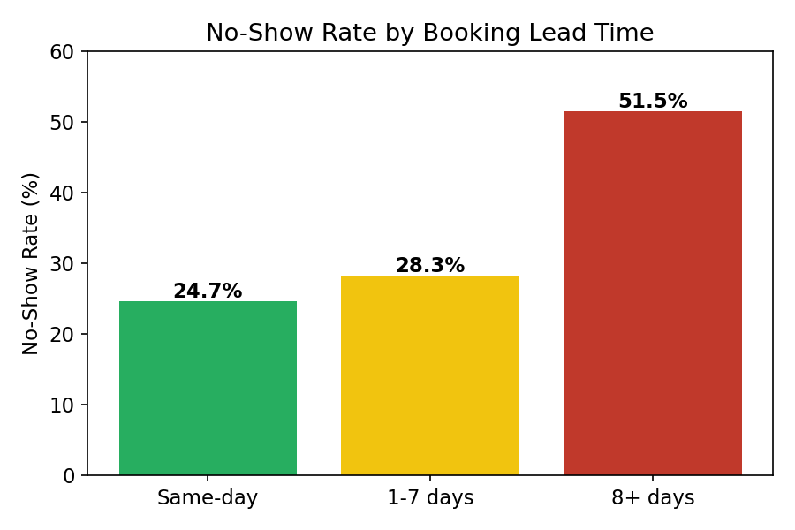
Business question: This extends the original Week 4 questions — does how far ahead an appointment is booked affect attendance?
Interpretation: This is the strongest pattern found in the whole dataset. Appointments booked 8 or more days in advance are more than twice as likely to be missed as same-day bookings. Patients likely forget or deprioritise appointments booked far ahead.

KPI 4 — Average Distance and Waiting Time by Outcome
Definition: The average distance to the clinic and average waiting time, compared across Attended, No-Show, and Cancelled appointments.
Calculation: Distance — Attended 9.67km, No-Show 10.53km, Cancelled 10.11km. Waiting time — Attended 24.3min, No-Show 24.2min, Cancelled 23.2min.
Business question: Do distance to the clinic and waiting time influence attendance?
Interpretation: Distance has only a small effect — no-show patients live, on average, less than 1km further than those who attend. Waiting time shows essentially no difference between groups. Neither factor is a strong driver of no-shows in this dataset.

KPI 5 — Repeat No-Show Rate
Definition: No-show rate for patients who have missed at least one previous appointment, compared with patients who have no history of no-shows.
Calculation: Has previous no-shows: 55.4% (1,152 of 2,079). No previous no-shows: 43.5% (1,271 of 2,921).
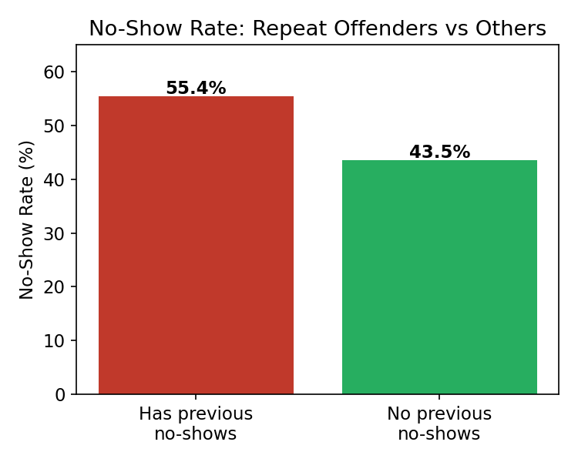
Business question: Are patients with a history of previous no-shows more likely to no-show again?
Interpretation: This is the second-strongest pattern in the data. Patients with any prior no-show history are almost 12 percentage points more likely to miss their next appointment too — past behaviour is a meaningful predictor of future attendance.

Part 4: Business Insights
- Nearly half of all appointments (48.5%) end in a no-show — this is a large-scale operational problem, not a minor inefficiency, and justifies dedicated intervention.
- Booking lead time is the strongest factor found: appointments booked 8+ days ahead have a 51.5% no-show rate versus 24.7% for same-day bookings. HealthConnect should prioritise reminder intensity for appointments booked far in advance.
- Patients with a history of missed appointments are significantly more likely to miss again (55.4% vs 43.5%). This group could be flagged for extra reminders, confirmation calls, or overbooking strategies to offset expected no-shows.
- SMS reminders show the lowest no-show rate (45.75%) among all channels tested, suggesting SMS should be the default or primary reminder channel where patient contact information allows.
- Distance to clinic and waiting time show only weak or negligible relationships with no-shows, suggesting that access/logistics are not the primary driver of missed appointments — behavioural and scheduling factors (lead time, prior history) matter more.

Part 5: Assumptions, Limitations, Risks & Dependencies
- Assumption (carried from Week 4, confirmed): the dataset is representative of typical HealthConnect appointment patterns.
- Limitation: distance and waiting-time gaps (1.8%, 1.2%) were excluded from those specific averages; this is unlikely to materially change the conclusions given the small proportion affected.
- Limitation: reminder_channel effectiveness can only be compared for patients who received a reminder; channel choice itself may be influenced by unmeasured factors (e.g. patient preference), so the comparison is correlational.
- Risk: all relationships reported here are correlations, not proven causes — booking lead time and prior no-show history are strongly associated with no-shows, but a causal claim would need controlled testing.
- Dependency: the KPIs and insights in this report (particularly booking lead time and repeat no-show history) are strong candidates as target/feature variables for the Data Science track's predictive model.

Part 6: Cross-Track Collaboration
Track interacted with: Data Science.
Information exchanged: The KPI findings from this report — particularly that booking lead time and prior no-show history are the strongest predictors of no-shows — are directly relevant to the Data Science track's Week 5 task of defining a target variable and candidate features for a no-show prediction model.
Why relevant: The Data Analytics track's exploratory findings can shortcut the Data Science track's own feature-relevance testing, avoiding duplicated analysis across tracks.
What changed as a result: These findings are shared here so the Data Science track can consider booking_lead_days and previous_no_shows as high-priority candidate features going into their baseline model.

Part 7: Week 5 Project Summary
Planned for Week 5: Calculate the five KPIs proposed in Week 4, produce supporting visualisations, and derive at least five business insights.
Actually completed: All five KPIs were calculated and interpreted, three charts were produced, and five business insights were documented, along with an updated risks/limitations review and a cross-track collaboration note.
Key findings: Booking lead time and prior no-show history are the two strongest predictors of no-shows found in the data; reminder channel has a modest effect (SMS performing best); distance and waiting time have little to no effect.
Major challenges: Confirming exact column locations and correct text values (e.g. "None" vs blank, "No-Show" vs "No-Shows") while working in Excel required careful double-checking against the Data Dictionary.
Important decisions: Chose to treat reminder_channel = "None" as a valid category rather than missing data, since it reflects a real absence of a reminder rather than a data quality issue.
Changes to Week 4 approach: No changes — all five originally proposed KPIs remained relevant and were carried through as planned.
Cross-track collaboration completed: Shared KPI findings with the Data Science track to inform their target/feature selection (see Part 6).
Remaining work: Deeper statistical testing (e.g. correlation significance) and a full dashboard could be developed in a later phase.
Proposed focus for Week 6: Build a more complete visual dashboard summarising all KPIs, and begin exploring how these findings could translate into an intervention strategy (e.g. targeted reminder rules).

