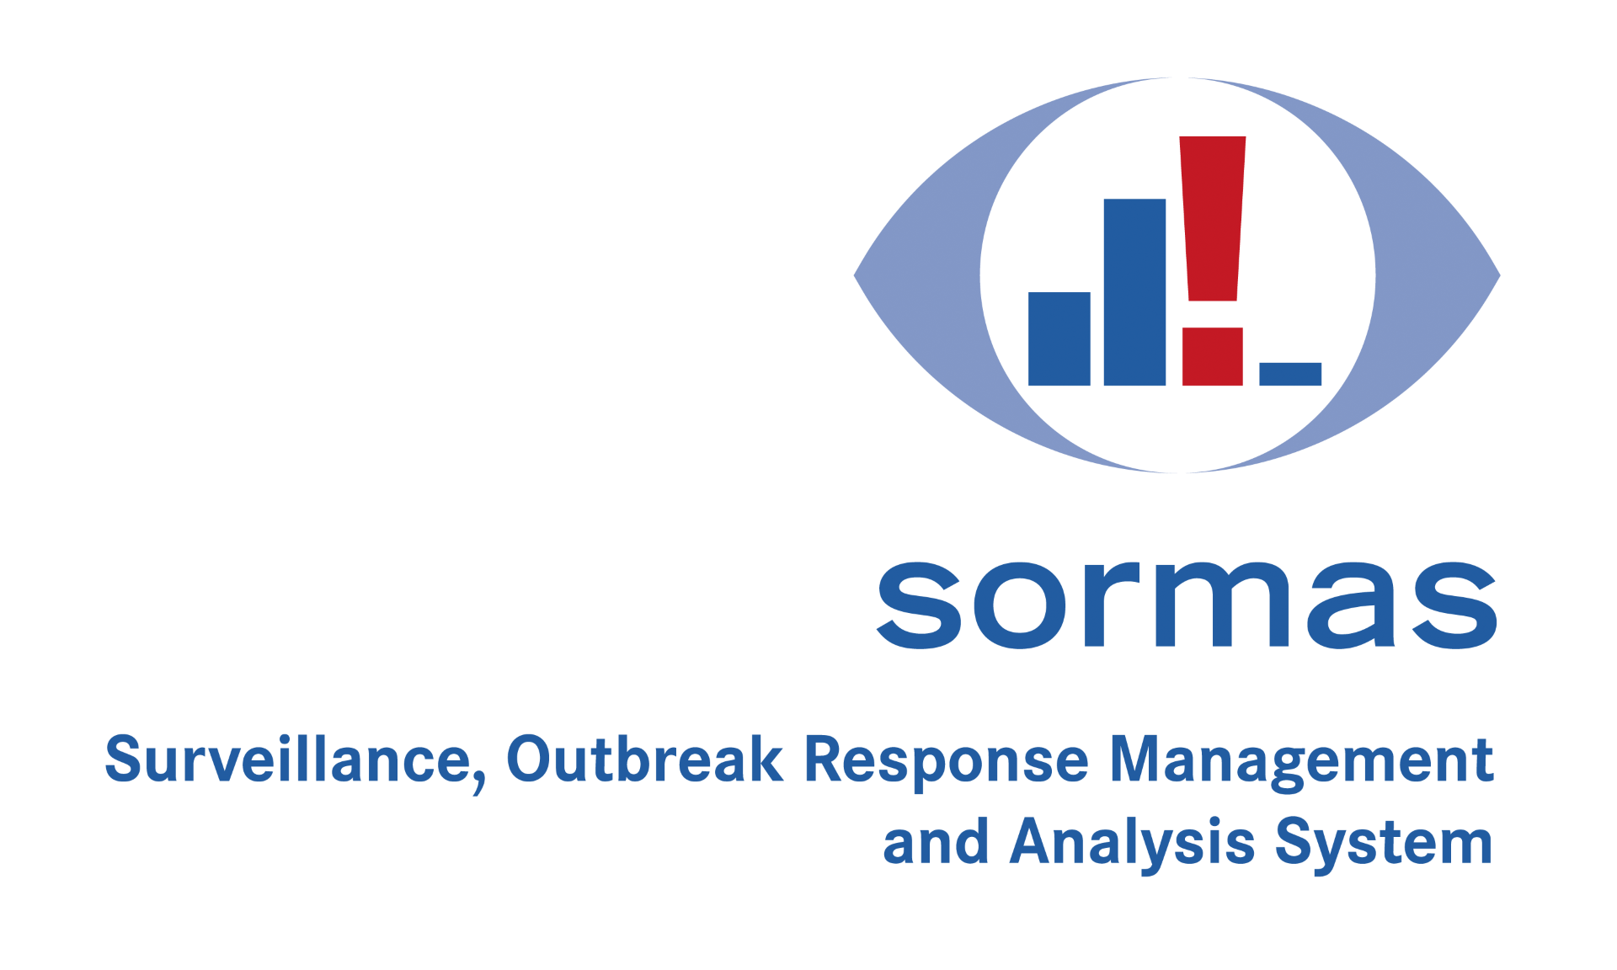

Example Document Template
This template has been created using LibreOffice.

To add placeholders, insert „${<placeholderName>}“ in the text.
If <placeholderName> is prefixed „case.“, the placeholder is resolved according to the SORMAS Data Dictionary and data from the SORMAS database is filled in.
For placeholders without this prefix, the user generating the document is prompted to provide a replacement text.

See below for examples.

Data from the SORMAS Database
Examples:
${case.person.lastName}, ${case.person.firstName}

born:
${case.person.birthDateDD}.${case.person.birthDateMM}.${case.person.birthDateYYYY}

${case.person.address.street} ${case.person.address.houseNumber}
${case.person.address.postalCode} ${case.person.address.city}

Phone: ${case.person.phone}

Quarantine:
from ${case.quarantineFrom} to ${case.quarantineTo}

Custom Placeholders

For all placeholders not prefixed with „case.“, the user will be prompted to fill in a text:

Custom remark: ${remark}

