Lecture 0 → Two coursework’s during the year. 1St 40% , 2nd 60%

Lecture 1

Protocols: are agreements for how to communicate
Computer protocols: are agreements are specified with enough clarity that a computer can follow them.

- Internet: global system of interconnected computer networks, built on shared & agreed protocols – The Internet Protocol Suite (TCP/IP).
- WWW is the information resource/service that communicates using the internet

Internet Protocol:
- Application layer: DNS, HTTP, IMAP, POP
- Transport Layer: TCP
- Internet Layer: IP
- Link Layer: Ethernet

An application layer protocol for distributed and collaborative hypermedia/hypertext systems.

HTTP session is a sequence f request-response transaction transmitted over TCP. Connects to a specific port (usually 80).

Hypertext: term coined by Ted Nelson in 1965. The text is displayed on an electronic device that incorporates reference called Hyperlinks, to other text. One implementation of the hypertext idea is in HTML.

Invention of the web:
- Invented in 1989
- Initially formatted text only, rapidly moved to support images, audio , video and other media types.
- Text formatted using HTML & communicated using HTTP.

HTML: Hyper Text Mark-up Language
A languages for turning text into hypertext using mark-up:
- Text: string encoded in UTF8
- Language: means for communication
- Hypertext: links between text
- Markup: many ways to do markup, not specific to HTML.

Server:
- Software that runs on a computer . This software listens for messanges and provide the right response.

Web clients: Another piece of software , known as a user agent. The browser is on type of web client but there are others:
- Web crawlers, voice browser, mobile apps.

Browser: software containing a layout engine that renders web pages. It has been invented by Berners-Lee. IT IS USED TO NAVIGTE the web but also private networks, IoT interfaces and local file systems.

Tor: fee and open source software form enabling anonymous communication.

Basic Web Architecture:
- Clients: software that communicate to a server by making requests using HTTP.
- Servers: software that responds to HTTP requests from clients. The response is a document (HTML).
DOM:
- Document Object Model
- Cross platform, language independent API
- HTML is treated as a tree data structure within the browser
- HTML is parsed into this structure to construct the DOM (for a specific document)

A cross-platform, language independent API.
HTML is treated as a tree data structure within your browser. Html is parsed into this data structure to construct the DOM (for that document). Each node in the tree is an object representing part of the document. Objects can be manipulated programmatically, using JavaScript and the results displayed in the view pane of the user agent.

Browser Developer Tools:
- Web page assets, resources, network information
- profiling and auditing
- JavaScript Debugging & Console
- Html & DOM viewers & editors

Web client: software containing a layout engine that renders web pages (HTML). It is used to navigate the web but also private networks, IoT, interfaces, local files.

Lecture 02: Data (HTML5) Hypertext & Hypermedia

HTML:
- Is an application layer protocol for distributed and collaborative hypermedia / hypertext systems.
- Server stores resources and returns a response that may include providing access to those resources. (a resource could be web page , image , audio or video file etc…)
- Request methods: HTTP verbs: GET, HEA, POST, PUT, DELETE, OPTIONS PATCH.
- HTML 4
  - Based on Standards Generalised Mark-up Language (SGML)
- Modern HTML
  - Describes the content , it’s structure and it’s relation to other content. Visual presentation of those this is delegated to CSS.
- HTML document are constructed from HTML elements
  - HTML Elements: are keyword encapsulated witching angle brackets, as <div>

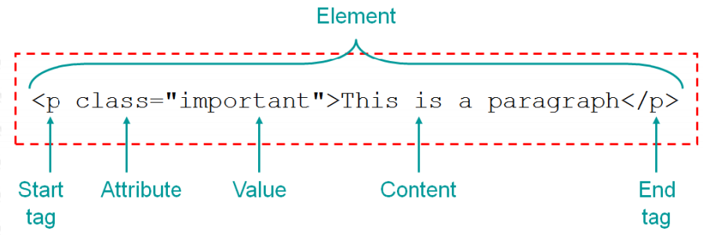
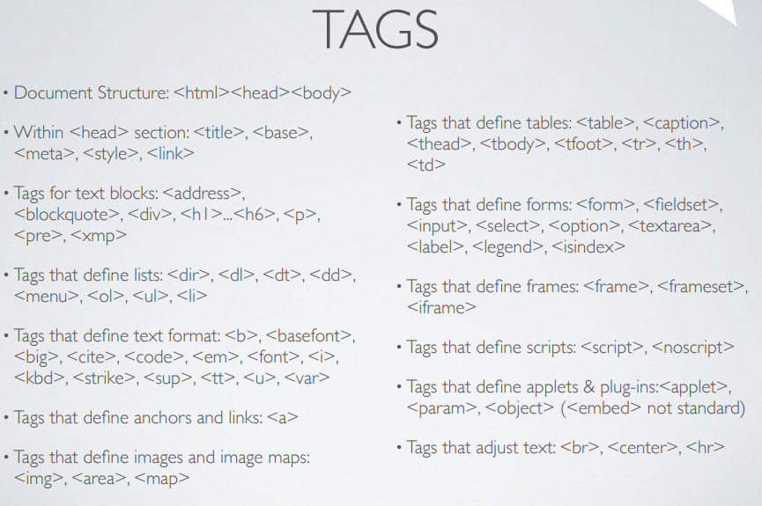
- List:
  - Definition Lists
    - <dl>
    - <dt>
    - <dd>
  - Ordered Lists
    - <ol>
    - <li>
  - Unordered Lists
    - <ul>
    - <li>

- Tables:
  - <table> , <tr> , <td>
  - <thead> , <tbody> , <tfoot> , <caption>

<form name=”name” action=”page.html” method=”POST”>

- Input type:
  - button
  - reset
  - image
  - hidden
  - file

<fieldset> , <legend>

To view a DOM node (HTML element): right click → inspect OR ctrl + shift + I
Search within the Inspect Element of the Developer Tool: ctrl F

If we do inspect on a specific element , we can see immediately its code also going in the console (in the dev tools) and lunch the command $0 ,we will receive in output a string with al the HTMLK code for that specifici DOM node.

The browser parses the HTML and creates a tree of object like this:
html
head
title
body
h1
p
script

To add JS script: inside the body tag: <script src = “path/file.js” async> </script>
async is a Boolean attribute. When present, it speciifc that the script will be executed asynchronously as soon as it is available. Async should be used just for external scripts (if the rc attribute is present so).

If async is not present, the js script will be executed when the page has finished parsing.
If we want the the js script is executed just once the html page has been parse, we have to put the Boolean attribute defer instead sync.

Add a class to a css element: go on inspect , in the bottom section (with css properties , click on .cls and type the name of the new class).
If we go on :hov, we can add the css for hover , visited , focus , active , focus-within etc.

Lecture 3 → CSS

- CSS: Cascading style sheet
  - Gives us a way to improve they way how are pages are presented.
  - CSS is text-based appearance description language. It permit almost every html tag t be saled, positioned and decorated.
- Css Layout:
  - Inline: elements flows horizontally left to right as space allows. Line breaks happen when the edge of the container is reached and the flow continues on the next line.
  - Block: Element flow top down, one after another The width of the block what is available in the container, the height is defined by the content.
  - Table: child elements are aligned both vertically and horizontally
  - Flex: child elements are places on a single axis either vertically o horizontally, which specified alignment, adjustments and spacing.

- CSS can be used with HTML in 3 primary ways:
  - Attached to a specific tag using the style parameter
  - Inlined globally using a <style> block
  - Retrieved from an external URL using <link rel=”stylesheet” type=”text/css” href=”theme.cs”> directive.

Pre CSS html repsentational attribute
<h1> <font color=’red’> h1 content </h1>
Style parameter
H1 style=”color:red;” > H1 content </h1>
To style block
<head.>
<style type=”text/css”>
H1{color:red;}
</style>
</head>

External style sheets
<link href=”path/file.css” rel=”stylesheet” type=”text/css”>

specified by id attribute, e.g.
<p id=”para-123”
#para-123{
font-size: 18px;
}

- Font properties
  - Font family: which font to use
  - Font-size: how big it shoud be
  - Font-style {normal , italic , oblique}
  - Font-weigh: normal , bold, bolder, lighter, + numeric values}.

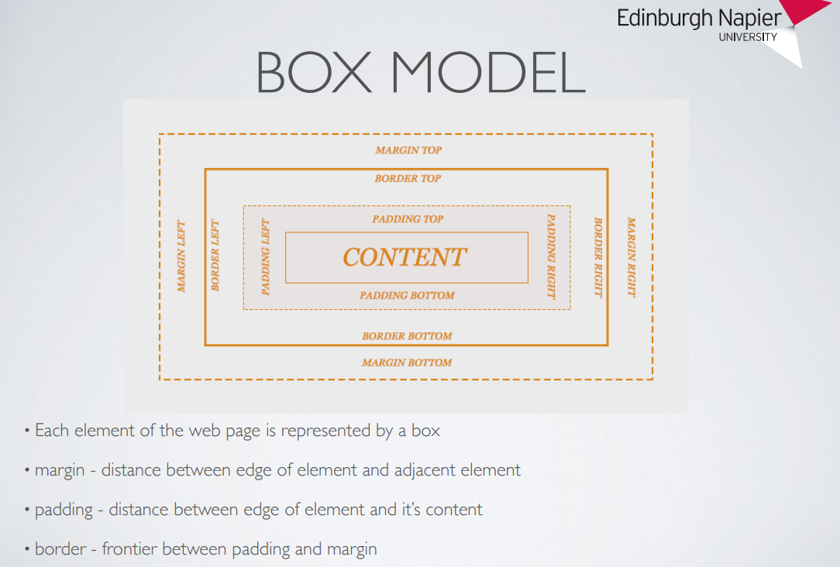

- Layout: We use HTML <span> and <div> block elements to assemble page layout.
  - Two column layout: navbar + content
  - Three column layout: navbar + content +sidebar (of course we conside heade & footer as well).

Part 3 CSS Layout approaches in Lecture 3

Lecture 4 → Javascript

Lecture 5 → Principles of Web Design and development

Lecture 6 → Servers, web serving & Web scale

Lecture 7 → Javascript: Core language

JS Engine:

V8 is google chrome engine, also used in Node.JS
Spidermonkey: firefox engine
Javascipt Core: used in Safari.

Javascript is used to :
- Interact with the DOM of a given web page and the user agent using Browsers APIs.
- Provide a serverside environment so that our core tools can be cohesive.

JavaScript can be used:
- Inline: <button id=”helloButton” onclick=”alert(‘Hello’)”>Click Me </button>
- Withing a JS script block: <script> document.getElementBId(‘helloButton’).onclick = functon() { alert(‘Hello’);}; </script>
- HTML 4: <script type=”text/javascript src=”javascript.js”> </script>
- • HTML 5: <script src=”javascript.js”> </script>

Lecture 8 → web-apps & RESTful design

Lecture 9 → Datastores: JSON & Databased

Lecture 10 → web standards & accessibilit

Lecture 11 → Security and privacu

Lecture 12 → Cosa & review

