1. A description of the game that you are planning with enough background

context for your reader to understand what you are trying to do. If you have a

draft of your story or storyline then you should include it here.

My Website, myOwnAdventure, will allow to any users to have access to multiple stories,

splitted also in according wiht their category (Fantasy - Childhood - Horror).

For the coursework dimostration, I will complete just one story, for the purpose to show to the lecture how

actually the website works.

The story that I will use, it's a Childhood sotry extremely famous in Italy, called "Pollicino",

quite difficult to forget considering my Surname.

Of course,the story is based on the original one, but the user will have the opportunity to completely change

the destiny of Pollicino and the end of many adventures, that could be potentially be releated between them.

Defintely, the only point of each story that will always be equals to the original one, is going to be the start,

to allow to the users to understan the scenario and context of the story, decide if keep reading it or change of something else.

2. A summary of any background research you have done with a description of how

this has contributed to your project (perhaps through better understanding of

potential solutions, libraries, or APIs that might assist you).

Of course, before start myOwnAdventure, I had to understand first of all what it is and how it could look a potential website.

For this reason, seaching online I have found to extremelly useful websites that allows me to understand the potential structure of my final coursework

and how myOwnAdventure works.

* http://chooseyourstory.com/

* https://infinite-story.com/

Many users, could find a website with bright colours harmful for their eyes. Personally, I prefer use a Dark Mode.

For this reason, I was thinking about a GUI element that could allows to the users to swap the color of a page.

For this reason, it was extremelly useful understand how a JS Slider works.

* JS Slider : https://www.w3schools.com/howto/howto_js_rangeslider.asp

An other functionality of the website was indicate a level of popularity of the story.

* https://codepen.io/jamesbarnett/pen/vlpkh

Working with Materialize, I had a problem with the footer, that was contantly having a white space between

the main and the botton of the page.

Searching online, I found out that Materialize needs to have a HTML5 page format, using header, main and footer tags inside the body.

Using these tags I have fixed this problem.

* Fix materialize footer: https://stackoverflow.com/questions/29703544/materialize-css-sticky-footer

MATERIALIZE requires the following structure:

<body>

<header></header>

<main></main>

<footer></footer>

</body>

3. A list of features and some discussion of why each feature is included.

* Select a specific category of stories

* Color inversion: Most of the users nowadays take care of their eyes. Most the users uses night screen mode, called also night reader mode in

MIcrosoft Windows environment.

* Contanct form : Give feedback about the website

* Suggest a story : contact form and suggest a story must be equals, the user must be able to upload a file if necessary.

4. A navigation tree and some discussion of how you plan to organise your site.

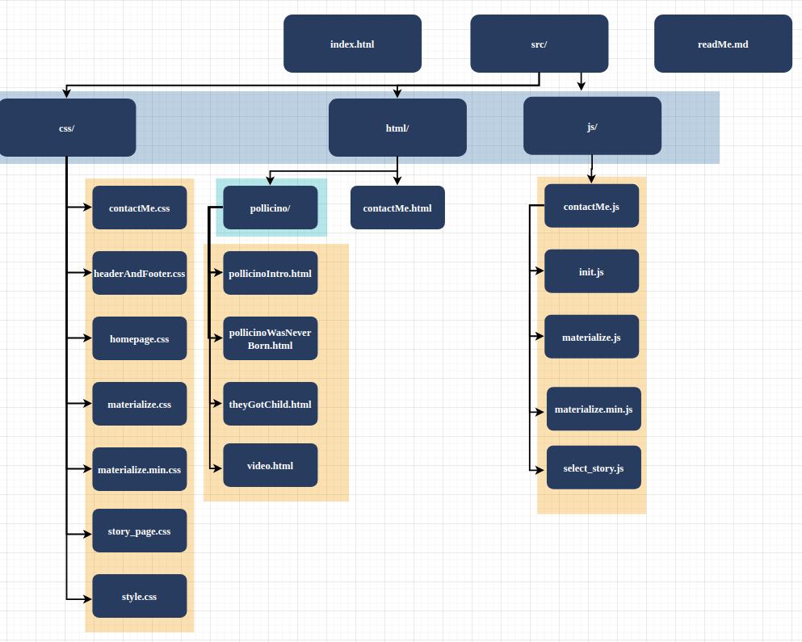

5. A sketch of an initial user interface for your system and some commentary on

the motivation for your design, i.e. how does your design address the features

you’ve listed. NB. Any designs can be hand-drawn and scanned/photographed for

inclusion in your report.

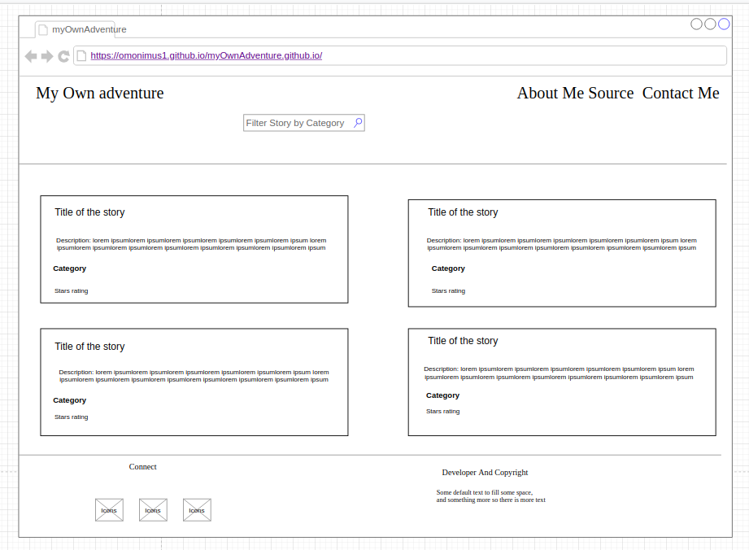

The bar search is going to be used to allow to the users to filter the stories by category.

6. As appropriate: any additional sections that you deem fit to describe your

project. For example, if you have decided to implement a particular feature as

an extension then this would be the place to report on it. Similarly if you intend

to save data within the browse, then some description of the kinds of data that

you intend to store, how you will store it, and how it will be structured, should

be reported on.

7. (Optional) You may include appendices in your report if you have too much

material to fit within the 8 page limit.