\-- Data Cleaning

SELECT \*

FROM world\_layoffs.layoffs;

\-- 1\. Check for duplicates and Remove Duplicates

\-- 2\. Standardize the Data and fix errors

\-- 3\. Null Values or blank values

\-- 4\. Remove Any Columns and Rows that are not needed for the analysis

CREATE TABLE layoffs\_stagings

LIKE world\_layoffs.layoffs;

INSERT layoffs\_stagings

SELECT \*

FROM world\_layoffs.layoffs;

\-- 1\. First let's check for duplicates

SELECT \*

FROM layoffs\_stagings;

Output:

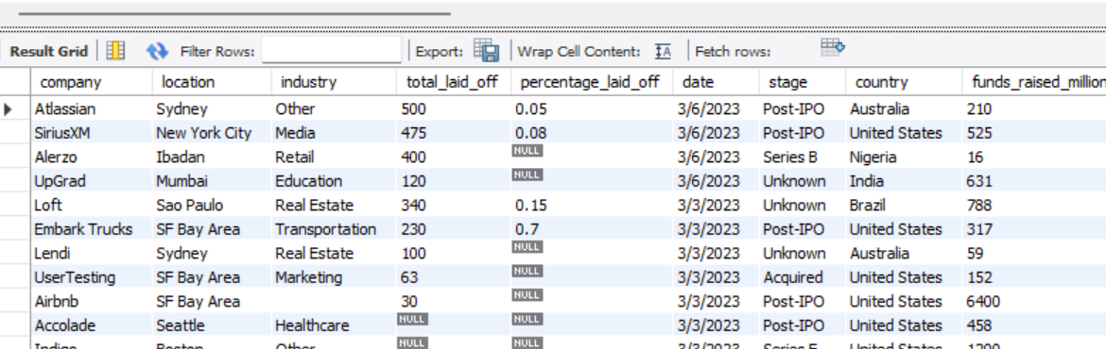

\-- Remove Duplicates

SELECT \*,

ROW\_NUMBER() OVER(

PARTITION BY company, location, industry, total\_laid\_off, percentage\_laid\_off,

'date', stage, country, funds\_raised\_millions) AS row\_num

FROM layoffs\_stagings;

Output:

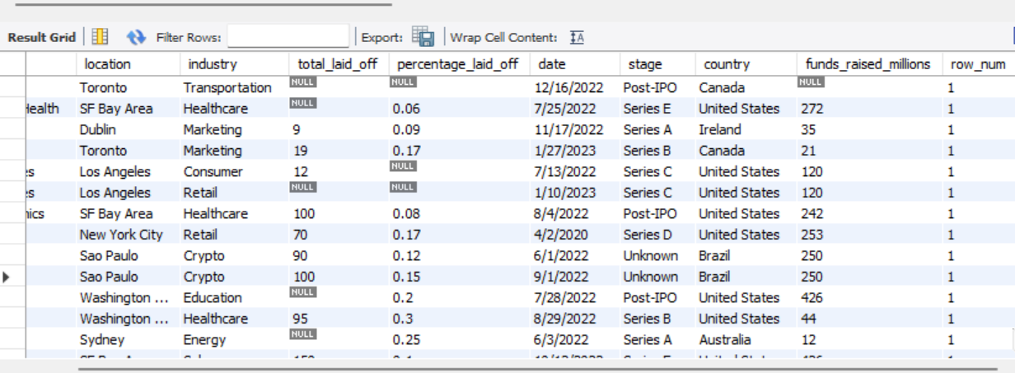

WITH duplicate\_cte AS

(

SELECT \*,

ROW\_NUMBER() OVER(

PARTITION BY company, location, industry, total\_laid\_off, percentage\_laid\_off,

'date', stage, country, funds\_raised\_millions) AS row\_num

FROM layoffs\_stagings

)

SELECT \*

FROM duplicate\_cte

WHERE row\_num \> 1;

Output:

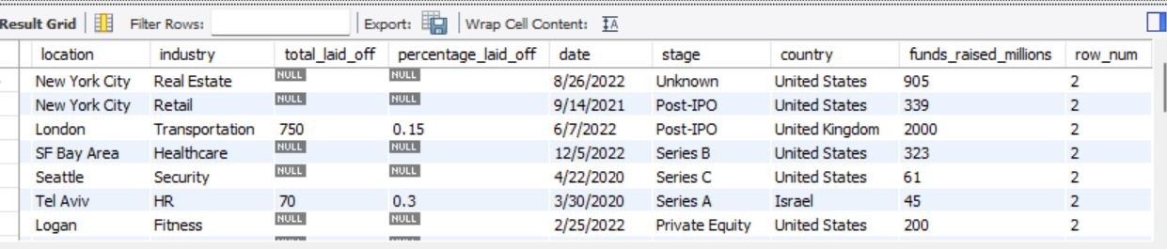

SELECT \*

FROM layoffs\_stagings

WHERE company \= 'Casper';

Output:

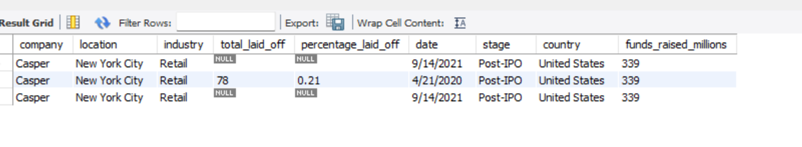

WITH duplicate\_cte AS

(

SELECT \*,

ROW\_NUMBER() OVER(

PARTITION BY company, location, industry, total\_laid\_off, percentage\_laid\_off, 'date', stage, country, funds\_raised\_millions) AS row\_num

FROM layoffs\_stagings

)

DELETE

FROM duplicate\_cte

WHERE row\_num \> 1;

CREATE TABLE \`layoffs\_stagings2\` (

\`company\` text,

\`location\` text,

\`industry\` text,

\`total\_laid\_off\` int DEFAULT NULL,

\`percentage\_laid\_off\` text,

\`date\` text,

\`stage\` text,

\`country\` text,

\`funds\_raised\_millions\` int DEFAULT NULL,

\`row\_num\` INT

) ENGINE=InnoDB DEFAULT CHARSET=utf8mb4 COLLATE=utf8mb4\_0900\_ai\_ci;

SELECT \*

FROM layoffs\_stagings2;

INSERT INTO layoffs\_stagings2

SELECT \*,

ROW\_NUMBER() OVER(

PARTITION BY company, location, industry, total\_laid\_off, percentage\_laid\_off,

'date', stage, country, funds\_raised\_millions) AS row\_num

FROM layoffs\_stagings;

SELECT \*

FROM layoffs\_stagings2

WHERE row\_num \> 1;

DELETE

FROM layoffs\_stagings2

WHERE row\_num \> 1;

SELECT \*

FROM layoffs\_stagings2;

\-- 2\. Standardize data :- Standardizing data means finding issues with your data and fixing it

SELECT DISTINCT(company)

FROM layoffs\_stagings2;

Output:

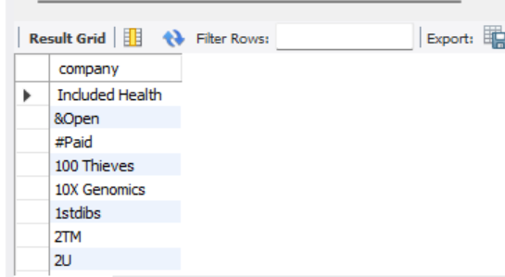

\-- TRIM() is used to remove whitespace

SELECT DISTINCT(TRIM(company))

FROM layoffs\_stagings2;

SELECT company, TRIM(company)

FROM layoffs\_stagings2;

Output:

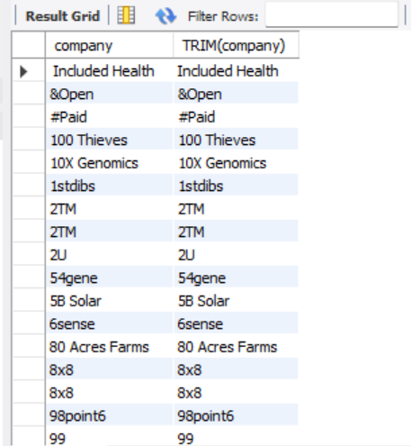

UPDATE layoffs\_staging2

SET company \= TRIM(company);

\-- If we look at industry it looks like we have null, I also noticed Crypto has multiple different variations. We need to standardize that. Let's set alll to Crypto

SELECT DISTINCT industry

FROM layoffs\_stagings2

ORDER BY 1;

SELECT \*

FROM layoffs\_stagings2

WHERE industry LIKE 'Crypto%';

Output:

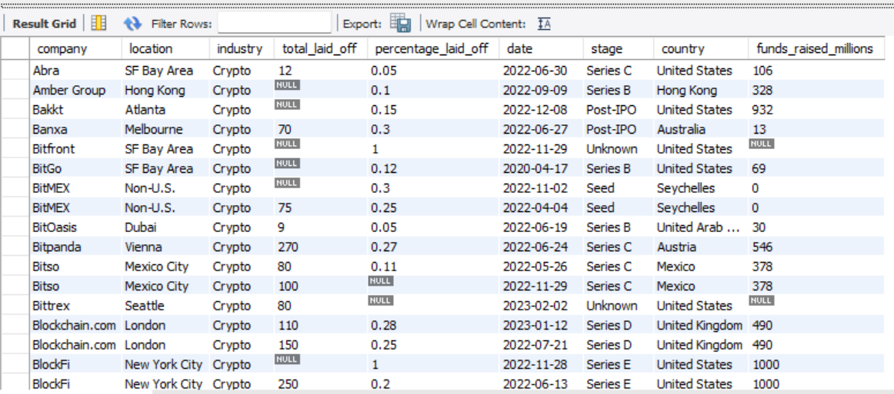

UPDATE layoffs\_stagings2

SET industry \= 'Crypto'

WHERE industry IN ('Crypto Currency', 'CryptoCurrency');

\-- now that's taken care of

SELECT DISTINCT industry

FROM layoffs\_stagings2

ORDER BY industry;

SELECT DISTINCT country

FROM layoffs\_stagings2

ORDER BY 1;

\-- We need to look at the country column, Everything looks good except apparently we have some "United States" and some "United States." with a period at the end. Let's standardize it.

SELECT DISTINCT country

FROM layoffs\_stagings2

WHERE country LIKE 'United States%'

ORDER BY 1;

Output:

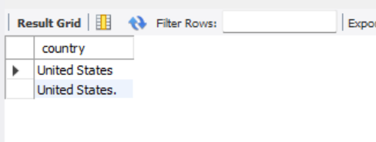

SELECT DISTINCT country, TRIM(TRAILING '.' FROM country)

FROM layoffs\_stagings2

ORDER BY 1;

UPDATE layoffs\_satgings2

SET country \= TRIM(TRAILING '.' FROM country)

WHERE country LIKE 'United States%';

SELECT DISTINCT country

FROM layoffs\_stagings2

ORDER BY country;

\-- Let's also fix the date columns

SELECT \`date\`,

STR\_TO\_DATE(\`date\`,'%m/%d/%Y')

FROM layoffs\_stagings2;

\-- We can use str for date to update this field

UPDATE layoffs\_stagings2

SET \`date\` \= STR\_TO\_DATE(\`date\`, '%m/%d/%Y');

\-- now we can convert the date type properly

ALTER TABLE layoffs\_stagings2

MODIFY COLUMN \`date\` DATE;

SELECT \`date\`

FROM layoffs\_stagings2;

Output:

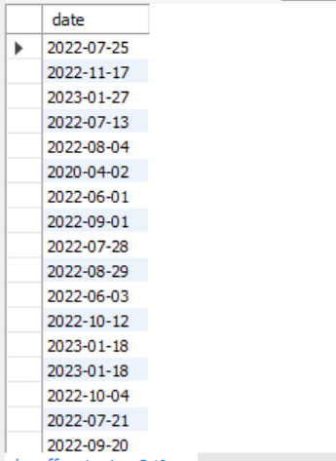

\-- 3\. Look at Null Values

\-- The null values in total\_laid\_off, percentage\_laid\_off and funds\_raised\_millions all look normal. I dont think I want to change alter that

\-- I like having them null because it makes it easier for calculations during the Exploratory Data Analysis(EDA) phase

\-- There's nothing i want to change with the null values

SELECT \*

FROM layoffs\_stagings2

WHERE total\_laid\_off IS NULL

AND percentage\_laid\_off IS NULL;

\-- We should set the blanks to nulls since those are typically easier to work with

UPDATE layoffs\_stagings2

SET industry \= NULL

WHERE industry \= '';

\-- Now if we check those are all null

SELECT \*

FROM layoffs\_stagings2

WHERE industry IS NULL

OR industry \= '';

SELECT \*

FROM layoffs\_stagings2

WHERE company \= 'Airbnb';

Output:

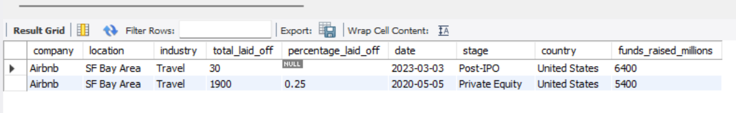

SELECT t1.industry, t2.industry

FROM layoffs\_stagings2 t1

JOIN layoffs\_stagings2 t2

ON t1.company \= t2.company

WHERE (t1.industry IS NULL OR t1.industry \= '')

AND t2.industry IS NOT NULL;

\-- We need to populate those nulls if possible

UPDATE layoffs\_stagings2 t1

JOIN layoffs\_stagings2 t2

ON t1.company \= t2.company

SET t1.industry \= t2.industry

WHERE t1.industry IS NULL

AND t2.industry IS NOT NULL;

\-- If we check it looks like Bally's was the only one without a populated row to populate this null values

SELECT \*

FROM layoffs\_stagings2

WHERE company LIKE 'Bally%';

Output:

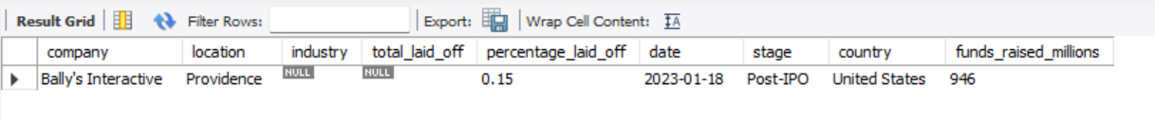

\-- 4\. Remove any columns and Rows we need to remove

SELECT \*

FROM layoffs\_stagings2

WHERE total\_laid\_off IS NULL

AND percentage\_laid\_off IS NULL;

\-- Delete Useless data we can't really use

DELETE

FROM layoffs\_stagings2

WHERE total\_laid\_off IS NULL

AND percentage\_laid\_off IS NULL;

ALTER TABLE layoffs\_stagings2

DROP COLUMN row\_num;

SELECT \*

FROM layoffs\_stagings2;

\-- Exploratory Data Analysis

SELECT \*

FROM layoffs\_stagings2;

SELECT MAX(total\_laid\_off)

FROM layoffs\_stagings2;

SELECT MAX(total\_laid\_off), MAX(percentage\_laid\_off)

FROM layoffs\_stagings2;

Output:

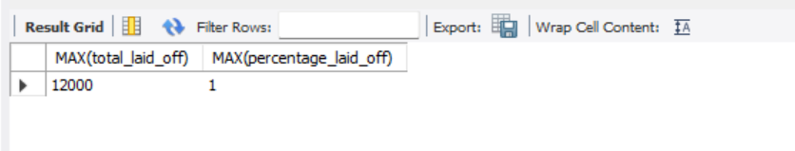

SELECT MAX(percentage\_laid\_off), MIN(percentage\_laid\_off)

FROM layoffs\_stagings2;

SELECT \*

FROM layoffs\_stagings2

WHERE percentage\_laid\_off \= 1

ORDER BY total\_laid\_off DESC;

Output:

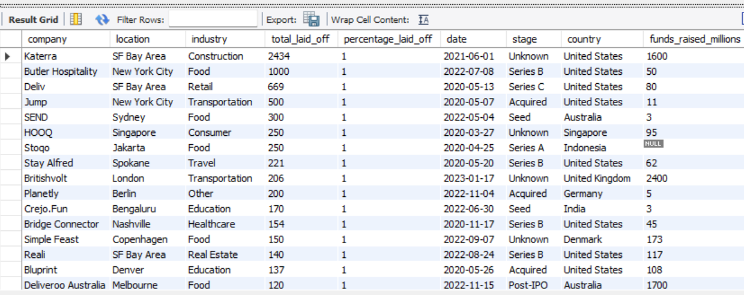

SELECT \*

FROM layoffs\_stagings2

WHERE percentage\_laid\_off \= 1

ORDER BY funds\_raised\_millions DESC;

Output:

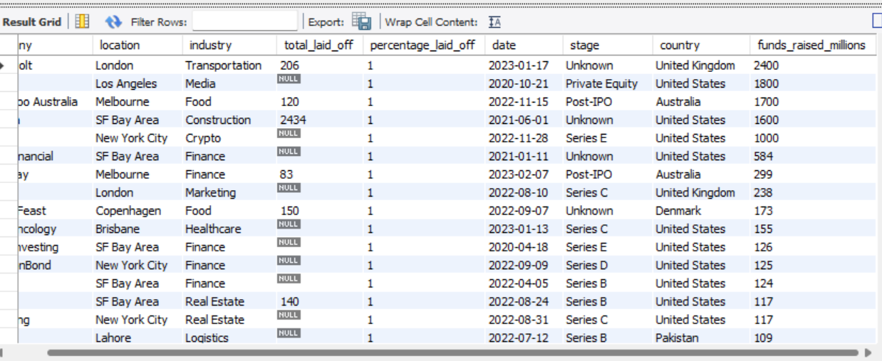

\-- Companies with the highest layoff

SELECT company, SUM(total\_laid\_off)

FROM layoffs\_stagings2

GROUP BY company

ORDER BY 2 DESC

LIMIT 7;

Output:

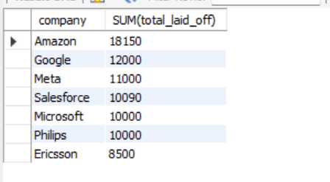

SELECT MIN(\`date\`), MAX(\`date\`)

FROM layoffs\_stagings2;

Output:



\-- What is the total laid off of the industries?

SELECT industry, SUM(total\_laid\_off)

FROM layoffs\_stagings2

GROUP BY industry

ORDER BY 2 DESC;

Output:

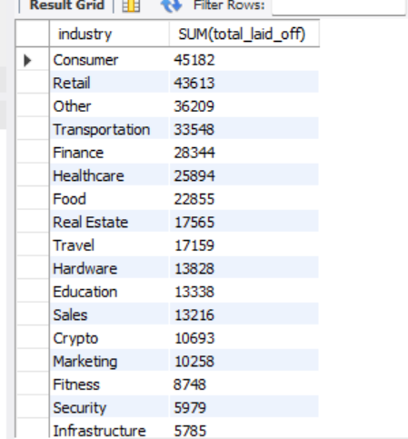

SELECT industry, ROUND(AVG(percentage\_laid\_off),2) AS Average\_percentage\_laid\_off

FROM layoffs\_stagings2

WHERE percentage\_laid\_off IS NOT NULL

GROUP BY industry

ORDER BY Average\_percentage\_laid\_off DESC;

Output:

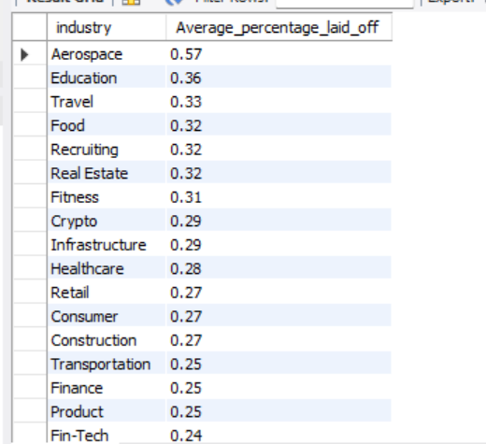

\-- What is the total laid off of each countries?

SELECT country, SUM(total\_laid\_off)

FROM layoffs\_stagings2

GROUP BY country

ORDER BY 2 DESC;

Output:

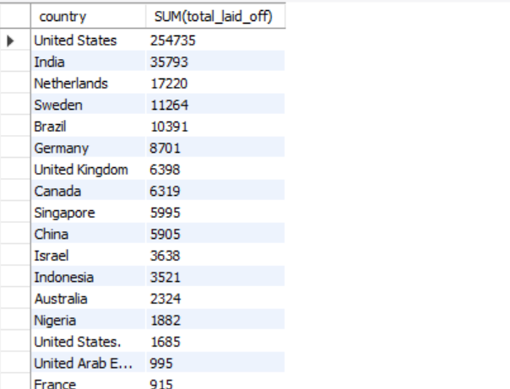

SELECT country, ROUND(AVG(percentage\_laid\_off),2) AS Average\_percentage\_laid\_off

FROM layoffs\_stagings2

WHERE percentage\_laid\_off IS NOT NULL

GROUP BY country

ORDER BY Average\_percentage\_laid\_off DESC;

Output:

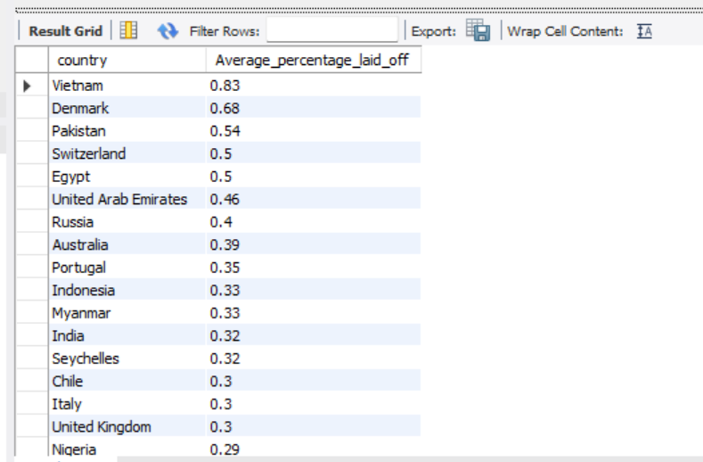

SELECT company, industry, total\_laid\_off, percentage\_laid\_off

FROM layoffs\_stagings2

ORDER BY total\_laid\_off DESC;

Output:

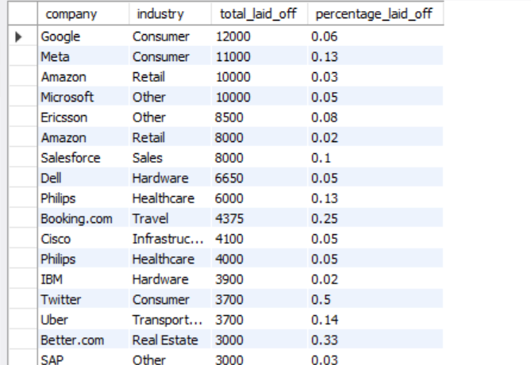

\-- What is the total laid off for each year?

SELECT YEAR(\`date\`), SUM(total\_laid\_off)

FROM layoffs\_stagings2

GROUP BY YEAR(\`date\`)

ORDER BY 1 DESC;

Output:

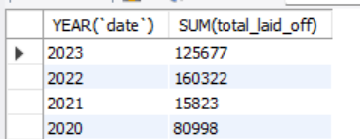

\-- What is the total laid off of each stage?

SELECT stage, SUM(total\_laid\_off)

FROM layoffs\_stagings2

GROUP BY stage

ORDER BY 2 DESC;

Output:

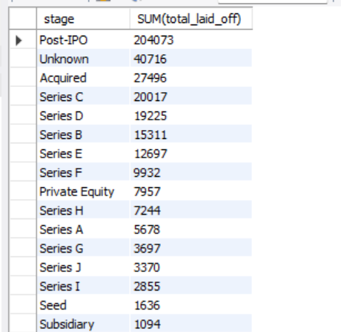

SELECT stage, SUM(total\_laid\_off) AS total\_laid\_off

FROM layoffs\_stagings2

WHERE stage IN ('Acquired', 'Post-IPO')

GROUP BY stage

ORDER BY 2 DESC;

Output:

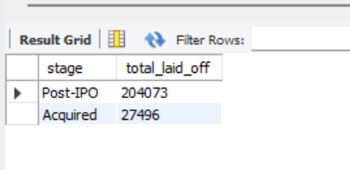

SELECT SUBSTRING(\`date\`, 1, 7\) AS \`MONTH\`, SUM(total\_laid\_off)

FROM layoffs\_stagings2

WHERE SUBSTRING(\`date\`, 1, 7\) IS NOT NULL

GROUP BY \`MONTH\`

ORDER BY 1 ASC;

Output:

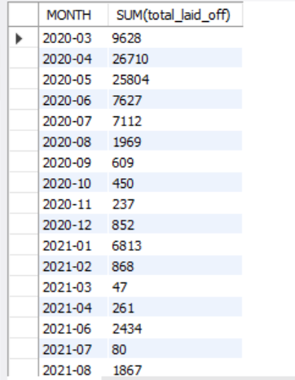

\-- Rolling total of Layoffs per Month

WITH Rolling\_Total AS

(

SELECT SUBSTRING(\`date\`, 1, 7\) AS \`MONTH\`, SUM(total\_laid\_off) AS Total\_off

FROM layoffs\_stagings2

WHERE SUBSTRING(\`date\`, 1, 7\) IS NOT NULL

GROUP BY \`MONTH\`

ORDER BY 1 ASC

)

SELECT \`MONTH\`, Total\_off,

SUM(Total\_off) OVER(ORDER BY \`MONTH\`) AS Rolling\_total

FROM Rolling\_Total;

Output:

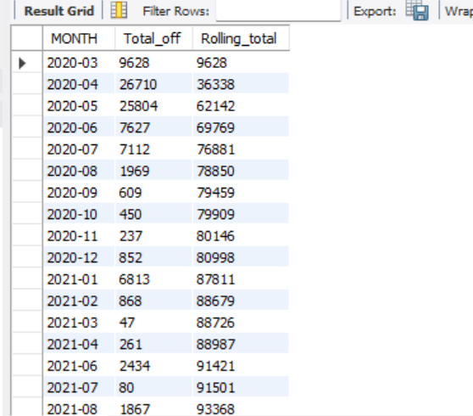

SELECT company, SUM(total\_laid\_off)

FROM layoffs\_stagings2

GROUP BY company

ORDER BY 2 DESC;

Output:

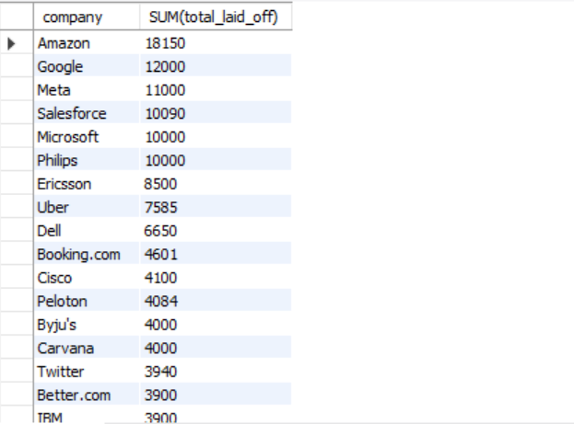

\-- Identify the top 5 companies with the highest percentage of layoffs.

SELECT company, ROUND(SUM(percentage\_laid\_off),2)

FROM layoffs\_stagings2

WHERE percentage\_laid\_off IS NOT NULL

GROUP BY company

ORDER BY 2 DESC

LIMIT 5;

Output:

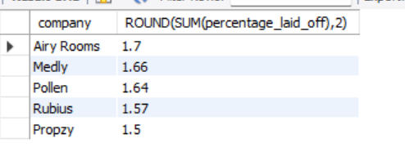

SELECT company, YEAR(\`date\`), SUM(total\_laid\_off)

FROM layoffs\_stagings2

GROUP BY company, YEAR(\`date\`)

ORDER BY 3 DESC;

Output:

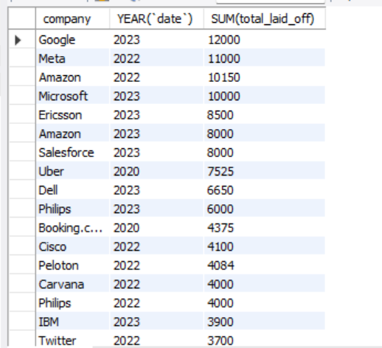

WITH Company\_Year (company, years, total\_laid\_off) AS

(

SELECT company, YEAR(\`date\`), SUM(total\_laid\_off)

FROM layoffs\_stagings2

GROUP BY company, YEAR(\`date\`)

), Company\_Year\_Rank AS

(SELECT \*,

DENSE\_RANK() OVER (PARTITION BY years ORDER BY total\_laid\_off DESC) AS Ranking

FROM Company\_Year

WHERE years IS NOT NULL

)

SELECT \*

FROM Company\_Year\_Rank

WHERE Ranking \<= 5;

Output:

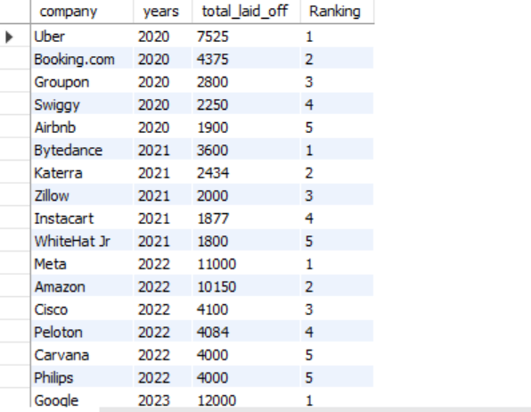

SELECT company, funds\_raised\_millions, SUM(total\_laid\_off)

FROM layoffs\_stagings2

WHERE funds\_raised\_millions IS NOT NULL

GROUP BY company, funds\_raised\_millions

ORDER BY SUM(total\_laid\_off) DESC;

Output:

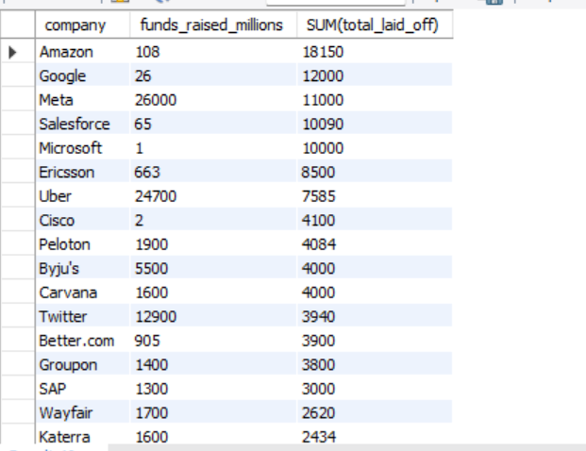

SELECT AVG(funds\_raised\_millions) AS Average\_funds\_raised

FROM layoffs\_stagings2

WHERE total\_laid\_off IS NOT NULL AND funds\_raised\_millions IS NOT NULL;

Output:

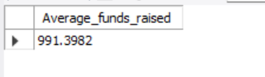

WITH significant\_layoffs AS (

SELECT \*

FROM layoffs\_stagings2

WHERE total\_laid\_off \> 100 \-- Filter companies with more than 100 layoffs

)

SELECT industry, SUM(total\_laid\_off) AS total\_laid\_off, ROUND(AVG(percentage\_laid\_off),2) AS Average\_percentage\_laid\_off

FROM significant\_layoffs

GROUP BY industry

ORDER BY total\_laid\_off DESC;

Output:

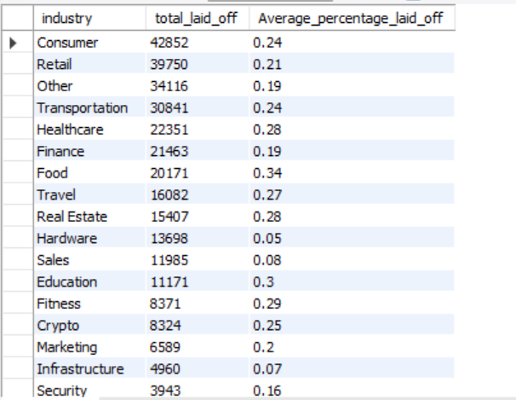

\-- Relationship between the amounts of funds raised and percentage laid off

SELECT funds\_raised\_millions, AVG(percentage\_laid\_off) AS avg\_percentage\_laid\_off

FROM layoffs\_stagings2

WHERE percentage\_laid\_off IS NOT NULL AND funds\_raised\_millions IS NOT NULL

GROUP BY funds\_raised\_millions

ORDER BY funds\_raised\_millions DESC;

Output:

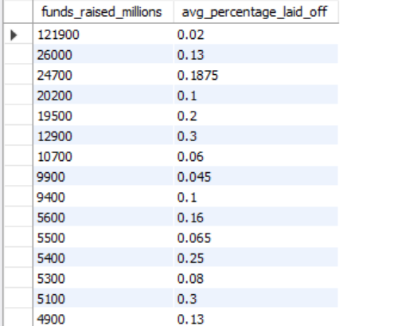

\-- Which sectors are most impacted by layoff

SELECT industry, COUNT(company) AS companies\_affected, SUM(total\_laid\_off) AS total\_laid\_off

FROM layoffs\_stagings2

WHERE total\_laid\_off IS NOT NULL

GROUP BY industry

ORDER BY total\_laid\_off DESC;

Output:

