# Python Project One

## Question One – Random Number Generator

## Select one of the following:

### Magic 8 Ball

The Magic 8 Ball is a plastic sphere, made to look like an oversized eight ball, that is used for fortune-telling or seeking advice. It was invented in 1946 by Albert C. Carter and Abe Bookman and is currently manufactured by Mattel. The user asks a yes–no question to the ball, then turns it over to reveal an answer that floats up into a window (Magic 8 Ball, 2023).

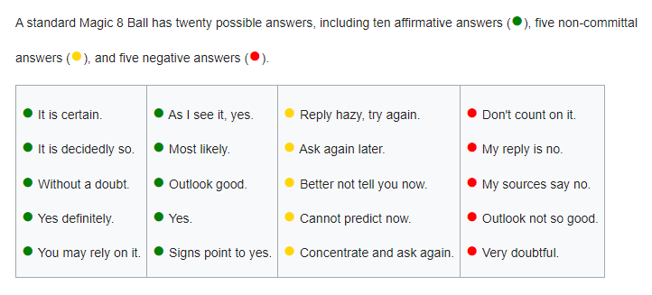

### Assignment

Write a program in python that simulates the function of the Magic 8 Ball by printing a response to a user’s question. Please ensure that of the possible responses you have at least 3 from the affirmation answers, 3 from the non-committal and 3 from the negative.

### Fortune Cookie

A fortune cookie is a crisp and sugary cookie wafer made from flour, sugar, vanilla, and sesame seed oil with a piece of paper inside, a "fortune", an aphorism, or a vague prophecy. The message inside may also include a Chinese phrase with translation and/or a list of lucky numbers used by some as lottery numbers. Fortune cookies are often served as a dessert in Chinese restaurants in the United States, Canada, Australia, and other countries, but they are not Chinese in origin. The exact origin of fortune cookies is unclear, though various immigrant groups in California claim to have popularized them in the early 20th century. They most likely originated from cookies made by Japanese immigrants to the United States in the late 19th or early 20th century. The Japanese version did not have the Chinese lucky numbers and was eaten with tea (Fortune cookie, 2023).

### Assignment

Write a program in python that will simulate the function of the Fortune cookie by printing a fortune along with 4 random numbers. You should have at least 6 possible fortunes and your random numbers should range between 1 and 99.

## Question Two Loop Practice

### Fizz buzz

Fizz buzz is a group word game for children to teach them about division.[1] Players take turns to count incrementally, replacing any number divisible by three with the word "fizz", and any number divisible by five with the word "buzz", and any number divisible by both 3 and 5 with the word "fizzbuzz".

### Assignment

Fizz Buzz - write a program that prints the numbers from 1 to 100. But for multiples of three print “Fizz” instead of the number and for the multiples of five print “Buzz”. For numbers which are multiples of both three and five print “FizzBuzz” (Fizz buzz, 2023).

## References

Fizz buzz. (2023, April 5). In *Wikipedia*. https://en.wikipedia.org/wiki/Fizz_buzz

Fortune cookie. (2023, April 19). In *Wikipedia*. https://en.wikipedia.org/wiki/Fortune_cookie

Magic 8 Ball. (2023, April 17). In *Wikipedia*. https://en.wikipedia.org/wiki/Magic_8_Ball