Mental Health in Tech Survey - Part 1

Oscar Monroy

5/19/2022

Timestamp  
  
Age  
  
Gender  
  
Country  
  
state: If you live in the United States, which state or territory do you live in?  
  
self_employed: Are you self-employed?  
  
family_history: Do you have a family history of mental illness?  
  
treatment: Have you sought treatment for a mental health condition?  
  
work_interfere: If you have a mental health condition, do you feel that it interferes with your work?  
  
no_employees: How many employees does your company or organization have?  
  
remote_work: Do you work remotely (outside of an office) at least 50% of the time?  
  
tech_company: Is your employer primarily a tech company/organization?  
  
benefits: Does your employer provide mental health benefits?  
  
care_options: Do you know the options for mental health care your employer provides?  
  
wellness_program: Has your employer ever discussed mental health as part of an   
employee wellness program?  
  
seek_help: Does your employer provide resources to learn more about mental health   
issues and how to seek help?  
  
anonymity: Is your anonymity protected if you choose to take advantage of mental   
health or substance abuse treatment resources?  
  
leave: How easy is it for you to take medical leave for a mental health condition?  
  
mentalhealthconsequence: Do you think that discussing a mental health issue with   
your employer would have negative consequences?  
  
physhealthconsequence: Do you think that discussing a physical health issue with   
your employer would have negative consequences?  
  
coworkers: Would you be willing to discuss a mental health issue with your coworkers?  
  
supervisor: Would you be willing to discuss a mental health issue with your direct supervisor(s)?  
  
mentalhealthinterview: Would you bring up a mental health issue with a potential employer   
in an interview?  
  
physhealthinterview: Would you bring up a physical health issue with a potential employer   
in an interview?  
  
mentalvsphysical: Do you feel that your employer takes mental health as seriously as p. health?  
  
obs_consequence: Have you heard of or observed negative consequences for coworkers with   
mental health conditions in your workplace?

mht <- read.csv("survey.csv")  
summary(mht) # The data seems to be mostly error free, except Gender and age

## Timestamp Age Gender   
## 2014-08-27 12:31:41: 2 Min. :-1.726e+03 Male :615   
## 2014-08-27 12:37:50: 2 1st Qu.: 2.700e+01 male :206   
## 2014-08-27 12:43:28: 2 Median : 3.100e+01 Female :121   
## 2014-08-27 12:44:51: 2 Mean : 7.943e+07 M :116   
## 2014-08-27 12:54:11: 2 3rd Qu.: 3.600e+01 female : 62   
## 2014-08-27 14:22:43: 2 Max. : 1.000e+11 F : 38   
## (Other) :1247 (Other):101   
## Country state self_employed family_history treatment  
## United States :751 CA :138 No :1095 No :767 No :622   
## United Kingdom:185 WA : 70 Yes : 146 Yes:492 Yes:637   
## Canada : 72 NY : 57 NA's: 18   
## Germany : 45 TN : 45   
## Ireland : 27 TX : 44   
## Netherlands : 27 (Other):390   
## (Other) :152 NA's :515   
## work_interfere no_employees remote_work tech_company  
## Never :213 1-5 :162 No :883 No : 228   
## Often :144 100-500 :176 Yes:376 Yes:1031   
## Rarely :173 26-100 :289   
## Sometimes:465 500-1000 : 60   
## NA's :264 6-25 :290   
## More than 1000:282   
##   
## benefits care_options wellness_program seek_help   
## Don't know:408 No :501 Don't know:188 Don't know:363   
## No :374 Not sure:314 No :842 No :646   
## Yes :477 Yes :444 Yes :229 Yes :250   
##   
##   
##   
##   
## anonymity leave mental_health_consequence  
## Don't know:819 Don't know :563 Maybe:477   
## No : 65 Somewhat difficult:126 No :490   
## Yes :375 Somewhat easy :266 Yes :292   
## Very difficult : 98   
## Very easy :206   
##   
##   
## phys_health_consequence coworkers supervisor   
## Maybe:273 No :260 No :393   
## No :925 Some of them:774 Some of them:350   
## Yes : 61 Yes :225 Yes :516   
##   
##   
##   
##   
## mental_health_interview phys_health_interview mental_vs_physical  
## Maybe: 207 Maybe:557 Don't know:576   
## No :1008 No :500 No :340   
## Yes : 44 Yes :202 Yes :343   
##   
##   
##   
##   
## obs_consequence  
## No :1075   
## Yes: 184   
##   
##   
##   
##   
##   
## comments   
## * Small family business - YMMV. : 5   
## - : 1   
## : 1   
## (yes but the situation was unusual and involved a change in leadership at a very high level in the organization as well as an extended leave of absence) : 1   
## A close family member of mine struggles with mental health so I try not to stigmatize it. My employers/coworkers also seem compassionate toward any kind of health or family needs.: 1   
## (Other) : 155   
## NA's :1095

table(mht$Gender) # There's a lot of misspellings here...

##   
## A little about you   
## 1   
## Agender   
## 1   
## All   
## 1   
## Androgyne   
## 1   
## cis-female/femme   
## 1   
## Cis Female   
## 1   
## cis male   
## 1   
## Cis Male   
## 2   
## Cis Man   
## 1   
## Enby   
## 1   
## f   
## 15   
## F   
## 38   
## femail   
## 1   
## Femake   
## 1   
## female   
## 62   
## Female   
## 121   
## Female   
## 2   
## Female (cis)   
## 1   
## Female (trans)   
## 2   
## fluid   
## 1   
## Genderqueer   
## 1   
## Guy (-ish) ^_^   
## 1   
## m   
## 34   
## M   
## 116   
## Mail   
## 1   
## maile   
## 1   
## Make   
## 4   
## Mal   
## 1   
## male   
## 206   
## Male   
## 615   
## Male-ish   
## 1   
## Male   
## 3   
## Male (CIS)   
## 1   
## male leaning androgynous   
## 1   
## Malr   
## 1   
## Man   
## 2   
## msle   
## 1   
## Nah   
## 1   
## Neuter   
## 1   
## non-binary   
## 1   
## ostensibly male, unsure what that really means   
## 1   
## p   
## 1   
## queer   
## 1   
## queer/she/they   
## 1   
## something kinda male?   
## 1   
## Trans-female   
## 1   
## Trans woman   
## 1   
## woman   
## 1   
## Woman   
## 3

# Normally, I'd do some regex to change the misspelled levels into  
# correctly spelled form, but using the indices for the levels would   
# make this job a lot faster. I'll also be making an "Other" level  
# to fit all the people who don't fit within the definition of  
# cis-gendered. Also because there is a very small smaple size for them.  
# Trans women will also be fit into the "Female" category as they choose  
# to identify as female. Ultimately, there will be some subjectivity at  
# play here; for example, "male leaning androgynous" will be fit in the   
# "Male" category as they still identify as male, but "something kinda male?"  
# will be put in the "other" category as they are unsure of their status.  
levels(mht$Gender)[c(1,2,3,4,10,20,21,22,38,39,40,42,43,44,45)] <- "Other"  
levels(mht$Gender)[c(2,3,7:15,32:35)] <- "Female"  
levels(mht$Gender)[-c(1,2)] <- "Male"  
table(mht$Gender) # Much better

##   
## Other Female Male   
## 15 251 993

# Time to fix the age variable.  
t10 <- sort(mht$Age)  
head(t10, 10) # These are some VERY young people...

## [1] -1726 -29 -1 5 8 11 18 18 18 18

tail(t10, 10) # We also got some aged 329 years old and 100 billion years old. Seems normal

## [1] 5.70e+01 5.80e+01 6.00e+01 6.00e+01 6.10e+01 6.20e+01 6.50e+01 7.20e+01  
## [9] 3.29e+02 1.00e+11

error_num <- c(t10[c(1:6, length(t10) - 1, length(t10))])  
mht <- mht[-which(mht$Age %in% error_num), ]  
summary(mht$Age)

## Min. 1st Qu. Median Mean 3rd Qu. Max.   
## 18.00 27.00 31.00 32.08 36.00 72.00

# Now we look for duplicates  
sum(duplicated(mht)) # None, luckily

## [1] 0

# The Demographic

library(ggplot2)

## Warning: package 'ggplot2' was built under R version 3.6.3

library(dplyr)

## Warning: package 'dplyr' was built under R version 3.6.3

# Age groups defined here:   
# https://www.pewresearch.org/fact-tank/2019/01/17/where-millennials-end-and-generation-z-begins/  
# Millenial -> 1981-1996   
# Generation X -> 1965-1980   
# Boomer & Silent Gen. -> 1928-1964  
  
gen_groups <- cut(mht$Age, c(17,34,50,75),  
 labels=c("Millenial", "Generation X", "Boomer/Silent Gen"))  
mht2 <- cbind(mht, "Gen" = gen_groups)  
  
hist(mht2$Age, col = "Red", xlab = "Age", main = "Histogram of Age Variable",  
 ylim = c(0, 150), xlim = c(10, 80), breaks = 20)

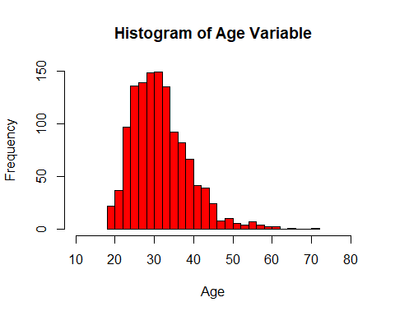

a_m <- mht2 %>%  
 filter(Gender == "Male")  
a_f <- mht2 %>%  
 filter(Gender == "Female")  
a_o <- mht2 %>%  
 filter(Gender == "Other")  
  
hist(a_m$Age, col = rgb(1,0,1,1/4), xlab = "Age", main = "Histogram of Age by Gender",  
 ylim = c(0, 125), xlim = c(10, 80), breaks = 20)  
hist(a_f$Age, col = rgb(0,1,0,1/4), breaks = 20, add = T)  
hist(a_o$Age, col = rgb(0,1,1,1/4), breaks = 20, add = T)  
legend(60, 100, legend = c("Male", "Female", "Other"),  
 fill = c(rgb(1,0,1,1/4), rgb(0,1,0,1/4), rgb(0,1,1,1/4)))

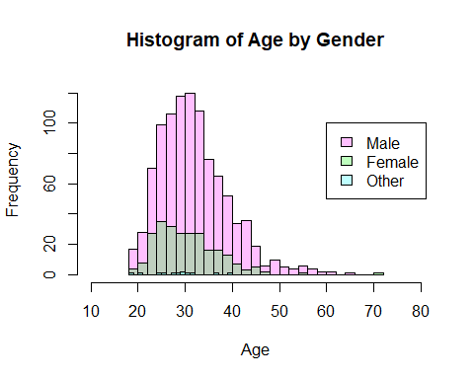

# We see that the majority of people that answered the survey  
# are in their late 20's (25-29).  
  
ggplot(mht2, aes(x = Gender)) +   
 geom_bar(aes(y = (..count..)/sum(..count..)), fill = "purple") +  
 ylab("Proportion (%)") +  
 ggtitle("Proportion of Workers by Gender")

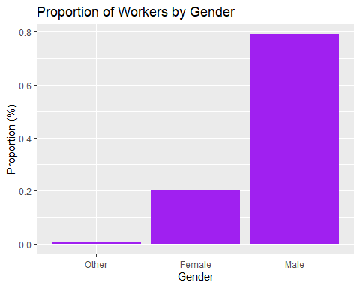

prop.table(table(mht2$Age))

##   
## 18 19 20 21 22 23   
## 0.0055955236 0.0071942446 0.0047961631 0.0127897682 0.0167865707 0.0407673861   
## 24 25 26 27 28 29   
## 0.0367705835 0.0487609912 0.0599520384 0.0567545963 0.0543565148 0.0679456435   
## 30 31 32 33 34 35   
## 0.0503597122 0.0535571543 0.0655475620 0.0559552358 0.0519584333 0.0439648281   
## 36 37 38 39 40 41   
## 0.0295763389 0.0343725020 0.0311750600 0.0263788969 0.0263788969 0.0167865707   
## 42 43 44 45 46 47   
## 0.0159872102 0.0223820943 0.0087929656 0.0095923261 0.0095923261 0.0015987210   
## 48 49 50 51 53 54   
## 0.0047961631 0.0031974420 0.0047961631 0.0039968026 0.0007993605 0.0023980815   
## 55 56 57 58 60 61   
## 0.0023980815 0.0031974420 0.0023980815 0.0007993605 0.0015987210 0.0007993605   
## 62 65 72   
## 0.0007993605 0.0007993605 0.0007993605

ggplot(mht2, aes(x = Gen)) +   
 geom_bar(aes(y = (..count..)/sum(..count..)), fill = "green") +  
 ylab("Proportion (%)") +  
 ggtitle("Proportion of Workers by Generation")

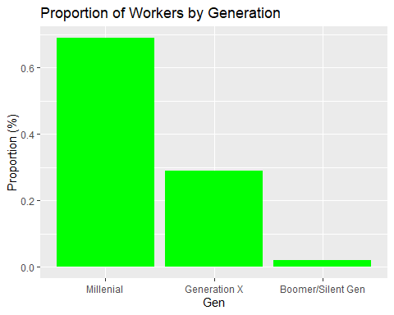

prop.table(table(mht2$Gen))

##   
## Millenial Generation X Boomer/Silent Gen   
## 0.68984812 0.28936851 0.02078337

p <- prop.table(table(mht2$Gen, mht2$Gender))  
p_df <- as.data.frame(p)  
p_df

## Var1 Var2 Freq  
## 1 Millenial Other 0.007993605  
## 2 Generation X Other 0.001598721  
## 3 Boomer/Silent Gen Other 0.000000000  
## 4 Millenial Female 0.149480416  
## 5 Generation X Female 0.049560352  
## 6 Boomer/Silent Gen Female 0.001598721  
## 7 Millenial Male 0.532374101  
## 8 Generation X Male 0.238209432  
## 9 Boomer/Silent Gen Male 0.019184652

ggplot(p_df, aes(x = Var1, y = Freq, fill = Var2)) +   
 geom_bar(stat="identity", position = "dodge") +  
 xlab("Generation") +  
 ylab("Proportion (%)") +  
 ggtitle("Proportional Frequency of Each Generation by Gender")

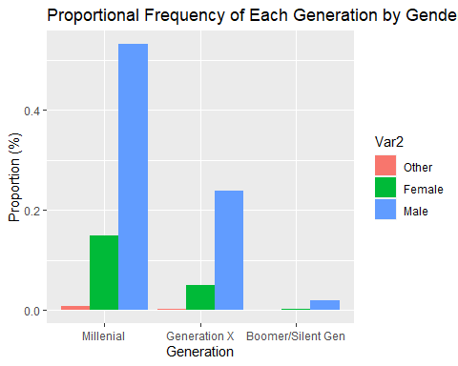

fh_gen <- mht2 %>%  
 select(Gen, family_history) %>%  
 group_by(Gen) %>%  
 count(family_history)  
  
ggplot(fh_gen, aes(x = Gen, y = n, fill = family_history)) +   
 geom_bar(stat="identity", position = "dodge") +  
 xlab("Generation") +  
 ylab("Total") +  
 ggtitle("Reported Family History of Mental Illness by Age Group")

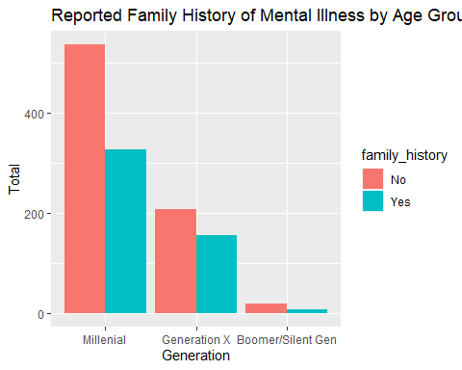

table(mht2$Country) # Countries that people from this survey are in

##   
## Australia Austria Bahamas, The   
## 21 3 0   
## Belgium Bosnia and Herzegovina Brazil   
## 6 1 6   
## Bulgaria Canada China   
## 4 72 1   
## Colombia Costa Rica Croatia   
## 2 1 2   
## Czech Republic Denmark Finland   
## 1 2 3   
## France Georgia Germany   
## 13 1 45   
## Greece Hungary India   
## 2 1 10   
## Ireland Israel Italy   
## 27 5 7   
## Japan Latvia Mexico   
## 1 1 3   
## Moldova Netherlands New Zealand   
## 1 27 8   
## Nigeria Norway Philippines   
## 1 1 1   
## Poland Portugal Romania   
## 7 2 1   
## Russia Singapore Slovenia   
## 3 4 1   
## South Africa Spain Sweden   
## 6 1 7   
## Switzerland Thailand United Kingdom   
## 7 1 184   
## United States Uruguay Zimbabwe   
## 746 1 0

table(mht2$state) # US states that people from this survey are in

##   
## AL AZ CA CO CT DC FL GA IA ID IL IN KS KY LA MA MD ME MI MN   
## 7 7 138 9 4 4 15 12 4 1 28 27 3 5 1 20 8 1 22 20   
## MO MS NC NE NH NJ NM NV NY OH OK OR PA RI SC SD TN TX UT VA   
## 12 1 14 2 3 6 2 3 57 27 6 29 29 1 5 3 45 44 11 14   
## VT WA WI WV WY   
## 3 70 12 1 2

# Survey Results

### MH = Mental Health

### PH = Physical Health

library(ggpubr)

## Warning: package 'ggpubr' was built under R version 3.6.3

summary(mht2[, -c(1:5, 27)])

## self_employed family_history treatment work_interfere no_employees  
## No :1091 No :762 No :619 Never :212 1-5 :158   
## Yes : 142 Yes:489 Yes:632 Often :140 100-500 :175   
## NA's: 18 Rarely :173 26-100 :288   
## Sometimes:464 500-1000 : 60   
## NA's :262 6-25 :289   
## More than 1000:281   
## remote_work tech_company benefits care_options wellness_program  
## No :880 No : 226 Don't know:407 No :499 Don't know:187   
## Yes:371 Yes:1025 No :371 Not sure:313 No :837   
## Yes :473 Yes :439 Yes :227   
##   
##   
##   
## seek_help anonymity leave   
## Don't know:363 Don't know:815 Don't know :561   
## No :641 No : 64 Somewhat difficult:125   
## Yes :247 Yes :372 Somewhat easy :265   
## Very difficult : 97   
## Very easy :203   
##   
## mental_health_consequence phys_health_consequence coworkers   
## Maybe:476 Maybe:273 No :258   
## No :487 No :920 Some of them:771   
## Yes :288 Yes : 58 Yes :222   
##   
##   
##   
## supervisor mental_health_interview phys_health_interview  
## No :390 Maybe: 207 Maybe:555   
## Some of them:349 No :1003 No :496   
## Yes :512 Yes : 41 Yes :200   
##   
##   
##   
## mental_vs_physical obs_consequence Gen   
## Don't know:574 No :1070 Millenial :863   
## No :338 Yes: 181 Generation X :362   
## Yes :339 Boomer/Silent Gen: 26   
##   
##   
##

se <- mht2 %>%  
 count(self_employed)  
  
g1 <- ggplot(se[-3, ], aes(x = self_employed, y = n)) +   
 geom_bar(stat="identity", position = "dodge", fill = c("red", "green")) +  
 xlab("Answer") +  
 ylab("Total") +  
 ggtitle("Reported as Self-Employed") +   
 theme(plot.title = element_text(size = 10))  
  
fh <- mht2 %>%  
 count(family_history)  
  
g2 <- ggplot(fh, aes(x = family_history, y = n)) +   
 geom_bar(stat="identity", position = "dodge", fill = c("red", "green")) +  
 xlab("Answer") +  
 ylab("Total") +  
 ggtitle("Family History of Mental Illness?") +   
 theme(plot.title = element_text(size = 10))  
  
tr <- mht2 %>%  
 count(treatment)  
  
g3 <- ggplot(tr, aes(x = treatment, y = n)) +   
 geom_bar(stat="identity", position = "dodge", fill = c("red", "green")) +  
 xlab("Answer") +  
 ylab("Total") +  
 ggtitle("Sought Treatment for Mental Health?") +   
 theme(plot.title = element_text(size = 10))  
  
wi <- mht2 %>%  
 count(work_interfere)  
wi2 <- wi[-5, ]  
wi2 <- wi2[c(1, 3, 4, 2), ]  
wi2$work_interfere <- factor(wi2$work_interfere, levels = wi2$work_interfere)  
  
g4 <- ggplot(wi2, aes(x = work_interfere, y = n)) +   
 geom_bar(stat="identity", position = "dodge", fill = 1:4) +  
 xlab("Answer") +  
 ylab("Total") +  
 ggtitle("Mental Health Interferes w/ Work?") +   
 theme(plot.title = element_text(size = 10))  
  
ne <- mht2 %>%  
 count(no_employees)  
ne2 <- ne[c(1, 5, 3, 2, 4, 6), ]  
ne2$no_employees <- factor(ne2$no_employees, levels = ne2$no_employees)  
  
g5 <- ggplot(ne2, aes(x = no_employees, y = n)) +   
 geom_bar(stat="identity", position = "dodge", fill = 1:6) +  
 xlab("Answer") +  
 ylab("Total") +  
 ggtitle("How Many Employees in the Company?") +   
 theme(plot.title = element_text(size = 20))  
  
rw <- mht2 %>%  
 count(remote_work)  
  
g6 <- ggplot(rw, aes(x = remote_work, y = n)) +   
 geom_bar(stat="identity", position = "dodge", fill = c("red", "green")) +  
 xlab("Answer") +  
 ylab("Total") +  
 ggtitle("Work Remotely?") +   
 theme(plot.title = element_text(size = 10))  
  
tc <- mht2 %>%  
 count(tech_company)  
  
g7 <- ggplot(tc, aes(x = tech_company, y = n)) +   
 geom_bar(stat="identity", position = "dodge", fill = c("red", "green")) +  
 xlab("Answer") +  
 ylab("Total") +  
 ggtitle("Work for a Tech Company?") +   
 theme(plot.title = element_text(size = 10))  
  
bn <- mht2 %>%  
 count(benefits)  
  
g8 <- ggplot(bn, aes(x = benefits, y = n)) +   
 geom_bar(stat="identity", position = "dodge", fill = c("purple", "red", "green")) +  
 xlab("Answer") +  
 ylab("Total") +  
 ggtitle("Employer Provide MH Benefits?") +   
 theme(plot.title = element_text(size = 10))  
  
co <- mht2 %>%  
 count(care_options)  
  
g9 <- ggplot(co, aes(x = care_options, y = n)) +   
 geom_bar(stat="identity", position = "dodge", fill = c("red", "purple", "green")) +  
 xlab("Answer") +  
 ylab("Total") +  
 ggtitle("Knowledge of MH Care Employer Have") +   
 theme(plot.title = element_text(size = 10))  
  
wp <- mht2 %>%  
 count(wellness_program)  
  
g10 <- ggplot(wp, aes(x = wellness_program, y = n)) +   
 geom_bar(stat="identity", position = "dodge", fill = c("purple", "red", "green")) +  
 xlab("Answer") +  
 ylab("Total") +  
 ggtitle("MH Part of Employee Wellness Program?") +   
 theme(plot.title = element_text(size = 10))  
  
sh <- mht2 %>%  
 count(seek_help)  
  
g11 <- ggplot(sh, aes(x = seek_help, y = n)) +   
 geom_bar(stat="identity", position = "dodge", fill = c("purple", "red", "green")) +  
 xlab("Answer") +  
 ylab("Total") +  
 ggtitle("Resources Provided for MH Issues?") +   
 theme(plot.title = element_text(size = 10))  
  
an <- mht2 %>%  
 count(anonymity)  
  
g12 <- ggplot(an, aes(x = anonymity, y = n)) +   
 geom_bar(stat="identity", position = "dodge", fill = c("purple", "red", "green")) +  
 xlab("Answer") +  
 ylab("Total") +  
 ggtitle("Anonymity Kept for MH Issues?") +   
 theme(plot.title = element_text(size = 10))  
  
lv <- mht2 %>%  
 count(leave)  
lv2 <- lv[c(4, 2, 1, 3, 5), ]  
lv2$leave <- factor(lv2$leave, levels = lv2$leave)  
  
g13 <- ggplot(lv2, aes(x = leave, y = n)) +   
 geom_bar(stat="identity", position = "dodge", fill = 1:5) +  
 xlab("Answer") +  
 ylab("Total") +  
 ggtitle("Ease of Taking Leave for MH Issues?") +   
 theme(plot.title = element_text(size = 20))  
  
mc <- mht2 %>%  
 count(mental_health_consequence)  
  
g14 <- ggplot(mc, aes(x = mental_health_consequence, y = n)) +   
 geom_bar(stat="identity", position = "dodge", fill = c("purple", "red", "green")) +  
 xlab("Answer") +  
 ylab("Total") +  
 ggtitle("Discussing MH Issues have Consequences?") +   
 theme(plot.title = element_text(size = 10))  
  
pc <- mht2 %>%  
 count(phys_health_consequence)  
  
g15 <- ggplot(pc, aes(x = phys_health_consequence, y = n)) +   
 geom_bar(stat="identity", position = "dodge", fill = c("purple", "red", "green")) +  
 xlab("Answer") +  
 ylab("Total") +  
 ggtitle("Discussing PH Issues have Consequences?") +   
 theme(plot.title = element_text(size = 10))  
  
cw <- mht2 %>%  
 count(coworkers)  
  
g16 <- ggplot(cw, aes(x = coworkers, y = n)) +   
 geom_bar(stat="identity", position = "dodge", fill = c("red", "purple", "green")) +  
 xlab("Answer") +  
 ylab("Total") +  
 ggtitle("Willing to Discuss MH Issues w/ Coworkers?") +   
 theme(plot.title = element_text(size = 10))  
  
su <- mht2 %>%  
 count(supervisor)  
  
g17 <- ggplot(su, aes(x = supervisor, y = n)) +   
 geom_bar(stat="identity", position = "dodge", fill = c("red", "purple", "green")) +  
 xlab("Answer") +  
 ylab("Total") +  
 ggtitle("Willing to Discuss MH Issues w/ Supervisor(s)?") +   
 theme(plot.title = element_text(size = 9))  
  
mi <- mht2 %>%  
 count(mental_health_interview)  
  
g18 <- ggplot(mi, aes(x = mental_health_interview, y = n)) +   
 geom_bar(stat="identity", position = "dodge", fill = c("purple", "red", "green")) +  
 xlab("Answer") +  
 ylab("Total") +  
 ggtitle("Willing to Bring Up MH Issues in an Interview?") +   
 theme(plot.title = element_text(size = 9))  
  
pi <- mht2 %>%  
 count(phys_health_interview)  
  
g19 <- ggplot(pi, aes(x = phys_health_interview, y = n)) +   
 geom_bar(stat="identity", position = "dodge", fill = c("purple", "red", "green")) +  
 xlab("Answer") +  
 ylab("Total") +  
 ggtitle("Willing to Bring Up PH Issues in an Interview?") +   
 theme(plot.title = element_text(size = 10))  
  
mp <- mht2 %>%  
 count(mental_vs_physical)  
  
g20 <- ggplot(mp, aes(x = mental_vs_physical, y = n)) +   
 geom_bar(stat="identity", position = "dodge", fill = c("purple", "red", "green")) +  
 xlab("Answer") +  
 ylab("Total") +  
 ggtitle("Feel that Employer Takes MH as Seriously as PH?") +   
 theme(plot.title = element_text(size = 8.5))  
  
oc <- mht2 %>%  
 count(obs_consequence)  
  
g21 <- ggplot(oc, aes(x = obs_consequence, y = n)) +   
 geom_bar(stat="identity", position = "dodge", fill = c("red", "green")) +  
 xlab("Answer") +  
 ylab("Total") +  
 ggtitle("Heard/Observed Consequences for Coworkers w/ MH Issues?") +   
 theme(plot.title = element_text(size = 10))  
  
g_all <- c(g1, g2, g3, g4, g5, g6, g7,  
 g8, g9, g10, g11, g12, g13, g14,  
 g15, g16, g17, g18, g19, g20, g21)  
ggarrange(g1, g2, g3, g4, g6, g7,  
 g8, g9, g10, g11, g12, g14, g15,  
 g16, g17, g18, g19, g20, g21, ncol = 2, nrow = 2)

## $`1`

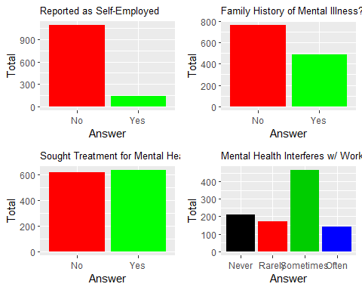

##   
## $`2`

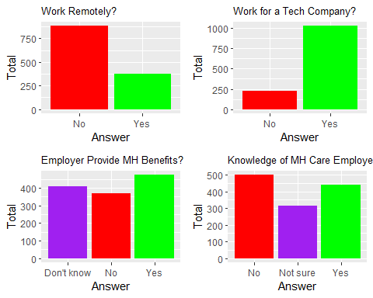

##   
## $`3`

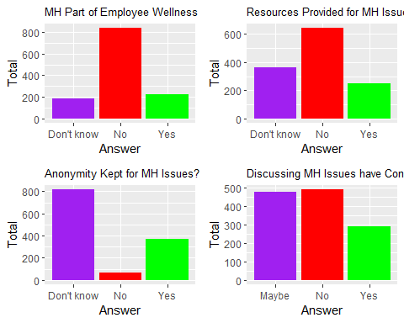

##   
## $`4`

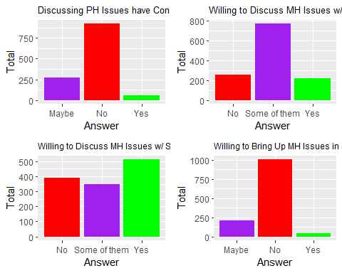

##   
## $`5`

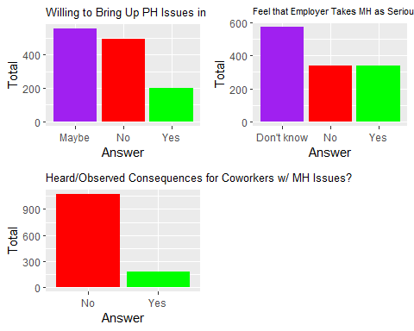

##   
## attr(,"class")  
## [1] "list" "ggarrange"

g5

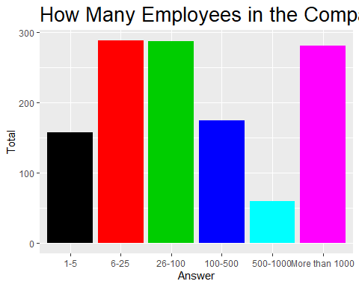

g13

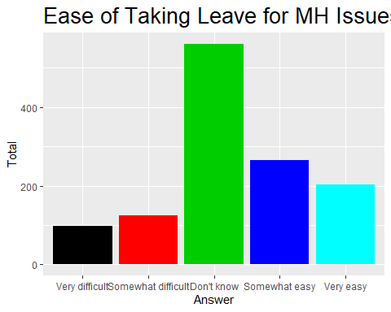

# Does Gender Make a Difference in the Survey Answers?

### Since the “other” category of the Gender variable only has a sample

### size of 15, we won’t include it as the amount is too small to analyze.

library(rcompanion)

## Warning: package 'rcompanion' was built under R version 3.6.3

f1 <- table("Gender" = mht2$Gender, "self_employed" = mht2$self_employed)  
  
f2 <- table("Gender" = mht2$Gender, "family_history" = mht2$family_history)  
  
f3 <- table("Gender" = mht2$Gender, "treatment" = mht2$treatment)  
  
f4 <- table("Gender" = mht2$Gender, "work_interfere" = mht2$work_interfere)  
  
f5 <- table("Gender" = mht2$Gender, "no_employees" = mht2$no_employees)  
  
f6 <- table("Gender" = mht2$Gender, "remote_work" = mht2$remote_work)  
  
f7 <- table("Gender" = mht2$Gender, "tech_company" = mht2$tech_company)  
  
f8 <- table("Gender" = mht2$Gender, "benefits" = mht2$benefits)  
  
f9 <- table("Gender" = mht2$Gender, "care_options" = mht2$care_options)  
  
f10 <- table("Gender" = mht2$Gender, "wellness_program" = mht2$wellness_program)  
  
f11 <- table("Gender" = mht2$Gender, "seek_help" = mht2$seek_help)  
  
f12 <- table("Gender" = mht2$Gender, "anonymity" = mht2$anonymity)  
  
f13 <- table("Gender" = mht2$Gender, "leave" = mht2$leave)  
  
f14 <- table("Gender" = mht2$Gender, "mh_consequence" = mht2$mental_health_consequence)  
  
f15 <- table("Gender" = mht2$Gender, "ph_consequence" = mht2$phys_health_consequence)  
  
f16 <- table("Gender" = mht2$Gender, "coworkers" = mht2$coworkers)  
  
f17 <- table("Gender" = mht2$Gender, "supervisor" = mht2$supervisor)  
  
f18 <- table("Gender" = mht2$Gender, "mh_interview" = mht2$mental_health_interview)  
  
f19 <- table("Gender" = mht2$Gender, "ph_interview" = mht2$self_employed)  
  
f20 <- table("Gender" = mht2$Gender, "mental_vs_physical" = mht2$mental_vs_physical)  
  
f21 <- table("Gender" = mht2$Gender, "obs_consequence" = mht2$obs_consequence)

## We’ll first use Fisher’s Test to see if there are some variables

## where there are differences in the survey results in respect to

## the survey takers’ gender.

pairwiseNominalIndependence(f1, compare = "row", fisher = T,  
gtest = F, chisq = F, digits = 3)[3, ]

## Comparison p.Fisher p.adj.Fisher  
## 3 Female : Male 0.18 0.464

pairwiseNominalIndependence(f2, compare = "row", fisher = T,  
gtest = F, chisq = F, digits = 3)[3, ]

## Comparison p.Fisher p.adj.Fisher  
## 3 Female : Male 3.48e-07 1.04e-06

pairwiseNominalIndependence(f3, compare = "row", fisher = T,  
gtest = F, chisq = F, digits = 3)[3, ]

## Comparison p.Fisher p.adj.Fisher  
## 3 Female : Male 2.19e-11 6.57e-11

pairwiseNominalIndependence(f4, compare = "row", fisher = T,  
gtest = F, chisq = F, digits = 3)[3, ]

## Comparison p.Fisher p.adj.Fisher  
## 3 Female : Male 0.000389 0.00117

pairwiseNominalIndependence(f5, compare = "row", fisher = T,  
gtest = F, chisq = F, digits = 3, simulate.p.value = T)[3, ]

## Comparison p.Fisher p.adj.Fisher  
## 3 Female : Male 5e-04 0.0015

pairwiseNominalIndependence(f6, compare = "row", fisher = T,  
gtest = F, chisq = F, digits = 3)[3, ]

## Comparison p.Fisher p.adj.Fisher  
## 3 Female : Male 0.757 1

pairwiseNominalIndependence(f7, compare = "row", fisher = T,  
gtest = F, chisq = F, digits = 3)[3, ]

## Comparison p.Fisher p.adj.Fisher  
## 3 Female : Male 0.00572 0.0172

pairwiseNominalIndependence(f8, compare = "row", fisher = T,  
gtest = F, chisq = F, digits = 3)[3, ]

## Comparison p.Fisher p.adj.Fisher  
## 3 Female : Male 5.51e-07 1.65e-06

pairwiseNominalIndependence(f9, compare = "row", fisher = T,  
gtest = F, chisq = F, digits = 3)[3, ]

## Comparison p.Fisher p.adj.Fisher  
## 3 Female : Male 5.97e-05 0.000179

pairwiseNominalIndependence(f10, compare = "row", fisher = T,  
gtest = F, chisq = F, digits = 3)[3, ]

## Comparison p.Fisher p.adj.Fisher  
## 3 Female : Male 0.0879 0.264

pairwiseNominalIndependence(f11, compare = "row", fisher = T,  
gtest = F, chisq = F, digits = 3)[3, ]

## Comparison p.Fisher p.adj.Fisher  
## 3 Female : Male 0.239 0.638

pairwiseNominalIndependence(f12, compare = "row", fisher = T,  
gtest = F, chisq = F, digits = 3)[3, ]

## Comparison p.Fisher p.adj.Fisher  
## 3 Female : Male 0.392 0.791

pairwiseNominalIndependence(f13, compare = "row", fisher = T,  
gtest = F, chisq = F, digits = 3)[3, ]

## Comparison p.Fisher p.adj.Fisher  
## 3 Female : Male 0.232 0.524

pairwiseNominalIndependence(f14, compare = "row", fisher = T,  
gtest = F, chisq = F, digits = 3)[3, ]

## Comparison p.Fisher p.adj.Fisher  
## 3 Female : Male 0.00121 0.00363

pairwiseNominalIndependence(f15, compare = "row", fisher = T,  
gtest = F, chisq = F, digits = 3)[3, ]

## Comparison p.Fisher p.adj.Fisher  
## 3 Female : Male 0.0101 0.0303

pairwiseNominalIndependence(f16, compare = "row", fisher = T,  
gtest = F, chisq = F, digits = 3)[3, ]

## Comparison p.Fisher p.adj.Fisher  
## 3 Female : Male 0.149 0.447

pairwiseNominalIndependence(f17, compare = "row", fisher = T,  
gtest = F, chisq = F, digits = 3)[3, ]

## Comparison p.Fisher p.adj.Fisher  
## 3 Female : Male 0.000456 0.00137

pairwiseNominalIndependence(f18, compare = "row", fisher = T,  
gtest = F, chisq = F, digits = 3)[3, ]

## Comparison p.Fisher p.adj.Fisher  
## 3 Female : Male 3.73e-06 1.12e-05

pairwiseNominalIndependence(f19, compare = "row", fisher = T,  
gtest = F, chisq = F, digits = 3)[3, ]

## Comparison p.Fisher p.adj.Fisher  
## 3 Female : Male 0.18 0.464

pairwiseNominalIndependence(f20, compare = "row", fisher = T,  
gtest = F, chisq = F, digits = 3)[3, ]

## Comparison p.Fisher p.adj.Fisher  
## 3 Female : Male 0.564 0.564

pairwiseNominalIndependence(f21, compare = "row", fisher = T,  
gtest = F, chisq = F, digits = 3)[3, ]

## Comparison p.Fisher p.adj.Fisher  
## 3 Female : Male 0.0121 0.0363

Using the adjusted P-value of the results, we can see that the most  
significant variables (using a threshold of 0.05) are:  
family_history, treatment, work_interfere, no_employees, tech_company,  
benefits, care_options, mental_health_consequence, phys_health_consequence,  
supervisor, mental_health_interview, and obs_consequence.

## Let’s see the confusion matrices for those that are significant.

# We'll use proportion tables where the total amount of   
# the respective gender is used instead of the grand total  
# to calculate the proportions.  
  
list("family_history" = prop.table(f2[-1, ], margin = 1),   
 "Treatment" = prop.table(f3[-1, ],margin = 1),   
 "work_interfere" = prop.table(f4[-1, ], margin = 1),   
 "no_employees" = prop.table(f5[-1, ], margin = 1),   
 "tech_company" = prop.table(f7[-1, ], margin = 1),   
 "benefits" = prop.table(f8[-1, ], margin = 1),   
 "care_options" = prop.table(f9[-1, ], margin = 1),   
 "mental_health_consequence" = prop.table(f14[-1, ], margin = 1),   
 "phys_health_consequence" = prop.table(f15[-1, ], margin = 1),   
 "supervisor" = prop.table(f17[-1, ], margin = 1),   
 "mental_health_interview" = prop.table(f18[-1, ], margin = 1),   
 "obs_consequence" = prop.table(f21[-1, ], margin = 1))

## $family_history  
## family_history  
## Gender No Yes  
## Female 0.4701195 0.5298805  
## Male 0.6477733 0.3522267  
##   
## $Treatment  
## treatment  
## Gender No Yes  
## Female 0.3107570 0.6892430  
## Male 0.5455466 0.4544534  
##   
## $work_interfere  
## work_interfere  
## Gender Never Often Rarely Sometimes  
## Female 0.1162791 0.1674419 0.2093023 0.5069767  
## Male 0.2437746 0.1363041 0.1651376 0.4547837  
##   
## $no_employees  
## no_employees  
## Gender 1-5 100-500 26-100 500-1000 6-25 More than 1000  
## Female 0.11553785 0.17928287 0.21912351 0.08764940 0.15537849 0.24302789  
## Male 0.12955466 0.12854251 0.23279352 0.03846154 0.25202429 0.21862348  
##   
## $tech_company  
## tech_company  
## Gender No Yes  
## Female 0.2430279 0.7569721  
## Male 0.1649798 0.8350202  
##   
## $benefits  
## benefits  
## Gender Don't know No Yes  
## Female 0.2868526 0.1952191 0.5179283  
## Male 0.3360324 0.3228745 0.3410931  
##   
## $care_options  
## care_options  
## Gender No Not sure Yes  
## Female 0.2868526 0.2669323 0.4462151  
## Male 0.4301619 0.2449393 0.3248988  
##   
## $mental_health_consequence  
## mh_consequence  
## Gender Maybe No Yes  
## Female 0.4382470 0.2908367 0.2709163  
## Male 0.3674089 0.4149798 0.2176113  
##   
## $phys_health_consequence  
## ph_consequence  
## Gender Maybe No Yes  
## Female 0.27490040 0.66135458 0.06374502  
## Male 0.20344130 0.75506073 0.04149798  
##   
## $supervisor  
## supervisor  
## Gender No Some of them Yes  
## Female 0.3466135 0.3466135 0.3067729  
## Male 0.3046559 0.2580972 0.4372470  
##   
## $mental_health_interview  
## mh_interview  
## Gender Maybe No Yes  
## Female 0.083665339 0.908366534 0.007968127  
## Male 0.186234818 0.777327935 0.036437247  
##   
## $obs_consequence  
## obs_consequence  
## Gender No Yes  
## Female 0.8047809 0.1952191  
## Male 0.8684211 0.1315789

We'll make some simple interpretations of the results we see above,  
though there'll be some assumptions that'll be made:  
  
family_history - Women are more likely to have/admit that they have  
a family history of mental illness than men.  
  
treatment: Women are more likely to admit/seek out treatments for  
their mental health than men are.  
  
work_interfere: More men claim to never have mental health issues  
interfere with their work than women.However, the other answers  
where there are some claims of interference have seemingly similar  
rates between both genders, though women still are a bit more likely  
to admit it.  
  
no_employees: More men appear to work in smaller companies while  
women appear to work in larger companies.  
  
tech_company: More men in this survey work in tech companies than   
women, although the gap seems to be narrowing.   
  
benefits: More women seem to understand the mental health benefits  
their employers offer than men. Perhaps women are more likely to   
care about/seek out information relating to benefits than men are.  
  
care_options: Similarly to "benefits", women are more likely to  
know and undersrtand their mental health care options their   
workplace offers than men are.  
  
mental_health_consequence: More women believe that there's a possibility  
that discussing mental health issues with their employers will lead to   
negative consequences than men. However, more men are confident that  
talking about mental health issues won't lead to consequences than women.  
It's unknown if this is because men just don't seem to care much for   
mental health issues, are confident in their abilities to get their   
employers on their side, or something else.  
  
phys_health_consequence: Very similar to the results and interpretation  
found in "mental_health_consequence".  
  
supervisor: More men are likely to discuss mental health issues with their  
direct supervisors tahn women are. However, more women are likely to be   
more selective about which supervisor to talk to compared to men acccording to  
percent of answers for "Some of them".  
  
mental_health_interview: Women are both far less unlikely to outright discuss  
mental health issues in an interview and less likely to consider doing so than   
ment are. While 8% of women would consider bringing up the subject in an  
interview, nearly 19% would consider doing so. It is unclear if this is   
because men are more confident in bringing up mental health issues in an  
interview, women believe they'll be taken less seriously as a candidate, both,  
or something else entirely.  
  
obs_consequence: Slighltly more women claimed to have heard of or observed negative   
consequences for coworkers with mental health issues than men have.

# Is it possible to predict whether someone is male or female

# based on the results of the survey answers?

## We’ll use Random Forest to see if this is possible.

library(randomForest)

## Warning: package 'randomForest' was built under R version 3.6.3

## randomForest 4.6-14

## Type rfNews() to see new features/changes/bug fixes.

##   
## Attaching package: 'randomForest'

## The following object is masked from 'package:dplyr':  
##   
## combine

## The following object is masked from 'package:ggplot2':  
##   
## margin

library(caret)

## Warning: package 'caret' was built under R version 3.6.3

## Loading required package: lattice

set.seed(11)  
mht_mf <- mht2[-which(mht2$Gender == "Other"), ]  
mht_mf$Gender <- droplevels(mht_mf$Gender, exclude = "Other")  
mht_mf <- mht_mf[, -c(1, 5, 6, 27)] # Exclude filler variables  
  
# We'll split 70/30  
sbst <- createDataPartition(mht_mf$Gender, p = 0.7, list = F)  
train1 <- mht_mf[sbst, ]  
test1 <- mht_mf[-sbst, ]  
  
# We now begin the random forest modeling  
survey_rf <- randomForest(Gender ~ ., train1, mtry = 23,   
 importance = T, na.action = na.omit)  
# Using the model, we'll the testing eubset to make predictions.  
survey_pred1 <- predict(survey_rf, test1)  
varImpPlot(survey_rf)

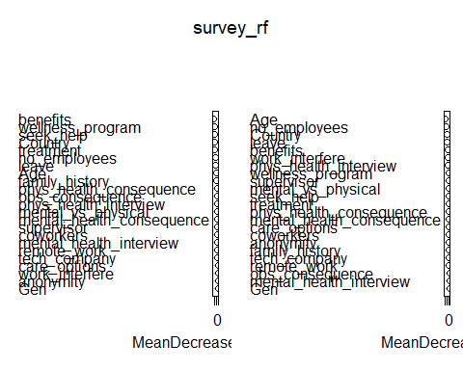

# Oddly enough, state and age seems to have the most influence on  
# predicting the genders of the survey takers.  
  
table_survey1 <- table("original" = test1$Gender, "prediction" = survey_pred1)  
table_survey1

## prediction  
## original Female Male  
## Female 3 57  
## Male 10 222

accuracy <- sum(diag(table_survey1)) / sum(table_survey1)  
accuracy # Calculation of the prediction accuracy.

## [1] 0.7705479

# While the accuracy percentage itself looks impressive, looking  
# at the table does not as the model has a poor time predicting  
# which of the survey takers are female whereas it has an easier  
# time predicting male survey takers.  
  
# Let's see what happens when we only use the variables that  
# were found to be significant in the Fisher's Tests.  
mht_mf2 <- mht_mf[, -c(1, 3, 8, 12, 13, 14, 15, 18,   
 21, 22, 24)]  
  
# We'll split 70/30  
sbst2 <- createDataPartition(mht_mf2$Gender, p = 0.5, list = F)  
train2 <- mht_mf2[sbst2, ]  
test2 <- mht_mf2[-sbst2, ]  
  
# We now begin the random forest modeling  
survey_rf2 <- randomForest(Gender ~ ., train2, mtry = 12,   
 importance = T, na.action = na.omit)  
# Using the model, we'll the testing eubset to make predictions.  
survey_pred2 <- predict(survey_rf2, test2)  
varImpPlot(survey_rf2)

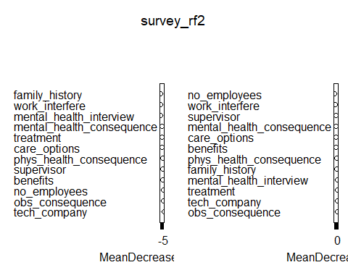

table_survey2 <- table("original" = test2$Gender, "prediction" = survey_pred2)  
table_survey2

## prediction  
## original Female Male  
## Female 19 87  
## Male 53 335

accuracy2 <- sum(diag(table_survey2)) / sum(table_survey2)  
accuracy2 # Calculation of the prediction accuracy.

## [1] 0.7165992

# The second model gains slightly more accuracy predicting which   
# survey takers are female but loses some with predicting males.  
# Overall, it's not very feasible to predict and distinguish between  
# men and women using a model on the survey answers. However,  
# this shouldn't discount the results gotten from the Fisher's Tests.

It's possible I may come back and continue analyzing this data set. Maybe next time,  
I'll see if geography produces differences in survey results. Maybe I'll try to  
optimize the random forest model and see if I squeeze out some more accuracy out of  
the prediction rates for women. But for now. Ultimately, I just think that there wasn't   
enough of a sample size compared to men and secondly, the answers (yes even some  
of those deemed significant by the Fisher's Tests) were mostly similar for both  
genders. Granted, there are a few questions/variables where the answers were  
night and day but I don't even think those variables alone could've helped out the model.  
I'll definitely be moving onto a different data set for the meantime. Until next time...