Automated Testing Report

Version | Date | Folio | Description | Tester
1.0.0 | 01/05/2026 | ATC01_NearpediaTest | Test 1 - Nearpedia Flight Search | Osiris Montiel

Step | Description | Evidence
1 | Clicking button "Flights" | 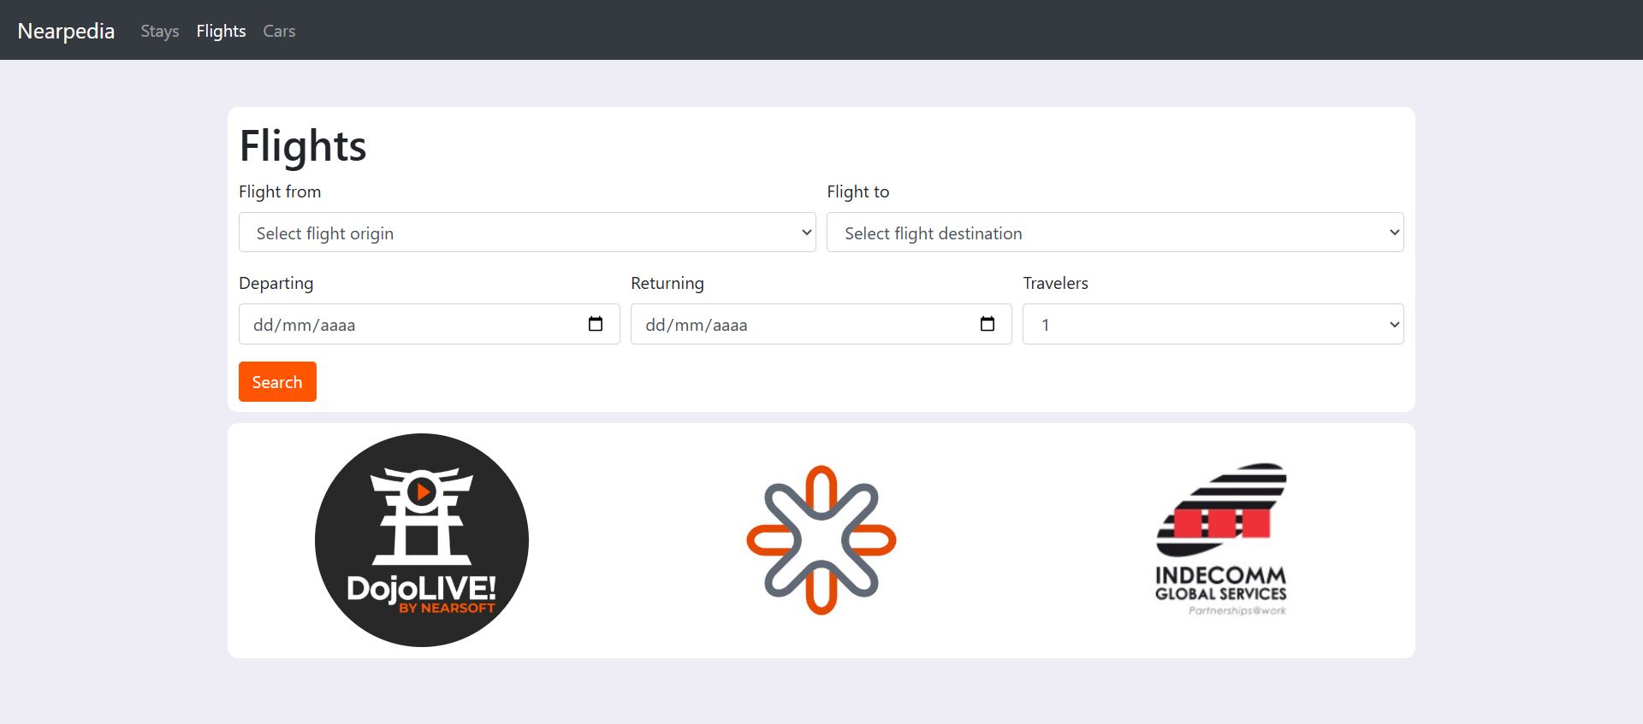

Step | Description | Evidence
2 | Selecting "CDMX" by text from list "Flight From" | 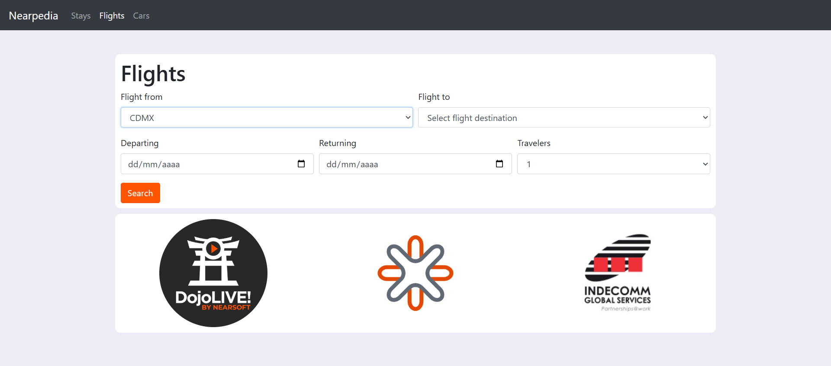

Step | Description | Evidence
3 | Selecting "La Habana" by text from list "Flight To" | 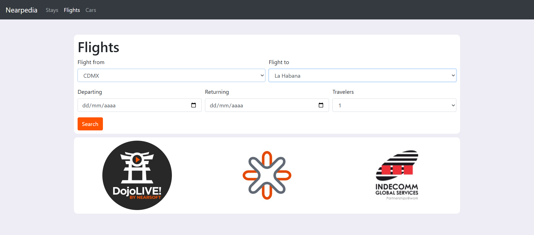

Step | Description | Evidence
4 | Typing text into "Departing" | 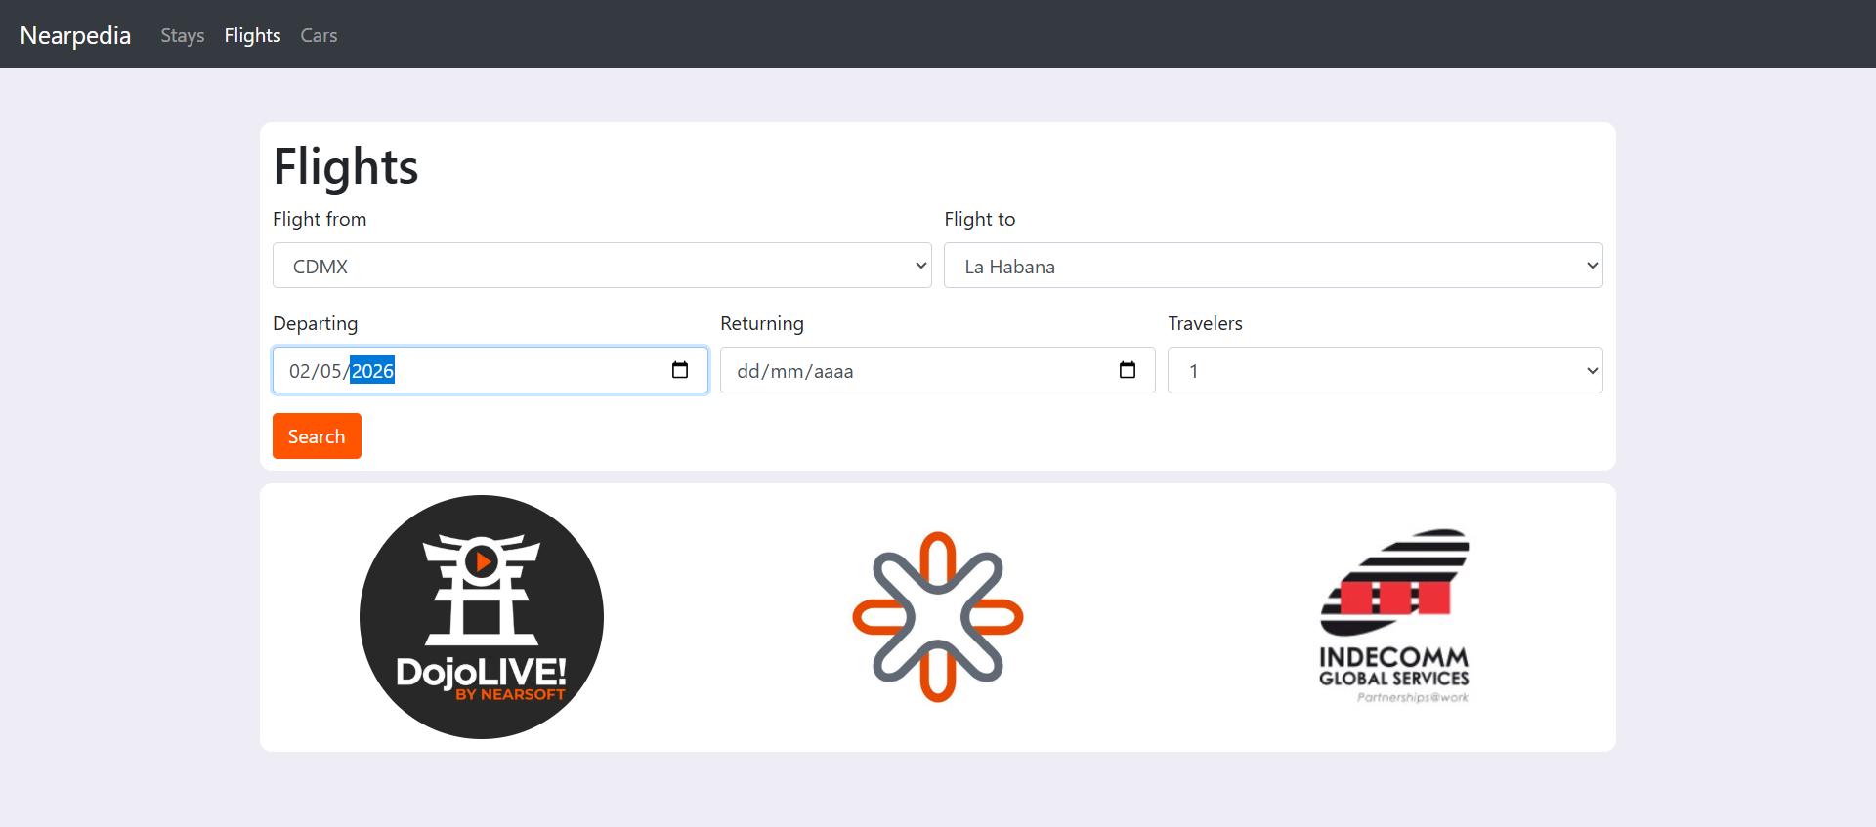

Step | Description | Evidence
5 | Typing text into "Returning" | 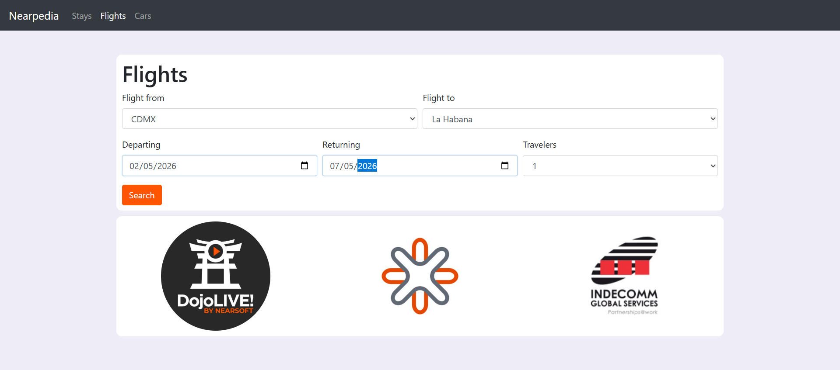

Step | Description | Evidence
6 | Clicking button "Search" | 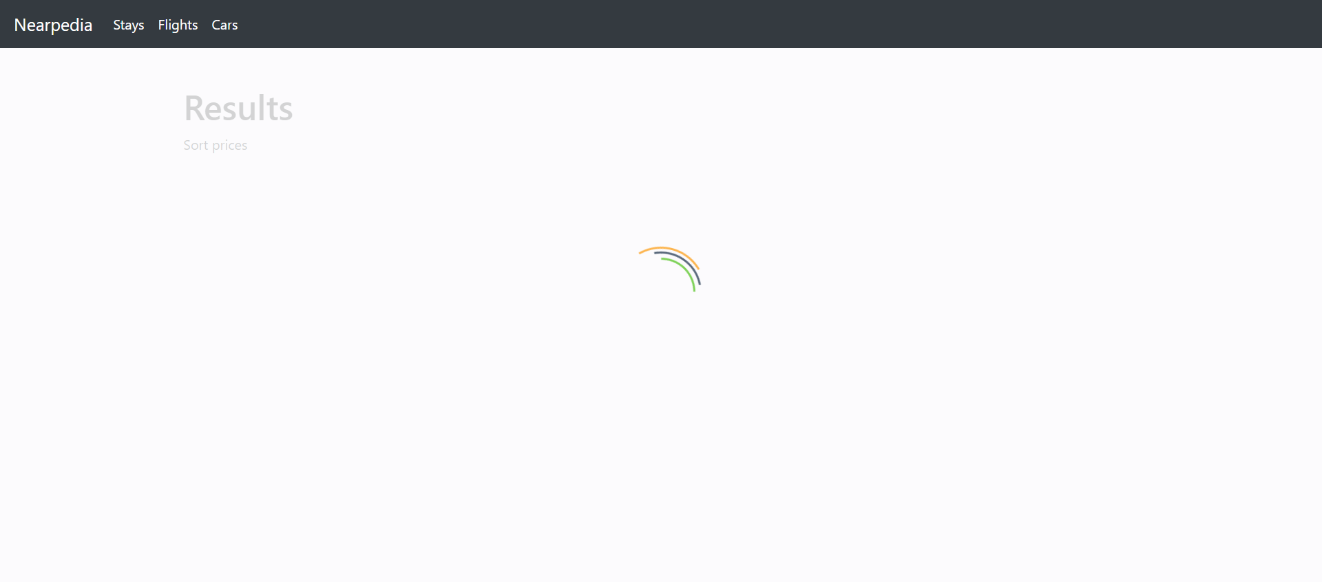

Step | Description | Evidence
7 | Selecting "Price ascending" by text from list "Sort By" | 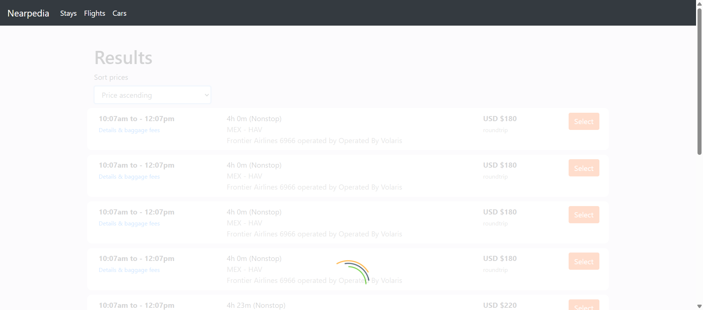

Step | Description | Evidence
8 | Results are correctly sorted in ascending order by price | 