Block Diagram (tentative):

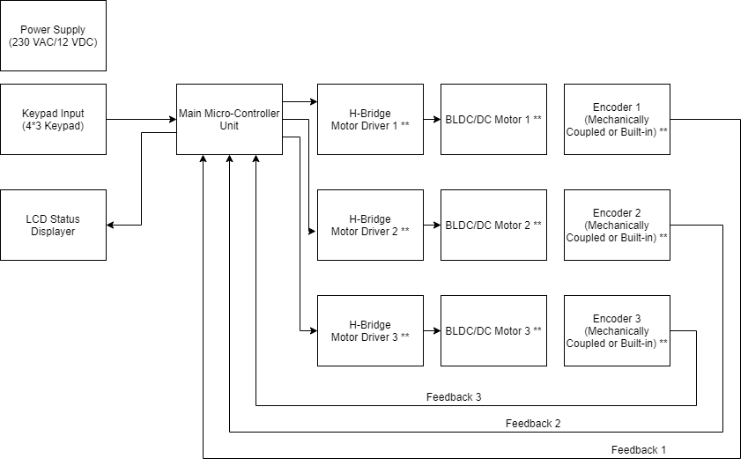

** Components can be modified, removed depending on motor selection

Rough Sketch:

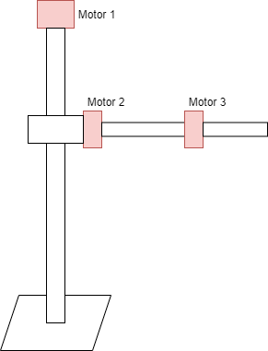

|  |  |
| --- | --- |
| **Motor Requirements** | |
| Motor Type | Motor 1, Motor 2, Motor 3: Servo Mechanism  DC (Brushless) – BLDC (for less maintenance, repeatability) |
| Operating Voltage | Motor 1, Motor 2, Motor 3: 12 V DC |
| Operating Torque (critical factor)  Safety Factor already considered (value=3) | Motor 1: 0.6 N-m  Motor 2: 22 N-m  Motor 3: 7 N-m |
| Motor Driver | Motor 1, Motor 2, Motor 3: Built-in or additional circuitry |
| Encoder coupling/type | Motor 1, Motor 2, Motor 3: Built-in or mechanically coupled/incremental |
| Mechanical Dimensions/Weight | As compact and lower weight as possible |

* **Motor 1: Torque required 0.6 N-m**

**Datasheet link:** [**http://cdn.crouzet-motors.com.s3.amazonaws.com/assets/library/Datasheets-and-3D/EN_SMI21_80280001.pdf**](http://cdn.crouzet-motors.com.s3.amazonaws.com/assets/library/Datasheets-and-3D/EN_SMI21_80280001.pdf)

Motor Specs

|  |  |
| --- | --- |
| BLDC Model | Crouzet SQ57 |
| Part Number | 80280001 |
| Operating Voltage | 12 – 36 VDC |
| Output Power | 82 W |
| Base Speed | 1100 rpm (at 12 VDC) |
| Driver necessary | No |
| Encoder | Built-in (4096 resolution) |

Output Power = (2*pi*speed*torque)/(60)

With speed=1100 rpm, output power=82 W (at 12 V DC)

Torque=0.71 N-m (satisfied).

* **Motor 2: Torque required 22 N-m**

**Datasheet link:** [**https://soda.crouzet.com/pn/?i=80289724**](https://soda.crouzet.com/pn/?i=80289724)

**Same Motor 1 is linked with gearbox to get required torque with reduced speed**

Motor Specs

|  |  |
| --- | --- |
| BLDC Model | Crouzet SQ57 |
| BLDC with gearbox  (complete part)  Part Number | 80289639 |
| Part Number | 80280001 (only motor) |
| Operating Voltage | 12 – 36 VDC |
| Output Power | 82 W |
| Base Speed | 1100 rpm (at 12 VDC) |
| Gearbox Ratio | 26.85:1 |
| Speed at Shaft | 41 rpm |
| Driver necessary | No |
| Encoder | Built-in (4096 resolution) |

Output Power = (2*pi*speed*torque)/(60)

With speed=41 rpm, output power=82 W (at 12 V DC)

Torque=19.22 N-m (not satisfied – nearby).

* **Motor 3: Torque required 7 N-m**

**Datasheet link:** <https://soda.crouzet.com/pn/?i=80289723>

**Same Motor 1 is linked with gearbox to get required torque with reduced speed**

Motor Specs

|  |  |
| --- | --- |
| BLDC Model | Crouzet SQ57 |
| BLDC with gearbox  (complete part)  Part Number | 80289723 |
| Part Number | 80280001 (only motor) |
| Operating Voltage | 12 – 36 VDC |
| Output Power | 82 W |
| Base Speed | 1100 rpm (at 12 VDC) |
| Gearbox Ratio | 19.2:1 |
| Speed at Shaft | 57 rpm |
| Driver necessary | No |
| Encoder | Built-in (4096 resolution) |

Output Power = (2*pi*speed*torque)/(60)

With speed=57 rpm, output power=82 W (at 12 V DC)

Torque=13.66 N-m (satisfied).