Start/Stop MongoDB server:

There are 2 ways to start/stop the server.

One is from services –

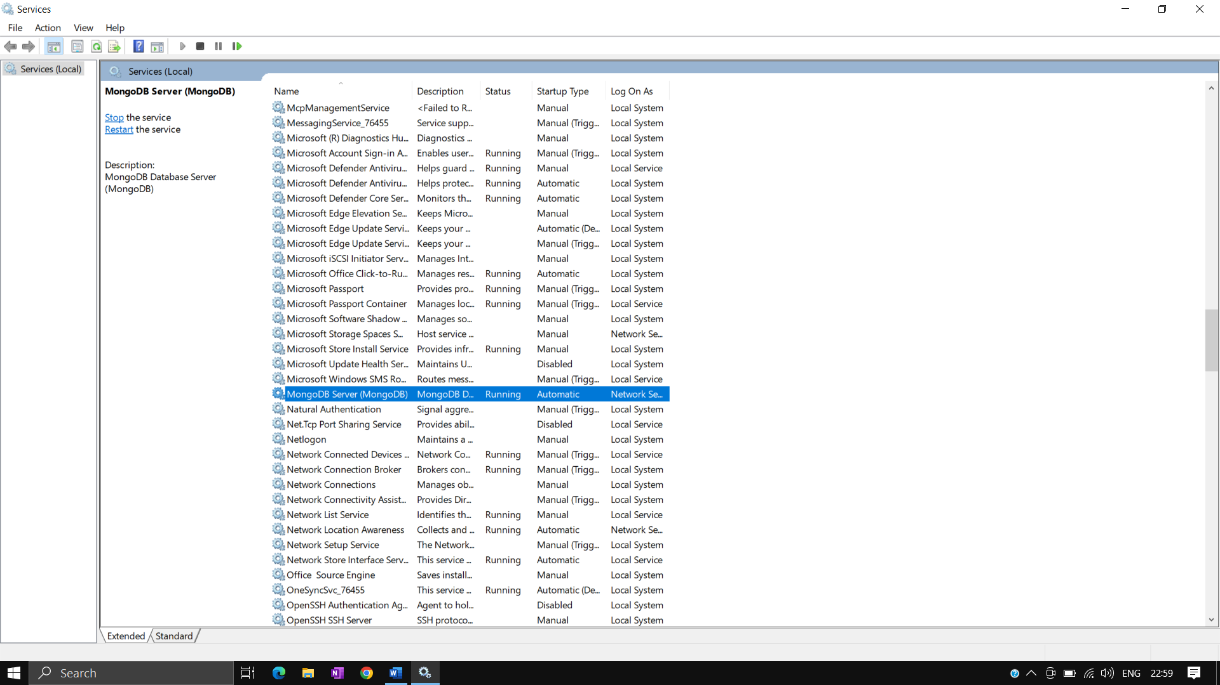

Another one is open command prompt with administrator and run below commands-

net start mongodb

net stop mongodb

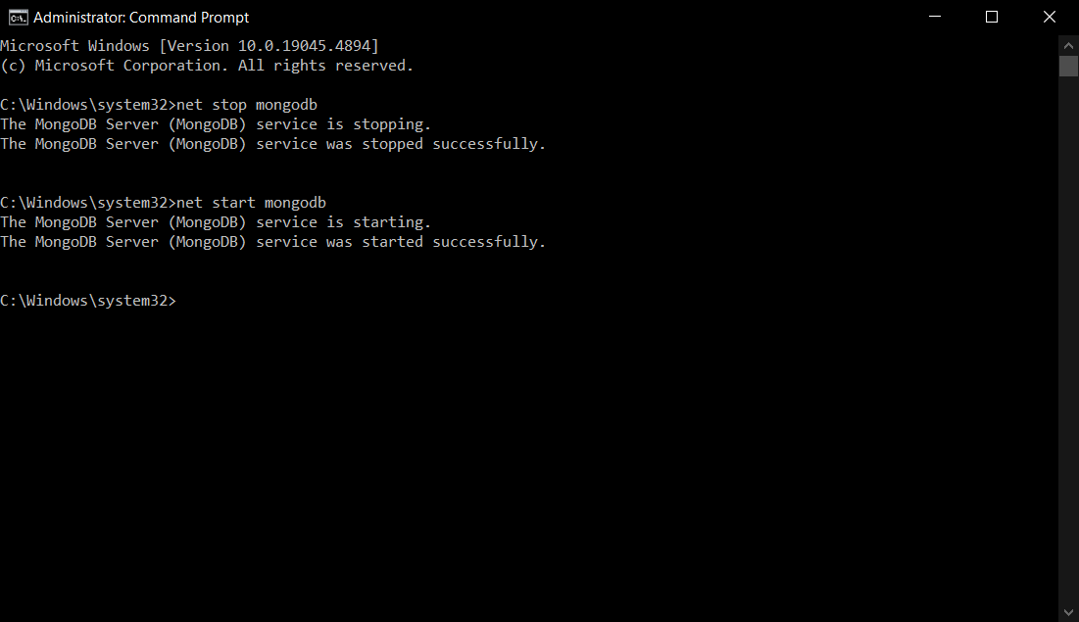

Once service is started, we are ready to use MongoDB server. We will use Mongo Shell to interact with the server. For this, we have downloaded the Mongo Shell zip file on our machine, and will extract it on the C: drive.

Once above step is done then we can open mongosh.exe file

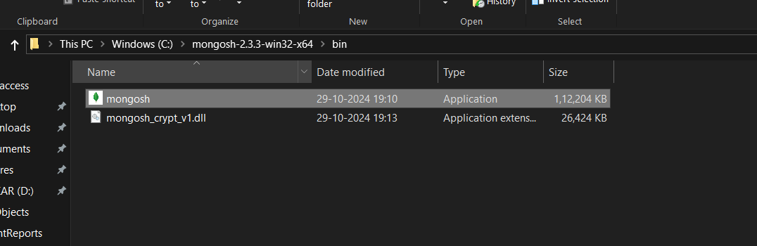

You will get below where you need to provide connection string

mongodb://localhost:27017

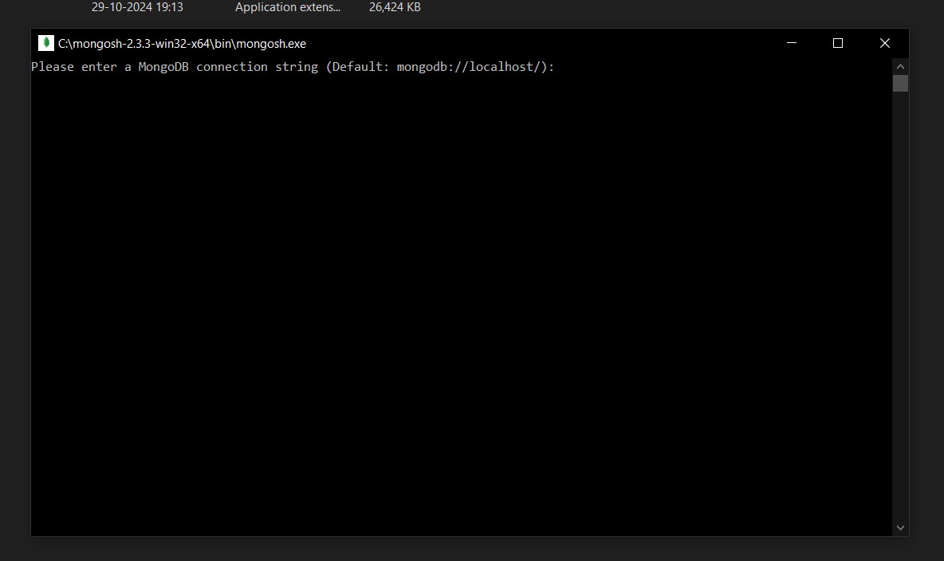

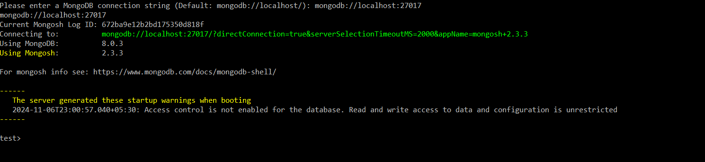

You can find the logs and data on below path-

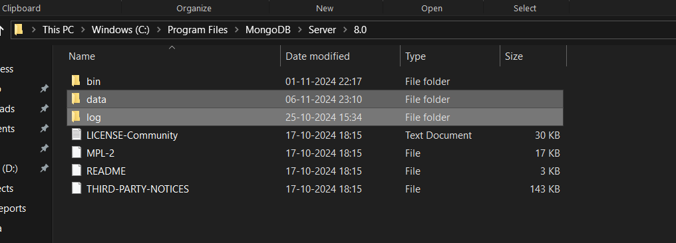

Now, we will use this shell to create collection, add some data into it and do some operations-

Command – show dbs

To get all the databases which are available on the server.

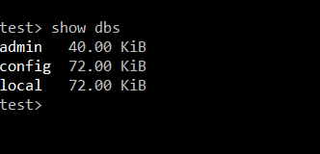

Command – use “dbname”

To switch to the existing database or create new database if not exist

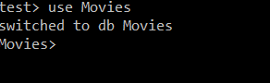

Now, if we run “show dbs” command then it will print this db name as it is an empty db. Once we add collection and documents inside this db then only it will be printed along with show dbs command.

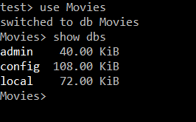

**Command – db**

To check in which db we are currently

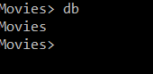

**Command – db.createCollection(“CollectionName”)**

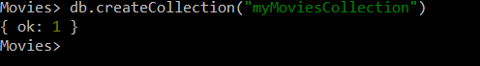

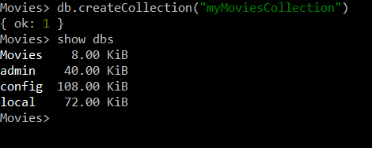

**Command – db.CollectionName.insertOne()**

To insert single document inside collection

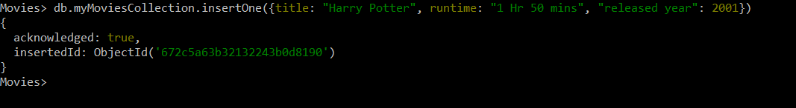

To insert multiple documents at the same time, we can use below command –

**db.CollectionName.insertMany()**

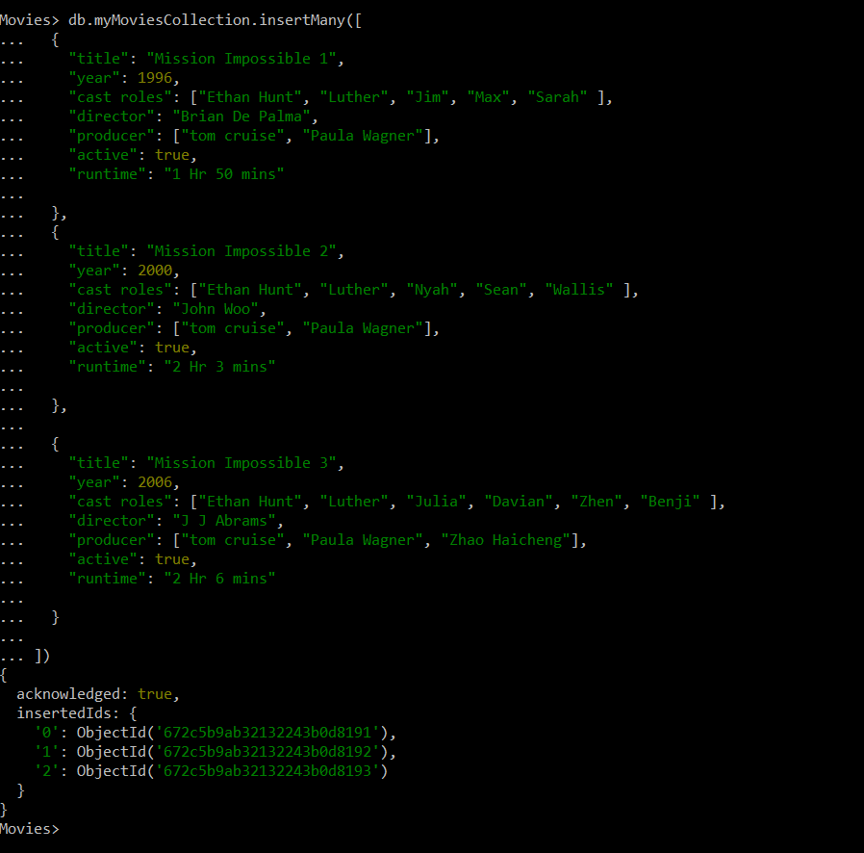

**Command – db.CollectionName.find(), db.CollectionName.find().pretty()**

This command will find all the documents available in that collection

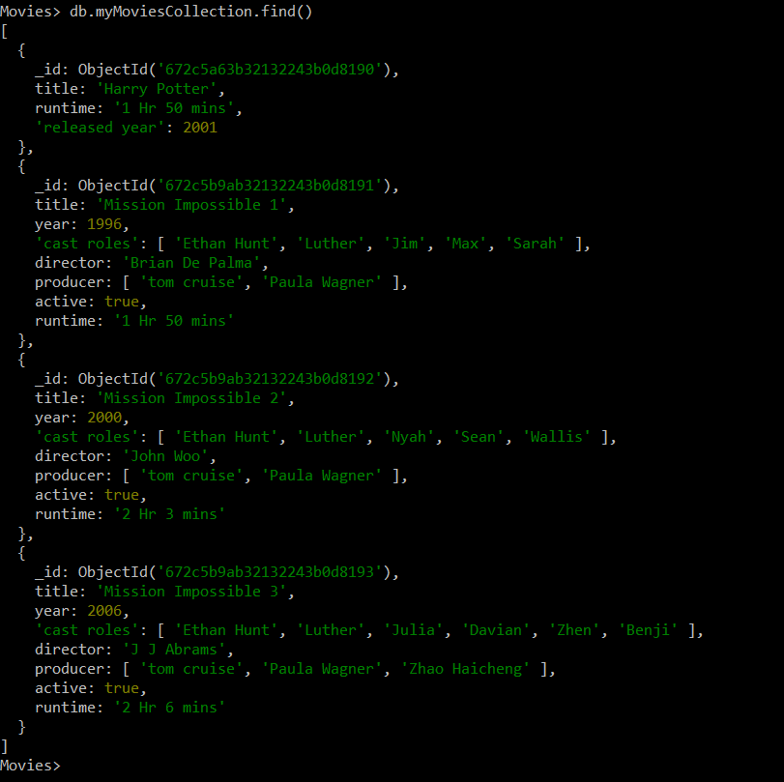

**Command – db.CollectionName.findOne()**

This command will fetch only one document

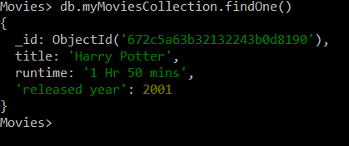

We can pass queries in from of key and value to fetch the documents

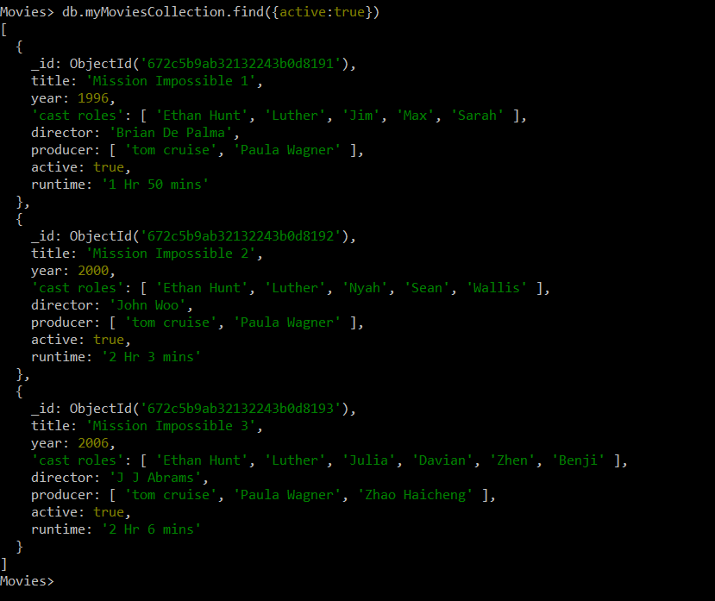

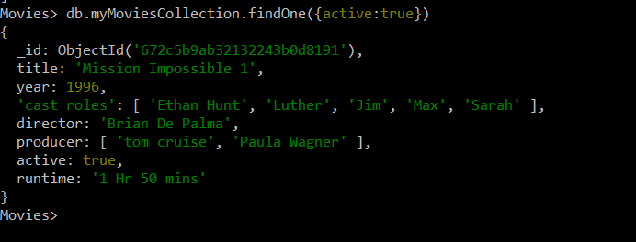

**Projection:**

To include/exclude data while fetching from the collection

1 – to include

0 – to exclude

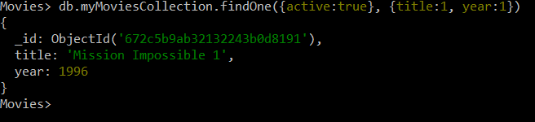

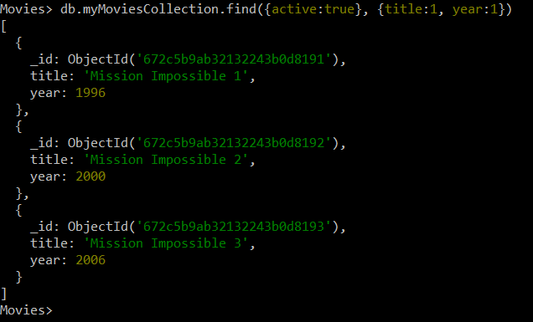

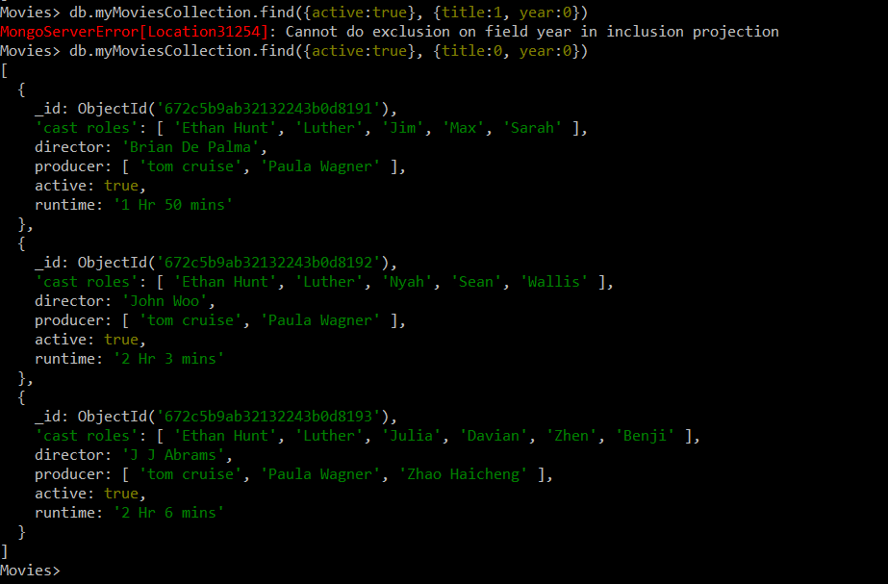

**Command – to update existing document**

“db.CollectionName.updateOne({find parameter}, {set parameter})

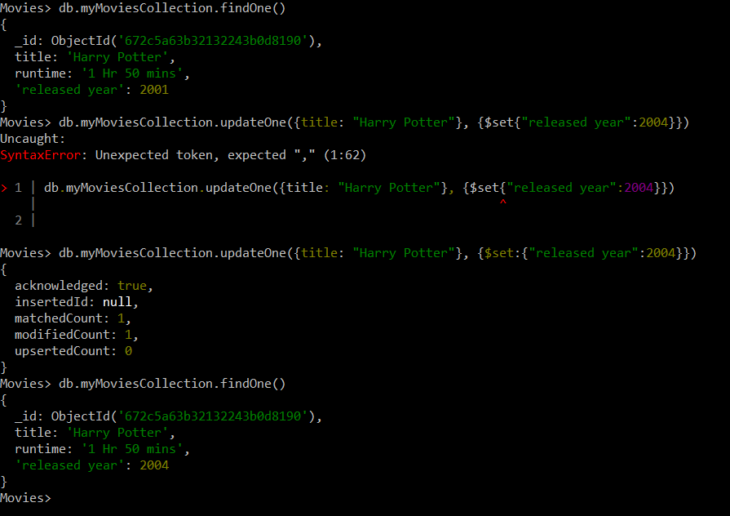

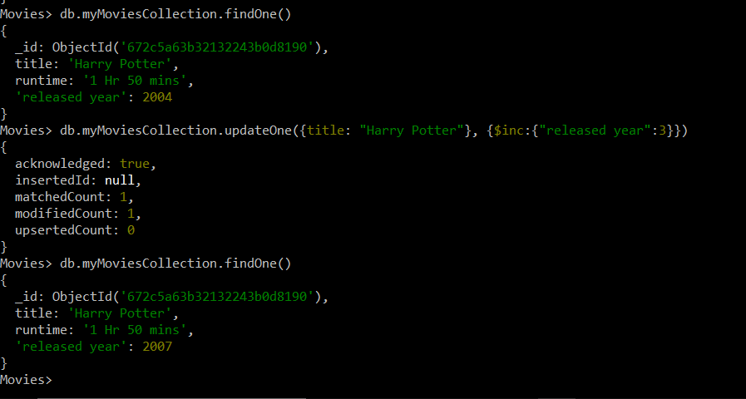

**updateMany**

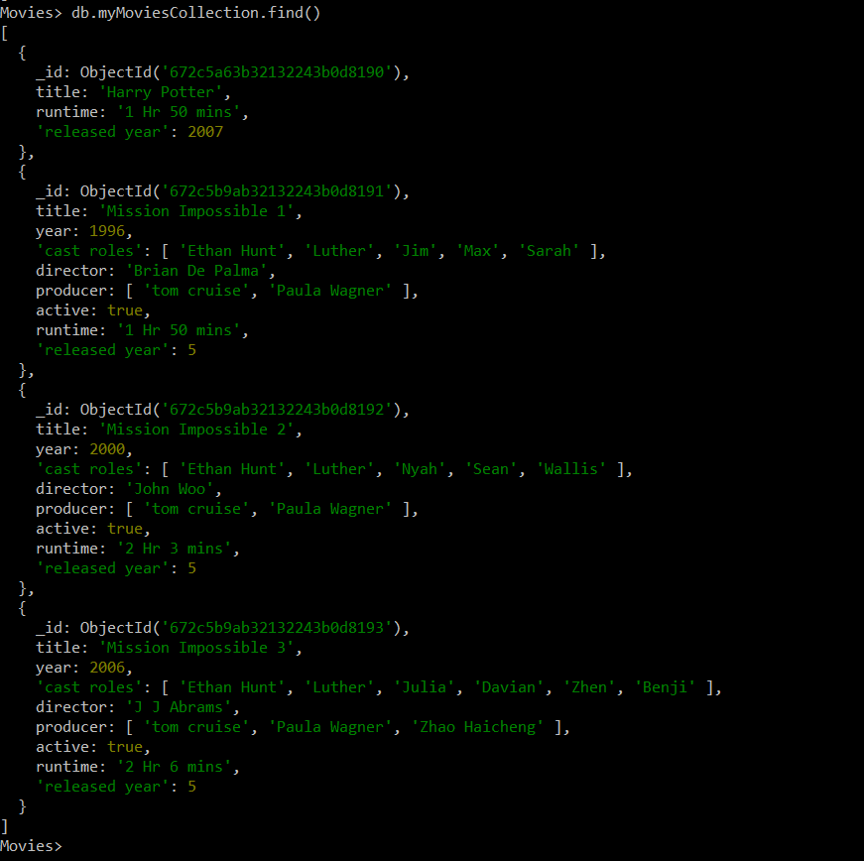

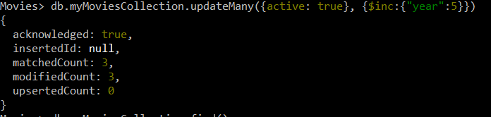

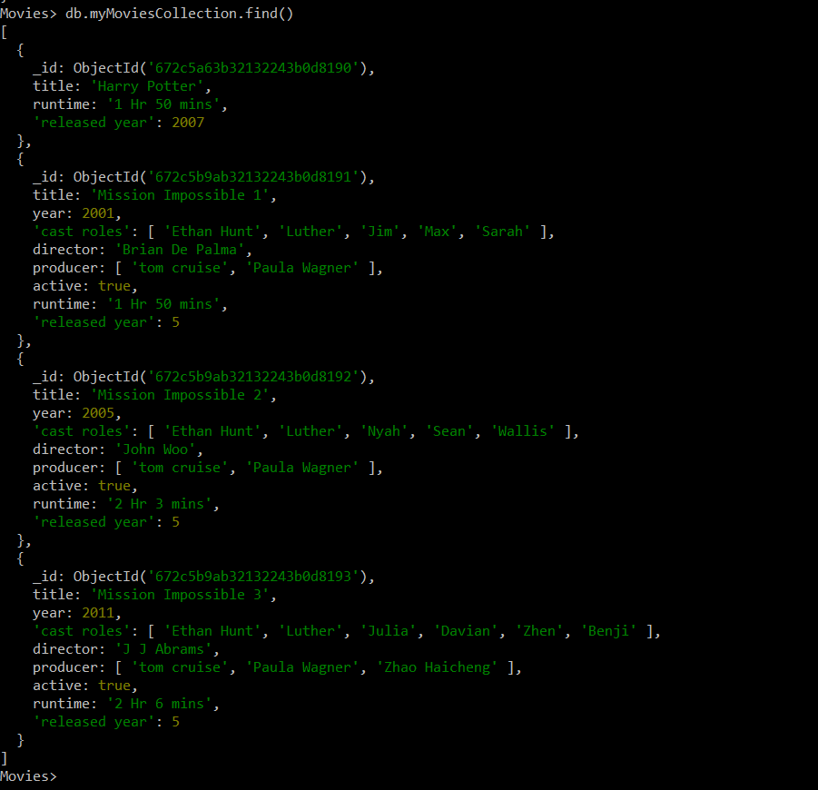

**Delete command**

