Contents
Web Introduction 2
Introduction to Web Technology 2
Components of Web Technology 2
Applications and Importance of Web Technology 2
Ai introduction 3
AI in Web Technology 3
Applications of AI in Web Development 3
Benefits and Future of AI in Web Technology 3
Introduction of robotics 4
Introduction to Robotics 4
Components of Robotics 4
Applications and Importance of Robotics 4
All university 5
Introduction to University 5
Academic Programs and Campus Facilities 5
Importance of University Education 5

Web technology

Web Introduction

Introduction to Web Technology
Web technology refers to the tools, programming languages, and protocols used to create and run websites and web applications on the internet. It enables communication between users and servers through web browsers.

Components of Web Technology
Web technology is mainly divided into front-end and back-end components. The front end includes HTML, CSS, and JavaScript, which control how a website looks and behaves in the browser.

Applications and Importance of Web Technology
Web technology is widely used in e-commerce, online education, social media, banking, healthcare, and entertainment. It allows businesses to reach global audiences, provides users with instant access to information, and supports online communication

Artificial intelligence

Ai introduction

AI in Web Technology
Artificial Intelligence (AI) in web technology refers to the use of intelligent algorithms and machine learning techniques to improve websites and web applications.

Applications of AI in Web Development
AI enhances web development by enabling features such as personalized content recommendations, automated customer support through chatbots, voice search, image recognition, predictive analytics, and fraud detection.

Benefits and Future of AI in Web Technology
The integration of AI into web technology offers several advantages, including faster decision-making, improved customer experiences, increased automation, and better data analysis.

Robotics

Introduction of robotics

Introduction to Robotics
Robotics is a branch of engineering and technology that focuses on the design, construction, operation, and application of robots. Robots are programmable machines that can perform tasks automatically or with minimal human intervention.

Components of Robotics
A robotic system consists of several key components, including sensors, actuators, controllers, power sources, and programming software. Sensors collect information from the environment, actuators create movement, and controllers process data to make decisions. The software provides instructions that enable the robot to perform tasks such as navigation, object detection, and automation.

Applications and Importance of Robotics
Robotics is used in industries such as manufacturing, healthcare, agriculture, logistics, defense, and space exploration. Robots improve productivity by performing repetitive or hazardous tasks with precision and consistency. In healthcare, they assist in surgeries and patient care, while in agriculture they help with planting and harvesting.

University

All university

Introduction to University
A university is a higher education institution that provides undergraduate, postgraduate, and doctoral programs in various fields of study. It aims to develop students’ knowledge, critical thinking, and professional skills through teaching, research, and practical learning.

Academic Programs and Campus Facilities
Universities offer a wide range of academic programs such as engineering, medicine, business, arts, science, law, and technology. They provide facilities like libraries, laboratories, research centers, computer labs, sports complexes, hostels, and student clubs to support learning and personal development. Many universities also encourage internships, projects, and extracurricular activities to enhance students’ overall experience.

Importance of University Education
University education helps individuals build expertise in their chosen fields and improves career opportunities. It fosters creativity, problem-solving abilities, communication skills, and lifelong learning.

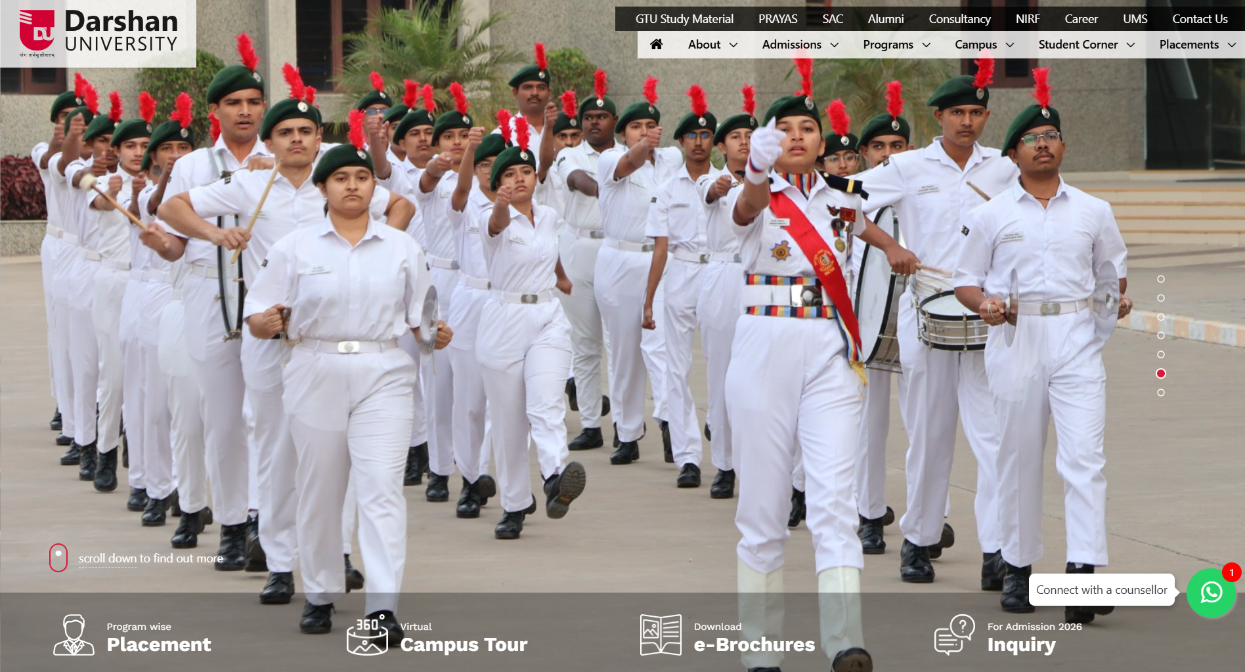
Video provides a powerful way to help you prove your point. When you click Online Video, you can paste in the embed code for the video you want to add. You can also type a keyword to search online for the video that best fits your document. To make your document look professionally produced, Word provides header, footer, cover page, and text box designs that complement each other. For example, you can add a matching cover page, header, and sidebar. Click Insert and then choose the elements you want from the different galleries. Themes and styles also help keep your document coordinated.
When you apply styles, your headings change to match the new theme. Save time in Word with new buttons that show up where you need them. To change the way a picture fits in your document, click it and a button for layout options appears next to it. When you work on a table, click where you want to add a row or a column, and then click the plus sign. Reading is easier, too, in the new Reading view. You can collapse parts of the document and focus on the text you want
When you click Online Video, you can paste in the embed code for the video you want to add. You can also type a keyword to search online for the video that best fits your document. To make your document look professionally produced, Word provides header, footer, cover page, and text box designs that complement each other. For example, you can add a matching cover page, header, and sidebar. Click Insert and then choose the elements you want from the different galleries. Themes and styles also help keep your document coordinated.
Save time in Word with new buttons that show up where you need them. To change the way a picture fits in your document, click it and a button for layout options appears next to it. When you work on a table, click where you want to add a row or a column, and then click the plus sign. Reading is easier, too, in the new Reading view. You can collapse parts of the document and focus on the text you want. If you need to stop reading before you reach the end,
You can also type a keyword to search online for the video that best fits your document. To make your document look professionally produced, Word provides header, footer, cover page, and text box designs that complement each other. For example, you can add a matching cover page, header, and sidebar. Click Insert and then choose the elements you want from the different galleries. Themes and styles also help keep your document coordinated. When you click Design and choose a new Theme, the pictures, charts, and SmartArt graphics change to match your new theme.

Introduction
Om Panchotiya,
Roll No. 201,
Class 3A
H₂o
21¹²²²

