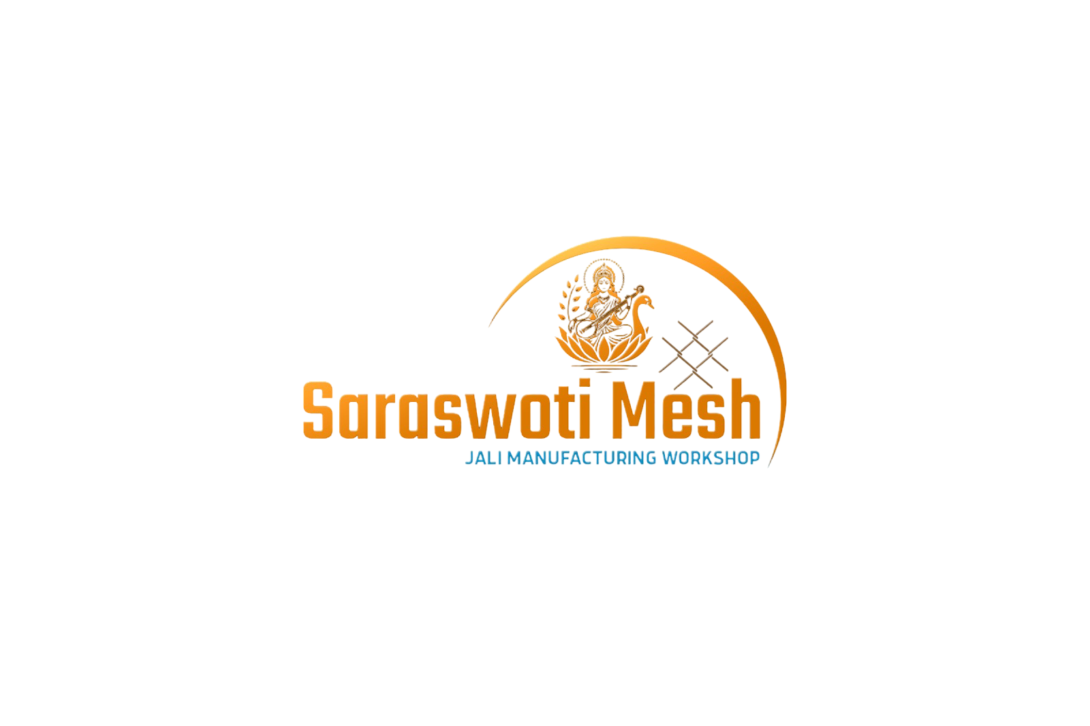
SARASWOTI MESH JALI MANUFACTURING WORKSHOP
भरतपुर, महानगरपालिका न्युरोड
To,
The Hostmaster,
Mercantile Communication Pvt. Ltd.
Durbar Marg, Kathmandu

Subject: NP Domain Registration
Dear Sir/Madam,

I am writing this letter to request you to kindly register a saraswotimesh.com.np domain for me based on my name. I have provided my personal details, and also attached a scanned copy of my citizenship with this letter. I would be very glad if you approve my domain registration request. Thank you very much for consideration. I look forward to hearing from you soon.
Domain name: saraswotimesh.com.np

Primary Name Server Secondary Name Server
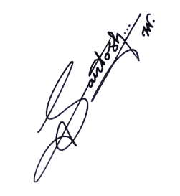
melody.ns.cloudflare.com mitch.ns.cloudflare.com

Sincerely,


Name: SARASWOTI MESH JALI MANUFACTURING WORKSHOP

Address: भरतपुर, महानगरपालिका न्युरोड

