# GUJARAT TECHNOLOGICAL UNIVERSITY

Chandkheda, Ahmedabad Affiliated

Under Subject of DESIGN ENGINEERING

B.E IV, Semester – V(Computer Branch) Submitted by Group

|  |  |  |
| --- | --- | --- |
| **Sr.** | **Name of the Student** | **Enrollment No.** |
| **1** | **Gaurang patel** | **210290131509** |

# PROTOTYPE SCREENSHOTS

# DASHBOARD

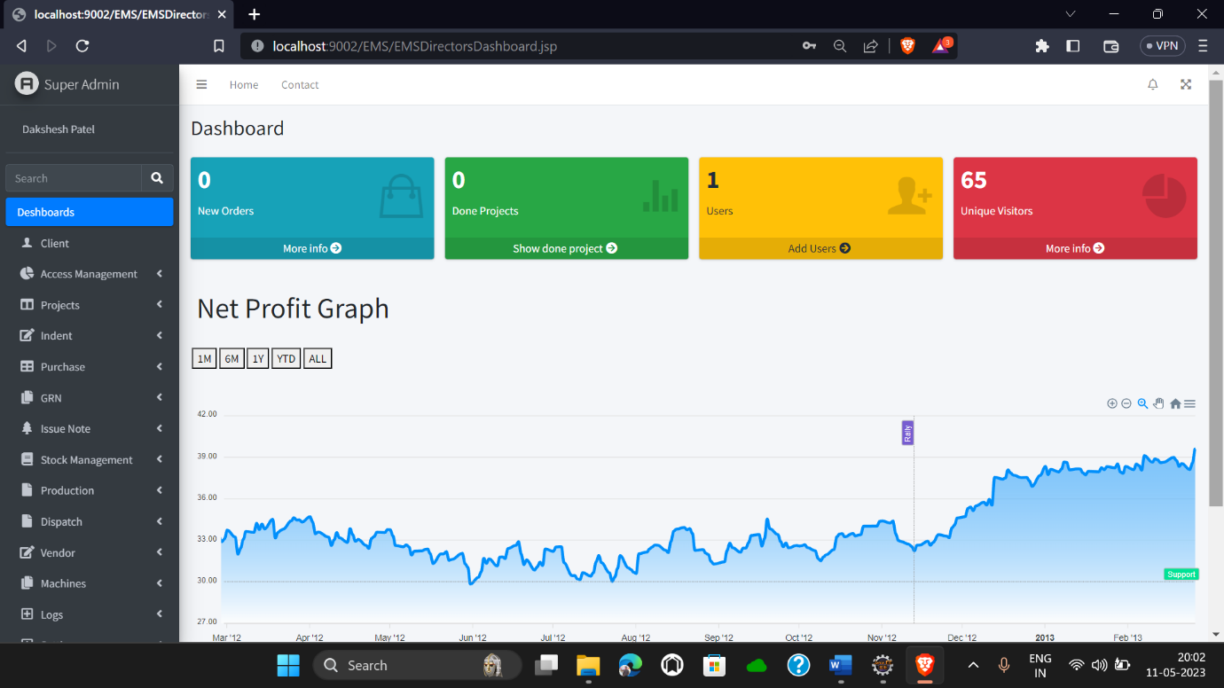

**PERMISSION PROVIDER**

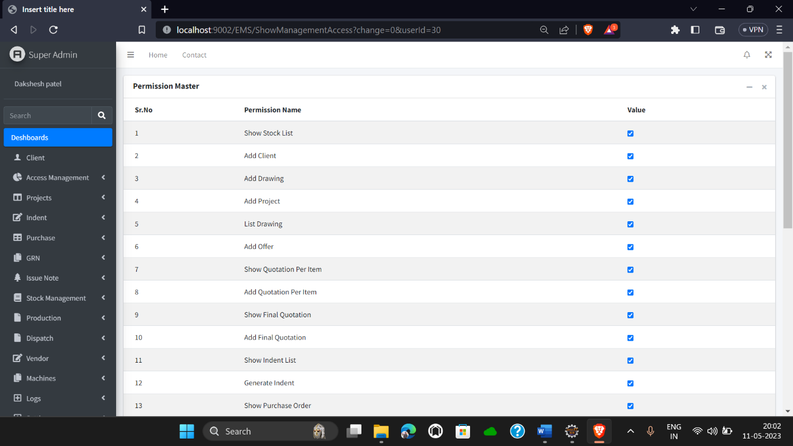

**ADD OFFERS**

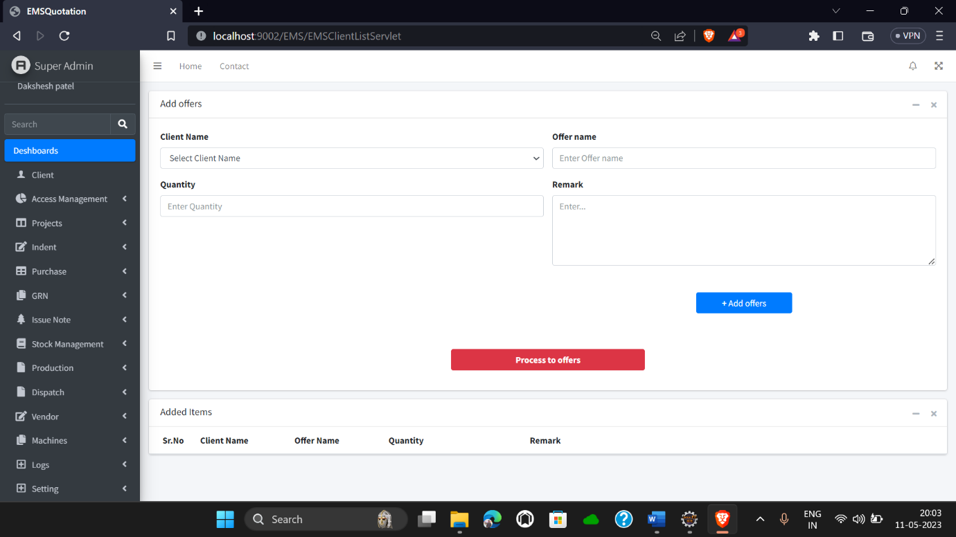

**ISSUE GRN**

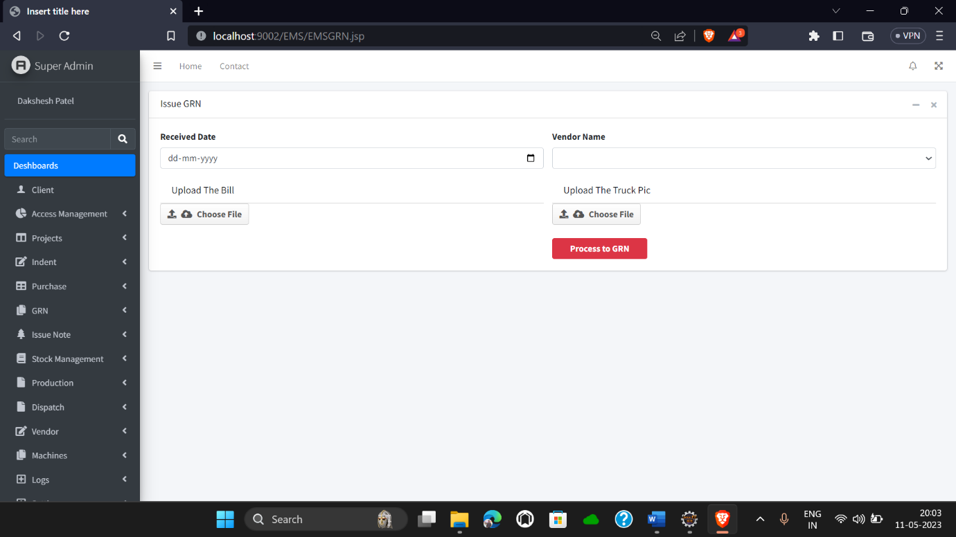

**ADD CATEGORY/GRADE/SIZE**

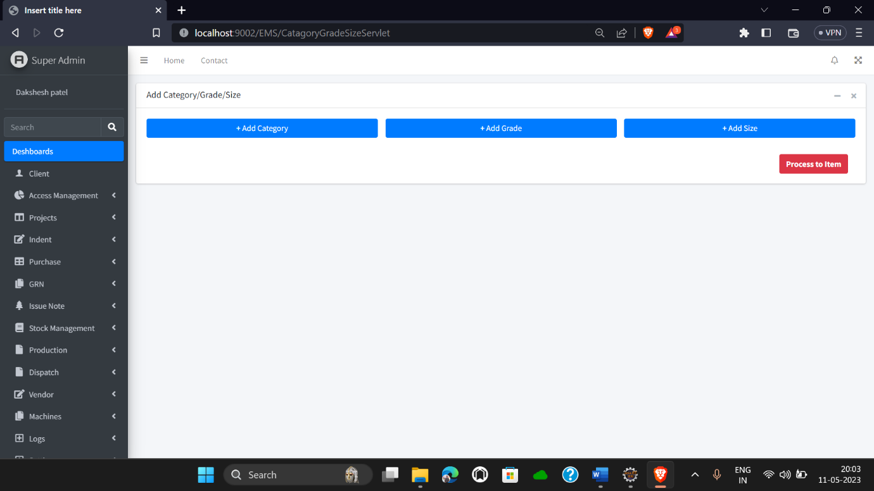

**DISPATCH**

