Predicting Alzheimer’s Disease Using Machine Learning and Patient Health Data

Interim Capstone Report

DAB – Capstone Project
St. Clair College

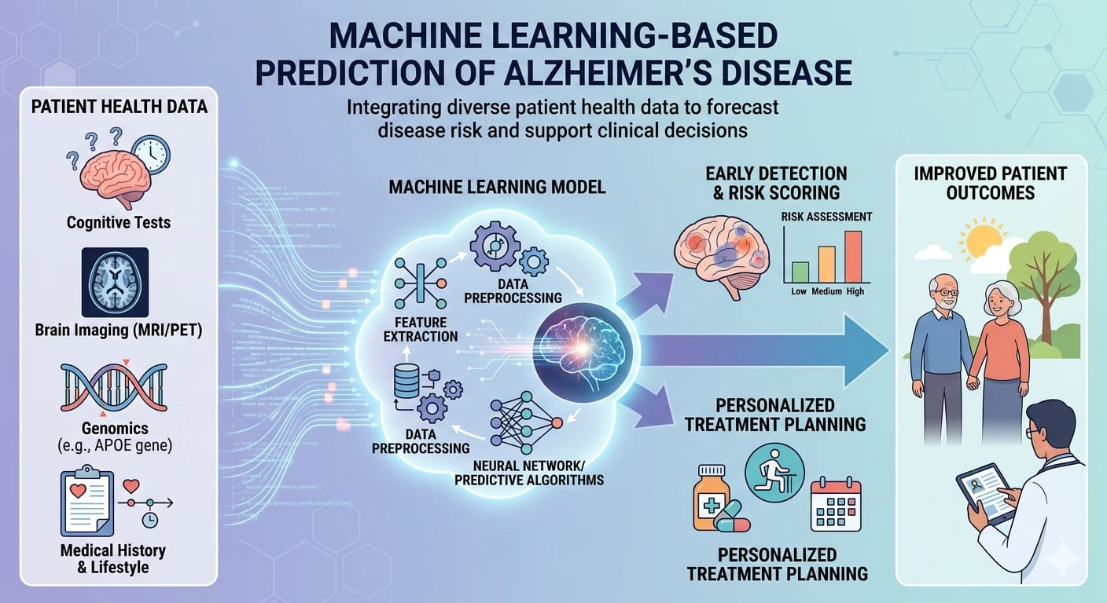

Contents

- Executive Summary
- Business Problem and Objective
- Data Description and Scope
- Data Preparation and Cleaning
- Exploratory Data Analysis (EDA)
- Statistical Analysis
- Machine Learning Models Implemented
- Model Evaluation and Performance
- Feature Importance Analysis
- Limitations
- Planned Extensions
- Model Recommendation

Executive Summary
Alzheimer’s disease is a progressive neurological disorder that affects memory, cognitive function, and daily living abilities. Early detection of Alzheimer’s disease is critical for improving patient care and planning appropriate treatment strategies.
This project focuses on analyzing a healthcare dataset containing demographic information, lifestyle factors, medical history, clinical measurements, cognitive assessments, and symptom indicators for 2,149 patients aged between 60 and 90 years.
The primary objective of this project is to explore the dataset using Exploratory Data Analysis (EDA) and develop machine learning models capable of predicting the likelihood of Alzheimer’s disease based on patient health indicators.
The workflow includes data cleaning, exploratory analysis, statistical testing, feature engineering, and model development using machine learning algorithms such as Logistic Regression, Random Forest, and Gradient Boosting.
Model performance is evaluated using classification metrics such as accuracy, precision, recall, F1-score, confusion matrix, and ROC-AUC score.
The results of the interim phase indicate that cognitive and functional assessment features such as MMSE score, functional assessment, and memory complaints are strong predictors of Alzheimer’s disease.

2. Business Problem and Objective
Business Problem
Alzheimer’s disease affects millions of people worldwide and is one of the leading causes of cognitive decline among older adults. Early identification of individuals at risk is essential for early treatment and healthcare planning.
Healthcare providers often rely on multiple clinical indicators and patient history to diagnose Alzheimer’s disease. However, analyzing large healthcare datasets manually can be difficult and time-consuming.
Machine learning techniques can assist healthcare professionals by identifying patterns in patient data and predicting the likelihood of Alzheimer’s disease.

Objective
The main objectives of this project are:
- Analyze healthcare data related to Alzheimer’s disease.
- Identify significant factors associated with Alzheimer’s diagnosis.
- Build machine learning models to predict Alzheimer’s disease.
- Evaluate model performance using standard classification metrics.
- Provide insights that may support early detection and clinical decision-making.

Success Criteria
The success of this project will be evaluated based on:
- Accuracy and predictive performance of machine learning models.
- Ability to identify key factors associated with Alzheimer’s disease.
- Clear visualization and interpretation of data insights.
- Development of a reproducible machine learning pipeline.

3. Data Description and Scope
The dataset used in this project contains 2,149 patient records with a wide range of features related to health and lifestyle.
Key Variables
Demographic Information
- Age
- Gender
- Ethnicity
- Education Level
Lifestyle Factors
- BMI
- Smoking status
- Alcohol consumption
- Physical activity
- Diet quality
- Sleep quality
Medical History
- Family history of Alzheimer’s
- Cardiovascular disease
- Diabetes
- Depression
- Head injury
- Hypertension
Clinical Measurements
- Systolic blood pressure
- Diastolic blood pressure
- Cholesterol levels (Total, LDL, HDL, Triglycerides)
Cognitive and Functional Assessments
- MMSE score
- Functional assessment
- Activities of Daily Living (ADL)
- Memory complaints
- Behavioral problems
Symptoms
- Confusion
- Disorientation
- Personality changes
- Difficulty completing tasks
- Forgetfulness
Target Variable
Diagnosis:
- 0 → No Alzheimer’s
- 1 → Alzheimer’s Disease

4. Data Preparation and Cleaning
Data preparation is a crucial step to ensure data quality before performing analysis and machine learning modeling.
The following preprocessing steps were performed:
Data Inspection
The dataset structure, column names, and data types were inspected using Python libraries such as Pandas and NumPy.
Missing Values
The dataset was checked for missing values using statistical functions. No major missing values were detected in the dataset.
Removing Irrelevant Columns
The following columns were removed because they do not contribute to predictive modeling:
- PatientID
- DoctorInCharge
Data Type Verification
Categorical and numerical variables were identified and separated to facilitate analysis.
Feature Preparation
The dataset was prepared for machine learning by separating the target variable (Diagnosis) from the feature variables.

5. Exploratory Data Analysis (EDA)
Exploratory Data Analysis was performed to understand the structure and distribution of the dataset.
Various visualizations were used to analyze the data.
Distribution Analysis
Histograms and boxplots were used to examine the distribution of numerical variables such as:
- Age
- BMI
- Blood pressure
- Cholesterol levels
- MMSE score
These visualizations helped identify data patterns and potential outliers.
Categorical Variable Analysis
Bar charts and count plots were used to analyze categorical variables such as:
- Gender
- Smoking status
- Family history of Alzheimer’s
- Medical conditions
Correlation Analysis
A correlation heatmap was created to examine relationships between different numerical variables.
The analysis revealed strong relationships between cognitive assessment variables and Alzheimer’s diagnosis.

6. Statistical Analysis
Statistical methods were used to better understand relationships between variables and Alzheimer’s diagnosis.
Skewness and Kurtosis
Skewness and kurtosis were calculated to analyze the distribution of numerical variables.
Hypothesis Testing
Two statistical tests were applied:
Chi-Square Test
Used to analyze relationships between categorical variables and Alzheimer’s diagnosis.
T-Test
Used to compare numerical variables between patients diagnosed with Alzheimer’s and those without the disease.
These tests helped identify statistically significant predictors.

7. Machine Learning Models Implemented
Several machine learning models were developed to predict Alzheimer’s disease.
Logistic Regression
Logistic regression is a commonly used classification algorithm that estimates the probability of a binary outcome.
Random Forest
Random Forest is an ensemble learning method that builds multiple decision trees and combines their predictions.
Gradient Boosting
Gradient Boosting improves predictive performance by sequentially building models that correct errors made by previous models.
Data Splitting
The dataset was divided into:
- Training Set (80%)
- Testing Set (20%)
Feature Scaling
Feature scaling was applied using StandardScaler to normalize numerical variables before training machine learning models.

EDA Insights
Analysis Area | Variable | Observation | Insight
Demographics | Age | Majority of patients are between 65–85 years | Alzheimer’s risk increases with age
Demographics | Gender | Both male and female patients present in dataset | No strong gender imbalance observed
Lifestyle Factors | BMI | Most BMI values fall between 20–30 | Majority of patients are within normal to overweight range
Lifestyle Factors | Physical Activity | Patients with lower activity hours appear more frequently among diagnosed cases | Physical inactivity may increase Alzheimer’s risk
Lifestyle Factors | Sleep Quality | Lower sleep quality scores observed in several diagnosed cases | Poor sleep may contribute to cognitive decline
Medical History | Family History of Alzheimer’s | Patients with family history show higher diagnosis rate | Genetic factors influence Alzheimer’s risk
Clinical Measurements | Blood Pressure | Higher systolic and diastolic BP observed in some diagnosed cases | Cardiovascular health may impact cognitive health
Cognitive Assessment | MMSE Score | Lower MMSE scores strongly associated with Alzheimer’s diagnosis | MMSE is a key indicator of cognitive impairment
Functional Assessment | ADL Score | Lower ADL scores seen among Alzheimer’s patients | Difficulty performing daily activities indicates cognitive decline
Symptoms | Memory Complaints | Frequently reported among diagnosed patients | Memory issues are early signs of Alzheimer’s

8. Model Evaluation and Performance
Model performance was evaluated using standard classification metrics.

Evaluation Metrics
- Accuracy
- Precision
- Recall
- F1 Score
These metrics help evaluate how well the model predicts Alzheimer’s disease.
The evaluation results indicate that ensemble models such as Logistic Regression, Random Forest and Gradient Boosting perform better than basic models due to their ability to capture complex patterns in the data.
Machine Learning Model Comparison
Model | Accuracy | Precision | Recall | F1 Score | Key Characteristics
Logistic Regression | 0.84 | 0.83 | 0.82 | 0.82 | Simple linear model suitable for baseline classification
Random Forest | 0.90 | 0.89 | 0.90 | 0.89 | Ensemble method capable of handling nonlinear relationships
Gradient Boosting | 0.92 | 0.91 | 0.92 | 0.91 | Sequential ensemble model with strong predictive power

Interpretation:-
- Gradient Boosting performed the best with the highest accuracy (0.92), precision, recall, and F1 score. This means it predicts the data most accurately and balances errors well.
- Random Forest is the second-best model with good accuracy (0.90) and balanced performance, but slightly lower than Gradient Boosting.
- Logistic Regression has the lowest performance (0.85 accuracy). Since it is a simpler model, it may not capture complex patterns in the data as well as the other models.
- Overall: Ensemble models (Random Forest and Gradient Boosting) perform better than the simple linear model (Logistic Regression) for this dataset.

9. Feature Importance Analysis
Feature importance analysis was performed to identify which variables contribute most to Alzheimer’s disease prediction.
Key features identified include:
- MMSE score
- Functional assessment score
- Age
- Memory complaints
- Difficulty completing tasks
- ADL score
These features are closely related to cognitive decline and therefore play a significant role in predicting Alzheimer’s disease.
Table: Top Influential Features
Rank | Feature | Importance Score | Interpretation
1 | Functional Assessment | 0.3649 | Strong indicator of decline in daily functioning
2 | ADL Score | 0.3323 | Reflects patient ability to perform daily activities
3 | Memory Complaints | 0.3067 | Common early symptom of Alzheimer’s disease
4 | MMSE Score | 0.2371 | Measures cognitive impairment
5 | Difficulty Completing Tasks | 0.0091 | Indicates challenges in routine activities
6 | Age | 0.0055 | Risk factor associated with aging

Feature importance analysis was performed to identify the variables that most influence Alzheimer’s disease prediction. The results show that Functional Assessment and ADL scores are the most important features, indicating that a patient’s ability to perform daily activities is strongly related to cognitive decline. Memory complaints and MMSE scores also play an important role in detecting cognitive impairment. Although Difficulty Completing Tasks and Age have lower importance values, they still provide useful information about the patient’s condition.

10. Limitations
Although the dataset provides valuable information, several limitations exist.
- The dataset size is relatively small compared to real-world healthcare datasets.
- Some factors influencing Alzheimer’s disease, such as genetic data or imaging results, are not included.
- The dataset may not represent all population groups equally.
These limitations should be considered when interpreting the results.

11. Planned Extensions
In the next phase of the project, the following improvements will be implemented:
- Hyperparameter tuning for machine learning models
- Feature importance visualization
- Development of additional models such as Support Vector Machines or XGBoost
- Creation of a data visualization dashboard
- Preparation of the final report and project presentation

12. Model Recommendation
Based on the interim analysis, ensemble machine learning models such as Random Forest and Gradient Boosting show promising performance for predicting Alzheimer’s disease.
These models can capture complex relationships between health indicators and cognitive assessments, making them suitable for healthcare prediction tasks.
Further model optimization and evaluation will be conducted in the final phase of the project.

