Marathon Day 1: Morning & Early Afternoon Progress
Hour 1 | 8:50 AM – 10:00 AM | MA103 | Setup & GitHub:
- Started the marathon in lab MA103.
- Created the main GitHub repository: https://github.com/ompatelok/DeskBot.
- Set up all my project folders and linked them to VS Code to make sure my code saves online without any issues.
Captured data:
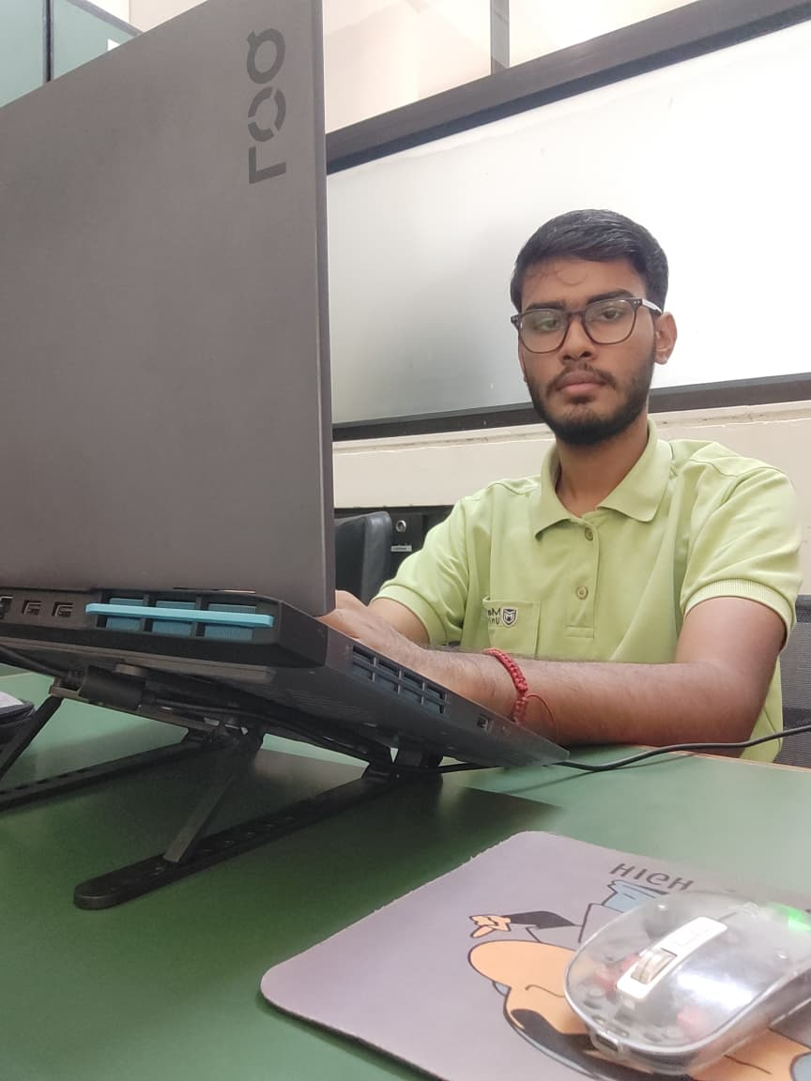
Hour 2 | 10:00 AM – 11:00 AM | MA103 | Planning Data Collection:
- Started working on the AI model. Instead of using random photos from the internet, I decided to train the AI with real data.
- Made a python script to collect only excel data (coordinates in written form) of a person.
- I collected my classmates data, explained my project to them, and gave a small demo before collecting the sample, and collected sample in different scenarios and angles.
Capture:
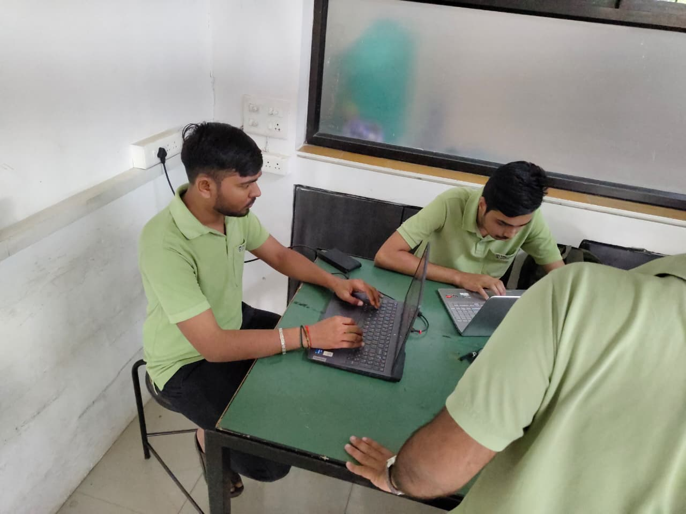
Hour 3 | 11:00 AM – 12:00 PM | MA108 | Recording Real Posture Samples:
- Spent this hour actively collecting data from my friends in the lab.
- I had them sit in good postures and bad postures (slouching) in front of the webcam to record real-world samples for the AI to learn from.
- Different classes and different labs
- Collected 43 samples of classmate till now (near to 25+ samples of good posture and 25+ bad posture(60 per person Excel data) and also some samples of ‘Not at desk’.
Capture:
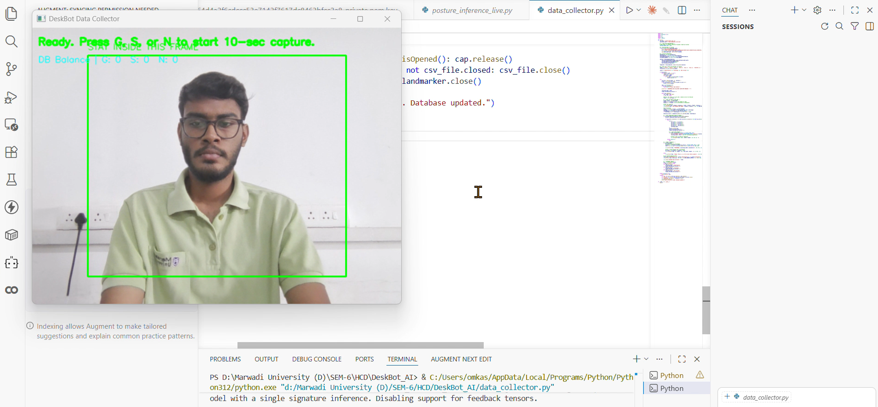
Hour 4 | 12:00 PM – 1:00 PM | MA108 | Collecting More Data :
- Continued taking more live posture samples to make sure the dataset is big enough.
- Also got a few samples from the faculty members to add variety to the data.
- Made sure the camera captured different angles and sitting styles.
- Collected near to 39 hundred samples including 63 persons with different scenarios, angles and clothes.
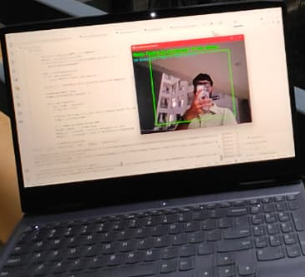

Hour 5 | 1:00 PM – 2:00 PM | MA108 | Cleaning the Dataset:
- Stopped collecting and started managing all the data I just gathered.
- Cleaned up the files, removed any bad or blurry samples, and organized everything into the correct folders.
- Made sure the data is in the perfect format so I can actually start training the AI model with it.
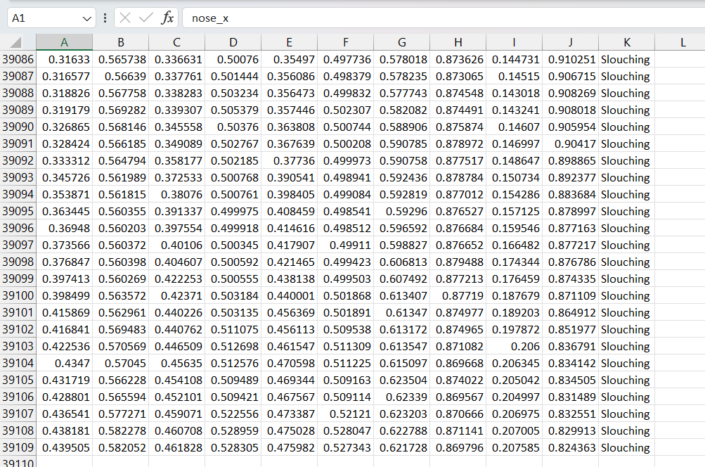
Hour 6 | 2:00 PM – 3:00 PM | MA108 | Designing the AI Model Script:
- Started writing the main Python script to train the Machine Learning model using the 3900+ data samples I collected earlier.
- Chose to use a Random Forest algorithm because it is really good at understanding coordinate data (like shoulder and neck positions).
- Wrote the code to read the Excel files and split the data into "training" and "testing" sets.
- Problem faced: I ran into major compatibility issues between different Python libraries. The code kept crashing because the versions of scikit-learn and pandas did not match properly.
- Solution: I created a fresh Python virtual environment and installed the exact matching versions of the libraries. This stopped the crashing instantly.
- Capture:
Hour 7 | 3:00 PM – 4:00 PM | MA108 | Training the AI & Error Solving:
- Ran the Python training script to officially teach the AI the difference between "Good Posture" and "Slouching".
- Wrote extra code to mathematically scale the data so the AI treats tall people and short people equally.
- Problem faced: The training code failed midway because a few rows in the Excel sheet had empty cells (where the camera couldn't see a body part during data collection).
- Solution: Added a data-cleaning function in my Python script to automatically find and drop any empty or corrupted rows before feeding the data to the AI.
- Successfully generated the trained model file (.pkl file) so it is ready to be used with the live webcam! Capture:
Hour 8 | 4:00 PM – 5:00 PM | MA108 | Arduino IDE & Hardware Setup:
- Switched my focus from the Python software to the physical IoT device.
- Set up the Arduino IDE on my laptop and installed all the necessary board managers for the NodeMCU (ESP8266).
- Started wiring the basic sensors, the OLED display, and the buzzer on a breadboard to test them.
- Problem faced: My laptop was not detecting the NodeMCU board when I plugged it in, showing a "COM port not found" error.
- Solution: I realized the USB cable I was using was only for charging and didn't support data transfer. I swapped it for a proper data cable and installed the CH340 drivers, and it finally connected. Capture:

