Student Name: Om Kasvala
Enrollment Number: 92410133005
Division/Semester: 3EK2 / Semester 6
Institution: Marwadi University
Course Assignment: TASK 2 - Problem Definition Identification (HCD)
Project Title: DeskBot: An AI-Powered Cloud Interactive Assistant

1. Community & Stakeholder Identification
Target Community: The primary community identified for this challenge is Work-From-Home (WFH) and Hybrid Professionals (e.g., software engineers, remote freelancers, and corporate employees) who spend 8 to 10+ hours a day stationed at a home desktop setup.
Key Stakeholders:
- Primary Stakeholders (End-Users): Remote workers suffering from screen fatigue, poor ergonomics, and blurred work-life boundaries.
- Secondary Stakeholders: Employers/Managers (invested in team productivity and reducing burnout-related leaves).
- Tertiary Stakeholders: Healthcare and ergonomic professionals (who treat the physical symptoms of sedentary remote work).

2. User Research & Summary of Stakeholder Interviews
To uncover genuine insights and identify opportunities for innovation (CO2), qualitative interviews were conducted with three WFH professionals.
Interview Summaries & Key Findings:
- Subject A (Software Developer, 25): Insight: "I set alarms on my phone to remind me to stretch, but I just swipe them away and keep coding."
  - Pain Point: Digital reminders are too passive and easily ignored. Technology needs a physical presence to demand attention.
- Subject B (Freelance Designer, 28): Insight: "Because my desk is in my bedroom, my brain never feels like it has left the office. I check emails at 10 PM."
  - Pain Point: Lack of a physical "boundary" or contextual shift to signal the end of the workday.
- Subject C (Remote Data Analyst, 32): Insight: "I get severe neck pain by Thursday every week. I don't realize I'm slouching until it hurts."
  - Pain Point: Users are unconscious of their physical posture while in "deep focus" mode.

3. Empathy Mapping & Key Insights

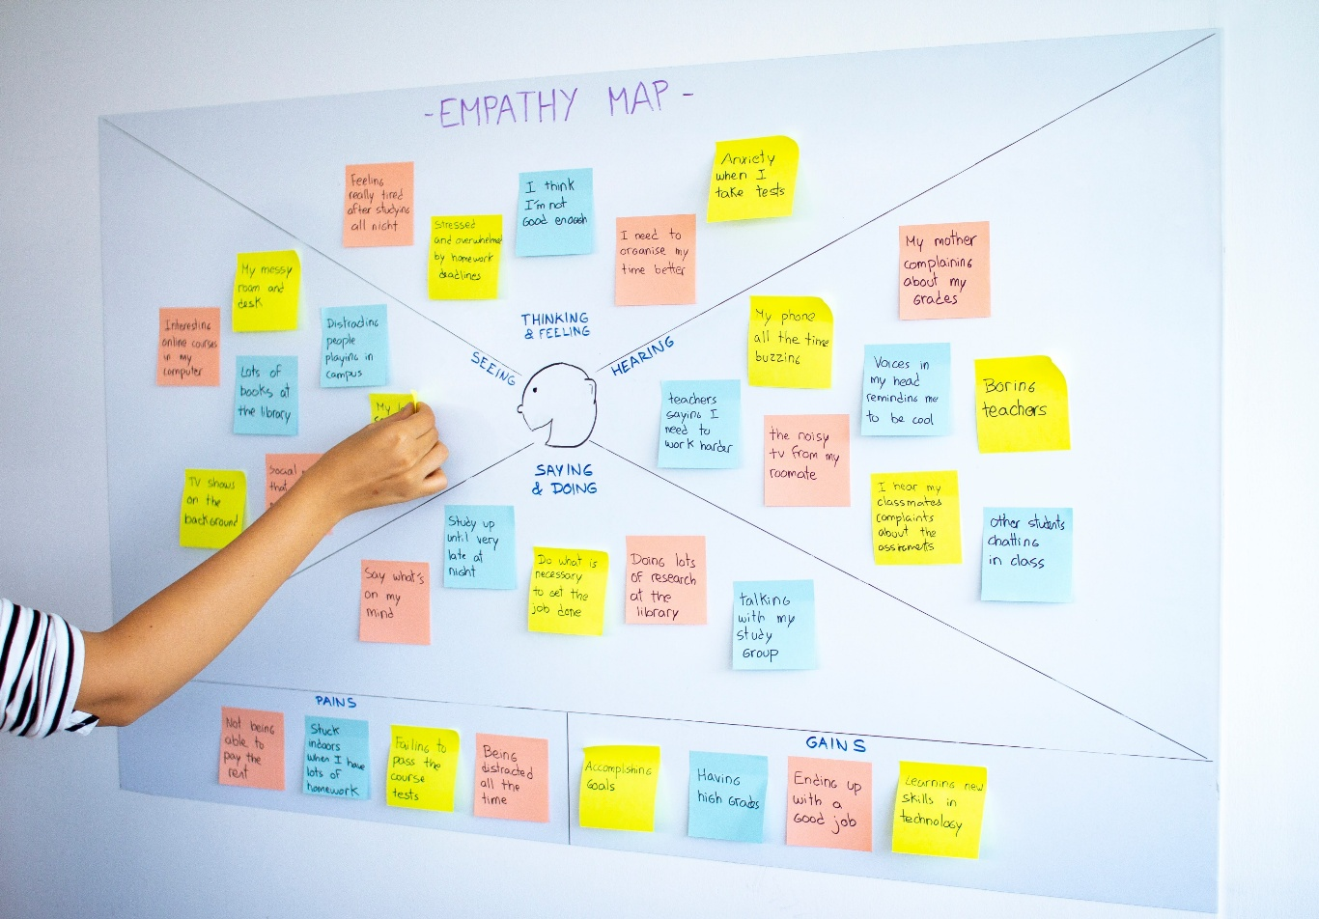

Shutterstock

Explore
To synthesize the research and map the user's emotional and physical state, an empathy map was generated for the standard WFH professional:
- SAYS: "I'm exhausted but I didn't even leave my chair today." / "I'll just work for 15 more minutes."
- THINKS: "I need to separate my workspace from my living space." / "I wish I had a coworker to chat with to break up the monotony."
- DOES: Slouches close to the monitor. Ignores digital screen-time alerts. Reaches for their smartphone out of habit during slight drops in focus.
- FEELS: Physically stiff (neck/back pain), digitally fatigued, isolated, and anxious about productivity.
Synthesized Insights: The core failure of current desktop technology (like smart speakers or apps) is that it is reactive and passive. Users do not need more software apps; they need a proactive, physical intervention that bridges the cyber-physical gap to enforce healthy habits.

4. Problem Framing & Ideation ("How Might We?")
Based on the empathy map, the following "How Might We?" (HMW) questions were formulated to guide the ideation phase creatively and feasibly:
- HMW make posture and break reminders unignorable without being highly annoying?
  - Ideation Output: Use physical affective feedback. A desktop robot that physically droops its head and makes a sad sound when the user slouches, utilizing human empathy rather than a jarring alarm.
- HMW create a distinct boundary between "work time" and "home time" in a single room?
  - Ideation Output: A "Context Switcher" routine where a desktop companion physically turns its back to the user and goes to sleep at 6:00 PM, triggering a cloud webhook to mute work notifications.
- HMW intercept digital distractions during deep-focus hours?
  - Ideation Output: Utilize Edge AI vision to detect when a user picks up a smartphone, prompting the robot to physically shake its head to enforce social accountability.

5. Final Problem Definition
Problem Statement: "Work-from-home professionals experience high levels of physical fatigue, digital distraction, and blurred work-life boundaries due to prolonged isolation and the reliance on passive, reactive technology. There is a critical need for a proactive, physically interactive desktop companion that actively monitors posture, intercepts digital distractions, and enforces ergonomic breaks to improve both physical well-being and productivity in remote work environments."
Alignment & Feasibility: This problem definition directly targets the societal and health impacts of remote work (PO6). The proposed solution pathway—integrating AI vision models, Cloud IoT telemetry, and Cyber-Physical Systems (CPSI)—ensures the challenge can be addressed utilizing complex engineering principles (PO1, PO2) while remaining deeply rooted in human-centered needs.

