Software Requirements Specification

Task Manager Application
Version 1.0 approved
Prepared by Team 4
PES University, Bangalore
PES1UG24CS309 - PES1202400285 - OM SATYAJYOTI PATTANAYAK
PES1UG24CS325 - PES1202400330 - PRACHI GANESH JOSHI
PES1UG24CS344 - PES1202400032 - priyansh soni
PES1UG24CS362 - PES1202403607 - RAJAT KIRAN KOOGE
02-10-2026
Table of Contents
1. Introduction
1.1 Purpose
1.2 Scope
1.3 Definitions, acronyms, and abbreviations
1.4 References
1.5 Overview
2. Overall description
2.1 Product perspective
2.2 Product functions
2.3 User characteristics
2.4 Constraints
2.5 Assumptions and dependencies
3. Specific requirements
3.1 External Interface
3.2 Functional Requirements
3.3 Non-Functional Requirements
3.4 Design Constraints
Appendixes
Index

Revision History
Name | Date | Reason For Changes | Version
Team 4 | 02-10-2026 | Initial SRS preparation | 1.0

Introduction

Purpose
The purpose of this Software Requirements Specification is to define the requirements of the Task Manager Application. The system provides a platform for organizing and tracking work progress through task creation, task assignment, task updates, and task monitoring.

Intended Audience
This document is intended for the project team, developers, testers, project evaluators, and users of the Task Manager Application. It describes the system requirements, interfaces, functional requirements, non-functional requirements, and design constraints.

Product Scope
The Task Manager Application is a task management tool used to organize and track work progress. The system allows users to create, view, update, assign, prioritize, and track tasks.

References
1. Software Engineering Mini-Project Deliverables Part-1, 2026.
2. Mini-Project Problem Statement, Section F, Team 4.
3. Project Guidelines, Software Engineering Mini-Project.

Overall Description

Product Perspective
The Task Manager Application is a web-based software system for organizing and tracking work progress. The system provides a user interface for task management and application services for processing and storing user and task information.

Product Functions
The major functions of the product are:
• User registration and authentication.
• User login and logout.
• Create, view, edit, and delete tasks.
• Assign tasks to team members.
• Set task priority and deadline.
• Update and track task status.
• Search and filter tasks.
• View task progress through a dashboard.

User Classes and Characteristics
Registered User: Creates an account, logs in, manages authorized tasks, and tracks progress.
Team Member: Views assigned tasks, updates task status, and tracks assigned work.

Operating Environment
The system will operate as a web-based application accessed through a modern web browser. The frontend will be implemented using React.js and the backend will be implemented using Node.js. A database will be used for persistent storage.

Design and Implementation Constraints
The system shall use JavaScript with React.js for the frontend and Node.js for the backend. The system shall use persistent storage for user and task information. Authentication and authorization shall be implemented for protected operations. The system shall follow modular software design principles.

2.6 Assumptions and Dependencies
Users are assumed to have access to a compatible web browser and network connectivity. Users are assumed to provide valid information. The system depends on React.js, Node.js, the selected database system, and the required software libraries and packages.

External Interface Requirements

User Interfaces
The system shall provide a web-based graphical user interface with screens for registration, login, task management, task details, task tracking, and dashboard information. Forms shall validate required input and display appropriate error messages.

Software Interfaces
The React.js frontend shall communicate with the Node.js backend through application APIs. The Node.js backend shall communicate with the database for storing and retrieving user and task information.

Communications Interfaces
The application shall use HTTP/HTTPS-based client-server communication. API requests and responses shall use JSON or another structured data format. HTTPS shall be used in deployment to protect data transmitted between the client and server.

Hardware Interfaces: No dedicated hardware interface is required.

Analysis Models
The UML use case diagram below identifies the main interactions between the user and the Task Manager Application.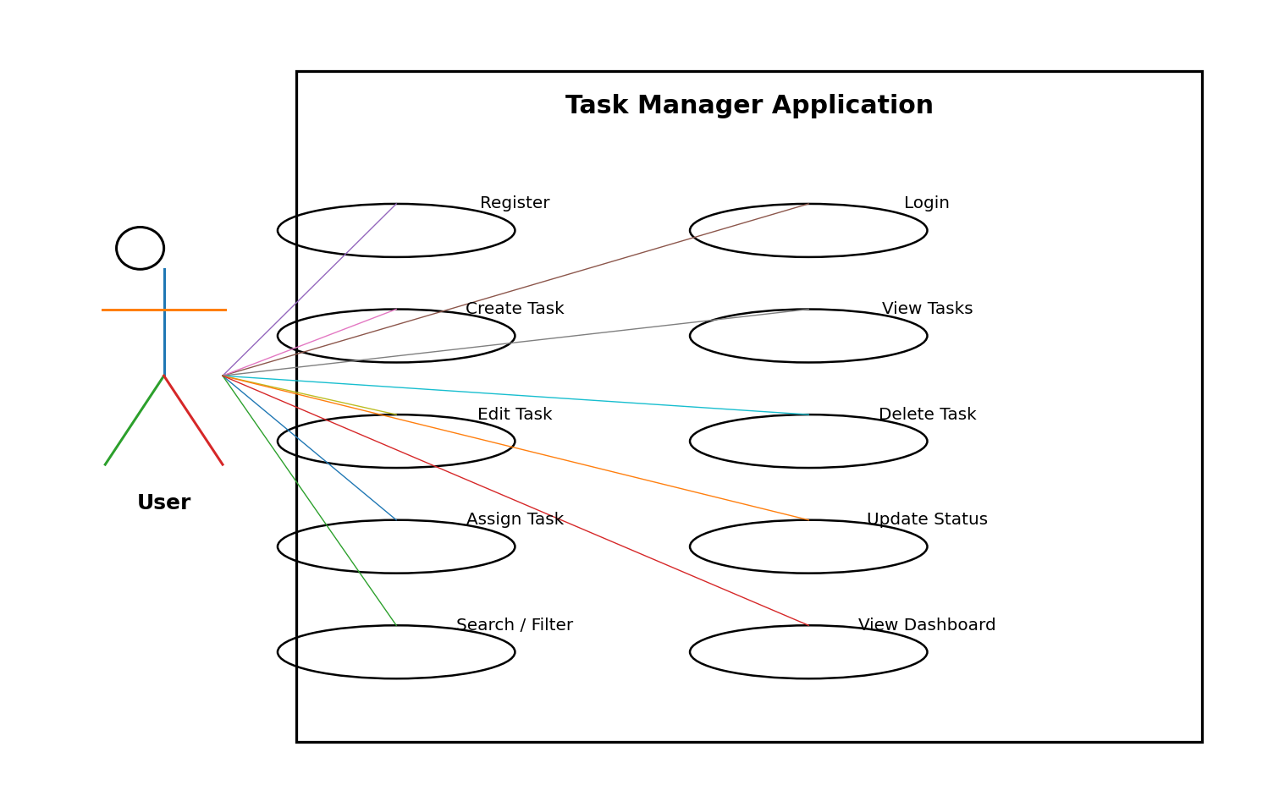

System Features
The functional requirements are organized by the major services provided by the Task Manager Application.

System Feature 1
Authentication and User Management
5.1.1 Description and Priority
Provides user registration, login, logout, and authentication. Priority: High.
5.1.2 Stimulus/Response Sequences
User submits registration details → system validates the details and creates an account. User submits login credentials → system validates the credentials and grants or denies access.
5.1.3 Functional Requirements
FR-01: The system shall allow a new user to register using a unique email address and password.
FR-02: The system shall authenticate registered users before allowing access to protected functionality.

Each functional requirement is uniquely identified using a requirement ID.

FR-01: The system shall allow a new user to register using a unique email address and password.
FR-02: The system shall authenticate registered users before allowing access to protected functionality.

System Feature 2 — Task Management
Priority: High.
FR-03: The system shall allow an authenticated user to create a task with a title, description, priority, and deadline.
FR-04: The system shall allow an authenticated user to view tasks that the user is authorized to access.
FR-05: The system shall allow an authorized user to edit an existing task.
FR-06: The system shall allow an authorized user to delete an existing task.
FR-07: The system shall allow an authorized user to assign a task to a registered team member.
FR-08: The system shall allow an authorized user to update the status of a task.
FR-09: The system shall allow an authorized user to specify and modify task priority.
FR-10: The system shall allow users to search and filter authorized tasks using task attributes.
FR-11: The system shall display task progress information through a dashboard.

Other Nonfunctional Requirements

Performance Requirements
NFR-01: The system shall return normal task-management requests within 3 seconds under normal operating conditions.

Safety Requirements
The system is not intended for safety-critical operations or control of physical equipment. No dedicated safety interface is required.

Security Requirements
Security Objectives:
1. Ensure that only authenticated users can access protected task-management functionality.
2. Protect user and task information from unauthorized access or modification.
Security Requirements:
SR-01: The system shall require authentication before allowing access to protected task-management functions.
SR-02: The system shall enforce authorization checks before allowing a user to access or modify a task.
SR-03: The system shall not expose user passwords in application responses or normal application logs.
SR-04: The system shall validate user-supplied input before processing task-management requests.

Software Quality Attributes
NFR-02: The system shall prevent unauthorized users from accessing protected task-management functions.
NFR-03: The system shall provide a consistent interface for creating, viewing, editing, and tracking tasks.
NFR-04: The system shall preserve successfully stored task information during normal application operation.
NFR-05: The system shall use modular components so that individual modules can be modified without requiring changes to unrelated modules.
NFR-06: The system shall structure major functional components so that they can be tested independently.

Business Rules
1. A user must be authenticated before accessing protected task-management functions.
2. Only authorized users may modify or delete a task.
3. A task must contain a title before it can be stored.
4. A task shall have a valid status value.
5. A task assigned to a user shall reference a registered user.

Domain requirements: task information shall include a title, description, priority, deadline, assignee where applicable, and status.

Other Requirements
The system shall maintain persistent records for users and tasks. The implementation shall separate application logic and data storage and shall support future task-management enhancements.
Appendix A: Glossary
Task: A unit of work that needs to be completed.
Priority: The importance level assigned to a task.
Status: The current state of a task.
Dashboard: A view that summarizes task and progress information.
Authentication: Verification of a user's identity.
Authorization: Determination of permitted operations.
API: Application Programming Interface.
FR: Functional Requirement.
NFR: Non-Functional Requirement.

Appendix B: Field Layouts
Field layouts and properties for the Task Manager Application are provided below.
Task information fields and their properties are listed in the table.
Field | Length | Data Type | Description | Is Mandatory
Task ID | 20 | Alphanumeric | Unique identifier for a task | Y
Title | 100 | Title of the task |  | Y
Description | 500 | String | Detailed task description | N
Priority | 10 | String | Priority of the task | Y
Deadline | 10 | Date | Task deadline | N
Status | 20 | String | Current task status | Y
Assignee | 50 | String | Assigned team member | N
Task and progress report fields are listed in the report requirements table.
Task Report | Progress Report
Task ID | Total Tasks
Title | To Do Tasks
Priority | In Progress Tasks
Deadline | Completed Tasks
Status | Overdue Tasks
Assignee | Progress Percentage

Appendix C: Requirement Traceability Matrix
Sl. No | Requirement ID | Brief Description of Requirement | Architecture Reference | Design Reference | Code File Reference | Test Case ID | System Test Case ID
1 | FR-01 | User registration | TBD | TBD | TBD | TBD | TBD
2 | FR-02 | User authentication | TBD | TBD | TBD | TBD | TBD
3 | FR-03 | Create task | TBD | TBD | TBD | TBD | TBD
4 | FR-04 | View tasks | TBD | TBD | TBD | TBD | TBD
5 | FR-05 | Edit task | TBD | TBD | TBD | TBD | TBD
6 | FR-06 | Delete task | TBD | TBD | TBD | TBD | TBD
7 | FR-07 | Assign task | TBD | TBD | TBD | TBD | TBD
8 | FR-08 | Update task status | TBD | TBD | TBD | TBD | TBD
9 | FR-09 | Task priority | TBD | TBD | TBD | TBD | TBD
10 | FR-10 | Search and filter | TBD | TBD | TBD | TBD | TBD
11 | FR-11 | Dashboard | TBD | TBD | TBD | TBD | TBD
12 | NFR-01 | Performance | TBD | TBD | TBD | TBD | TBD
13 | NFR-02 | Security | TBD | TBD | TBD | TBD | TBD
14 | NFR-03 | Usability | TBD | TBD | TBD | TBD | TBD
15 | NFR-04 | Reliability | TBD | TBD | TBD | TBD | TBD
16 | NFR-05 | Maintainability | TBD | TBD | TBD | TBD | TBD
17 | NFR-06 | Testability | TBD | TBD | TBD | TBD | TBD
18 | SR-01 | Authentication security requirement | TBD | TBD | TBD | TBD | TBD
19 | SR-02 | Authorization security requirement | TBD | TBD | TBD | TBD | TBD
20 | SR-03 | Password protection | TBD | TBD | TBD | TBD | TBD
21 | SR-04 | Input validation | TBD | TBD | TBD | TBD | TBD

