College Event Feedback Analysis Report

# 1. Graphs of Ratings

This section summarizes the average ratings and rating distribution across events. Tech Fest and Cultural Night received high average ratings, while Workshop on AI received mixed responses.

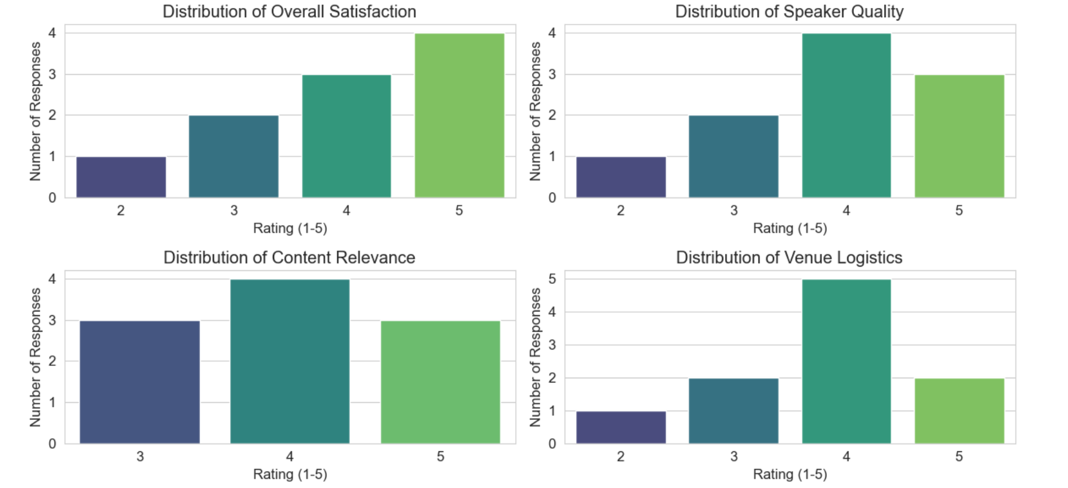

# 2. Sentiment Analysis Summary

Sentiment was analyzed using TextBlob.

Sentiment Breakdown:

* - Positive: 8 (80%)
* - Negative: 1 (10%)
* - Neutral: 1 (10%)

Most feedback was positive, highlighting general satisfaction with the events. Negative feedback focused on delays, seating, and engagement issues.

# 3. Key Recommendations for Event Organizers

WHAT WENT WELL:

* - Cultural events and Tech Fests were most appreciated.
* - Students enjoyed interactive sessions.
* - High ratings indicate strong engagement.

AREAS TO IMPROVE:

* - Reduce scheduling delays.
* - Improve venue logistics (seating, coordination).
* - Make technical sessions more interactive.

SUGGESTED ACTIONS:

1. Collect event-specific feedback.

2. Use live polls during events.

3. Share summary reports post-event.

4. Repeat this analysis framework for future improvements.