**Q2.Ans:**

Understanding of data

df_day.shape

#It contains (731, 16)

#Describing the data

df_day.describe()

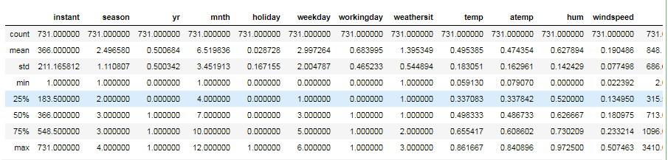

Univariate Analysis

# Target variable analysis

#descriptive of statistics summary

df_day['cnt'].describe()

#Check whether target variable is normal or not

sns.distplot(df_day['cnt']);

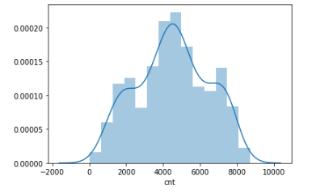

Relation between Numerical Variable 'temp' and target variable 'cnt'

df_day['temp'].value_counts()

#Now draw scatter plot between 'temp' and 'cnt' variables

var = 'temp'

data = pd.concat([df_day['cnt'], df_day[var]], axis=1)

data.plot.scatter(x=var, y='cnt', ylim=(0,9000));

# It is showing there is good relation between 'temp' and 'cnt'

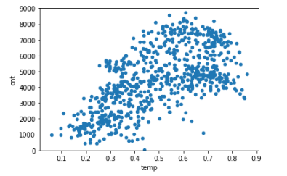

Box plot 'Weekdays' with 'CNT'

var_weekdays = 'weekday'

data = pd.concat([df_day['cnt'], df_day[var_weekdays]], axis=1)

f, ax = plt.subplots(figsize=(8, 6))

fig = sns.boxplot(x=var_weekdays, y="cnt", data=data)

fig.axis(ymin=0, ymax=9000);

#below Boxplot is saying that for all the weekdays median in between 4000- 5000

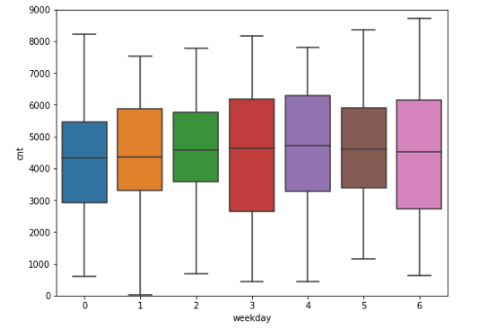

Finding total missing values and percentage of missing data to compare the data

total = df_day.isnull().sum().sort_values(ascending=False)

percent = (df_day.isnull().sum()/df_day.isnull().count()).sort_values(ascending=False)

missing_data = pd.concat([total, percent], axis=1, keys=['Total', 'Percent'])

missing_data.head(20)

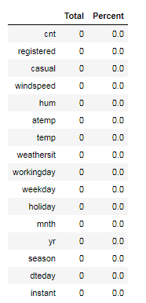

Correlation before outlier treatment

# Correlation between 'casual' and 'cnt' before removal of outliers

#sns.regplot(x="casual", y="cnt", data=df_day);

df_day['casual'].corr(df_day['cnt'])

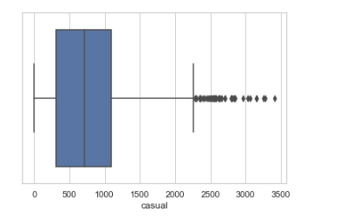

Boxplot for casual after aoutlier removal

sns.set(style="whitegrid")

#tips = sns.load_dataset("tips")

ax = sns.boxplot(x=df_day_out['casual'],orient ='h')

# Correlation between 'casual' and 'cnt' after removal of outliers

sns.regplot(x="casual", y="cnt", data=df_day_out);

df_day_out['casual'].corr(df_day_out['cnt'])

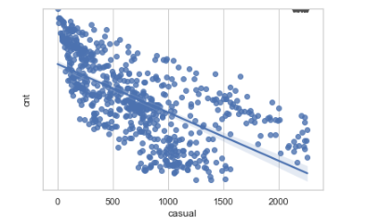

Feature selection

df_day.head()

#Selection of numerical feature based on pearson corelation

day_numeric = df_day.loc[:,['temp','atemp','hum','windspeed','casual','registered','cnt']]

#draw correlation matrix between all numeric variables and analyse what are the variables are important

day_numeric.corr(method='pearson').style.format("{:.2}").background_gradient(cmap=plt.get_cmap('coolwarm'), axis=1)

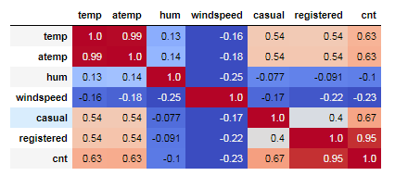

Check relationship with scatter plots

sns.set()

cols = ['temp', 'atemp', 'hum', 'windspeed', 'casual', 'registered', 'cnt']

sns.pairplot(day_numeric[cols], size = 2.5,kind="reg")

plt.show();

#As per scatter plots and above Correlation graph there is strong relation

# Independent variable 'temp' and 'atemp'

# There is a poor relation between Independent variable 'hum' and dependent variable 'cnt'

# so dropping two variables for feature selection

numeric_features = day_numeric.loc[:,['temp', 'windspeed', 'casual', 'registered', 'cnt']]

numeric_features.head()

numeric_features.shape

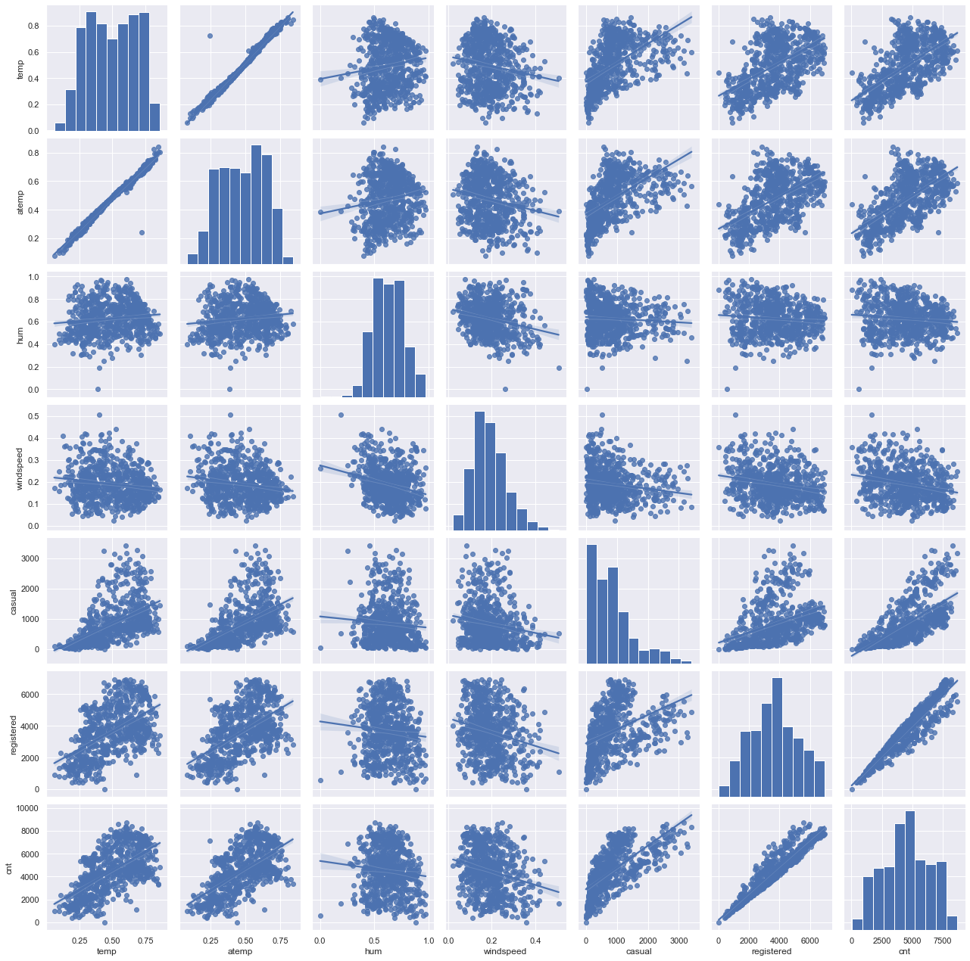

Decision Tree Regressor

#Importing Decision Tree Regressor from sklear.tree

from sklearn.tree import DecisionTreeRegressor

#Train/Test is a method to measure the accuracy of your model.

train_features_one = train[['season','yr','mnth','holiday','weekday','weathersit','temp','windspeed','casual','registered']].values

train_target_feature = train['cnt'].values

test_feature = test[['season','yr','mnth','holiday','weekday','weathersit','temp','windspeed','casual','registered']].values

test_target_feature= test['cnt'].values

train_features_one

#target_feature

# Implement decision tree algorithm

# Fit your first decision tree: my_tree_one

my_tree_one = DecisionTreeRegressor()

my_tree_one = my_tree_one.fit(train_features_one, train_target_feature)

print(my_tree_one)

#Decision tree for regression

#fit_DT = DecisionTreeRegressor(max_depth=2).fit(train.iloc[:,2:13], train.iloc[:,13])

#Apply model on test data

predictions_DT = my_tree_one.predict(test_feature)

print(predictions_DT)

# prediction by using predict method

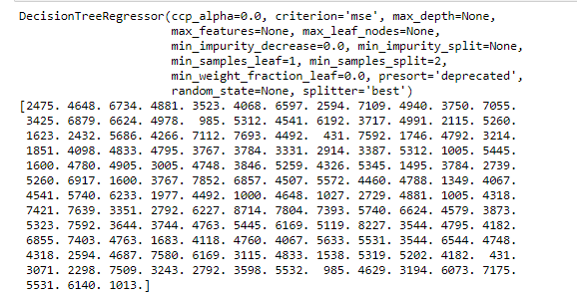

Random Forest

# Instantiate random forest and train on new features

from sklearn.ensemble import RandomForestRegressor

RF_model_one = RandomForestRegressor(n_estimators= 500, random_state=100).fit(train_features_one,train_target_feature)

# Predict the model using predict funtion

RF_predict_one= RF_model_one.predict(test_feature)

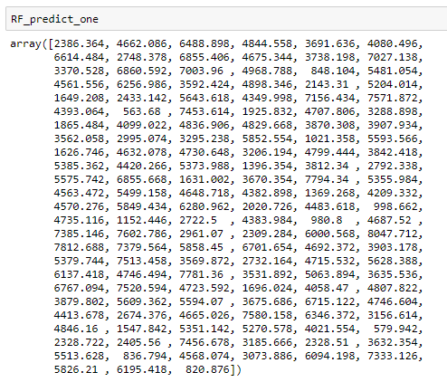

Evaluate Random forest using MAPE

MAPE(test_target_feature,RF_predict_one)

#Here it is stating accuracy of the model increases

Output=19.148590089060665

Evaluate Model using RMSE

RMSE(test_target_feature,RF_predict_one)

Output:

Mean Square : 17866.347121741488

Root Mean Square : 133.6650557241551

133.6650557241551

List of x locations for plotting

x_values = list(range(len(mir_result)))

# Make a bar chart

plt.bar(x_values, mir_result, orientation = 'vertical', color = 'r', edgecolor = 'k', linewidth = 1.2)

# Tick labels for x axis

plt.xticks(x_values, train_variables_one_1, rotation='vertical')

# Axis labels and title

plt.ylabel('Importance'); plt.xlabel('Variable'); plt.title('Variable Importances');

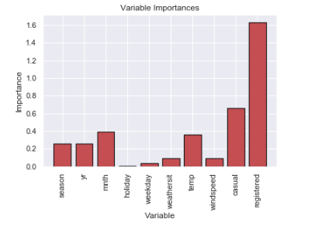

The above graph is stating that only few features are important to decide the accuracy of the model

# Now we

#wil check our model accuracy by reducing features

train_feature_two = train[["yr" ,"mnth","weekday","workingday","temp","casual","registered"]].values

test_feature_two= test[["yr" ,"mnth","weekday","workingday","temp","casual","registered"]].values

# build random forest model

Rf_model_two = RandomForestRegressor(n_estimators= 500, random_state=100).fit(train_feature_two,train_target_feature)

RF_predict_two= Rf_model_two.predict(test_feature_two)

print(RF_predict_two)

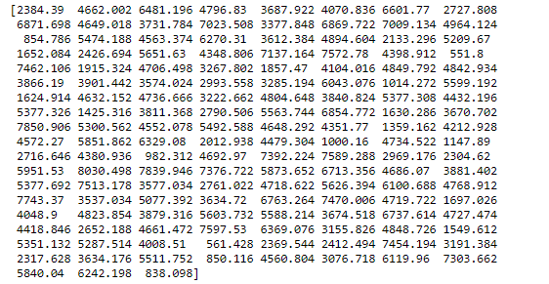

Evaluate model using MAPE

MAPE(test_target_feature,predict_LR)

#Predict the model using RMSE

RMSE(test_target_feature,predict_LR)

#it is showing that Linear Regression model is best suitable for the dataset

Output:

Mean Square : 9.13121055765183e-24

Root Mean Square : 3.0217892973620497e-12

3.0217892973620497e-12

Linear regression is the best model for the dataset.