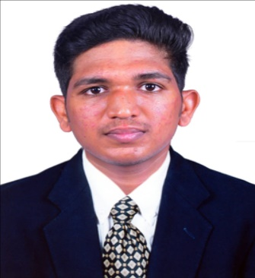OM PRAKASH S

### COMPUTER SCIENCE ENGINEERING GRADUATE

**MOBILE:** 9003985132 **| E-MAIL:** [ombshss2005@gmail.com](mailto:ombshss2005@gmail.com)

**RESS:**Ews:669,Kurumbapet,HousingBoard,Puducherry-605009. **LINKEDIN:** www.linkedin.com/in/om-prakash-81736a256

**GITHUB:** [omprakash1305 · GitHub](https://github.com/omprakash1305)

_ _

# Career Objective:

A Fresher who wishes to equip myself with additional skills and hone my leadership skills by working with a team that enables me to develop and work hard.

# Education:

**2022 – 2026:**

**UG - B. Tech CSE**

CGPA – 8.07 (Till III Sem)

(Pondicherry University) Manakula Vinayagar Institute of Technology, Puducherry.

**2021 – 2022:**

**HSC (TN Board)**

Percentage – 89.5%

Blue Star Hr. Sec. School, Puducherry.

**2019 – 2020:**

**SSLC (TN Board)**

Percentage – 84.21%

Sri Raghevendirar High. School, Puducherry.

# Technical Skills:

**Front End:** HTML, CSS, JavaScript

**Back End:** Python

**Database: My**SQL,

**Others:** MS Word, MS PowerPoint, MS Excel

# Areas of Interest:

* Object Oriented Programming – Java
* Data Structures and Algorithms
* Python programming

# Project:

## Modular Lighting System using Raspberry Pi

Abstract: Smart Lighting systems are a type of intelligent technology that revolutionizies the way we illuminate our homes and office. These systems are connected to the internet, allowing for remote control and automation of lighting processes.

# Certifications:

* Completed HTML,CSS certification in Free Code Camp.
* Certified JavaScript, Data Science (Basic) in Great Learning.
* Certified Data Analysis with Python in Cognitive Class.ai
* Certified in Data Analytics in LinkedIn Learning.

# Internships:

* Prodigy Info Tech as Web Developer.
* Assistlana as Data Analyst.

## Regards,

### Om Prakash. S