SEQUENT
A Temporal Event-Driven Domain-Specific Language and Compiler
A Compiler-Based Framework for Modeling, Analyzing, and Simulating Event-Driven Systems with Temporal Constraints
COMPILER DESIGN LABORATORY
PHASE 1 PROJECT DOCUMENTATION
Problem Definition and System Design
Submitted by:
JEERU OMPRAKASH REDDY
Registration Number:
24BKT0080
Fall Semester 2026–27

Table of Contents
Table of Contents ............................................................ 2
ABSTRACT ..................................................................... 3
Chapter 1 – Introduction ..................................................... 4
1.1 Background ............................................................. 4
1.2 Project Overview ....................................................... 4
1.3 Motivation ............................................................. 4
1.4 Project Relevance ...................................................... 4
1.5 Phase 1 Focus .......................................................... 4
Chapter 2 – Problem Definition ............................................... 5
2.1 Problem Statement ...................................................... 5
2.2 Existing Problem ....................................................... 5
2.3 Proposed Solution ...................................................... 5
2.4 Demonstration Domain ................................................... 5
2.5 Scope of the Problem ................................................... 5
Chapter 3 – Objectives ....................................................... 6
3.1 Primary Objective ...................................................... 6
3.2 Specific Objectives .................................................... 6
Chapter 4 – Scope ............................................................ 6
4.1 Phase 1 Scope .......................................................... 6
4.2 Overall Project Scope .................................................. 6
4.3 Current Limitations .................................................... 6
4.4 Future Scope ........................................................... 6
Chapter 5 – Background Study ................................................. 7
5.1 DSLs, 5.2 Event Systems, 5.3 Front-End, 5.4 Lexical, 5.5 Parsing ....... 7
5.6 ASTs, 5.7 Symbol Tables, 5.8 Semantics, 5.9 Temporal Constraints ....... 7
5.10 Comparative Background and Existing Approaches ........................ 8
Chapter 6 – Requirements Analysis ............................................ 9
6.1 Functional, 6.2 Input, 6.3 Output, 6.4 Non-Functional Requirements ..... 9
6.5 Software Requirements & 6.6 Hardware Requirements ...................... 9
Chapter 7 – SEQUENT Language Specification .................................. 10
7.1 Philosophy, 7.2 Keywords, 7.3 Identifiers, 7.4 Literals, 7.5 Operators .... 10
7.6 Time Units, 7.7 Comments, 7.8 Syntax Rules, 7.9 Formal Grammar ........ 10
7.10 Primary Demonstration Program (EmergencyResponse) .................... 11
Chapter 8 – Compiler Design Concepts ........................................ 12
8.1 Lexical Analysis & Token Specification Table .......................... 12
8.2 Syntax Analysis & 8.3 Recursive-Descent Parsing ....................... 12
8.4 AST, 8.5 Symbol Table, 8.6 Semantic, 8.7 Type Checking ................ 13
8.8 Temporal Analysis, 8.9 Error Reporting & Core Algorithms .............. 13
Chapter 9 – Proposed Methodology ............................................ 14
9.1 Development Methodology & 9.2 Compiler Pipeline ....................... 14
9.3 Phase 1 Workflow & 9.4 Validation Strategy ............................ 14
Chapter 10 – System Design .................................................. 15
10.1 High-Level Architecture & 10.2 Module Architecture ................... 15
10.3 Module Descriptions Table, 10.4 Data Flow, 10.5 Workflow ............. 16
10.6 AST Design & 10.7 Symbol Table Architecture .......................... 17
10.8 Semantic Analysis Design & 10.9 Temporal Analysis Design ............. 18
Chapter 11 – Technology Stack ............................................... 19
11.1 Language, 11.2 Environment, 11.3 Libraries, 11.4 Testing, 11.5 Tree .... 19
Chapter 12 – Initial Prototype .............................................. 20
12.1 Objective, 12.2 Components, 12.3 CLI, 12.4 Valid Program ............. 20
12.5 Token Stream, 12.6 AST, 12.7 Symbols, 12.8 Temporal Outputs .......... 21
12.9 Error Detection & 12.10 Automated Test Suite ......................... 21
Chapter 13 – Prototype Results .............................................. 22
13.1 Valid Result, 13.2 Syntax Error, 13.3 Semantic Error ................. 22
13.4 Type Error, 13.5 Temporal Error, 13.6 Test Suite Result (29/29) ...... 23
13.7 Phase 1 Achievement Summary .......................................... 23
Chapter 14 – Current Limitations and Future Development ..................... 24
14.1 Phase 1 Limitations, 14.2 Phase 2 Planned, 14.3 Phase 3 Planned ...... 24
Chapter 15 – Conclusion ..................................................... 25
References .................................................................. 25
Appendix A – SEQUENT Grammar ................................................ 26
Appendix B – Prototype Commands ............................................. 26
Appendix C – Phase 1 Test Case Summary ...................................... 26

ABSTRACT
SEQUENT is a specialized Domain-Specific Language (DSL) and compiler framework engineered for the formal modeling and static analysis of temporal event-driven architectures. In complex reactive software systems, expressing precise event ordering dependencies and strict timing deadlines using conventional general-purpose programming languages frequently yields brittle, fragmented implementations scattered across asynchronous callbacks, imperative timer handles, and nested conditional guards. SEQUENT resolves this fundamental challenge by elevating temporal constraints to first-class syntactic and semantic language constructs, allowing system architects to declare reactive state transitions, event triggers, and inter-event timing deadlines directly in source code. This project documentation presents the Phase 1 milestone—Problem Definition and System Design—completed in strict accordance with the Compiler Design Laboratory manual without relying on external parser generators. The implemented compiler front-end encompasses a deterministic hand-crafted lexical analyzer, an LL(1) recursive-descent syntax parser generating an explicit Abstract Syntax Tree (AST), a centralized symbol table manager tracking state variables and event declarations with duplicate detection, a static semantic and type analyzer, and a dedicated temporal constraint analyzer that validates event relationships and normalizes duration bounds into canonical milliseconds. Evaluated against an Emergency Response coordination domain, the compiler successfully identifies valid system configurations and issues precise diagnostic messages for syntax, semantic, type, and temporal violations. The implementation is verified through an automated test suite achieving 29/29 passed tests (100% pass rate). This robust front-end provides the formal static-analysis foundation for planned Phase 2 intermediate representations, bytecode compilation, and virtual machine execution, followed by Phase 3 runtime simulation and visualization.
Keywords: Domain-Specific Language (DSL), Compiler Front-End, Recursive-Descent Parsing, Abstract Syntax Tree (AST), Symbol Table, Static Semantic Analysis, Type Checking, Temporal Constraints, Emergency Response.

Chapter 1 – Introduction
1.1 Background
Compiler Design provides the foundational theoretical principles and engineering techniques for analyzing formal languages and transforming high-level human-readable representations into rigorous structured models, intermediate representations, and executable machine code. The Compiler Design Laboratory curriculum emphasizes the end-to-end realization of regular expressions, lexical scanning, context-free grammars, syntactic parsing, Abstract Syntax Tree (AST) construction, symbol-table management, static semantic analysis, type checking, and location-aware diagnostic error attribution [2]. SEQUENT applies these classical compiler construction principles to an emerging and safety-critical domain: temporal event-driven reactive systems.
1.2 Project Overview
SEQUENT is a Temporal Event-Driven Domain-Specific Language (DSL) and compiler framework. It enables system architects to formally model, statically analyze, and simulate discrete reactive architectures. Using SEQUENT, developers can specify system boundaries, state variables with initial types and values, observable external and internal events, reactive state-mutation handlers, and strict inter-event temporal constraints in a compact, declarative notation. The compiler parses and validates these specifications statically, guaranteeing structural and temporal consistency before execution.
1.3 Motivation
In modern mission-critical domains—such as emergency dispatch coordination, industrial automation, robotics, avionics, medical devices, and distributed financial systems—correctness depends not only on functional state transformations but also on temporal predictability. In traditional general-purpose languages, timing relationships between asynchronous events are typically scattered across ad-hoc timers, callback functions, sleep statements, and nested conditional guards. This fragmentation obscures temporal intent, impedes formal auditing, and defers timing violations to difficult-to-reproduce runtime failures. SEQUENT solves this by elevating temporal constraints to explicit first-class language constructs:
constraint EmergencyDetected -> TeamDispatched within 5s
By making timing relationships explicit at the syntax level, the compiler can inspect, parse, normalize, and validate temporal dependencies statically at build time, preventing invalid temporal configurations before software deployment.
1.4 Project Relevance
SEQUENT directly embodies the core learning outcomes of the Compiler Design Laboratory. The project requires the practical implementation of every front-end compiler phase: lexical scanning via deterministic character recognition, context-free parsing via recursive descent, strongly typed AST synthesis, symbol-table construction with identifier resolution, static type checking, domain-specific temporal analysis, and structured error diagnostics. Furthermore, the modular front-end architecture establishes a clean, decoupled foundation that interfaces seamlessly with subsequent code generation and execution stages.
1.5 Phase 1 Focus
In strict compliance with the laboratory curriculum, Phase 1 focuses exclusively on 'Problem Definition and System Design'. The scope of this phase encompasses formalizing the problem, defining the SEQUENT grammar, designing the complete system architecture, implementing the front-end prototype (Lexer, Parser, AST, Symbol Table, Semantic Analyzer, Temporal Analyzer), and validating the prototype against automated test suites. Downstream components—such as Intermediate Representation (IR), bytecode generation, virtual machine execution, and runtime simulation—are formally scheduled for subsequent project milestones.

Chapter 2 – Problem Definition
2.1 Problem Statement
Event-driven systems are characterized by asynchronous occurrences that trigger state changes and subsequent reactions. In safety-critical environments, these occurrences must satisfy strict ordering dependencies and timing limits (e.g., 'TeamDispatched must follow EmergencyDetected within 5 seconds'). When such requirements are expressed in general-purpose languages, the temporal contracts are buried inside imperative application code. The core problem addressed by this project is the lack of a dedicated, lightweight domain-specific language and compiler that treats states, events, and temporal constraints as first-class citizens with static compile-time verification.
2.2 Existing Problem
Existing software engineering approaches suffer from major limitations when modeling temporal event-driven systems:
• Scattered Timing Logic: Timing deadlines are managed via disparate platform timers, threads, and callback queues, making system-wide temporal auditing nearly impossible.
• Late Fault Detection: Temporal constraint violations (such as circular dependencies, invalid durations, or missing events) are detected only at runtime, often in production environments.
• Lack of Static Type & Symbol Binding: Timers and callbacks are decoupled from formal symbol tables, allowing undeclared events and invalid state mutations to pass compilation unchecked.
• Heavyweight Formal Verification: While formal formalisms (e.g., UPPAAL, Timed Automata) offer mathematical verification, they are complex, disconnected from executable software codebases, and incur state-space explosion.
2.3 Proposed Solution
SEQUENT introduces a clean, declarative domain-specific language supported by a custom compiler front-end. The language provides intuitive syntax for declaring state variables, observable events, reactive event handlers, and inter-event temporal constraints. The compiler parses the source code into an AST, maintains an internal symbol table, enforces static semantic and type invariants, validates temporal event bindings, and normalizes time units to canonical milliseconds. This guarantees compile-time correctness and provides a verified AST for downstream execution.
2.4 Demonstration Domain
The primary demonstration scenario chosen for Phase 1 is an Emergency Response coordination workflow. In this scenario, when an EmergencyDetected event is observed, emergency personnel must be mobilized and the TeamDispatched event must occur within 5 seconds. Following team dispatch, the incident must be brought under control and the IncidentResolved event must occur within 30 minutes. This domain provides realistic state transitions, multiple asynchronous events, and multi-tier temporal deadlines, making it an ideal benchmark.
2.5 Scope of the Problem
The scope of the problem addressed in Phase 1 focuses on static structural and temporal correctness. The compiler front-end verifies that all referenced events and states exist, that state mutations respect static type boundaries, and that temporal constraints specify positive, valid durations. Dynamic execution and runtime deadline enforcement are formally scoped for subsequent project phases.

Chapter 3 – Objectives
3.1 Primary Objective
The primary objective of Phase 1 is to design, implement, and verify a complete compiler front-end prototype for the SEQUENT DSL, satisfying all criteria established in the Compiler Design Laboratory manual [1] without utilizing external parser-generator libraries.
3.2 Specific Objectives
1. Design a domain-specific language tailored for modeling states, events, handlers, and timing constraints in reactive systems.
2. Formulate a formal context-free grammar in Extended Backus-Naur Form (EBNF) specifying unambiguous syntactic productions for SEQUENT V1.
3. Implement a deterministic lexical analyzer tokenizing source text and preserving exact line and column coordinates for location-aware error reporting.
4. Implement a hand-written recursive-descent parser constructing a strongly typed Abstract Syntax Tree (AST) representing system declarations, handlers, and constraints.
5. Develop a symbol table manager tracking state variables, inferred types, initial literal values, and declared events with duplicate collision detection.
6. Perform static semantic analysis and type checking verifying that all referenced symbols exist and that assigned values conform to declared state types.
7. Implement temporal constraint static analysis validating that constraint events exist, durations are strictly positive, and normalizing units (ms, s, m, h) into milliseconds.
8. Provide structured diagnostic error reporting issuing categorized, informative compiler errors for lexical, syntax, semantic, type, and temporal violations.
9. Develop and verify an initial prototype CLI supporting command-line compilation and inspection flags (--tokens, --ast, --symbols, --temporal).
10. Execute comprehensive automated test suites validating 100% of unit and integration test cases across all compiler front-end modules.
Chapter 4 – Scope
4.1 Phase 1 Scope
The Phase 1 milestone establishes the foundational language specification, system architecture, and verified compiler front-end. Specifically, the Phase 1 implementation encompasses:
• Formal language specification and EBNF grammar definition for SEQUENT V1.
• Deterministic lexical scanner with source line and column tracking.
• Hand-written LL(1) recursive-descent syntax parser constructing strongly typed AST nodes.
• State and event symbol table manager with duplicate collision detection.
• Static semantic analyzer enforcing symbol resolution and assignment type compatibility.
• Temporal static analyzer validating event existence and normalizing durations to milliseconds.
• Location-aware diagnostic compiler error reporting with source position coordinates.
• CLI compiler driver (main.py) with inspection switches (--tokens, --ast, --symbols, --temporal).
• Automated unit and integration test suite achieving 29/29 passing tests.
4.2 Overall Project Scope
The overall SEQUENT project spans three distinct implementation phases culminating in a complete end-to-end compiler, bytecode virtual machine, discrete-event simulation engine, and interactive web visualization interface for temporal reactive systems.
4.3 Current Limitations
In accordance with disciplined laboratory milestones, the Phase 1 prototype deliberately excludes:
• Intermediate Representation (IR / 3-address code) generation (scheduled for Phase 2).
• IR-level compiler optimization passes (scheduled for Phase 2).
• Bytecode compilation and instruction set generation (scheduled for Phase 2).
• SEQUENT Virtual Machine execution runtime (scheduled for Phase 2).
• Runtime discrete-event simulation queue and event dispatcher (scheduled for Phase 3).
• Dynamic temporal deadline monitoring during live simulation (scheduled for Phase 3).
• JSON execution trace logging and web dashboard visualization (scheduled for Phase 3).
4.4 Future Scope
Future project phases will extend the validated AST into a linear Intermediate Representation, perform basic block optimizations, compile to a stack-based Bytecode ISA, interpret bytecode via the SEQUENT VM, simulate discrete event timelines, track dynamic deadline violations, and stream telemetry logs to a real-time React web dashboard.

Chapter 5 – Background Study
5.1 Domain-Specific Languages
A Domain-Specific Language (DSL) is a computer language specialized to a particular application domain [2]. Unlike General-Purpose Languages (GPLs) such as C, Java, or Python, which provide universal expressive capability at the cost of syntactic boilerplate, a DSL offers expressive abstractions tailored specifically to the vocabulary, constraints, and semantics of the target problem. By constraining the problem domain, DSLs enable higher productivity, ease of formal verification, and direct static analysis by compilers.
5.2 Event-Driven Systems
Event-driven architecture is a software architecture pattern wherein discrete occurrences (events)—such as sensor signals, network messages, user alarms, or hardware faults—trigger state changes and reactions. Managing asynchronous event processing requires strict deterministic semantics to prevent state inconsistency, race conditions, or unhandled event cascades. SEQUENT formalizes these concepts with explicit event declarations and dedicated 'on <Event>' reactive handlers.
5.3 Compiler Front-End
The front-end of a compiler is responsible for analyzing source code and synthesizing structured, verified representations suitable for subsequent intermediate translation and code generation [2, 3]. The front-end pipeline includes lexical scanning, syntax parsing, Abstract Syntax Tree synthesis, symbol-table construction, and static semantic verification.
5.4 Lexical Analysis
Lexical analysis transforms an unstructured character stream into a sequence of atomic tokens based on regular expressions [2]. It strips whitespace and comments while maintaining precise source coordinates (line and column numbers) for diagnostic reporting.
5.5 Syntax Analysis
Syntax analysis verifies that the token sequence adheres to the language Context-Free Grammar (CFG) [2]. SEQUENT utilizes an LL(1) top-down recursive-descent parsing strategy implemented by hand without generator tools, ensuring full control over grammar rules.
5.6 Abstract Syntax Trees (AST)
The AST is a hierarchical tree representation of source code that retains essential semantic operations while discarding extraneous concrete syntax like punctuation, semicolons, and parentheses [3]. Each node represents a distinct language construct.
5.7 Symbol Tables
A symbol table is an associative data structure storing identifier declarations and associated attributes such as type and source location [2]. In SEQUENT, the symbol table records declared state variables (with inferred primitive types and initial values) and declared events with duplicate collision detection.
5.8 Semantic Analysis
Semantic analysis enforces context-sensitive rules that context-free grammars cannot express, including identifier existence, declaration consistency, and type compatibility during state assignment mutations [2, 3]
5.9 Temporal Constraints
Temporal constraints express mandatory sequencing and maximum latency bounds between asynchronous events. In safety-critical systems, verifying that dependent events occur within strict time limits is vital. SEQUENT models these as first-class language constructs: 'constraint SourceEvent -> TargetEvent within Duration'.

5.10 Comparative Background and Existing Approaches
Table 5.1 compares existing approaches for modeling temporal event-driven systems against the architectural choices of SEQUENT.
Approach | Core Strengths | Limitations for SEQUENT's Goal
General-Purpose Languages (C, Java, Python) [4] | Universal programmability, mature libraries, wide ecosystem. | Temporal deadlines are buried in timers, callbacks, and sleep statements. No compile-time static temporal validation.
Event-Driven Frameworks (Node.js, RxJS, Akka) | High-throughput non-blocking asynchronous event handling. | Callback cascades or complex stream operators. Lacks first-class domain syntax and static deadline consistency checking.
Rule-Based Systems (Drools, Jess, ECA Rules) | Declarative rule matching, clean business logic separation. | Heavyweight rule engines. Temporal reasoning requires complex CEP engines rather than lightweight compilation.
Temporal Formalisms (LTL, Timed Automata, UPPAAL) | Mathematically rigorous, exhaustive model-checking proofs. | Steep learning curve, state-space explosion on scale. Serves as abstract specification rather than executable compiler language.
SEQUENT DSL & Compiler (This Project) | Declarative syntax, first-class temporal constraints, lightweight static compile-time verification, direct compiler pipeline [1]. | Phase 1 prototype is bounded to front-end static analysis; runtime bytecode execution and dynamic monitoring scheduled for later phases.
Table 5.1 – Comparative analysis of approaches for temporal event-driven systems.

Chapter 6 – Requirements Analysis
6.1 Functional Requirements
• FR-01: The system shall accept standard UTF-8 SEQUENT source files (.seq) via command-line arguments.
• FR-02: The lexer shall tokenize source characters into categorized tokens and track line/column coordinates.
• FR-03: The parser shall parse SEQUENT grammar using deterministic recursive-descent parsing.
• FR-04: The system shall construct an Abstract Syntax Tree (AST) representing the program structure.
• FR-05: The symbol table shall register state variables (with inferred types/values) and declared events.
• FR-06: The symbol table shall detect duplicate state or event identifier declarations.
• FR-07: The semantic analyzer shall verify that all referenced states and events are formally declared.
• FR-08: The semantic analyzer shall enforce static type compatibility between state variables and assigned literals.
• FR-09: The temporal analyzer shall verify that constraint events exist and durations are strictly positive.
• FR-10: The duration engine shall normalize time units (ms, s, m, h) into canonical integer milliseconds.
• FR-11: The diagnostic system shall emit formatted, location-aware error messages identifying error category.
6.2 Input Requirements
The compiler requires valid UTF-8 plain-text files with the .seq extension. The input must contain a top-level 'system' declaration enclosing optional state declarations, event declarations, on-handlers, and temporal constraints.
6.3 Output Requirements
Upon successful compilation, the compiler outputs a structured status report indicating success across all front-end stages. When inspection flags are provided, the CLI outputs formatted token streams, hierarchical AST trees, symbol table listings, or normalized temporal constraints. Upon detecting errors, it outputs structured diagnostic messages containing line and column coordinates.
6.4 Non-Functional Requirements
• NFR-01: Modularity – Cleanly decoupled components with explicit single-responsibility interfaces.
• NFR-02: Zero External Parser Dependencies – Pure Python standard library implementation without third-party generators.
• NFR-03: Determinism – 100% reproducible execution on identical source inputs across operating platforms.
• NFR-04: Performance – Sub-second compilation of standard domain programs (typical runtime < 0.10s).
• NFR-05: Testability – Automated test suite coverage achieving 100% pass rate across all modules.
6.5 Software Requirements
• Operating System: Windows 10/11, Linux, or macOS.
• Python Environment: Python 3.10 or higher.
• Standard Library Modules: sys, os, pathlib, enum, dataclasses, typing, argparse, unittest.
6.6 Hardware/System Requirements
• Processor: 1.0 GHz or faster x86-64 or ARM processor.
• Memory: Minimum 512 MB RAM (1 GB recommended).
• Storage: 50 MB available disk space for source files, test suites, and documentation.

Chapter 7 – SEQUENT Language Specification
7.1 Language Philosophy
SEQUENT is designed around three core principles: (1) Declarative Simplicity – making state definitions and event handlers concise; (2) First-Class Temporality – treating timing bounds as primary syntax rather than imperative code; and (3) Static Verifiability – enforcing strict type and symbol binding at compile time.
7.2 Keywords
system, state, event, on, constraint, within, true, false
7.3 Identifiers
User-defined names matching [a-zA-Z_][a-zA-Z0-9_]*. Used for system names, state variables, and event names.
7.4 Literals
• Integer: Continuous digit sequences (e.g., 1, 42, 100).
• Float: Decimal numbers (e.g., 3.14, 0.5).
• String: Double-quoted string literals (e.g., "AVAILABLE", "DISPATCHED").
• Boolean: true or false.
7.5 Operators & Delimiters
• = : Assignment operator used in state initializations and handler body mutations.
• -> : Temporal transition operator specifying the ordered dependency between source and target events.
• {, } : Left and right braces delimiting system containers and handler body blocks.
7.6 Time Units
ms (milliseconds), s (seconds), m (minutes), h (hours). Attached directly to numeric duration values (e.g., 5s, 30m).
7.7 Comments
Single-line comments starting with '//' extend to the end of the line and are ignored by the lexer.
7.8 Syntax Rules
• Every program must begin with 'system <Identifier> {' and terminate with '}'.
• State variables must be initialized upon declaration: 'state <Name> = <Literal>'.
• Events are declared with 'event <Name>'.
• Event handlers begin with 'on <EventName> {' and contain one or more assignments.
• Temporal constraints follow: 'constraint <SourceEvent> -> <TargetEvent> within <Duration>'.
7.9 Formal Grammar in EBNF
Program ::= 'system' Identifier '{' SystemBody '}'
SystemBody ::= { Declaration | Handler | Constraint }
Declaration ::= StateDeclaration | EventDeclaration
StateDeclaration ::= 'state' Identifier '=' Literal
EventDeclaration ::= 'event' Identifier
Handler ::= 'on' Identifier '{' { Assignment } '}'
Assignment ::= Identifier '=' Literal
Constraint ::= 'constraint' Identifier '->' Identifier 'within' Duration
Duration ::= Integer TimeUnit
TimeUnit ::= 'ms' | 's' | 'm' | 'h'
Literal ::= Integer | Float | String | Boolean
Identifier ::= [a-zA-Z_][a-zA-Z0-9_]*
7.10 Primary Demonstration Program
The primary demonstration program represents an Emergency Response system (examples/valid.seq):
system EmergencyResponse {
state active = false
state team = "AVAILABLE"
event EmergencyDetected
event TeamDispatched
event IncidentResolved
on EmergencyDetected {
active = true
team = "DISPATCHED"
}
on IncidentResolved {
active = false
team = "AVAILABLE"
}
constraint EmergencyDetected -> TeamDispatched within 5s
constraint TeamDispatched -> IncidentResolved within 30m
}

Chapter 8 – Compiler Design Concepts
8.1 Lexical Analysis
Lexical analysis is the initial phase of the compiler front-end [2]. The lexer scans characters sequentially, discards whitespace and comments, matches multi-character operators, categorizes literals, and checks identifiers against keyword tables. Table 8.1 details the complete token specification from compiler/tokens.py.
Token Type | Category | Lexeme / Pattern | Example Usage | Description
SYSTEM | Keyword | system | system EmergencyResponse | Declares the root system boundary
STATE | Keyword | state | state active = false | Declares a typed state variable
EVENT | Keyword | event | event EmergencyDetected | Declares an observable discrete event
ON | Keyword | on | on EmergencyDetected { | Begins a reactive event handler block
CONSTRAINT | Keyword | constraint | constraint E1 -> E2 | Declares an inter-event timing constraint
WITHIN | Keyword | within | within 5s | Specifies the maximum temporal deadline
IDENTIFIER | Identifier | [a-zA-Z_][a-zA-Z0-9_]* | EmergencyDetected, active | User-defined name for system, state, or event
INT | Literal | [0-9]+ | 10, 42, 0 | Integer numeric literal value
FLOAT | Literal | [0-9]+\.[0-9]+ | 3.14, 0.5 | Floating-point numeric literal value
STRING | Literal | "[^"]*" | "AVAILABLE", "YES" | Double-quoted string literal value
BOOL | Literal | true | false | true, false | Boolean true or false literal value
EQUALS | Operator | = | active = true | Assignment and initialization operator
ARROW | Operator | -> | E1 -> E2 | Temporal transition / sequence operator
LBRACE | Delimiter | { | { | Opens system or handler body block
RBRACE | Delimiter | } | } | Closes system or handler body block
TIME_UNIT | Unit | ms | s | m | h | 5s, 30m, 500ms, 2h | Duration unit modifier for temporal bounds
EOF | Control | \0 / End-of-file | End of source text | Signals the end of token stream
UNKNOWN | Error | Any illegal character | @, $, ^ | Marks unrecognized character for error reporting
Table 8.1 – SEQUENT token specification and classification.
8.2 Syntax Analysis
Syntax analysis parses the linear token stream into hierarchical grammatical structures matching the EBNF grammar [2]. If an invalid token sequence is encountered, the parser halts and emits a syntax error identifying the expected construct and source coordinates.
8.3 Recursive-Descent Parsing
SEQUENT uses an LL(1) recursive-descent parser (compiler/parser.py). Recursive-descent is a top-down parsing technique where each non-terminal in the grammar is implemented as a dedicated parsing function. By using one token of lookahead via peek(), the parser deterministically decides which production rule to expand.

8.4 AST Construction
The parser synthesizes an explicit Abstract Syntax Tree (AST) using strongly typed dataclasses (compiler/ast.py) [3]. The AST represents ProgramNode, StateDeclNode, EventDeclNode, HandlerNode, AssignmentNode, and ConstraintNode.
8.5 Symbol Table
The symbol table (compiler/symbol_table.py) maintains declarations for SEQUENT state variables and events, detects duplicate declarations, and provides identifier lookup during semantic and temporal analysis. It infers primitive types (bool, int, float, string) from state initialization literals and prevents duplicate definitions across the system.
8.6 Semantic Analysis
Semantic analysis (compiler/semantic_analyzer.py) verifies identifier resolution: ensuring that events referenced in 'on' handlers and states referenced in assignment statements were formally declared in the symbol table.
8.7 Type Checking
The type checker enforces static type safety during state assignments. If a state variable declared as bool is assigned a string literal, a SemanticError is raised specifying the expected and observed types.
8.8 Temporal Static Analysis
The temporal analyzer (compiler/temporal_analyzer.py) performs static constraint validation, normalization, and bounds checking. It verifies that both the source event and target event in a constraint exist in the symbol table, validates duration positivity, and converts duration units (ms, s, m, h) into canonical integer milliseconds.
8.9 Error Reporting & Core Algorithms
The front-end pipeline is driven by four core algorithms executed in sequence:
Algorithm 1 – Lexical Scanning
Input: Source string S of length N
Output: Ordered list of Token objects
1. Initialize index = 0, line = 1, col = 1, tokens = []
2. While index < N:
3. c = S[index]
4. If c in whitespace: advance index, update line/col
5. Else if S[index:index+2] == '//': skip single-line comment to newline
6. Else if is_alpha(c) or c == '_': scan identifier/keyword
7. Else if is_digit(c): scan number and optional time unit
8. Else if c == '"': scan string literal
9. Else if S[index:index+2] == '->': create ARROW token; index += 2
10. Else if c in {'=', '{', '}'}: create delimiter token; index += 1
11. Else: raise LexicalError(f"Unexpected character '{c}'", line, col)
12. Append EOF token and return tokens

Algorithm 2 – Recursive-Descent Parsing
Input: Token stream from Lexer
Output: Abstract Syntax Tree ProgramNode
1. function parseProgram():
2. expect(TokenType.SYSTEM)
3. name = expect(TokenType.IDENTIFIER).value
4. expect(TokenType.LBRACE)
5. While peek().type not in {RBRACE, EOF}:
6. if peek().type == STATE: declarations.append(parseState())
7. else if peek().type == EVENT: declarations.append(parseEvent())
8. else if peek().type == ON: handlers.append(parseHandler())
9. else if peek().type == CONSTRAINT: constraints.append(parseConstraint())
10. else: raise SyntaxError(f"Unexpected token {peek().value}")
11. expect(TokenType.RBRACE); expect(TokenType.EOF)
12. return ProgramNode(name, declarations, handlers, constraints)
Algorithm 3 – Semantic & Type Analysis
Input: ProgramNode AST
Output: Populated SymbolTable and error report
1. Initialize sym_table = SymbolTable(), errors = []
2. Register all state declarations in sym_table; check duplicate collisions
3. Register all event declarations in sym_table; check duplicate collisions
4. For each handler in AST.handlers:
5. verify handler.event_name exists in sym_table
6. For each assign in handler.assignments:
7. verify assign.state_name exists in sym_table
8. verify sym_table.get_type(assign.state_name) == assign.value_type
9. If errors: raise CompilerErrorGroup(errors)
10. Return sym_table
Algorithm 4 – Temporal Constraint Static Analysis
Input: List of ConstraintNode, populated SymbolTable
Output: Validated list of normalized temporal constraints
1. TIME_MULTIPLIERS = {'ms': 1, 's': 1000, 'm': 60000, 'h': 3600000}
2. For each c in AST.constraints:
3. verify c.source_event exists in sym_table
4. verify c.target_event exists in sym_table
5. verify c.duration_value > 0 and c.duration_unit in TIME_MULTIPLIERS
6. c.normalized_ms = int(c.duration_value * TIME_MULTIPLIERS[c.duration_unit])
7. Return validated constraints

Chapter 9 – Proposed Methodology
9.1 Development Methodology
The SEQUENT project follows a phased, test-driven compiler-construction methodology. In Phase 1, development focused strictly on the compiler front-end and static verification passes. Each component was designed with modular interfaces, implemented using pure Python standard library features, and validated through isolated unit tests before pipeline integration.
9.2 Compiler Pipeline
Figure 9.1 depicts the complete planned SEQUENT compiler pipeline, clearly distinguishing the implemented Phase 1 front-end stages from the downstream Phase 2 (IR, Bytecode, VM) and Phase 3 (Simulation, Visualization) stages.
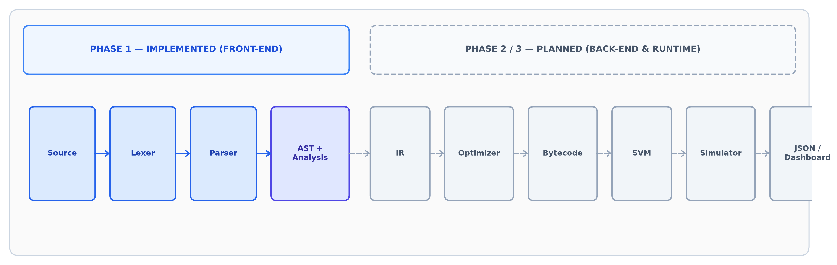
Figure 9.1 – Complete Planned SEQUENT Compiler Pipeline (Phase 1 Implemented vs Later Phases).
9.3 Phase 1 Workflow
The Phase 1 compilation workflow executes through seven sequential processing stages:
1. Write a SEQUENT source program defining system states, events, handlers, and constraints.
2. Lex the source text into categorized tokens, eliminating comments and whitespace while tracking coordinates.
3. Parse tokens according to the EBNF grammar using recursive descent, synthesizing the AST.
4. Populate the symbol table from state and event declarations, checking for duplicate identifiers.
5. Perform static semantic analysis, verifying identifier resolution and state assignment type compatibility.
6. Perform static temporal validation, verifying event references and converting durations into milliseconds.
7. Report successful compilation status or emit categorized diagnostic error messages with source coordinates.
9.4 Validation Strategy
Validation is conducted at three levels: (1) Unit Testing – verifying isolated behavior of tokens, lexer scanning, parser productions, symbol registration, semantic checks, and temporal conversions; (2) Integration Testing – verifying full end-to-end compilation through main.py; and (3) Negative Test Suite – confirming that invalid syntax, undeclared symbols, type mismatches, and undefined temporal events trigger precise, expected error diagnostics.

Chapter 10 – System Design
10.1 High-Level Architecture
The Phase 1 High-Level Architecture represents the implemented front-end compiler pipeline. It demonstrates feed-forward data processing from raw source characters to a fully validated system model, backed by an error diagnostics reporter.
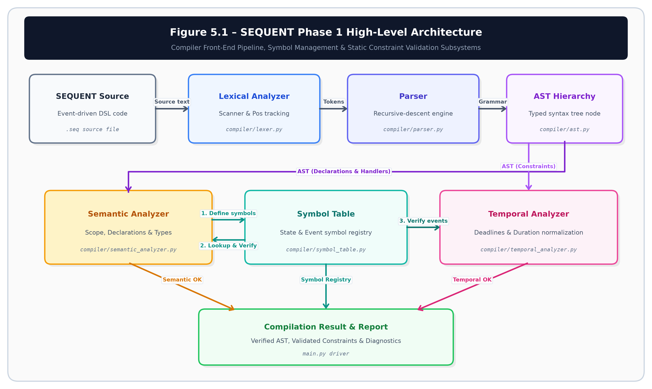
Figure 10.1 – SEQUENT Phase 1 High-Level Architecture (HLD).
10.2 Module Architecture
Figure 10.2 illustrates the multi-phase project roadmap, clearly delineating Phase 1 implemented components from Phase 2 and Phase 3 planned components.
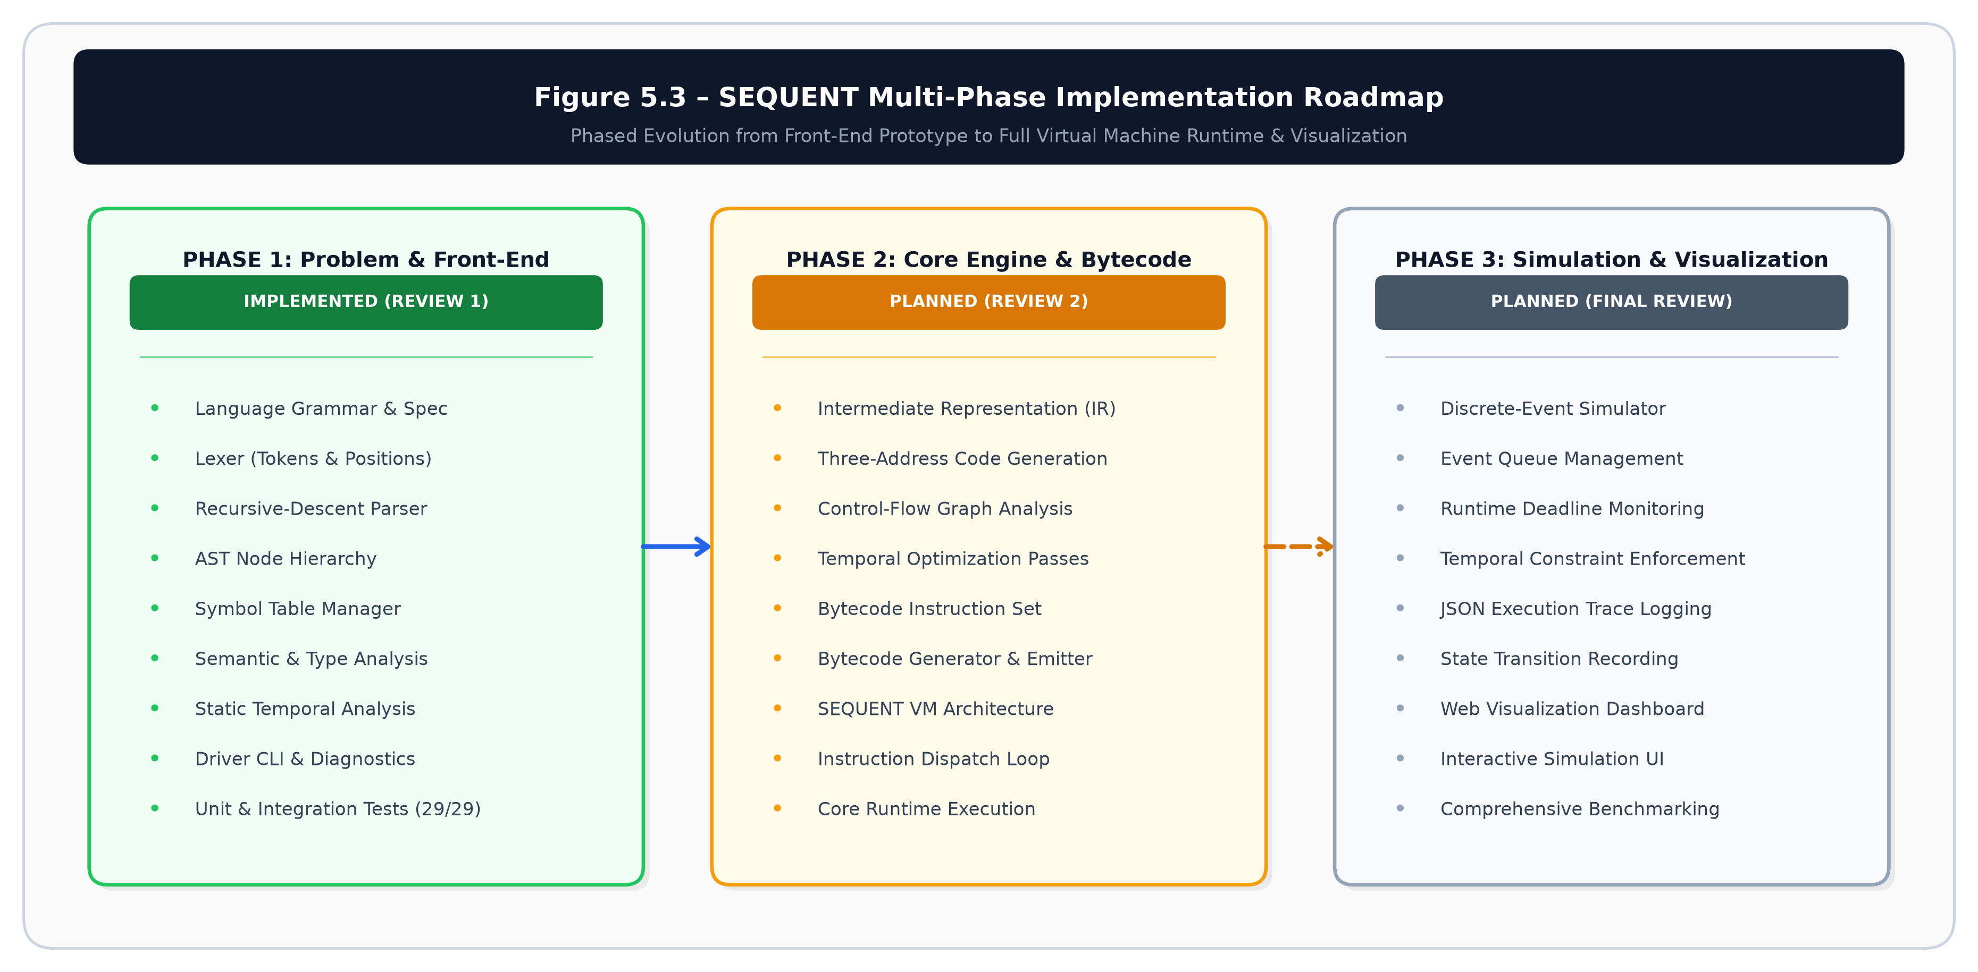
Figure 10.2 – SEQUENT Multi-Phase Module Architecture and Technical Roadmap.
10.3 Module Descriptions
Table 10.1 provides the detailed responsibilities of each module in the Phase 1 codebase:
Module | File Location | Responsibility | Status
Driver | main.py | CLI entry point, pipeline orchestrator, and flag handler. | Implemented
Tokens | compiler/tokens.py | TokenType enumeration and Token data structures. | Implemented
Lexer | compiler/lexer.py | Converts source text into tokens with line/column coordinates. | Implemented
AST | compiler/ast.py | Strongly typed AST node classes and formatting methods. | Implemented
Parser | compiler/parser.py | Recursive-descent syntax analyzer generating AST. | Implemented
Symbol Table | compiler/symbol_table.py | Tracks state variables, initial values, and declared events. | Implemented
Semantic | compiler/semantic_analyzer.py | Validates symbol declarations, identifier references, and type compatibility. | Implemented
Temporal | compiler/temporal_analyzer.py | Validates event existence and normalizes durations to ms. | Implemented
Unit Tests | tests/test_phase1.py | Modular unit test classes (Lexer, Parser/AST, SymbolTable, SemanticAnalyzer, TemporalAnalyzer: 24 test cases). | Implemented
Integration Tests | tests/test_phase1.py | End-to-end pipeline execution tests via TestEndToEndExamples (5 test cases). | Implemented
Examples | examples/*.seq | Demonstration programs (valid and categorized error cases). | Implemented
Table 10.1 – Phase 1 module descriptions and status.
10.4 Data Flow
The data flow through the compiler is strictly unidirectional: SEQUENT Source (.seq) → Token Stream → AST Hierarchy → Populated Symbol Table → Semantically Validated AST → Normalized Temporal Constraints → Final Status / Diagnostic Report.
10.5 Processing Workflow
Each front-end module transforms its input data structure into a higher-level abstraction. If any stage encounters an invariant violation, processing halts and control transfers immediately to the diagnostic reporter, preventing cascading syntax or type errors.

10.6 AST Design
Figure 10.3 illustrates the hierarchical structure of the generated Abstract Syntax Tree for the EmergencyResponse system, demonstrating the encapsulation of declarations, handlers, and temporal constraints.
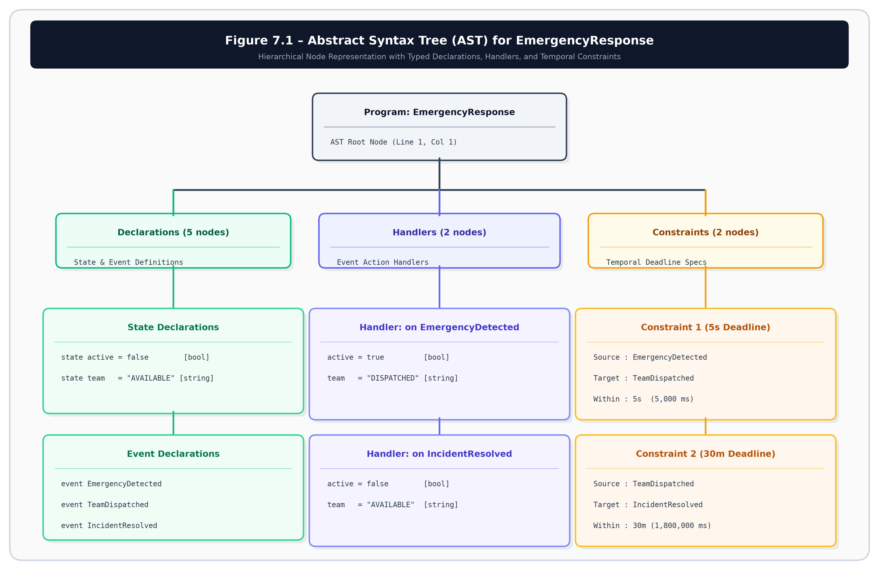
Figure 10.3 – Abstract Syntax Tree Structure for EmergencyResponse.
10.7 Symbol Table Design
The symbol table (compiler/symbol_table.py) maintains declarations for SEQUENT state variables and events, detects duplicate declarations, and provides identifier lookup during semantic and temporal analysis. It utilizes internal dictionaries ('states' and 'events') to store StateSymbol descriptors (name, inferred type, initial value, source coordinates) and EventSymbol descriptors (name, source coordinates). Lookup operations execute in O(1) time complexity, and collision checks prevent duplicate identifier definitions across the system.

10.8 Semantic Analysis Design
Semantic validation traverses the AST to verify that every state referenced in assignment statements exists in the symbol table and that the assigned literal matches the declared state type. In addition, it verifies that every event referenced in an 'on' handler is declared.
10.9 Temporal Analysis Design
The temporal analyzer verifies that both the source event and target event in a constraint exist in the symbol table, ensures that duration values are positive, and normalizes duration units into canonical integer milliseconds. Figure 10.4 depicts constraint semantics.
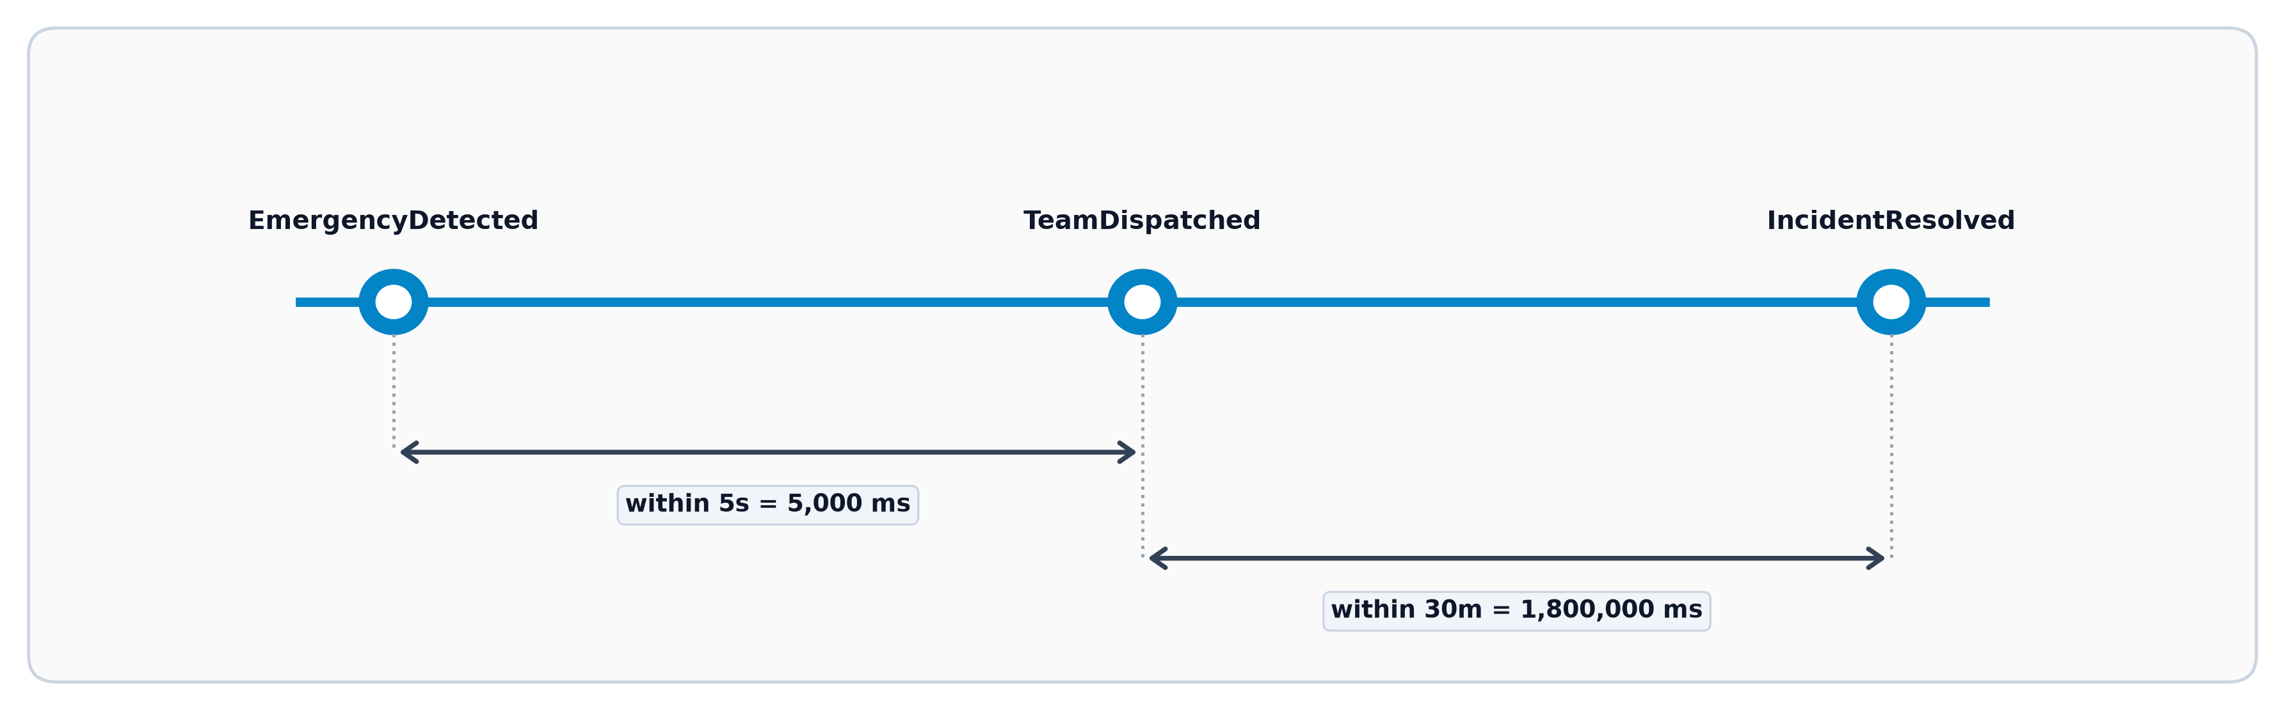
Figure 10.4 – Temporal Constraint Interpretation and Duration Normalization.

Chapter 11 – Technology Stack
11.1 Programming Language
Python 3.10+ was selected as the implementation language for its clean syntax, strong typing via dataclasses and enums, robust standard library, and rapid prototyping capabilities. The entire compiler front-end requires zero third-party packages [4].
11.2 Development Environment
• Platform: Windows 10/11 64-bit environment.
• CLI Shell: PowerShell and Command Prompt for running main.py and unit tests.
• Version Control: Git tracking phased implementation milestones.
11.3 Libraries
The project deliberately avoids external parser generators (such as Lex, Yacc, ANTLR, or PLY). The implementation relies exclusively on built-in Python standard library modules:
• dataclasses – For defining immutable, strongly typed AST nodes and Token structures.
• enum – For formal TokenType definitions.
• argparse – For parsing CLI flags (--tokens, --ast, --symbols, --temporal).
• pathlib – For cross-platform filesystem path operations.
• unittest – For automated unit and integration testing.
11.4 Testing Framework
The automated test suite uses Python's built-in unittest framework. Test discovery and execution are performed via 'python -m unittest discover', providing automated test verification without requiring third-party testing dependencies.
11.5 Project Structure
The repository layout inside D:\SEQUENT is organized cleanly into modular packages:
D:\SEQUENT
├── compiler
│ ├── __init__.py # Package marker
│ ├── tokens.py # TokenType enum and Token dataclass
│ ├── lexer.py # Character scanner and tokenizer
│ ├── ast.py # AST node classes and tree formatter
│ ├── parser.py # Recursive-descent syntax analyzer
│ ├── symbol_table.py # State and event symbol registry
│ ├── semantic_analyzer.py # Static semantic and type validator
│ └── temporal_analyzer.py # Temporal constraint analyzer
├── examples
│ ├── valid.seq # Emergency Response demonstration
│ ├── syntax_error.seq # Missing brace error test
│ ├── semantic_error.seq # Undeclared state error test
│ ├── type_error.seq # Type mismatch error test
│ └── temporal_error.seq # Undeclared event constraint test
├── tests
│ ├── __init__.py # Test package marker
│ └── test_phase1.py # 29 automated test cases across 6 test classes
├── docs
│ ├── figures # Architecture diagrams
│ └── SEQUENT_PHASE_1_DOCUMENTATION_FINAL.docx
├── presentation
├── screenshots
├── main.py # Compiler CLI driver
├── README.md # Project documentation
└── requirements.txt # Minimal dependency metadata
Chapter 12 – Initial Prototype
12.1 Prototype Objective
The objective of the Phase 1 initial prototype is to demonstrate a fully functional, verified compiler front-end pipeline capable of ingesting SEQUENT source code, performing lexical, syntactic, semantic, and temporal validation, and emitting structured inspection representations and location-aware diagnostics.
12.2 Implemented Components
The prototype includes: (1) Lexer scanning tokens with coordinate tracking; (2) Recursive-descent parser; (3) AST generator; (4) Symbol table manager; (5) Semantic analyzer; (6) Type checker; (7) Temporal constraint analyzer; (8) CLI compiler driver; and (9) Automated unit and integration test suite.
12.3 CLI Interface
The driver main.py supports the following operational commands:
python main.py examples/valid.seq # Standard compilation
python main.py examples/valid.seq --tokens # Token stream inspection
python main.py examples/valid.seq --ast # AST hierarchy inspection
python main.py examples/valid.seq --symbols # Symbol table inspection
python main.py examples/valid.seq --temporal # Temporal constraints inspection
12.4 Valid Program
The standard demonstration program (examples/valid.seq) models the Emergency Response coordination scenario with 2 typed state variables (active, team), 3 discrete observable events (EmergencyDetected, TeamDispatched, IncidentResolved), 2 reactive event handlers, and 2 inter-event temporal constraints.
12.5 Token Stream
Executing 'python main.py examples/valid.seq --tokens' generates the complete 53-token categorized stream with precise source coordinates. Representative segment:
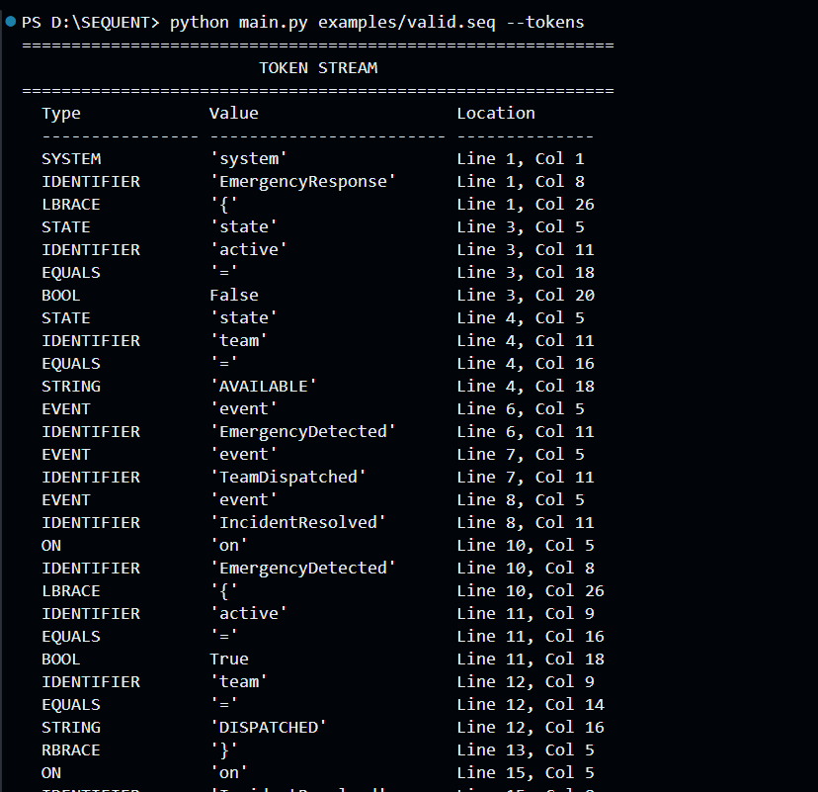 Description: Terminal execution of 'python main.py examples/valid.seq --tokens' displaying token stream.
12.6 AST Output
Executing 'python main.py examples/valid.seq --ast' outputs the exact formatted hierarchy produced by the compiler:
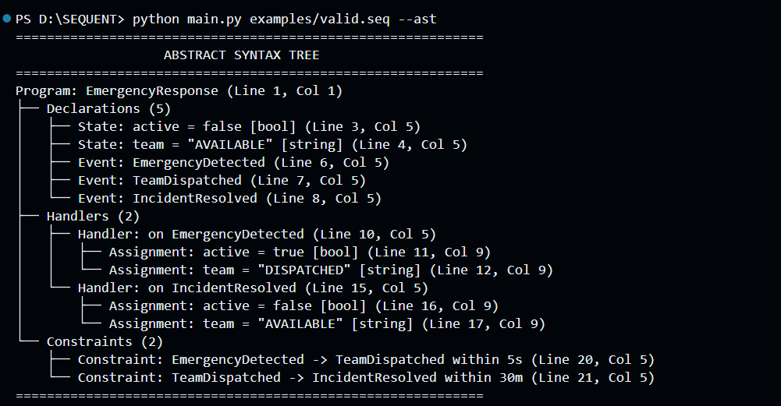 Description: Terminal execution of 'python main.py examples/valid.seq --ast' displaying AST hierarchy.
12.7 Symbol Table Output
Executing 'python main.py examples/valid.seq --symbols' inspects the registered state and event symbols:
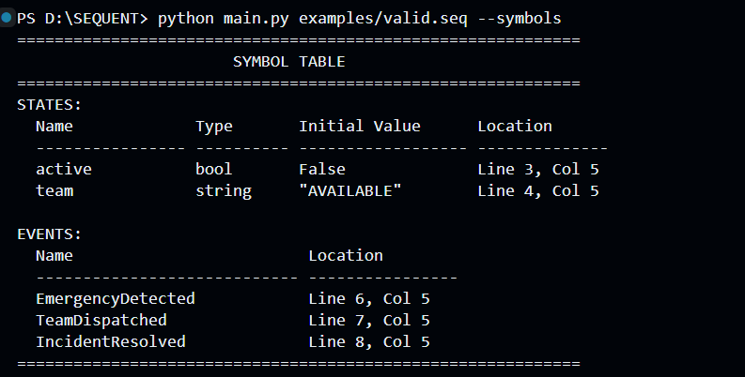
Description: Terminal execution of 'python main.py examples/valid.seq --symbols' displaying symbol table.

12.8 Temporal Analysis Output
Executing 'python main.py examples/valid.seq --temporal' displays the registered and normalized temporal constraints:
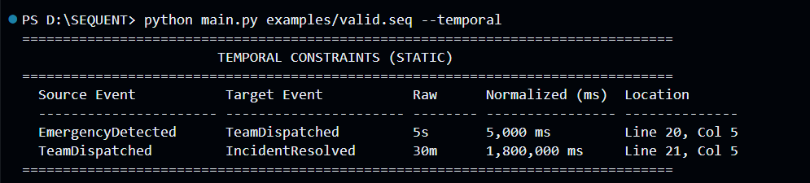 Description: Terminal execution of 'python main.py examples/valid.seq --temporal' displaying normalized constraints.
12.9 Error Detection
The prototype detects syntax errors, undeclared states, type mismatches, and undefined temporal constraint events, emitting formatted error messages with line and column pointers.
12.10 Test Suite
The Phase 1 automated test suite is implemented in tests/test_phase1.py, comprising 29 automated test cases organized into 6 modular test classes: TestLexer (9 tests), TestParserAndAST (4 tests), TestSymbolTable (2 tests), TestSemanticAnalyzer (5 tests), TestTemporalAnalyzer (4 tests), and TestEndToEndExamples (5 tests). All test cases are executed automatically via 'python -m unittest discover'.

Chapter 13 – Prototype Results
13.1 Valid Program Result
Executing 'python main.py examples/valid.seq' verifies all front-end compilation stages sequentially:
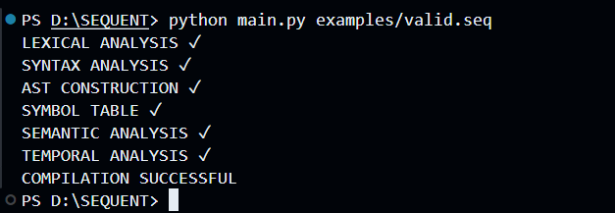
Description: Terminal execution of 'python main.py examples/valid.seq' showing all stages successful.
13.2 Syntax Error Result
Executing 'python main.py examples/syntax_error.seq' detects a missing closing brace:
Description: Terminal execution of syntax error test showing syntax diagnostic.
13.3 Semantic Error Result
Executing 'python main.py examples/semantic_error.seq' detects an assignment to an undeclared state:
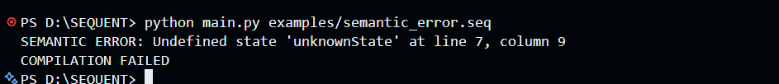
Description: Terminal execution of semantic error test showing undefined state diagnostic.

13.4 Type Error Result
Executing 'python main.py examples/type_error.seq' detects assigning a string literal to a boolean state:
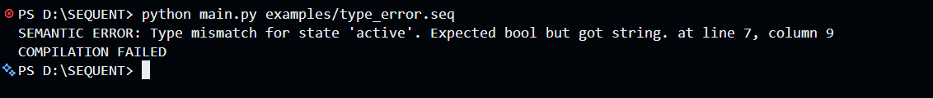
Description: Terminal execution of type error test showing type mismatch diagnostic.
13.5 Temporal Error Result
Executing 'python main.py examples/temporal_error.seq' detects an undeclared event in a temporal constraint:
Description: Terminal execution of temporal error test showing undefined event diagnostic.
13.6 Automated Testing Result
Table 13.1 summarizes the test execution results across the entire test suite:
Metric | Verification Result
Total Test Cases Executed | 29
Passing Tests | 29
Failed Tests | 0
Execution Errors | 0
Test Pass Rate | 100.0%
Execution Duration | < 0.05 seconds (0.007s measured)
Test Suite Location | tests/test_phase1.py (6 modular test classes)
Test Runner Framework | Python unittest (Standard Library)
Table 13.1 – Automated test execution results.
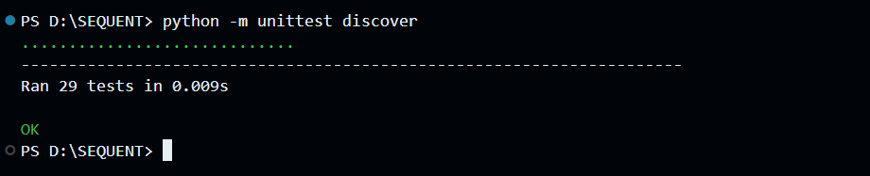
Description: Terminal execution of 'python -m unittest discover' showing 29 tests passed OK.

13.7 Phase 1 Achievement Summary
The Phase 1 prototype satisfies the defined Phase 1 implementation objectives and provides a validated foundation for subsequent development. The front-end operates deterministically, parses the language correctly, builds typed ASTs, maintains symbol integrity, enforces type rules, normalizes temporal constraints, and produces accurate diagnostics across all error categories.

Chapter 14 – Current Limitations and Future Development
14.1 Phase 1 Limitations
In accordance with disciplined milestone boundaries, the Phase 1 prototype is intentionally bounded as follows:
• Grammar Scope: Supports core system, state, event, handler, and constraint constructs. Complex expressions (arithmetic operations, nested conditionals) are reserved for future phases.
• Static Temporal Analysis Only: Validates symbol existence, positive durations, and unit normalization at compile time. Runtime deadline monitoring during active execution is scheduled for Phase 3.
• No Bytecode Generation: Intermediate Representation and bytecode synthesis are scheduled for Phase 2.
• No Simulation Runtime: The discrete-event queue, JSON telemetry logging, and web dashboard are scheduled for Phase 3.
14.2 Phase 2 Planned Components
Phase 2 will focus on core compiler backend and execution components:
• Intermediate Representation (IR): Lowering AST into a linear, three-address code representation.
• IR Optimization: Implementing dead handler elimination, constant propagation, and constraint simplification.
• Bytecode Generator: Compiling IR into a compact, binary bytecode format (.seqc).
• SEQUENT Virtual Machine (VM): Constructing a high-performance stack-based virtual machine.
14.3 Phase 3 Planned Components
Phase 3 will complete the runtime simulation and user-interface suite:
• Discrete-Event Simulation Queue: Simulating external event arrival sequences with timestamp progression.
• Dynamic Temporal Monitoring: Tracking elapsed time between events and detecting runtime deadline violations.
• JSON Execution Tracing: Exporting detailed telemetry logs of state mutations and timing metrics.
• Interactive Web Dashboard: Providing real-time visual inspection of state machines and event timelines.
Table 14.1 delineates the multi-phase implementation boundaries:
Phase | Scope & Deliverables | Status
Phase 1 | Problem Definition, Grammar, Lexer, Parser, AST, Symbol Table, Semantic & Type Analyzer, Temporal Static Analyzer, CLI Driver, 29 Automated Tests. | IMPLEMENTED  (Verified)
Phase 2 | Intermediate Representation (IR), Optimizer, Bytecode Generator, Bytecode ISA, SEQUENT Virtual Machine (VM), State Transition Runtime. | PLANNED  (Future Scope)
Phase 3 | Runtime Simulation Queue, Dynamic Deadline Monitoring, JSON Telemetry Logging, Interactive Web Dashboard, End-to-End Stress Testing. | PLANNED  (Future Scope)
Table 14.1 – Multi-phase implementation roadmap and component status.

Chapter 15 – Conclusion
SEQUENT Phase 1 successfully establishes a functional, robust compiler front-end prototype for a temporal event-driven domain-specific language. Developed in strict accordance with the Compiler Design Laboratory instruction manual [1], the prototype demonstrates complete lexical scanning, recursive-descent syntax parsing, Abstract Syntax Tree synthesis, symbol-table management, static semantic and type validation, and specialized temporal constraint analysis with duration normalization without external parser generators.
The project directly addresses the challenge of modeling asynchronous temporal systems by elevating timing constraints to first-class language constructs. Evaluated against an Emergency Response coordination domain, the compiler compiles valid specifications flawlessly and emits accurate diagnostic messages across syntax, semantic, type, and temporal error categories. With a 100% automated test pass rate across 29 test cases, the front-end provides a validated architectural foundation ready for Phase 2 Intermediate Representation and Bytecode synthesis, and Phase 3 runtime simulation.
References
[1] Compiler Design Laboratory Project Instruction Manual, Fall Semester 2026–27, Department of Computer Science and Engineering.
[2] A. V. Aho, M. S. Lam, R. Sethi, and J. D. Ullman, Compilers: Principles, Techniques, and Tools, 2nd ed., Boston, MA: Pearson / Addison-Wesley, 2006.
[3] C. N. Fischer, R. K. Cytron, and R. J. LeBlanc, Crafting a Compiler, Boston, MA: Pearson / Addison-Wesley, 2009.
[4] Python Software Foundation, Python 3.10+ Language Reference and Standard Library Documentation, Available: https://docs.python.org/3/.

Appendix A – SEQUENT Grammar
Program ::= 'system' Identifier '{' SystemBody '}'
SystemBody ::= { Declaration | Handler | Constraint }
Declaration ::= StateDeclaration | EventDeclaration
StateDeclaration ::= 'state' Identifier '=' Literal
EventDeclaration ::= 'event' Identifier
Handler ::= 'on' Identifier '{' { Assignment } '}'
Assignment ::= Identifier '=' Literal
Constraint ::= 'constraint' Identifier '->' Identifier 'within' Duration
Duration ::= Integer TimeUnit
TimeUnit ::= 'ms' | 's' | 'm' | 'h'
Literal ::= Integer | Float | String | Boolean
Identifier ::= [a-zA-Z_][a-zA-Z0-9_]*
Comment ::= '//' [^\n]*
Appendix B – Prototype Commands
# Navigate to project root
cd D:\SEQUENT
# Standard compilation
python main.py examples/valid.seq
# Inspection switches
python main.py examples/valid.seq --tokens
python main.py examples/valid.seq --ast
python main.py examples/valid.seq --symbols
python main.py examples/valid.seq --temporal
# Error test executions
python main.py examples/syntax_error.seq
python main.py examples/semantic_error.seq
python main.py examples/type_error.seq
python main.py examples/temporal_error.seq
# Automated unit and integration test suite
python -m unittest discover -s tests
Appendix C – Phase 1 Test Case Summary
Table C.1 provides the complete inventory of 29 automated test cases implemented in tests/test_phase1.py across 6 modular test classes:
Test Suite / Class | Test Method | Scope & Verification Objective | Result
TestLexer | test_keywords | Verifies tokenization of language keywords (system, state, event, on, constraint, within) | PASSED
TestLexer | test_identifiers | Verifies recognition of valid user-defined identifiers including underscores | PASSED
TestLexer | test_literals | Verifies scanning of integer, float, string, and boolean (true/false) literals | PASSED
TestLexer | test_operators_and_symbols | Verifies scanning of assignment '=', arrow '->', and delimiters '{', '}' | PASSED
TestLexer | test_duration_tokens | Verifies scanning of duration values with units (ms, s, m, h) | PASSED
TestLexer | test_comments_and_whitespace | Verifies clean skipping of whitespace and single-line '//' comments | PASSED
TestLexer | test_line_and_column_tracking | Verifies exact tracking of source line and column coordinates | PASSED
TestLexer | test_lexer_error_invalid_char | Verifies LexerError raised when encountering invalid character | PASSED
TestLexer | test_lexer_error_unterminated_string | Verifies LexerError raised for unterminated string literals | PASSED
TestParserAndAST | test_valid_parsing | Verifies recursive-descent parsing into valid ProgramNode AST | PASSED
TestParserAndAST | test_ast_pretty_print | Verifies textual tree hierarchy formatting via format_ast() | PASSED
TestParserAndAST | test_syntax_error_missing_closing_brace | Verifies ParseError raised on unclosed block delimiters | PASSED
TestParserAndAST | test_syntax_error_missing_system_keyword | Verifies ParseError raised when system keyword is omitted | PASSED
TestSymbolTable | test_symbol_table_operations | Verifies state/event definition, type inference, and lookup | PASSED
TestSymbolTable | test_symbol_table_display | Verifies formatted tabular string generated by format_display() | PASSED
TestSemanticAnalyzer | test_duplicate_state_declaration | Verifies SemanticError on duplicate state variable declaration | PASSED
TestSemanticAnalyzer | test_duplicate_event_declaration | Verifies SemanticError on duplicate event declaration | PASSED
TestSemanticAnalyzer | test_undefined_state_assignment | Verifies SemanticError when assigning to undeclared state variable | PASSED
TestSemanticAnalyzer | test_undefined_event_in_handler | Verifies SemanticError when handler references undeclared event | PASSED
TestSemanticAnalyzer | test_type_mismatch_error | Verifies SemanticError when assigned type mismatches state declaration | PASSED
TestTemporalAnalyzer | test_valid_temporal_normalization | Verifies static constraint validation and conversion of time units to ms | PASSED
TestTemporalAnalyzer | test_undefined_source_event | Verifies TemporalError when constraint references undeclared source event | PASSED
TestTemporalAnalyzer | test_undefined_target_event | Verifies TemporalError when constraint references undeclared target event | PASSED
TestTemporalAnalyzer | test_non_positive_duration | Verifies TemporalError when constraint duration is non-positive (<= 0) | PASSED
TestEndToEndExamples | test_compile_valid_example | Verifies end-to-end compilation success on examples/valid.seq | PASSED
TestEndToEndExamples | test_compile_syntax_error_example | Verifies end-to-end syntax diagnostic on examples/syntax_error.seq | PASSED
TestEndToEndExamples | test_compile_semantic_error_example | Verifies end-to-end semantic diagnostic on examples/semantic_error.seq | PASSED
TestEndToEndExamples | test_compile_temporal_error_example | Verifies end-to-end temporal diagnostic on examples/temporal_error.seq | PASSED
TestEndToEndExamples | test_compile_type_error_example | Verifies end-to-end type diagnostic on examples/type_error.seq | PASSED
Table C.1 – Complete automated test suite inventory in tests/test_phase1.py (29/29 passing).

