Commodity chosen: Iced Tea
Abu Tanbir Mondal (P2512004)
Arpan Bose (P2512014)
Manya Dua (P2512040)
Om Prakash Meher (P2512044)
Samarth Garg (P2512057)
Microeconomics Project
Chill Sip by Group B-07, PGDM 2025-27 Section B

Contents
Context | Page
1. Business Project Overview | 2
2. Demand analysis of Micro-Business | 3
3. Market Demand Data Collection | 4
4. Effect of different price points on demand | 6
5. Relationship between Price and Quantity Demanded | 7
6. Price elasticity of demand | 9
7. Revenue Analysis | 10
8. TR regression Equation and Effect of Brand Ambassador on PED | 13
9. Sales Data trends | 14
10. Sales data summary | 18
11. Cost Curves | 19
12. Derivation of the Total Cost function depending on Q, Q2 & Q3 | 27
13. Break-even Analysis | 34
14. Insights from break even analysis | 35
15. Competition Analysis | 36
16. Cross elasticity against competitor | 37
17. Executive Summary | 38
1. Business Project Overview
The project report presents a detailed demand analysis of a microbusiness ran by students. The business involves setting up an Iced Tea stall offering three premium flavours- Peach, Cranberry and Blueberry. These flavours were chosen based on refreshing taste, popularity among students and the ability to attract repeat buye₹ Another reason as to why iced tea was specifically chosen was to “Beat the Heat”, thanks to its fluid content and richness in Vitamin C, while keeping a low sugar content.

The Business is temporary. It is an experimental setup aimed at studying and analysing market behaviour, pricing strategies and the influence of promotion.

2. Demand analysis of Micro-Business
Pricing Strategy
After conducting a survey on what should be the price of Iced Tea, we concluded that customers are ready to pay anything between ₹ 30 – 40 given that the taste remains the same.
Total cost of one cup of our Iced Tea for any of the flavours was ₹ 34 which included, cost of the glass & straw, cost of ingredients and other miscellaneous expenses like cost of the utilities paid. So, we decided to sell one cup of Peach Iced Tea at ₹ 40 and of Cranberry & Blueberry Iced Tea at ₹ 50.
Flavour Preference
In the survey conducted we also noticed that customers love cranberry and blueberry flavour more in comparison to peach flavour, so we decided to keep a price difference between these two categories.
Timing & Location
The best time for sales for our product was during the evening/ snacks time after the classes are over. Everyone is in a chill & relaxed mood and feels like enjoying something refreshing. This is where our products meet the needs of consume₹
Choosing a location was not tough cause mess/canteen area is the most crowded during the evening snack hours₹
Marketing & Promotion
For marketing purposes, we circulated our stall flyer on all the WhatsApp groups, shared it on our Social Media Handles, this helped us in creating a buzz and more people getting to know about our business.
Operational Logistics
To start with the first day, we decided to purchase the inventory for 100 glasses of 250ml each, this was thought after keeping risk analysis in check. We thought about first to know how consumers are going to respond at the time of purchase.
We also purchased 4 bags of Iced tea mix (Two Blueberry, one Cranberry and one peach.
We also purchased 400 grams of dried berries to add to the flavour of our product to differentiate us from the competition.

3. Market Demand Data Collection
To analyse the consumer behaviour, a primary survey was conducted where 10 respondents were approached. The survey process consisted of preparing small samples for the respondents to taste the sample and the following question was asked:
"How many glasses of iced tea would you purchase at each of the following prices?"
The prices ranged from ₹10 to ₹70 in ₹5 intervals.
Price | Individual Demand |  |  |  |  |  |  |  |  |  | Market Demand
 | C1 | C2 | C3 | C4 | C5 | C6 | C7 | C8 | C9 | C10
70 | 0 | 1 | 0 | 0 | 0 | 0 | 1 | 0 | 0 | 1 | 3
65 | 0 | 0 | 0 | 0 | 0 | 0 | 1 | 0 | 0 | 0 | 2
60 | 1 | 1 | 0 | 0 | 1 | 0 | 1 | 0 | 0 | 1 | 5
55 | 1 | 1 | 0 | 1 | 1 | 0 | 0 | 1 | 1 | 1 | 7
50 | 1 | 1 | 1 | 1 | 1 | 1 | 1 | 1 | 1 | 1 | 10
45 | 1 | 1 | 1 | 1 | 1 | 1 | 1 | 1 | 1 | 2 | 11
40 | 1 | 2 | 1 | 1 | 1 | 1 | 2 | 1 | 1 | 2 | 13
35 | 1 | 2 | 2 | 1 | 2 | 1 | 2 | 1 | 1 | 2 | 15
30 | 2 | 2 | 2 | 2 | 2 | 1 | 2 | 2 | 1 | 2 | 18
25 | 2 | 2 | 2 | 2 | 2 | 2 | 2 | 2 | 1 | 2 | 19
20 | 2 | 3 | 2 | 3 | 2 | 2 | 3 | 2 | 2 | 3 | 24
15 | 3 | 3 | 3 | 3 | 3 | 2 | 3 | 3 | 3 | 0 | 26
10 | 3 | 3 | 3 | 4 | 3 | 3 | 4 | 3 | 3 | 0 | 29
Individual Demand Schedule:
The above table shows the different quantities of a good or service that a single consumer is willing to purchase at various prices, assuming all other factors remain constant, which in our case was Iced tea.

We can use the above data to make an aggregated market demand schedule:
Price (₹) | Quantity Demanded
70 | 3
65 | 2
60 | 5
55 | 7
50 | 10
45 | 11
40 | 13
35 | 15
30 | 18
25 | 19
20 | 24
15 | 26
10 | 29
The Visual Representation is as follows: 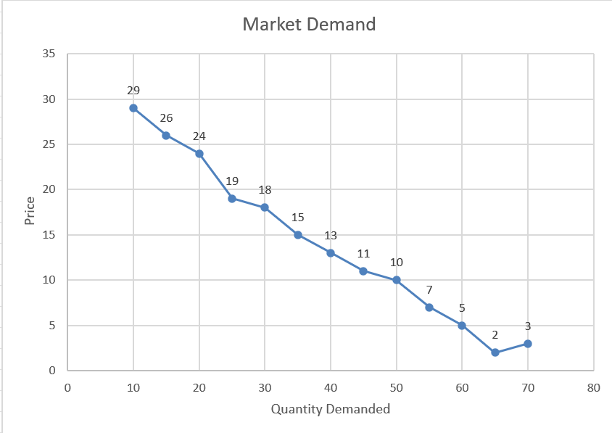
In the graph we can clearly see the demand curve and the relation between price and quantity demanded at different points on the curve.
4. Effect of different price points on demand
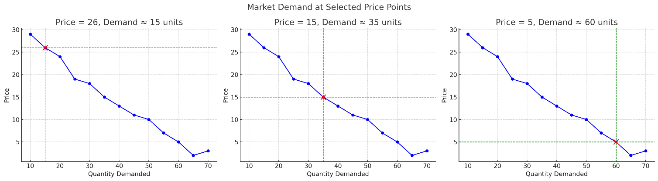
In the three graphs, three different points are being chosen. The movement of price points results in different demands.
1. High Price (₹26)
- At a relatively high price of ₹26, the demand falls to about 15 units.
- This shows the typical inverse relationship between price and demand: as price rises, consumers purchase fewer units.

2. Mid-range Price (₹15)
- At a moderate price of ₹15, demand rises to about 35 units.
- This reflects the sweet spot where more consumers can afford the product, resulting in higher sales.
3. Low Price (₹5)
- At a low price of ₹5, demand surges to around 60 units.
- This shows strong price sensitivity — reducing price significantly boosts quantity demanded.
- However, such a low price may also squeeze profit margins.

5. Relationship between Price and Quantity Demanded
To understand the relationship between price and quantity demanded, a linear regression analysis was performed using the market demand data obtained from the survey.
Using the following table:
Price (Xi) | Quantity (Yi) | (Xi – x̄) | (Yi – ӯ̄) | (Xi – x̄)*(Yi – ӯ̄) | (Xi – x̄)^2
70 | 3 | 30 | -11 | -330 | 900
65 | 2 | 25 | -12 | -300 | 625
60 | 5 | 20 | -9 | -180 | 400
55 | 7 | 15 | -7 | -105 | 225
50 | 10 | 10 | -4 | -40 | 100
45 | 11 | 5 | -3 | -15 | 25
40 | 13 | 0 | -1 | 0 | 0
35 | 15 | -5 | 1 | -5 | 25
30 | 18 | -10 | 4 | -40 | 100
25 | 19 | -15 | 5 | -75 | 225
20 | 24 | -20 | 10 | -200 | 400
15 | 26 | -25 | 12 | -300 | 625
10 | 29 | -30 | 15 | -450 | 900
And the regression formula:
Q = a + bP
Where:
- Q = Quantity demanded
- P = Price
- a = Intercept (When P=0)
- b = Slope (rate of change of demand with respect to price)

Calculation of Slope (b)
b = Σ[(Xi – x̄)(Yi – ӯ̄)] / Σ[(Xi – x̄)^2]
- Numerator (covariance): ≈ –239.17
- Denominator (variance of X): ≈ 530.0
- Therefore, b ≈ –0.45
Calculation of Intercept (a)
a = ӯ̄ – b·x̄
a = 13.56 – (–0.45 × 40)
a = 13.56 + 18 = 31.56 (rounded to 31.93)
Demand Equation:
Q = 31.93 - 0.45P
Interpretation: For every ₹1 increase in price, the expected demand (Q) falls by about 0.45 units. This shows a negative slope, which is expected: higher prices reduce demand. At P = 0 (hypothetically), demand would be ~32 units. At P = 70, demand drops close to 0.
Limitation: It assumes a straight-line relationship, which may not fit real consumer behaviour at extreme prices.

  - 6. Price elasticity of demand
PED was calculated using the midpoint formula to measure the responsiveness of quantity demanded to changes in price. The following values were observed:
- Between ₹65 to ₹60: PED = -10.71 (Highly elastic)
- Between ₹60 to ₹55: PED = -3.83 (Elastic)
- With Brand Ambassador and Social Media Marketing (₹60 to ₹55): PED = -3.29 (Moderately elastic)
The elasticity values indicate that demand is highly sensitive to price in this student-driven market.
Assuming the introduction of a well-known and relatable brand ambassador (e.g., a popular senior or social media influencer), the perceived value of the product increases. This typically reduces price sensitivity among consume₹
By estimating a 20% increase in demand at all price points due to promotional influence, the PED reduced from -3.83 to -3.29. This demonstrates that branding efforts can reduce elasticity, enabling slightly higher pricing without significant drop in sales.

  - 7. Revenue Analysis
  - Revenue is the income generated from selling iced tea. It is calculated as TR = P × Q, AR = TR ÷ Q, MR = ΔTR ÷ ΔQ. The revenue schedule is as follows.
Price (₹) | Quantity (Q) | Total Revenue TR (₹) | Average Revenue AR (₹) | Marginal Revenue MR (₹)
70 | 3 | 210 | 70
65 | 2 | 130 | 65 | 80
60 | 5 | 300 | 60 | 56.67
55 | 7 | 385 | 55 | 42.5
50 | 10 | 500 | 50 | 38.33
45 | 11 | 495 | 45 | -5
40 | 13 | 520 | 40 | 12.5
35 | 15 | 525 | 35 | 2.5
30 | 18 | 540 | 30 | 5
25 | 19 | 475 | 25 | -65
20 | 24 | 480 | 20 | 1
15 | 26 | 390 | 15 | -45
10 | 29 | 290 | 10 | -33.33
Interpretation: TR rises with Q initially, peaks around 18 cups, then declines as MR turns negative, illustrating diminishing revenue beyond saturation.
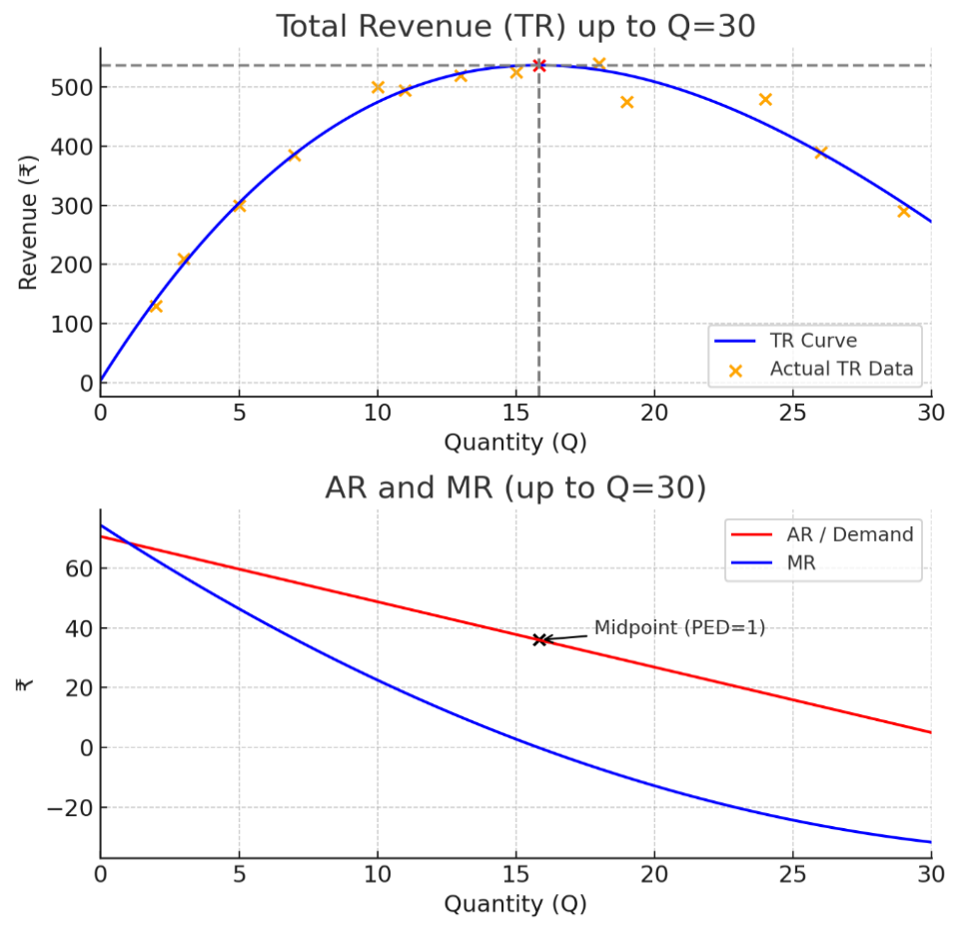
Interpretation of Graph
Top Graph: Total Revenue (TR)
This graph shows the total income a firm receives from selling different quantities of its product.
- Shape: The Total Revenue (TR) curve is an inverted 'U' or parabola. It starts at zero (selling nothing yields no revenue), increases as more units are sold, reaches a maximum point, and then begins to decrease.
- Revenue Maximization: The peak of the curve, at a quantity of approximately 16 units, represents the point of maximum total revenue (just over ₹500). Selling more or fewer units than this quantity would result in lower total revenue.
- Why it Falls: The TR curve eventually falls because to sell more units, the firm must lower its price. After the peak, the negative effect of the price reduction on all units sold outweighs the positive effect of selling one more unit.

Bottom Graph: Average and Marginal Revenue (AR & MR)
This graph shows the revenue on a per-unit basis.
- Average Revenue (AR / Demand): The red line is the Average Revenue curve (AR=TR/Q), which is also the firm's demand curve. Its downward slope shows the inverse relationship between price (AR) and the quantity the market is willing to buy. To sell more, the firm must lower its price.
- Marginal Revenue (MR): The blue line is the Marginal Revenue curve, which represents the additional revenue gained from selling one more unit. It lies below the AR curve and is twice as steep. This is because when the firm lowers the price to sell an extra unit, it must also accept that lower price for all the previous units it could have sold at a higher price.
The Relationship Between the Graphs
The two graphs are fundamentally linked and tell a cohesive story about the firm's revenue and its relationship with price elasticity of demand.
- When TR is Increasing (Q from 0 to 16): The MR is positive. Each additional unit sold adds to the total revenue. In this region, demand is elastic (PED > 1), meaning consumers are relatively responsive to price changes. A price decrease leads to a proportionally larger increase in quantity sold, thus increasing total revenue.
- When TR is at its Maximum (Q ≈ 16): The MR is zero. The last unit sold added nothing to the total revenue. This is the point of unit elasticity (PED = 1), as marked on the graph.
- When TR is Decreasing (Q > 16): The MR is negative. Each additional unit sold actually reduces total revenue. In this region, demand is inelastic (PED < 1). A price decrease leads to a proportionally smaller increase in quantity sold, causing total revenue to fall.
In summary, a profit-seeking firm will never choose to produce on the inelastic portion of its demand curve, as it could always increase revenue (and reduce costs) by producing less. The graphs clearly show that the revenue-maximizing output is achieved where marginal revenue is zero.

  - 8. TR regression Equation and Effect of Brand Ambassador on PED
Calculation of TR and Regression
Q | TR (Yi) | Q^2 | Q^3
3 | 210 | 9 | 27
2 | 130 | 4 | 8
5 | 300 | 25 | 125
7 | 385 | 49 | 343
10 | 500 | 100 | 1000
11 | 495 | 121 | 1331
13 | 520 | 169 | 2197
15 | 525 | 225 | 3375
18 | 540 | 324 | 5832
19 | 475 | 361 | 6859
24 | 480 | 576 | 13824
26 | 390 | 676 | 17576
29 | 290 | 841 | 24389

Estimated regression equation:
TR(Q) = 3.4284 + 74.4303·Q − 3.0075·Q² + 0.027512·Q³
Interpretation: The cubic fit captures increasing TR at first, then flattening, and eventual decline, consistent with survey data.
Elasticity and Brand Ambassador Impact
From Price | To Price | From Q | To Q | PED (midpoint)
60 | 55 | 5 | 7 | -3.83
65 | 60 | 2 | 5 | -10.71

Without brand ambassador, PED ≈ -3.83 (elastic). Branding and promotions shift the demand curve outward, reducing PED, and making the product less price sensitive.

  - 9. Sales Data trends
The following are the sales data trends for the four days that the microbusiness was conducted. From the four days, the prices set on the first day was taken as control/baseline, and the prices were changed (Both increased and decreased) to see the effect on demand. The market preference for the three flavours has also been recorded.
Sales Data for Day 1
Flavour | No. of cups | Sold for price | Amount
Peach | 13 | 40 | 520
Cranberry | 24 | 50 | 1200
Blueberry | 29 | 60 | 1740
Totals | 66 |  | 3460

Flavour Preference of the market

Explanation
The sales data from the first day indicates that there is a higher demand for blueberry iced tea despite it being the most expensive. This indicates that the utility gained by the customers from blueberry iced tea is high enough that their willingness to pay (WTP) is high. The prices set on this day are baseline.
Weighted average price per cup was ₹ 52.42, Total quantity sold was 66, and total revenue was ₹3460. Normal demand at baseline prices, demand is somewhat elastic.

Sales Data for Day 2
Flavour | No. of cups | Sold for price | Amount
Peach | 14 | 45 | 630
Cranberry | 15 | 55 | 825
Blueberry | 20 | 65 | 1300
Totals | 49 |  | 2755

Flavour Preference of the market

Explanation
The prices for all three flavours were increased by ₹5 on the second day to check the effects of price on demand. There was a decline in sales. However, there is a possibility that an external factor was responsible for the dip, as there was an outbreak of cough and cold among the target customer base (DM1) when the stall was set up on Day 2.
A 7% increase in average price caused a 25% drop in sales when compared to Day 1, hence, Law of Demand was at play as increase in price led to lower quantity sold*
Despite higher unit prices, total revenue fell, showing demand is elastic in this price range.
Weighted average price per cup was ₹56.22, Total quantity sold was 49, and total revenue was ₹2755. Blueberry still the most preferred.

*The dip could be caused due to the external factor of customer illness as mentioned above
Sales Data for Day 3
Flavour | No. of cups | Sold for price | Amount
Peach | 17 | 30 | 510
Cranberry | 29 | 40 | 1160
Blueberry | 31 | 50 | 1550
Totals | 77 |  | 3220

Flavour Preference of the market

Explanation
  - The prices of all three flavours were decreased by ₹10 on the third day. This lowering of prices boosted sales, highest of the four days. In terms of elasticity, we can say that customers are highly price sensitive as a 20% price cut (vs. Day 2) led to a 57% increase in sales. Revenue recovered is close to Day 1 levels, showing that lowering prices increases sales volume significantly.
Weighted average price per cup was ₹41.82, Total quantity sold was 77, and total revenue was ₹3220.
  - In terms of flavour preferences, the gap between Cranberry and Blueberry had decreased significantly, but blueberry is still the preferred flavour.

Sales Data for Day 4
Flavour | No. of cups | Sold for price | Amount
Peach | 15 | 50 | 750
Cranberry | 11 | 60 | 660
Blueberry | 8 | 70 | 560
Totals | 34 |  | 1970

Flavour preference of the market

Explanation
The prices of all three flavours were increased by ₹10 on the fourth day. This 10.5% heightening of prices tanked the sales by nearly 50% showing a strong example of elastic demand. This led to an over 40% drop in revenue, the lowest revenue of all days. This confirms that when demand is elastic, rising prices reduces total revenue. The implication of this is that the stall exceeded customer’s reservation price/willingness to pay (WTP), leading to a sharp fall in demand.
Another thing that was noticed was that despite Blueberry being the flavour which provided the most utility (As per previous days), when price was too high, customers paid for the Peach flavour even though it gave the lowest utility.
Weighted average price per cup was ₹57.94, Total quantity sold was 34, and total revenue was ₹1970.

10. Sales data summary
From the above summary we can get the following insights.
Law of Demand: The law of demand is clearly visible across the four days, where higher prices equal lower demand and lower prices equal higher demands.
Elastic Demand Curve: The demand for iced tea is elastic in the observed price range which means that customers are very sensitive to price.
Revenue Maximization: When it comes to revenue maximization, Mid to low prices as in the case of Day 3 maximizes sales volume, whereas very high prices as seen in day 4 harms both sales and revenue.
Strategy: Going forward, if the business is to be continued, a moderate price range of ₹40 to ₹50 balances revenue and demand, while premium pricing isn’t sustainable for this market.

  - 11. Cost Curves
For the business, Total Fixed Cost (TFC) is ₹1520 (₹1000 for licence fees, ₹500 for Mela License fees (One Time) and ₹80 for tables (₹20 per day). The Total Variable Cost (TVC) rises with output. The Total Cost (TC) can be defined as TFC+TVC, the Average Cost (AC)= TC/Q and the Marginal Cost (MC)= MC = ΔTC/ΔQ.
This results in our Marginal Cost (MC) to be ₹28.37.
Note. We had a constant Marginal Cost as all our materials for the four days was purchased on the same day together.
When spread out over 4 days, fixed cost per day is ₹250 plus ₹50 which gives us a daily fixed cost of ₹270, the only exception being the first day which was ₹770 where an additional fee of ₹500 was incurred as license fee for holding the stall in the CultCom Mela. The following is a consolidated schedule of the four days.
Q | TFC | TVC | TC | MC | AC
1 | 1580 | 28.37 | 1608.37 | 28.37 | 1608.37
2 | 1580 | 56.74 | 1636.74 | 28.37 | 818.37
3 | 1580 | 85.11 | 1665.11 | 28.37 | 555.04
4 | 1580 | 113.48 | 1693.48 | 28.37 | 423.37
5 | 1580 | 141.85 | 1721.85 | 28.37 | 344.37
6 | 1580 | 170.22 | 1750.22 | 28.37 | 291.7
7 | 1580 | 198.59 | 1778.59 | 28.37 | 254.08
8 | 1580 | 226.96 | 1806.96 | 28.37 | 225.87
9 | 1580 | 255.33 | 1835.33 | 28.37 | 203.93
10 | 1580 | 283.7 | 1863.7 | 28.37 | 186.37
11 | 1580 | 312.07 | 1892.07 | 28.37 | 172.01
12 | 1580 | 340.44 | 1920.44 | 28.37 | 160.04
13 | 1580 | 368.81 | 1948.81 | 28.37 | 149.91
14 | 1580 | 397.18 | 1977.18 | 28.37 | 141.23
15 | 1580 | 425.55 | 2005.55 | 28.37 | 133.7
16 | 1580 | 453.92 | 2033.92 | 28.37 | 127.12
17 | 1580 | 482.29 | 2062.29 | 28.37 | 121.31
18 | 1580 | 510.66 | 2090.66 | 28.37 | 116.15
19 | 1580 | 539.03 | 2119.03 | 28.37 | 111.53
20 | 1580 | 567.4 | 2147.4 | 28.37 | 107.37
21 | 1580 | 595.77 | 2175.77 | 28.37 | 103.61
22 | 1580 | 624.14 | 2204.14 | 28.37 | 100.19
23 | 1580 | 652.51 | 2232.51 | 28.37 | 97.07
24 | 1580 | 680.88 | 2260.88 | 28.37 | 94.2
25 | 1580 | 709.25 | 2289.25 | 28.37 | 91.57
26 | 1580 | 737.62 | 2317.62 | 28.37 | 89.14
27 | 1580 | 765.99 | 2345.99 | 28.37 | 86.89
28 | 1580 | 794.36 | 2374.36 | 28.37 | 84.8
29 | 1580 | 822.73 | 2402.73 | 28.37 | 82.85
30 | 1580 | 851.1 | 2431.1 | 28.37 | 81.04
31 | 1580 | 879.47 | 2459.47 | 28.37 | 79.34
32 | 1580 | 907.84 | 2487.84 | 28.37 | 77.75
33 | 1580 | 936.21 | 2516.21 | 28.37 | 76.25
34 | 1580 | 964.58 | 2544.58 | 28.37 | 74.84
35 | 1580 | 992.95 | 2572.95 | 28.37 | 73.51
36 | 1580 | 1021.32 | 2601.32 | 28.37 | 72.26
37 | 1580 | 1049.69 | 2629.69 | 28.37 | 71.07
38 | 1580 | 1078.06 | 2658.06 | 28.37 | 69.95
39 | 1580 | 1106.43 | 2686.43 | 28.37 | 68.88
40 | 1580 | 1134.8 | 2714.8 | 28.37 | 67.87
41 | 1580 | 1163.17 | 2743.17 | 28.37 | 66.91
42 | 1580 | 1191.54 | 2771.54 | 28.37 | 65.99
43 | 1580 | 1219.91 | 2799.91 | 28.37 | 65.11
44 | 1580 | 1248.28 | 2828.28 | 28.37 | 64.28
45 | 1580 | 1276.65 | 2856.65 | 28.37 | 63.48
46 | 1580 | 1305.02 | 2885.02 | 28.37 | 62.72
47 | 1580 | 1333.39 | 2913.39 | 28.37 | 61.99
48 | 1580 | 1361.76 | 2941.76 | 28.37 | 61.29
49 | 1580 | 1390.13 | 2970.13 | 28.37 | 60.61
50 | 1580 | 1418.5 | 2998.5 | 28.37 | 59.97
51 | 1580 | 1446.87 | 3026.87 | 28.37 | 59.35
52 | 1580 | 1475.24 | 3055.24 | 28.37 | 58.75
53 | 1580 | 1503.61 | 3083.61 | 28.37 | 58.18
54 | 1580 | 1531.98 | 3111.98 | 28.37 | 57.63
55 | 1580 | 1560.35 | 3140.35 | 28.37 | 57.1
56 | 1580 | 1588.72 | 3168.72 | 28.37 | 56.58
57 | 1580 | 1617.09 | 3197.09 | 28.37 | 56.09
58 | 1580 | 1645.46 | 3225.46 | 28.37 | 55.61
59 | 1580 | 1673.83 | 3253.83 | 28.37 | 55.15
60 | 1580 | 1702.2 | 3282.2 | 28.37 | 54.7
61 | 1580 | 1730.57 | 3310.57 | 28.37 | 54.27
62 | 1580 | 1758.94 | 3338.94 | 28.37 | 53.85
63 | 1580 | 1787.31 | 3367.31 | 28.37 | 53.45
64 | 1580 | 1815.68 | 3395.68 | 28.37 | 53.06
65 | 1580 | 1844.05 | 3424.05 | 28.37 | 52.68
66 | 1580 | 1872.42 | 3452.42 | 28.37 | 52.31
67 | 1580 | 1900.79 | 3480.79 | 28.37 | 51.95
68 | 1580 | 1929.16 | 3509.16 | 28.37 | 51.61
69 | 1580 | 1957.53 | 3537.53 | 28.37 | 51.27
70 | 1580 | 1985.9 | 3565.9 | 28.37 | 50.94
71 | 1580 | 2014.27 | 3594.27 | 28.37 | 50.62
72 | 1580 | 2042.64 | 3622.64 | 28.37 | 50.31
73 | 1580 | 2071.01 | 3651.01 | 28.37 | 50.01
74 | 1580 | 2099.38 | 3679.38 | 28.37 | 49.72
75 | 1580 | 2127.75 | 3707.75 | 28.37 | 49.44
76 | 1580 | 2156.12 | 3736.12 | 28.37 | 49.16
77 | 1580 | 2184.49 | 3764.49 | 28.37 | 48.89
78 | 1580 | 2212.86 | 3792.86 | 28.37 | 48.63
79 | 1580 | 2241.23 | 3821.23 | 28.37 | 48.37
80 | 1580 | 2269.6 | 3849.6 | 28.37 | 48.12
81 | 1580 | 2297.97 | 3877.97 | 28.37 | 47.88
82 | 1580 | 2326.34 | 3906.34 | 28.37 | 47.64
83 | 1580 | 2354.71 | 3934.71 | 28.37 | 47.41
84 | 1580 | 2383.08 | 3963.08 | 28.37 | 47.18
85 | 1580 | 2411.45 | 3991.45 | 28.37 | 46.96
86 | 1580 | 2439.82 | 4019.82 | 28.37 | 46.74
87 | 1580 | 2468.19 | 4048.19 | 28.37 | 46.53
88 | 1580 | 2496.56 | 4076.56 | 28.37 | 46.32
89 | 1580 | 2524.93 | 4104.93 | 28.37 | 46.12
90 | 1580 | 2553.3 | 4133.3 | 28.37 | 45.93
91 | 1580 | 2581.67 | 4161.67 | 28.37 | 45.73
92 | 1580 | 2610.04 | 4190.04 | 28.37 | 45.54
93 | 1580 | 2638.41 | 4218.41 | 28.37 | 45.36
94 | 1580 | 2666.78 | 4246.78 | 28.37 | 45.18
95 | 1580 | 2695.15 | 4275.15 | 28.37 | 45
96 | 1580 | 2723.52 | 4303.52 | 28.37 | 44.83
97 | 1580 | 2751.89 | 4331.89 | 28.37 | 44.66
98 | 1580 | 2780.26 | 4360.26 | 28.37 | 44.49
99 | 1580 | 2808.63 | 4388.63 | 28.37 | 44.33
100 | 1580 | 2837 | 4417 | 28.37 | 44.17
101 | 1580 | 2865.37 | 4445.37 | 28.37 | 44.01
102 | 1580 | 2893.74 | 4473.74 | 28.37 | 43.86
103 | 1580 | 2922.11 | 4502.11 | 28.37 | 43.71
104 | 1580 | 2950.48 | 4530.48 | 28.37 | 43.56
105 | 1580 | 2978.85 | 4558.85 | 28.37 | 43.42
106 | 1580 | 3007.22 | 4587.22 | 28.37 | 43.28
107 | 1580 | 3035.59 | 4615.59 | 28.37 | 43.14
108 | 1580 | 3063.96 | 4643.96 | 28.37 | 43
109 | 1580 | 3092.33 | 4672.33 | 28.37 | 42.87
110 | 1580 | 3120.7 | 4700.7 | 28.37 | 42.73
111 | 1580 | 3149.07 | 4729.07 | 28.37 | 42.6
112 | 1580 | 3177.44 | 4757.44 | 28.37 | 42.48
113 | 1580 | 3205.81 | 4785.81 | 28.37 | 42.35
114 | 1580 | 3234.18 | 4814.18 | 28.37 | 42.23
115 | 1580 | 3262.55 | 4842.55 | 28.37 | 42.11
116 | 1580 | 3290.92 | 4870.92 | 28.37 | 41.99
117 | 1580 | 3319.29 | 4899.29 | 28.37 | 41.87
118 | 1580 | 3347.66 | 4927.66 | 28.37 | 41.76
119 | 1580 | 3376.03 | 4956.03 | 28.37 | 41.65
120 | 1580 | 3404.4 | 4984.4 | 28.37 | 41.54
121 | 1580 | 3432.77 | 5012.77 | 28.37 | 41.43
122 | 1580 | 3461.14 | 5041.14 | 28.37 | 41.32
123 | 1580 | 3489.51 | 5069.51 | 28.37 | 41.22
124 | 1580 | 3517.88 | 5097.88 | 28.37 | 41.11
125 | 1580 | 3546.25 | 5126.25 | 28.37 | 41.01
126 | 1580 | 3574.62 | 5154.62 | 28.37 | 40.91
127 | 1580 | 3602.99 | 5182.99 | 28.37 | 40.81
128 | 1580 | 3631.36 | 5211.36 | 28.37 | 40.71
129 | 1580 | 3659.73 | 5239.73 | 28.37 | 40.62
130 | 1580 | 3688.1 | 5268.1 | 28.37 | 40.52
131 | 1580 | 3716.47 | 5296.47 | 28.37 | 40.43
132 | 1580 | 3744.84 | 5324.84 | 28.37 | 40.34
133 | 1580 | 3773.21 | 5353.21 | 28.37 | 40.25
134 | 1580 | 3801.58 | 5381.58 | 28.37 | 40.16
135 | 1580 | 3829.95 | 5409.95 | 28.37 | 40.07
136 | 1580 | 3858.32 | 5438.32 | 28.37 | 39.99
137 | 1580 | 3886.69 | 5466.69 | 28.37 | 39.9
138 | 1580 | 3915.06 | 5495.06 | 28.37 | 39.82
139 | 1580 | 3943.43 | 5523.43 | 28.37 | 39.74
140 | 1580 | 3971.8 | 5551.8 | 28.37 | 39.66
141 | 1580 | 4000.17 | 5580.17 | 28.37 | 39.58
142 | 1580 | 4028.54 | 5608.54 | 28.37 | 39.5
143 | 1580 | 4056.91 | 5636.91 | 28.37 | 39.42
144 | 1580 | 4085.28 | 5665.28 | 28.37 | 39.34
145 | 1580 | 4113.65 | 5693.65 | 28.37 | 39.27
146 | 1580 | 4142.02 | 5722.02 | 28.37 | 39.19
147 | 1580 | 4170.39 | 5750.39 | 28.37 | 39.12
148 | 1580 | 4198.76 | 5778.76 | 28.37 | 39.05
149 | 1580 | 4227.13 | 5807.13 | 28.37 | 38.97
150 | 1580 | 4255.5 | 5835.5 | 28.37 | 38.9
151 | 1580 | 4283.87 | 5863.87 | 28.37 | 38.83
152 | 1580 | 4312.24 | 5892.24 | 28.37 | 38.76
153 | 1580 | 4340.61 | 5920.61 | 28.37 | 38.7
154 | 1580 | 4368.98 | 5948.98 | 28.37 | 38.63
155 | 1580 | 4397.35 | 5977.35 | 28.37 | 38.56
156 | 1580 | 4425.72 | 6005.72 | 28.37 | 38.5
157 | 1580 | 4454.09 | 6034.09 | 28.37 | 38.43
158 | 1580 | 4482.46 | 6062.46 | 28.37 | 38.37
159 | 1580 | 4510.83 | 6090.83 | 28.37 | 38.31
160 | 1580 | 4539.2 | 6119.2 | 28.37 | 38.24
161 | 1580 | 4567.57 | 6147.57 | 28.37 | 38.18
162 | 1580 | 4595.94 | 6175.94 | 28.37 | 38.12
163 | 1580 | 4624.31 | 6204.31 | 28.37 | 38.06
164 | 1580 | 4652.68 | 6232.68 | 28.37 | 38
165 | 1580 | 4681.05 | 6261.05 | 28.37 | 37.95
166 | 1580 | 4709.42 | 6289.42 | 28.37 | 37.89
167 | 1580 | 4737.79 | 6317.79 | 28.37 | 37.83
168 | 1580 | 4766.16 | 6346.16 | 28.37 | 37.77
169 | 1580 | 4794.53 | 6374.53 | 28.37 | 37.72
170 | 1580 | 4822.9 | 6402.9 | 28.37 | 37.66
171 | 1580 | 4851.27 | 6431.27 | 28.37 | 37.61
172 | 1580 | 4879.64 | 6459.64 | 28.37 | 37.56
173 | 1580 | 4908.01 | 6488.01 | 28.37 | 37.5
174 | 1580 | 4936.38 | 6516.38 | 28.37 | 37.45
175 | 1580 | 4964.75 | 6544.75 | 28.37 | 37.4
176 | 1580 | 4993.12 | 6573.12 | 28.37 | 37.35
177 | 1580 | 5021.49 | 6601.49 | 28.37 | 37.3
178 | 1580 | 5049.86 | 6629.86 | 28.37 | 37.25
179 | 1580 | 5078.23 | 6658.23 | 28.37 | 37.2
180 | 1580 | 5106.6 | 6686.6 | 28.37 | 37.15
181 | 1580 | 5134.97 | 6714.97 | 28.37 | 37.1
182 | 1580 | 5163.34 | 6743.34 | 28.37 | 37.05
183 | 1580 | 5191.71 | 6771.71 | 28.37 | 37
184 | 1580 | 5220.08 | 6800.08 | 28.37 | 36.96
185 | 1580 | 5248.45 | 6828.45 | 28.37 | 36.91
186 | 1580 | 5276.82 | 6856.82 | 28.37 | 36.86
187 | 1580 | 5305.19 | 6885.19 | 28.37 | 36.82
188 | 1580 | 5333.56 | 6913.56 | 28.37 | 36.77
189 | 1580 | 5361.93 | 6941.93 | 28.37 | 36.73
190 | 1580 | 5390.3 | 6970.3 | 28.37 | 36.69
191 | 1580 | 5418.67 | 6998.67 | 28.37 | 36.64
192 | 1580 | 5447.04 | 7027.04 | 28.37 | 36.6
193 | 1580 | 5475.41 | 7055.41 | 28.37 | 36.56
194 | 1580 | 5503.78 | 7083.78 | 28.37 | 36.51
195 | 1580 | 5532.15 | 7112.15 | 28.37 | 36.47
196 | 1580 | 5560.52 | 7140.52 | 28.37 | 36.43
197 | 1580 | 5588.89 | 7168.89 | 28.37 | 36.39
198 | 1580 | 5617.26 | 7197.26 | 28.37 | 36.35
199 | 1580 | 5645.63 | 7225.63 | 28.37 | 36.31
200 | 1580 | 5674 | 7254 | 28.37 | 36.27
201 | 1580 | 5702.37 | 7282.37 | 28.37 | 36.23
202 | 1580 | 5730.74 | 7310.74 | 28.37 | 36.19
203 | 1580 | 5759.11 | 7339.11 | 28.37 | 36.15
204 | 1580 | 5787.48 | 7367.48 | 28.37 | 36.12
205 | 1580 | 5815.85 | 7395.85 | 28.37 | 36.08
206 | 1580 | 5844.22 | 7424.22 | 28.37 | 36.04
207 | 1580 | 5872.59 | 7452.59 | 28.37 | 36
208 | 1580 | 5900.96 | 7480.96 | 28.37 | 35.97
209 | 1580 | 5929.33 | 7509.33 | 28.37 | 35.93
210 | 1580 | 5957.7 | 7537.7 | 28.37 | 35.89
211 | 1580 | 5986.07 | 7566.07 | 28.37 | 35.86
212 | 1580 | 6014.44 | 7594.44 | 28.37 | 35.82
213 | 1580 | 6042.81 | 7622.81 | 28.37 | 35.79
214 | 1580 | 6071.18 | 7651.18 | 28.37 | 35.75
215 | 1580 | 6099.55 | 7679.55 | 28.37 | 35.72
216 | 1580 | 6127.92 | 7707.92 | 28.37 | 35.68
217 | 1580 | 6156.29 | 7736.29 | 28.37 | 35.65
218 | 1580 | 6184.66 | 7764.66 | 28.37 | 35.62
219 | 1580 | 6213.03 | 7793.03 | 28.37 | 35.58
220 | 1580 | 6241.4 | 7821.4 | 28.37 | 35.55
221 | 1580 | 6269.77 | 7849.77 | 28.37 | 35.52
222 | 1580 | 6298.14 | 7878.14 | 28.37 | 35.49
223 | 1580 | 6326.51 | 7906.51 | 28.37 | 35.46
224 | 1580 | 6354.88 | 7934.88 | 28.37 | 35.42
225 | 1580 | 6383.25 | 7963.25 | 28.37 | 35.39
226 | 1580 | 6411.62 | 7991.62 | 28.37 | 35.36

These are the relations can be extrapolated.
MC = 28.37 (constant)
AVC = 28.37 (constant)
AFC = 1580 / Q (decreasing)
ATC = AFC + AVC = (1580 / Q) + 28.37

The Following Curves can be extracted from the data
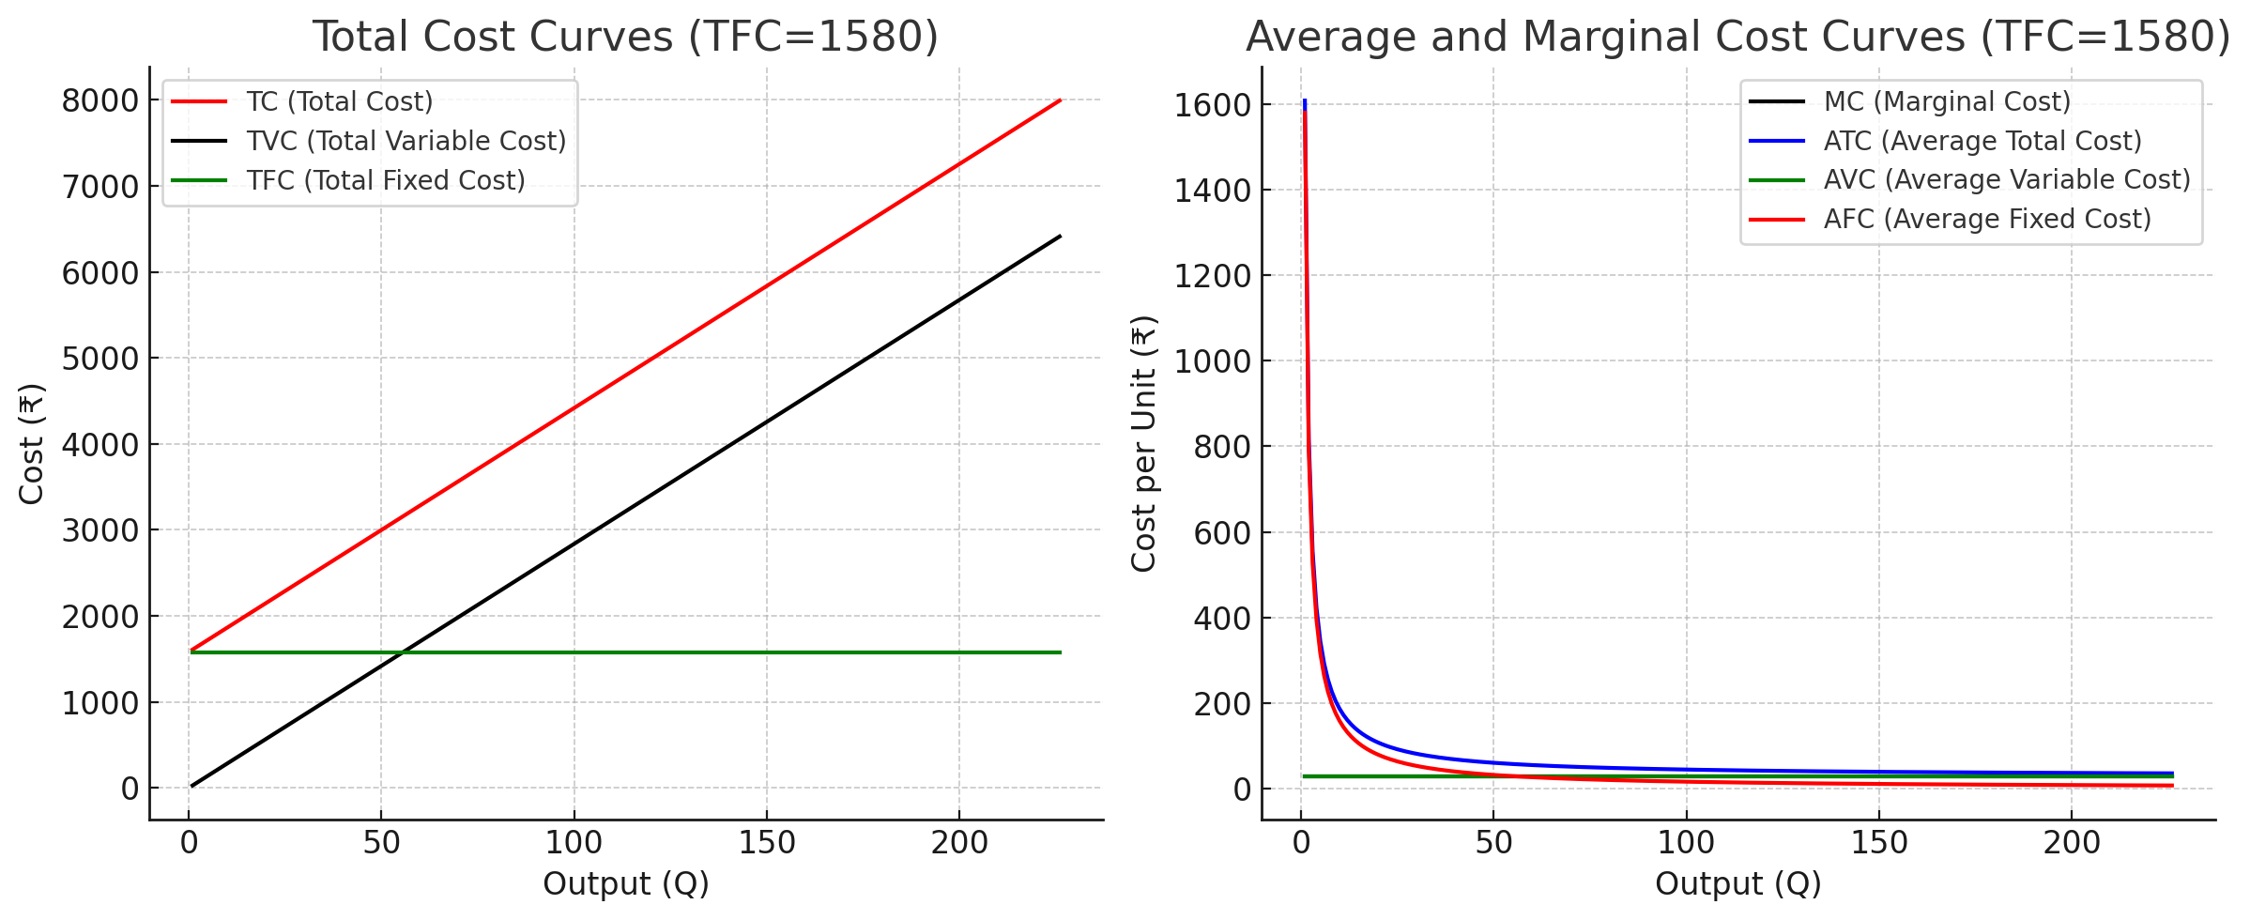

Interpretation of the Cost Curve
Total Cost Curves (Left Graph)
This graph shows the relationship between total production costs and the quantity of output (Q).
- Total Fixed Cost (TFC): The green horizontal line at ₹1580 shows that fixed costs do not change, regardless of how many units are produced. This represents costs like rent or salaries that must be paid even if output is zero.
- Total Variable Cost (TVC): The black line starting from the origin (0,0) and rising steadily shows that total variable costs increase directly and proportionally with output. This straight line indicates that each additional unit produced adds the exact same amount to the total variable cost.
- Total Cost (TC): The red line represents the sum of TFC and TVC (TC=TFC+TVC). It starts at the TFC level (₹1580) and runs perfectly parallel to the TVC curve. The constant vertical gap between the TC and TVC lines is equal to the Total Fixed Cost.

Average and Marginal Cost Curves (Right Graph)
This graph breaks down the costs on a per-unit basis, which is crucial for pricing and production decisions.
- Average Fixed Cost (AFC): The green curve starts high and continuously slopes downward, approaching zero. This classic "spreading effect" shows that as more units are produced, the fixed cost of ₹1580 is spread over a larger quantity, so the fixed cost per unit decreases.
- Average Variable Cost (AVC) and Marginal Cost (MC): The most telling feature of this graph is that the AVC (green) and MC (black) curves are the same horizontal line at ₹28.37.
  - A horizontal MC means that the cost of producing one more additional unit is always constant, in this case, ₹28.37.
  - When the marginal cost is constant, the AVC is also constant and equal to the marginal cost. This confirms what the TVC curve on the left graph suggested: every unit has the same variable cost.
- Average Total Cost (ATC): The blue curve represents the total cost per unit (ATC=AFC+AVC). It starts high and slopes downwards because it is the sum of the continuously falling AFC and the constant AVC. As output increases, the ATC curve gets closer and closer to the constant AVC/MC line because the AFC component becomes progressively smaller.

  - 12. Derivation of the Total Cost function depending on Q, Q2 & Q3

Q | TC | Q2 | Q3
0 | 1580 | 0 | 0
1 | 1608.37 | 1 | 1
2 | 1636.74 | 4 | 8
3 | 1665.11 | 9 | 27
4 | 1693.48 | 16 | 64
5 | 1721.85 | 25 | 125
6 | 1750.22 | 36 | 216
7 | 1778.59 | 49 | 343
8 | 1806.96 | 64 | 512
9 | 1835.33 | 81 | 729
10 | 1863.7 | 100 | 1000
11 | 1892.07 | 121 | 1331
12 | 1920.44 | 144 | 1728
13 | 1948.81 | 169 | 2197
14 | 1977.18 | 196 | 2744
15 | 2005.55 | 225 | 3375
16 | 2033.92 | 256 | 4096
17 | 2062.29 | 289 | 4913
18 | 2090.66 | 324 | 5832
19 | 2119.03 | 361 | 6859
20 | 2147.4 | 400 | 8000
21 | 2175.77 | 441 | 9261
22 | 2204.14 | 484 | 10648
23 | 2232.51 | 529 | 12167
24 | 2260.88 | 576 | 13824
25 | 2289.25 | 625 | 15625
26 | 2317.62 | 676 | 17576
27 | 2345.99 | 729 | 19683
28 | 2374.36 | 784 | 21952
29 | 2402.73 | 841 | 24389
30 | 2431.1 | 900 | 27000
31 | 2459.47 | 961 | 29791
32 | 2487.84 | 1024 | 32768
33 | 2516.21 | 1089 | 35937
34 | 2544.58 | 1156 | 39304
35 | 2572.95 | 1225 | 42875
36 | 2601.32 | 1296 | 46656
37 | 2629.69 | 1369 | 50653
38 | 2658.06 | 1444 | 54872
39 | 2686.43 | 1521 | 59319
40 | 2714.8 | 1600 | 64000
41 | 2743.17 | 1681 | 68921
42 | 2771.54 | 1764 | 74088
43 | 2799.91 | 1849 | 79507
44 | 2828.28 | 1936 | 85184
45 | 2856.65 | 2025 | 91125
46 | 2885.02 | 2116 | 97336
47 | 2913.39 | 2209 | 103823
48 | 2941.76 | 2304 | 110592
49 | 2970.13 | 2401 | 117649
50 | 2998.5 | 2500 | 125000
51 | 3026.87 | 2601 | 132651
52 | 3055.24 | 2704 | 140608
53 | 3083.61 | 2809 | 148877
54 | 3111.98 | 2916 | 157464
55 | 3140.35 | 3025 | 166375
56 | 3168.72 | 3136 | 175616
57 | 3197.09 | 3249 | 185193
58 | 3225.46 | 3364 | 195112
59 | 3253.83 | 3481 | 205379
60 | 3282.2 | 3600 | 216000
61 | 3310.57 | 3721 | 226981
62 | 3338.94 | 3844 | 238328
63 | 3367.31 | 3969 | 250047
64 | 3395.68 | 4096 | 262144
65 | 3424.05 | 4225 | 274625
66 | 3452.42 | 4356 | 287496
67 | 3480.79 | 4489 | 300763
68 | 3509.16 | 4624 | 314432
69 | 3537.53 | 4761 | 328509
70 | 3565.9 | 4900 | 343000
71 | 3594.27 | 5041 | 357911
72 | 3622.64 | 5184 | 373248
73 | 3651.01 | 5329 | 389017
74 | 3679.38 | 5476 | 405224
75 | 3707.75 | 5625 | 421875
76 | 3736.12 | 5776 | 438976
77 | 3764.49 | 5929 | 456533
78 | 3792.86 | 6084 | 474552
79 | 3821.23 | 6241 | 493039
80 | 3849.6 | 6400 | 512000
81 | 3877.97 | 6561 | 531441
82 | 3906.34 | 6724 | 551368
83 | 3934.71 | 6889 | 571787
84 | 3963.08 | 7056 | 592704
85 | 3991.45 | 7225 | 614125
86 | 4019.82 | 7396 | 636056
87 | 4048.19 | 7569 | 658503
88 | 4076.56 | 7744 | 681472
89 | 4104.93 | 7921 | 704969
90 | 4133.3 | 8100 | 729000
91 | 4161.67 | 8281 | 753571
92 | 4190.04 | 8464 | 778688
93 | 4218.41 | 8649 | 804357
94 | 4246.78 | 8836 | 830584
95 | 4275.15 | 9025 | 857375
96 | 4303.52 | 9216 | 884736
97 | 4331.89 | 9409 | 912673
98 | 4360.26 | 9604 | 941192
99 | 4388.63 | 9801 | 970299
100 | 4417 | 10000 | 1000000
101 | 4445.37 | 10201 | 1030301
102 | 4473.74 | 10404 | 1061208
103 | 4502.11 | 10609 | 1092727
104 | 4530.48 | 10816 | 1124864
105 | 4558.85 | 11025 | 1157625
106 | 4587.22 | 11236 | 1191016
107 | 4615.59 | 11449 | 1225043
108 | 4643.96 | 11664 | 1259712
109 | 4672.33 | 11881 | 1295029
110 | 4700.7 | 12100 | 1331000
111 | 4729.07 | 12321 | 1367631
112 | 4757.44 | 12544 | 1404928
113 | 4785.81 | 12769 | 1442897
114 | 4814.18 | 12996 | 1481544
115 | 4842.55 | 13225 | 1520875
116 | 4870.92 | 13456 | 1560896
117 | 4899.29 | 13689 | 1601613
118 | 4927.66 | 13924 | 1643032
119 | 4956.03 | 14161 | 1685159
120 | 4984.4 | 14400 | 1728000
121 | 5012.77 | 14641 | 1771561
122 | 5041.14 | 14884 | 1815848
123 | 5069.51 | 15129 | 1860867
124 | 5097.88 | 15376 | 1906624
125 | 5126.25 | 15625 | 1953125
126 | 5154.62 | 15876 | 2000376
127 | 5182.99 | 16129 | 2048383
128 | 5211.36 | 16384 | 2097152
129 | 5239.73 | 16641 | 2146689
130 | 5268.1 | 16900 | 2197000
131 | 5296.47 | 17161 | 2248091
132 | 5324.84 | 17424 | 2299968
133 | 5353.21 | 17689 | 2352637
134 | 5381.58 | 17956 | 2406104
135 | 5409.95 | 18225 | 2460375
136 | 5438.32 | 18496 | 2515456
137 | 5466.69 | 18769 | 2571353
138 | 5495.06 | 19044 | 2628072
139 | 5523.43 | 19321 | 2685619
140 | 5551.8 | 19600 | 2744000
141 | 5580.17 | 19881 | 2803221
142 | 5608.54 | 20164 | 2863288
143 | 5636.91 | 20449 | 2924207
144 | 5665.28 | 20736 | 2985984
145 | 5693.65 | 21025 | 3048625
146 | 5722.02 | 21316 | 3112136
147 | 5750.39 | 21609 | 3176523
148 | 5778.76 | 21904 | 3241792
149 | 5807.13 | 22201 | 3307949
150 | 5835.5 | 22500 | 3375000
151 | 5863.87 | 22801 | 3442951
152 | 5892.24 | 23104 | 3511808
153 | 5920.61 | 23409 | 3581577
154 | 5948.98 | 23716 | 3652264
155 | 5977.35 | 24025 | 3723875
156 | 6005.72 | 24336 | 3796416
157 | 6034.09 | 24649 | 3869893
158 | 6062.46 | 24964 | 3944312
159 | 6090.83 | 25281 | 4019679
160 | 6119.2 | 25600 | 4096000
161 | 6147.57 | 25921 | 4173281
162 | 6175.94 | 26244 | 4251528
163 | 6204.31 | 26569 | 4330747
164 | 6232.68 | 26896 | 4410944
165 | 6261.05 | 27225 | 4492125
166 | 6289.42 | 27556 | 4574296
167 | 6317.79 | 27889 | 4657463
168 | 6346.16 | 28224 | 4741632
169 | 6374.53 | 28561 | 4826809
170 | 6402.9 | 28900 | 4913000
171 | 6431.27 | 29241 | 5000211
172 | 6459.64 | 29584 | 5088448
173 | 6488.01 | 29929 | 5177717
174 | 6516.38 | 30276 | 5268024
175 | 6544.75 | 30625 | 5359375
176 | 6573.12 | 30976 | 5451776
177 | 6601.49 | 31329 | 5545233
178 | 6629.86 | 31684 | 5639752
179 | 6658.23 | 32041 | 5735339
180 | 6686.6 | 32400 | 5832000
181 | 6714.97 | 32761 | 5929741
182 | 6743.34 | 33124 | 6028568
183 | 6771.71 | 33489 | 6128487
184 | 6800.08 | 33856 | 6229504
185 | 6828.45 | 34225 | 6331625
186 | 6856.82 | 34596 | 6434856
187 | 6885.19 | 34969 | 6539203
188 | 6913.56 | 35344 | 6644672
189 | 6941.93 | 35721 | 6751269
190 | 6970.3 | 36100 | 6859000
191 | 6998.67 | 36481 | 6967871
192 | 7027.04 | 36864 | 7077888
193 | 7055.41 | 37249 | 7189057
194 | 7083.78 | 37636 | 7301384
195 | 7112.15 | 38025 | 7414875
196 | 7140.52 | 38416 | 7529536
197 | 7168.89 | 38809 | 7645373
198 | 7197.26 | 39204 | 7762392
199 | 7225.63 | 39601 | 7880599
200 | 7254 | 40000 | 8000000
201 | 7282.37 | 40401 | 8120601
202 | 7310.74 | 40804 | 8242408
203 | 7339.11 | 41209 | 8365427
204 | 7367.48 | 41616 | 8489664
205 | 7395.85 | 42025 | 8615125
206 | 7424.22 | 42436 | 8741816
207 | 7452.59 | 42849 | 8869743
208 | 7480.96 | 43264 | 8998912
209 | 7509.33 | 43681 | 9129329
210 | 7537.7 | 44100 | 9261000
211 | 7566.07 | 44521 | 9393931
212 | 7594.44 | 44944 | 9528128
213 | 7622.81 | 45369 | 9663597
214 | 7651.18 | 45796 | 9800344
215 | 7679.55 | 46225 | 9938375
216 | 7707.92 | 46656 | 10077696
217 | 7736.29 | 47089 | 10218313
218 | 7764.66 | 47524 | 10360232
219 | 7793.03 | 47961 | 10503459
220 | 7821.4 | 48400 | 10648000
221 | 7849.77 | 48841 | 10793861
222 | 7878.14 | 49284 | 10941048
223 | 7906.51 | 49729 | 11089567
224 | 7934.88 | 50176 | 11239424
225 | 7963.25 | 50625 | 11390625
226 | 7991.62 | 51076 | 11543176

Using the above data, a regression was performed. The following is the result.
Regression analysis was conducted to derive a Total Cost (TC) function for the microbusiness. Instead of just presenting fixed and variable costs separately, regression allows us to formally test whether costs rise linearly with output or if higher-order effects (Q², Q³) indicate economies or diseconomies of scale.
This method ensures the cost structure is expressed as a clear mathematical function that can be used for break-even analysis, revenue comparison, and profit planning.

Regression Statistics
Multiple R | 1
R Square | 1
Adjusted R Square | 1
Standard Error | 1.60523E-12
Observations | 227

ANOVA
 | df | SS | MS | F | Significance F
Regression | 3 | 784524605 | 261508201.7 | 1.01488E+32 | 0
Residual | 223 | 5.74615E-22 | 2.57675E-24
Total | 226 | 784524605

 | Coefficients | Standard Error | t Stat | P-value | Lower 95% | Upper 95% | Lower 95.0% | Upper 95.0%
Intercept | 1580 | 4.19226E-13 | 3.76885E+15 | 0 | 1580 | 1580 | 1580 | 1580
Q | 28.37 | 1.61001E-14 | 1.7621E+15 | 0 | 28.37 | 28.37 | 28.37 | 28.37
Q2 | 1.41895E-16 | 1.6575E-16 | 0.856080476 | 0.392872195 | -1.84741E-16 | 4.68531E-16 | -1.8E-16 | 4.69E-16
Q3 | -3.66621E-19 | 4.82041E-19 | -0.760560523 | 0.447723015 | -1.31656E-18 | 5.83317E-19 | -1.3E-18 | 5.83E-19
The regression was done with a 5% significance level. The coefficients for Q² and Q³ were found to be statistically insignificant (p > 0.05), while the coefficients for fixed cost and Q were significant. Therefore, the final cost function simplifies to a linear form
Using the regression data, we get the following regression equation
TC(Q)=a+bQ+cQ²+dQ³
The regression was run with Q, Q², and Q³ as independent variables. The estimated cost function was:
= TC(Q)=1580+28.37Q+0.0000Q2+0.0000Q3TC(Q)
= 1580 + 28.37Q + 0.0000Q^2 + 0.0000Q^3TC(Q)
= 1580+28.37Q+0.0000Q2+0.0000Q3
Since the coefficients of Q² and Q³ were negligible, the cost function effectively reduces to:
= TC(Q)=1580+28.37QTC(Q)
= 1580 + 28.37QTC(Q)
= 1580+28.37Q
Interpretation of the equation
As mentioned already, the ₹1580 is the total fixed cost.
28.37Q is the per-unit variable cost, hence marginal cost of ₹28.37.
Q² and Q³ were dropped out because of how insignificant they were. Hence, this meant that the cost curve was linear, i.e., no economies or diseconomies of scale.

  - 13. Break-even Analysis
Break-even occurs when TR = TC, where,
TR is the total revenue = Price x Quantity
TC is the total cost = Total Fixed cost + Total Variable Cost.
From all the data we have derived, weighted average selling price is ₹50.46, the total fixed cost is ₹1,580 and the variable cosy per unit is ₹28.37.
So, TR(Q) = 50.46 x Q and TC(Q) = 1580 + 28.37 x Q
Therefore, in TR = TC, we can put the above values
= 50.46Q=1580+28.37Q
= (50.46−28.37) x Q=1580
= 22.09Q=1580
Now solving for Q,
Q = 1580/22.09 ≈ 71.55.
As we cannot sell half a cup, we round it up to Q ≈ 72.
We can verify the quantity by doing the following
TR = 50.46 x 72 = ₹3,633
TC = 1580 + (28.37 x 72) = ₹3,623
The difference between the two is ₹11 which is very close to zero, hence break even.

14. Insights from break even analysis
The Graphical representation of the Break-even analysis is given below
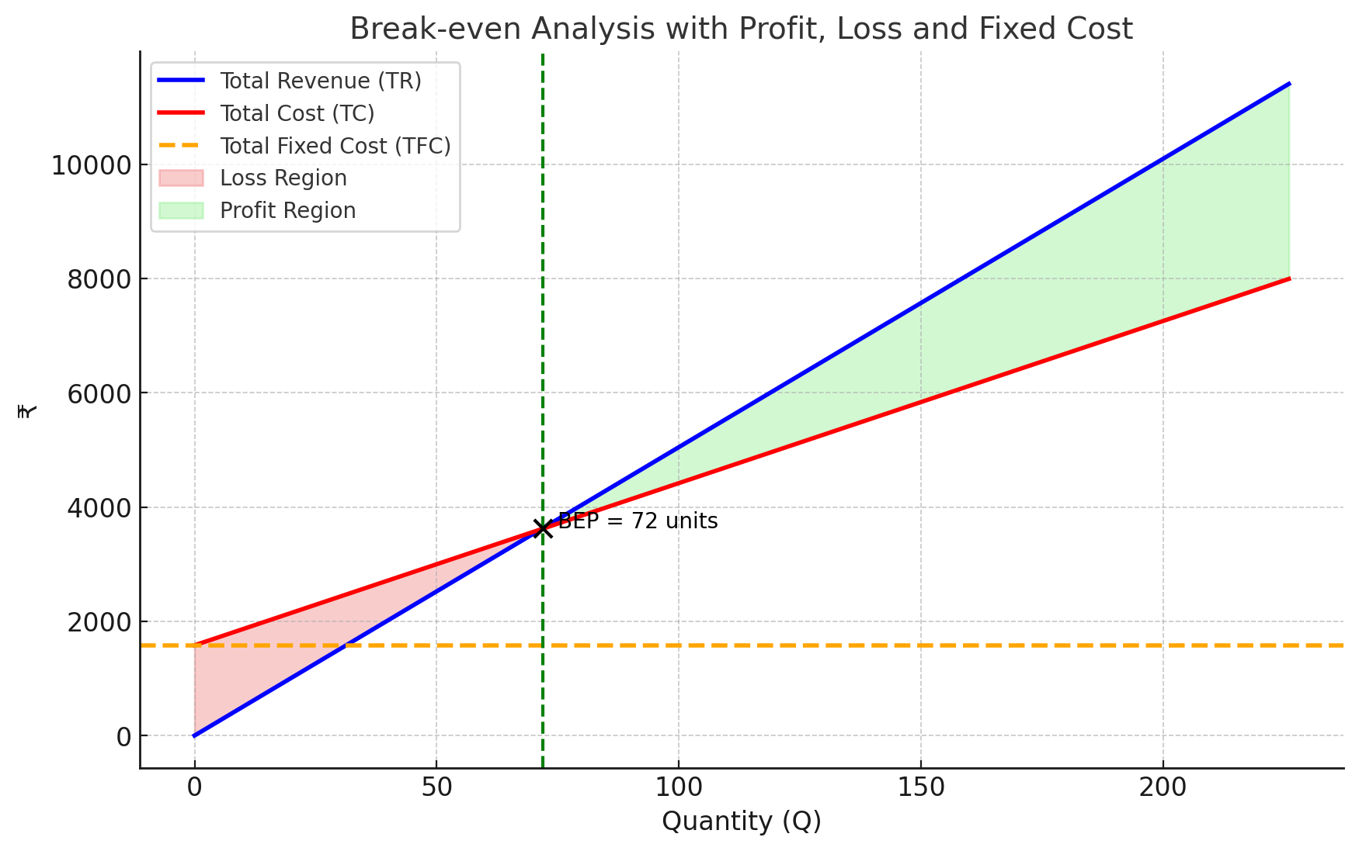
The break-even analysis reveals that the microbusiness must sell approximately 72 cups to cover both its fixed and variable costs. Beyond this point, every additional cup sold contributes directly to profit at a margin of ₹22.09 per unit. In practice, the stall sold 226 cups, which is almost 68% above the break-even level, indicating a strong margin of safety and minimal risk of losses. The fixed cost of ₹1,580 is modest, while the constant marginal cost of ₹28.37 per cup ensures cost predictability and stability. With an average selling price of ₹50.46 per cup, the business is positioned for reliable profitability and scalability. Overall, the analysis confirms that the stall not only achieved profitability early but also operated with a wide buffer, making it a low-risk and high-reward venture.

15. Competition Analysis
Closest Competitor
We had assumed that our product was unique enough to not face any adversary, but there was still competition, firstly from a different team selling iced tea at lower price and then we had also faced some competition from mojito stall as well.
- Tea-quila: One competitor also selling iced tea at a lower price range of ₹25 to ₹35.
- Mocktail mafia- A mojito stall was also selling multiple flavours within a price range of ₹45 to ₹60
- Theka A Taazgi- Another mojito stall who were selling at a premium price of 50-70 similar to our microbusiness.
These competitors had affected our sales differently. People would often visit the cheaper tea stall first, but would then visit ours, signifying that people were getting less utility from the other tea stall and then purchase our product despite it being more expensive, showing that utility was more important than money paid, to an extent of course.
When it came to the two Mojito stalls, the competition varied and depended on what price point they were selling. If they raised their price, our income would increase as customers preferred that the utility of the iced tea at a higher price was better than the utility of the Mojito at a higher price.

16. Cross elasticity against competitor
Competitor | %ΔP (Price) | %ΔQ (Our Quantity) | CPED (ΔQ% ÷ ΔP%) | Interpretation
Tea-quila | 14.3% | 40% | 2.8 | Very strong substitute (closest competitor)
Mocktail Mafia | 28.6% | 20% | 0.7 | Weak substitute
Theka A Taazgi | 20% | 10% | 0.5 | Very weak substitute

Tea-quila (another iced tea stall) is the closest competitor (CPED = 2.8).
- Their price increase led to the biggest gain in our demand.
- Both sell the same product category (iced tea) at similar price points.
Mojito stalls (Mocktail Mafia and Theka A Taazgi) were less of a threat because they sell different products (mojitos), even if overlapping in price range.

17. Executive Summary
We set up and managed our iced tea stall, Chill Sip, over a span of four days as part of our microeconomics project. Our goal was to design a microbusiness that balanced creativity, demand potential, and practical execution while applying microeconomic concepts to real-world decision-making.
We chose to sell three premium iced tea flavours—Peach, Cranberry, and Blueberry—based on health appeal, student preferences, and the opportunity to differentiate ourselves from standard offerings. To understand our market, we conducted surveys and built demand schedules, which confirmed the law of demand: as prices rose, quantity demanded fell, and vice versa. Using regression analysis, we derived a demand function (Q = 31.93 – 0.45P) and confirmed that our product faced highly elastic demand. However, we observed that promotional activities and branding helped reduce this elasticity, giving us some control over consumer perception. On the revenue side, we discovered that total revenue peaked around 16 units and declined afterwards, highlighting the importance of operating in the elastic portion of the demand curve. Across four days, our sales patterns reflected this: lower pricing on Day 3 maximized sales, while higher pricing on Day 4 significantly reduced both demand and earnings. From a cost perspective, we worked with a fixed cost of ₹1,580 and a constant marginal cost of ₹28.37 per cup. This gave us a linear cost function:
TC(Q)=1580+28.37QTC(Q) = 1580 + 28.37QTC(Q)=1580+28.37Q
Our break-even analysis showed that we needed to sell 72 cups to recover costs, while we ultimately sold 226 cups, achieving a healthy margin of safety of about 68%. This reassured us that our business model was low-risk and profitable, with scalability potential. We also studied competition on campus. Our cross-price elasticity analysis revealed that Tea-quila, another iced tea stall, was our closest competitor (CPED = 2.8), while mojito stalls such as Mocktail Mafia and Theka A Taazgi posed weaker competition due to product differentiation. This emphasized that our primary challenge came from direct substitutes, not alternatives.
Through this exercise, we learned how to connect theory with practice. We saw how pricing, demand elasticity, cost behavior, and competition directly influenced business decisions and outcomes. Most importantly, we experienced the challenges of teamwork, data collection, and adapting strategies in a live market setting.
In summary, Chill Sip was a successful venture that not only gave us profits but also valuable insights into microeconomics in action. We are confident that the skills and lessons we gained will carry forward into more complex business scenarios.

