MARKETING MANAGEMENT
A Project Report on Levis Strauss and Co.
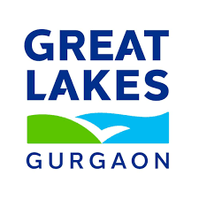
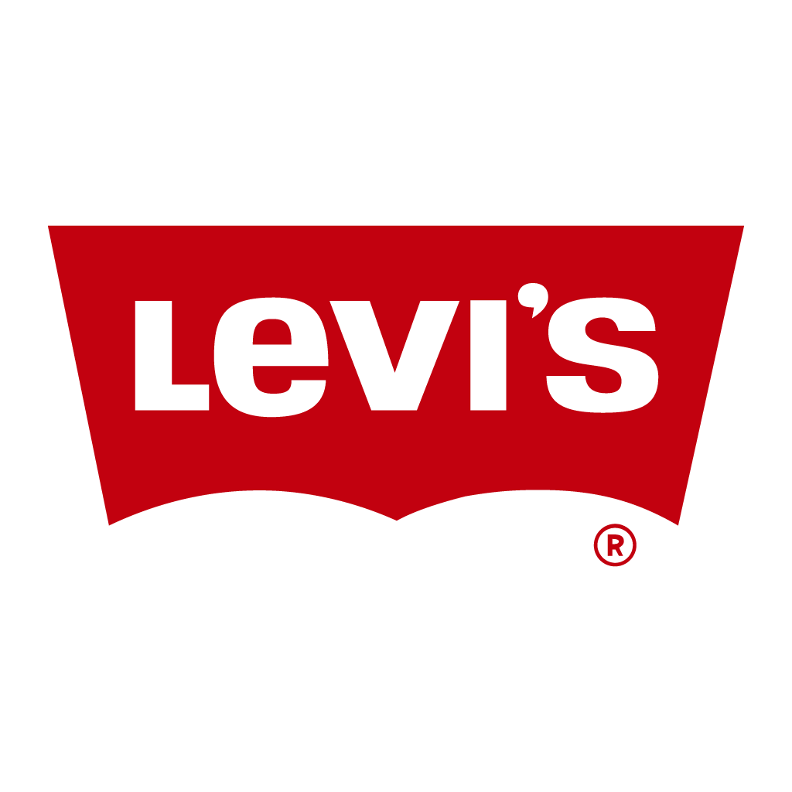

Group Number: B07
Manya Dua (P2512040)
Samarth Garg (P2152057)
Abu Tanbir Mondal (P2512004)
Om Prakash Meher (P2512044)
Arpan Bose (P2512014)

C O N T E N T S
Executive Summary ………………………………………………………………………………… .04
- Chapter 1: Introduction ………………………………………………………… 05
- Chapter 2: Competitive Scenario 06
  - About Company
  - SWOT Analysis
  - Sales Turnover
  - Management Team
  - Major Competitors & Why They Compete
- Chapter 3: PESTEL & Porter’s Five Forces Analysis 11
  - PESTEL Analysis
  - Porter’s Five Forces Model
- Chapter 4: Internal Analyses ……………………………………………………. 14
  - Company Background
  - Scope of Operations
  - Levi’s Performance till Date
  - Brand Portfolio
  - Market Share of Indian Denim Industry
- Chapter 5: Research Findings 17
  - Research Objective
  - Research Methodology
    - Approach
    - Target Segment & Sample Size
  - Key Findings
- Chapter 6: Proposed Future Work……………………………………………………… .………………20
  - Segmentation, Targeting & Positioning
  - Value Population
- Bibliography

Tables List
- Table 1: SWOT Matrix 07
- Table 2: Management Team 09
- Table 3: Brand Portfolio 15
- Table 4: Market Share of Denim Industry 16
- Table 5: Customer Segmentation 17
- Table 6: Demographic of Customer 18

Executive Summary
This report presents a detailed analysis of Levi Strauss & Co., focusing on its Indian operations, market position, competitive landscape, and brand strategy. Founded in 1853, Levi’s is a global leader in denim apparel with a significant manufacturing presence in India, which contributes up to 20% of its global output. In India, Levi’s holds a strong market share of around 4.2–4.3% in the fashion industry and dominates the denim segment with 40–45% market share. The brand maintains rapid growth through expanding product lines, including women’s apparel and casual tops.
Levi’s faces intense competition from global and domestic brands like Wrangler, Lee, H&M, and Zara. Strategic analyses using PESTEL, Porter’s Five Forces, and SWOT highlight Levi’s brand strength, omnichannel reach, and growth opportunities alongside challenges such as pricing pressures and market competition. The company targets young, style-conscious urban consumers and positions itself as a symbol of authenticity, quality, and sustainability.
Overall, Levi’s is well positioned as a market leader in India’s denim and apparel sectors with strategic growth avenues in diversification, digital expansion, and sustainable fashion.

Chapter 1 Introduction
Levi Strauss & Co., founded in 1853, is a global leader in denim apparel and iconic for inventing the first riveted blue jeans. With a rich heritage and commitment to innovation, Levi’s has become synonymous with quality, style, and durability across the world. India plays a strategic role as a key manufacturing hub and one of the fastest-growing markets for Levi’s, reflecting the brand’s expanding footprint and diverse product offerings. This report analyses Levi’s operations, market position, competitive landscape, and growth opportunities in India using marketing frameworks such as SWOT, PESTEL, and Porter’s Five Forces to provide actionable insights for sustained success.

Chapter 2 Competitive Scenario
2.1 About Company
Levi Strauss, a German immigrant, established the company in San Francisco, California, in May 1853, recognizing a demand for durable goods during the California Gold Rush. Recognizing the need for sturdy workwear, Strauss partnered with tailor Jacob Davis in 1873 to create the world’s first riveted blue jeans, marking the birth of an iconic brand. This innovative approach quickly transformed the company from a local dry goods business into a global apparel pioneer.
Levi Strauss manages a vast manufacturing footprint with over 500 supplier facilities in approx. 40 countries, relying primarily on independent, 3rd party factories to produce their diverge range of apparel. It serves markets across North America, Asia-Pacific, Europe, and beyond, ensuring rapid response to demand and streamlined logistics.
The globally renowned 501® jeans recognized worldwide as blue jeans, the timeless Trucker Jackets, and expansive women’s and men’s apparel lines featuring a variety styles.
2.2 SWOT
Strength  - Prominent international corporation with more than 17 decades of experience.  - Huge retail presence in India, with over 500 major shops and increasing exclusive stores.  - Superior placement with a high degree of brand trust and image quality.  - Omnichannel presence and wide distribution (e-commerce + offline).  - Strong parent-company support and international collaborations. | Weaknesses  - Premium pricing limits affordability in price-sensitive Indian market.  - Dependence on denim category; limited diversification historically.  - Profitability pressure from high royalty/marketing costs.  - Franchise-heavy model dilutes control over retail experience.  - Third in popularity in India behind local denim brands.
Opportunities  - High growth denim market in India (~8–9% CAGR, youth-driven).  - Expanding women’s wear and non-denim product lines.  - High online penetration and online retail in India.  - Increasing desire for environmentally friendly and sustainable denim.  - Prospects of market penetration in tier-2 as well as tier-3 cities. | Threats  - Fierce rivalry from fast-fashion retailers like H&M, Zara, and Uniqlo.  - The use of denim is being reduced by alternatives like athleisure (Nike, Adidas, Puma).  - Rising cotton/raw material costs impacting margins.  - Sustainability compliance pressures increasing costs.  - Economic slowdowns may cut discretionary fashion spending.
Table 1: SWOT Matrix
Explanation of SWOT Elements
Strengths
The jeans of Levi's have a known global reputation. With over 170 years of history, the brand has a connection with realness and excellent quality. In India, Levi's has a large retail presence, with over five hundred exclusive stores, which includes flagship outlets. Its good position increases consumer trust. An omnichannel plan and parent company help make its market dominance greater.
Weaknesses
But the decent price of Levi's limits its access in India's very price sensitive market. The brand's past focus on denim made it open to problems, but it does now offer a wider range of items. Profit was under pressure because of high royalty and marketing costs. In addition, the franchise heavy business plan of Levi's makes direct brand control over retail experiences less. Despite its history, it ranks just third in popularity among denim brands in India.
Opportunities
India’s denim market is rapidly expanding at ~8–9% CAGR, driven by its young, urban population. Levi's has an opportunity to get growth by making women's wear, non-denim clothes along with sustainable fashion lines stronger. The rise of e-commerce and digital shopping offers ways for direct engagement with customers. Also moving into tier-2 and tier-3 cities could really grow the reach of Levi's.
Threats
Levi's faces intense competition from fast fashion sellers like H&M, Zara in addition to Uniqlo, who offer denim that follows trends at lower prices. Substitutes such as athleisure are reducing denim usage among youth. Rising cotton and raw material costs cause risks to profit. The brand also must continue to meet strict sustainability ideas, which make operational costs higher. An economic slowdown or drop in spending can negatively impact the sales of Levi's.
2.3 Sales Turnover
- The estimated market size of Levi’s brand in India in terms of volume for FY2024 is approximately 9.37 million pieces.
- Reported revenue for Levi’s India of about ₹1,687 crore in FY24 and an average selling price of ₹1,800 per piece of apparel, mostly denim products.
- Levi’s India is among the fastest growing and largest markets for the brand within Asia, with continued double-digit growth expected.
- Brand has a strong presence with over four hundred exclusive brand outlets, and it is expanding its product range beyond denim to include tops, shirts, and women’s apparel.
- Despite a modest net profit decline, Levi’s sustains sales growth of about 3.3%.
- Levi’s holds 4.2% to 4.3% market share in the Indian apparel/fashion industry as of Q2 2025.
- Levi’s India is now the largest market for the brand in Asia and ranks sixth globally.
- The brand has seen rapid growth, with a 50% increase in revenue compared to pre-pandemic levels.
2.4 Management Team
Executive | Role
Michelle Gass | President & CEO (since Jan 2024)
Harmit Singh | CFO & Chief Growth Officer
Gianluca Flore | Chief Commercial Officer
Karyn Hillman | Chief Product & Merchandising Officer
Jason Gowans | Chief Digital & Technology Officer
Table 2: Management Team
2.5 Major Competitors & Why They Compete
1. Wrangler
Globally renowned for durable denim, rugged styles, and strong positioning in youth and adventure lifestyles. Wrangler competes with Levi’s on quality, price, and similar product segments (jeans & casuals).
2. Lee
Classic denim brand with a strong presence in India’s mass premium market. Lee offers competitive pricing and diverse styles, appealing to the same urban, youth-driven demographic as Levi’s.

3. Pepe Jeans
Known for trendy styles, European fashion influences, and aggressive marketing, Pepe Jeans targets the youth fashion segment. It rivals Levi’s in new fits, colours, and fast-fashion-like responsiveness.
4. Mufti
Homegrown Indian brand focused on casual and denimwear, Mufti is recognized for contemporary designs and affordability. It competes with Levi’s on price and style, especially in tier-2 and tier-3 cities.
5. Spyker
Focuses on innovative denim styles, fits, and youth marketing. Like Mufti, Spyker leverages strong distribution across multiple cities and is competitive on pricing and customization.
6. Flying Machine
Pioneering Indian denim brand with mass appeal, Flying Machine offers affordable, trendy products, making it a strong challenger for Levi’s in the value-driven segment.

Chapter 3 PESTEL Analysis & Porter’s Five Forces Model
3.1 PESTEL Analysis
1. Political
- Levi’s gets less than 1% of its products for the U.S. from China, so trade tariffs do not affect it much. This means even when tariffs rise, the company’s costs and profits stay mostly stable compared to competitors who depend more on China.
- Regional conflicts such as the Russia Ukraine war led Levi’s to suspend operations in Russia, showing how geopolitics can directly impact sales.
2. Economic
- Levi’s net sales rose to $6.4 billion in 2024, marking the highest revenue in three decades.
- Levi’s previously aimed for $9–ten billion by 2027, that target was deferred due to rising cost-of-living pressures in developed markets.
3. Social
- Younger buyers like Gen Z and Millennials make up most of Levi’s customers, and they care a lot about the environment. This means Levi’s focus on sustainability and connects with the values of its biggest customer group.
- Old fashion styles from the 1990s and early 2000s, like baggy jeans and denim shorts are becoming popular again. This trend has made people more excited about wearing denims, which directly benefits Levi’s because it is one of the most trusted and iconic denim brands.
4.Technological
- Levi’s is using machine learning to make its internal work easier and faster. For example, it helps the company decide which sizes to produce and stock, reducing mistakes and saving time.
- Broader fashion industry trends like AI driven personalization and immersive digital retail experiences in the metaverse also present future opportunities for the company to innovate in customer engagement and product design.
5.Environmental
- Levi’s has set ambitious environmental goals for the future. It plans to cut its greenhouse gas emissions by 90% and run fully on renewable energy by 2025. This shows the brand’s serious commitment to fighting climate change and reducing waste.
- Levi’s has developed special techniques to use much less water when making its jeans. This not only saves a valuable resource but also strengthens its image as a leader in sustainable and responsible fashion.
6.Legal
- Levi’s does not just follow laws it also takes a stand on important social issues. For example, it has openly supported LGBTQ rights in the past, which shows that the company’s actions are guided by values and ethics, not just business rules.
- Levi’s actively protects its trademarks and designs, especially the famous double-arc stitching on the back pockets. By defending its intellectual property, the company makes sure its brand identity stays unique and cannot be copied by competitors.
3.2 Porter’s Five Forces Model
1. Competition – HIGH
- Levi’s has to compete with many denim and fashion brands like Wrangler, Lee, Diesel, H&M, Zara, and Uniqlo. Fast-fashion companies copy denim styles quickly and sell them cheaply, while luxury brands fight in the premium space. Even though Levi’s is famous and trusted, the overall competition in fashion is still very tough.
2. Threat of New Entrants – MODERATE
- Starting a new fashion brand has low barriers thanks to e-commerce, social media marketing, and outsourced production. However, building Levi’s level of brand trust, heritage, and global distribution network is difficult, which reduces the actual threat.

3. Bargaining Power of Buyers – HIGH
- Today’s consumers have endless options for denim and fashion. They can easily switch to cheaper brands or trendy alternatives if Levi’s prices feel too high. Younger buyers are also highly value-driven, expecting sustainability and ethical practices, which gives them strong influence over Levi’s strategy.
4. Bargaining Power of Suppliers – LOW
- Levi’s works with a large number of suppliers spread across many countries. Because it is such a big and well-known brand, suppliers want to do business with Levi’s, which reduces their influence. If one supplier raises prices or fails to meet standards, Levi’s can often switch to another, so the suppliers do not have too much power.
5. Threat of Substitutes – HIGH
- People do not always have to buy denim, they might also choose a different type of clothing instead of jeans Many consumers today prefer alternatives like leggings, joggers, chinos, or athleisure wear, which are often seen as more comfortable or trendy. Since these styles can replace denim in everyday use, the threat of substitutes for Levi’s is high.

Chapter 4 Internal Analyses
4.1 Company Background
- Levi Strauss & Co., commonly known as Levi’s, was founded in 1853 by Levi Strauss, a Bavarian immigrant who settled in San Francisco during the California Gold Rush.
- Originally a dry goods wholesale business, Levi Strauss & Co. soon innovated durable work pants through a partnership with tailor Jacob Davis.
- The patented innovation of copper riveting in 1873 became the hallmark of Levi’s iconic denim jeans, the legendary “501” model emerging by the 1890s. The company grew steadily through the 20th century, shifting from wholesaling to focusing on manufacturing branded apparel, becoming a global leader in jeanswear and casual apparel.
- Levi’s branding innovations like the two-horse logo and red tab helped it become a cultural icon internationally by the 1960s.
- Today, Levi’s operates approximately five hundred stores worldwide and maintains a strong presence in over one hundred countries, transitioning beyond workwear to lifestyle fashion while emphasizing sustainability and inclusivity.
4.2 Scope of Operations
- In terms of scope of operations, Levi Strauss & Co. is a global company with diversified operations encompassing product design, manufacturing, marketing, and retail sales. It competes across multiple geographic markets including the Americas, Europe, and Asia, with strong direct-to-consumer (DTC) channels and wholesale distribution.
- The company’s product portfolio includes not only its denim jeans but also casual apparel under Levi’s and related brands like Beyond Yoga. Levi’s has embraced digital transformation, focusing on direct sales growth through e-commerce, which now forms a significant portion of revenue.
- The company also integrates sustainability deeply into its operations, targeting environmental impact reductions in supply chain, product lifecycle, and store operations.
- Supply chain innovation and strategic merchandise planning remain central to Levi’s operational excellence.
4.3 Levi’s Performance till Date
- Regarding performance to date, Levi Strauss & Co. has demonstrated strong financial growth and operational resilience in recent years.
- In 2025, the company reported record margins and robust revenue increases, with net revenues hitting $1.4 billion in Q2 2025—up 6% reported and 9% organically over the previous year. The Levi’s brand itself experienced 9% global organic growth, with significant strength in the Americas and Europe, while e-commerce revenues grew by 13%.
- Direct-to-consumer sales increased, representing more than half of Levi’s total revenue. Profitability also improved with gross margins reaching 62.6%, an all-time high, and adjusted EBIT margin expanding to 8.3%.
- Earnings per share for Q2 2025 rose by 37% year-over-year, reflecting effective strategic initiatives, including strong product innovation, channel mix optimization, and cost management.
4.4 Brand Portfolio
Brand | Positioning
Levi’s® | Premium denim heritage leader
Dockers® | Casual business khakis
Denizen® | Value-oriented denim in emerging markets
Signature by Levi’s® | Entry-level, mass-market denim
Beyond Yoga® | Women’s active lifestyle
Table 3: Brand Portfolio
4.5 Market Share of Indian Denim Industry
- The denim market in India is experiencing robust growth, driven by rising disposable incomes, fashion consciousness, urbanization, and the expanding e-commerce sector.
- The market size was approximately USD 1.14 billion in 2024 and is forecasted to grow to about USD 1.83 billion by 2033, with a CAGR of around 5-8% expected in the coming years.
Brand/Company | Approximate Denim Market Share (India, 2025) | Key Notes
Levi's | 40% - 45% | Largest player, premium denim leader
Wrangler, Lee, Pepe | 20% - 25% | Notable global competitors
Others (local, niche) | 30% - 35% | Regional brands and emerging premium lines
Table 4: Market Share of Denim Industry

Chapter 5 Research Findings
5.1 Research Objective
The aim of this survey was to collect direct feedback from customers and dealers about Levis. It helped us understand customer preferences, competitor’s positioning and dealer’s insights into sales and demand. The survey was conducted to:
- Understand customer buying behaviour, satisfaction levels, and expectations from Levi’s
- Analyse competitor strategies, strengths, and weaknesses as perceived in the market.
- Capture dealer perspectives on sales performance, distribution, and demand trends.
- Identify gaps and opportunities for Levi’s to strengthen its marketing and brand strategy in India.
5.2 Research Methodology
5.2.1 Approach
The study followed a primary research approach using surveys and interviews to collect first-hand insights. Data was collected through short interviews; the customers were selected from different age groups to reflect diverse perspective.
5.2.2 Target Segment & Sample Size
Category | Breakdown
Total Respondents | 12
Age Range | Between 27 to 58 years
Gender | 9 males and 3 women
Table 5: Customer Segmentation

Respondents | Age/Age Group | Gender | Occupation
1 | 55-60 | Male | Businessman
2 | 30-35 | Male | Self Employed
3 | 55-60 | Male | Businessman
4 | 40-45 | Male | Senior Working Professional
5 | 40-45 | Female | Senior Working Professional
6 | 25-30 | Male | Young Working Professional
7 | 25-30 | Male | Young Working Professional
8 | 45-50 | Male | Self Employed
9 | 35-40 | Male | Senior Working Professional
10 | 35-40 | Female | Senior Working Professional
11 | 35-40 | Female | Homemaker
12 | 40-45 | Female | Senior Working Professional
Table 6: Demographics of Customers
5.3 Key Findings
Based on the responses collected several important insights emerged about Levi’s, the findings are summarized below:
- Product Preference
- Denim jeans continue to be the strongest and most preferred product line for Levi’s.
- Fits like straight slim, belly fit, and boot cut are commonly preferred among customers.
- Levi’s is strong in denim, but many customers are less aware or interested in its other products like tops, jackets, and women’s wear. This shows that its diversification is not reaching consumers effectively.

- Customer Satisfaction and Perceptions
- Respondents who currently shop from Levi’s value the brand’s international image, heritage, and consistent quality
- Levis is seen as trusted global brand.
- However, several customers also felt Levi’s was not keeping up with new fashion trends, making the brand look “retro” compared to fast-fashion competitors.
- The premium pricing strategy was highlighted as a major concern, especially in India’s price-sensitive market.
- Staff behaviour and in-store experience needing improvement.

- Competitor Shift
- Many customers shifted to Uniqlo, Wrangler, and Flying Machine, citing better trend alignment, affordability, and service experience.
- Levi’s is increasingly seen as a premium brand, but some also classify it as a mass media brand because of its wide presence.

- Purchase Frequency
- Most customers shop for apparel every 3–6 months, but Levi’s purchases are less frequent.
- Repeat buying from Levi’s is lower compared to competitors.
- This shows that Levi’s is trusted for quality, but repeat buying is low.

- Dealer’s Insights
- Dealer reported that Levi’s attracts customers but faces tough competition from brands like US polo.
- The usual spending range for Levi’s customers is ₹10,000 – ₹25,000 annually.
- Most sold item is jeans and denims especially straight and slim fit jeans.
- The Connaught Place Exclusive Store also offers extra paid services like custom embroidery, which customers enjoy for a better shopping experience.
- Dealers noticed that customers are willing to pay higher prices because of Levi’s brand value.
Chapter 6 Proposed Future Work
6.1 Segmentation, Targeting & Positioning
Segmentation
Levi’s divides its customers by:
- Age: Focus is on teenagers, young adults, and adults who like jeans and casual clothes.
- Income: Targets both middle and higher-income groups. Some Levi’s jeans are premium, but there are also options for people looking for mid-range items.
- Lifestyle: Appeals to people who care about style, comfort, and want clothes that reflect their personality. Many Levi’s customers choose jeans for everyday wear, work, and outings.
Major Segments of Levi's in India
- Denim Bottoms (Jeans): The core and most significant product category, constituting the majority of Levi’s sales volume and value.
- Tops and Shirts: This segment has been expanding steadily. It includes casual shirts, T-shirts, and other upper wear.
- Women's Apparel: Significantly growing segment, now representing a larger portion of the business.
- Accessories and Other Apparel: Includes belts, caps, and lifestyle accessories, contributing a smaller but strategic share of sales.
Segment Contribution to Total Sales
- Levi's India recorded a total product sales revenue of approximately ₹1,615 crore to ₹1,668 crore in FY24.
- Denim bottoms form the largest portion, estimated at over 60-70% of total sales revenue.
- Tops and shirts account for around 20-25% of sales, reflecting growth from diversified apparel lines.
- Women’s apparel has increased its contribution, making up about 20-30% of revenue, with a clear upward trend noted in recent years.
- Accessories and other categories constitute the remaining 5-10%.
Targeting
Levi’s aims its products at:
- Young people and working professionals who want trendy and comfortable jeans.
- People who value good quality and long-lasting denim.
- People who like fashionable but practical clothes and want unique styles for
Positioning
Levi’s is known for:
- Being the original and classic jeans brand
- Offering quality and durable products that people trust to last long.
- Always keeping up with latest trends but staying true to its classic style.
- Highlighting values like individuality, freedom, and self-expression. Wearing Levi’s is seen as a way to feel confident and express one's personal style.
- Promoting sustainability, with efforts to save water and use eco-friendly materials.
6.2 Value Population
Levi Strauss & Co.'s value population in terms of brand value, market capitalization, and market position in 2025 can be detailed as follows:
Brand Value and Market Position
- Levi's is recognized as one of the most iconic and valuable apparel brands globally, with a rich heritage dating back to 1853. According to Brand Finance and other valuation studies, Levi's brand value has been consistently tracked and recognized for its enduring appeal, innovation, and strong consumer loyalty.
- The brand is seen as a symbol of quality, durability, and cultural relevance worldwide, positioning it strongly in both emerging and developed markets.
- Its appeal extends beyond denim to a broad portfolio of casual wear and lifestyle apparel, boosting its market strength and consumer reach globally.
Market Capitalization and Financial Valuation
- As of September 2025, Levi Strauss & Co.'s market capitalization stands around $8.7 to $8.8 billion (INR 771 billion), reflecting solid investor confidence and company growth.
- The market cap, which is the total value of the company's outstanding shares, has grown by more than 12% over the past year, demonstrating positive market sentiment driven by strong financial performance and strategic initiatives.
- The stock price is approximately $22, with forward price-to-earnings (P/E) ratios indicating reasonable growth expectations by the market.
Financial Strength Indicators
- The company achieved record gross margins above 62% and adjusted EBIT margins improved to 8.3% in recent quarters. Earnings per share grew by 37% year-over-year, underscoring operational efficiency and effective cost management.
- Direct-to-consumer sales constitute over half of revenues, helping enhance brand equity and customer loyalty while boosting higher-margin revenue streams. Continued innovation, product diversification, and global expansion support Levi’s market valuation.

Bibliography
- Levis
- Statista
- Uni Commerce
- India Retailing
- Economic Times
- Fashion United
- Indian Textile Journal
- IMARC Group
- Denim & Jeans
- McKinsey
- Grand View Research
- Fortune India
- India Retailing
- https://investors.levistrauss.com/news/financial-news/news-details/2025/Levi-Strauss--Co.-Reports-Strong-Fourth-Quarter-Results/default.aspx

