Doctor Appointment Booking Application
Submitted by: Omprkash Kumar
Roll Number: 2214502456
Program: BCA
Session: June/2022
Guide: Mrs. Dipali Borade
Organization: NeoSoft
Project Duration: July 2025 – August 2025
Table of Contents
1. Introduction & Objectives
2. System Analysis
3. Identification of Need
4. Preliminary Investigation
5. Feasibility Study
6. Project Planning
7. Project Scheduling (PERT Chart & Gantt Chart) 8. Software Requirement Specifications (SRS) 9. Software Engineering Paradigm
10. Data Models
11. System Design
12. Modularisation Details
13. Data Integrity and Constraints
14. Database Design
15. User Interface Design
16. Coding
17. SQL Commands
18. Code Quality
19. Testing
20. System Security
21. Cost Estimation
22. Future Scope
23. Bibliography
24. Appendices

25. Data Dictionary
1. Introduction & Objectives
A web-based system designed to simplify and digitize the doctor appointment booking process.
Objectives:
- Enable patient registration and login
- List/search doctors based on specialization
- Allow real-time booking and availability tracking
- Provide admin controls to manage doctors, patients, and appointments
2. System Analysis
This system addresses inefficiencies in traditional appointment systems through real-time booking, better record management, and accessibility via mobile/desktop.
3. Identification of Need
Manual systems suffer from mismanagement, double bookings, and lack of transparency. Patients and clinics benefit from automation and digitization.
4. Preliminary Investigation
Analysis was conducted via:
- Informal interviews with doctors and patients
- Study of platforms like Practo, Zocdoc: A comparative analysis of existing healthcare platforms such as Practo and Zocdoc was performed. These platforms provided insights into best practices, common features, and user expectations, which helped in defining the scope and feature set of the proposed system.
5. Feasibility Study
- Technical Feasibility: MERN Stack supports scalable web apps.
- Operational Feasibility: System is simple to operate for users and admins. - Economic Feasibility: Minimal cost using open-source tools and free hosting (Render/Vercel).
Technical Feasibility:
The system is built using the MERN Stack (MongoDB, Express.js, React.js, Node.js), which is widely adopted for building modern, scalable, and high-performance web applications. The technology stack is well-supported and suitable for both current and future expansion needs.
Operational Feasibility:
The system is designed with a user-friendly interface for both patients and administrators.

Basic training or prior technical knowledge is not required, making it easy to operate and manage on a day-to-day basis.
Economic Feasibility:
Development and deployment costs were kept minimal by leveraging open-source technologies and free-tier hosting services such as Render and Vercel. This makes the system financially feasible, especially for academic and small-scale deployment scenarios.
6. Project Planning
Adopted Agile methodology with 2-week sprints for feature rollout and feedback.
Sprint-Based Development:
Each sprint included planning, development, testing, and review phases. At the end of every sprint, the system was evaluated, and feedback was collected to refine upcoming tasks.
Continuous Feedback and Improvement:
Regular feedback loops from test users (doctors and patients) allowed for timely improvements and feature enhancements, aligning the project closely with real-world requirements.
Task Management:
Project tracking tools (such as Trello or GitHub Projects) were used to manage tasks, set priorities, and monitor progress throughout the development lifecycle.
7. Project Scheduling (PERT Chart & Gantt Chart)
PERT and Gantt charts are used to track the flow and timing of development activities.
What It Does: It shows the sequence of tasks and dependencies, helping you find the critical path (minimum time to complete project)
a)Visual PERT Chart Layout

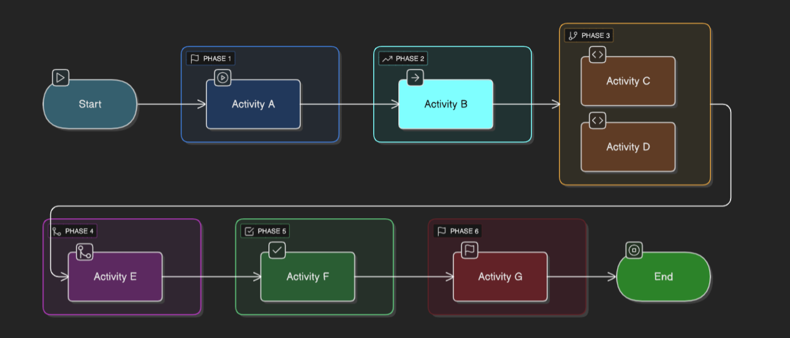
2. Gantt Chart
What It Shows: Timeline view of tasks — great for showing when and how long each task runs.
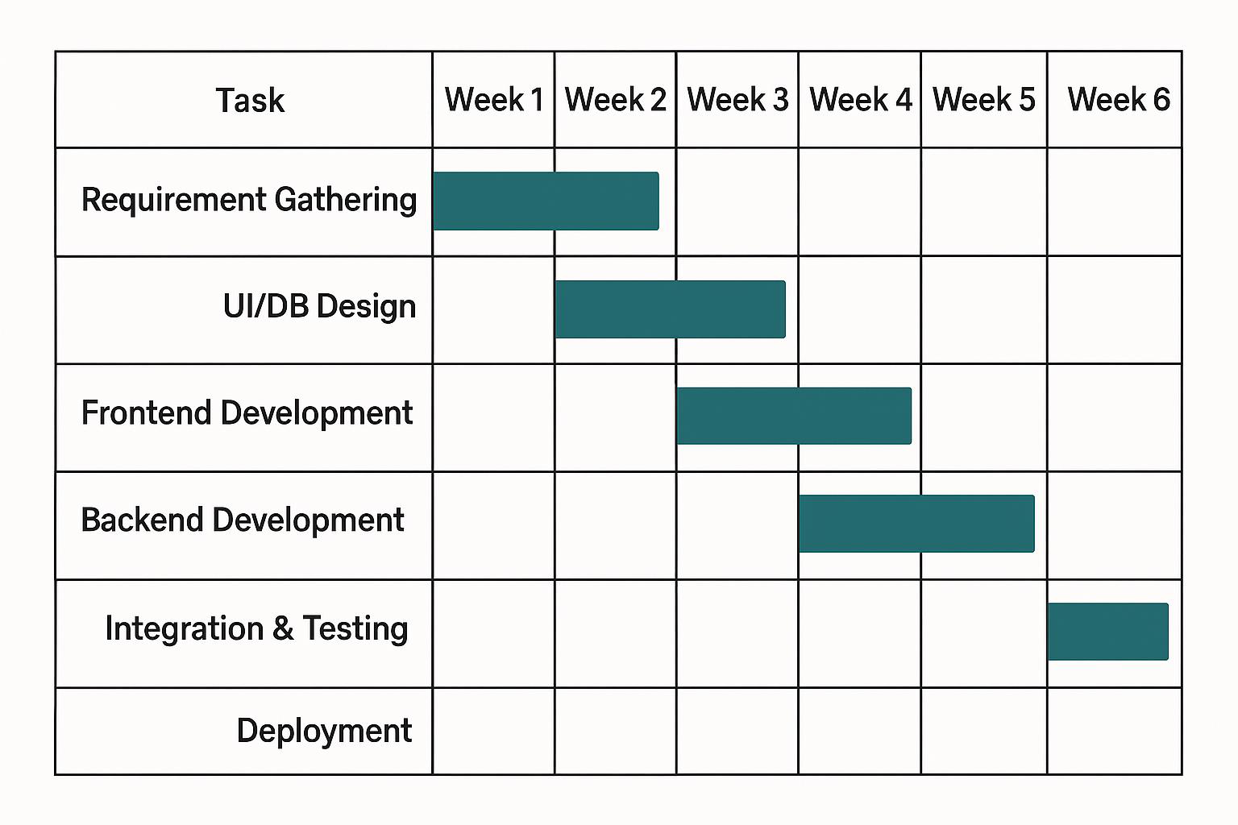
8. Software Requirement Specifications (SRS)
Includes:
8.1 Functional Requirements

• User Registration and Login (with role-based access for Patients, Doctors, and
Admins)
• Appointment Booking and Cancellation
• Doctor Availability Management
• Admin Dashboard for User and Appointment Oversight
• Email Notifications and Appointment Reminders
8.2 Non-Functional Requirements
• Performance: Fast and responsive UI across devices.
• Security: JWT-based authentication, role-based access control, and HTTPS
deployment.
• Scalability: Built using the MERN stack to support future feature additions.
• Availability: Deployed on cloud hosting (Render/Vercel) with high uptime using
free-tier services.
8.3 User Roles
• Patient:
Can register, log in, view doctors, book or cancel appointments, and view
appointment history.
• Doctor:
Can manage availability slots, view appointments, and update profile information.
• Admin:
Has full control over system data, including managing users, doctors, and
appointments.
8.4 System Features
• Responsive UI with real-time validations
• Role-based dashboards
• Secure authentication
• MongoDB cloud integration
• Email alert system
- Use Case Diagrams

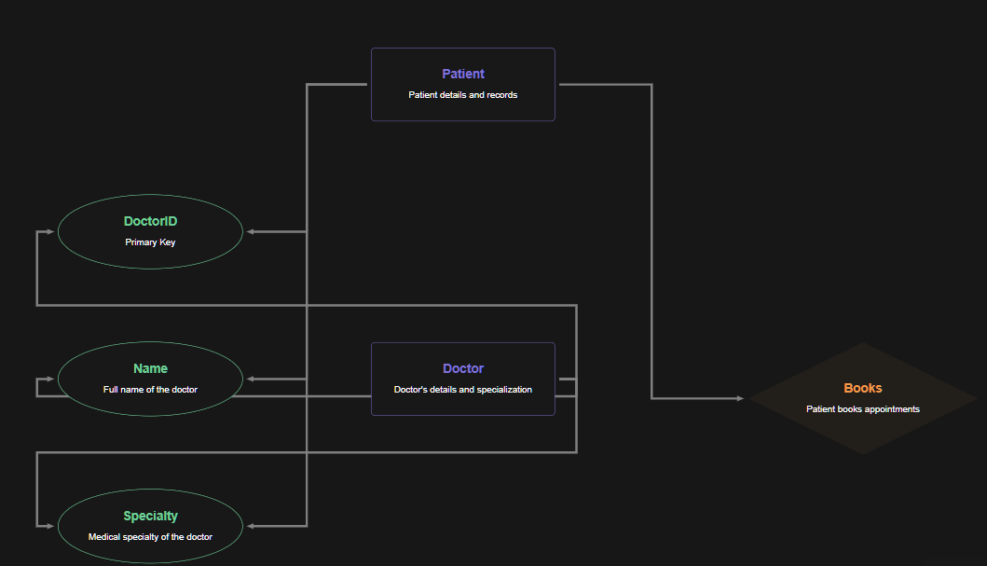
9. Software Engineering Paradigm
Adopted Agile SDLC with iterative development, testing, and feedback loop.
Key Characteristics of the Adopted Paradigm:
• Iterative Development:
The system was developed in multiple iterations (sprints), with each cycle focusing on a specific module or functionality (e.g., user authentication, appointment booking, admin dashboard).
• Early and Continuous Testing:
Testing was integrated into each sprint cycle to ensure that defects were identified and resolved early, maintaining a high level of code quality.
• Customer-Centric Feedback Loop:
Regular feedback was gathered from potential users (patients and doctors) to validate usability, identify missing features, and align the product with real-world needs.
• Adaptive Planning:
Agile allowed changes in requirements to be incorporated easily without disrupting the development flow.
Benefits Observed:
• Faster development and deployment of core features

• Easier debugging due to modular releases
• Improved user satisfaction through continuous feedback and iteration
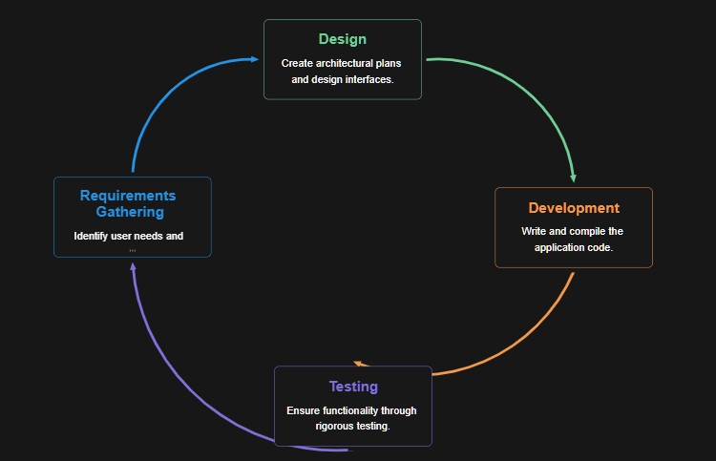
10. Data Models
- ER Diagram for database

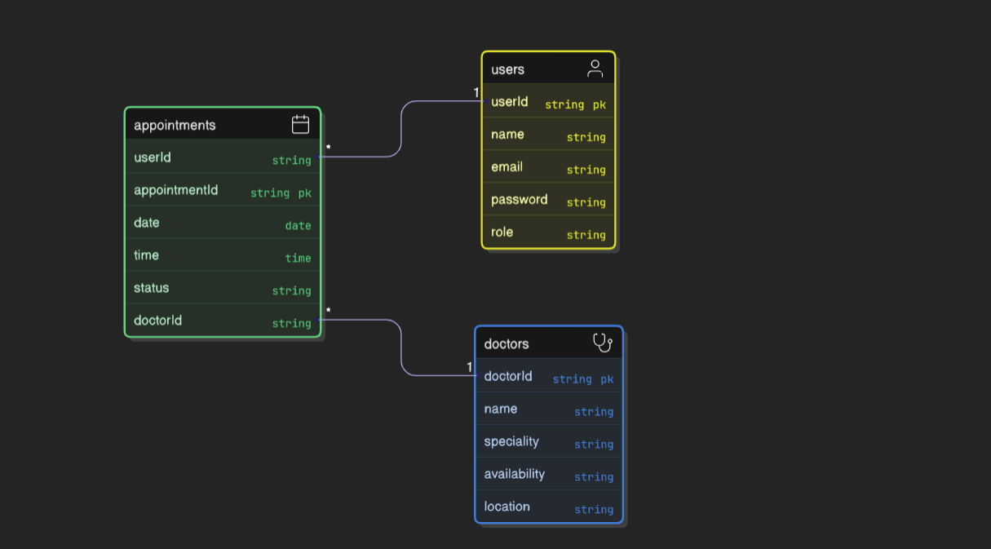
- Use-Case Diagram for user interactions
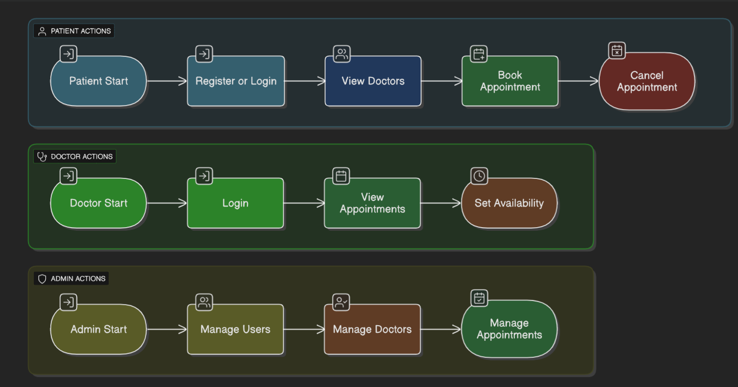
- DFD (Level 0 & 1) for process flow
11. System Design
- Low-fidelity Wireframes via Figma
- Component-based design for React frontend
- REST API structure
11.1 Low-Fidelity Wireframes.

To visualize the application's user flow and interface layout, low-fidelity wireframes were created using Figma. These wireframes served as blueprints for frontend development, enabling early feedback and UI/UX refinement.
Key Screens Designed:
•  •  •  •  •  • | Login / Signup Page  Patient Dashboard  Doctor Dashboard  Appointment Booking Page  Admin Panel  Appointment History
11.2 Component-Based Design (React Frontend)
The frontend was developed using React.js with a component-based architecture, promoting reusability and modularity.
Main Components:
• AuthForm: Handles login and signup
• Navbar: Dynamic navigation for all user roles
• AppointmentForm: Used by patients to book appointments
• Dashboard: Separate dashboards for doctor, patient, and admin views
• AppointmentList: Displays upcoming and past appointments
• UserProfile: Profile and settings section for all users
12. Modularisation Details
Modules:
- Auth Module
- Appointment Module
- Doctor Management
- Admin Dashboard
- Patient Profile
12.1 Auth Module

Purpose:
Handles user registration, authentication, and role-based access control.
Key Features:
•Signup and Login (JWT-based authentication) •Password hashing using bcrypt
Role-based redirection (Patient, Doctor, Admin) •
•
Middleware to protect private routes Key Routes:
•  •  • | POST /auth/register  POST /auth/login  GET /auth/profile (Protected)
12.2 Appointment Module
Purpose:
Manages all functionalities related to booking, viewing, and canceling appointments.
Key Features:
•Book appointment (select doctor, date, and time) •View upcoming and past appointments
•Cancel/reschedule appointments (if allowed) •
Doctor view for managing schedules Key Routes:
•  •  • | POST /appointments  GET /appointments/user/:id  DELETE /appointments/:id
12.3 Doctor Management Module

Purpose:
Allows admin to manage doctor profiles and availability.
Key Features:
•Add/edit/remove doctor details
•Assign specialties and working hours
View doctor activity and appointments •
Key Routes:
•  •  •  • | GET /doctors  POST /doctors  PUT /doctors/:id  DELETE /doctors/:id
12.4 Admin Dashboard Module
Purpose:
Provides system-wide control and analytics to the admin.
Key Features:
•View all users and doctors
•Monitor system appointments and usage
•Approve or manage users
•
Generate basic reports Key Routes:
•  •  • | GET /admin/users  GET /admin/appointments  GET /admin/stats
12.5 Patient Profile Module

Purpose:
Allows patients to manage their personal information and appointment history.
Key Features:
• Edit profile (name, contact, etc.)
• View personal appointment history
• Change password
Key Routes:
• GET /users/:id
• PUT /users/:id
• GET /appointments/user/:id (reused from appointment module)
13. Data Integrity and Constraints
- Email must be unique
- Date fields restricted to future dates
- Passwords hashed using bcrypt
13.1 Unique Email Constraint
• Purpose: Prevent duplicate user registrations.
• Implementation:
o Enforced at the database level using a unique index on the email field.
o Also validated in the backend before creating a new user account.
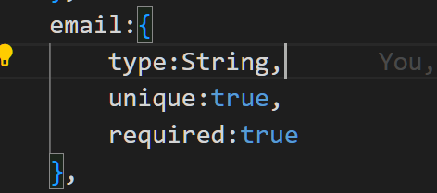

13.2 Date Fields Restricted to Future Dates
•Purpose: Prevent users from booking appointments in the past.
• Implementation:
o Frontend date pickers limit selection to current date + future dates.
o Backend validation checks if the selected appointment date is greater than or equal to the current date.
13.3 Password Hashing with Bcrypt
•Purpose: Enhance user security by not storing plain-text passwords.
• Implementation:
o Passwords are hashed using bcrypt.js before being saved in the database.
o During login, bcrypt compares the hashed version of the entered password with the stored hash.
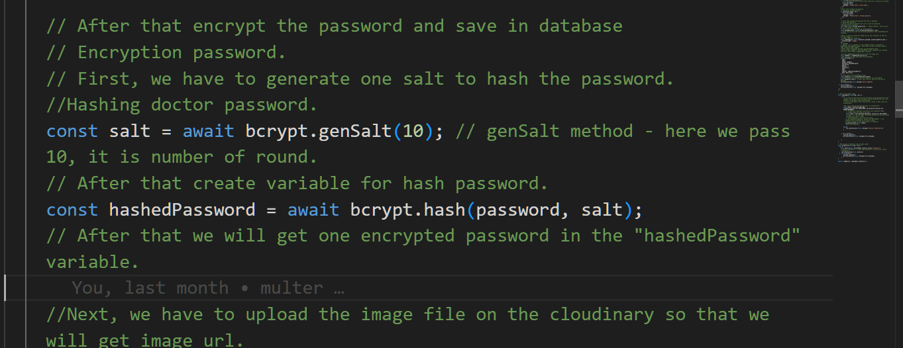
14. Database Design
- MongoDB collections: Users, Doctors, Appointments - Use of indexes for fast lookup
14.1 Collections Overview
1.Users Collection
o Stores information for all system users (patients, doctors, admins).

o Common fields: name, email, password, role, createdAt.
o Role-based access is controlled via a role field (patient, doctor, admin).
Shema
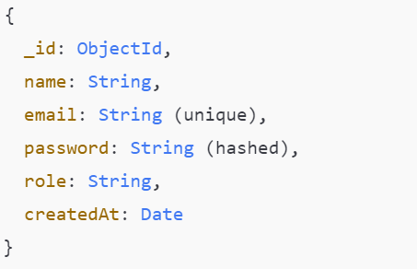
2.Doctors Collection
• Contains doctor-specific data such as specialty and available timings. • Linked to Users collection via a userId reference.
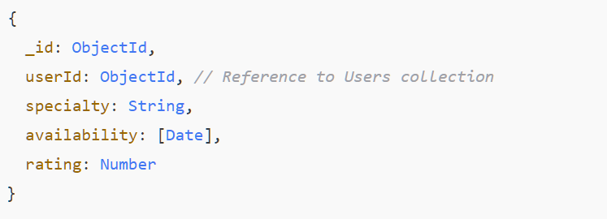
3.Appointments Collection
• Stores details about appointments between patients and doctors.

• Linked to both Users and Doctors collections via references.
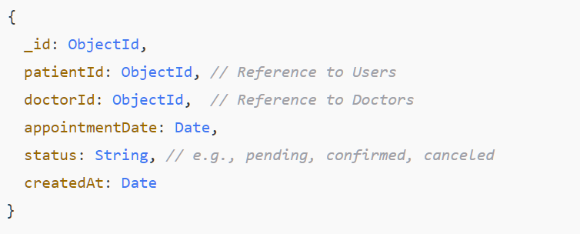
14.2 Relationships and Data Access
• One-to-One:
Each doctor has one linked user account (Doctors.userId → Users._id).
• One-to-Many:
A patient can have multiple appointments (Appointments.patientId → Users._id). A doctor can also have multiple appointments.
• Referential Integrity:
While MongoDB is schema-less, these relationships are enforced logically in the application layer using Mongoose references
15. User Interface Design
- Responsive UI with Tailwind CSS
- Optimized for mobile & desktop
- Accessibility features included
15.1 Responsive UI with Tailwind CSS
• The frontend was styled using Tailwind CSS, a utility-first CSS framework.
• Tailwind enabled rapid prototyping with consistent spacing, typography, colors, and responsive utilities.

• Mobile-first design principles were followed using Tailwind’s responsive
breakpoints (sm, md, lg, xl).
15.2 Optimized for Mobile & Desktop
• All critical pages (e.g., login, booking, dashboards) were tested across devices using
Chrome DevTools and mobile emulators.
• Flexbox and grid systems were used to create dynamic layouts that adjust gracefully
to available screen real estate.
• Buttons, inputs, and navigation elements are touch-friendly and appropriately sized
for mobile interaction.
15.3 Accessibility Features Included
Accessibility was considered during UI development to ensure the application is usable by
all, including those with disabilities.
Key Accessibility Features:
• Keyboard Navigation: All interactive elements can be accessed using the Tab key.
• Semantic HTML: Use of proper tags (<header>, <main>, <section>, <button>, etc.)
improves screen reader support.
• ARIA Labels: Added for non-text content (e.g., icons, buttons) to describe
functionality to screen readers.
• Color Contrast: Maintained recommended contrast ratios for text and UI
components for readability.
16. Coding
- MERN Stack
- Modular Codebase
- Key Features: Auth, CRUD for appointments, Doctor availability
16.1 MERN Stack

• MongoDB – NoSQL database for storing user, doctor, and appointment data.
• Express.js – Backend framework to define RESTful APIs.
• React.js – Frontend library for building reusable components and managing UI
state.
• Node.js – JavaScript runtime for server-side development.
This full-stack JavaScript setup allowed seamless data flow from frontend to backend and
efficient real-time UI updates.
16.2 Modular Codebase
The code is organized into modules and follows the MVC architecture:
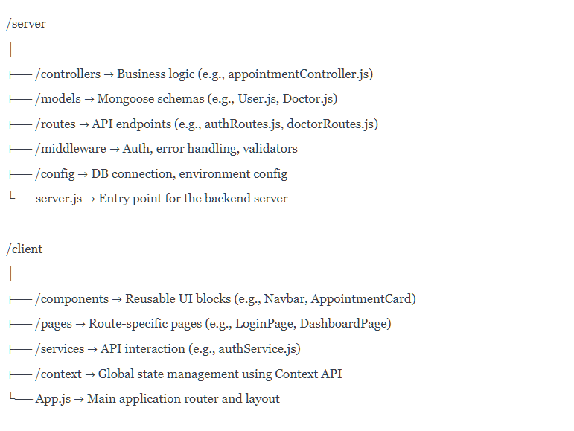
16.3 Key Features Implemented
Authentication (JWT-based)

• Signup/Login with role-based access control
• Protected routes via middleware
• Bcrypt hashing for password security
CRUD for Appointments
• Patients can book, view, and cancel appointments
• Doctors can view and manage their appointments
• Admin has access to all appointments for monitoring
Doctor Availability Management
• Admin can create/edit doctors and set available time slots
• Patients can only book from available slots
• Doctors can update their own availability (optional)
17. SQL Commands
While MongoDB doesn't use SQL, here are equivalents:
- Collection creation with schema constraints
- Insert many documents
- Role-based access (handled via logic in Node.js middleware)
While this project uses MongoDB, a NoSQL database that doesn’t use SQL syntax, many
common database tasks such as creating collections, inserting data, and enforcing
constraints still apply. Below are MongoDB-native commands with references to their SQL
counterparts — included for clarity and academic comparison.
17.1 Creating Collections with Constraints
MongoDB collections are usually created automatically when a document is inserted.
However, with Mongoose, schema constraints can be defined explicitly.

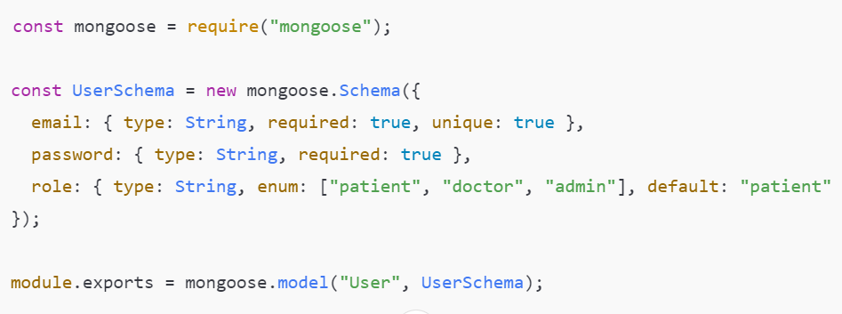
17.2 Insert Multiple Documents
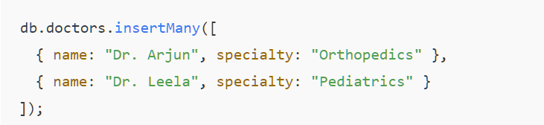
17.3 Role-Based Access (Application Level)
MongoDB doesn't natively support role-based UI access. Instead, it's handled in the Node.js backend using middleware.
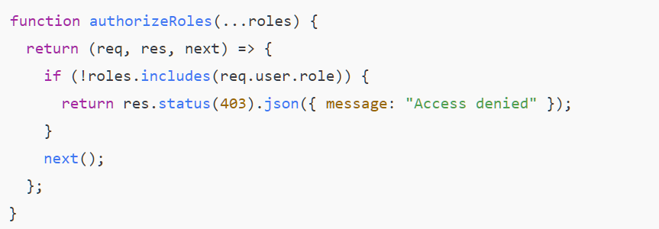

18. Code Quality
- Followed coding standards (ESLint + Prettier)
- Secure API endpoints with JWT
- Reusable components
18.1 Followed Coding Standards (ESLint + Prettier)
• ESLint was used to statically analyze JavaScript code and identify problematic
patterns or deviations from best practices.
• Prettier was used to auto-format code to a consistent style across the codebase.
• A shared .eslintrc.json and .prettierrc configuration was used across both the client
and server folders.
Benefits:
•  •  • | Eliminates inconsistent formatting  Encourages clean, readable, and uniform code Prevents common bugs and anti-patterns
18.2 Secure API Endpoints with JWT
• All private routes are protected using JSON Web Tokens (JWT).
• Users must include a valid token in the Authorization header to access protected
resources.
• Middleware checks token validity and extracts user info for role-based access
control.
Example Middleware
function authMiddleware(req, res, next) {

const token = req.headers.authorization?.split(" ")[1];

if (!token) return res.status(401).json({ message:

"Unauthorized" });

try {

const decoded = jwt.verify(token, process.env.JWT_SECRET);

req.user = decoded;

next();

} catch {

res.status(403).json({ message: "Invalid token" });

}

}
18.3 Reusable Components (React)
• UI was broken down into small, reusable React components to follow the DRY
(Don’t Repeat Yourself) principle.
• Components like Navbar, AuthForm, AppointmentCard, UserProfile, and DoctorList
were created for reusability across pages.
Benefits:
• Reduces code duplication
• Improves readability and debugging
• Makes testing and refactoring easier
Example
// AppointmentCard.jsx

function AppointmentCard({ doctor, date, status }) {

return (

<divclassName="p-4 rounded shadow bg-white">

<h3>{doctor}</h3>

<p>{date}</p>

<spanclassName={`badge${status}`}>{status}</span>

</div>

);

}
19. Testing
- Unit Testing: Jest
- Integration Testing: Postman

- Manual testing for UI
- Bug report log maintained
19.1 Unit Testing (Jest)
• Tool Used:
• Focused on testing individual functions, utilities, and backend logic in isolation.
• Key targets included authentication logic, middleware functions, and appointment
handlers.
Example
describe("Token Verification", () => {

it("should return a decoded user object for a valid token", ()

=> {

const token = generateTestToken({ id: "user123", role:

"doctor" });

const user = jwt.verify(token, process.env.JWT_SECRET);

expect(user.id).toBe("user123");

});

});
19.2 Integration Testing (Postman)
• Tool Used: Postman
• All REST API endpoints were tested for:
o Valid input and expected output
o Authentication and authorization
o Error handling and edge cases
• Test collections were created and saved for repeated use.
Tested Scenarios:
• User signup/login
• Token expiration and invalid JWTs

• Appointment creation and cancellation
• Access control for patients, doctors, and admins
19.3 Manual Testing for UI
• The React frontend was manually tested on:
o Desktop (Chrome, Firefox)
o Mobile view (using Chrome DevTools and real Android device)
• Checked for:
o Responsiveness
o Navigation flow
o Visual consistency
o Accessibility issues
20. System Security
- JWT-based Authentication: JSON Web Tokens (JWT) were used to securely transmit user
identity after login. Tokens are signed and verified using a secret key, ensuring that only
authenticated users can access protected routes.
- Role-Based Access Control: The system distinguishes between different user roles (e.g.,
Admin, Doctor, Patient) and enforces permission boundaries accordingly. Access to APIs
and functionalities is controlled based on user roles to prevent unauthorized operations.
- HTTPS deployment: The application was deployed on a secure HTTPS endpoint,
ensuring encrypted communication between client and server. This protects against data
interception and man-in-the-middle attacks.
- MongoDB Atlas IP whitelisting: The MongoDB database was hosted on MongoDB Atlas,
with IP whitelisting configured to allow access only from specific, trusted IP addresses. This
adds a layer of network-level protection to the database.

21. Cost Estimation
The COCOMO (Constructive Cost Model) Basic Model was used for estimating the effort and development time of the project. The estimation was based on academic-level data and assumptions suitable for student or prototype-level projects.
Model Used: COCOMO Basic Model
Project Type: Organic (suitable for small teams, familiar technology) Estimated Size: ~x KLOC (example: 2 KLOC – Key Lines of Code) Effort Applied (Person-Months): E = a × (KLOC)^b
For Organic projects, typically:
•a = 2.4, b = 1.05
•
Example: E = 2.4 × (2)^1.05 ≈ 4.92 PM Development Time (TDEV): D = c × (E)^d
Hosting and Tools
•Tools Used: VS Code, GitHub, MongoDB Atlas, Render, and Draw.io
•Hosting: Deployed using Render and MongoDB Atlas, both in free-tier plans.
• Cost Incurred: ₹0 (due to usage of free-tier services)
22. Future Scope
- Video Consultation integration
- Payment Gateway (Razorpay)
- SMS/Email Reminders
- Analytics Dashboard
23. Bibliography
- www.practo.com
- www.mongodb.com
- www.reactjs.org
- www.nodejs.org
24. Appendices
- Screenshots of UI

Home page
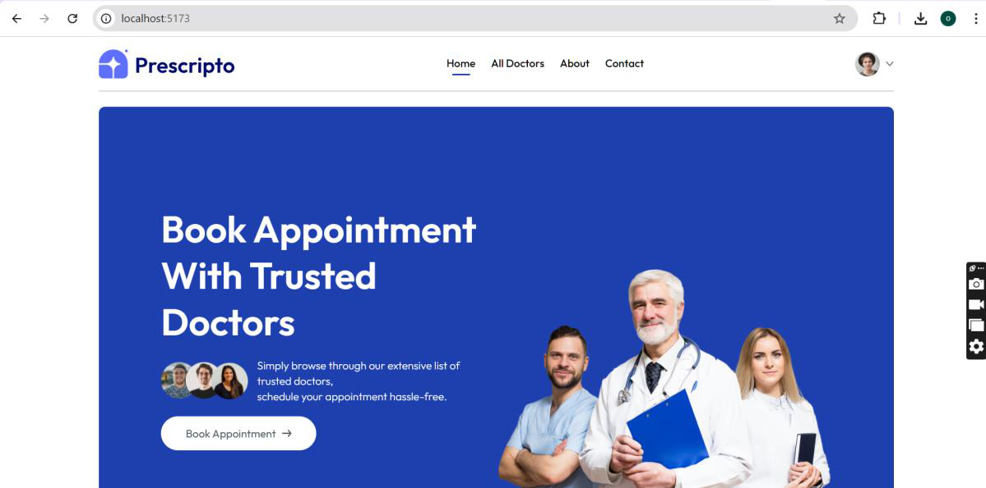
Find by Specialty page
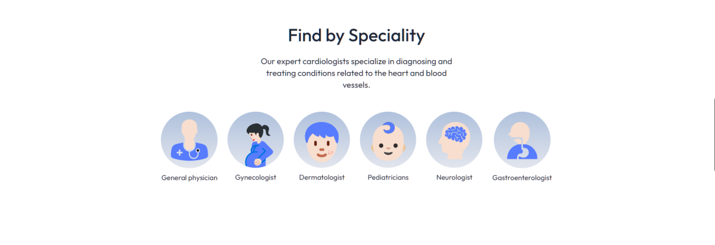
Top doctor page

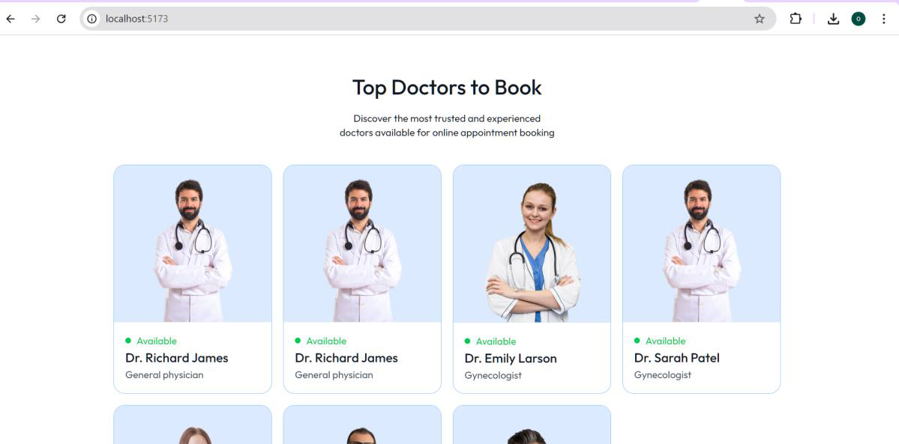
Book Appointment page
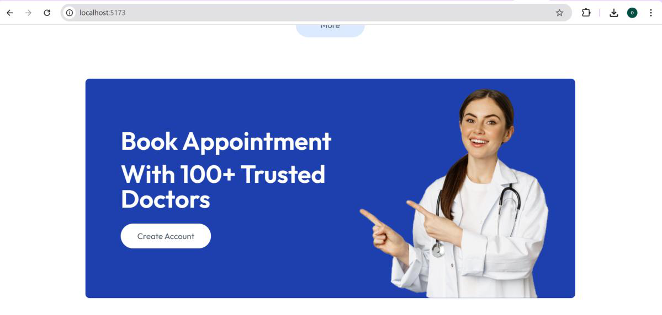
Footer page

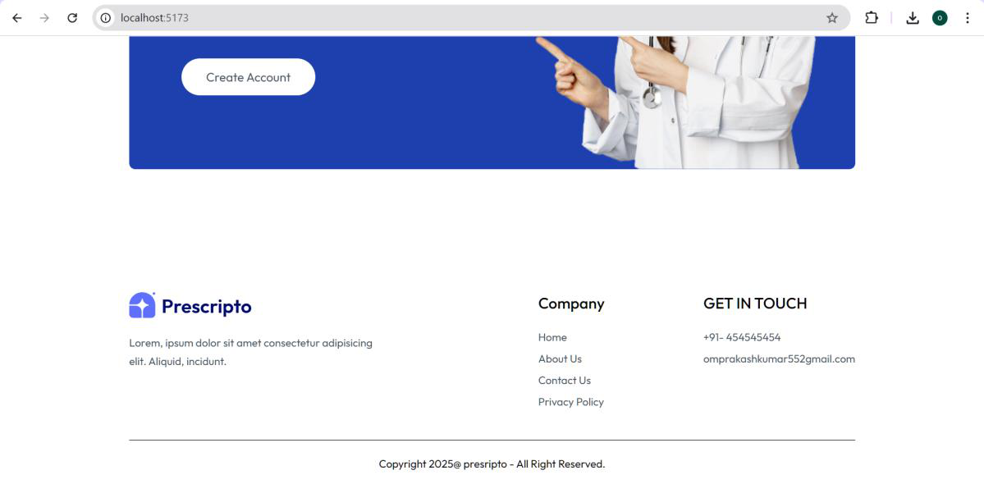
All Doctor page
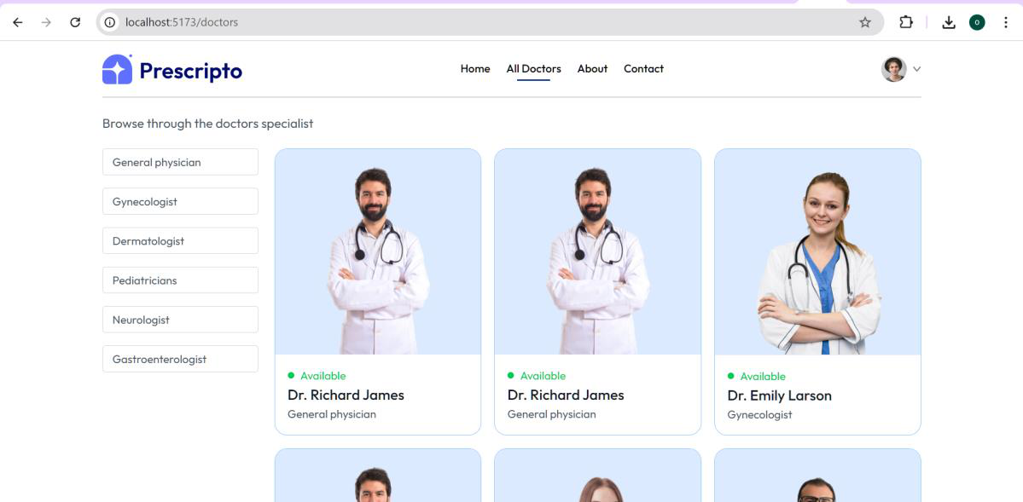
Individual doctor page with more information

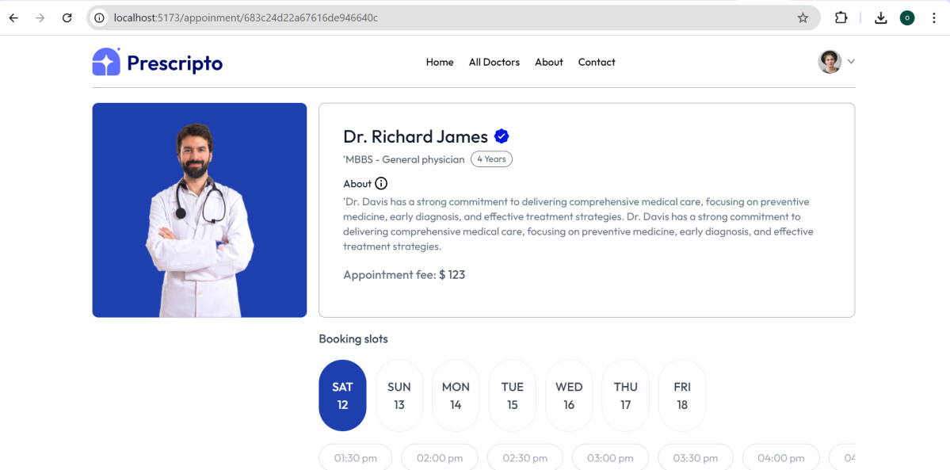
About page
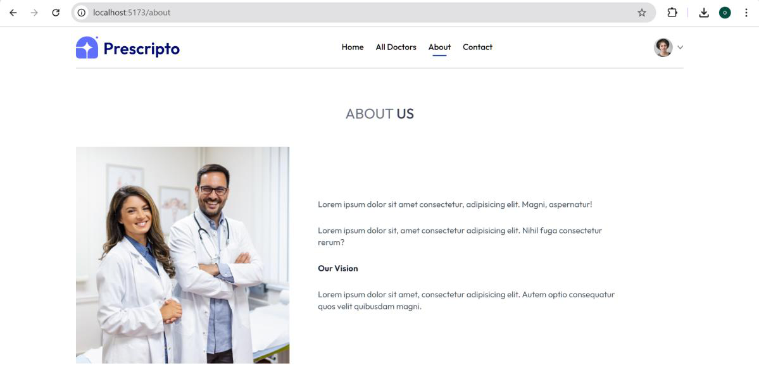
Contact page

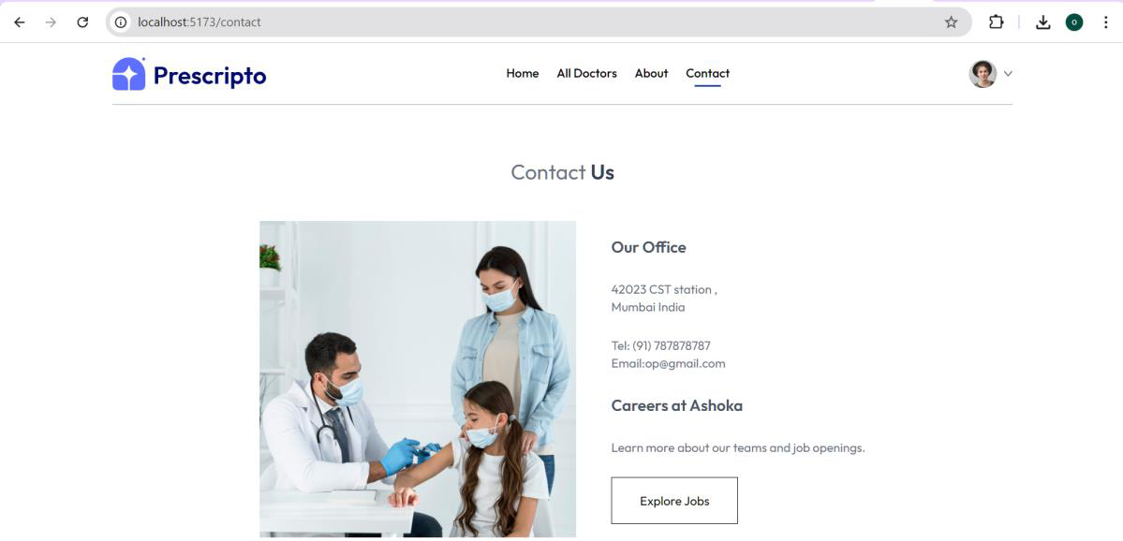
Login page
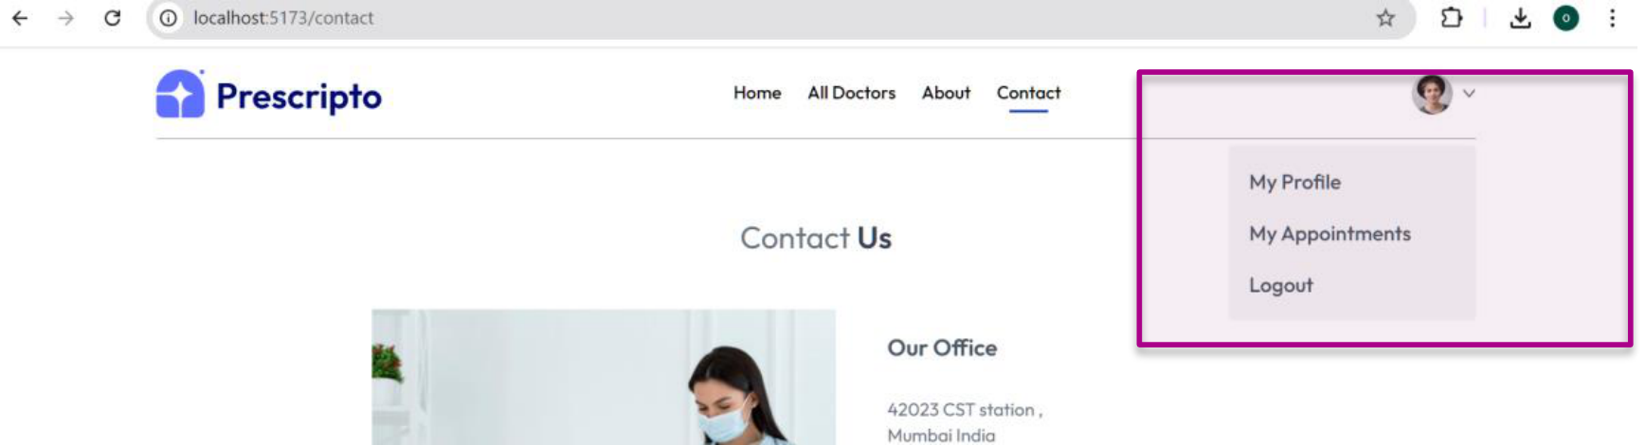

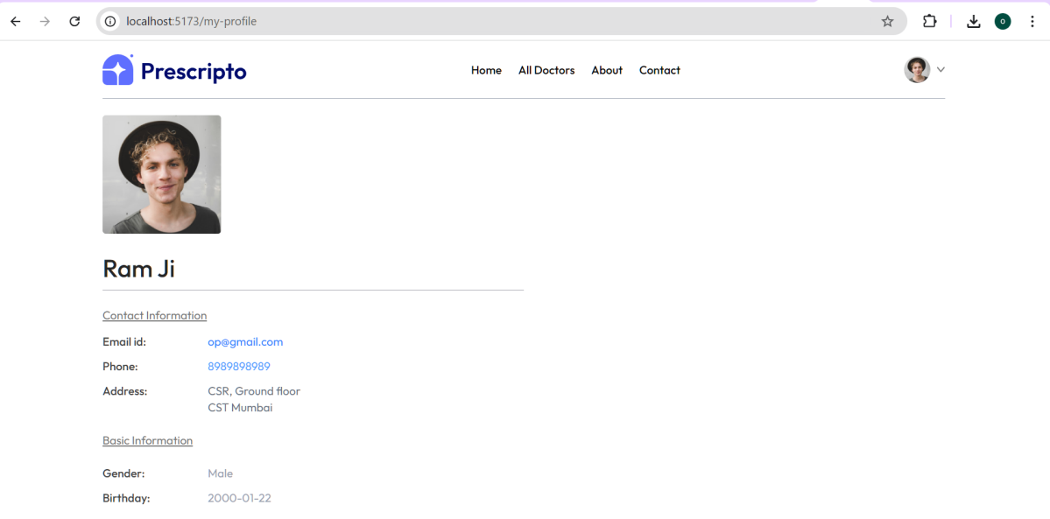
My appointment page
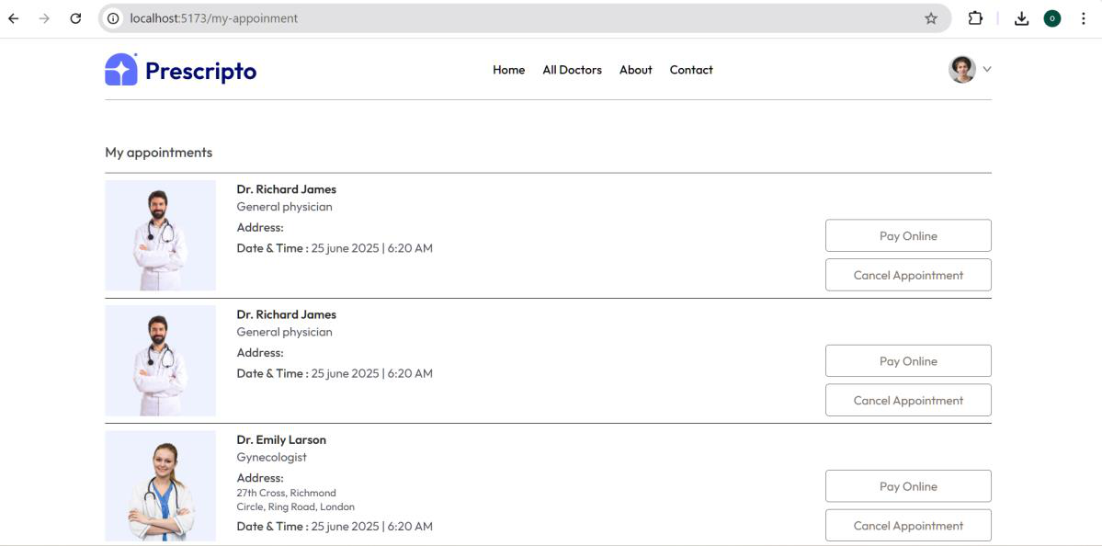
- Login/Signup Flow Diagram

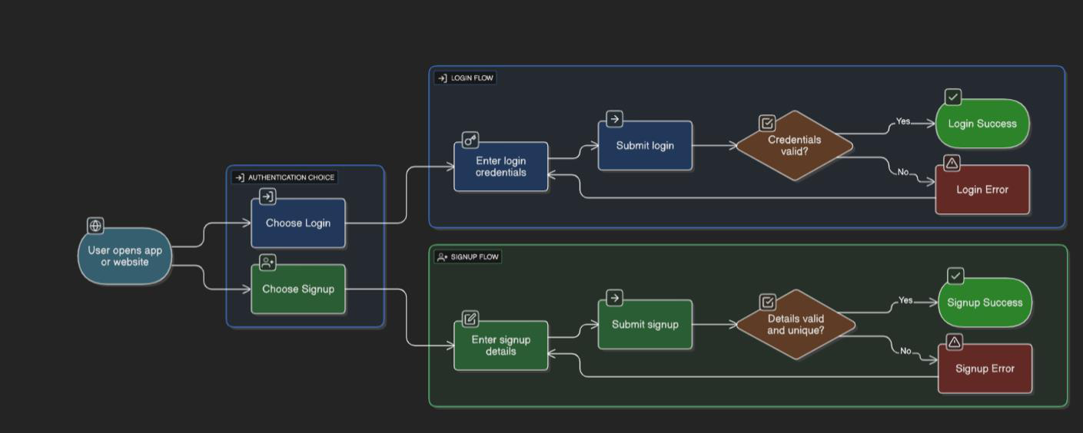
25. Data Dictionary
