ANNEXURE II
SUBMISSION OF PROJECT SYNOPSIS AND GUIDE ACCEPTANCE FORM (To be submitted to the Project Steering Committee)
PART A: Project Synopsis
I. Student Details:
1.Name of the Program: BCA
2.Name of the Student: omprkash Kumar
3.Roll Number: 2214502456
4.Session & Year: June/2022
II. Project Synopsis:
1.Title of the Project: Doctor Appointment Booking Application
2.Introduction and Review of Literature: In today’s fast-paced world, healthcare accessibility and timely appointment scheduling are essential.
Traditional appointment booking processes are often inefficient, time-consuming, and subject to human error. A digital solution that automates this process enhances convenience for both patients and healthcare providers. The Doctor Appointment Booking Application aims to address these issues by providing a web-based system where users can easily register, search for doctors, and schedule appointments. Several similar systems exist, such as Practo and Zocdoc, which validate the need and feasibility of this project. These platforms inspire improvements in user interface, real-time availability, and scalability tailored for clinics and hospitals of various sizes.
3.Objectives of the Study: To develop an online platform that allows patients to book doctor appointments efficiently.

To manage doctor availability, patient details, and appointment history digitally.
To enable admin roles for managing users and medical data securely.
To provide a responsive and user-friendly interface for all stakeholders.
4.Research Methodology: The methodology includes both primary and secondary research. Requirements are gathered through observation and informal interviews with users of existing systems. The development follows an Agile methodology with iterative cycles of development and feedback. Tools such as wireframing, user testing, and database normalization are used. The backend and frontend will be built and tested in phases, with continuous deployment and code versioning managed through Git .
This project follows a systematic software development lifecycle (SDLC) approach using Agile methodology to ensure iterative development, flexibility, and regular feedback incorporation.
The steps include:
A)Requirement Analysis
oInformal discussions with local doctors and patients to understand their pain points.
oStudy of existing platforms like Practo and Zocdoc to understand best practices.
B)System Design
oDesigning user interfaces using wireframing tools like Figma.
oPlanning database schema and API structure.
C)Development

oUsing MERN Stack (MongoDB, Express, React, Node) for scalable development.
oModular code structure with reusable components and secure backend logic.
D)Testing
oUnit testing and integration testing to ensure correctness.
oUser acceptance testing with real users to collect feedback.
E)Deployment and Evaluation
oDeploying frontend on Vercel and backend on Render or Railway.
oCollecting post-deployment feedback and performing refinements.
F) 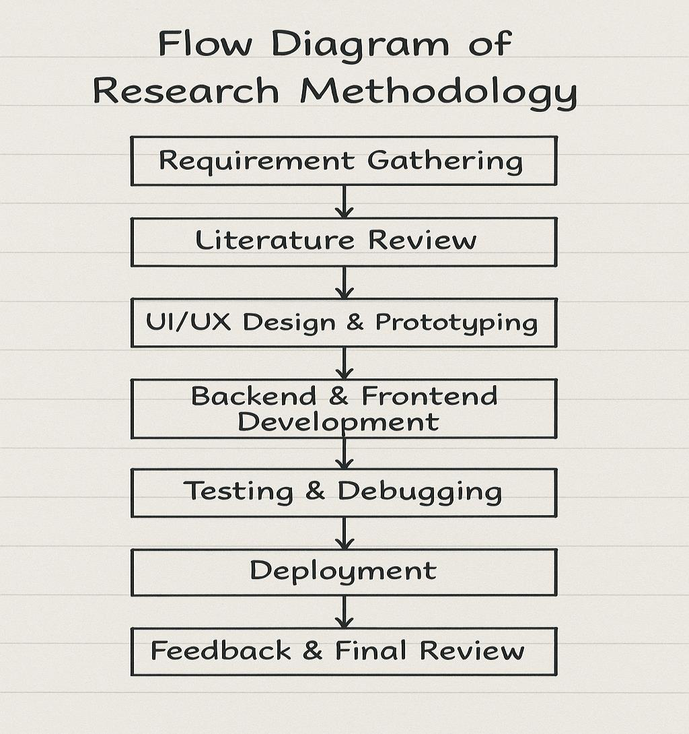

5.Technology to be Used:
•Frontend: React.js
•Backend: Node.js with Express
•Database: MongoDB
•Authentication: JWT (JSON Web Token)
•Deployment Platform: Vercel (Frontend), Render or Railway (Backend) •Tools & Libraries: Axios, Redux, Mongoose, Tailwind CSS
The MERN stack (MongoDB, Express, React, Node) is used for full-stack
development, ensuring modern, scalable, and maintainable code practices.
6.References
www.practo.com
III. Guide Details:
1.Name of Proposed Guide: Dipali Borade 2.Guide Registration No. (If available): 3.Designation: Software Engineer
4.Affiliation: NeoSoft
5.Qualification: BE in Computer Science 6.Total Experience: 5
7.Communication Address: Chinchwali 8.Contact No.: 9011537369
9.E-mail ID: boradedipali81@gmail.com
PART – B: Guide Acceptance

I, Mrs. Dipali Borade working with NeoSoft as Software Engineer hereby confirm my willingness to guide Mr. Omprakash Kumar Reg No. 2214502456 for the topic (title of the project) - Doctor Appointment Booking Application during the period July 2025 to Aug 2025.
Place: Pune

Date: 1/07/2025



(Note: A Guide needs to get registered with the University if he/ she is guiding a MUJDOE project for the first time. The guide Registration form can be downloaded from the LMS portal)

DECLARATION
I hereby declare that this project synopsis is an original work carried out by me and has not been/will not be submitted to any other University for the fulfilment of any course of study.
Place: Nashik
Date: 01/07/2025
(*Filled in application forms to be signed by both student and the Guide. Forms must be scanned in either .pdf/.doc format and submitted through the LMS student’s Login.)
