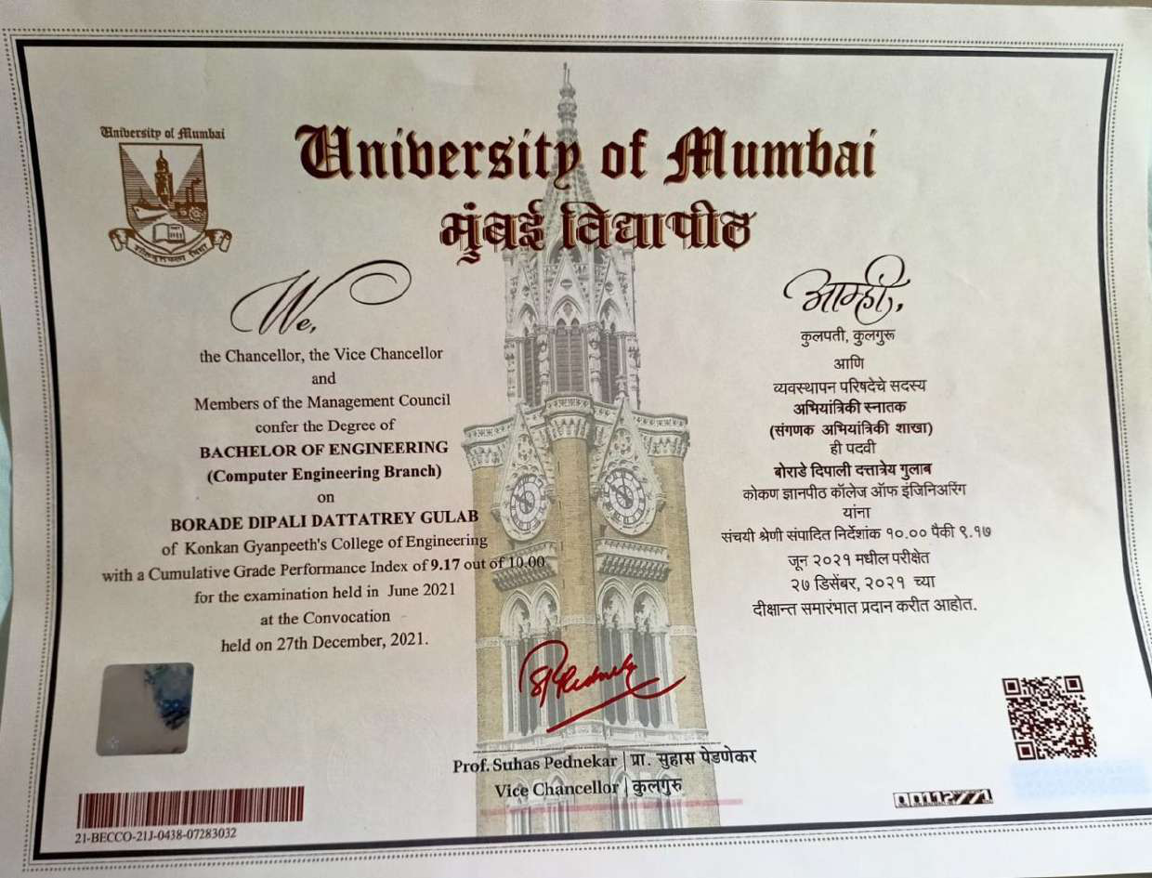

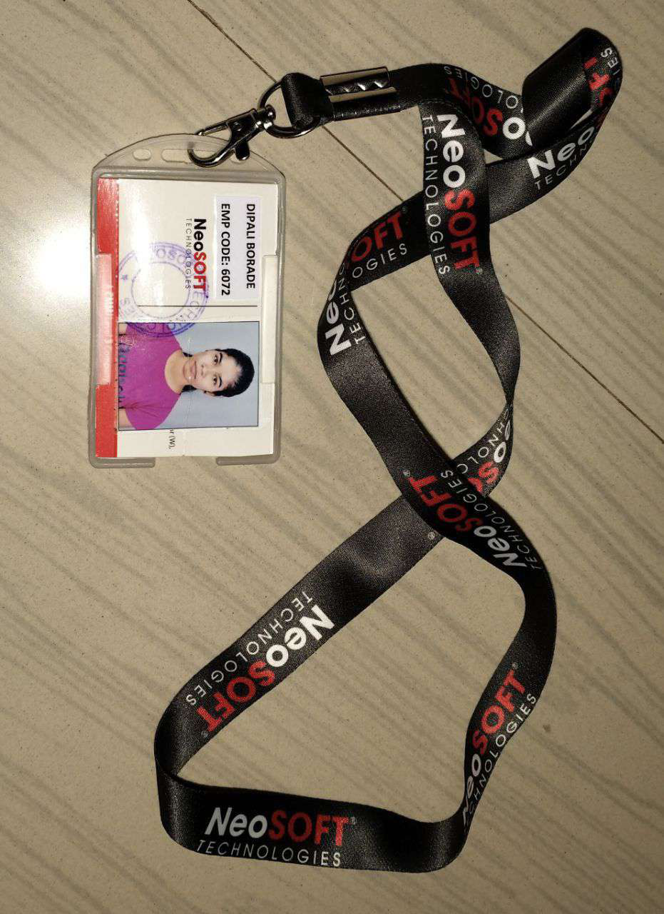

Date : 1 st January, 2022 Ms. Dipali Borade
At.Eksal, Tal. Karjat,
Dist.Raigad,
Post.Chinchawali
Maharashtra.
Pin Code - 410201.
Subject: Confirmation Letter
Dear Dipali,
Consequent to the review of your performance during 01st July 2021 to December 2021 we have the pleasure in informing you that your services are being confirmed as
“Trainee Software Engineer” with effect from January 2022.
Kindly note that your compensation is personal confidential information of the company. Any discussion or disclosure of your compensation with anybody other than your departmental head or HR will be considered as breach of agreement by you.
Performance linked incentives are paid annually if any.
All the other terms and conditions as detailed in your appointment letter remain unchanged.
For NeoSOFT Private Limited

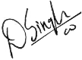

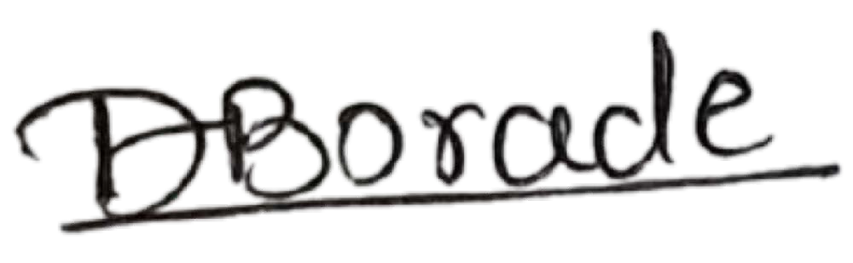

Ms. Simran Singh
(Associate Vice President – HR)


