RADHARANI JEWELLERY WORKS
Radharani ERP
Step-by-step manual
For counter staff, managers and the owner. Every job in the system, one step at a time.
Version of 14 October 2026

What is in this manual
Each part is one job in the shop. Open the part you need and follow the numbered steps. The pictures show the screen as it looks, so you can check you are in the right place.
- Part 1. Getting started: signing in, finding your way, and the few rules that apply everywhere
- Part 2. Every morning: today's rates
- Part 3. Stock: adding pieces, boxes and packets, HUIDs, raw material
- Part 4. Vault and counter: taking pieces out in the morning, putting them back in the evening
- Part 5. A custom order from start to finish
- Part 6. The karigar desk
- Part 7. Hallmarking
- Part 8. Selling: the sale, GST, payments, the bill and verification
- Part 9. Old gold and silver: exchange and the refinery
- Part 10. The monthly scheme
- Part 11. Purchases of raw material
- Part 12. Customers
- Part 13. Reports, exports and messages
- Part 14. For the owner: locations and trays, pricing rules, GST rates
- Part 15. Quick answers when something looks wrong

The boxes you will see
Note Something good to know.
Tip A shortcut or a way to save typing.
Careful Something that is easy to get wrong, or cannot be undone.
Admin only A job only the owner, a manager or an admin can do. If you do not see the button, that is why.

Part 1. Getting started

1.1 Signing in
- Open the ERP address in your browser.
- Choose Email or Mobile at the top of the form. You can sign in with either.
- Type your email (or your 10 digit mobile number) and your password, then press Sign in.
- You land on the Dashboard.
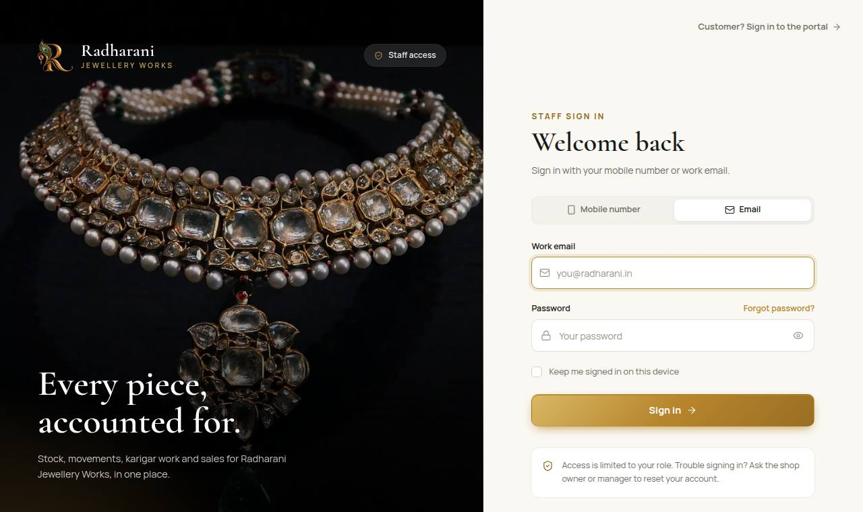
The sign-in page
Note Everything you do is recorded with your name. Never sign in with someone else's login, and sign out when you leave the counter.

1.2 Finding your way around
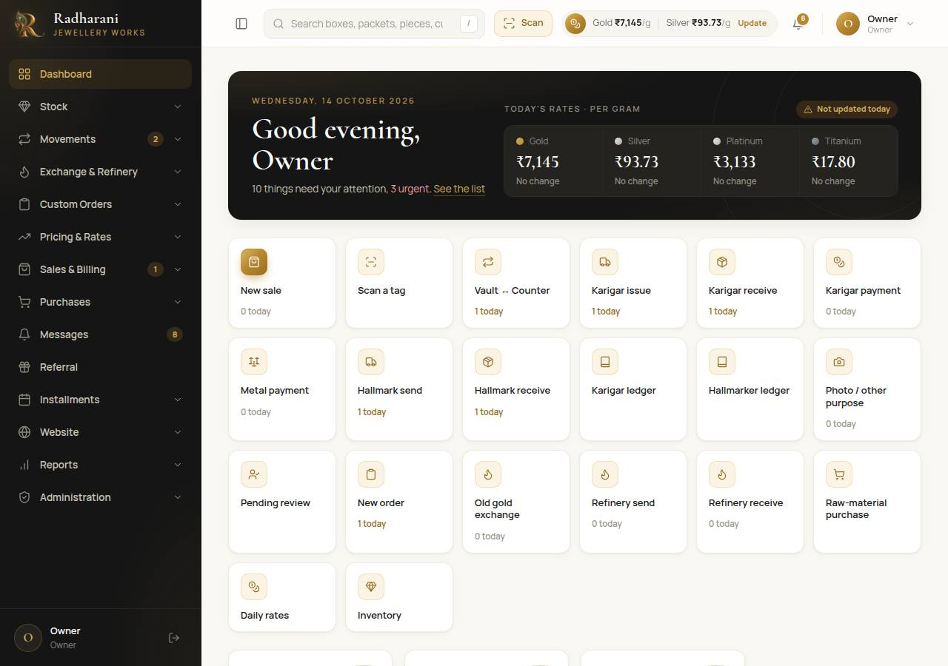
The dashboard, with the menu on the left
- The menu on the left has a group for each kind of work: Stock, Movements, Exchange and Refinery, Custom Orders, Pricing and Rates, Sales and Billing, Purchases, Messages, Referral, Installments, Website, Reports and Administration. Click a group to open it. The menu stays where you scrolled it when you move from page to page.
- Search at the top finds boxes, packets, pieces, customers and orders. Press the / key to jump to it.
- Scan at the top opens the camera. Point it at any QR sticker or barcode and the system opens that piece, packet or box. The camera needs the secure (https) address.
- The rates chip shows today's gold and silver rate. If it says the rate is old, go and enter today's rates (Part 2).
- The bell shows how many messages are waiting to be copied and sent to customers (Part 13).
- The round button with your name at the top right is for your profile and for signing out.

1.3 The rules that apply everywhere
- History is never edited. If something was recorded wrongly, you do not change it. You add a new entry that corrects it, and an owner approves where needed. This is what keeps the stock records trustworthy.
- Photos are needed when pieces leave or come back (karigar, hallmarking, refinery). Take them with the phone. The system shrinks them automatically.
- Weights are typed in, never worked out. Weight loss from a karigar or a hallmarking centre is what you weighed, not a calculation.
- Pieces that come back wait for review. Anything returning from a karigar or hallmarking sits in Pending Review until an admin confirms it into stock.
- A sale is not final until an admin verifies it. Until then the pieces are held for it.

Part 2. Every morning: today's rates
Every price in the system comes from today's rate. When you enter the rates, every piece is priced again at once. Nothing else needs updating.

2.1 Entering the rates
- Open Pricing and Rates, then Daily Rate Entry.
- For each metal there is a rate for every carat: gold 24K, 22K, 18K, 14K and 9K, silver 99.9 and 92.5, platinum and titanium.
- Type today's rate per gram for each carat you sell. Leave a carat empty if you do not sell it.
- Press Save today's rates. The rates chip at the top updates.
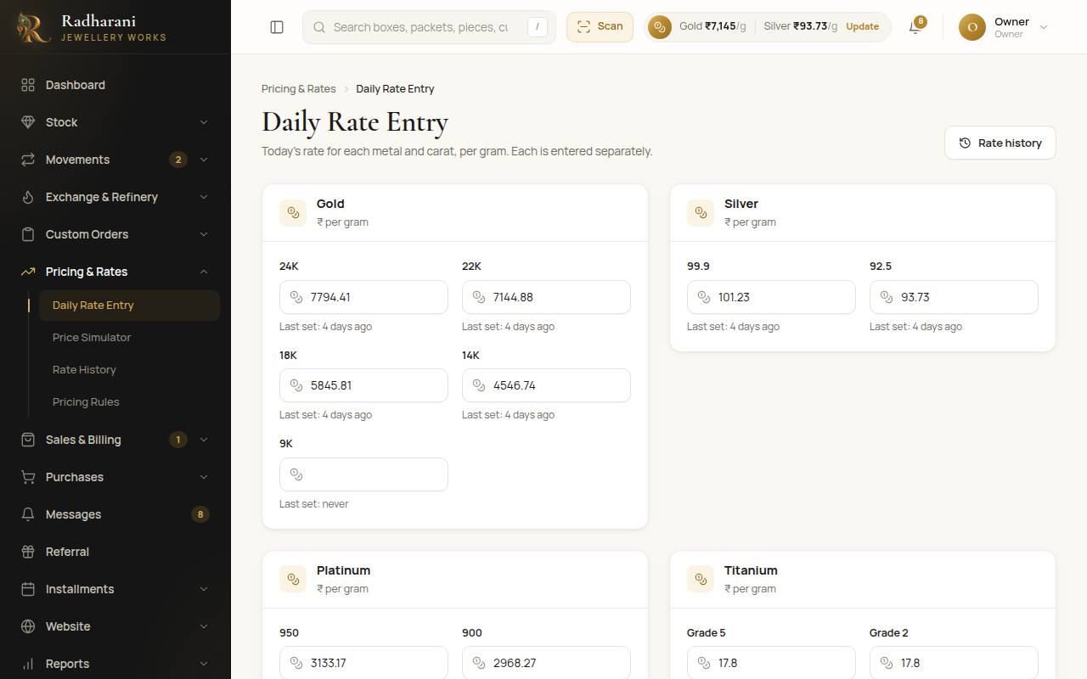
Daily rate entry
Note A carat with no rate has no metal value, so pieces of that carat show a price with no metal in it. If a price looks too low, check that the carat has a rate today.
Admin only The same page sets the exchange deduction for each metal and carat: the percentage taken off when old gold is melted (Part 9). Rate History shows every rate that was ever entered.

2.2 Checking a price: the price simulator
To see what a piece would cost before it exists, open Pricing and Rates, then Price Simulator. Choose the metal and carat, type the weight, and the price builds up line by line: the metal, the making charge, stones, hallmarking, extra charges, any discount, and the GST.
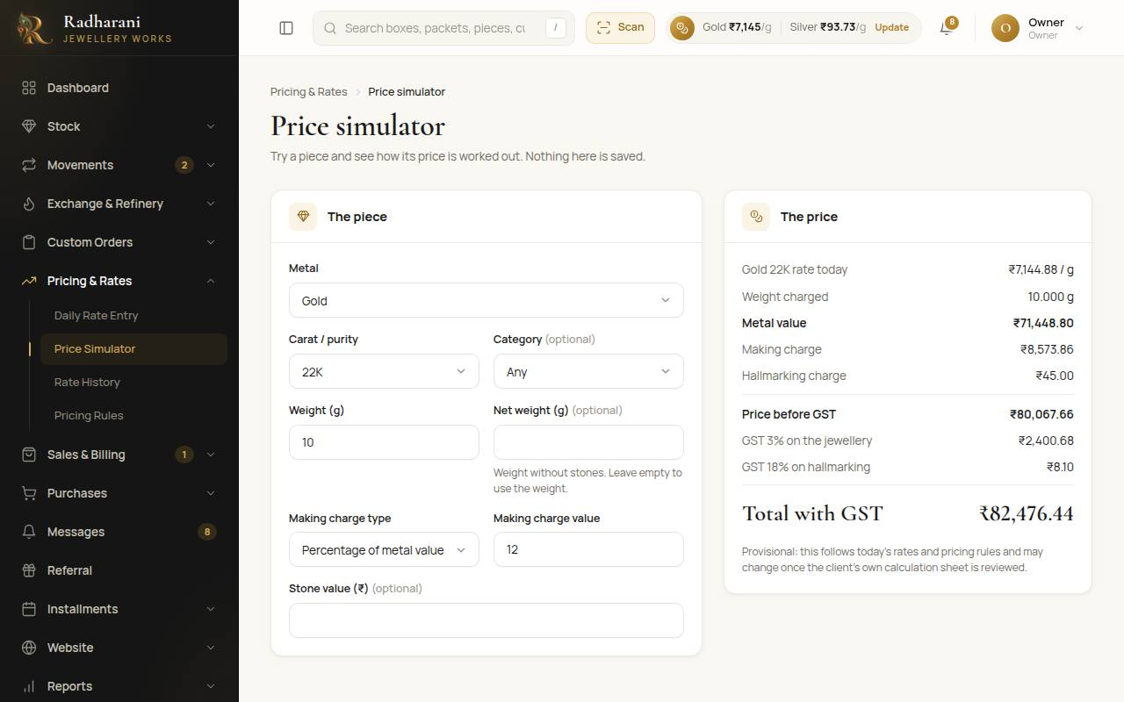
The price simulator

Part 3. Stock
Stock holds three levels. A box contains packets, and a packet contains pieces. A piece can exist before it is in a packet, and fill-up can happen later.

3.1 Adding one piece
- Open Stock, then Inventory, and press Add piece.
- Choose the metal and the subcategory (for example Gold, then Ring). Choose the carat.
- Type the weight. If the piece has stones, also type the net weight (the metal alone). The metal is priced on the net weight.
- Set the making charge: a percentage of the metal value, a flat amount per piece, or a flat amount per gram.
- If the piece has a HUID, type it. A piece with no HUID gets a short internal code automatically.
- Choose a packet if you know it, or leave it for later.
- Press Add to stock. You can then print the QR sticker for it from the piece's page.
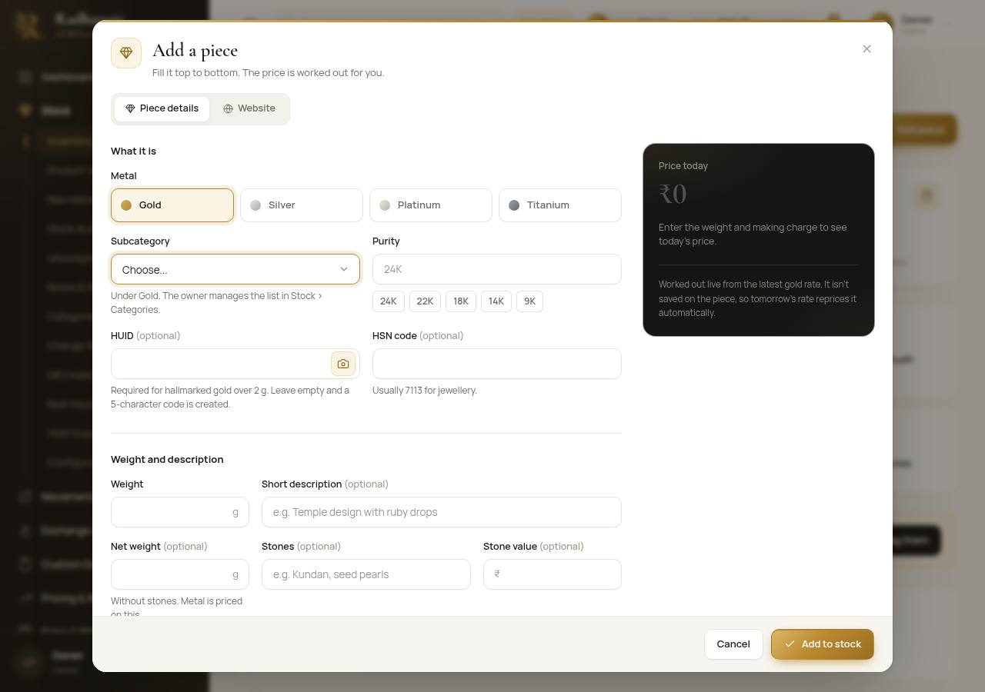
The Add piece form

Diamond pieces
Choose the subcategory Diamond. The form then asks for the diamond weight in carats, the cut and a summary number. The gold weight is the net weight, and the diamond's value goes in the diamond value box. All of it shows on the piece's page and on the bill.

Pairs
Earrings and bangles can be added as a pair. Each piece keeps its own weight, and the two stay linked.

3.2 Adding many pieces at once: bulk import
Open Stock, then Bulk Import. There are four steps, shown across the top: Upload file, Match columns, Review rows and Done. Nothing is saved until you have reviewed every row.
- Press Template (or Download blank (HUID format) on the right) to get a sheet to fill in, one row per piece. Weight is needed for every piece.
- Upload file. Drop the Excel or CSV file on the page. Up to 1,000 rows.
- Match columns. Say which of your columns is the weight, the category, the HUID and so on. Your own column names are fine.
- Review rows. Every row is checked. Rows with a problem say what is wrong and cannot be included. Rows that look like pieces already in stock are flagged and left out unless you tick them.
- Press Import N and confirm. All the pieces from one import are kept together as one batch, named by the date and time.
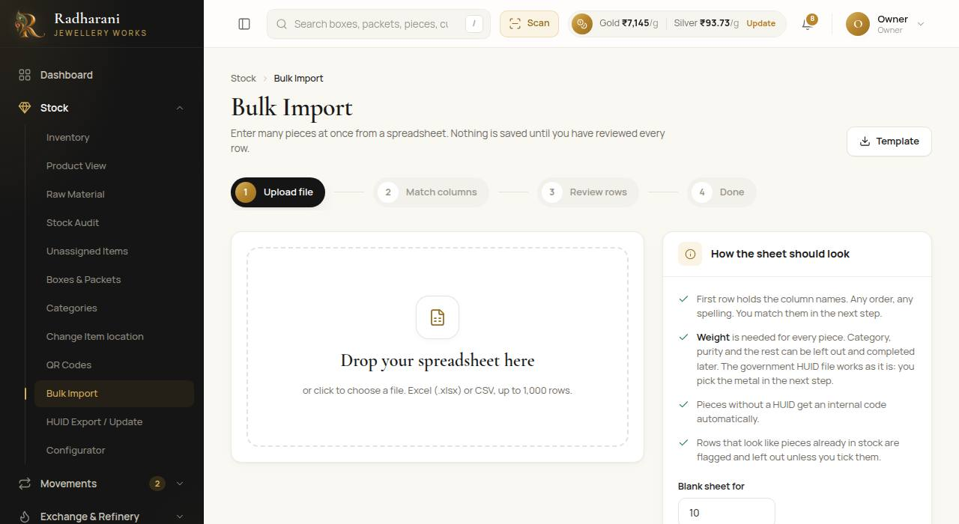
Bulk import

3.3 Boxes and packets
- Open Stock, then Boxes and Packets. Boxes and packets are in one list.
- New box and New packet open a small form. A packet can sit in a box or stand alone.
- Open a box or packet to see what is inside, where it is, and its full history.
- A box or packet with nothing in it can be removed. One with pieces in it cannot.
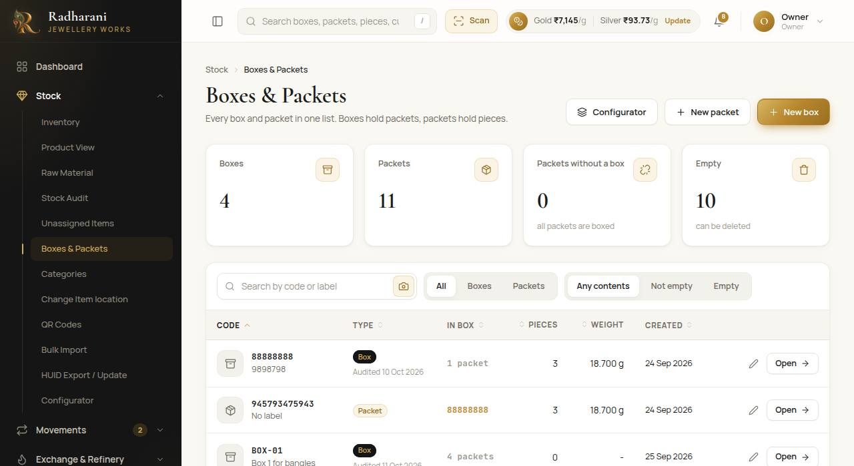
Boxes and packets
Tip To reorganise many things at once, use Configurator: drag pieces onto packets and packets onto boxes, or tick them and use Move to. Every move is saved in each piece's history.

Moving pieces between packets: Change Item location
Open Stock, then Change Item location. Scan or choose a packet or box first, then scan pieces into it one after another. You can also pick pieces from a list, or upload a sheet of codes and destinations. A packet whose name has spaces, like GENTS RING, is understood as one code.

3.4 Pieces not in a packet yet: Unassigned Items
Stock, then Unassigned Items, lists every piece that is in no packet, grouped into batches by when it was entered, newest first.
- Tick the pieces (or tick a whole batch) and press Move to packet to put them away.
- To save a batch as a spreadsheet, press Export CSV on that batch. Export all as CSV at the top saves every batch, with a column that says which batch each piece came from.
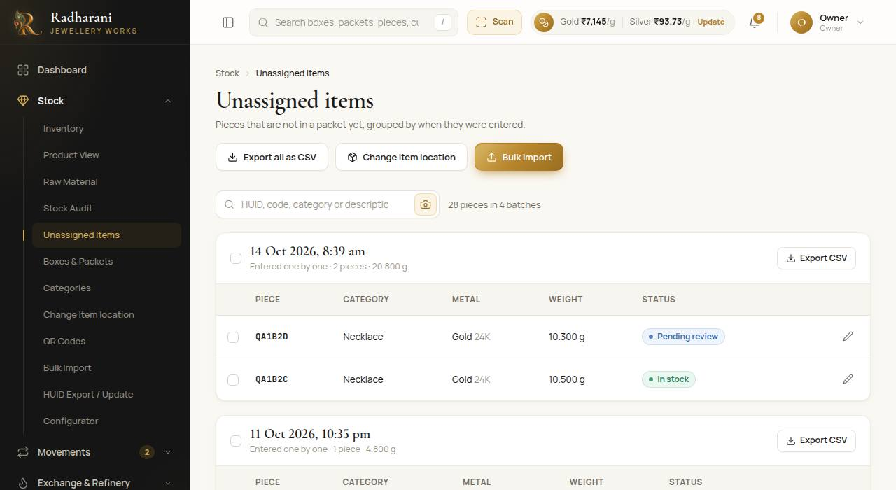
Unassigned items, grouped by batch

3.5 HUIDs: export and update
Open Stock, then HUID Export / Update. This page does two jobs.
- Choose Which pieces: all of them, or just one batch (an import, or the pieces added together at one time).
- Press HUID file to download the file in the layout of the government HUID website.
- Press Excel sheet or CSV for every detail of each piece. Fill in the HUIDs and other leftovers.
- Upload the filled sheet in step 2. The page shows what will change. Confirm to apply it. Each change is saved in that piece's history.
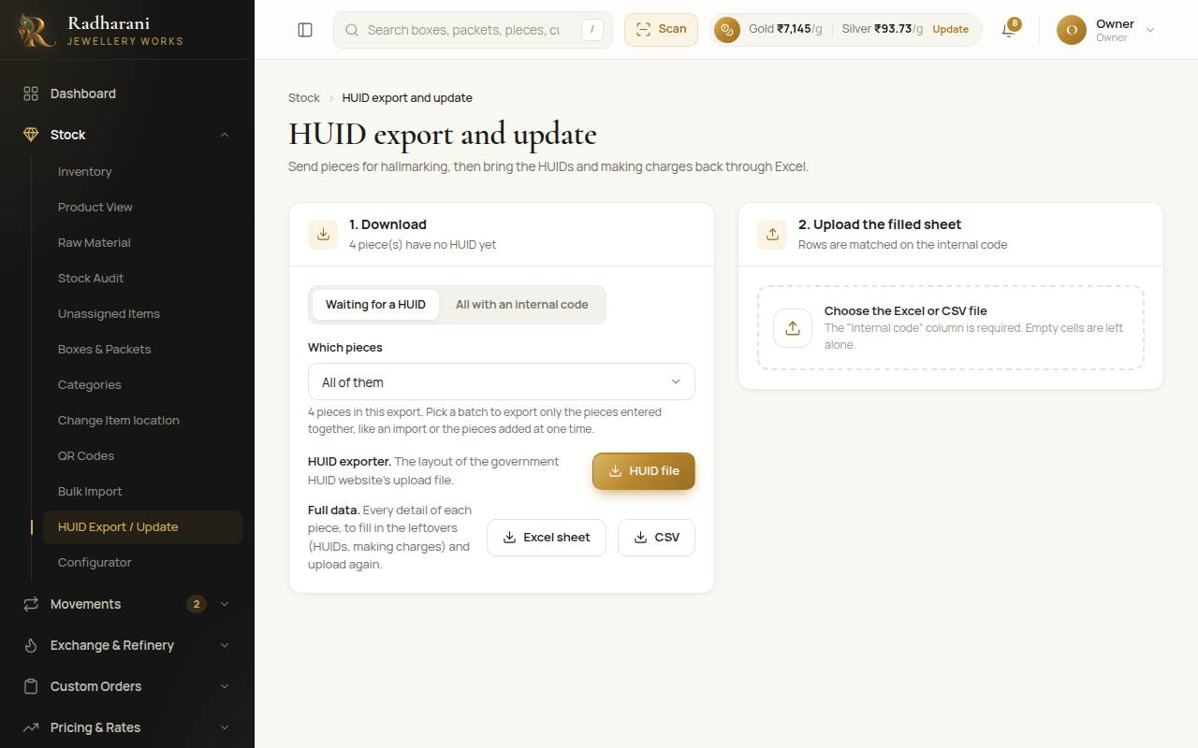
HUID export and update

3.6 The Inventory page
Stock, then Inventory, lists every piece. Search by code, or narrow by category, box, metal and status. Click a piece to open its page: price, history, QR sticker, and where it came from. The tiles under the figures take you straight to the stock pages you use most, with live counts for the unassigned pieces and the review queue.
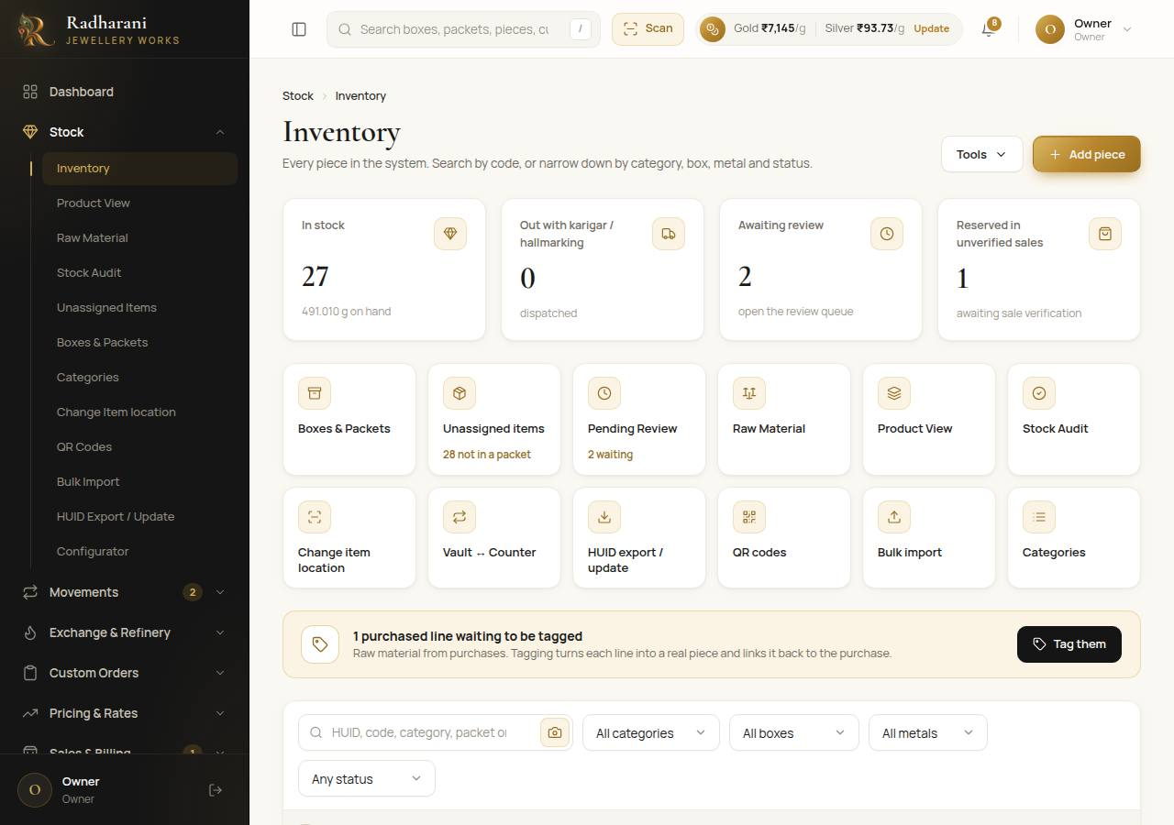
Inventory, with the link tiles

3.7 Raw material
Raw material is metal the shop holds that is not yet a finished piece: bought metal, old gold from exchanges, scrap, and metal lent to karigars. Open Stock, then Raw Material.
- In shop, With karigars, At the refinery are the three places metal can be. Each shows the balance by metal and carat.
- Metal has a kind: Refined (ready to use), Old metal from exchange (taken in, not yet refined) or Scrap.
- Under the balances is the ledger: every change, with who made it. Nothing is ever edited. Export CSV saves it.
- Purchases, settled exchanges, the refinery and the karigar desk add to and take from this automatically. You do not type those.
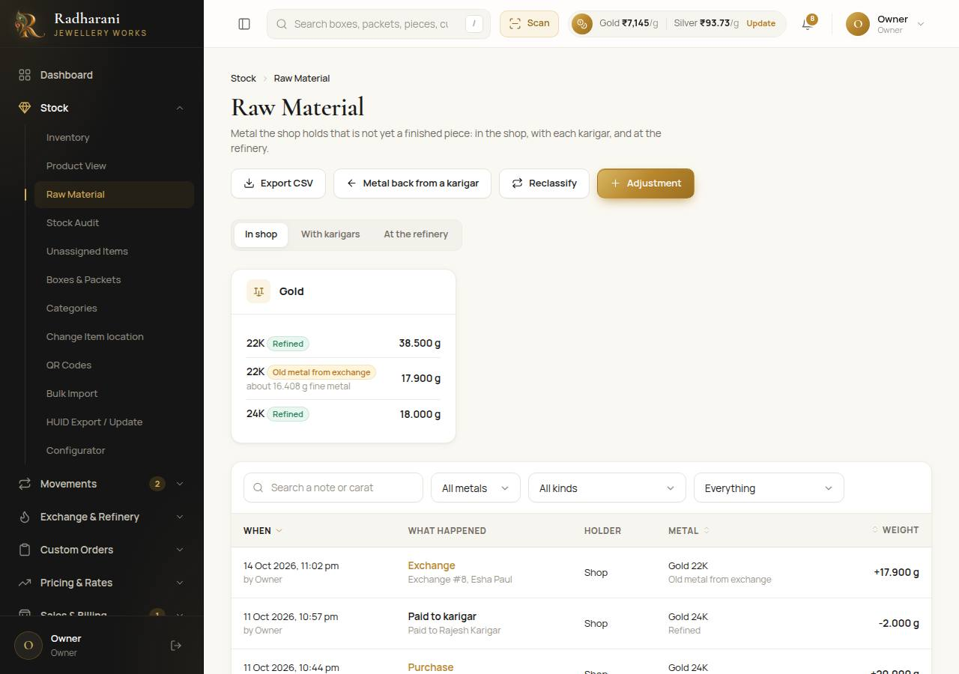
Raw material
Admin only Three actions are for owners and managers. Adjustment adds or removes metal with a reason, for example an opening balance. Reclassify treats old metal or scrap that has been melted and tested as refined, so it can go to a karigar. Metal back from a karigar returns metal a karigar was advanced but did not use.
Careful A karigar advance or payment in metal can only use refined metal. If old metal is what you have, refine it through the refinery or reclassify it first. The screen tells you when this is the reason.

Part 4. Vault and counter
The vault holds the stock. Each morning pieces go out to the counter, and each evening they come back. The system keeps the record of what is where.

4.1 Morning: sending pieces to the counter
- Open Movements, then Vault and Counter. Send to counter is selected.
- Under Going to, choose the counter or display the pieces are going to.
- Put each piece, packet or box on the list: scan its tag, or type a code, a name or a category in the same box and pick from the list that appears. You can also paste several codes at once.
- A message under the box tells you what happened: added, or why not (sold, out with a karigar, waiting for review).
- When the list is right, press the Send N to button at the bottom (it names the counter). One entry is recorded for each line, with your name and the time.
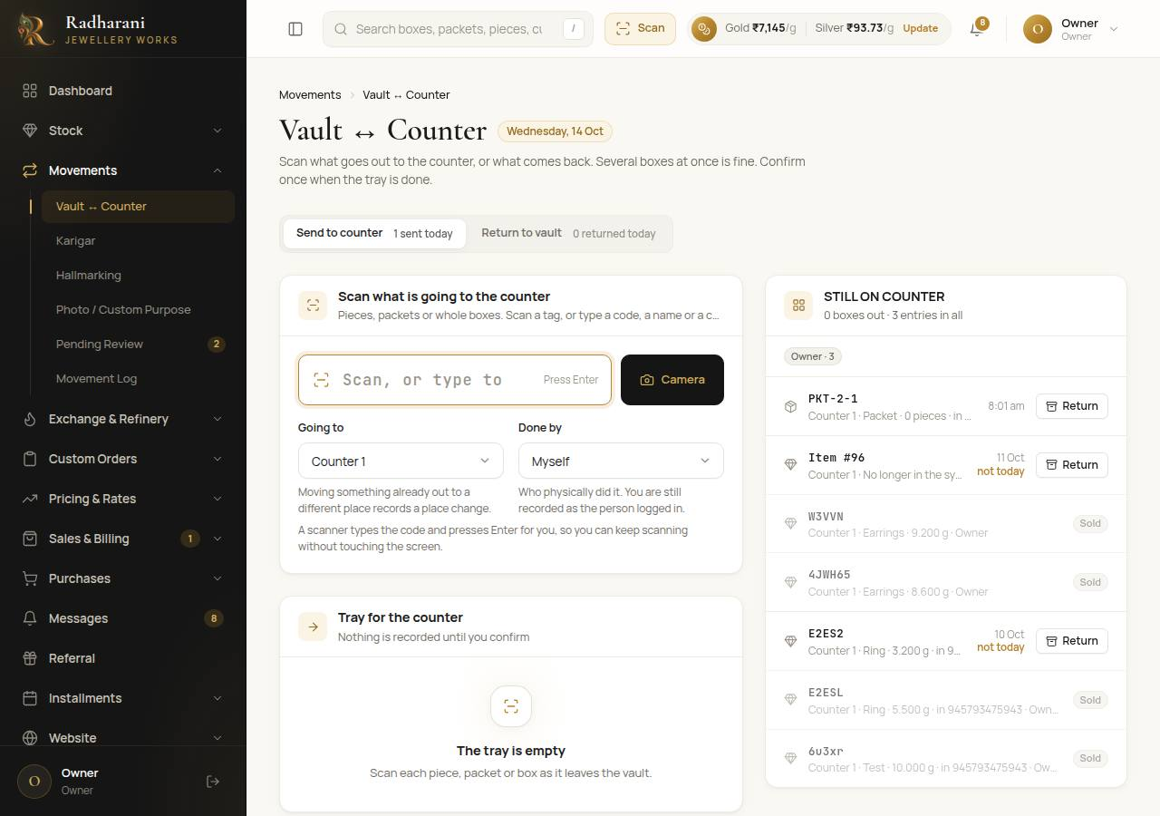
Vault and counter. The scan box also searches.
Note If a packet's box is already on the counter, scanning the packet says so and adds nothing. If you send a box while one of its packets is already out on its own, you are warned.

4.2 Evening: putting pieces back
- Press Return to vault at the top.
- Scan or search everything that is left unsold. The list on the right shows what is still recorded on the counter, so you can see what has not been scanned back.
- If the vault has trays, you can choose a tray under Put on a tray. Leave it empty for just the vault.
- Press Return N to Vault. If something on the counter was not scanned, the screen asks you to confirm.
Tip The Return button beside a row in the Still on counter list returns that one thing straight away, without a list.

4.3 Trays in the vault
A tray is a place inside the vault. Choosing a tray when you put pieces back records where in the vault they are. Open Reports, then Location Report to see every place and how many pieces and how much weight is in it. The vault line includes its trays and lists them. Open a tray to see exactly what is on it.
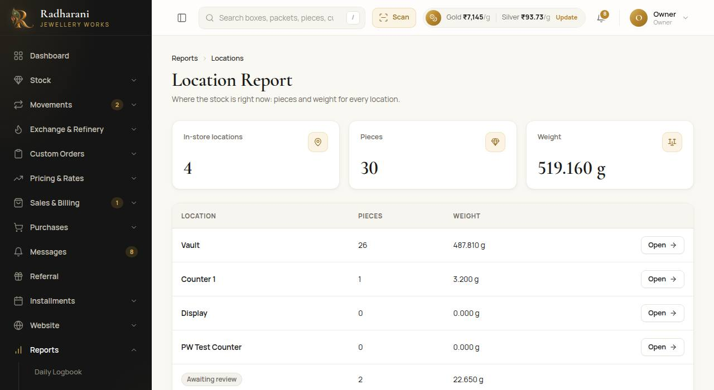
The location report
Admin only The owner adds trays under Administration, then Locations (Part 14).

Part 5. A custom order from start to finish
A customer asks for a piece that is not in stock. The order moves through the shop in a fixed path. Each step opens the next with everything already filled in, so you only add what is new.
The path: Order, then Karigar, then Hallmarking, then Pending Review, then Sale. The order page shows where it is.

5.1 Taking the order
- Open Custom Orders, then New Order. (Status Board shows every order by stage, and Ready Reminders lists the ones ready for collection.)
- Step 1, the customer: search, or press New customer to add one on the spot (name and mobile are enough, GSTIN is optional).
- Step 2, the product: describe it, choose the metal and category, estimated weight, expected ready date, and where it will come from (made by a karigar, in stock, bought in). Add reference photos if the customer has any.
- Step 3, the advance: type what the customer pays now. Tick Full payment now to lock the rate at today's. If the customer has exchange credit, you can put part of the advance from it (Part 9).
- Press Place order. A message for the customer is queued in Messages.
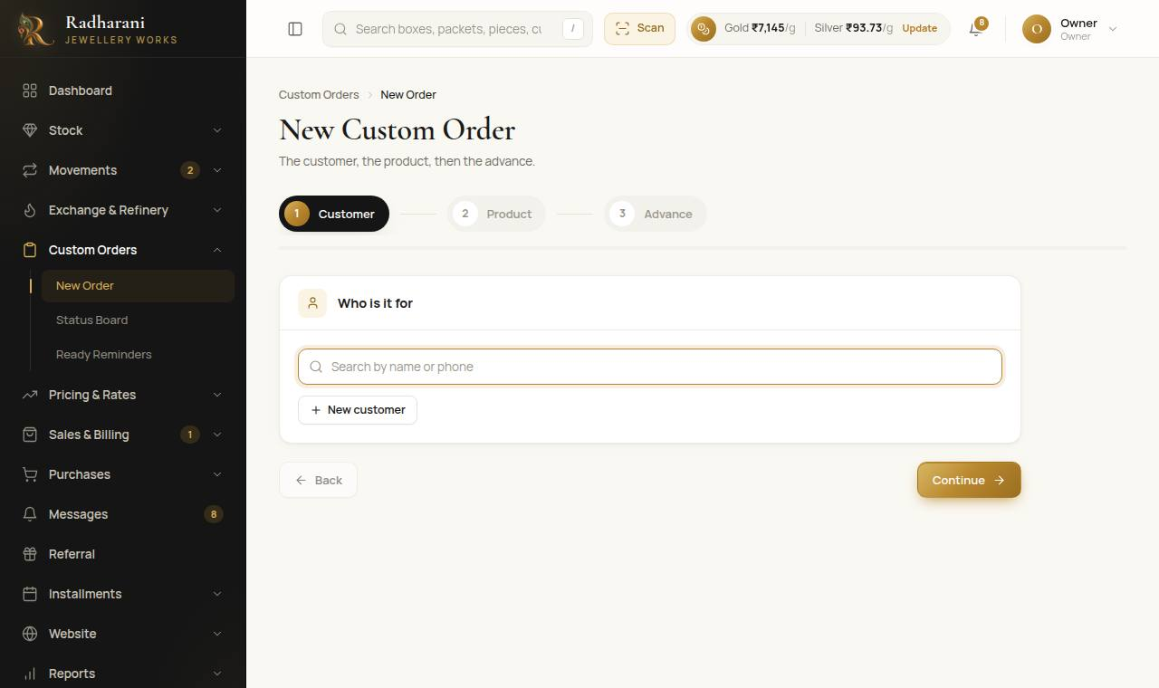
A new custom order

5.2 The order page
Open any order to see its path. Each step has a status (To do, In progress, Done) and an Open button that takes you to that screen already set up for this order.
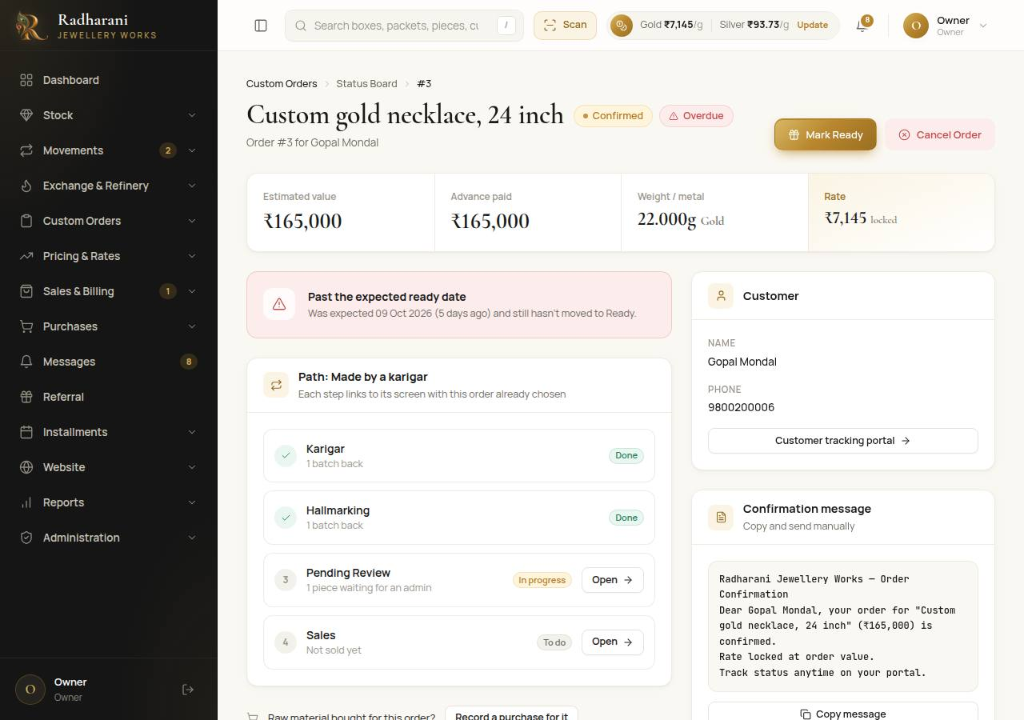
An order and its path

5.3 Sending it to a karigar
- On the order page, press Open beside Karigar.
- The Karigar desk opens about this order only. A banner shows the order, the customer and the reference images. Only the steps that apply to it are shown.
- The form is already filled in: description, metal, estimated weight, the subcategory and the due date. Choose the karigar, check the pieces expected, and take the photo of what goes out.
- If you are lending metal, tick With an advance and fill in the cash and/or the metal. Metal comes off the raw material balance.
- Press Issue batch and print the report. The job sheet prints with the photo and the customer's reference images, for the karigar to sign.
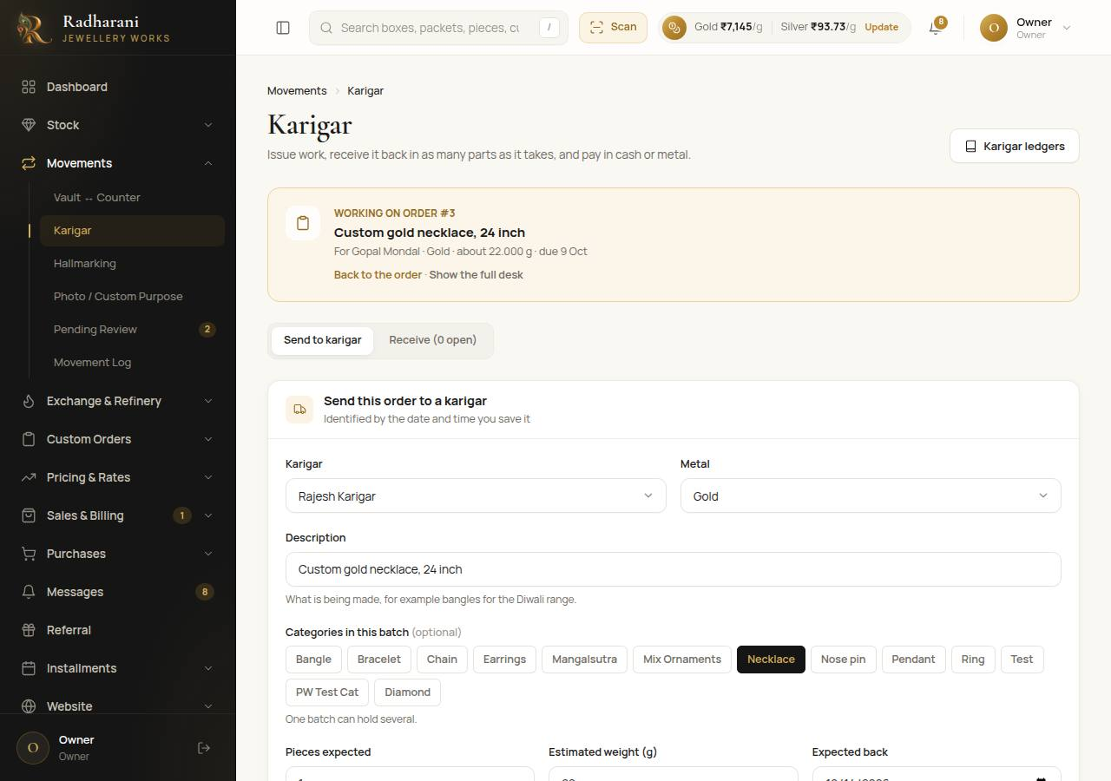
The karigar desk, opened from an order
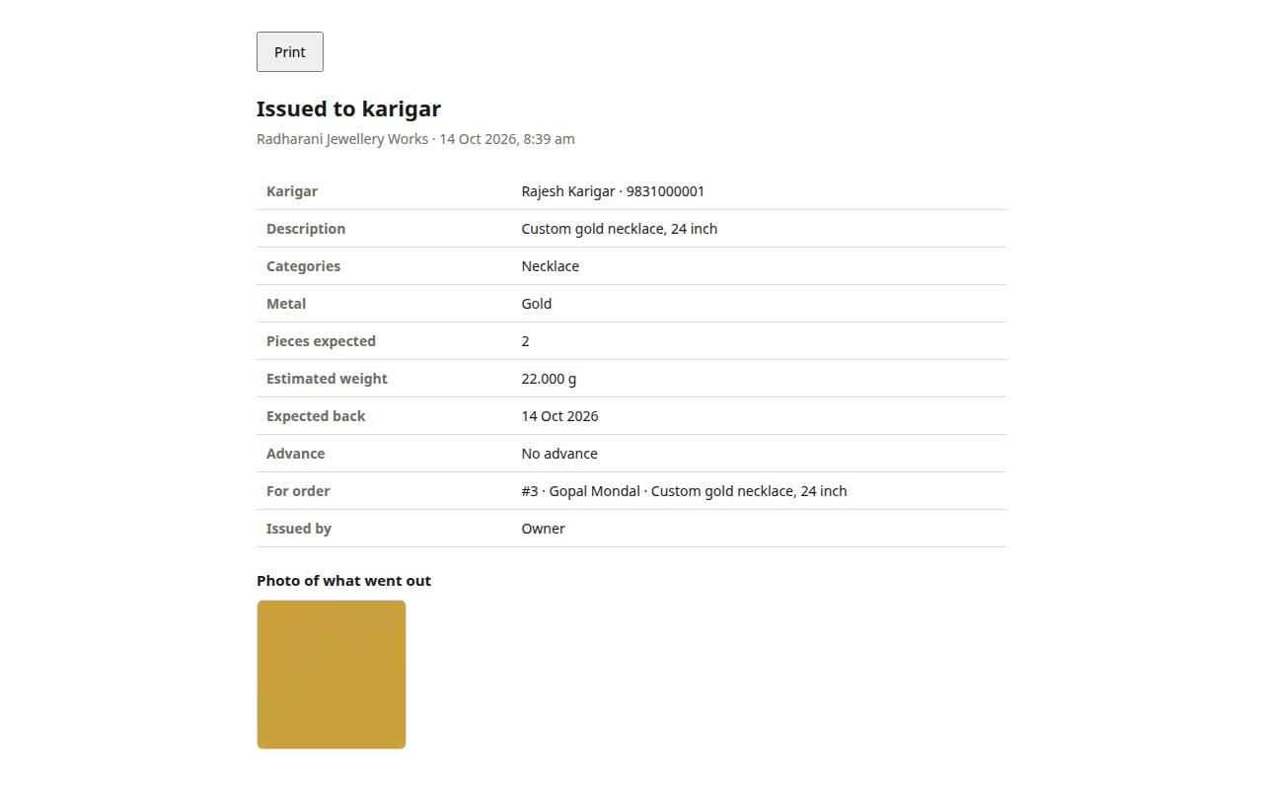
The printed job sheet
Note Press Show the full desk in the banner if you need the normal Karigar page with all its tabs.

5.4 When the work comes back
- Open the order again and press Open beside Karigar. It goes straight to Receive for this order's batch.
- Choose where the pieces go: Add to stock, or Send for hallmarking.
- To stock: choose the subcategory and carat (already suggested), type the weight of each piece (one number per piece), the weight loss if any, and take the photo. Each piece waits in Pending Review.
- For hallmarking: type how many pieces and their total weight, the loss, and the photo. A green box appears: Send to hallmarking.
- Press it. The Hallmarking screen opens for this order with the pieces already ticked. Choose the centre, take the photo, and press Confirm dispatch. You land back on the order.

5.5 Hallmarking and the return
See Part 7. When the pieces come back with their HUIDs they wait in Pending Review.
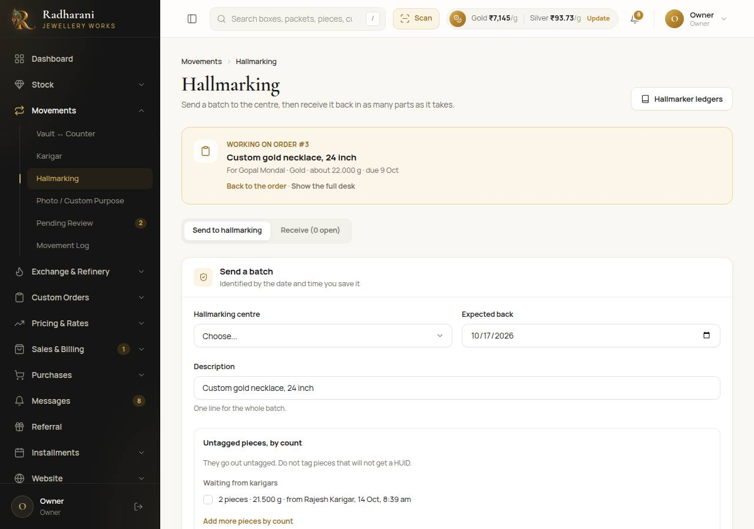
Hallmarking, opened from an order

5.6 Confirming, then selling
Admin only An admin opens Movements, then Pending Review. Each piece made for an order says For order #3 and the customer's name. Check it and press Confirm, or Confirm and sell to confirm it and open the sale for that order straight away.
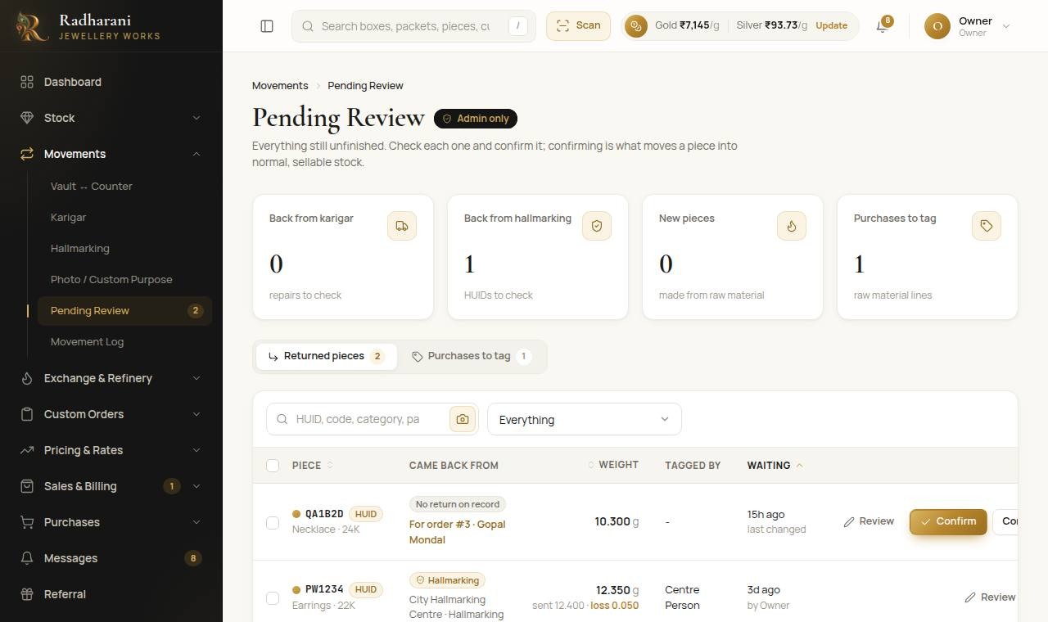
Pending Review
The sale for an order opens at the Items step with the customer chosen and the order's confirmed pieces already in the cart. Pieces still waiting for review are not in the cart, and a note says how many are waiting. The advance already paid is on the payment step. See Part 8.

Part 6. The karigar desk
Open Movements, then Karigar. A batch is one issue of work to a karigar, named by its date and time. Pieces can come back in as many parts as it takes, and what is still pending is always shown.
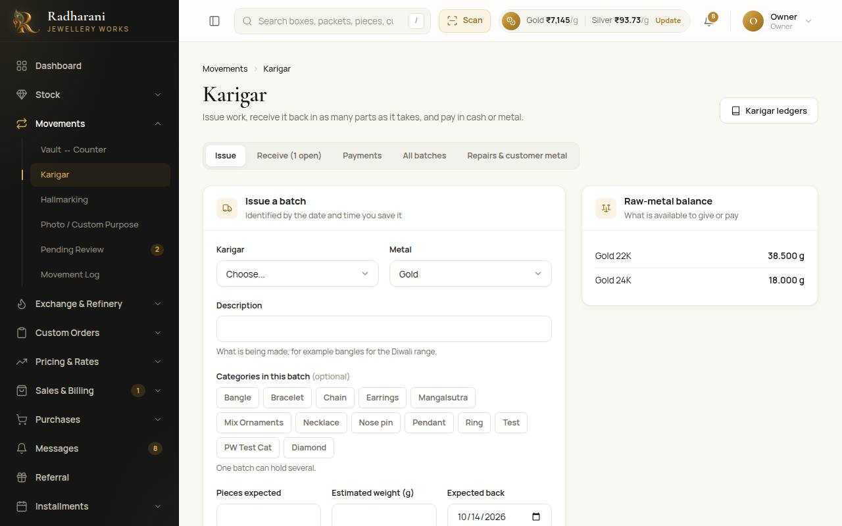
The Karigar desk

6.1 The tabs
- Issue. Send work out: karigar, metal, what is being made, the categories, pieces expected, estimated weight, the date it is expected, an advance if any, a photo.
- Receive. Pick an open batch on the left and record what came back, in parts if needed. Pieces for stock become pending-review pieces. Pieces for hallmarking go on to the Hallmarking desk.
- Payments. Pay a karigar in cash or in metal. Metal comes out of the refined metal in the shop and is refused if there is not enough.
- All batches. Every batch, open or done, with what is pending.
- Repairs and customer metal. A tagged piece sent for repair, and a customer's own metal sent for work (it is never shop stock).

6.2 Closing what will not come back
Admin only If part of a batch will never come back, an owner or manager can close it from the Receive tab, with a note saying why.

6.3 Ledgers
Karigar ledgers (button at the top right) show, for each karigar, what was issued, received, lost and paid. Weights and counts only. Download as PDF or Excel.

6.4 Metal a karigar holds
When a karigar is lent metal, it shows under With karigars in Raw Material. Each time pieces come back, the metal he holds for that batch goes down by the weight received plus the loss. If he returns unused metal, an owner or manager records it with Metal back from a karigar.

Part 7. Hallmarking
Open Movements, then Hallmarking. One dispatch to a centre is a batch, named by its date and time.

7.1 Sending pieces
- Press the Dispatch tab.
- Choose the hallmarking centre and the date you expect them back.
- Choose where it comes from: stock, or an order.
- Add the pieces. Untagged pieces by count are pieces a karigar sent on (tick them) or pieces counted by hand (type how many and the total weight). Tagged pieces from stock are scanned in one after another.
- Take the photo and press Confirm dispatch.

7.2 Receiving them back, in parts
- Open the Receive tab and pick the batch.
- For tagged pieces in the batch, tick the ones that came back and check the HUID and weight. An edited weight is logged.
- For new pieces from the counted batch, the metal, subcategory and carat are filled in. There is one row for each piece still to come. Type the HUID (if it was tagged), the weight, and an optional description. A piece under 2 g needs no HUID and gets an internal code.
- Type who did the tagging, the weight loss if any, and take the photo. Press Receive.
Note Everything that comes back waits in Pending Review until an admin confirms it.

Part 8. Selling
Open Sales and Billing, then New Sale. A sale has five steps. You can go back to any earlier step and the figures follow.

8.1 Step 1: the customer
- Search the customer by name or mobile number.
- If they are new, press New customer. Type the name and mobile. Add a GSTIN if it is a business bill. The customer is chosen for you.
- If the customer was referred by someone, type that person's referral code.

8.2 Step 2: the pieces and the price
- Scan each piece, or type a code or category and pick it from the list.
- Each piece shows its price. Press Price breakup to see how it is built: the metal (weight times today's rate), the making charge, stones or diamond, hallmarking, extra charges, any discount, then the price before GST and the GST.
- Under the pieces, GST on this bill has two choices. The usual rates are already chosen. Change one, or choose 0 for a bill without GST.
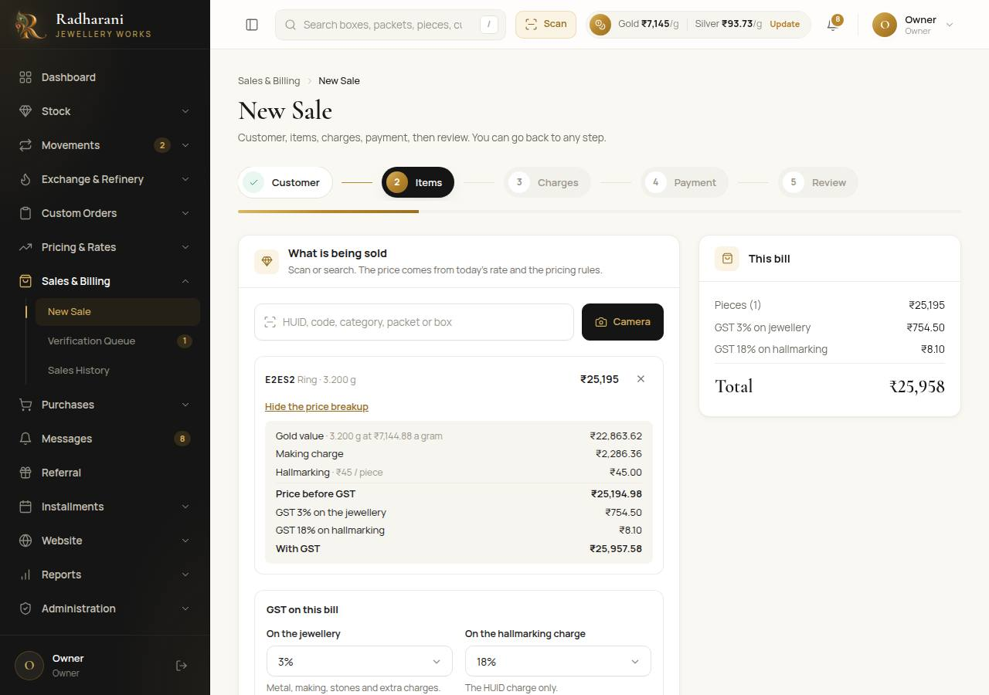
The items step with the price breakup and the GST choice
Careful A piece recorded as in the vault cannot be sold until it is at the counter. The row offers Move to counter. A piece held for a customer's order can only be sold by an admin, with a reason.

8.3 Step 3: charges and adjustment
Add any extra charge (for example packaging), with a name and an amount. An adjustment is a discount, as a flat amount or a percentage. It needs no approval. Extra charges are taxed with the jewellery. The adjustment comes off the jewellery, never the hallmarking charge.
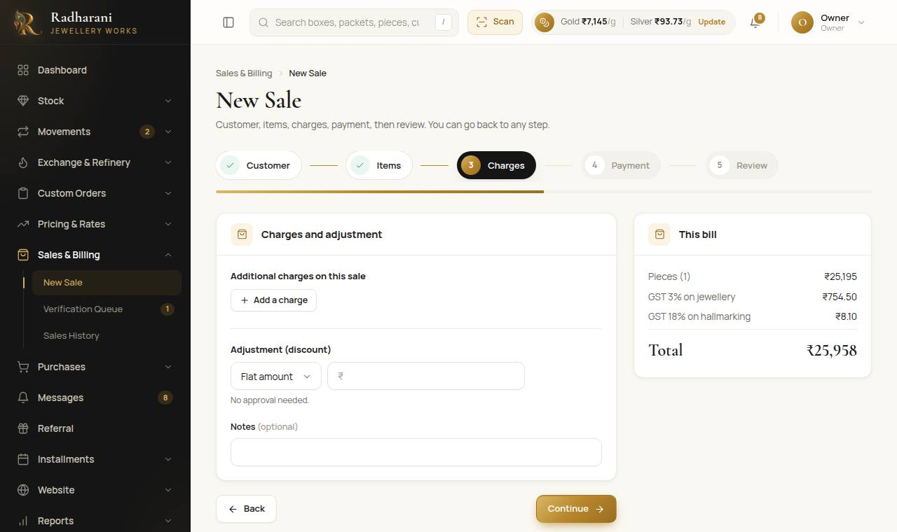
Charges and adjustment

8.4 Step 4: payment
- The first payment line is already filled in with the whole bill, GST included. Change the amount if the customer pays only part.
- Choose the mode: cash, UPI, card, bank, or cheque. For a cheque, type the cheque number and bank in the box that appears.
- Press Another payment to pay in parts. Rest puts whatever is left on that line.
- If the customer has exchange credit from old gold, a gold box shows it. Press Use it on this bill. The credit takes what it can and the rest stays as credit.
- The balance at the bottom is what is still unpaid. A balance is allowed, and shows on the bill.
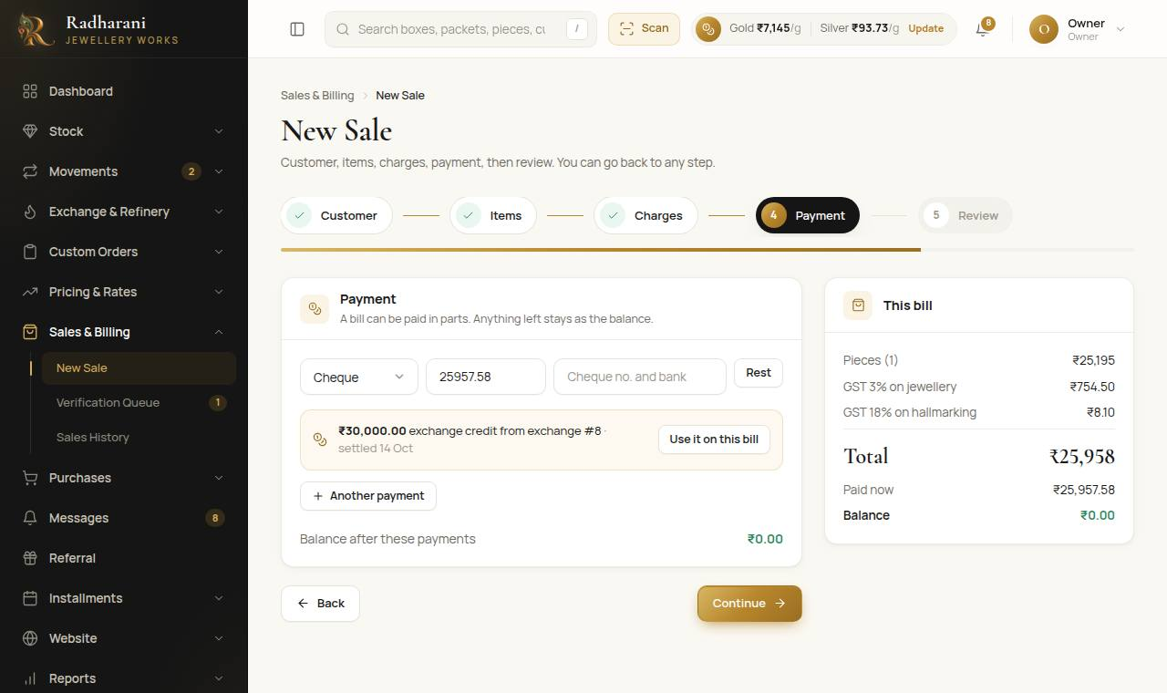
The payment step, with a cheque and exchange credit on offer

8.5 Step 5: review and save
Check the pieces and the totals, then press Save sale. The pieces are now held for the sale. They are not sold until an admin verifies it. The printable bill opens.

8.6 Verification (admin)
Admin only Open Sales and Billing, then Verification Queue. For each sale, check it and press Verify. Type the Tally bill number and press Verify sale. The pieces become sold, and the sale is final. A balance does not stop verification.
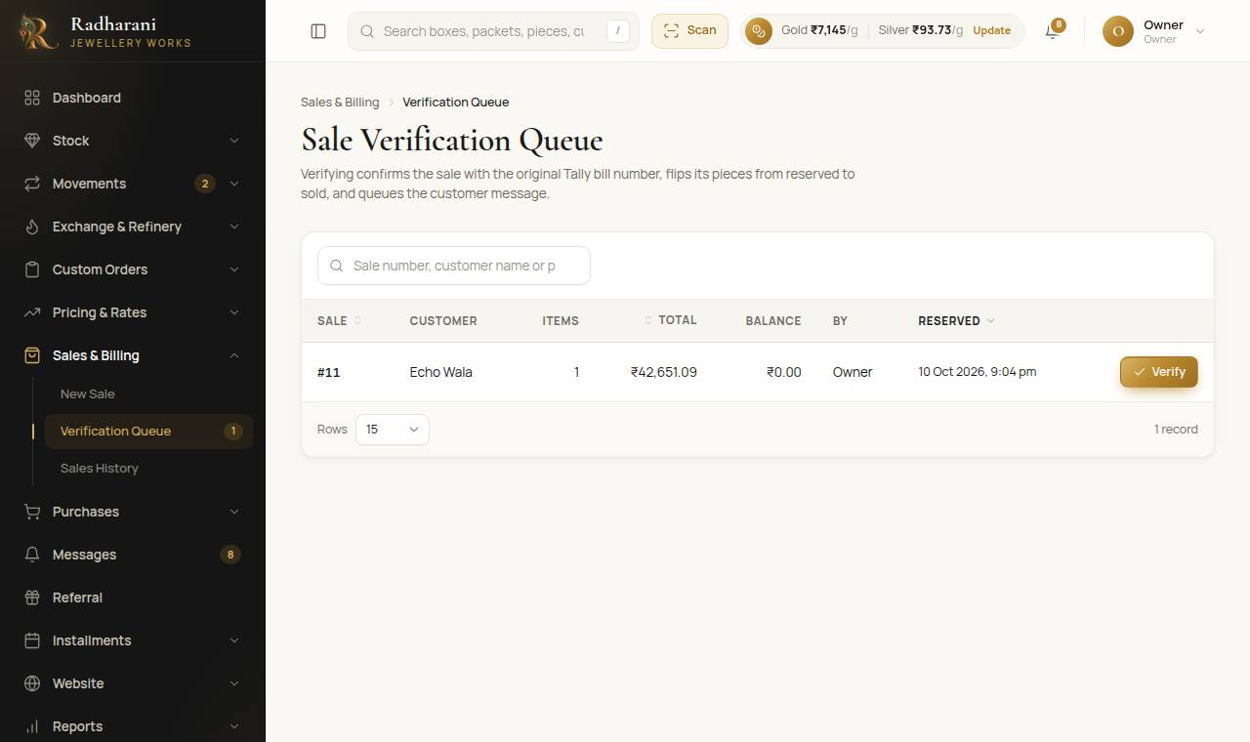
The verification queue

8.7 The bill and sales history
Sales History lists every sale. Open one to see the bill: the pieces, the extra charges, the adjustment, the GST on the jewellery and on the hallmarking, the total, each payment and the balance. The customer's GSTIN prints under their name when there is one. Print makes the paper copy.
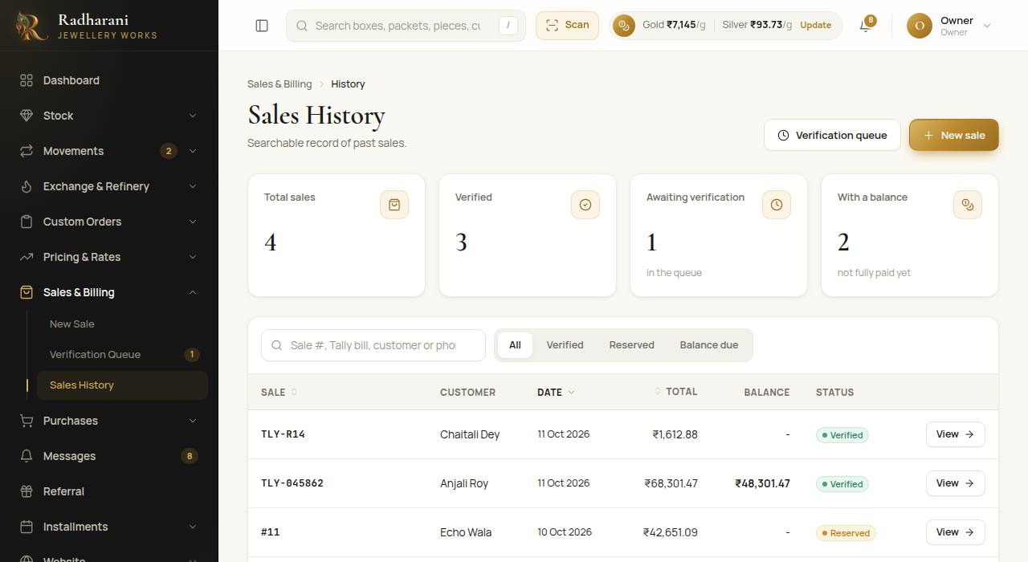
Sales history
Note The GST rates are kept on each bill when it is made. Changing the usual rates later never changes a bill that was already made.

Part 9. Old gold and silver: exchange and the refinery
A customer brings old jewellery. It is weighed, melted, tested and valued in fixed steps that are never combined, so every figure is what was measured.

9.1 Taking in an exchange
- Open Exchange and Refinery, then New Exchange.
- Received. Choose the customer (or add a new one) and the metal, and type the gross weight and a short description.
- Melted. Type the net weight after melting.
- Tested. Type two separate purity readings. They are averaged for you.
- Deduction. The deduction for that metal and carat is set by the owner. It is shown, and the payable weight is worked out.
- Summary. Check everything. You can copy the summary for the accounts person.
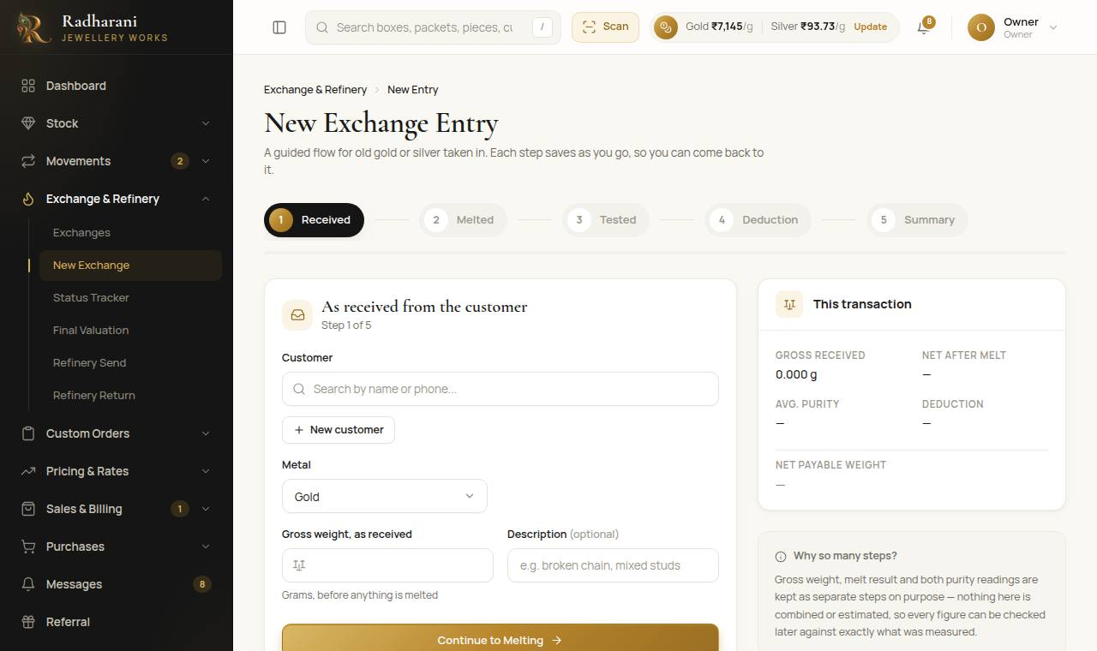
A new exchange
Note You can stop at any step and carry on later from the Exchanges list. Every edit is logged. Once an exchange is settled it is locked.

9.2 Final valuation
Admin only Open Final Valuation. It lists exchanges that finished testing. Press Settle beside one, type the final value (the rupee amount to be paid or credited to the customer), and confirm. It cannot be changed afterwards. The old metal now counts as raw material in the shop, and the exchange's page opens.
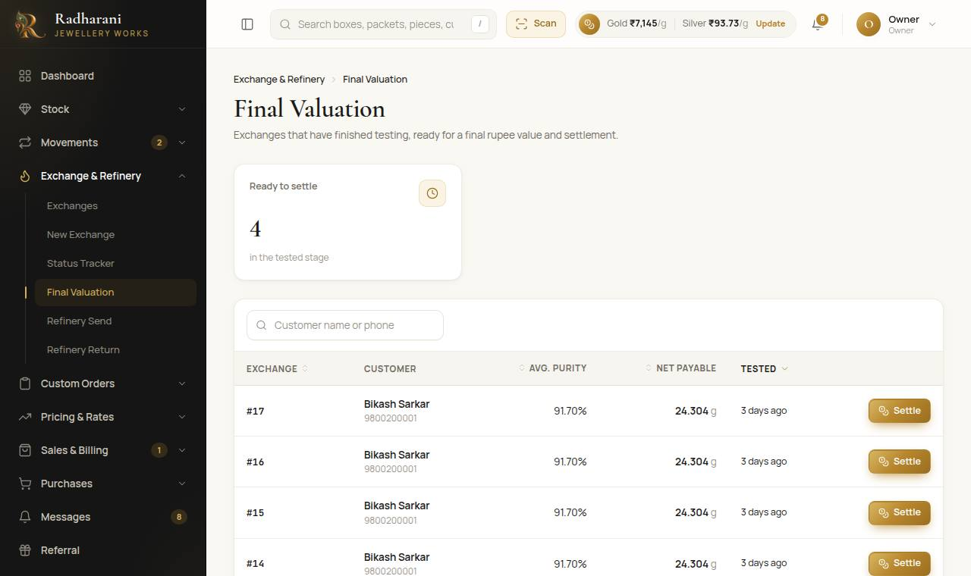
Final valuation

9.3 What the customer does with the value
The value of a settled exchange is credit. The exchange's page opens with What next? and three choices.
- Use in a sale. Opens New Sale for this customer. The payment step starts with the credit, up to the bill. If the credit is bigger than the bill, the rest stays as credit for next time.
- Use for a new order. Opens New Order for this customer. The advance can come from the credit.
- Paid out in cash. Records the amount the customer took in cash, so it leaves the credit. (Owners and managers.)
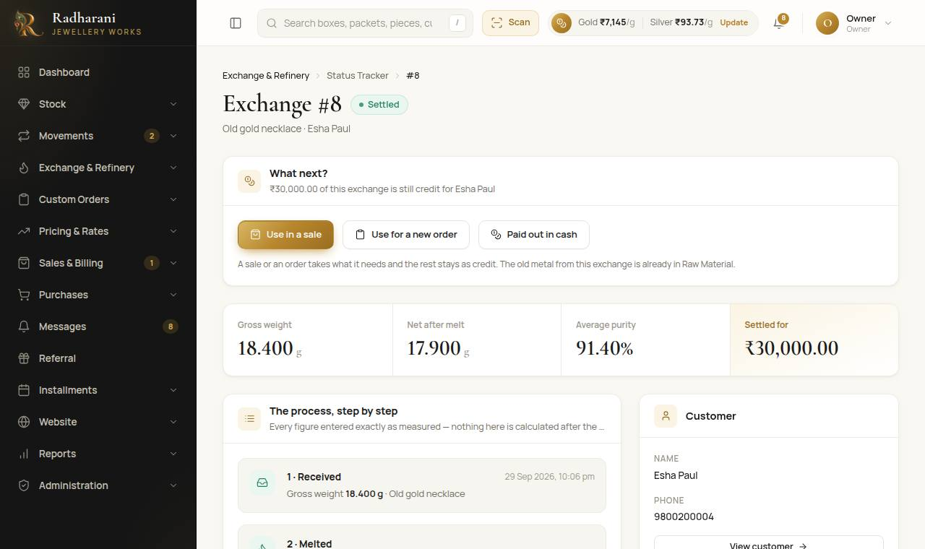
An exchange page with What next?
Careful Credit can never be spent twice. The system checks what is left each time. If an order that used credit is cancelled, the credit goes back to the customer unless a manager unticks that box before cancelling.

9.4 Taking the customer's old gold into a new piece
If the customer wants a new piece made: settle the exchange, press Use for a new order, and follow Part 5. If you want to give the karigar the old metal as an advance, it must first be refined through the refinery or reclassified in Raw Material (Part 3.7), because advances use refined metal only.

9.5 The refinery
- Refinery Send. Choose what is being sent: the list shows the old metal and scrap in the shop, by metal and carat. Type the weight (or press All of it), take the photo and press Confirm Send. The metal moves from the shop to the refinery.
- Refinery Return. Pick the batch that has come back on the left. Type the refined weight and the purity the refinery reports, then press Confirm Return. The system works out the figure after the deduction.
- The refined metal goes back into the shop as refined metal. The difference between what was sent and what came back is the refining loss, visible in Raw Material.
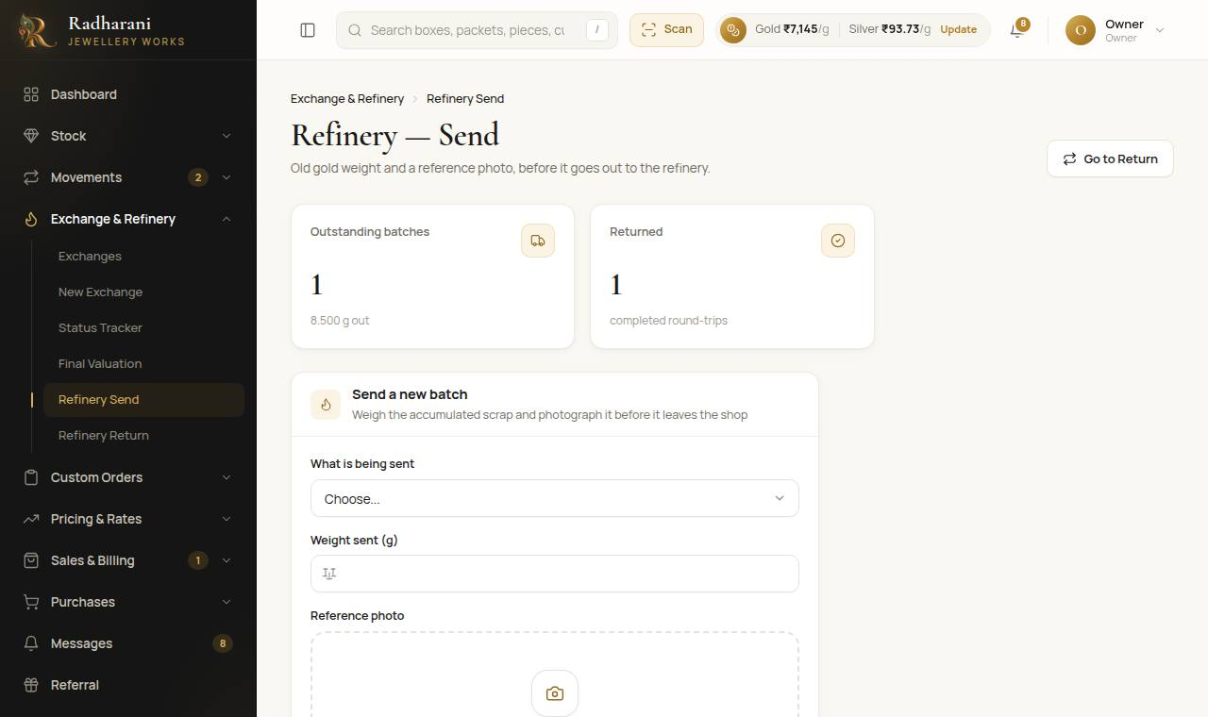
Refinery send

Part 10. The monthly scheme
A member pays a fixed amount each month. Each instalment falls due a month after the one before, counting from the start date: the first is due on the start date.

10.1 Enrolling one member
- Open Installments, then Scheme Enrolment.
- Choose the customer. If they are not a customer yet, press New customer and add them there and then.
- Type the monthly amount, the months in the scheme and the start date. The completion date is the start plus those months.
- Usual late fee is optional. It only starts the late fee box when a payment is late.
- For someone who joined earlier, tick Already a member and type the months already paid and the amount still pending.
- Press Enrol. A welcome message is queued in Messages.
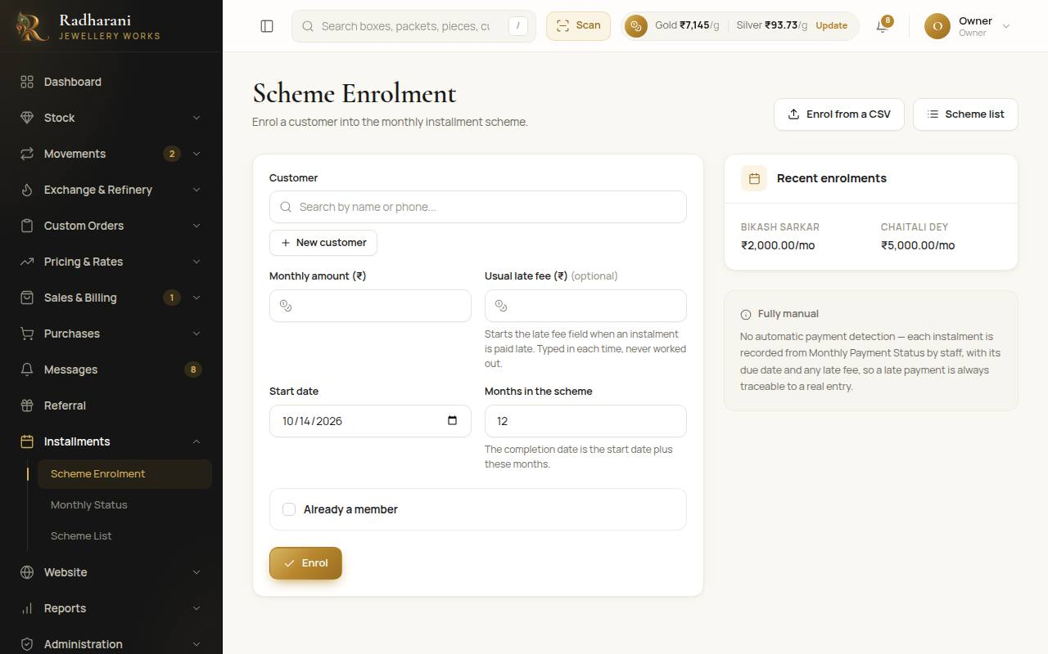
Scheme enrolment

10.2 Enrolling many members from a CSV
- On the enrolment page press Enrol from a CSV.
- Press Download the template and fill it in, one row per member: name, phone, monthly amount, total months, months already paid, start date, late fee, pending amount. Only the phone and the monthly amount are needed.
- Choose the file and press Check the file. Every row is checked and shown. Rows with a problem say what is wrong and are left out.
- A phone number that is not a customer yet becomes one, so give a name for those rows. A member who already has an active scheme is never enrolled twice.
- Press Enrol N members. Nothing is saved until you press it.
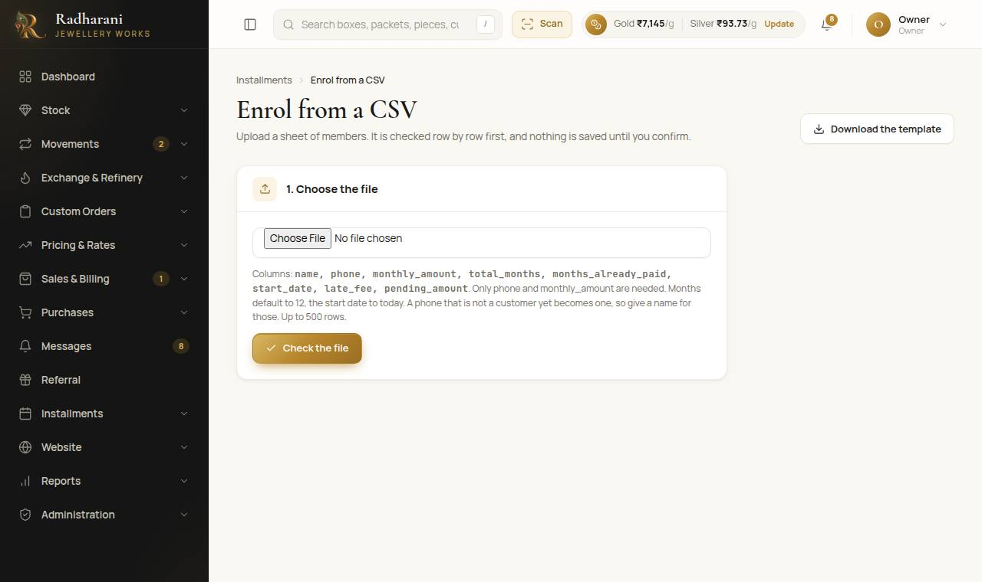
Enrolling from a CSV

10.3 Monthly payments and late payments
- Open Installments, then Monthly Status.
- Each scheme is Paid up, Due this month, or Late (an instalment is past its date and unpaid, with how many months and days).
- Use the buttons above the list to see only the late ones, or only those due.
- Press Send reminder to queue a reminder message for the member (you copy and send it).
- When a member pays, press Record payment. It covers the next unpaid instalment. If it is late, a late fee box appears, already showing the usual fee. Type the fee you are charging, or leave it empty. It is never worked out for you, and it is separate from the instalment.
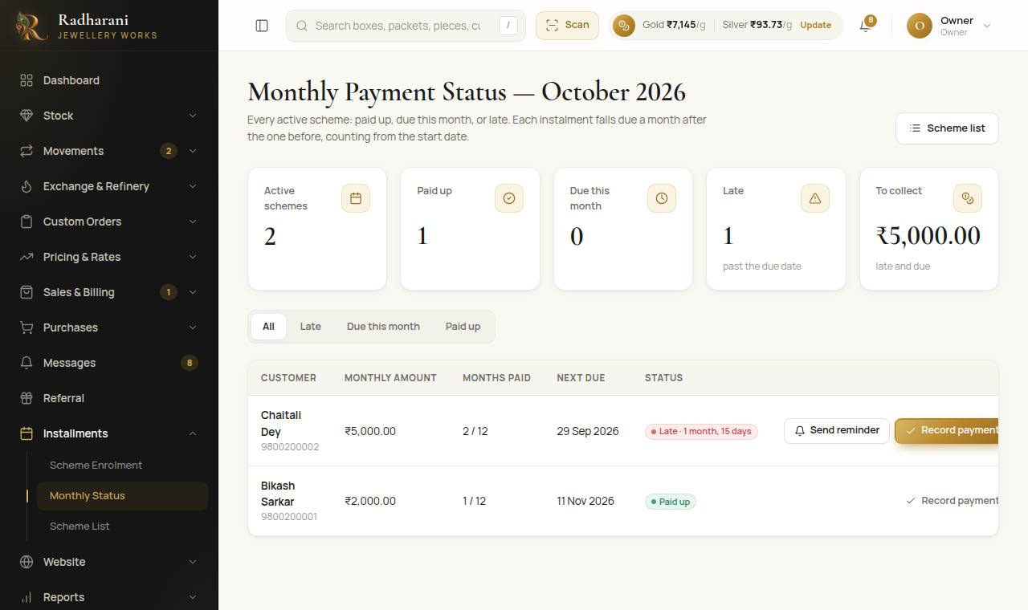
Monthly status
Careful A payment records which instalment it covers. If two people open the same payment, only the first is recorded.
Note When the last instalment is paid the scheme matures. In Scheme List choose what happens next: create an order, make a sale, or reserve a piece in stock.

Part 11. Purchases of raw material
Open Purchases, then New Purchase. Purchases here are raw metal only. Purchase List shows the earlier ones.
- Add a line for each metal bought: metal, carat and weight (and a note if you like). Press Add a line if the bill has several.
- Type the reference bill number and any notes. If it is for a custom order, choose the order.
- Press Record purchase. The metal is added to the shop's refined raw material straight away.
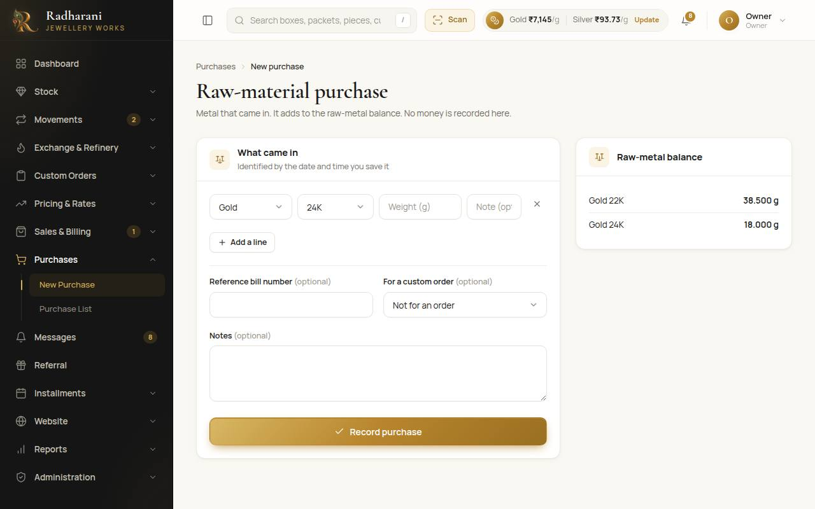
A new purchase

Part 12. Customers

12.1 Adding a customer from the Customers page
- Open Administration, then Customers. (Bulk Import on that page loads a list from Excel or CSV.)
- Press New customer. Type the name and mobile number. Add the email, address and GSTIN if you have them.
- Press Add customer.
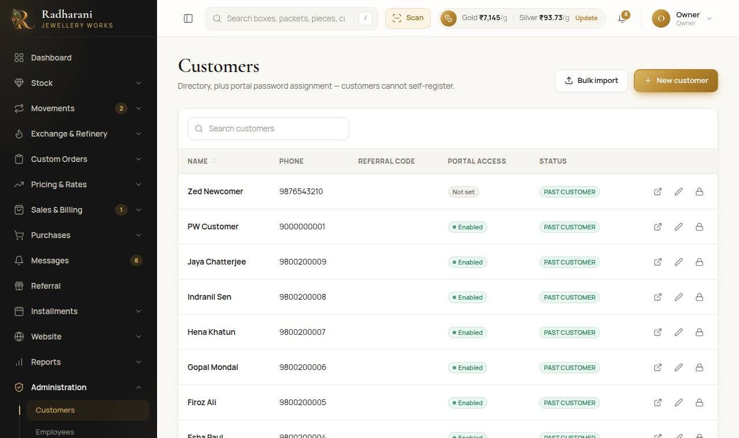
The customers list

12.2 Adding a customer in the middle of something else
In a sale, an order, an exchange or a scheme enrolment, press New customer where you choose the customer. A small form opens with what you typed in the search box already filled in. If that mobile number already belongs to a customer, the system picks that customer instead of adding a second one.

12.3 GSTIN
A GSTIN is 15 characters, for example 19ABCDE1234F1Z5. Type it in capitals or small letters; spaces are removed. A wrong number is refused with a message, so you can fix it. It prints on that customer's bills.

12.4 A customer's page
Open a customer to see their sales, what they paid, what they still owe, their schemes and referrals. Ledgers can be downloaded as PDF or Excel. A customer can also be given access to the customer website with their mobile number as the login.

Part 13. Reports, exports and messages

13.1 Daily Logbook (the daybook)
- Open Reports, then Daily Logbook. It shows the day's movements and sales together, newest first. Choose another day with the date box.
- Press Export this day (CSV) to download it. A search you typed narrows the file too.
- For several days, open Export several days, choose the first and last day, and press Download CSV. A sale row has its total and what was paid.
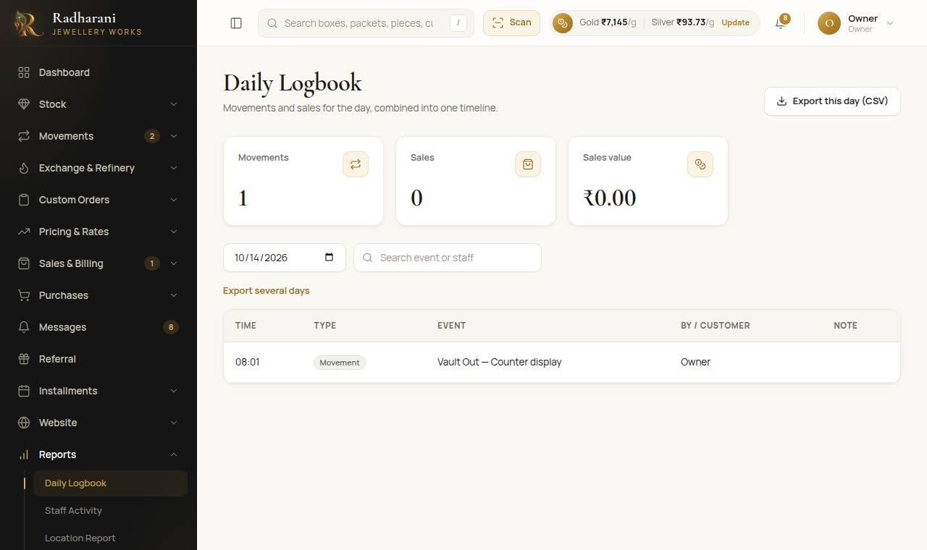
The daily logbook

13.2 Other reports
- Location Report (under Reports). Pieces and weight at every place in the shop, and where the rest is (out with a karigar, in review, held for a sale).
- Staff Activity (under Reports). What each person handled, across everything.
- Ledgers (under Reports). The karigar, hallmarking centre and customer ledgers, as PDF or Excel.
- Movement Log (under Movements). Every movement of every piece, packet and box.
- Stock Audit (under Stock). Check a box: scan what is in it and see what is present, missing or extra.

13.3 Messages to customers
The system never sends a message by itself. It writes it for you and keeps it in Messages in three groups: Sales, Installment and Order.
- Open Messages (the Pending Messages Queue). Each message shows who it is for and the text. The buttons at the top show Pending, Sent or All.
- Press Copy, open WhatsApp or SMS, and paste it to the customer.
- Press Mark sent after you have really sent it, so the list shows only what is waiting.
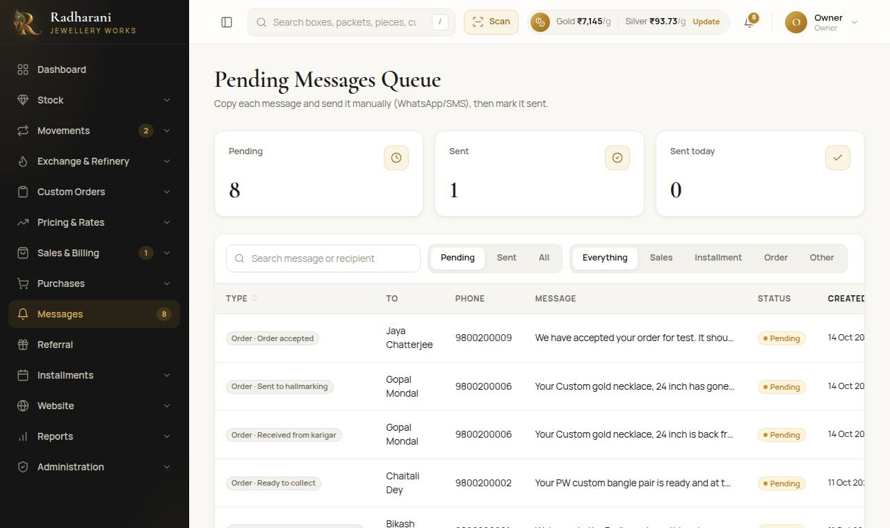
Messages waiting to be sent

Part 14. For the owner

14.1 Locations and trays
Admin only Open Administration, then Locations. Each counter, display or other place is a location. New location adds one. Choose the type Tray (inside the vault) to add a tray. Locations are never deleted, so past movements keep their place. Switch one off to stop using it. The vault cannot be switched off.
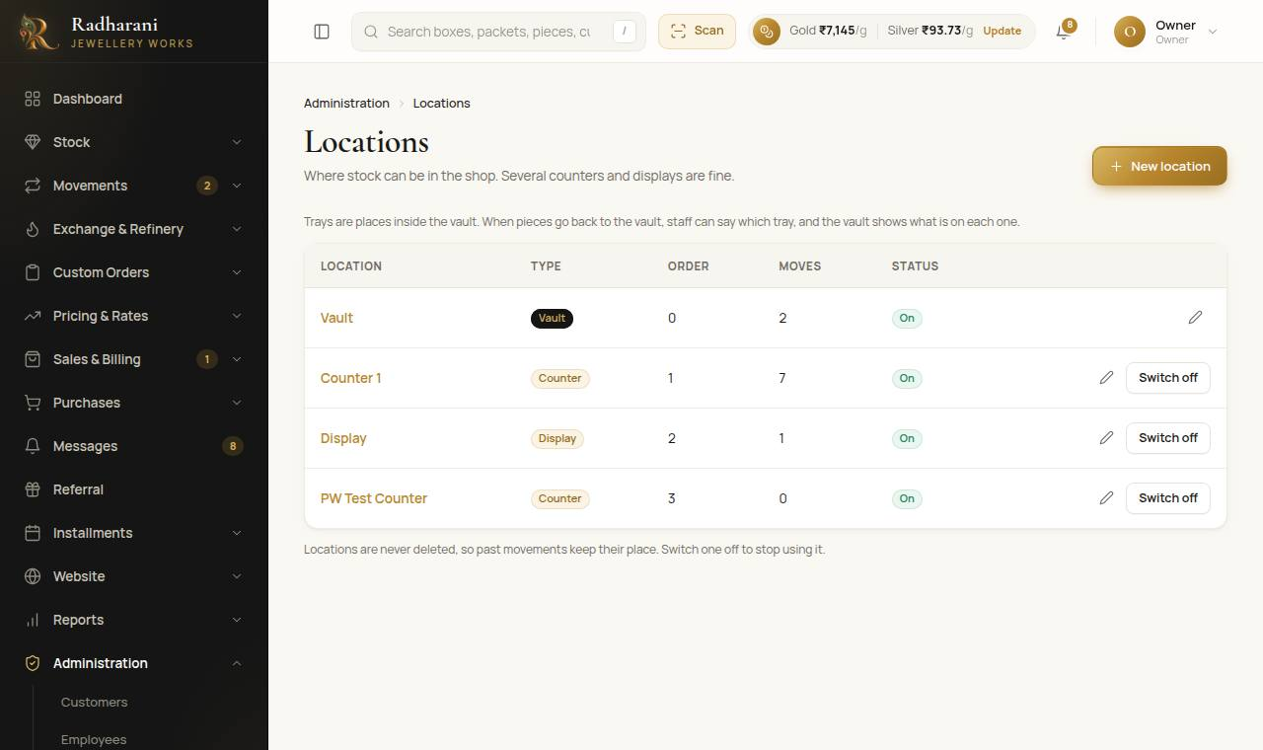
Locations and trays

14.2 Pricing rules
Admin only Open Pricing and Rates, then Pricing Rules. There is a tab for each kind of rule: Making charge, Additional charge, Discount and Hallmarking charge, plus Making charges by category and GST.
A rule says what to charge and for what: a product, a category, a weight range, a metal, or everything, optionally for one carat. The most specific rule wins: product, then category, then weight range, then metal, then everything.
- Press New rule and choose what it applies to.
- For a weight range, type where it starts and where it ends in grams. The start is included and the end is not, so 5 to 10 g takes 5 g and 9.99 g but not 10 g. Leave one end empty for "or more" or "up to".
- Choose how it is charged: a percentage of the metal value, per gram, or per piece, and type the value.
- Save. Switch a rule off at any time. Removed rules stay in the audit log.
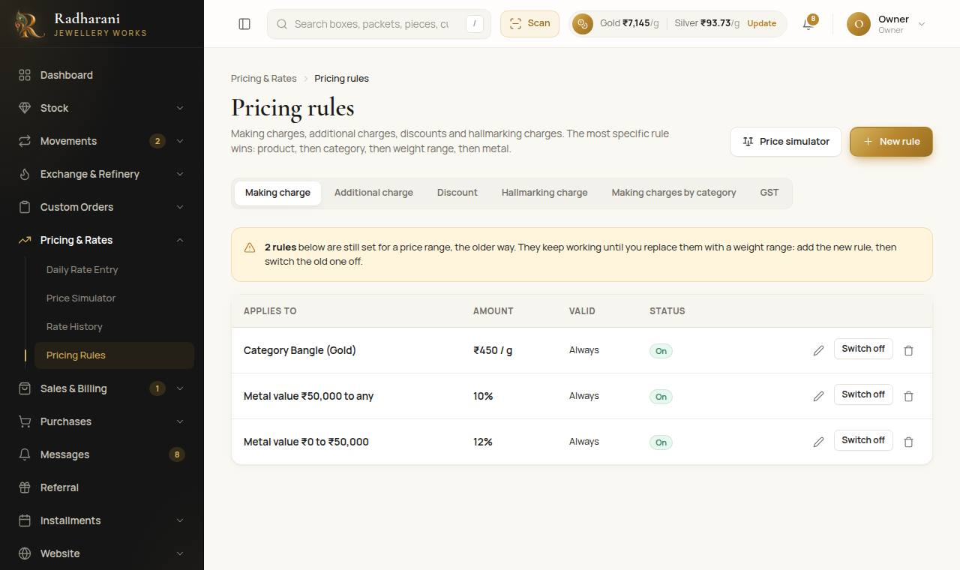
Pricing rules
Note Rules made earlier for a price range still work, and a notice on the page lists them. Replace each with a weight range when you can: add the new rule, then switch the old one off.

14.3 GST rates
Admin only On the GST tab of Pricing Rules, set the usual rate on the jewellery and the usual rate on the hallmarking charge. New bills start with these, and staff can choose another rate or 0 on any bill. The public website shows prices with GST at these rates.
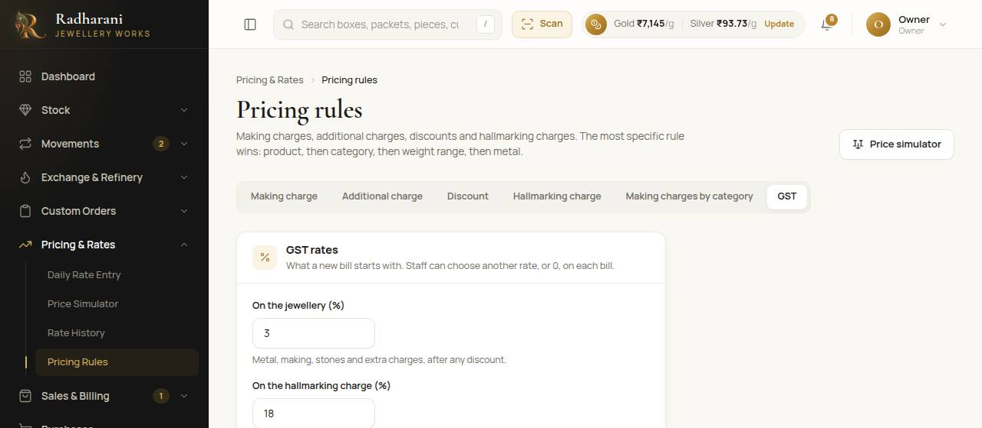
GST rates

14.4 Who can do what
Each person has a role. Under Administration: Users (staff logins), Roles & Permissions (what each role may do), Employees, Karigars and Centres, Customers, Locations and the Audit Log, which shows what changed, who changed it, and the values before and after.

Part 15. Quick answers
I scanned a code and it says "Nothing found".
Check the code, or type part of it in the same box and pick from the list. Packet and box codes can have spaces; type the whole code.
A piece will not go on the sale: "still recorded as in the vault".
It has not been moved to the counter. Press Move to counter on its row, or do it in Vault and Counter.
"A piece is held for a customer order."
An order has the piece reserved. Only an admin can sell it, with a reason. Otherwise leave it for that customer.
A piece I expected is not in the order's sale cart.
It is probably still in Pending Review. An admin has to confirm it first. The sale page says how many are waiting.
I cannot give a karigar metal: "only X g of refined metal".
Refined metal only. If old metal or scrap of that carat is in the shop, refine it or reclassify it in Raw Material first.
The refinery send page says there is nothing to send.
Old metal arrives when an exchange is settled, and scrap can be added with an Adjustment in Raw Material.
I recorded something wrong.
Do not look for an edit button. History is never edited. Tell an owner or manager. They add a correcting entry.
A price looks too low.
Check today's rate for that metal and carat (Part 2), and that the piece has its net weight and making charge.
A sale shows a balance.
That is allowed. The customer owes it, and it shows on the bill and in their ledger.
I pressed Confirm twice.
The system skips what is already recorded. Check the Movement Log if you are unsure.
The camera does not open.
It only works on the secure (https) address, and the browser must be allowed to use the camera.
The menu or a button I need is not there.
Your role may not allow it. Ask the owner.

