What is Apache Ant
Apache Ant (Another Neat Tool) is an open source project started by Apache Software Foundation. Ant is a Java library and a software tool used for automate software build processes such as compile, run, test and assemble Java application. It is designed and developed by Apache Software Foundation and initially released on 19 July 2000.
tt is a better alternate of Make build tool of Unix. Ant is written in Java and require JVM to build the Java projects.
Ant uses XML to describe build code and by default it's XML file name is build.xml.

Prerequisites
Before Learning Apache Ant, you must have the strong knowledge of Java and XML. You must also be familiar with Eclipse or NetBeans. All the examples in this tutorial has been tested on Eclipse IDE.

Apache Ant Features
- Open Source
- Flexible
- Easy To Use
- Cross Platform
- Extensible
- Scalable
- XML
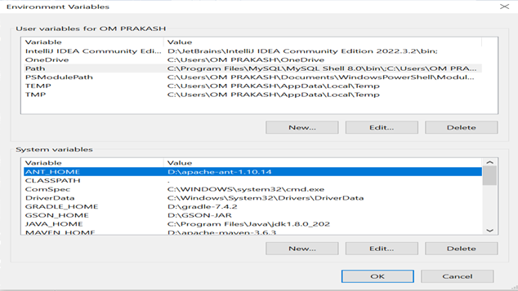

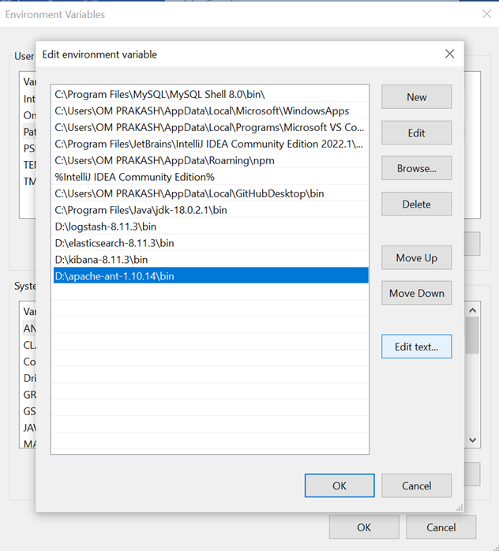
Microsoft Windows [Version 10.0.19045.3803]
(c) Microsoft Corporation. All rights reserved.

D:\apache-ant-1.10.14>ant -version
Apache Ant(TM) version 1.10.14 compiled on August 16 2023
Microsoft Windows [Version 10.0.19045.3803]
(c) Microsoft Corporation. All rights reserved.
D:\apache-ant-1.10.14>ant -f build.xml
Buildfile: D:\apache-ant-1.10.14\build.xml

BUILD SUCCESSFUL
Total time: 0 seconds

D:\apache-ant-1.10.14>ant -f build.xml echoHelloWorld
Buildfile: D:\apache-ant-1.10.14\build.xml

echoHelloWorld:
[echo] Hello World...!!!

BUILD SUCCESSFUL
Total time: 2 seconds

D:\apache-ant-1.10.14>ant -f build.xml
Buildfile: D:\apache-ant-1.10.14\build.xml

echoHelloWorld:
[echo] Hello World...!!!

BUILD SUCCESSFUL
Total time: 0 seconds

D:\apache-ant-1.10.14>ant cmdHelloWorld
Buildfile: D:\apache-ant-1.10.14\build.xml
Program 1
Hello.java
package com.pak;
public class Hello {
public static void main(String[] args) {
System.out.println("Hello ANT..!!!");
}
}
Build.xml
<?xml version="1.0" encoding="UTF-8"?>
<project name="antProject" default="run">
<property name="student-name" value = "RIYA"></property>

<target name="run" depends="compile">
<echo>${student-name} is our student.</echo>
<java classname = "com.pak.Hello">
<classpath path="test"></classpath>
</java>
</target>

<target name="compile">
<javac includeantruntime="false" srcdir="./src" destdir = "test"></javac>
</target>

<target name="clean">
<delete>
<fileset dir="./test/com/pak" includes="*.class"/>
</delete>
</target>

</project>

Run:-right click Build.xml->Run As->Ant Build

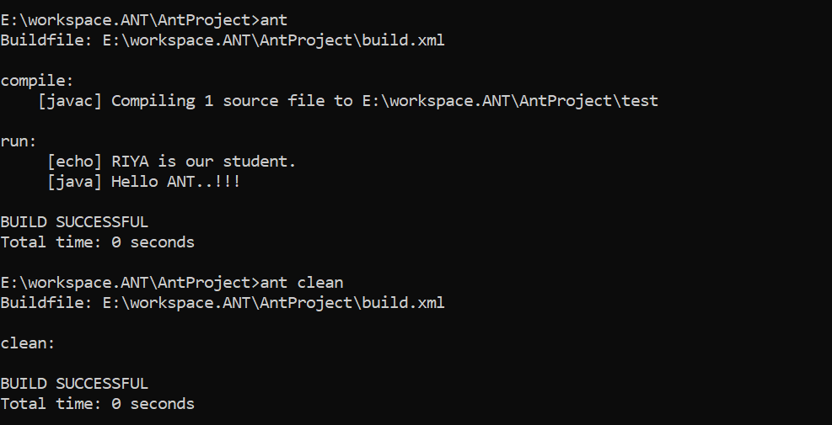

Apache Ant Projects
Apache Ant uses XML to write buildfiles and each buildfile contains one project and at least one default target. Target is a container of tasks and each task is a code that can be executed. We can understand to a project as a container that wraps targets and tasks into a single unit. To create a project, we can use <project> tag.
<project name="antProject" default="run"> </project>

Apache Ant Project Attributes
Attribute | Description | Required
name | It is a name of the project | No
default | It is used to set default target if no target is supplied explicitly. | No
basedir | It requires base directory path | No

Note: We can select which target to be executed. If target is not given project's default is used.

Apache Ant Targets
A target is a collection of one or more tasks. Task is a piece of code and that is to be executed. A buildfile contains a project and inside the project all the targets are declared. To create a target, we can use <target> tag.
<target name="run" depends="compile">
<java classname = "com.pak.Hello">
<classpath path="test"></classpath>
</java>
</target>
<target name="compile">
<javac includeantruntime="false" srcdir="./src" destdir = "test"></javac>
</target>
The target has various attributes that are given below.
Attribute | Description | Required
name | It sets name of the target | Yes
depends | list of targets on which it is depend. | No
if | A property that evaluates to true | No
unless | A property that evaluates to false | No
description | A short description of this target?s function | No
extensionOf | Adds the current target to the dependent list of extension point. | No
onMissingExtensionPoint | What to do if this target extends a missing extension point | No
The name attribute can be any valid alphanumeric string.

Apache Ant Tasks
Task is a piece of code that can be executed. A task can have multiple attributes and each task has a common structure. A common structure consists of task-name, attributes etc. See an example below.

Task Structure
A task may comprises of:
Apache Ant tasks are categories into two category.
- Built-in Tasks
- User defined Tasks

Built-In Tasks
Tasks those are provided by Apache Ant itself in it's library are known as built-in tasks. Apache ant provides large number of built-in tasks which can be used to execute distinguish tasks. A list is given below.
- Archive Tasks
- Audit Tasks
- Compile Tasks
- Execution Tasks
- File Tasks
- Logging Tasks
- Mail Tasks

Archive Tasks
Tasks which are used to compress and uncompress data are know as archive tasks. Some common built-in archived tasks are tabled below.
Task Name | Description
Ear | An extension of the Jar task with special treatment for files.
Jar | A set of files.
Tar | Creates a tar archive.
Unjar | Unzips a jarfile.
Untar | Untars a tarfile.
Unwar | Unzips a warfile.
Unzip | Unzip a zip file.
War | An extension of the Jar tasks.

Audit Tasks

Task Name | Description
JDepend | It is used to invoke JDepend parser.

Compile Tasks
Tasks which are used to compile source files are know as compile tasks. Some common built-in compile tasks are tabled below.
Tasks Name | Description
Depend | Determines which class files are out of date with respect to their resources.
Javac | It compiles the source file.
JspC | It runs the JSP compiler.
NetRexxC | It compiles a NetRexx source file.
Rmic | Runs the rmic compiler.

Execution Tasks
Tasks which are used to execute of run applications are know as execution tasks. Some common built-in execution tasks are tabled below.
Tasks Name | Description
Ant | It runs Ant on specified buildfile.
AntCall | It runs another target in the same buildfile.
Apply | It executes a system command.
Java | Executes a Java class.
Parallel | A container task that can contain other ant tasks.
Sleep | It suspends execution for the specified time.

File Tasks
Tasks which are related to handle file operations are know as file tasks. Some common built-in file tasks are tabled below.
Tasks Name | Description
Chmod | It changes permission of the file.
Chown | It changes ownership of the file.
Concat | It concatenates multiple files.
Copy | It copies file to new destination.
Delete | Delete a file.
Mkdir | It creates a directory.

Apache Ant Properties
Properties are key-value pairs where each value is associated to a key. The property is used to set value which can be accessed anywhere in the buildfile. Once a property is set, it cannot be changed.
Apache Ant provides <property> tag which can be used to set property.

Apache Ant Property Types
- Built-in Properties
- User defined Properties

1.Built-in Properties
Apache Ant provides various built-in properties and we can access all these properties in our buildfile. Some built-in properties are given below.
Property | Description
basedir | It is used for the absolute path of the project's basedir.
ant.file | It is used for the absolute path of the buildfile.
ant. | version It is used for the version of Ant.
ant.project.name | It holds name of the project that is currently executing.
ant.project.default-target | It holds name of the currently executing project's default target.
ant.project.invoked-targets | A list of the targets when invoking the current project.
ant.java.version | It holds the JVM version.
ant.core.lib | the absolute path of the ant.jar file.
ant.home | It contains home directory of Ant.
ant.library.dir | It holds the directory that has been used to load Ant's jars from.

2. User defined Properties
Apart from built-in properties, Apache Ant also provides the facility to create custom properties in buildfile.
To create properties, <property> tag is provided which uses name and value attributes. The name attribute is the name of the property and value attribute holds a value.

Apache Ant Token Filter
Token filter allows us to filter data from the file while copying. To filter, a token is used which must matched to @token@ set in filter task. Tasks uses @ as a token separator. To implement this feature, Apache Ant provides <filter> which uses token attribute.
This feature should be used with text file only.

Apache Ant Token Filter Attributes
Attribute | Description | Required
token | It is a token string without the separator chars (@). | Yes
value | It is a string that should be put to replace the token when the file is copied. | Yes
filtersfile | The file from which the filters must be read. This file must be a formatted as a property file. | Yes

Apache Ant Token Filter Example
The following code copy recursively all the files from the source directory into the destination directory by replacing all the repeatition of the string @name@ with rohan.
- <filter token="name" value="rohan"/>
- <copy todir="destination-directory" filtering="true">
- <fileset dir="source-directory"/>
- </copy>
To read all property entries from the student_data.properties file and set these as filters.
- <filter filtersfile="student_data.properties"/>

