What is Apache Ant
Ant is a Java library and a software tool used for automate software build processes such as compile, run, test and assemble Java application. Ant is written in Java and require JVM to build the Java projects.
Ant uses XML to describe build code and by default it's XML file name is build.xml.

ANT stands for Another Neat Tool. It is a Java-based build tool from computer software development company Apache. Before going into the details of Apache Ant, let us first understand why we need a build tool.

Prerequisites
Before Learning Apache Ant, you must have the strong knowledge of Java and XML.
Features of Apache Ant
• The features of Apache Ant are listed below −
• It is the most complete Java build and deployment tool available.
• It is platform neutral and can handle platform specific properties, such as file separators.
• It can be used to perform platform specific tasks such as modifying the modified time of a file using 'touch' command.
• Ant scripts are written using plain XML. If you are already familiar with XML, you can learn Ant pretty quickly.
• Ant is good at automating complicated repetitive tasks.
• Ant comes with a big list of predefined tasks.
• Ant provides an interface to develop custom tasks.
• Ant can be easily invoked from the command line and it can integrate with free and commercial IDEs.
Installing Apache Ant
It is assumed that you have already downloaded and installed Java Development Kit (JDK) on your computer. If not, please follow the instructions available at file:///C:/java/java_environment_setup.htm
Ensure that the JAVA_HOME environment variable is set to the folder, where your JDK is installed.
Download the binaries from https://ant.apache.org
Unzip the zip file to a convenient location c:\folder by using Winzip, winRAR, 7-zip or similar tools.
Create a new environment variable called ANT_HOME that points to the Ant installation folder. In this case, it is c:\apache-ant-1.10.12-bin folder.

Append the path to the Apache Ant batch file to the PATH environment variable. In our case, this would be the c:\apache-ant-1.10.12-bin\bin folder.
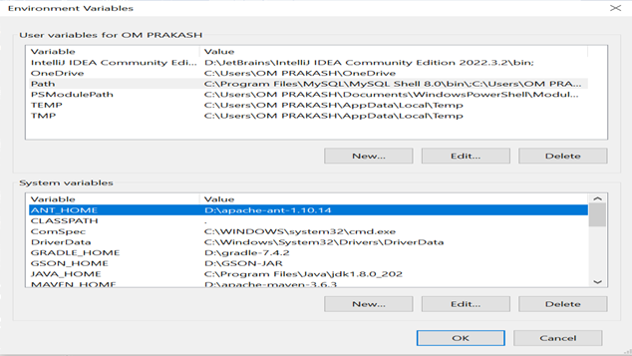

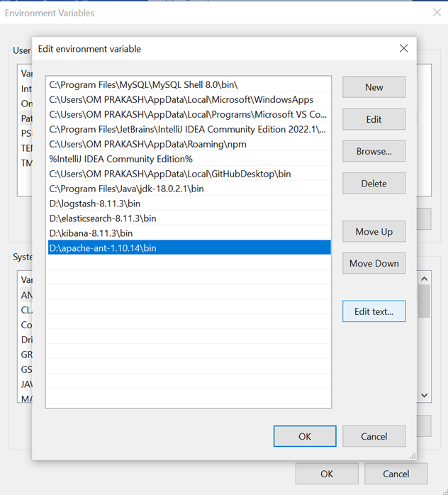
Verifying the Installation
D:\apache-ant-1.10.14>ant -version
Apache Ant(TM) version 1.10.14 compiled on August 16 2023
Microsoft Windows [Version 10.0.19045.3803]
(c) Microsoft Corporation. All rights reserved.
Ant - Build Files
The XML element project has three attributes which are as follows −

- name: The Name of the project. (Optional)
- default: The default target for the build script. A project may contain any number of targets. This attribute specifies which target should be considered as the default. (Mandatory)
- basedir: The base directory (or) the root folder for the project. (Optional)

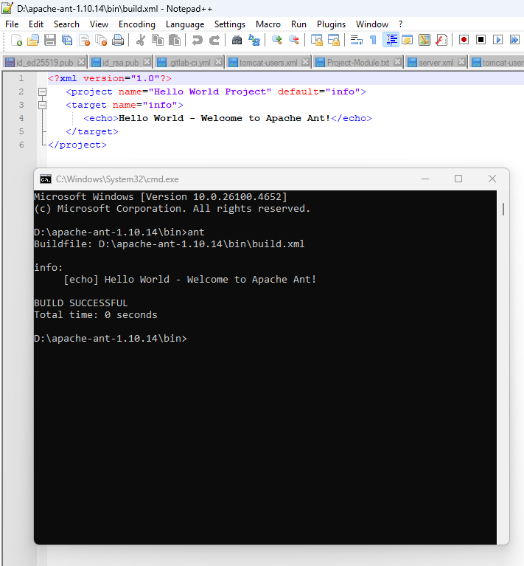
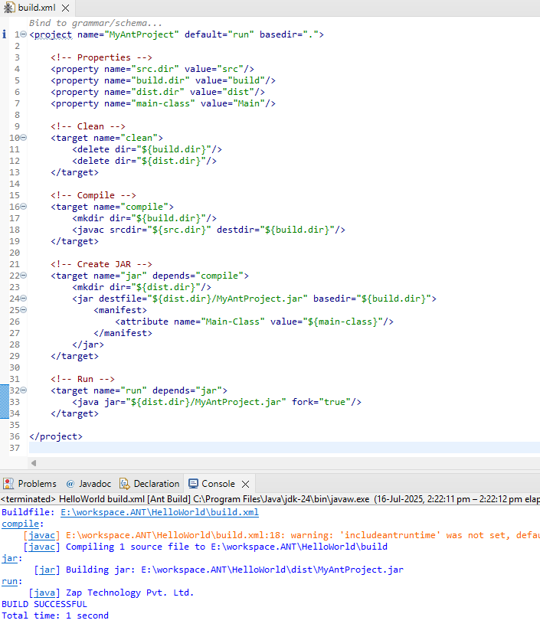
Program 1
Hello.java
package com.pak;
public class Hello {
public static void main(String[] args) {
System.out.println("Hello ANT..!!!");
}
}
Build.xml
<?xml version="1.0" encoding="UTF-8"?>
<project name="antProject" default="run">
<property name="student-name" value = "RIYA"></property>

<target name="run" depends="compile">
<echo>${student-name} is our student.</echo>
<java classname = "com.pak.Hello">
<classpath path="test"></classpath>
</java>
</target>

<target name="compile">
<javac includeantruntime="false" srcdir="./src" destdir = "test"></javac>
</target>

<target name="clean">
<delete>
<fileset dir="./test/com/pak" includes="*.class"/>
</delete>
</target>

</project>

Run:-right click Build.xml->Run As->Ant Build

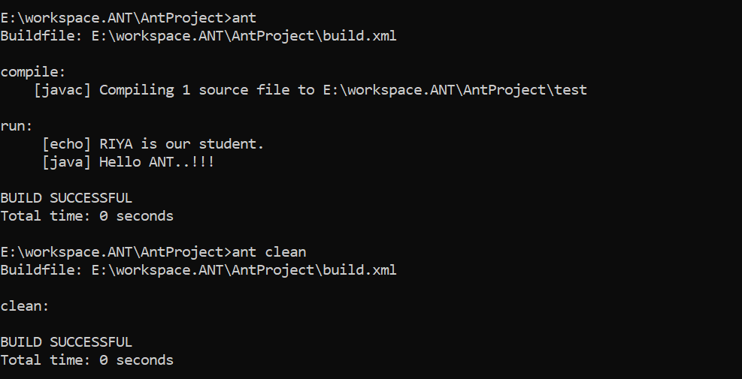
Example
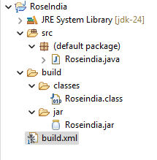
public class Roseindia {
public static void main(String args[]){
System.out.println("Roseindia Technology Pvt. Ltd.");
}
}
<?xml version="1.0"?>
<project name="Roseindia" default="main" basedir=".">
<property name="src.dir" value="src"/>
<property name="build.dir" value="build"/>
<property name="classes.dir" value="${build.dir}/classes"/>
<property name="jar.dir" value="${build.dir}/jar"/>
<property name="main-class" value="Roseindia"/>
<target name="clean">
<delete dir="${classes.dir}"/>
<delete dir="${jar.dir}"/>
<delete dir="${build.dir}"/>
</target>
<target name="prepare" depends="clean">
<mkdir dir="${build.dir}"/>
<mkdir dir="${classes.dir}"/>
<mkdir dir="${jar.dir}"/>
<mkdir dir="${src.dir}"/>
</target>
<target name="compile" depends="prepare">
<javac srcdir="${src.dir}" destdir="${classes.dir}"/>
</target>
<target name="jar" depends="compile">
<jar destfile="${jar.dir}/${ant.project.name}.jar" basedir="${classes.dir}">
<manifest>
<attribute name="Main-Class" value="${main-class}"/>
</manifest>
</jar>
</target>
<target name="run" depends="jar">
<java jar="${jar.dir}/${ant.project.name}.jar" fork="true"/>
</target>
<target name="main" depends="run">
<echo message="main target completed.." />
</target>
</project>
Right click->Run As ->Ant build.
Database
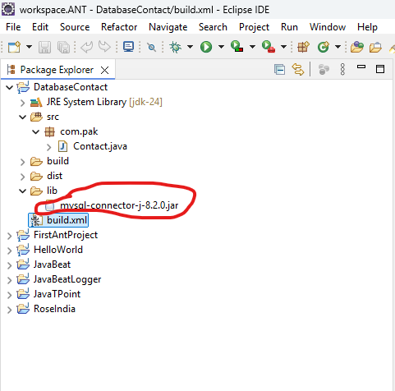
Contact.java
package com.pak;

import java.sql.*;
public class Contact {
public static void main(String[] args) {
String url = "jdbc:mysql://localhost:3306/contactsdb?useSSL=false";
String username = "root";
String password = "root";

String sql = "INSERT INTO contacts (firstname, lastname, city, country) VALUES (?, ?, ?, ?)";

try {

Connection connection = DriverManager.getConnection(url, username, password);
PreparedStatement statement = connection.prepareStatement(sql);

statement.setString(1, "Tom");
statement.setString(2, "Eagar");
statement.setString(3, "Chicago");
statement.setString(4, "U.S.A");

int rows = statement.executeUpdate();

if (rows > 0) {
System.out.println("A row was inserted.");
} else {
System.out.println("No row was inserted.");
}

connection.close();
} catch (SQLException e) {
e.printStackTrace();
}

}
}
//ant
// ant clean
//java -jar dist\ContactManager-20231231.jar

//ant compile dist run
Build.xml
<?xml version="1.0" encoding="UTF-8"?>
<project name="ContactProject" default="dist" basedir=".">

<property name="src" location="src"/>
<property name="build" location="build"/>
<property name="dist" location="dist"/>
<property name="lib" location="lib"/>
<property name="JdbcDriver" value="mysql-connector-j-8.2.0.jar"/>

<target name="init">
<tstamp/>
<mkdir dir="${build}"/>
</target>

<target name="compile" depends="init" description="compile the source">
<javac srcdir="${src}" destdir="${build}"/>
</target>

<target name="dist" depends="compile" description="generate the distribution">
<mkdir dir="${dist}"/>

<jar jarfile="${dist}/ContactManager-${DSTAMP}.jar" basedir="${build}">
<manifest>
<attribute name="Main-Class" value="com.pak.Contact"/>
<attribute name="Class-Path" value="${JdbcDriver}"/>
</manifest>
</jar>

<copy file="${lib}\${JdbcDriver}" todir="${dist}" overwrite="true" />

</target>

<target name="run" depends="dist">
<java jar="${dist}/ContactManager-${DSTAMP}.jar" fork="true"/>
</target>

<!--<target name="clean" description="clean up">
<delete dir="${build}"/>
<delete dir="${dist}"/>
</target>-->

</project>

Note: We can select which target to be executed. If target is not given project's default is used.

Apache Ant Targets
A target is a collection of one or more tasks. Task is a piece of code and that is to be executed. A buildfile contains a project and inside the project all the targets are declared. To create a target, we can use <target> tag.
<target name="run" depends="compile">
<java classname = "com.pak.Hello">
<classpath path="test"></classpath>
</java>
</target>
<target name="compile">
<javac includeantruntime="false" srcdir="./src" destdir = "test"></javac>
</target>
The target has various attributes that are given below.
Attribute | Description | Required
name | It sets name of the target | Yes
depends | list of targets on which it is depend. | No
if | A property that evaluates to true | No
unless | A property that evaluates to false | No
description | A short description of this target?s function | No
extensionOf | Adds the current target to the dependent list of extension point. | No
onMissingExtensionPoint | What to do if this target extends a missing extension point | No
The name attribute can be any valid alphanumeric string.

Ant- Property Tasks

Ant build files are written in XML, which does not allow declaring variables as you do in your favorite programming language. However, as you may have imagined, it would be useful if Ant allowed declaring variables such as project name, project source directory, etc.

Ant uses the property element which allows you to specify the properties. This allows the properties to be changed from one build to another or from one environment to another.

Ant Properties

By default, Ant provides the following pre-defined properties that can be used in the build file −

1. ant.file: The full location of the build file.

2. ant.version:The version of the Apache Ant installation.

3. basedir: The basedir of the build, as specified in the basedir attribute of the project element.

4. ant.java.version: The version of the JDK that is used by Ant.

5. ant.project.name : The name of the project, as specified in the name attribute of the project element.

6. ant.project.default-target: The default target of the current project.

7. ant.project.invoked-targets: Comma separated list of the targets that were invoked in the current project.

8. ant.core.lib: The full location of the Ant jar file.

9. ant.home: The home directory of Ant installation.

10. ant.library.dir :The home directory for Ant library files - typically ANT_HOME/lib folder.

Build.xml
<?xml version="1.0"?>
<project name="Hello World Project" default="info">

<property name="sitename" value="www.zap.com"/>
<target name="info">
<echo>Apache Ant version is ${ant.version} - You are at ${sitename} </echo>
</target>
</project>

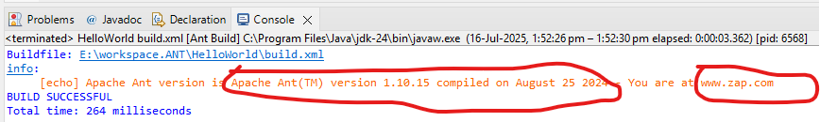

Ant - Property Files
Setting properties directly in the build file is fine, if you are working with a handful of properties. However, for a large project, it makes sense to store the properties in a separate property file.

build.properties
sitename=www.zap.com
buildversion=3.3.2

build.xml
<?xml version="1.0"?>
<project name="Hello World Project" default="info">
<property file="build.properties"/>
<target name="info">
<echo>Apache Ant version is ${buildversion} - You are at ${sitename} </echo>
</target>
</project>

output
