https://www.jenkins.io/doc/book/
Jenkins PATH Settings
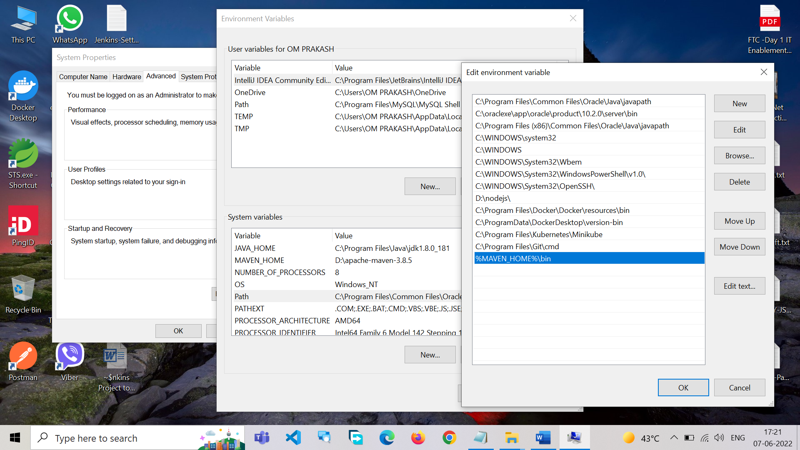
Run Jenkins
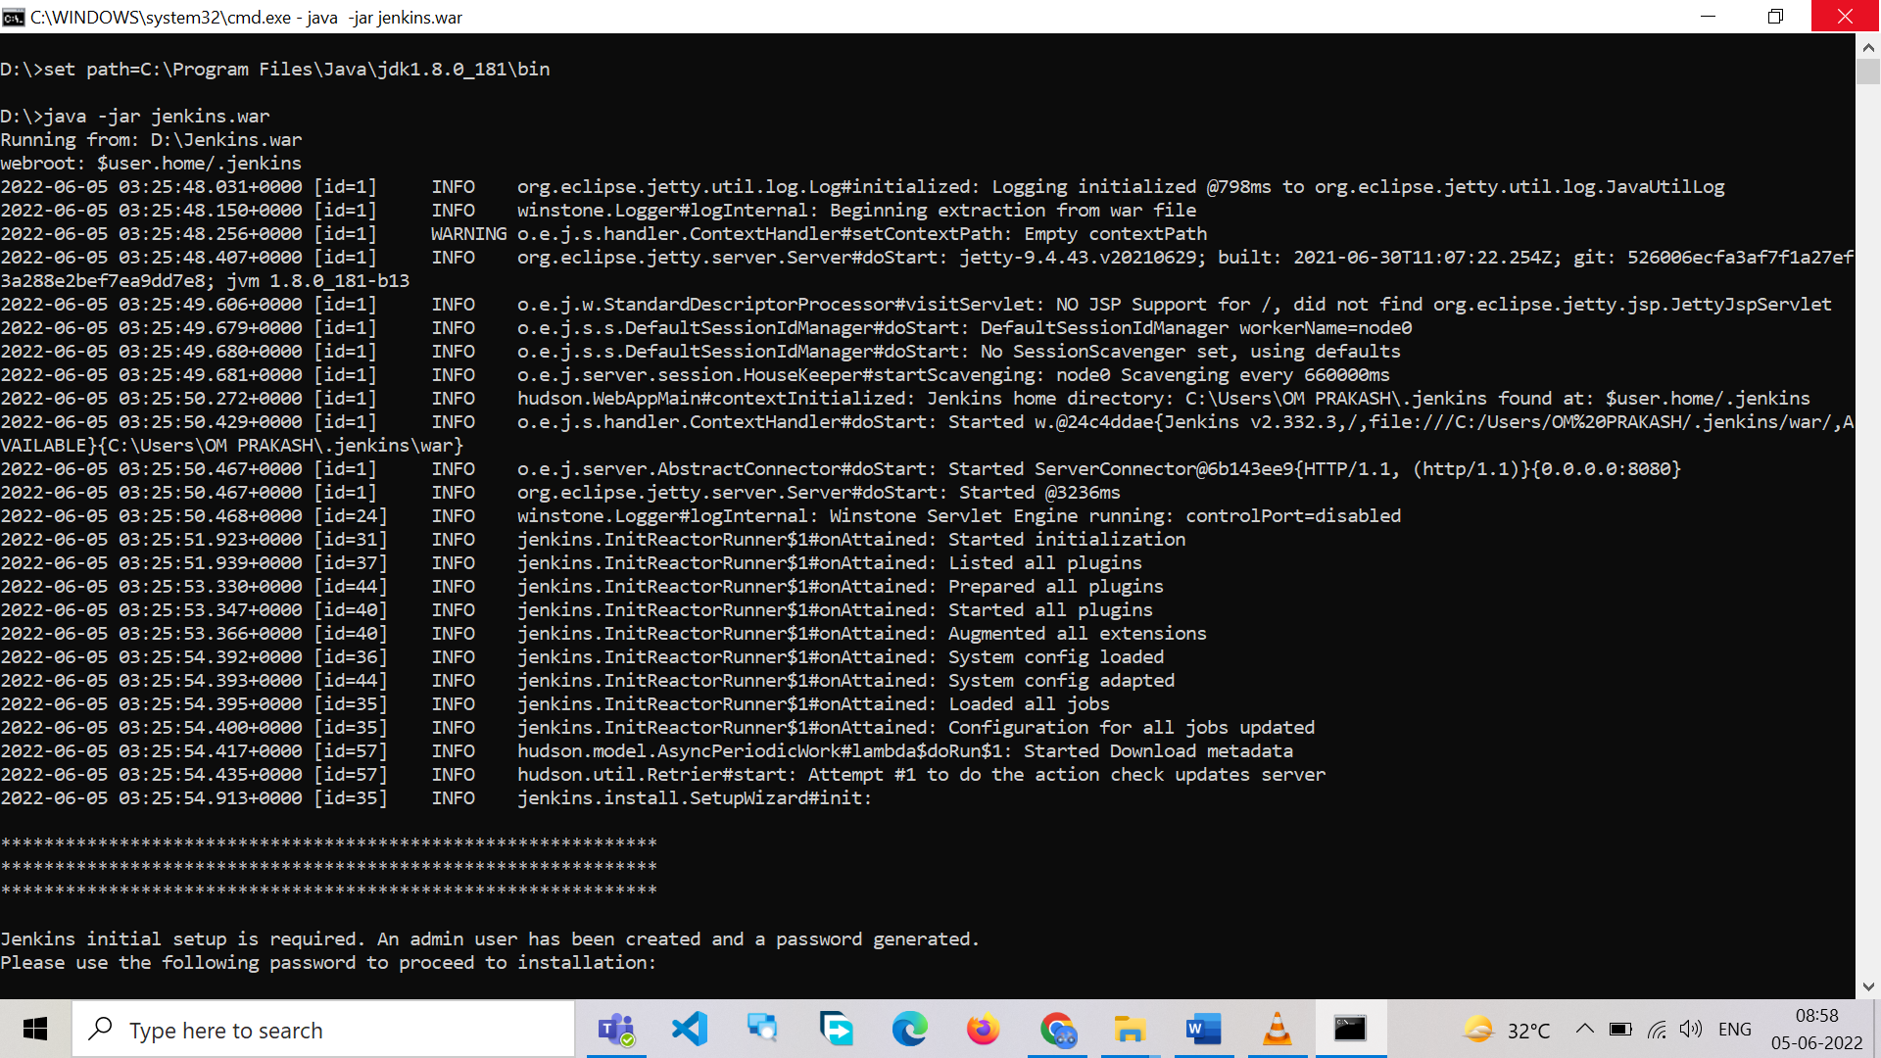
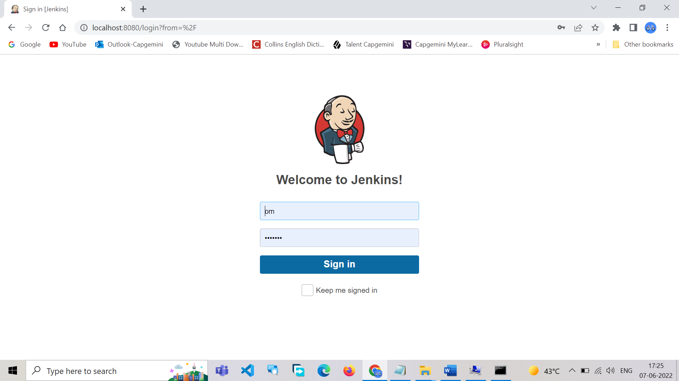

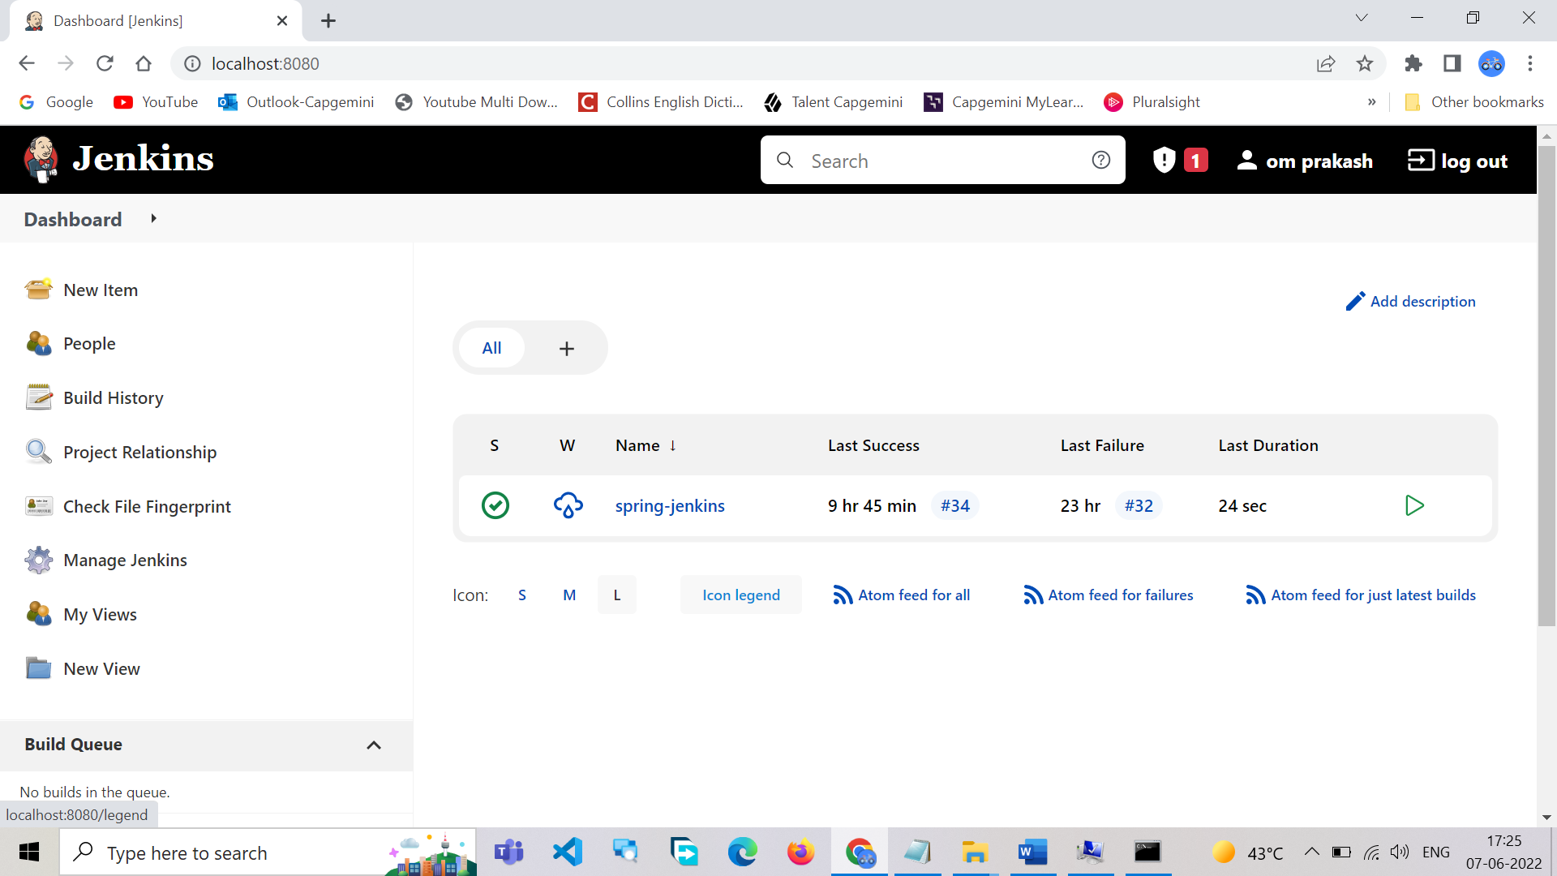
OM PRAKASH@DESKTOP-MDBEG5T MINGW64 /e/workspace.JENKINS.techie/spring-jenkins-master
$ git init
Initialized empty Git repository in E:/workspace.JENKINS.techie/spring-jenkins-master/.git/

OM PRAKASH@DESKTOP-MDBEG5T MINGW64 /e/workspace.JENKINS.techie/spring-jenkins-master (master)
$ git status
On branch master

No commits yet

Untracked files:
(use "git add <file>..." to include in what will be committed)
.classpath
.project
.settings/
README.md
mvnw
mvnw.cmd
pom.xml
src/
target/

nothing added to commit but untracked files present (use "git add" to track)

OM PRAKASH@DESKTOP-MDBEG5T MINGW64 /e/workspace.JENKINS.techie/spring-jenkins-master (master)
$ git add *
warning: LF will be replaced by CRLF in README.md.
The file will have its original line endings in your working directory
warning: LF will be replaced by CRLF in mvnw.
The file will have its original line endings in your working directory
warning: LF will be replaced by CRLF in mvnw.cmd.
The file will have its original line endings in your working directory
warning: LF will be replaced by CRLF in pom.xml.
The file will have its original line endings in your working directory
warning: LF will be replaced by CRLF in src/main/java/com/javatechie/jenkin/api/SpringJenkinsApplication.java.
The file will have its original line endings in your working directory
warning: LF will be replaced by CRLF in src/test/java/com/javatechie/jenkin/api/SpringJenkinsApplicationTests.java.
The file will have its original line endings in your working directory
warning: LF will be replaced by CRLF in target/m2e-wtp/web-resources/META-INF/maven/com.javatechie/spring-jenkins/pom.xml.
The file will have its original line endings in your working directory

OM PRAKASH@DESKTOP-MDBEG5T MINGW64 /e/workspace.JENKINS.techie/spring-jenkins-master (master)
$ git config --global user.email omprakashpandit@yahoo.co.in

OM PRAKASH@DESKTOP-MDBEG5T MINGW64 /e/workspace.JENKINS.techie/spring-jenkins-master (master)
$ git config --global user.name omprakashpandit

OM PRAKASH@DESKTOP-MDBEG5T MINGW64 /e/workspace.JENKINS.techie/spring-jenkins-master (master)
$ git commit -m "First Commit"
[master (root-commit) fe01fdb] First Commit
13 files changed, 600 insertions(+)
create mode 100644 README.md
create mode 100644 mvnw
create mode 100644 mvnw.cmd
create mode 100644 pom.xml
create mode 100644 src/main/java/com/javatechie/jenkin/api/SpringJenkinsApplication.java
create mode 100644 src/main/resources/application.properties
create mode 100644 src/test/java/com/javatechie/jenkin/api/SpringJenkinsApplicationTests.java
create mode 100644 target/classes/application.properties
create mode 100644 target/classes/com/javatechie/jenkin/api/SpringJenkinsApplication.class
create mode 100644 target/m2e-wtp/web-resources/META-INF/MANIFEST.MF
create mode 100644 target/m2e-wtp/web-resources/META-INF/maven/com.javatechie/spring-jenkins/pom.properties
create mode 100644 target/m2e-wtp/web-resources/META-INF/maven/com.javatechie/spring-jenkins/pom.xml
create mode 100644 target/test-classes/com/javatechie/jenkin/api/SpringJenkinsApplicationTests.class

OM PRAKASH@DESKTOP-MDBEG5T MINGW64 /e/workspace.JENKINS.techie/spring-jenkins-master (master)
$ git remote add origin https://github.com/omprakashpandit/spring-jenkins.git

OM PRAKASH@DESKTOP-MDBEG5T MINGW64 /e/workspace.JENKINS.techie/spring-jenkins-master (master)
$ git branch -M master #or main(Default)

OM PRAKASH@DESKTOP-MDBEG5T MINGW64 /e/workspace.JENKINS.techie/spring-jenkins-master (main)
$ git push -u origin master
Enumerating objects: 44, done.
Counting objects: 100% (44/44), done.
Delta compression using up to 8 threads
Compressing objects: 100% (22/22), done.
Writing objects: 100% (44/44), 9.85 KiB | 2.46 MiB/s, done.
Total 44 (delta 1), reused 0 (delta 0), pack-reused 0
remote: Resolving deltas: 100% (1/1), done.
To https://github.com/omprakashpandit/spring-jenkins.git
* [new branch] main -> main
branch 'main' set up to track 'origin/main'.

OM PRAKASH@DESKTOP-MDBEG5T MINGW64 /e/workspace.JENKINS.techie/spring-jenkins-master (main)
$ git clone https://github.com/omprakashpandit/spring-jenkins.git -- download project to my computer
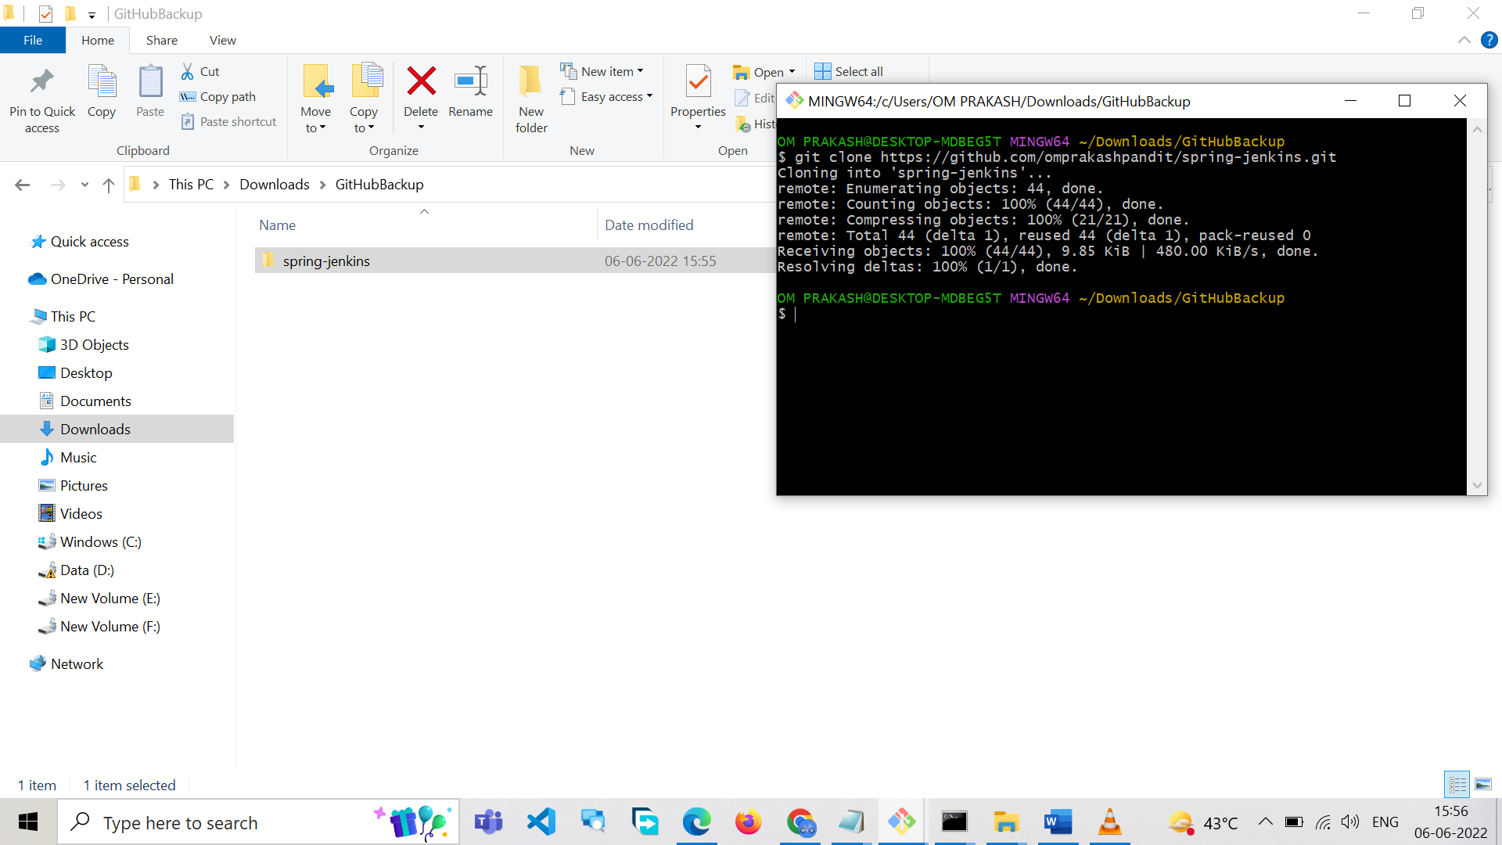
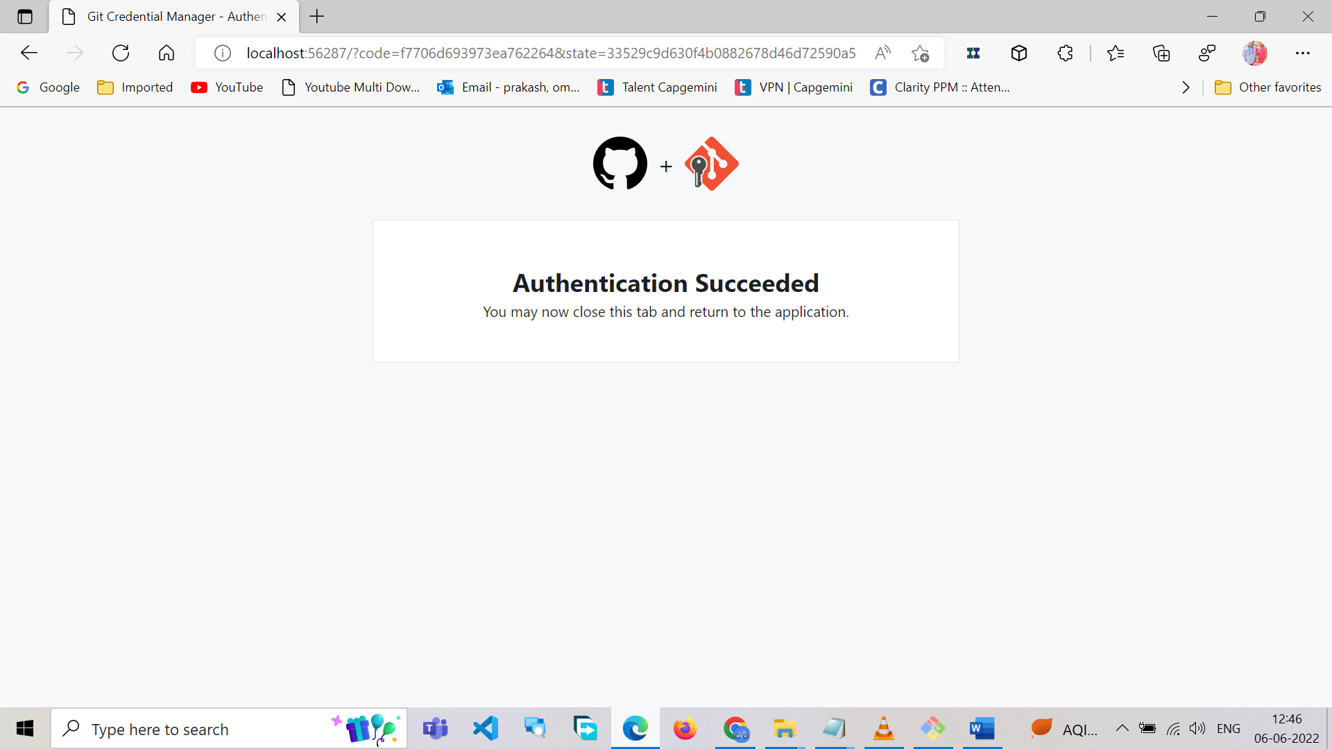
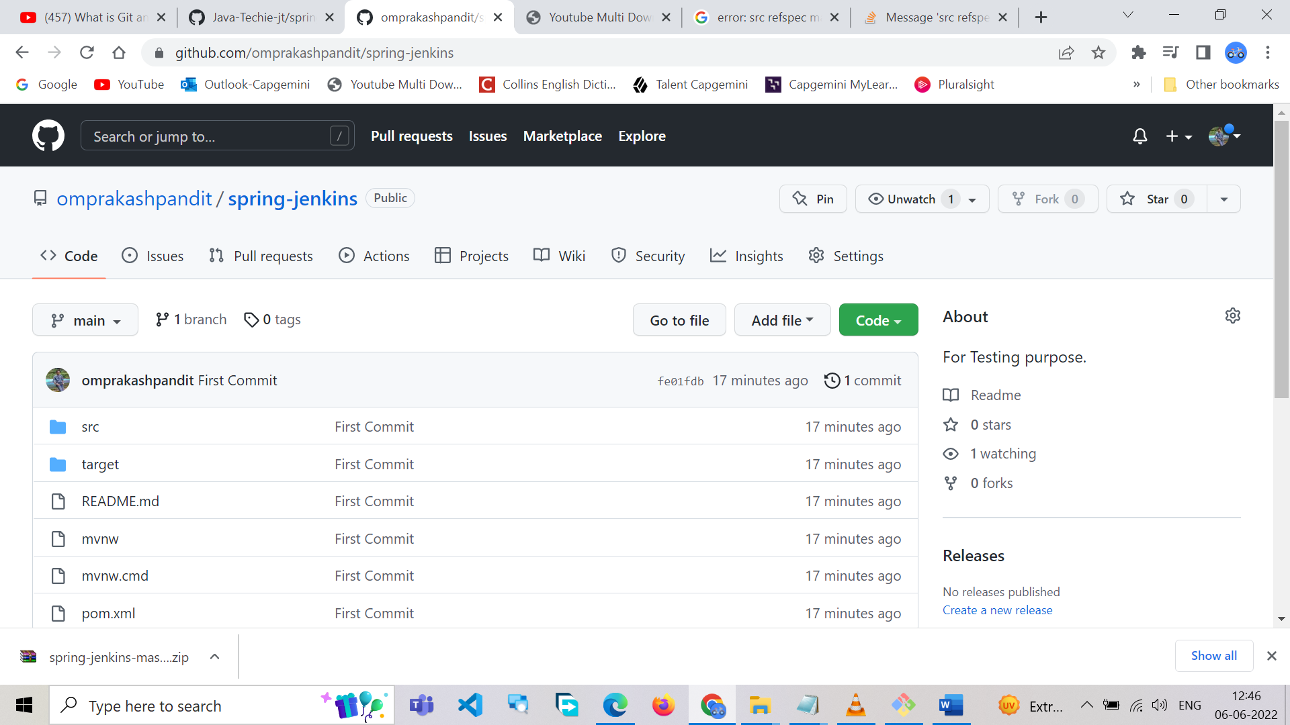
Jenkins Git Installation

C:\>git -v
C:\>git --exec-path
C:\>where git
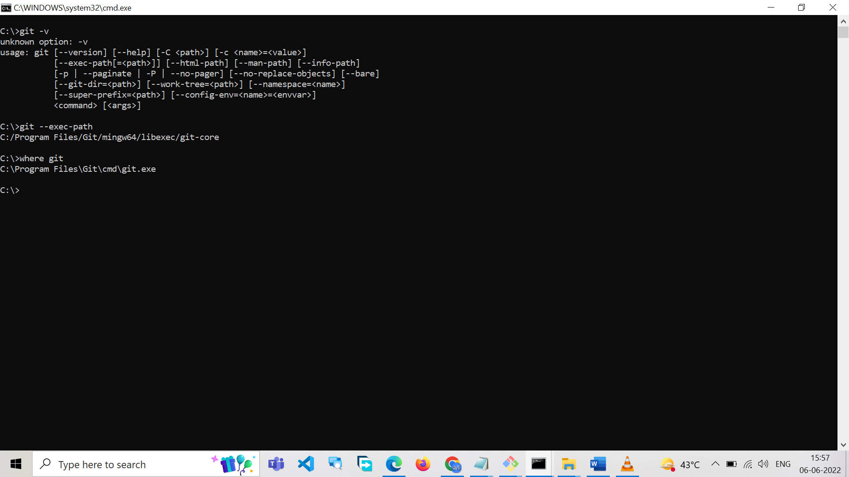

The solution for me was to set the git path in the Manage Jenkins > Global Tool Configuration settings.
In the Git section,
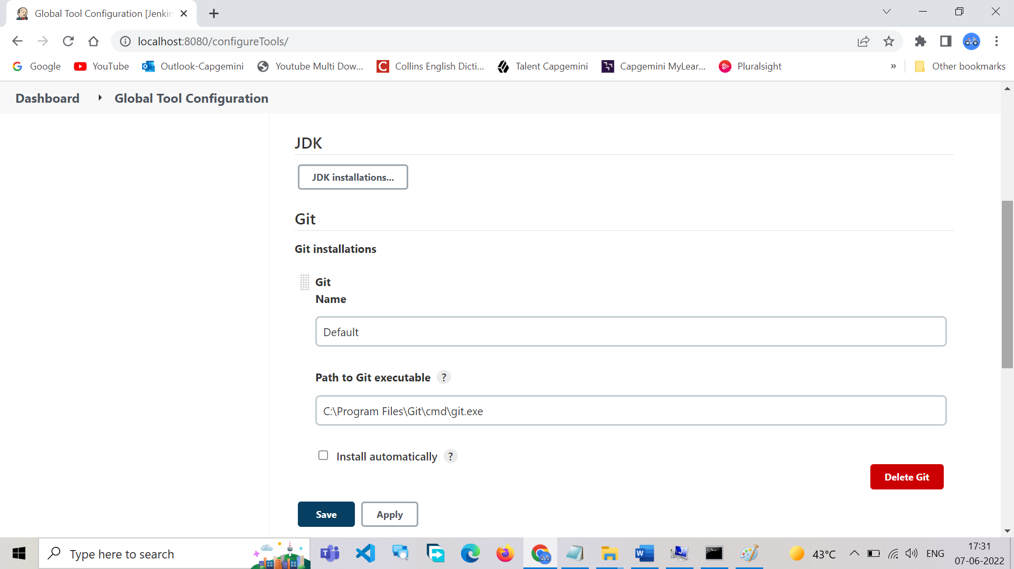
Jenkins Java Installation
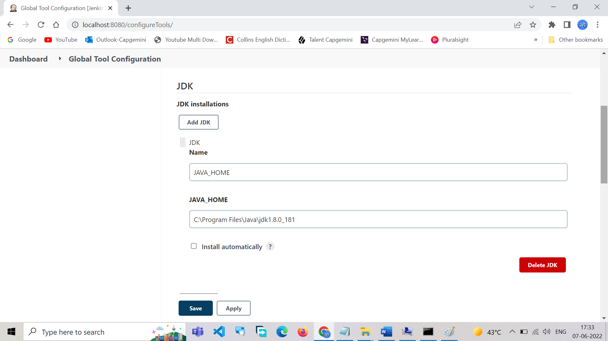
Jekins Maven Installation
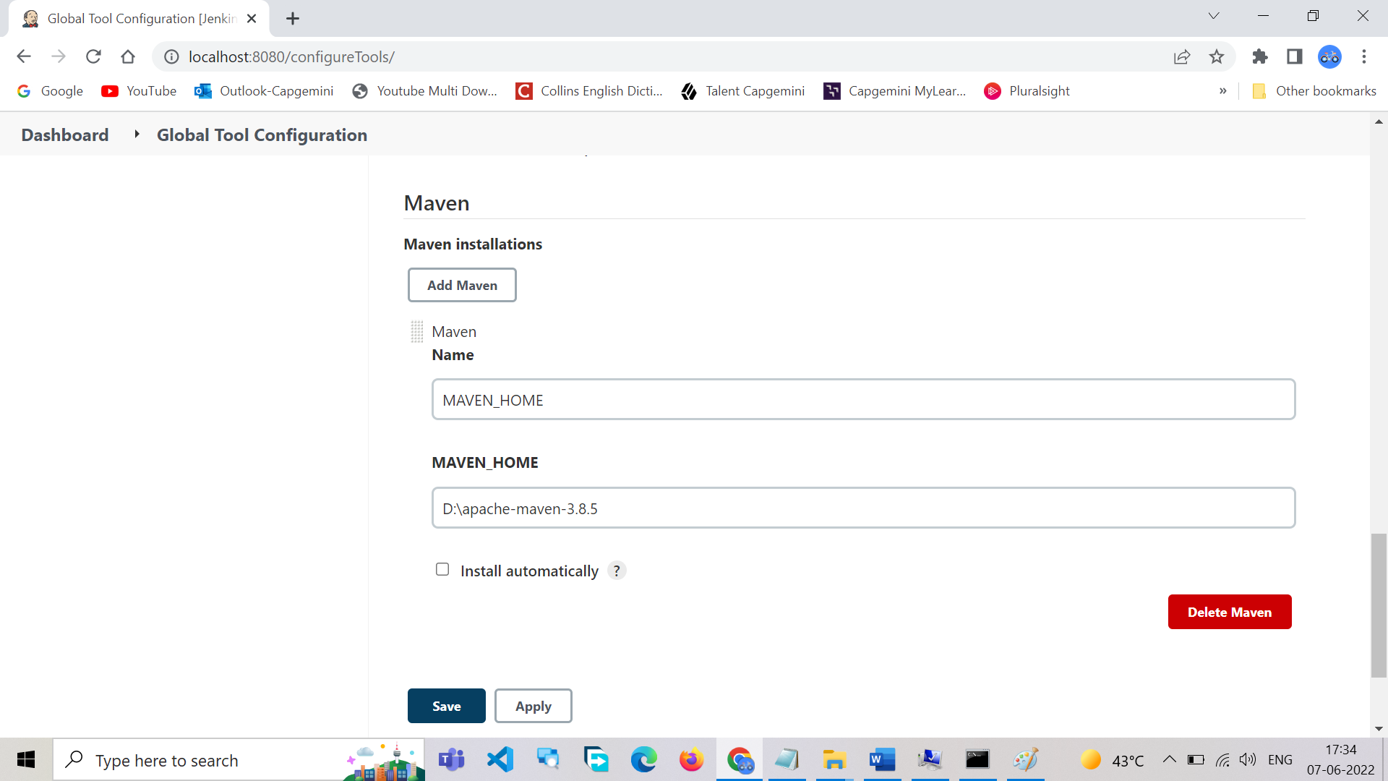

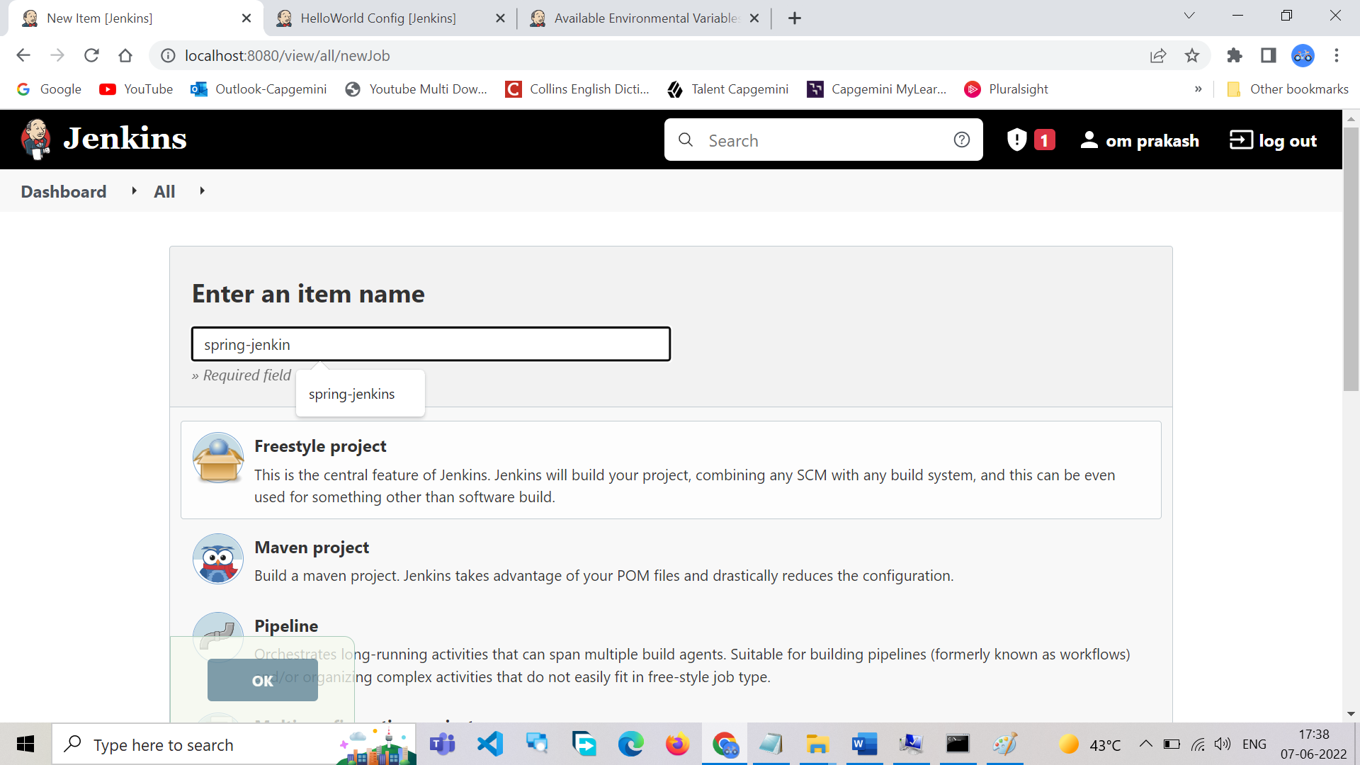

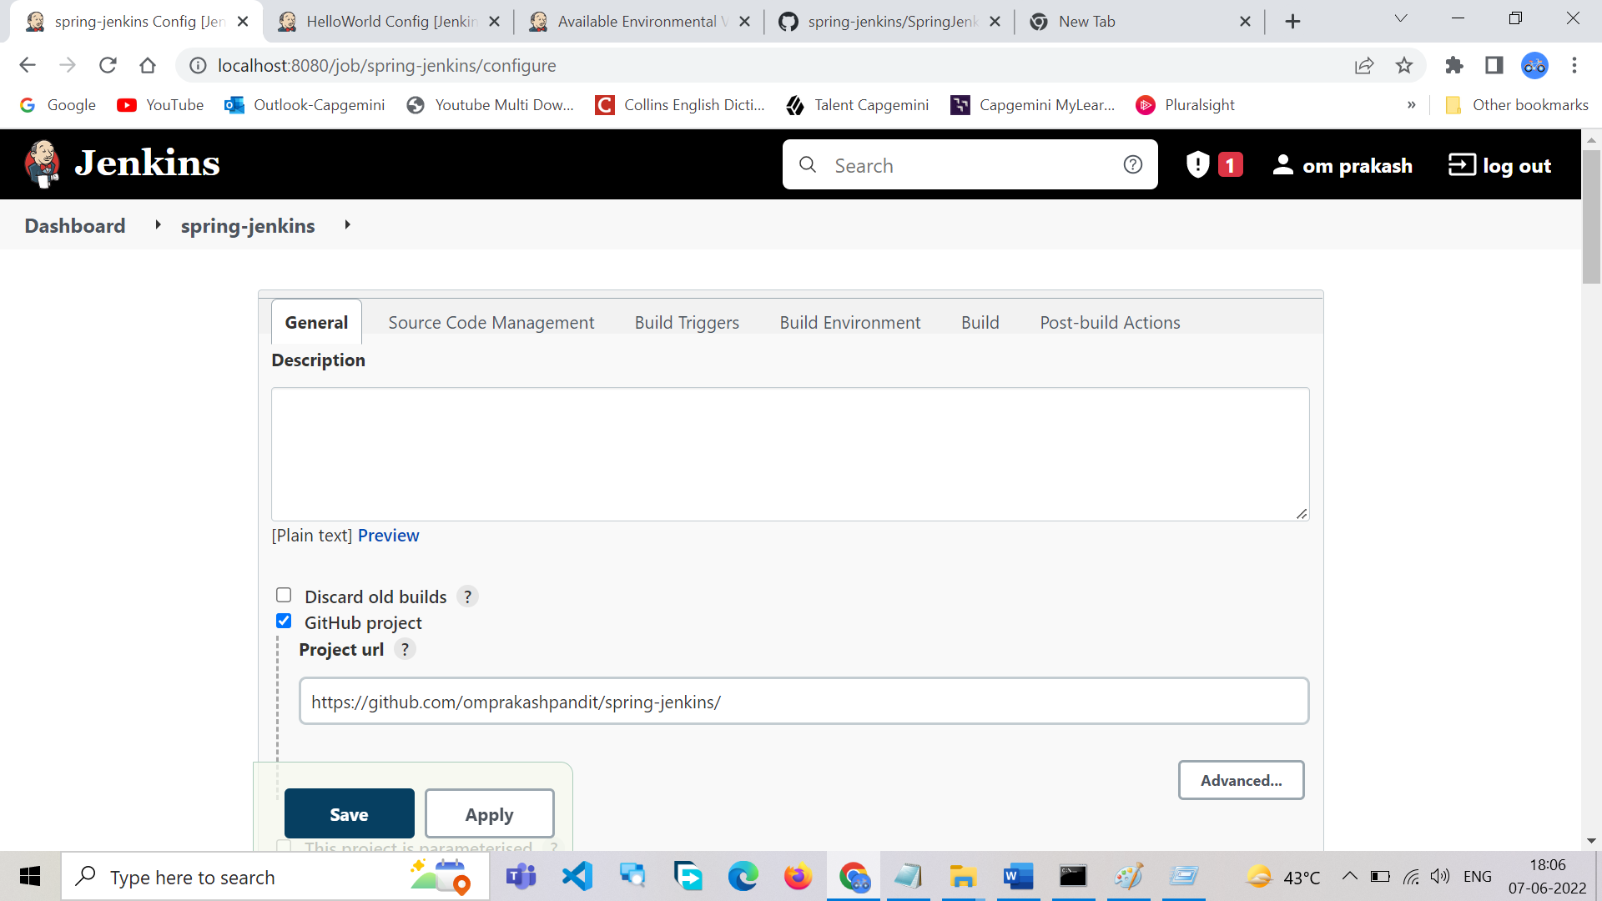
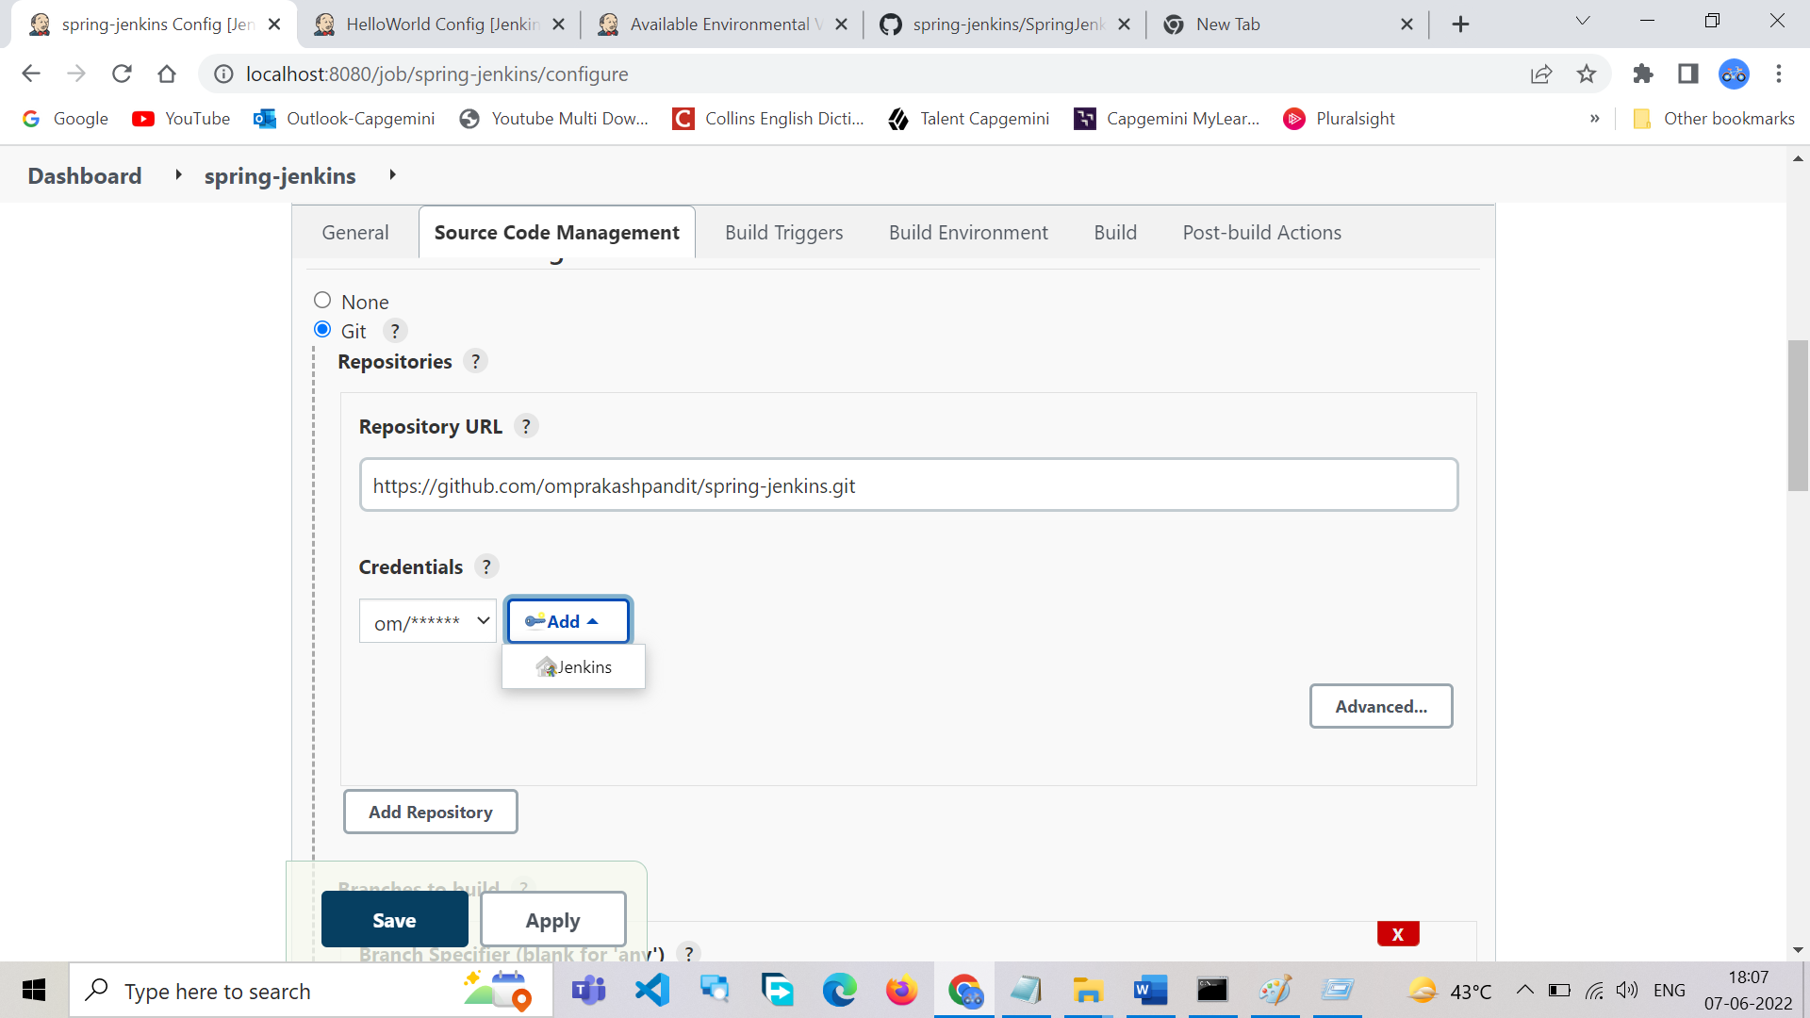

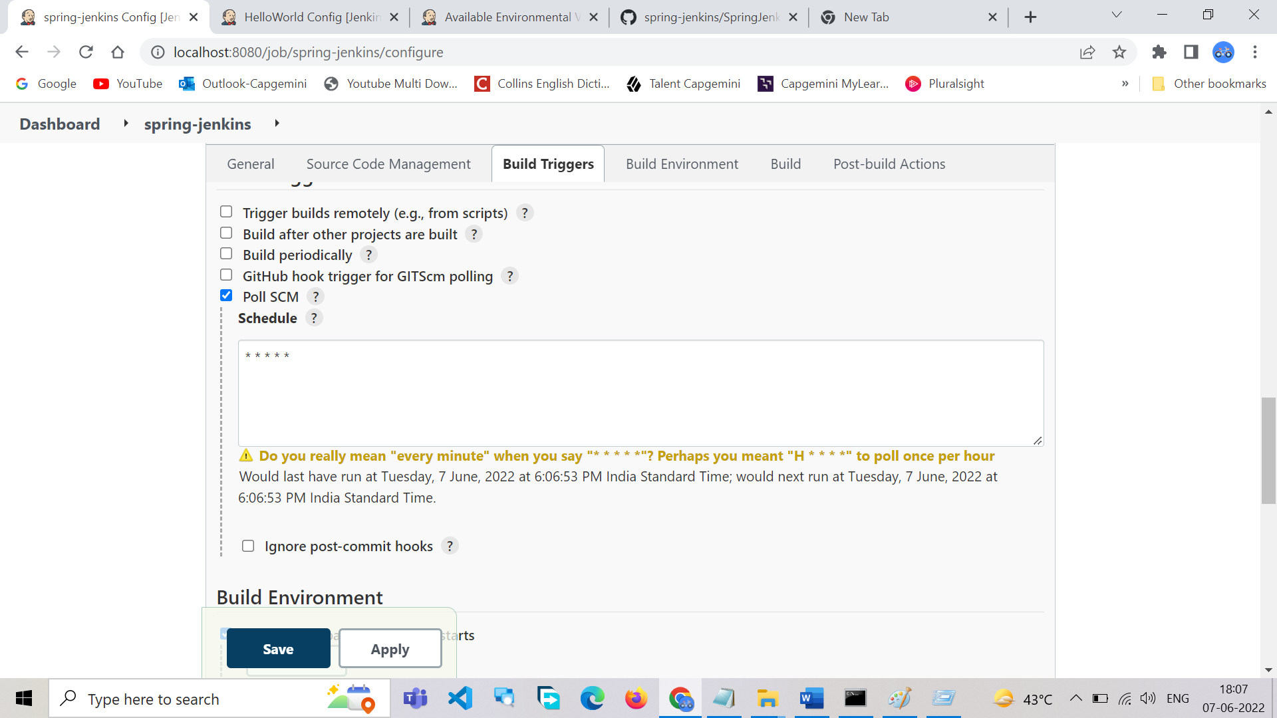

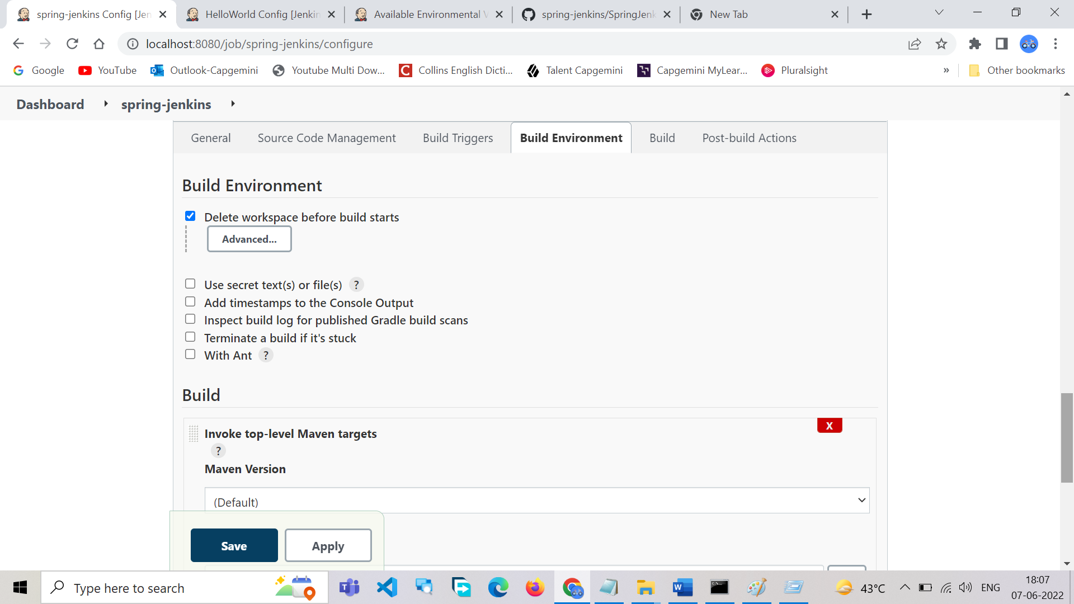
clean compile test package
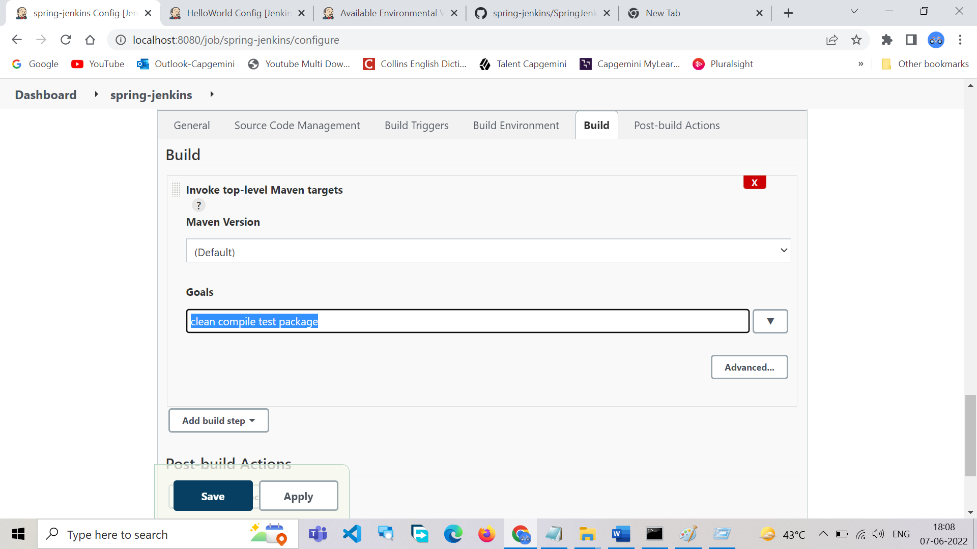

Install plugins: Maven and Docker
Step: Jenkins->Manage Jenkins->Global Tools configuration->in botton add maven and docker.
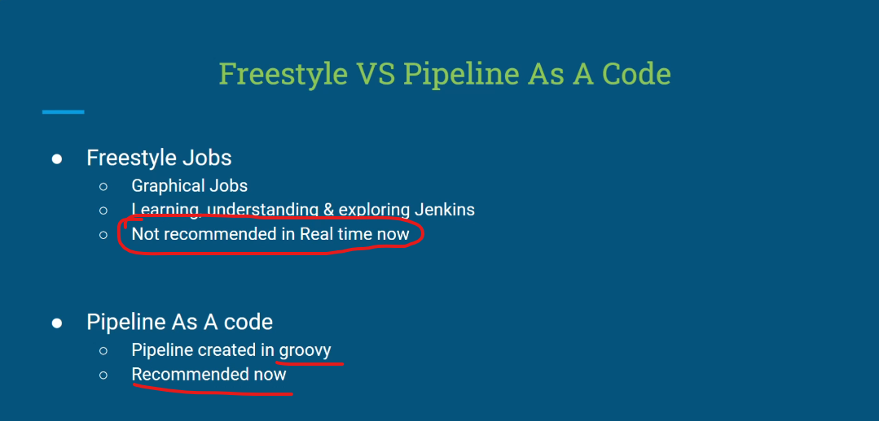
Types of PipeLine

1.Scripted:
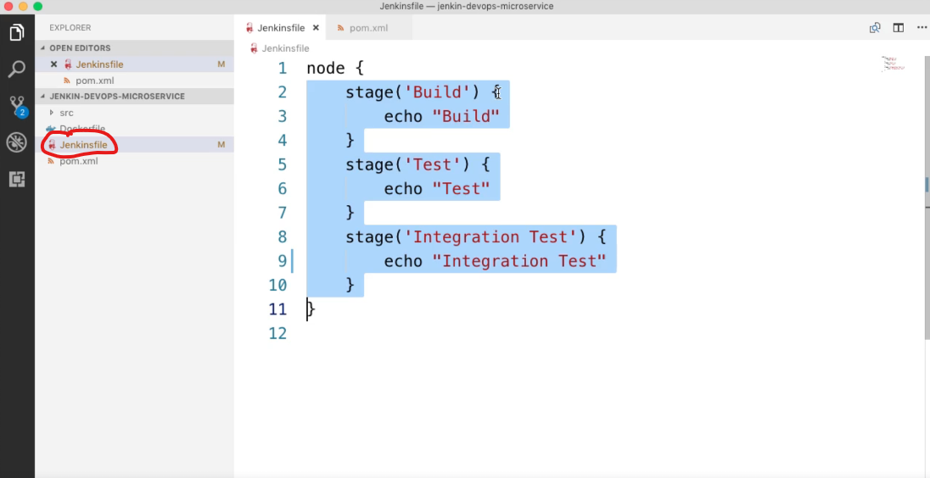
OR
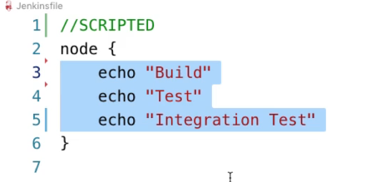

2.Declarative

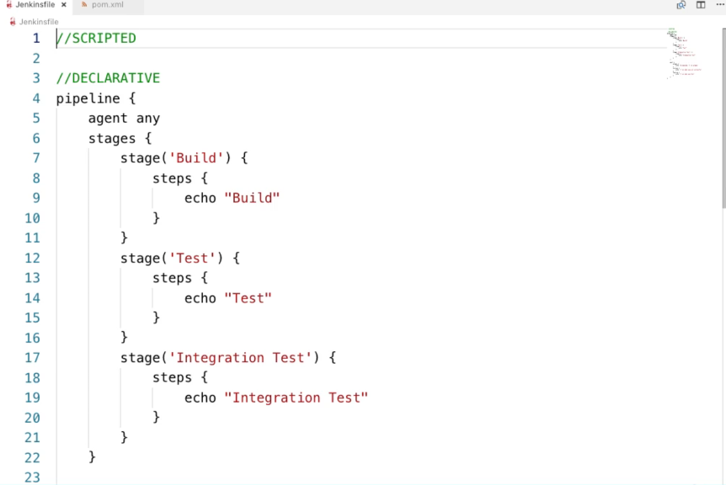
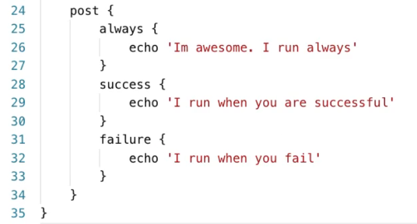

Code Generator
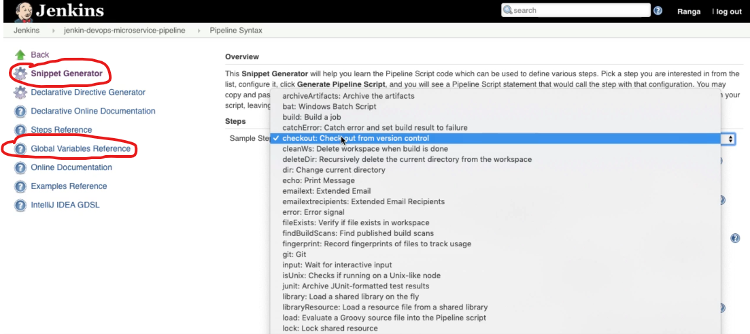
Global Variable
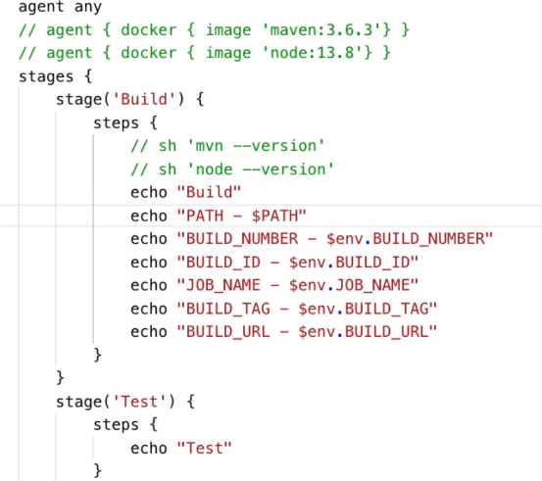
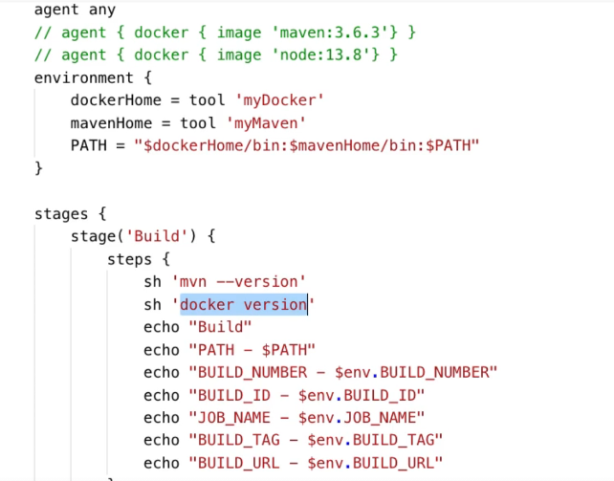

Docker
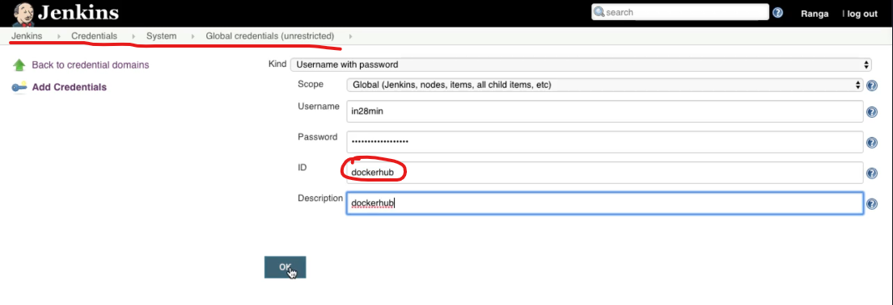
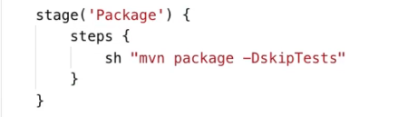
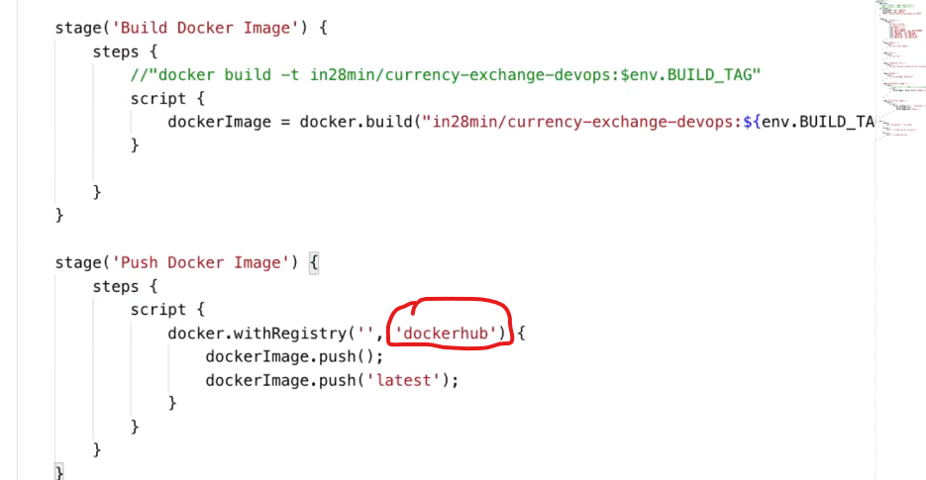

Bash Scripting(Linux)
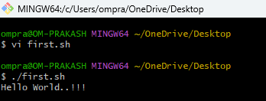
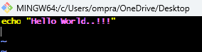

Variable in Script
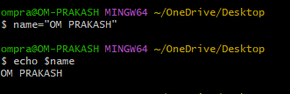
Command Line Arguments
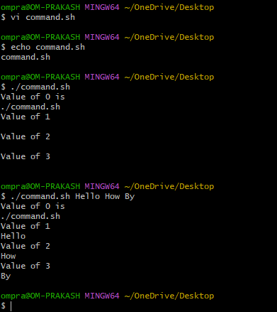
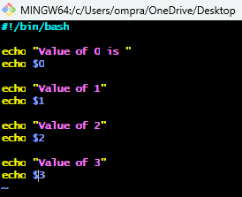

System Variable
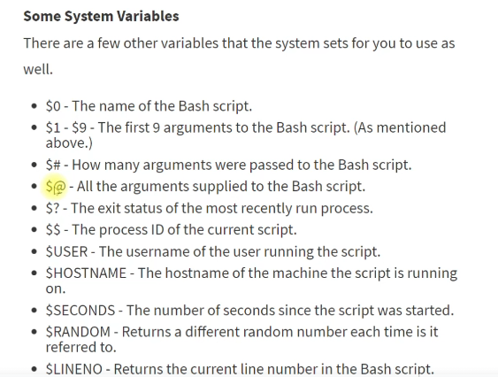
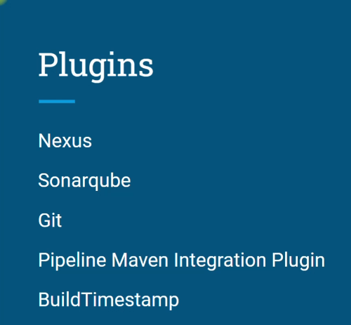
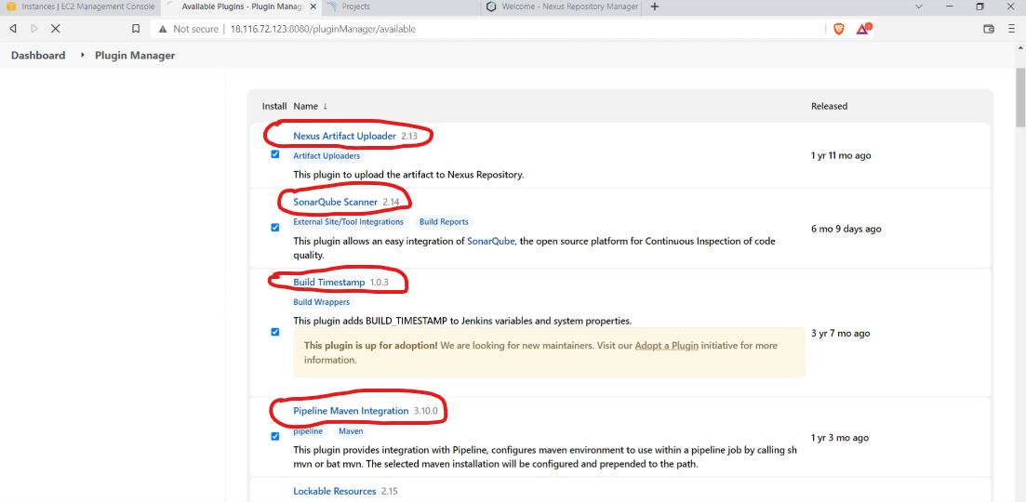

Jenkinsfile
A Jenkinsfile is a text file that defines a Jenkins pipeline—basically a set of instructions that tell Jenkins how to build, test, and deploy your application.
It’s written using Groovy-based DSL and can be stored in your project repository so that your pipeline is version-controlled alongside your code.

Two Types of Jenkins Pipelines
- Declarative Pipeline – newer, simpler, more structured.
- Scripted Pipeline – older, more flexible, fully Groovy-based.

Example: Declarative Jenkinsfile
pipeline {
agent any // Run on any available agent

environment {
APP_ENV = "staging"
VERSION = "1.0.0"
}

stages {
stage('Checkout') {
steps {
git branch: 'main', url: 'https://github.com/user/my-repo.git'
}
}

stage('Build') {
steps {
echo "Building version ${VERSION} for ${APP_ENV}"
sh 'mvn clean install'
}
}

stage('Test') {
steps {
sh 'mvn test'
}
}

stage('Deploy') {
steps {
echo "Deploying to ${APP_ENV} environment"
sh './deploy.sh'
}
}
}

post {
success {
echo 'Pipeline completed successfully!'
}
failure {
echo 'Pipeline failed!'
}
}
}

Example: Scripted Jenkinsfile
node {
stage('Checkout') {
git branch: 'main', url: 'https://github.com/user/my-repo.git'
}

stage('Build') {
sh 'mvn clean install'
}

stage('Test') {
sh 'mvn test'
}

stage('Deploy') {
sh './deploy.sh'
}
}

Key Benefits
- Version control – Jenkinsfile lives in your repo.
- Automation – Build, test, and deploy with a single commit.
- Consistency – Same pipeline runs every time.
- Flexibility – Can integrate with Docker, Kubernetes, cloud providers, etc.

