Assignment
Omprakash Reddy G19 ES&IOT
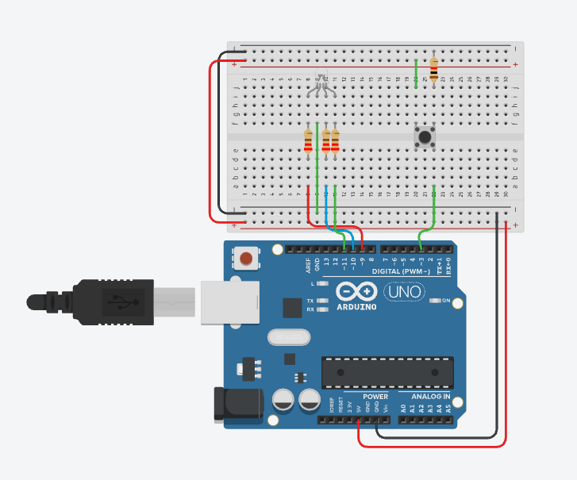
Push Button Control of an RGB LED
Code:
#define BUTTON 3
#define RED 9
#define GREEN 10
#define BLUE 11
#define DEBOUNCE_MS 30
#define DOUBLE_PRESS_MS 400
#define LONG_PRESS_MS 2000
int lastRawState = HIGH;
int buttonState = HIGH;
unsigned long lastDebounceTime = 0;
unsigned long rawPressTime = 0;
unsigned long rawReleaseTime = 0;
unsigned long pressStartTime = 0;
unsigned long firstReleaseTime = 0;
bool pendingSingle = false;
bool secondPress = false;
bool longPressDetected = false;
void allOff(){
digitalWrite(RED, LOW);
digitalWrite(GREEN, LOW);
digitalWrite(BLUE, LOW);
}
void showRed(){
allOff();
digitalWrite(RED, HIGH);
}
void showGreen(){
allOff();
digitalWrite(GREEN, HIGH);
}
void showBlue(){
allOff();
digitalWrite(BLUE, HIGH);
}
void setup(){
pinMode(BUTTON, INPUT);
pinMode(RED, OUTPUT);
pinMode(GREEN, OUTPUT);
pinMode(BLUE, OUTPUT);
allOff();
lastDebounceTime = millis();
}
void loop(){
unsigned long now = millis();
int reading = digitalRead(BUTTON);
if (reading != lastRawState){
lastRawState = reading;
lastDebounceTime = now;
if (reading == LOW)
rawPressTime = now;
else
rawReleaseTime = now;
}
// Single press timeout
if (pendingSingle &&buttonState == HIGH &&lastRawState == HIGH &&
(now - firstReleaseTime > DOUBLE_PRESS_MS)){
showRed();
pendingSingle = false;
}
// Debouncing
if ((now - lastDebounceTime >= DEBOUNCE_MS) &&(reading != buttonState)){
buttonState = reading;
// Button PRESSED
if (buttonState == LOW){
pressStartTime = rawPressTime;
longPressDetected = false;
secondPress = false;
// Check for double press
if (pendingSingle){
if ((rawPressTime - firstReleaseTime)
<= DOUBLE_PRESS_MS){
secondPress = true;
pendingSingle = false;
}
else{
showRed();
pendingSingle = false;
}
}
}
// Button RELEASED
else{
unsigned long duration =
rawReleaseTime - pressStartTime;
if (duration > LONG_PRESS_MS){
showBlue();
pendingSingle = false;
secondPress = false;
}
else if (secondPress){
showGreen();
secondPress = false;
pendingSingle = false;
}
else {
pendingSingle = true;
firstReleaseTime = rawReleaseTime;
}
}
}
// Detect long press while button is held
if (buttonState == LOW &&
lastRawState == LOW &&
!longPressDetected &&
(now - pressStartTime > LONG_PRESS_MS)){
showBlue();
longPressDetected = true;
pendingSingle = false;
secondPress = false;
}
}

