1. Create a project using angular-cli

Add one more module into the project, say FeatureModule. This module which you are adding should be generated using ng command. Add one directive called HighlightDirective to FeatureModule. This directive has to be generated using ng command. Use the directive of the FeatureModule in AppModule. If you use this directive for a para, background color of the para should become blue when mouseenter event occurs on the para element and no background color when mouseleave event occurs.

1. Create Navigation menu as shown below. Show the chosen option as shown below. Use the angular routing concept.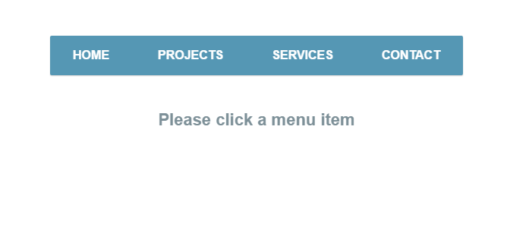

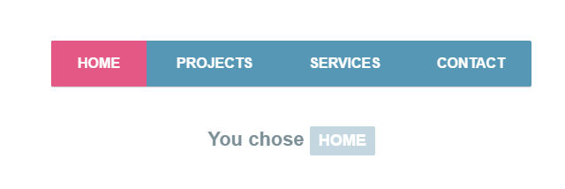

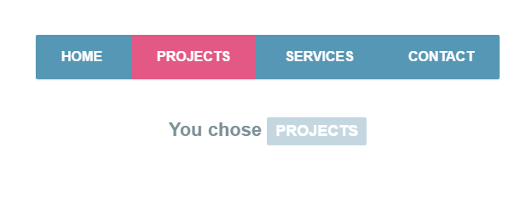

1. Create a SPA using Angular routing. Home page having 3 links home, contact and about. Create routing configuration to display content of different page depending on the user’s choice. Use the lazy loading concept. Do not load all modules at the beginning.
2. Using Animations, animate elements in and out of the view. Elements should enter after some delay and elements should leave after some delay. When the element is entering and leaving the view, let the opacity of the element change. If elements enter the view in the order A,B,C (first A enters, then B, then C) and while leaving, they should leave in the order C,B,A (first C leaves, then B, then A).