1. Create a page which has look similar to <https://angular.io>, with functionalities like Features, Events and Resources. Clicking on Features, should show the features and benefits of Angular. Clicking on Events should list the events planned for Angular in the current quarter. Clicking on Resources should give a list of references which can be used by the learner for learning Angular.
2. Create angular application (similar to home page of myWipro, where the important announcements keep moving in the screen, as shown below)

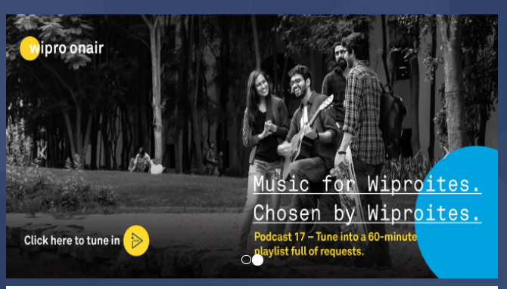

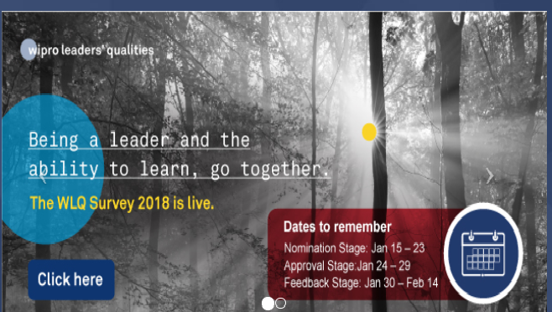

<https://mywipro.wipro.com/#/Home>

Click here should show the details of the announcement.