**PHP-OOPS-CODEIGNITER-LARAVEL**

OOPS: OOPS is a type of programming principle that helps in building complex, reusable applications.

**Class:** This is a programmer-defined data type, which includes member functions as well as data member. **Object**: Object is a specific instance of a class.

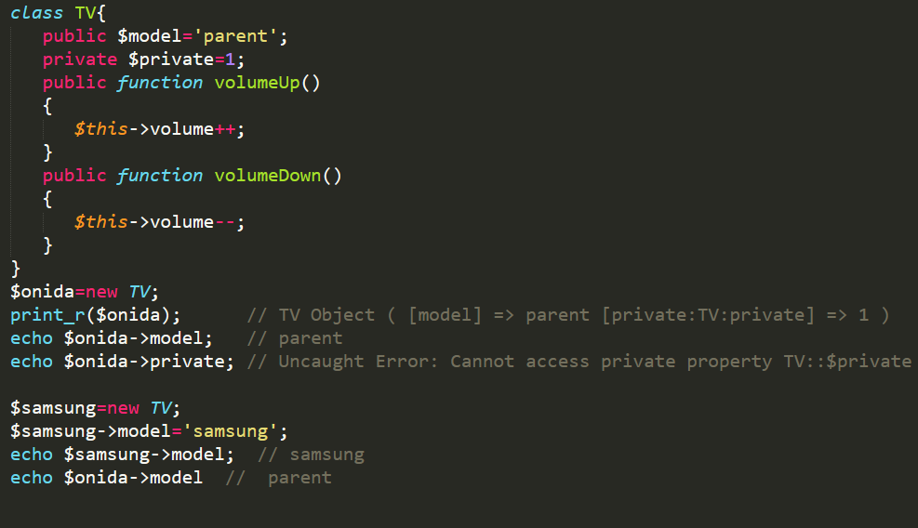

**Constructor**: Constructor is a special function and it automatically called when any object of a class is instantiated. Constructor is also called magic function because in PHP, magic method is start usually with two underscore.

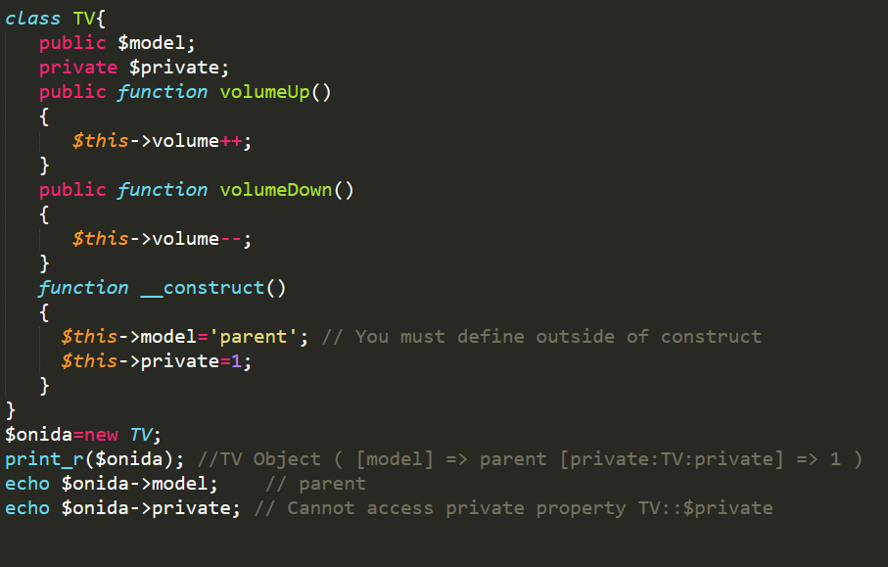

You can also pass **argument** in **constructer** function.

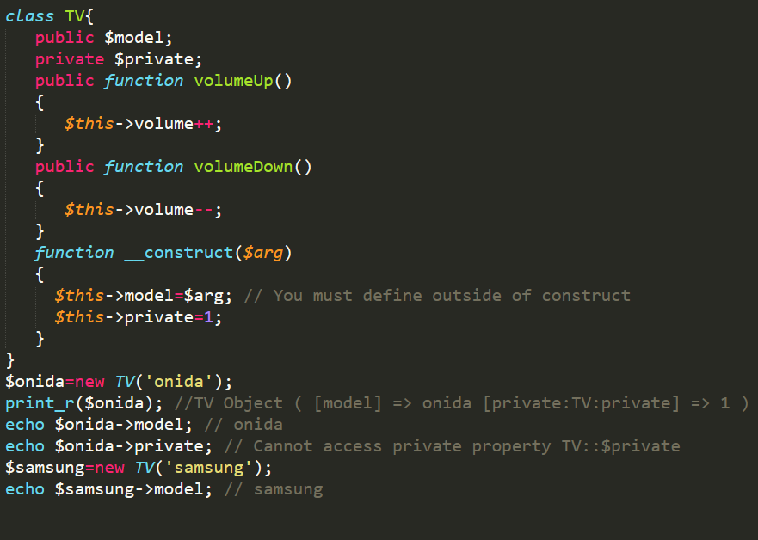

# Inheritance:

# Inheritance is a mechanism wherein a new class is derived from an existing class.

**Advances of inheritance:**

* **Reusability** - facility to use public methods of base class without rewriting the same.
* **Extensibility** - extending the base class logic as per business logic of the derived class.
* **Data hiding** - base class can decide to keep some data private so that it cannot be altered by the derived class
* **Overriding**-With inheritance, we will be able to override the methods of the base class so that meaningful implementation of the base class method can be designed in the derived class.
* Child class has more power than parent class member and function. Parent class get **override.**

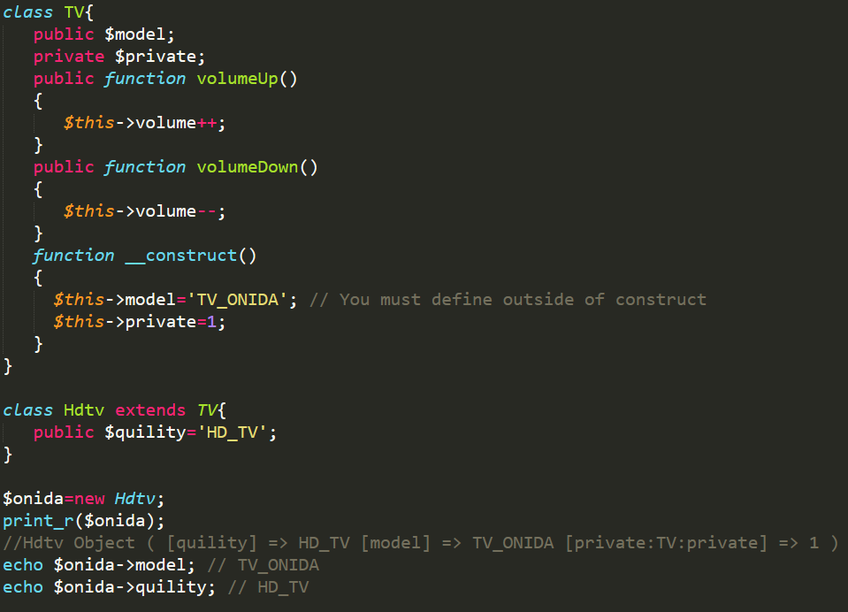

* **When overriding child class must have lower access level as compared to parent.**

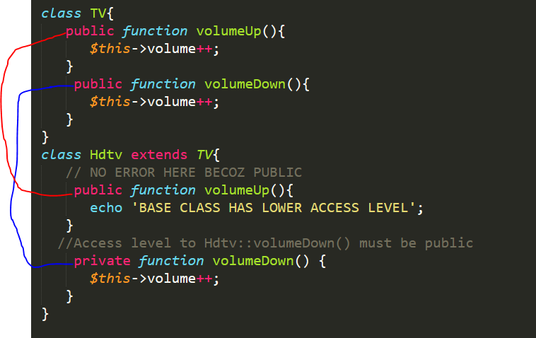

**Encapsulation**

# Wrapping some data in single unit is called Encapsulation. Encapsulation is used to safe data or information in an object from other it means encapsulation is mainly used for protection purpose. Second advantage of encapsulation is you can make the class read only or write only by providing setter or getter method.

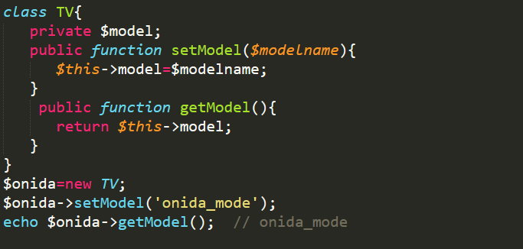

**Class Abstraction**

PHP 5 introduces abstract classes and methods. Classes defined as abstract may not be instantiated, and any class that contains at least one abstract method must also be abstract. *Methods defined as abstract simply declare the method's signature - they cannot define the implementation*. When inheriting from an abstract class, ***all methods marked abstract in the parent's class declaration must be defined by the child***; additionally, these methods must be defined with the same (***or a less restricted***) visibility. For example, if the abstract method is defined as **protected**, the function implementation must be defined as either **protected or public, but not private**. Furthermore the signatures of the methods must match, i.e. the type hints and the number of required arguments must be the same. For example, if the child class defines an optional argument, where the abstract method's signature does not, there is no conflict in the signature.

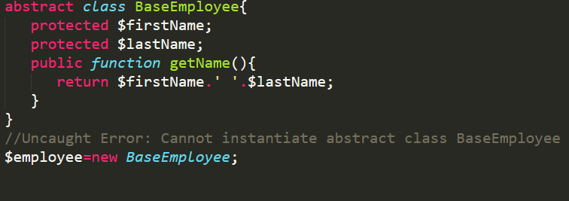

Abstract class uses for Enforcement. That means if we **declared a method** and **not define** that method then the class that drive this class must define that methods. So every class that extent a class having a abstract methods must define that methods in their own body.

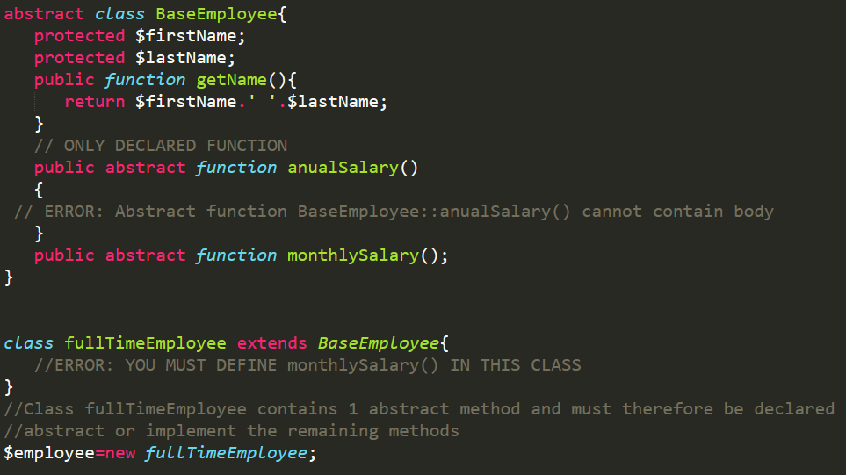

**-**If any class that has at least one abstract method becomes abstract class no need to use **abstract** **class.**

**-Can declared and also define the function in abstract class. See getName is define in abstract class.**

**-If abstract removed from class name and define a abstract method in that class then also you can’t create direct object of that base class.**

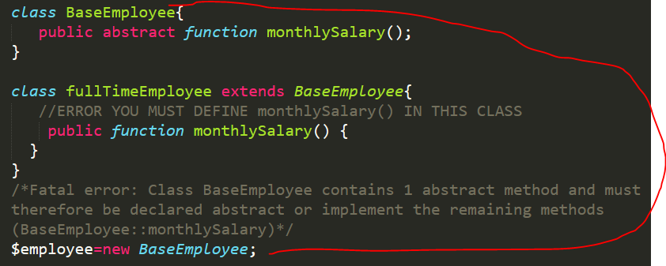

**Interface**

An Interface allows the users to create programs, specifying the **only public methods** that a class must implement, without involving the complexities and details of how the particular methods are implemented. It is generally referred to as the next level of abstraction. It resembles the abstract methods, resembling the abstract classes. An Interface is defined just like a class is defined but with the class keyword replaced by the interface keyword and just the function prototypes. The interface **contains no Data Variables**/**Data** **Member**. The interface is helpful in a way that it ensures to maintain a sort of metadata for all the methods a programmer wishes to work on. **Not contain construct function**.

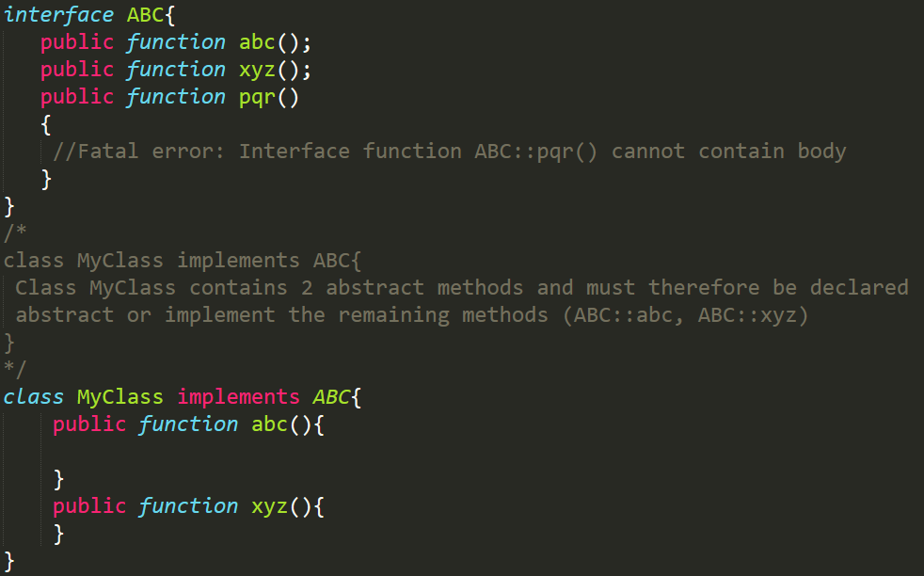

**Few characteristics of an Interface are:**

* An interface consists of methods that have no implementations, which means the interface methods are abstract methods.
* All the methods in interfaces must have public visibility scope.
* Interfaces are different from classes as the class can inherit from one class only whereas the class can implement one or more interfaces.

**Advantages of PHP Interface**

* An interface allows unrelated classes to implement the same set of methods, regardless of their positions in the class inheritance hierarchy.
* An **interface can model multiple inheritances** because a class can implement more than one interface whereas it can extend only one class.
* The implementation of an inheritance will save the caller from full implementation of object methods and focus on just he objects interface, therefore, the caller interface remains unaffected.

**STATIC KEYWORDS IN OPPS**

Static in oops refers to the class not to object. Static is not in context of object.

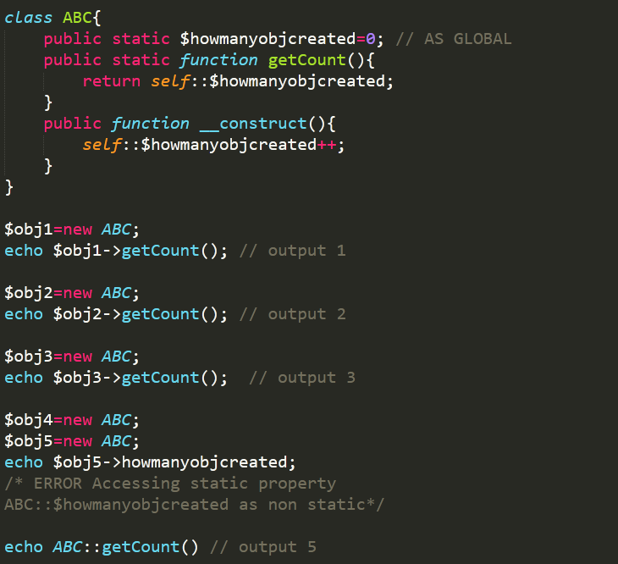

|  |  |
| --- | --- |
| **$this** | **self** |
| Represents an instance of the class or object | Represents a class |
| Always begin with dollar ($) sign | Never begin with dollar($) sign |
| Is followed by the -> operator | Is followed by the :: operator |
| The property name after the -> operator does not take dollar ($) sign, e.g., $this->property. | The property name after the :: operator always take the dollar ($) sign. |
|  |  |

**When we override the function and want a parent functionalities also in it then we use** parent::functionName();

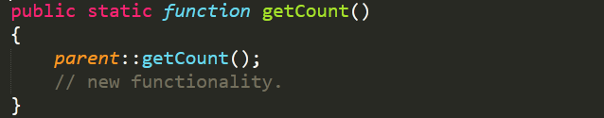

**Any class in which all methods are statics are called statics class. Class does not have any special keywords like statics.**

**Late Statics Binding:** Let's jump into an example up front to understand the concept. Let's create two classes parent and child which would tell us the name of the object using getName() method:

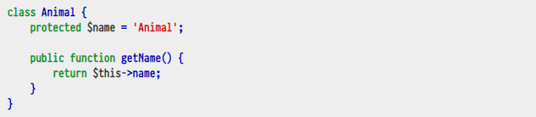

Let's extend the Animal class so we can use its getName() method without repeating it in child class. We will only need the $name variable in child class to get it's name:



Now we expect to get names of each object, let's do so:

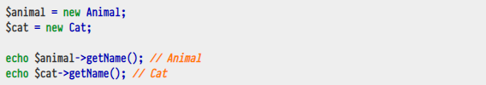

And we successfully get Animal and Cat echoed out. But now let's modify code a bit so that we can use those classes without creating their instances with the help of static keyword (eg global state):

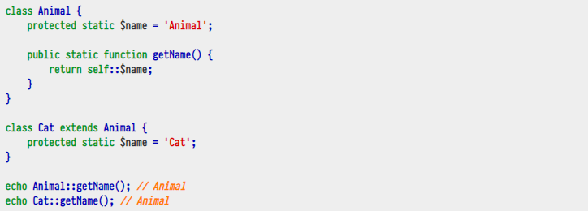

Noticed the problem ? We wanted to see Animal and Cat to be echoed out like previous example but in both cases it said Animal not Cat.

The reason why in previous example things worked the way expected is because we explicitly created new instances of both classes using new keyword and PHP knew which class and method to use. This is not the case in second static example. In the second example, we are using the self keyword which always resolves to current class where it is called. This is reason why the name for the Cat class wasn't echoed out.

So how do we get the name of cat ? Here are few ways.

**By Repeating Same Code In Child Class**

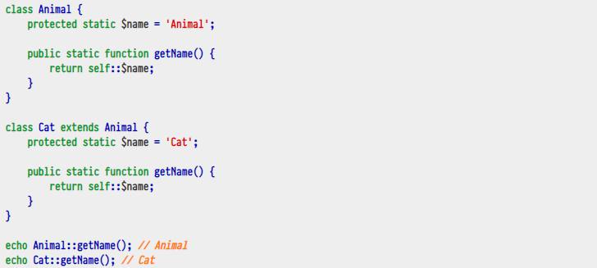

This works but it defeats the purpose of inheritance. What is the point of extending Animal class when we need to repeat same code in child class ? This isn't ideal.

**By Using get_called_class()**

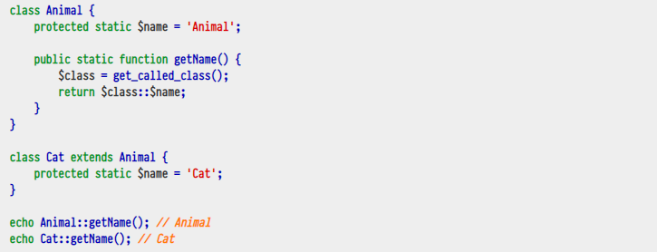

This is better and works for our purpose.

**By Using static keyword:**

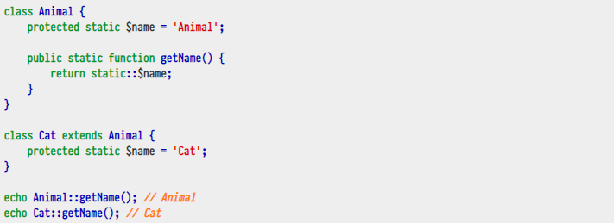

PHP 5.3 introduced the static keyword to help deal with this issue. Before that, get_called_class()was what was used. Let's get the expected result using static keyword:

And this works fine too. These days using static keyword seems to be common practice instead of get_called_class() to deal with this issue though get_called_class() has many other uses too.

So in simple words, **late static binding** is something that helps us correctly resolve to **static** classes at run time. So when we use self keyword, PHP checks it at compile time which class to **bind** the method call to but when we use static keyword, PHP would check it **late** eg it would determine which class to use and bind method call to at runtime. Doing it at runtime is what helps PHP determine which class was meant.

**DEPENDENCY INJECTION**

[**https://code.tutsplus.com/tutorials/dependency-injection-in-php--net-28146**](https://code.tutsplus.com/tutorials/dependency-injection-in-php--net-28146)

In simple terms, Dependency Injection is a design pattern that helps avoid hard-coded dependencies for some piece of code or software.

The dependencies can be changed at run time as well as compile time. We can use Dependency Injection to write modular, testable and maintainable code.

* **Modular**: The Dependency Injection helps create completely self-sufficient classes or modules
* **Testable**: It helps write testable code easily eg unit tests for example
* **Maintainable**: Since each class becomes modular, it becomes easier to manage it

**The Problem:** We have dependencies almost always in our code. Consider the following procedural example which is pretty common:

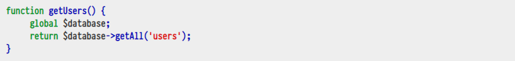

Here the function **getUsers** has dependency on the **$database** variable (tight coupling). It has some of these problems:

* The function **getUsers** needs a **working** connection to *some* ***database*** . Whether there is successful connection to database or not is the fate of **getUsers** function
* The **$database** comes from outer scope so chances are it might be overwritten by some other library or code in the same scope in which case function may fail

Of course you could have used the **try-catch** constructs but it still doesn't solve the second problem.

Let's consider another example for a class:

Let's consider another example for a class:

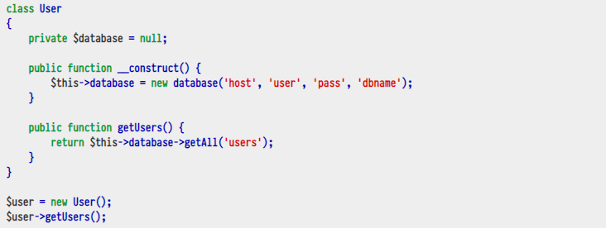

This code again has these problems:

* The class User has implicit dependency on the specific database. All dependencies should always be **explicit** not implicit. This defeats [Dependency inversion principle](http://en.wikipedia.org/wiki/Dependency_inversion_principle)
* If we wanted to change database credentials, we need to edit the User class which is not good; every class should be completely **modular** or black box. If we need to operate further on it, we should actually use its public properties and methods instead of editing it again and again. This defeats [Open/closed principle](http://en.wikipedia.org/wiki/Open/closed_principle)
* Let's assume right now class is using MySQL as database. What if we wanted to use some other type of database ? You will have to modify it.
* The User class does not necessarily need to know about database connection, it should be confined to its own functionality only. So writing database connection code in User class doesn't make it modular. This defeats the [Single responsibility principle](http://en.wikipedia.org/wiki/Single_responsibility_principle). Think of this analogy: A cat knows how to meow and a dog knows how to woof; you cannot mix them or expect dog to say meow. Just like real world, each object of a class should be responsible for its own specific task.
* It would become harder to write unit tests for the User class because we are instantiating the database class inside its constructor so it would be impossible to write unit tests for the User class without also testing the database class.

**Enter Dependency Injection!:** Let's see how we can easily take care of above issues by using Dependency Injection. The Dependency Injection is nothing but **injecting a dependency explicitly**. Let's re-write above class:

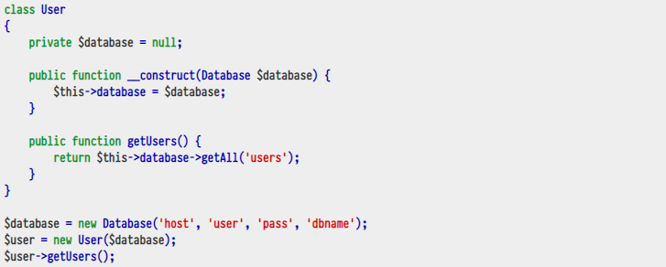

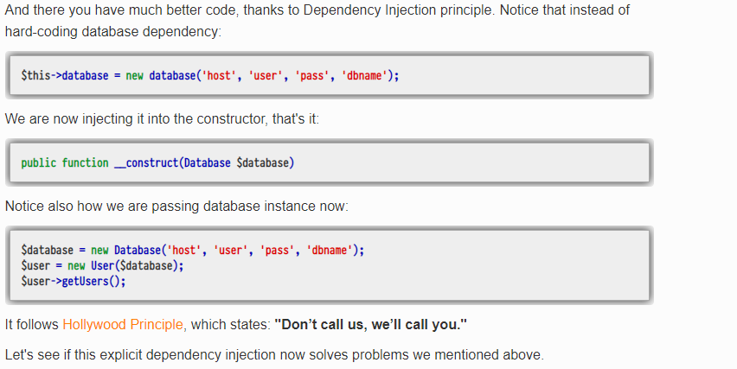

The class User has implicit dependency on the specific database . All dependencies should always be explicit not implicit. This defeats Dependency inversion principle.

We have already made database dependency explicit by requiring it into the constructor of the  User class:

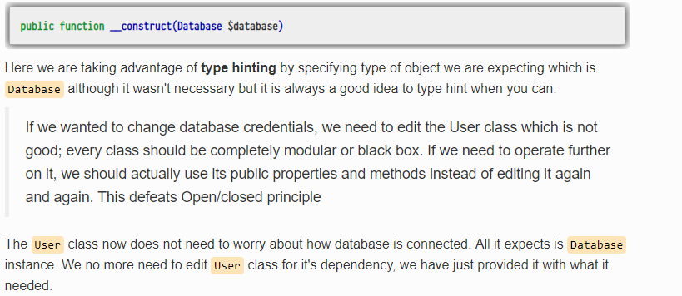

Let's assume right now class is using MySQL as database. What if we wanted to use some other type of database ? You will have to modify it.

Again, the User class doesn't need to know which type of database is used. For the Database, we could now create different adapters for different types of database and pass to User class. For example, we could create an interface that would enforce common methods for all different types of database classes that must be implement by them. For our example, we pretend that interface would enforce to have a getUser() method requirement in different types of database classes.

The User class does not necessarily need to know about database connection, it should be confined to its own functionality only. So writing database connection code in User class doesn't make it modular. This defeats the Single responsibility principle. Of course **User** class now doesn't know how database was connected. It just needs a valid connected **Database** instance.

It would become harder to write unit tests for the User class because we are instantiating the database class inside its constructor so it would be impossible to write unit tests for the User class without also testing the database class. If you have wrote unit tests, you know now it will be a breeze to write tests for the **User** class using something like [**Mockery**](https://github.com/padraic/mockery) or similar to create mock object for the **Database**.

**Different Ways of Injecting Dependencies**

Now that we have seen how useful Dependency Injection is, let's see different ways of injecting dependencies. There are three ways you can inject dependencies:

* Constructor Injection
* Setter Injection
* Interface Injection

**Constructor Injection**

We have already seen example of **Constructor Injection** in above example. Constructor injection is useful when:

* A dependency is **required** and class can't work without it. By using constructor injection. we make sure all its required dependencies are passed.
* Since constructor is called only at the time of instantiating a class, we can make sure that its dependencies cant be changed during the life time of the object.

Constructor injection suffer from one problem though:

* Since constructor has dependencies, it becomes rather difficult to extend/override it in child classes.

**Setter Injection**

Unlike Constructor injection which makes it **required** to have its dependencies passed, setter injection can be used to have **optional dependencies**. Let's pretend that our User class doesn't require Database instance but uses optionally for certain tasks. In this case, you would use a setter method to inject the Database into the User class something like:

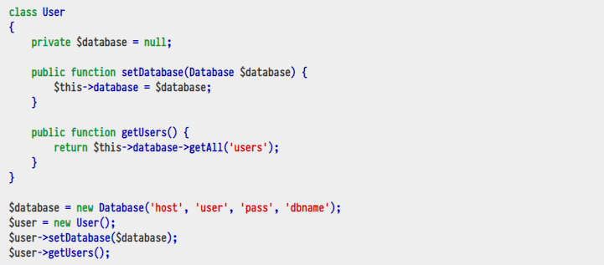

As you can see, here we have used setDatabase() setter function to inject Database dependency into the User class. If we needed some other dependency, we could have created one more setter method and injected in the similar fashion.

So Setter Injection is useful when:

* A class needs optional dependencies so it can set itself up with default values or add additional functionality it needs.

Notice that you could also inject dependency via **public property** for a class. So instead of using setter function $user->setDatabase($database);, you could also do $user->database = new Database(...);

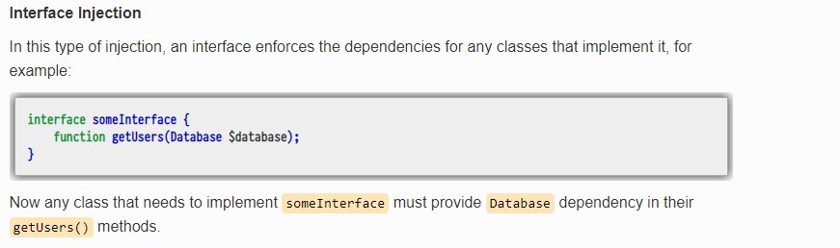

The Problem Again

So for we have seen very contrived example of injecting dependency into a simple class but in real world applications, a class might have many dependencies. It isn't all that easy to manage all those dependencies because you need to KNOW which dependencies are required by a certain class and HOW they need to be instantiated. Let's take example of setter injection:

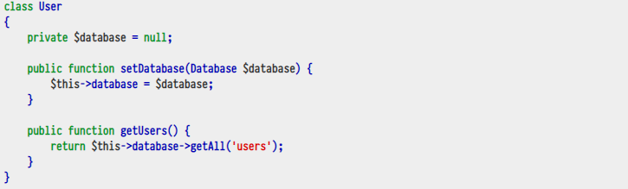

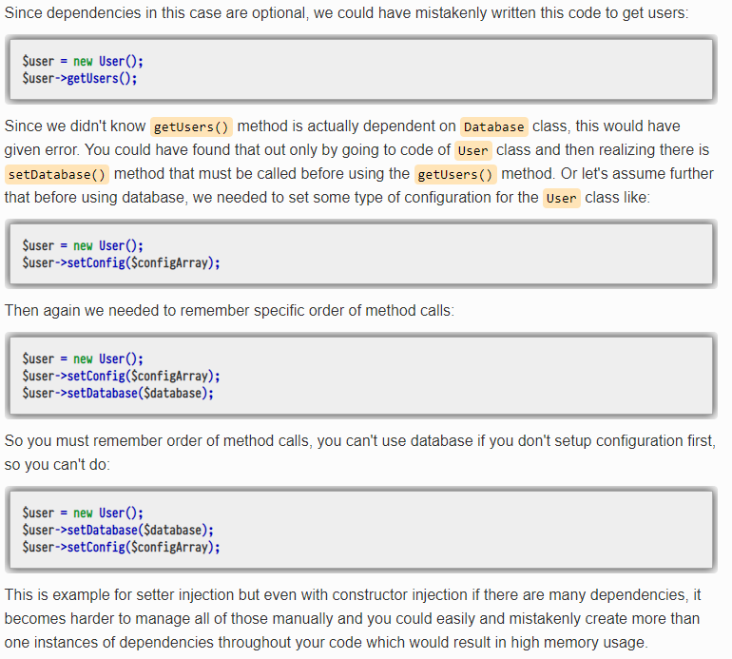

## Solution - Dependency Injection Container

Of course it would be difficult to manage dependencies manually; this is why you need a Dependency Injection Container. A Dependency Injection Container is something that handles dependencies for your class(es) automatically. If you have worked with Laravel or Symfony, you know that their components have dependencies on on other classes. How do they manage all of those dependencies ? Yes they use some sort of Dependency Injection Container.

There are [quite some dependency injection containers out there for PHP](http://www.sitepoint.com/php-dependency-injection-container-performance-benchmarks/) that can be used for this purpose or you can also write your own. Each container might have bit of different syntax but they perform the same thing under the hood.

So in conclusion, you must always remove hard-coded dependencies from your code and inject them using Dependency Injection instead for its benefits and then have all the injected dependencies managed automatically for you by using some dependency injection container.

**Consider Another Example:**

Before digging into the subject, let's precisely define what dependency injection is. Let's imagine that you currently work on a "Question and Answers" website, similar to [Stack Overflow](http://stackoverflow.com/). You would more than likely create a class, called **Question**, which would contain a member of type **Author**. In 'ye olden days, programmers would have created the **Author** object directly in the **Question** constructor, like this:

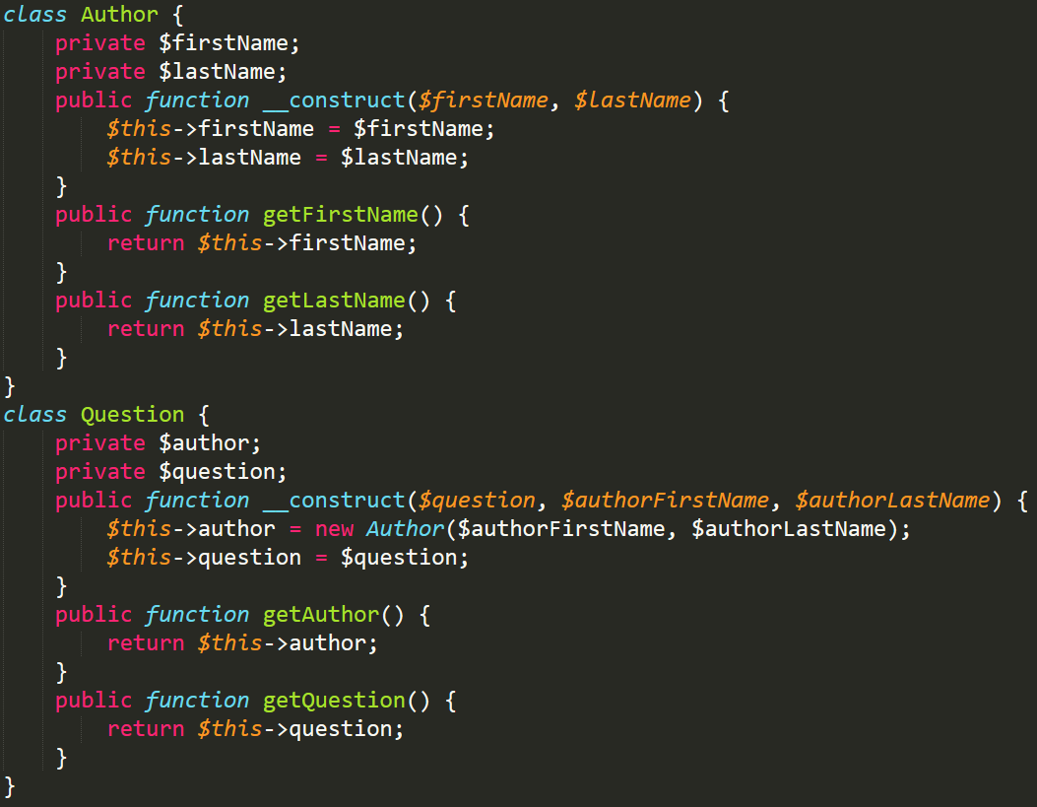

While many programmers might call this good code, there are in fact many problems with it:

* The author's information passed to the **Question** constructor has nothing to do inside **Question**'s scope. The name of an author should be inside the **Author** class because it has nothing to do with the question, itself.
* The **Author** class is tightly coupled with the**Question** class. If we add a new parameter to **Author**'s constructor, we then have to modify every class where we create an **Author** object - a tedious and long process, especially in large applications.
* Unit testing the **Question** class creates the unwanted behavior of having to test the **Author** class as well.

Dependency injection alleviates these issues by inserting the dependencies through the dependent class' constructor ("Constructor Injection"). The result is highly maintainable code, which might look like this:

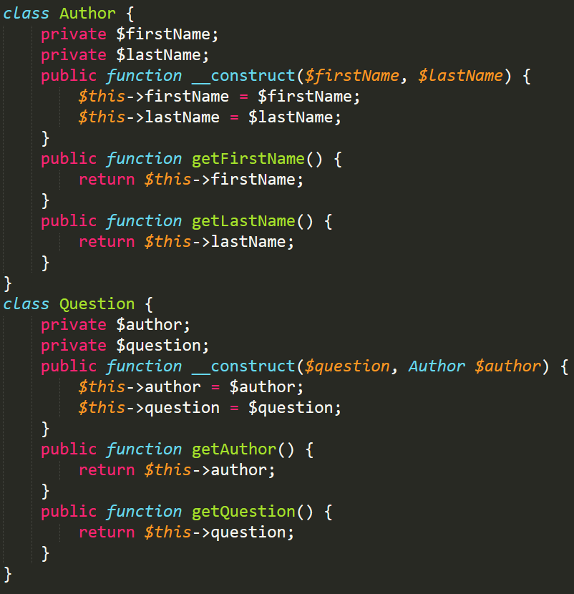

Polymorphism is derived from two Greek words. Poly (meaning many) and morph (meaning forms). Polymorphism is one of the PHP Object Oriented Programming (OOP) features.  In general, polymorphism means the ability to have many forms. If we say it in other words, "**Polymorphism describes a pattern in Object Oriented Programming in which a class has varying functionality while sharing a common interfaces.**". There are two types of Polymorphism; they are:

1. Compile time (function overloading)
2. Run time (function overriding)

But PHP "does not support" compile time polymorphism, which means **function overloading** and **operator overloading**.

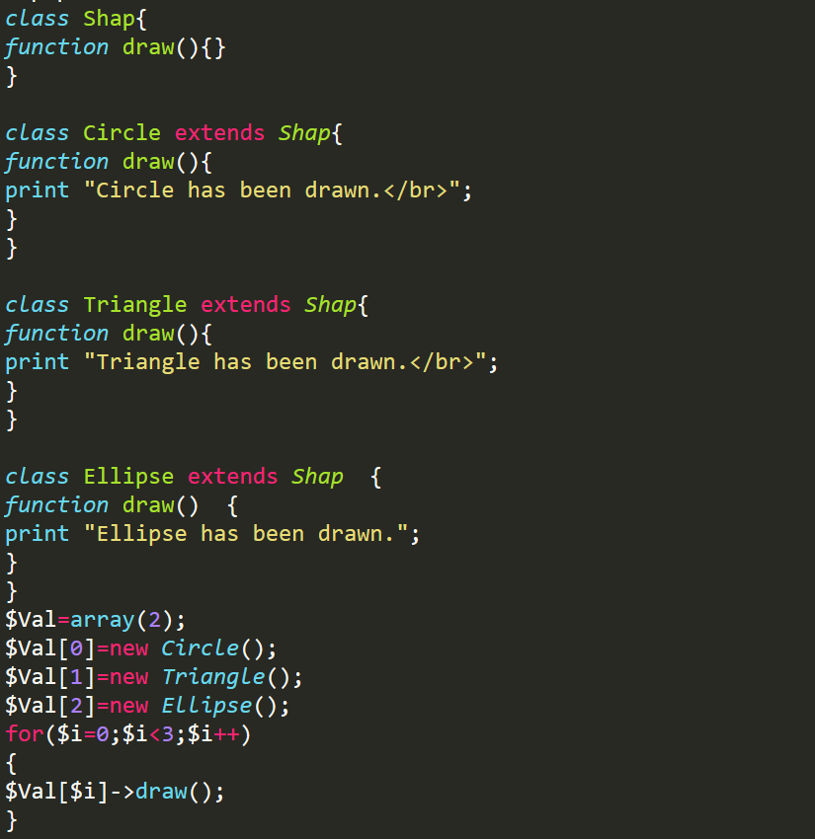

**Runtime Polymorphism**: The Runtime polymorphism means that a decision is made at runtime (not compile time) or we can say we can have multiple subtype implements for a super class, function overloading is an example of runtime polymorphism. I will first describe function overloading. When we create a function in a derived class with the same signature (in other words a function has the same name, the same number of arguments and the same type of arguments) as a function in its parent class then it is called method overriding.

**Example of runtime polymorphism in PHP**: In the example given **above** we created one base class called Shap. We have inherit the Shap class in three derived classes and the class names are Circle, Triangle and Ellipse. Each class includes function draw to do runtime polymorphism. In the calling process, we have created an array of length 2 and each index of the array is used to create an object of one class. After that we use a loop that is executed for the length of the array and each value of $i is passed to the object array variable called $Val[$i]. So it is executed three times and it will call the draw() method of every class (but those classes have a draw method, whose object is previously created).

Very USEFULL LINKS

<https://codeinphp.github.io/post/late-static-binding-in-php/>

https://www.youtube.com/watch?v=k9ak_rv9X0Y&list=PLfdtiltiRHWGXSggf05W-pJbD47-_d8bJ

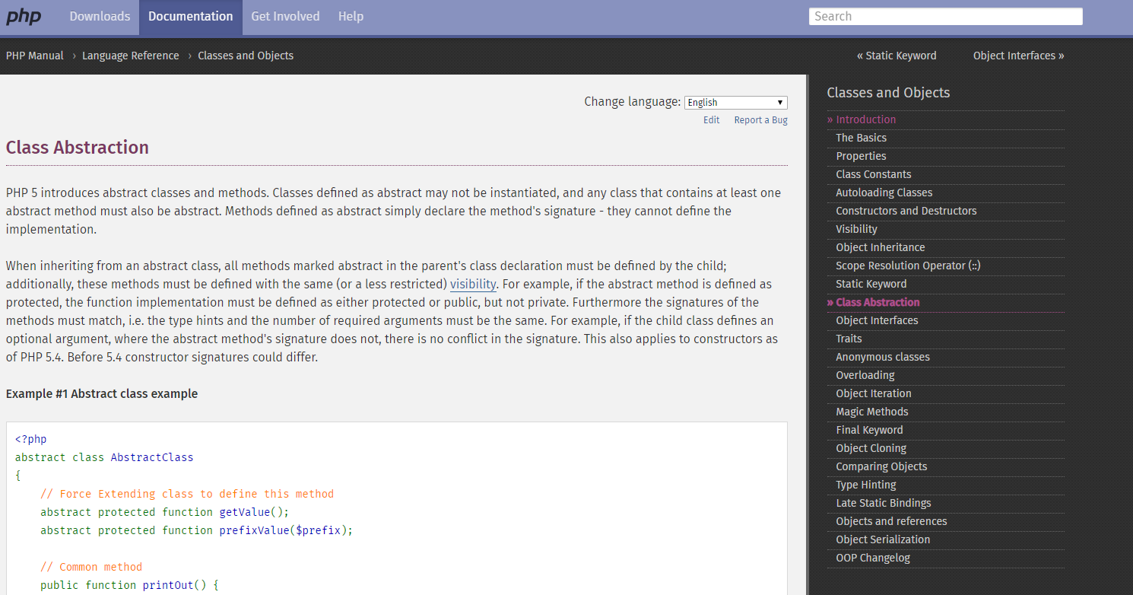

# PHP self Vs this208

**https://phppot.com/php/php-self-vs-this/**

<https://www.youtube.com/channel/UCIlPGCkXqjTDlmFPS6oMU9g/playlists> cache tutorial

**What are the must learn OOPS concepts in PHP?**

**overriding**

* **Class** − This is a programmer-defined data type, which includes local functions as well as local data. You can think of a class as a template for making many instances of the same kind (or class) of object.
* **Object** − An individual instance of the data structure defined by a class. You define a class once and then make many objects that belong to it. Objects are also known as instance.
* **Member Variable** − These are the variables defined inside a class. This data will be invisible to the outside of the class and can be accessed via member functions. These variables are called attribute of the object once an object is created.
* **Member function** − These are the function defined inside a class and are used to access object data.
* **Inheritance** − When a class is defined by inheriting existing function of a parent class then it is called inheritance. Here child class will inherit all or few member functions and variables of a parent class.
* **Parent class** − A class that is inherited from by another class. This is also called a base class or super class.
* **Child Class** − A class that inherits from another class. This is also called a subclass or derived class.
* **Polymorphism** − This is an object oriented concept where same function can be used for different purposes. For example function name will remain same but it make take different number of arguments and can do different task.
* **Overloading** − A type of polymorphism in which some or all of operators have different implementations depending on the types of their arguments. Similarly functions can also be overloaded with different implementation.
* **Data Abstraction** − Any representation of data in which the implementation details are hidden (abstracted).
* **Encapsulation** − refers to a concept where we encapsulate all the data and member functions together to form an object.
* **Constructor** − refers to a special type of function which will be called automatically whenever there is an object formation from a class.
* **Destructor** − refers to a special type of function which will be called automatically whenever an object is deleted or goes out of scope.