**Documentation**

* **Eclipse Installation-**
* visit <https://www.eclipse.org/downloads/packages/release/kepler/sr2/eclipse-ide-java-ee-developers>
* click on download

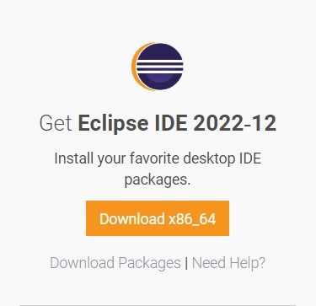

* again click on download

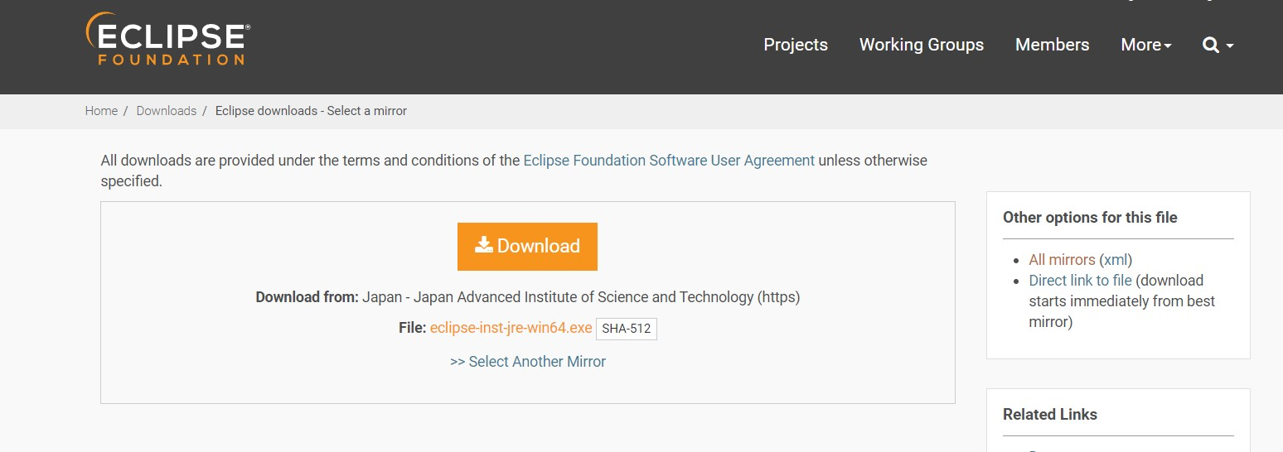

* after eclipse has been downloaded in your computer go to the file location where eclipse has been downloaded and right click on it and select run as administrator.
* It will give a few options click on eclipse ide for enterprise java and web developer

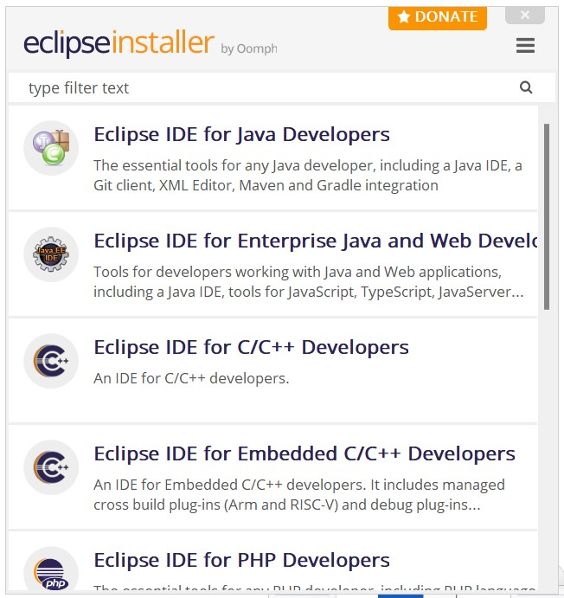

* Click install

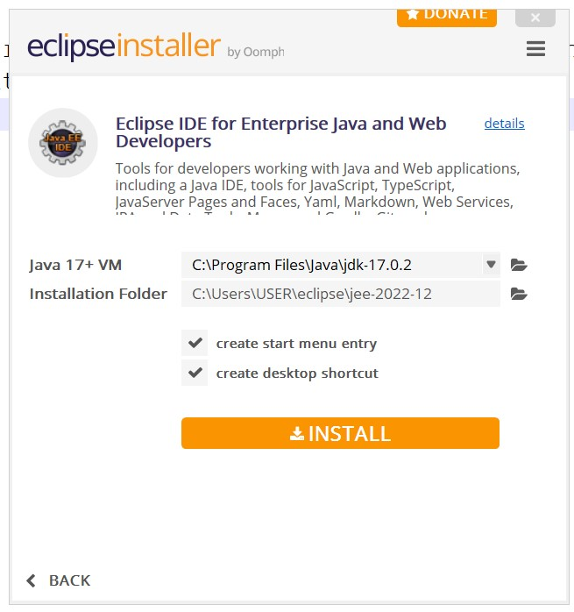

* Click on accept now

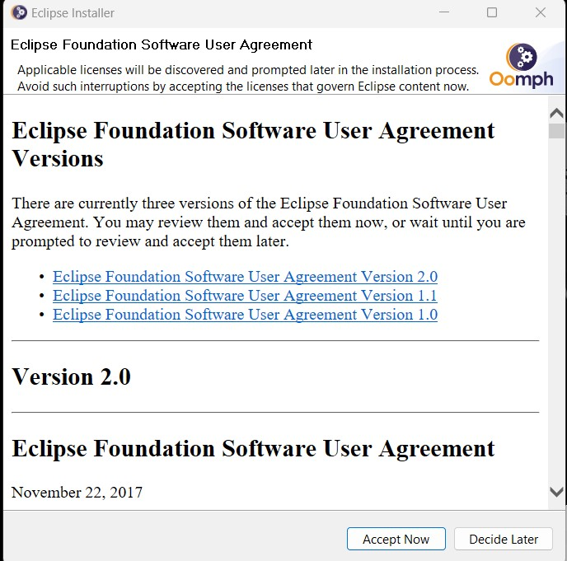

* It will start installing
* Click on launch

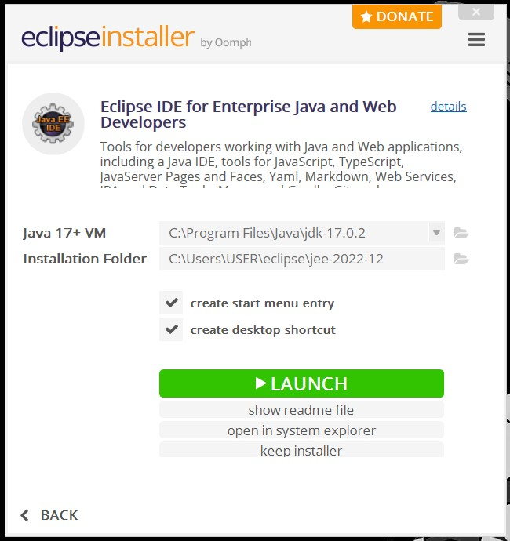

* Again click launch

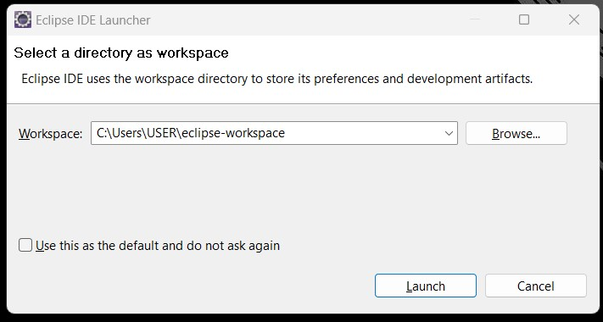

* Now eclipse has been installed in your device.
* **Apache Tomcat Installation-**
* visit tomcat.apache.org
* select tomcat version 9
* click on 64bit windows zip it will start the download

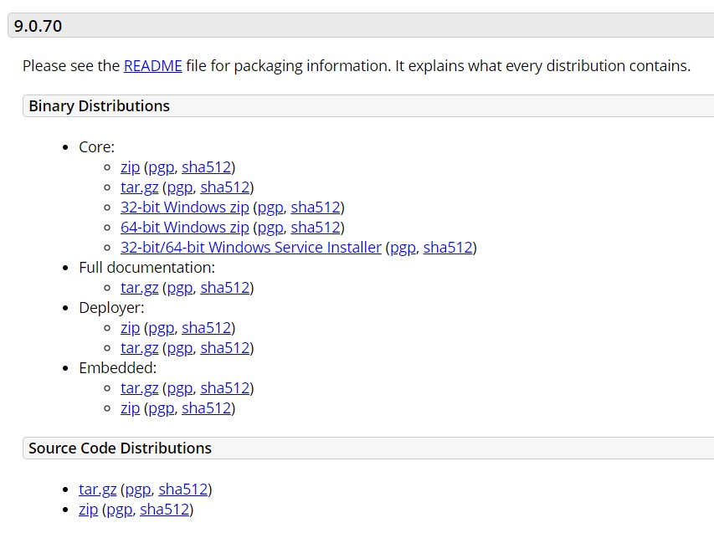

* after successful completion of download right click on the downloaded zip file and select extract all.
* **Configuring Tomcat in Eclipse-**
* open eclipse ide
* go to window->preferences

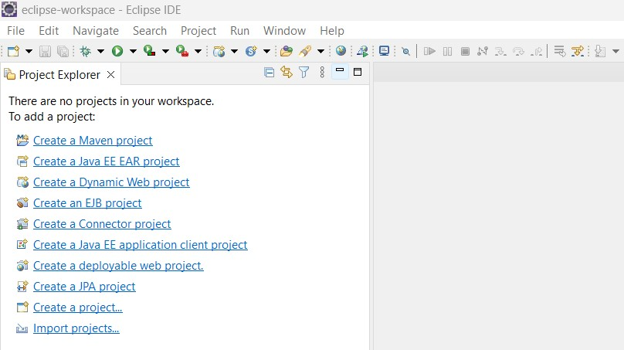

* go to server->runtime environment click on add

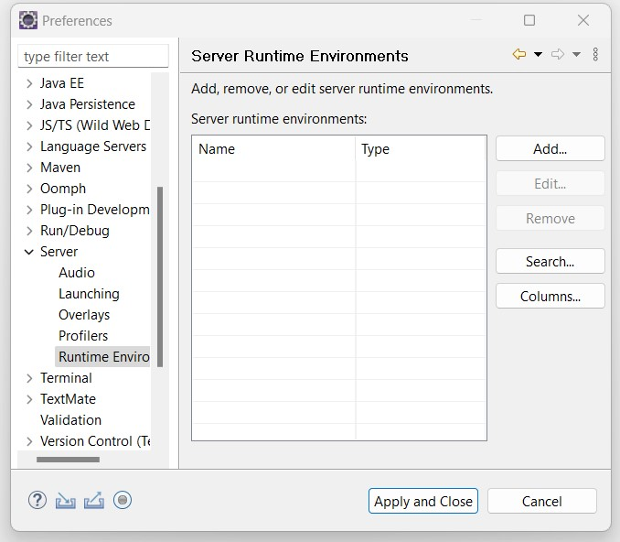

* chose the apache version. click on browse and go to apache tomcat and select the parent directory of bin and click on finish.

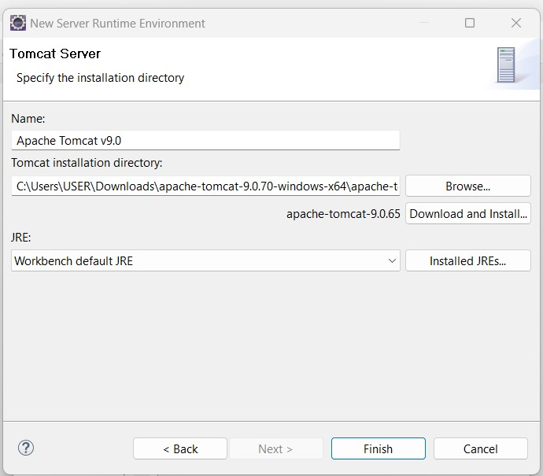

* click on apply and close

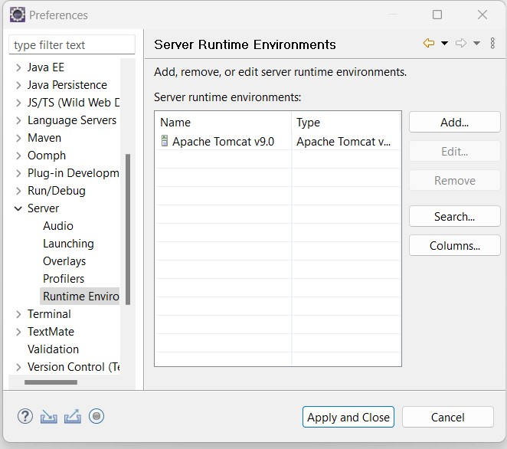

* go to window->show view->servers
* select the server and click on finish

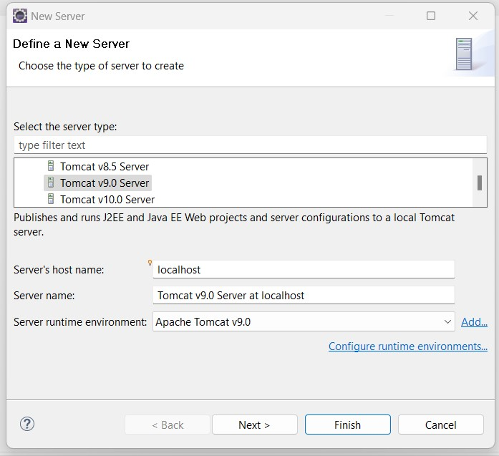

* right click on it and select start to start the server

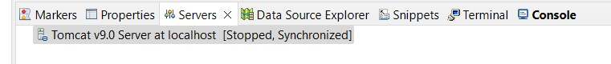

* **MySQL Installation-**
* visit https://dev.mysql.com/downloads/
* select my sql installer for windows
* download the msi installer
* double click on it and install with the default options
* after installation copy the path of the bin of my sql server and paste it in the path of system variables

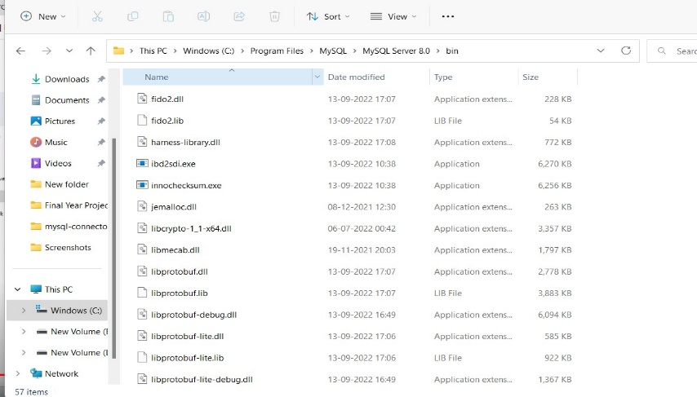

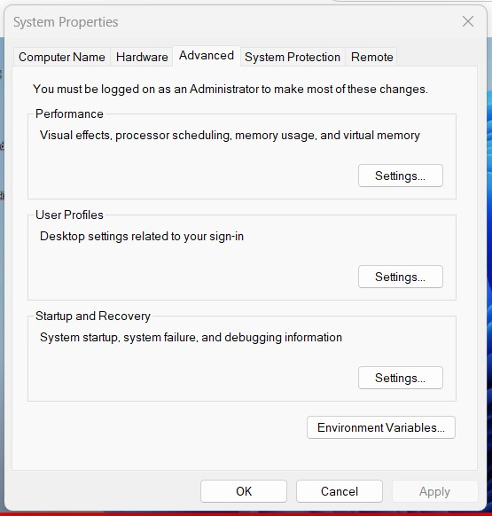

* visit https://dev.mysql.com/downloads/
* click on Connector/j

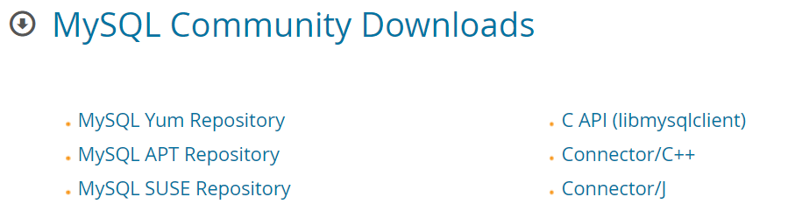

* select platform independent in the select operating system bar

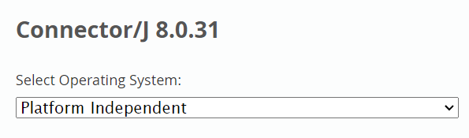

* download the .zip file



* extract the file in your desktop
* Now find the mysql-connector folder in the computer and copy the mysql-connector jar file and paste it inside the lib folder inside the apache-tomcat folder.



