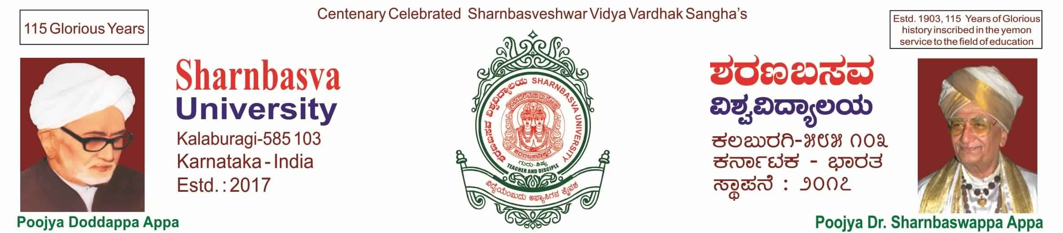

A

PROJECT REPORT ON

“ELECTRIC BIKES”

Submitted to

Computer Science and Engineering

Faculty of Engineering and Technology (Co-Education)

In partial fulfilment of the semester project

Submitted by

OMRAJ TENGLI USN: SG19CSE095

RUSHIKESH USN: SG19CSE113

ROHIT WACHCHE USN: SG19CSE110

PAVAN BIRADAR USN: SG19CSE096

**UNDER THE GUIDENCE OF**

**Prof.** **BASAVANTRAO PATIL**



CERTIFICATE

This is to certify that the project work entitled “ELECTRIC BIKES” is bonafide work carried out by RUSHIKESH(SG20CSE113), OMRAJ TENGLI(SG20CSE095), ROCHIT WACHCHE(SG20CSE110) AND PAVAN BIRADAR(SG20CSE096) in practical fulfilment of B.Tech of III Semester in Computer Science and Engineering of the Faculty of Engineering and Technology(Co-education), SHARNBASVA UNIVERSITY, KALABURAGI during the academic year 2020-2021. It is certified that, she/he has completed the project satisfactorily.

**MARKS DETAILS**

|  |  |  |  |  |
| --- | --- | --- | --- | --- |
| SL  NO. | Name of the student | USN | Maximum  Marks | Marks obtained |
| 1 | RUSHIKESH | SG19CSE113 |  |  |
| 2 | OMRAJ TENGLI | SG19CSE095 |  |  |
| 3 | ROCHIT WACHCHE | SG19CSE110 |  |  |
| 4 | PAVAN BIRADAR | SG19CSE096 |  |  |

Guide Head of Department Dean

Name of the examiner Signature

1.

2.

ACKNOWLEDGEMENT

We express our deep sense of gratitude to our esteemed “SHARNBASVA UNIVESITY” KALABURGI which has provided us an opportunity to fulfill the most cherished desire to reach our goal.

We also extend our sincere thanks to D**r**. ANILKUMAR G BIDVE, Registrar, Sharnbasva university, for his constant encouragement.

We would like to express our sense of gratitude to our beloved Dr. BASAVARAJ S MATHAPATI Dean for providing the right academic climate at this university that has made this entire task appreciate.

We are thankful to Prof. SHARANABASAPPA A MADIVAL Chairman, department of computer science & engineering, for giving permission to carry out this project in the university.

We wish to place our grateful thanks to our project guide Prof. BASAVANTRAO PATIL without their help and guidance, it would not have been possible to complete this project work.

Finally, we express our grateful thanks to all our staff members of our department, who helped us a lot in the completion of project directly or indirectly within the schedule period.

RUSHIKESH USN: SG19CSE113

OMRAJ TENGLI USN: SG19CSE095

ROCHIT WACHCHE USN: SG19CSE110

PAVAN BIRADAR USN: SG19CSE096

**CONTENTS**

**PARTICULAR PAGE NO.**

**Abstract**

1. **Introduction**
2. **About**
3. **Advantages**
4. **Results**

**INTRODUCTION**



ABOUT

New Delhi: Mumbai-based startup Earth Energy EV on Wednesday said it has appointed distributors across 10 states, Maharashtra, Gujarat, Karnataka, Kerala, Tamil Nadu, Telangana, Andhra Pradesh, Chhattisgarh, Madhya Pradesh and Orissa, and claims to have a total demand of over 37,000 vehicles a year.

Started in 2017, the startup focuses on manufacturing electric motorcycles, scooters, commercial vehicles and autonomous vehicle drivetrains. It has set up a 20,000 sq ft greenfield manufacturing facility, which can be expanded to an additional 20,000 sq ft, in Maharashtra with an annual capacity of 46,000 units, a company statement said.

The startup has set up a 20,000 sq ft greenfield manufacturing facility, which can be expanded to an additional 20,000 sq ft, in Maharashtra with an annual capacity of 46,000 units, the company said.

LANGUAGE USED

HTML, CSS, C++ etc.

ADVANTAGES



RESULT





