Smart India Hackathon 2026 · Problem Statement 26106 · AICTE Cyber Security Cell
MailTrace AI — Automated Email Collection & Bulk Threat Analysis
Solution document: replacing manual .eml download/upload with mailbox connectors, bulk import and a two-phase AI pipeline
Version 1.1.0 · September 2026 · Status: implemented, tested and shipped in the desktop and web builds

1. The problem
Until v1.0 every email had to be exported by hand as an .eml file and uploaded to MailTrace AI. This is acceptable for a handful of emails and impossible at the scale a Cyber Security Cell actually works at: an analyst with 100, 500 or 1,000 emails would spend hours doing nothing but downloading and uploading files, the organisation could never monitor continuously, and ordinary users could not report suspicious mail without a manual procedure.
The question was therefore: can the system connect directly to an inbox or accept many emails at once, retrieve the required data itself and feed the AI pipeline — securely, at scale and within reach of a student team?

Answer in one sentence
Yes. An .eml file is nothing more than the raw RFC 5322 bytes that every mail system already holds; MailTrace AI v1.1 fetches those bytes itself from three kinds of mail source — read-only IMAP mailboxes, whole-mailbox exports, and phishing-report / journal mailboxes — and pushes every message through the unchanged detection engine with automatic de-duplication, evidence sealing and chain of custody.

2. Options considered
Approach | How the raw message is obtained | Credentials | Real-time | Student effort | Decision
Manual .eml upload | user exports each email | none | no | done (v1.0) | kept as one input
Bulk file import | .mbox (Google Takeout, Thunderbird, Apple Mail), .zip of .eml/.msg, folders | none | no | 1–2 days | Implemented (Tier 1)
IMAP connector (RFC 3501/9051) | UID FETCH … BODY.PEEK[] — byte-identical to .eml | app password / OAuth2 | yes (poll or IDLE push) | 3–5 days | Implemented (Tier 2)
Gmail API / Microsoft Graph | messages.get?format=raw / $value | OAuth2 app registration | yes (webhooks) | +2–3 days each | adapter slot ready; not required for the prototype
Report / journal mailbox | users forward-as-attachment or admin journals to one mailbox; connector unwraps the original | one service mailbox | yes | +1 day | Implemented (Tier 3)
Mail-gateway plug-in (milter / transport agent) | inline at the MTA | admin | yes | high | out of scope for a prototype

IMAP was chosen as the primary automation because it is provider-agnostic, standard-library only (imaplib, ssl, email), and delivers exactly the same bytes as an .eml, so nothing in the analysis engine changes. Provider APIs add value only for Microsoft 365 (which no longer allows password IMAP) and for push notifications, so they are designed as optional adapters behind the same interface.

3. The implemented solution

3.1 Three ways in, one pipeline
Tier | Source | What the user does | Best for
1 | Bulk file import | Drops an .mbox / .zip / folder / many .eml on the Mail Sources page (files stream to disk; a 2 GB Takeout is fine) | Forensic investigation of an exported mailbox; offline demos; zero credentials
2 | IMAP connector | Picks a provider preset (Gmail, Outlook/M365, Zoho, Yahoo, NIC, custom), enters host / user / app password, folders, since-date and mode: manual, monitor (poll every N min) or IDLE (server push) | Universal automation: back-fill + continuous monitoring of any IMAP mailbox
3 | Report / journal mailbox | Users press “Forward as attachment” to phish-report@org, or the mail admin journals all inbound mail to mail-journal@org; that ONE mailbox is connected in IDLE mode with “unwrap wrappers” on | Organisation-wide rollout with zero user effort and no access to personal inboxes

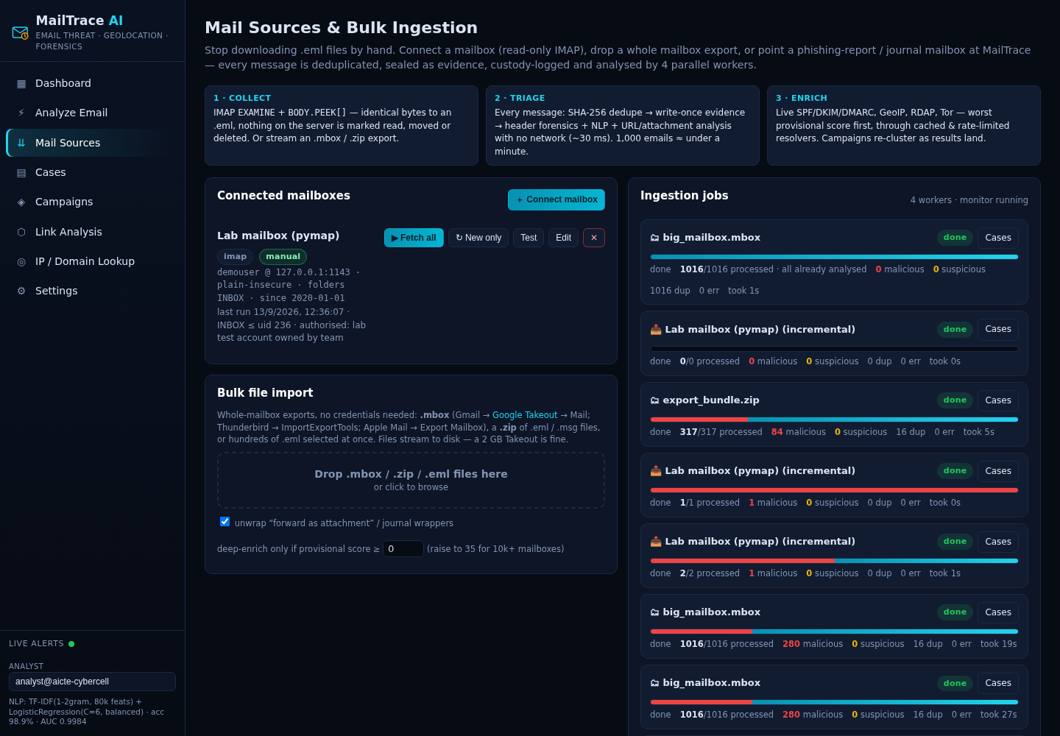
Figure 1 — Mail Sources page: connected mailbox with Fetch all / New only / Test, bulk file import zone, live ingestion job cards.

3.2 Pipeline
source ──▶ unwrap message/rfc822 wrapper (reports, journals) ──▶ SHA-256 ──▶ already in evidence store? ──▶ duplicate (custody note)
│ no
write-once evidence/<sha>.eml + custody: "ingested from imap://host/INBOX;uidvalidity=…;uid=4711 by <analyst>"
│
PHASE 1 · TRIAGE (worker pool, NO network) ◀────────────────────────┘
header forensics on recorded Authentication-Results · NLP classifier · URL / attachment analysis · cached GeoIP
→ provisional score saved as a case · SSE event · campaign re-clustering every 25 messages (~20–60 ms / email)
│
PHASE 2 · ENRICH (highest provisional score first; cached & rate-limited resolvers)
live SPF / DKIM / DMARC · GeoIP batch (≤100 IPs per call, 45 req/min budget) · RDAP · PTR · Tor exit list
→ final score · custody "enrich" · alert for anything that crossed 60 (skipped in offline mode)
Why two phases: 1,000 emails contain far fewer than 1,000 unique IPs and domains, while a live lookup costs 1–9 s per never-seen indicator. Triaging everything first fills the dashboard within seconds and gives the most dangerous emails their full attribution first, instead of making the analyst wait for newsletter number 612 to be geolocated.
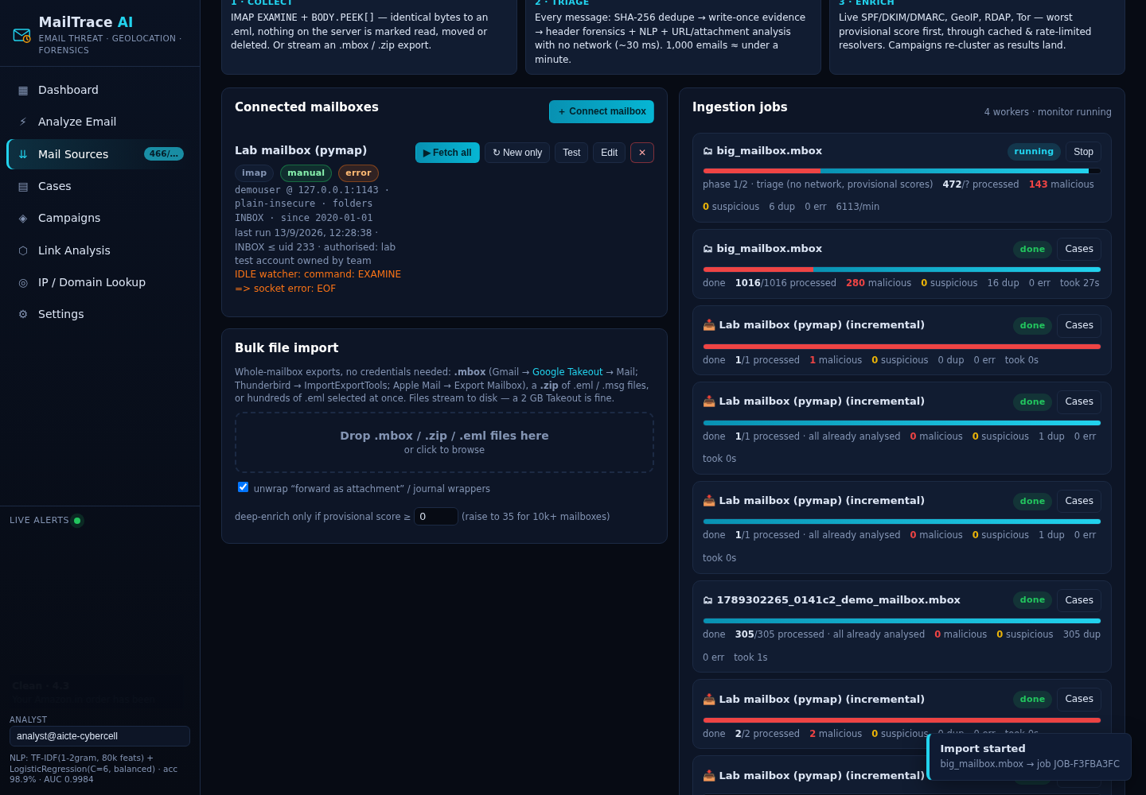
Figure 2 — a 1,000-email import in flight: phase 1 triage at ~6,000 emails/min, malicious share shown in red, live nav badge.

3.3 Step-by-step workflow (IMAP monitor)
- Configure. Mail Sources → Connect mailbox → provider preset → host, port 993 (TLS), login, app password or OAuth2 token, folders (e.g. INBOX, [Gmail]/Spam), since-date, mode, and who authorised the monitoring. Test connection lists folders and counts messages without storing anything.
- Enumerate. Folder opened read-only (EXAMINE); UID SEARCH SINCE <date>; UIDs processed in batches of 50.
- Fetch. UID FETCH n:m (UID INTERNALDATE BODY.PEEK[]) — PEEK never sets the \Seen flag; the mailbox stays pristine evidence.
- Seal. SHA-256 → skip if already in the evidence store → write-once .eml → custody entry → enqueue.
- Analyse. Triage pass (no network) gives a provisional score in milliseconds; the deep pass enriches worst-first through cached, rate-limited resolvers.
- Surface. Cases land in the store, campaigns re-cluster incrementally, progress cards show processed / malicious / duplicates / errors / rate / ETA; alerts ≥ 60 appear in the sidebar. The per-folder last_uid checkpoint means a closed laptop resumes exactly where it stopped.
- Monitor. monitor mode polls UID > last_uid every N minutes; IDLE mode keeps one connection open and the server pushes — new mail is scored ~0.3 s after arrival (measured).
Bulk-file path: drop .mbox/.zip → streamed into step 4 → identical pipeline. Report-mailbox path: step 3 fetches the wrapper mail, extracts the message/rfc822 attachment (original headers intact) and feeds it to step 4.
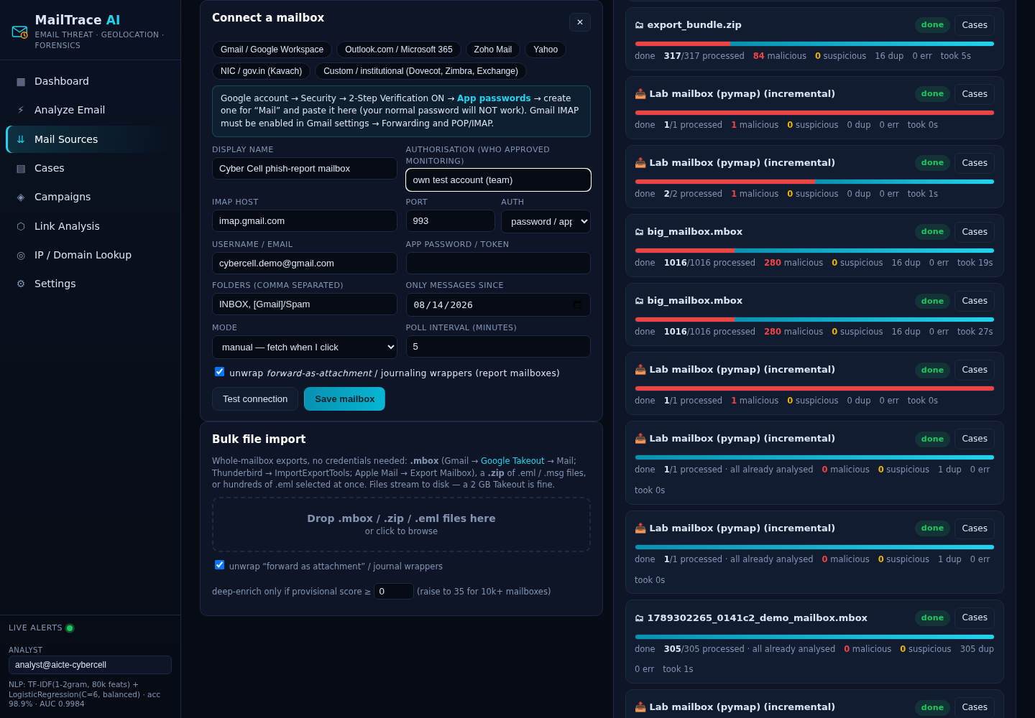
Figure 3 — Connect-a-mailbox form with provider presets, contextual setup tips, authorisation field, mode and unwrap option.

4. Measured results
Test (sandbox, 4 workers) | Result
1,000-email mailbox export (.mbox), 72 % benign traffic + mutated attack variants + reports + journals + duplicates | Triage complete in 12 s (dashboard populated); fully enriched in 27 s; 0 errors; 16 duplicates caught; 280 malicious; 6 campaigns clustered correctly
305-email export, cold caches | 22–34 s end-to-end, 0 errors, 84 malicious, 5 duplicates
IMAP back-fill from a local IMAP server (125 messages) | 3 s; unread flags on the server unchanged (BODY.PEEK)
Incremental fetch after 2 new mails arrive | exactly 2 fetched (UID checkpoint); 0 when nothing is new
IDLE push | new mail scored 0.3 s after arrival, exactly one job per event, watcher stops cleanly when mode changes
Forward-as-attachment reports / journal wrappers | original message unwrapped and traced; wrapper sender recorded in provenance
Zip containing 11 .eml + a nested .mbox + a non-email file | all messages found; non-email ignored; 0 errors
Real imap.gmail.com:993 (TLS) with deliberately wrong credentials | TLS handshake OK; friendly “use an App Password” error
Regression: the 11 bundled demo scenarios | identical scores to v1.0 (98.2 / 79.4 / 95.6 / 91.8 / 0.0 / 97.9 / 18.9 / 97.9 / 94.1 / 78.3 / 97.7)
Frozen Windows build (PyInstaller) smoke test | engine + bulk-import job pass; Mark-of-the-Web self-heal verified

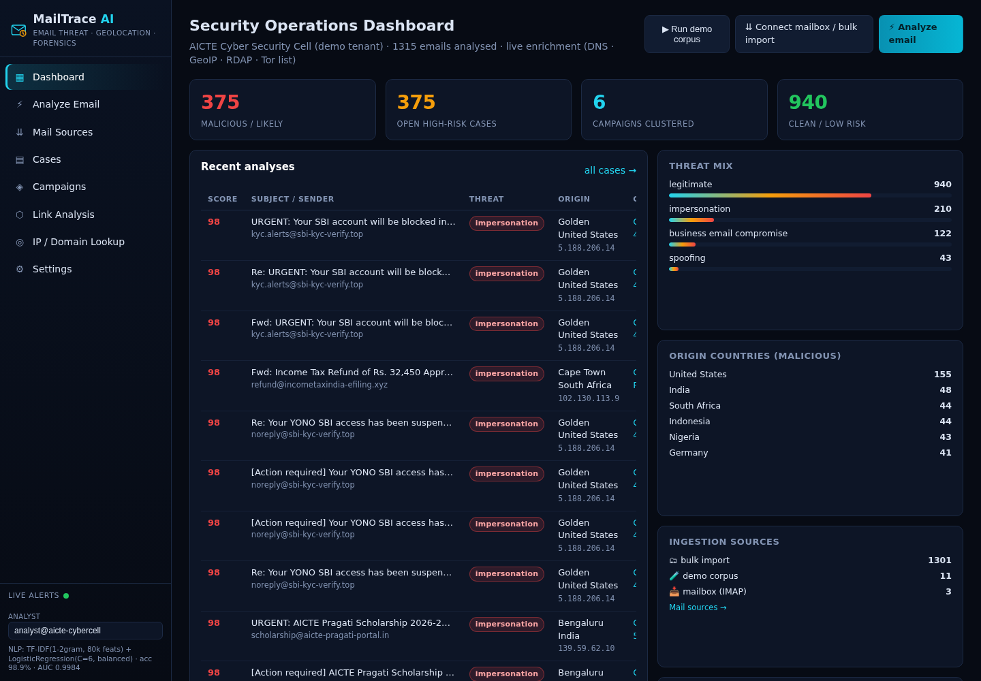
Figure 4 — dashboard after a 1,300-email session: ingestion-source mix, threat mix, origin countries, campaigns.

5. Security, privacy and legal safeguards
- Read-only by construction. EXAMINE + BODY.PEEK[] — nothing on the server is marked read, moved or deleted. No quarantine/response actions are implemented on purpose; those require write scope and an explicit, logged analyst decision.
- Transport. IMAPS on 993 with certificate verification, or STARTTLS on 143; the “plain-insecure” option exists only for loopback lab servers and is labelled as such.
- Secrets. App passwords / OAuth2 tokens are never returned by the API and are stored obfuscated under a per-installation key file (0600) in the data folder; Windows DPAPI / OS keyring is the production follow-up.
- Data minimisation. Message bodies never leave the machine; only IPs and domains are sent to GeoIP / RDAP, and Offline mode stops even that. Retention and masking settings apply to imported cases like any other.
- Authorisation & custody. Every source records who authorised the monitoring; it is written into the chain of custody of each case fetched from it. Only mailboxes you own or are explicitly authorised to monitor may be connected (IT Act 2000 §43/§66; DPDP Act 2023).
- Attachments. Hashed and parsed, never executed; per-message error isolation means one malformed mail cannot abort the other 999.

6. Feasibility for a student team
The whole ingestion layer (backend/ingest.py, ~900 lines) uses only the Python standard library — imaplib, ssl, email, mailbox, zipfile, sqlite3, threading — plus what the engine already used. No native dependencies were added, so the pure-Python desktop build is unchanged. Realised effort: bulk import 1 day, IMAP connector 2 days, job runner + progress UI 1 day, report-mailbox unwrapping ½ day, tests and documentation 1 day.

Demo plan for the finale
- Primary: a dedicated test Gmail account (2-Step Verification + App Password) pre-seeded with the synthetic corpus → on stage: Connect mailbox → Fetch all → 300 emails analysed in about half a minute → Campaigns view.
- Fallback: a local IMAP server (pip install pymap; one command) or the bundled demo_mailbox_300.mbox in Offline mode — the identical pipeline, no venue Wi-Fi needed.
- Data: scripts/make_test_mailbox.py --n 1000 builds a realistic mailbox (benign newsletters/transactional mail, mutated attack variants, forward-as-attachment reports, journaling wrappers, exact duplicates). Never put real personal mail on stage.

7. Limitations and challenges (stated honestly)
- Authentication landscape. Gmail needs 2-Step Verification + an App Password (or OAuth); Microsoft 365 / Outlook.com accept only OAuth2 — the connector speaks XOAUTH2 but obtaining and refreshing the token is left to the operator (MSAL device-code flow is the ~40-line follow-up); NIC/gov.in mail sits behind Kavach 2FA and departmental policy and needs IT approval.
- Header integrity. Only forward-as-attachment, IMAP/API fetch or journaling preserve original headers; inline forwards are analysed as what they are (a mail from the forwarder) and cannot be traced to the true origin.
- Throughput. Phase 2 is network-bound and third-party services rate-limit (ip-api 45 requests/min, rdap.org 429s). Coalesced batching, transient negative caching and worst-first ordering make it acceptable; a local GeoLite2 database would remove the limit entirely.
- Desktop lifecycle. IDLE / monitor stop when the desktop window closes; for 24×7 monitoring run the backend in server mode on a small VM and use the desktop app or browser as the console.
- Content edge cases. Outlook .msg files are converted best-effort (transport headers + text) unless the optional extract-msg package is installed; S/MIME- or PGP-encrypted bodies cannot be inspected (headers still are); the NLP model is English-trained, so Hindi/Hinglish lures rely more on header and URL signals.
- Legal / ethical. Monitoring real mailboxes requires authorisation and a privacy notice; the tool records the authorisation but cannot replace it.

8. Interfaces added
Method & path | Purpose
GET / POST /api/sources · PUT / DELETE /api/sources/{id} | manage mail sources (secret is write-only)
POST /api/sources/test[?sid=] | connect, list folders, count messages since date, detect IDLE — stores nothing
POST /api/sources/{id}/run {mode: backfill | incremental, limit, deep_min_score} | start a fetch job
POST /api/import/upload (multipart files, unwrap, deep_min_score) | bulk import .mbox / .zip / .eml
POST /api/import/path {paths} | desktop only: import local paths without copying
GET /api/jobs · GET /api/jobs/{id} · POST /api/jobs/{id}/cancel | job monitoring (also streamed as SSE events job / job-done / enriched)
GET /api/cases?job=&source=&min_score= | case-list filters; cases carry source and source_ref provenance

9. Deliverables
Artifact | Content
MailTrace-AI-Setup-1.1.0.exe / MailTrace-AI-1.1.0-windows-x64-portable.zip | Windows desktop application with the Mail Sources page, native import pickers and File-menu entries
mailtrace.zip | full source: backend/ingest.py (connectors, job runner, monitor, IDLE watcher), frontend Mail Sources page, scripts/make_test_mailbox.py, docs/INGESTION.md
docs/INGESTION.md | operator guide: provider setup, modes, API, limits
docs/demo_mailbox_300.mbox | ready-made demo mailbox export

Verdict: for SIH 26106 the best practical answer is an IMAP connector as the primary automation, bulk .mbox/.zip import as the zero-credential day-one path, and a report/journal mailbox as the organisation-wide story — with provider APIs as optional adapters. It replaces “download and upload 1,000 files” with one configuration screen, changes nothing in the AI engine, and strengthens the forensic case because every fetched message is sealed and logged automatically.

