
Narmo — Final Exam Project Report
E-Commerce & Web Application | Dr. Eric
Omran Nasir Abdelmoniem Mohamed | 28249/2024
UNILAK | EWA408510 | Semester II | 2025-2026

1. Introduction
Narmo is a full-stack, multi-vendor e-commerce marketplace for anime merchandise, fully themed around Attack on Titan. Built with Flask and SQLAlchemy, it enables customers to browse products by category and genre, add items to a session-based cart, checkout via three payment gateways (Stripe, PayPal, Mobile Money), and receive AI-powered product recommendations. Administrators manage products and view analytics dashboards; vendors have dedicated storefronts with ratings. The application is deployed on Vercel with Neon Postgres and uses GitHub Actions for CI/CD. The target audience is anime enthusiasts seeking an immersive, feature-rich shopping experience.

2. Problem Statement
Existing anime merchandise shopping platforms lack thematic immersion, AI-driven personalization, and modern e-commerce features. Generic solutions do not provide a cohesive brand identity, intelligent product discovery, or multi-vendor support with transparent ratings. There is a need for a themed, feature-rich marketplace that combines a compelling visual experience (Attack on Titan), machine learning-based recommendations, secure multi-gateway payment processing, administrative analytics, and responsive design within a single, deployable application.

3. Objectives
- Build a fully functional e-commerce platform with Flask, SQLAlchemy, and 7 normalized database models.
- Implement an AI-powered recommendation engine using TF-IDF cosine similarity, collaborative filtering, and trending popularity analysis.
- Support three payment gateways (Stripe, PayPal, Mobile Money) with a Strategy-pattern architecture for extensibility.
- Deploy on Vercel with a custom domain (narmostore.live), Neon Postgres database, and automated CI/CD via GitHub Actions.

4. System Features
- Product browsing by category (Figures, Apparel, Posters, Accessories, Manga) and genre with inline filter bar
- Session-based shopping cart with AJAX add/update/remove, hover preview dropdown, and badge count
- Checkout with three payment gateways: Stripe (card), PayPal (email), Mobile Money (MTN/AirtelTigo)
- AI recommendation engine: content-based TF-IDF, collaborative filtering, trending, popular, and hybrid personalized
- Admin analytics dashboard with stat cards and Chart.js charts (revenue, orders, status, top products)
- Admin product CRUD with image upload and auto-slug generation
- Customer dashboard for registered users to view order history with status timeline
- User authentication with role-based access (admin vs. regular users)
- Attack on Titan full theme: teal/gold palette, typing hero animation, particle embers, dark mode toggle
- Security: CSP per-request nonces, rate limiting (120 req/min), CSRF tokens, input sanitization, security headers
- SEO: dynamic sitemap.xml, robots.txt, JSON-LD structured data, Open Graph tags, canonical URLs

5. Technologies Used
Python 3.12+ / Flask 3.0: Lightweight backend framework with Blueprint support for modular routing.
SQLAlchemy 2.0: ORM providing database abstraction across SQLite (dev/test) and PostgreSQL (production).
Bootstrap 5, Chart.js, Bootstrap Icons: Frontend framework and charting library for responsive UI and data visualization.
Neon Postgres: Serverless PostgreSQL with automatic scaling and SSL connections, free tier for evaluation.
Vercel: Serverless Python runtime with global edge network, automatic HTTPS, and custom domain support.
GitHub Actions: CI/CD platform for automated linting (flake8), testing (pytest), and Docker image building.
TF-IDF / Cosine Similarity: Classic IR techniques for lightweight, no-external-dependency product recommendations.
Docker / docker-compose: Containerization for consistent development and alternative deployment on Render.

6. System Architecture
The application follows the Model-View-Controller (MVC) pattern using Flask's Blueprint system. Seven blueprints separate concerns into self-contained route modules. The App Factory pattern initializes extensions, registers blueprints, configures security middleware, runs auto-migrations, and seeds the database. SQLAlchemy handles all database interactions, abstracting between SQLite and PostgreSQL. The AI recommender module computes TF-IDF vectors and cosine similarity in-process.
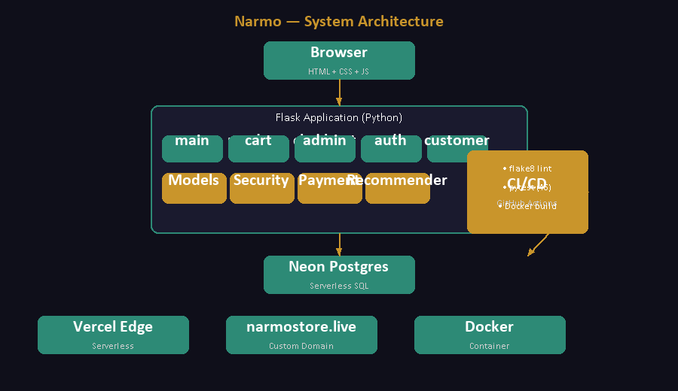

7. Screenshots
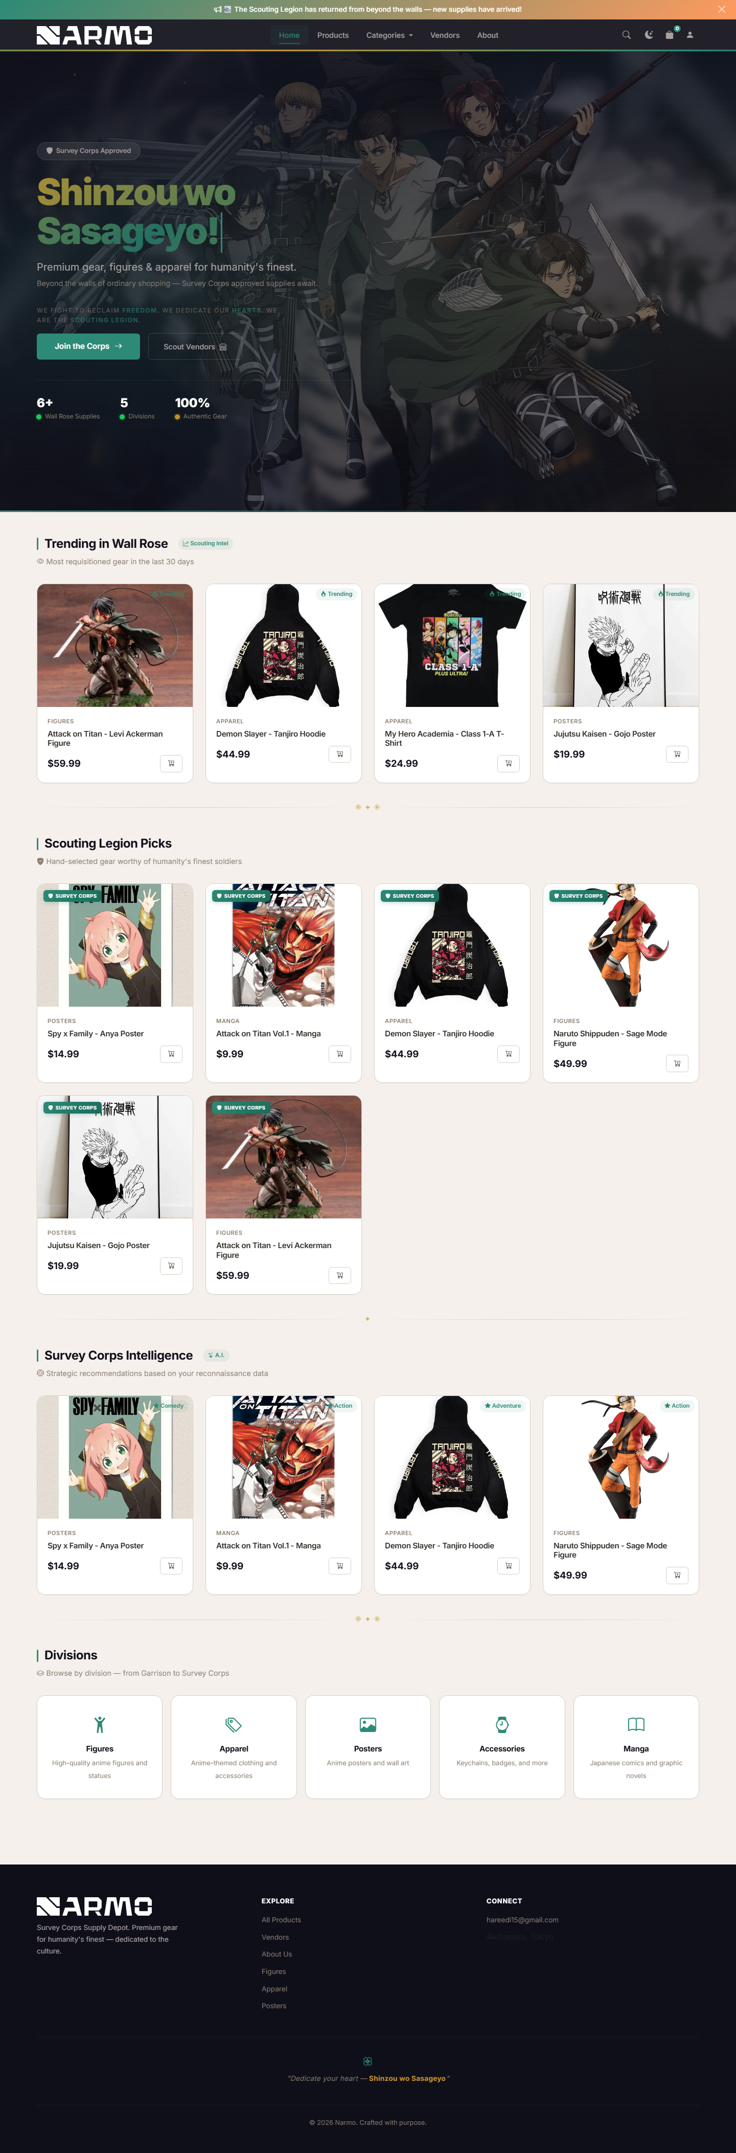
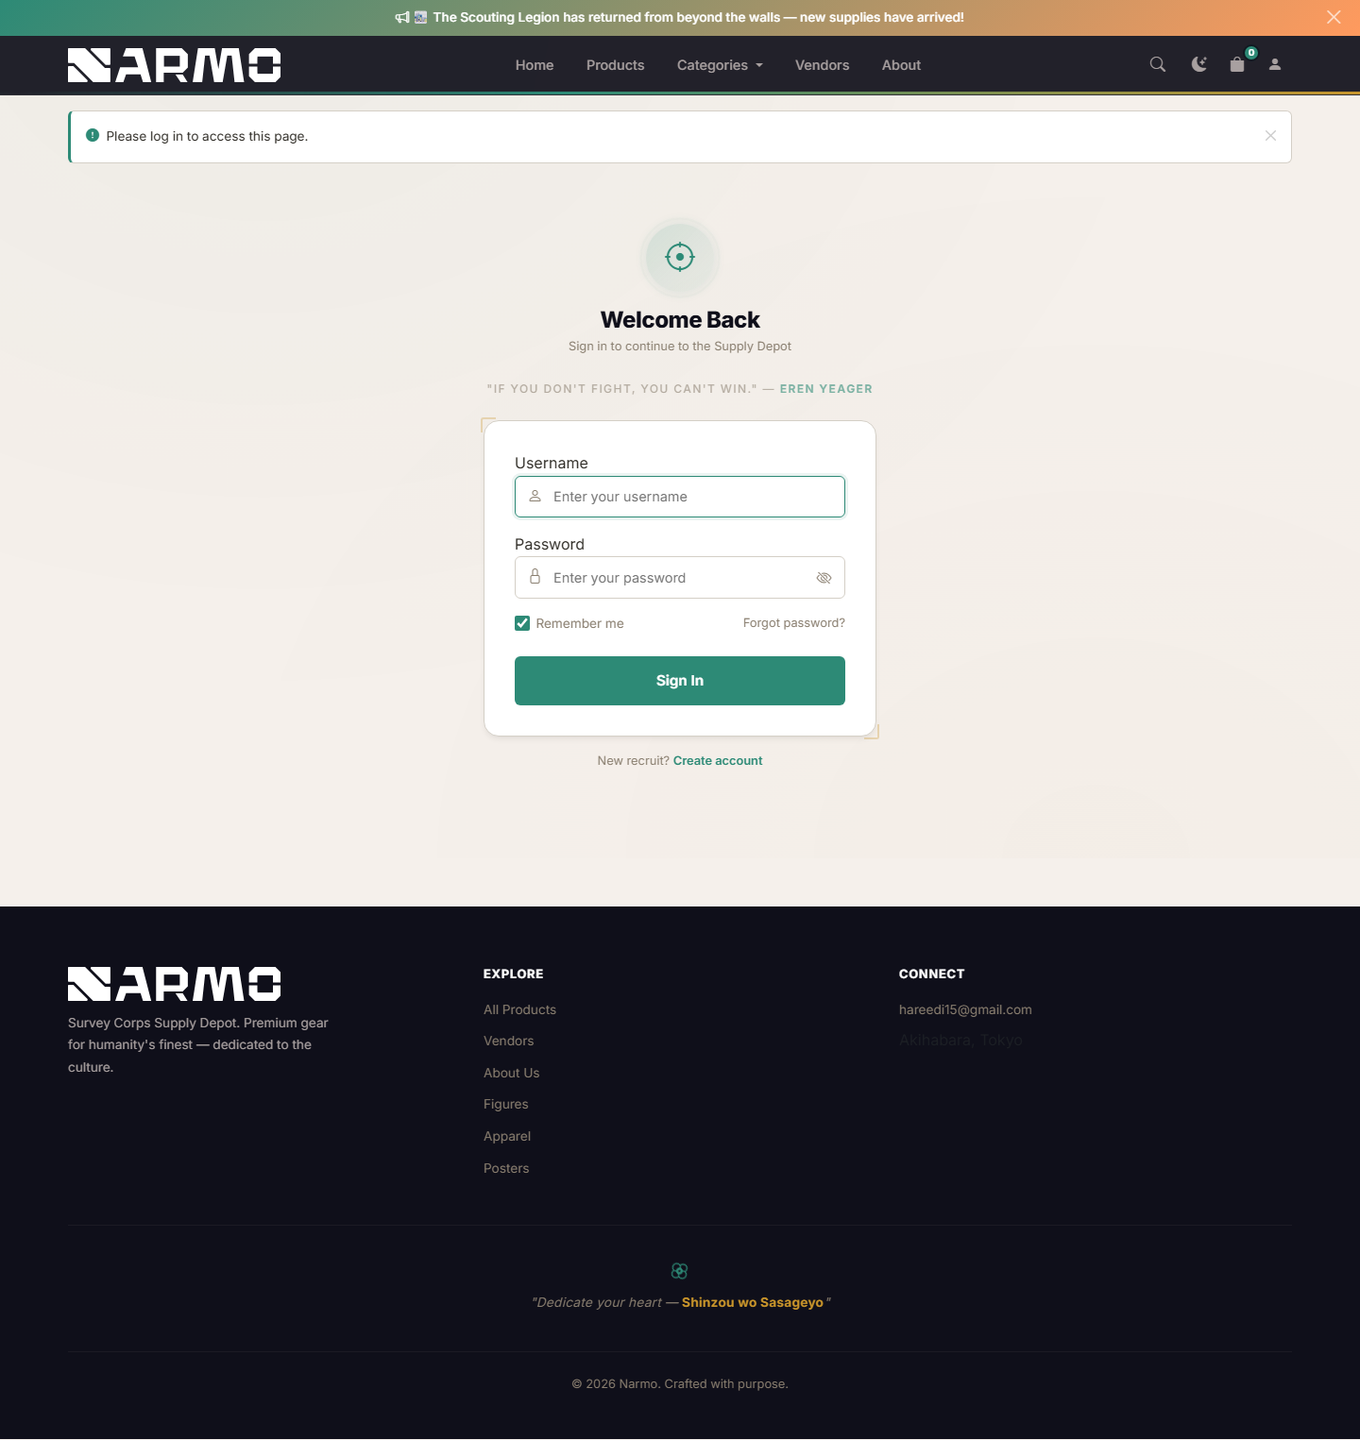
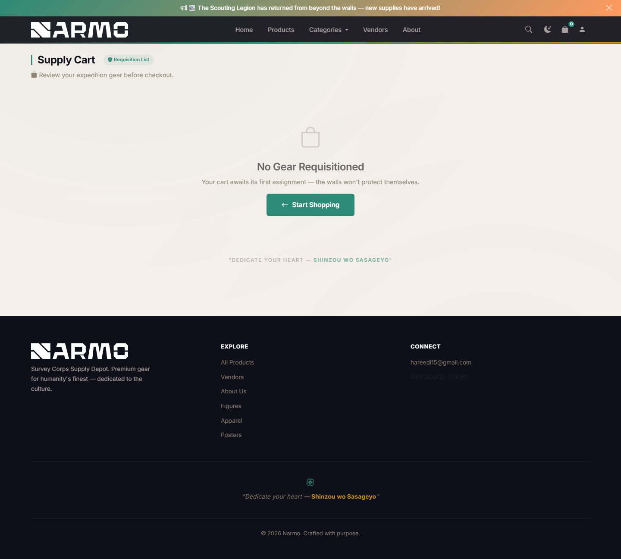

8. GitHub Repository Link
https://github.com/omranhareedi/anime-shop

9. Deployment Link
https://narmostore.live/
Fallback URL: https://anime-shop-ten.vercel.app/

10. CI/CD Description
The CI/CD pipeline is implemented via GitHub Actions with two jobs. The test job runs on every push and pull request: it spins up a PostgreSQL 16 service container, installs dependencies, runs flake8 linting, executes 46 pytest tests, and verifies the application boots. The build job runs only after tests pass on the main branch, building a Docker image with layer caching. Vercel is connected to the GitHub repository and automatically deploys on every push to main, aliasing the custom domain narmostore.live.

11. Challenges Encountered
Neon SSL Connection Drops: Neon closes idle PostgreSQL SSL connections, causing intermittent crashes. Resolved with SQLAlchemy pool_pre_ping=True and pool_recycle=300.
Mobile Money Field ID Mismatch: JavaScript referenced #mobile_money-fields while HTML had id="momo-fields" — fields stayed hidden. Fixed by aligning the HTML id with the JS selector.
CSP Blocking Inline Scripts: Content Security Policy blocked onclick/onsubmit attributes. Migrated all handlers to addEventListener inside nonced <script> blocks.

12. Future Work
- Real payment webhook integration (Stripe/PayPal) for asynchronous payment confirmation.
- Cloud-based image storage (AWS S3 or Cloudinary) to persist uploads across serverless cold starts.
- Persistent database-backed shopping cart across sessions and devices.

13. Conclusion
Narmo successfully demonstrates a complete, production-ready e-commerce platform with a cohesive Attack on Titan identity. The application delivers 46 automated tests, 7 normalized database models, an AI recommendation engine with five strategies, three payment gateways, a full admin analytics dashboard, a customer order portal, and CI/CD automation. Deployed on Vercel with a custom domain and Neon Postgres, Narmo meets all evaluation rubric requirements and provides a strong foundation for future enhancements including real payment processing, cloud storage, and expanded features.

