Graduate Course in Mechatronic Systems
Homework: Adaptive Control of a Nonlinear Third-Order System
Mass–Spring–Damper with Nonlinear Spring and First-Order Actuator
Model-Reference Adaptive Control (MRAC) — continuous and digital implementation

Contents
1. The Nonlinear Process and Its Model 3
1.1 Physical system 3
1.2 The actuator model and its physical meaning 3
1.3 Eliminating F(t): the combined third-order model 4
1.4 State-space representation 4
1.5 Casting the plant into the assignment model form 5
2. MRAC Design and Stability Proof 6
2.1 Reference model 6
2.2 Tracking error and the nominal control law 6
2.3 Adaptive control law (unknown a_i, b_i) 7
2.4 Adaptation laws 8
2.5 Lyapunov stability proof 8
3. Nominal Control with Known Parameters (Simulation) 9
3.1 How the model is implemented in software 10
4. Adaptive Control with Unknown Parameters (Simulation) 12
4.1 Implementation note 13
5. Digital Implementation (Indirect Design) 14
5.1 Discretization 14
5.2 Zero-order hold 14
5.3 Closed-loop results 15
6. Sampling-Time Effects and a PID Remedy 17
6.1 Performance degradation with larger sampling time 17
6.2 Reducing the degradation: PID phase-lead augmentation 17
6.3 Discussion 19

1. The Nonlinear Process and Its Model

1.1 Physical system
The chosen process is a horizontally moving mass connected to a wall through three parallel mechanical elements and driven by an actuator. The benchmark mass–spring–damper with a hardening (cubic) spring is taken from Slotine and Li, *Applied Nonlinear Control* (Prentice Hall, 1991, p. 71), where it appears as a canonical example of a nonlinear mechanical plant. The reference example is second order; to satisfy the assignment requirement of order n ≥ 3 we retain the cubic spring nonlinearity and additionally model the actuator as a genuine first-order dynamic element rather than an ideal force source. The added actuator state raises the system order to three.
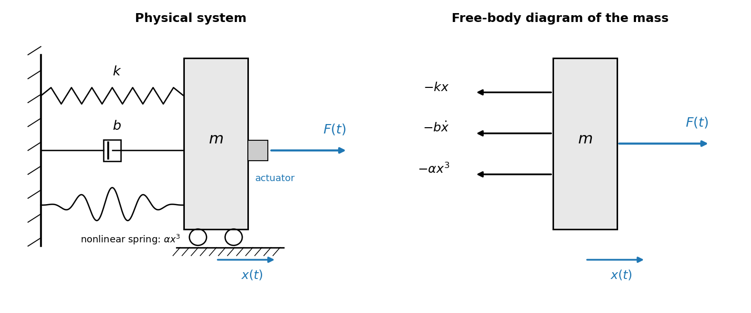
Figure 1.1 — Physical system (left) and free-body diagram of the mass (right).
The elements acting on the mass are a linear spring of stiffness k, a viscous damper of coefficient b, a nonlinear (cubic) spring producing the restoring force αx³, and the actuator force F(t). Summing forces along the direction of motion x(t) and applying Newton’s second law gives the mechanical subsystem:
This second-order equation describes the plant if the actuator were ideal, i.e. if it produced the commanded force instantaneously. That assumption is relaxed next.

1.2 The actuator model and its physical meaning
A real actuator (electric, hydraulic, or pneumatic) cannot deliver a step change of force instantaneously: inductance, fluid compressibility, valve dynamics, or amplifier bandwidth all introduce lag. The simplest faithful representation of this lag is a first-order system relating the commanded input u(t) to the delivered force F(t):
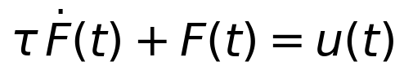
Here u(t) is the controller command and τ is the actuator time constant. The physical meaning is transparent if we hold the command constant at u(t)=u₀ from rest. Solving the first-order ODE gives:
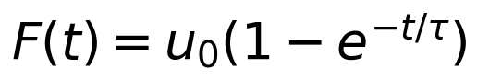
The force rises exponentially toward the commanded value, reaching about 63% of u₀ after one time constant τ and approximately 95% after 3τ. The actuator therefore follows the command with a finite response speed set by τ, rather than reproducing it instantly. As τ → 0 the actuator becomes ideal (F → u) and the system collapses back to the original second-order plant. A non-zero τ is what gives the combined system its third dynamic state.

1.3 Eliminating F(t): the combined third-order model
To obtain a single input–output equation we eliminate the internal force F(t). From the mechanical subsystem the force is:
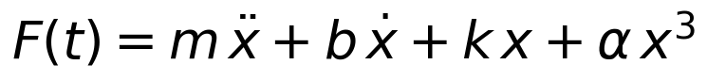
Differentiating once with respect to time:
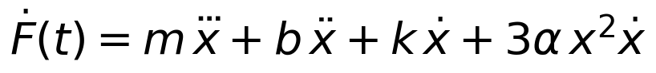
Substituting both F(t) and its derivative into the actuator relation τḞ + F = u and collecting terms by derivative order yields the combined third-order nonlinear differential equation:
This is the plant the controller must handle. It is genuinely third order and contains two nonlinear terms: the cubic restoring term αx³ and the mixed term 3ταx²ẋ produced by differentiating the cubic spring through the actuator dynamics.

1.4 State-space representation
For simulation it is convenient to keep the physical states rather than the input–output form. Choosing x₁ = x (position), x₂ = ẋ (velocity), and x₃ = F (actuator force) gives the first-order system:
The structure makes the order explicit:
- The mechanical mass–spring–damper subsystem contributes two states (position x₁ and velocity x₂) — it is second order on its own.
- The actuator contributes one additional first-order state (the force x₃), whose dynamics are governed by the time constant τ.
- The combined actuator-plant system therefore has three states and is third order, satisfying n ≥ 3.

1.5 Casting the plant into the assignment model form
The assignment requires the model to fit the general structure:
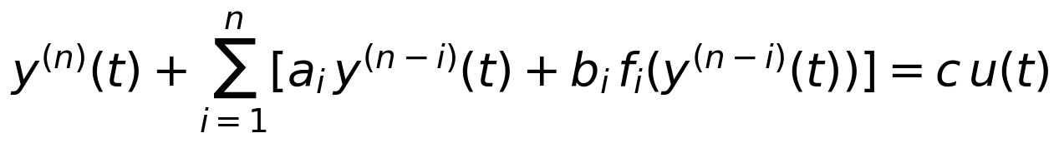
Dividing the third-order ODE by the leading coefficient τm and writing y ≡ x, n = 3, the normalized plant is:
Introducing h = 1/c and absorbing 1/c into each coefficient gives the compact form used throughout the design:
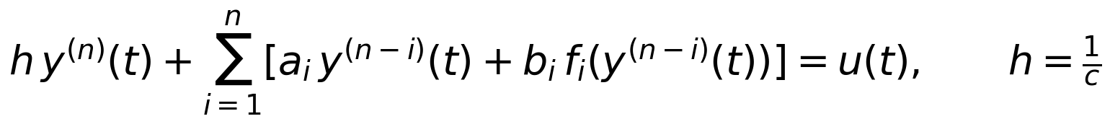
The nonlinear regressor functions are f for the cubic term (f(x) = x³) and the mixed term g·x²ẋ, both of which are known functions of the measured states with constant (possibly unknown) gains — exactly the structure the MRAC design below exploits.
Selecting physical values consistent with the second-order reference example (m = 1, b = 0.5, k = 2, α = 1) and an actuator time constant τ = 0.5 s produces the normalized coefficients:
Table 1.1 — Physical and normalized parameters.
Quantity | Symbol | Value | Role
Mass | m | 1.0 kg | inertia
Linear damping | b | 0.5 N·s/m | viscous friction
Linear stiffness | k | 2.0 N/m | restoring force
Cubic stiffness | α | 1.0 N/m³ | hardening spring
Actuator constant | τ | 0.5 s | actuator lag
Input gain | c = 1/(τm) | 2.0 | control authority
h = 1/c | h | 0.5 | known gain

2. MRAC Design and Stability Proof
The objective is an adaptive controller that makes the plant output y(t) follow the output ym(t) of a reference model driven by r(t), i.e. y(t) → ym(t), when only the coefficients ai, bi are unknown (the gain h = 1/c is assumed known, as stated in the assignment). The design follows the classical MRAC philosophy presented in class for first-order systems, generalized here to arbitrary order n, with the controller gains produced directly by adaptation laws.
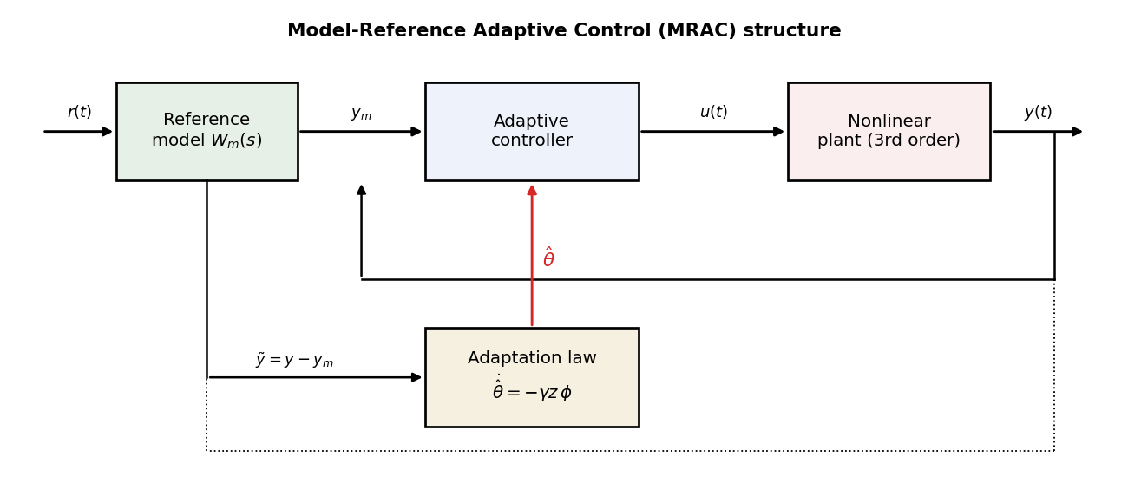
Figure 2.1 — Model-reference adaptive control structure: the reference model, adaptive controller, plant, and adaptation law form one closed system.

2.1 Reference model
The reference model is an integral part of the control system. It is chosen as a stable linear system of the same order n whose output defines the desired trajectory:
or, in transfer-function form (unity DC gain so that y_m tracks r in steady state):
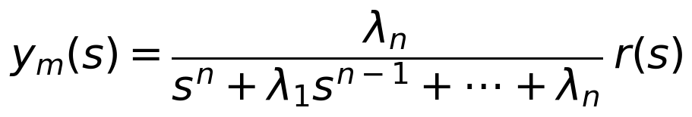
By the Routh–Hurwitz criterion the model is asymptotically stable whenever the polynomial sⁿ + λ₁sⁿ⁻¹ + … + λn is Hurwitz, i.e. for an appropriate positive choice of the λi.

2.2 Tracking error and the nominal (known-parameter) control law
Define the tracking error and require it to obey the same Hurwitz dynamics so that it decays to zero:
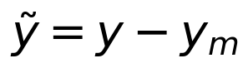
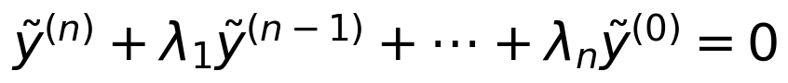
Expanding the error dynamics and solving for the highest plant derivative gives the trajectory the plant must produce:
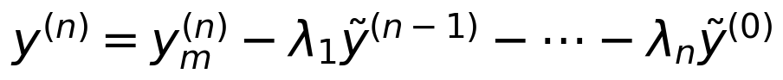
Because the plant in normalized form is h·y⁽ⁿ⁾ + Σ[ai y⁽ⁿ⁻ⁱ⁾ + bi f_i] = u, inverting it to realize the desired y⁽ⁿ⁾ produces the nominal control law (all parameters known):
Substituting this control back into the plant cancels all known terms and leaves exactly h·y⁽ⁿ⁾ = h·(desired y⁽ⁿ⁾), hence the homogeneous Hurwitz error equation ẽ⁽ⁿ⁾ + λ₁ẽ⁽ⁿ⁻¹⁾ + … + λ_n ẽ = 0. The error and all its derivatives therefore converge to zero, which proves nominal stability and perfect asymptotic tracking.

2.3 Adaptive control law (unknown a_i, b_i)
When the coefficients are unknown, each true gain is replaced by an on-line estimate, giving the certainty-equivalence controller:
Define the parameter errors:
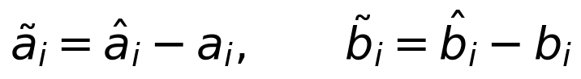
Substituting the adaptive control into the plant and using the nominal cancellation, the residual driving the error is exactly the parameter error multiplied by the known regressors. Introducing the filtered tracking error (a Hurwitz combination of error derivatives whose transfer function from the parametric residual is strictly positive real):
the closed-loop error model becomes a stable first-order relation driven by the parameter errors:
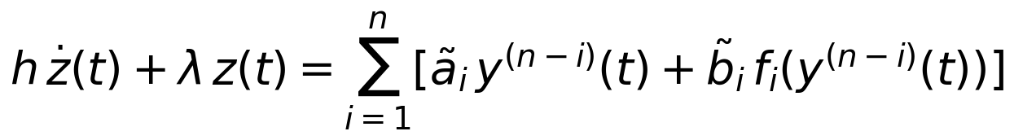
The left-hand operator is SPR (a stable first-order filter), so the error model has the structure required by the MRAC stability argument.

2.4 Adaptation laws
The gains are updated by gradient/Lyapunov laws that drive the filtered error to zero:
Each estimate is integrated on-line from the product of the filtered error z and the corresponding known regressor.

2.5 Lyapunov stability proof
Consider the positive-definite Lyapunov candidate combining the error energy and the parameter-error energy (θ̃ collects all ãi, b̃i):
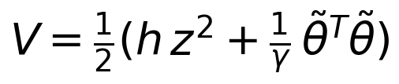
Differentiating along the trajectories of the error model and the adaptation laws:
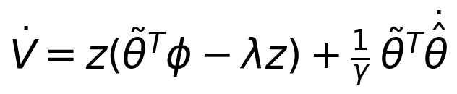
Substituting the adaptation law θ̂̇ = −γ z φ (with φ the regressor vector and v the update-rate vector) cancels the indefinite cross term, leaving:
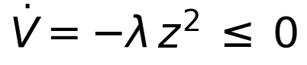
Thus V is non-increasing, which proves that z and the parameter errors θ̃ are bounded. To conclude that the tracking error itself goes to zero we invoke Barbalat’s lemma: V̇ is uniformly continuous because its derivative is bounded,
Since V is bounded below and V̇ ≤ 0, V converges; with V̈ bounded, Barbalat’s lemma gives V̇ → 0, hence z → 0. The Hurwitz definition of z then forces ẽ and all its derivatives to zero. Therefore y(t) → y_m(t) for any order n and any Hurwitz reference model, completing the stability proof. (Parameter estimates remain bounded but need not converge to the true values unless r(t) is persistently exciting.)

3. Nominal Control with Known Parameters (Simulation)
For the chosen third-order plant (n = 3) the design of Part 2 is specialized. The reference model is a third-order system with a triple real pole at p = 2.5 rad/s, chosen fast enough for good tracking yet compatible with the digital sampling rates used later in Parts 5–6:
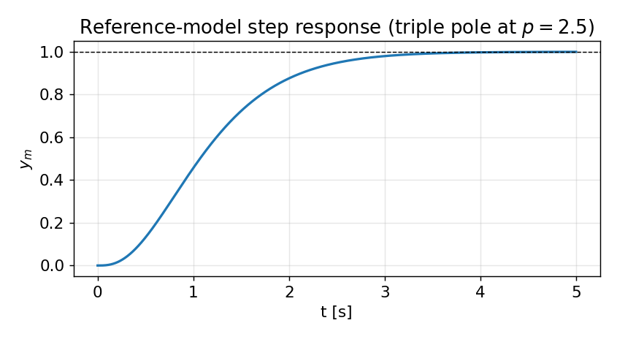
Figure 3.1 — Step response of the third-order reference model; smooth, well-damped, unity steady-state gain.
With all parameters known, the nominal control law instantiates the general expression with the two specific nonlinearities of this plant (cubic term x³ and mixed term x²ẋ):
Open-loop behaviour. Driving the plant with a constant command produces a lightly damped oscillation that settles around an offset value but does not track the reference — the nonlinear terms distort the response. This motivates the controller.
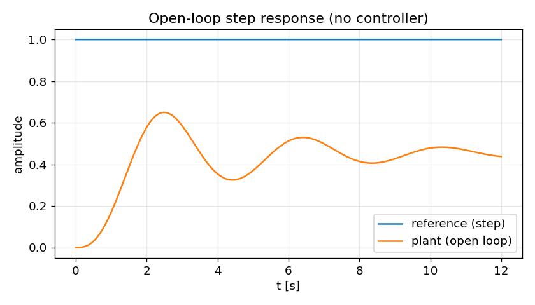
Figure 3.2 — Open-loop step response (no controller): the plant oscillates and fails to reach the reference.
Closed-loop with the nominal controller. Applying the known-parameter law, the plant output overlays the reference-model output and the tracking error is zero to machine precision. The controller exactly cancels both nonlinearities, so the closed loop behaves like the well-damped linear reference model.
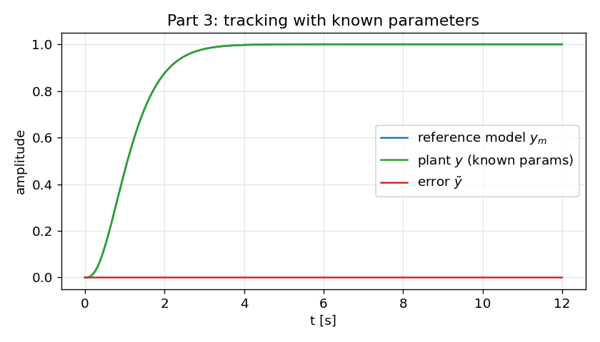
Figure 3.3 — Tracking with known parameters: plant output (green) overlays the reference model; error (red) stays at zero.
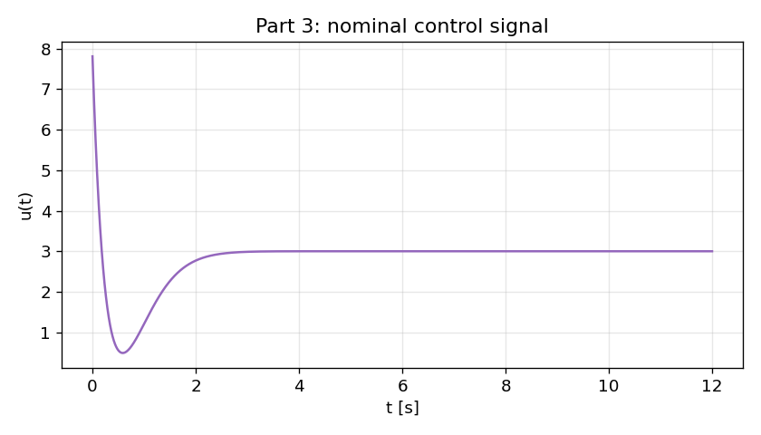
Figure 3.4 — Nominal control signal u(t): a smooth bounded effort that cancels the plant dynamics.

3.1 How the model is implemented in software
The plant, reference model, and controller are integrated together in Python using an explicit Euler scheme at a fine step (dt = 1 ms). At each step the simulator (i) advances the reference model one step from r(t), (ii) measures the plant states and forms the regressors, (iii) computes the control u from the known-parameter law, and (iv) advances the true plant in its physical state-space form. The physical state-space form (x₁, x₂, x₃) is used for the plant so that the actuator lag is represented exactly, while the controller works with the input–output (normalized) form.
# reference model (3rd order, triple pole p=2.5)
ymddd = L3*r[i] - L1*ymdd - L2*ymd - L3*ym

# error and desired highest derivative
e, ed, edd = y-ym, yd-ymd, ydd-ymdd
ydddes = ymddd - LAM[0]*edd - LAM[1]*ed - LAM[2]*e

# nominal control (known parameters); phi=[ydd,yd,y,y^3,y^2 yd]
u = H*ydddes + THETA @ phi

# advance true plant (physical state space) and reference model
state = plant_step(state, u, dt) # x1̇=x2, x2̇=(x3-bx2-kx1-αx1³)/m, x3̇=(u-x3)/τ
ym_st = ref_step(ym_st, r[i], dt)

4. Adaptive Control with Unknown Parameters (Simulation)
Now the coefficients a₁, a₂, a₃, b₃, g are treated as unknown and estimated on-line; the gain h remains known per the assignment. The adaptive controller uses the same structure as the nominal one but with estimated gains:
The filtered error for n = 3 and the corresponding adaptation laws are:
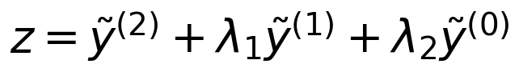
All estimates start from zero initial conditions. The adaptation gain was set to γ = 5 after a short tuning study: large enough for fast convergence, small enough to avoid an over-aggressive transient.
Results. Even starting with no knowledge of the parameters, the adaptive controller drives the tracking error to zero within the first few seconds. The known-parameter response is reproduced closely after the initial adaptation transient; the only visible difference is a small overshoot during the learning phase.
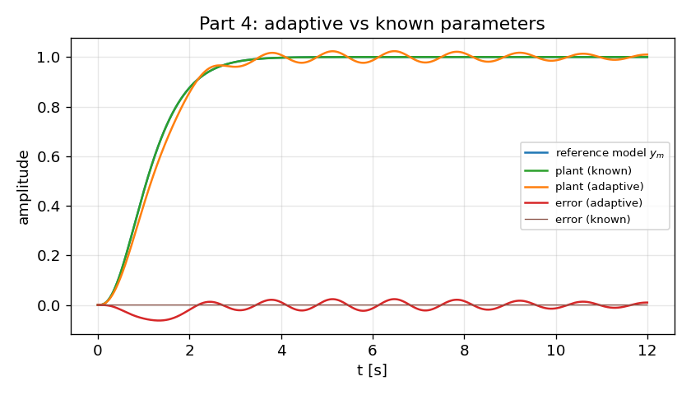
Figure 4.1 — Adaptive vs. known-parameter tracking. The adaptive plant (orange) converges to the reference model after a brief transient; both errors decay to zero.
Parameter estimates. The estimates start at zero and settle to constant values. They do not converge to the true physical coefficients, and this is expected: a step reference is not persistently exciting, so many parameter combinations achieve the same tracking. The adaptation finds a set of gains that minimizes the tracking error, not necessarily the true plant parameters — a standard and well-understood feature of MRAC.
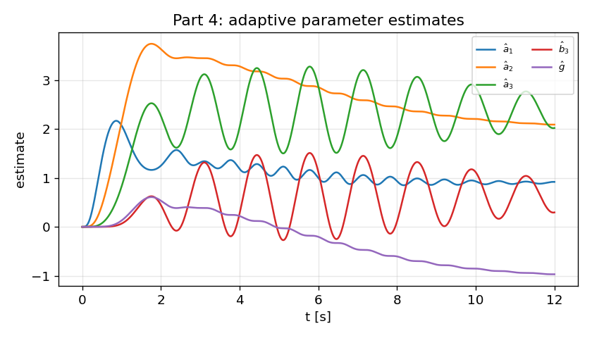
Figure 4.2 — On-line parameter estimates. They converge to steady values that achieve tracking, not to the true plant parameters (no persistent excitation under a step input).

4.1 Implementation note
The only change relative to Part 3 is that the controller now integrates the adaptation laws each step and uses the estimated gains in the control expression. Everything else — plant integration, reference model, regressor construction — is identical, which makes the comparison clean.
# adaptive: estimates theta_hat updated on-line (h known)
z = edd + LAM[0]*ed + LAM[1]*e # filtered error
u = H*v + th_hat @ phi # certainty-equivalence control
th_hat = th_hat - gamma*z*phi*dt # adaptation law (5 gains)

5. Digital Implementation (Indirect Design)
A microcontroller realization requires a discrete-time controller. Using the indirect digital design approach, the continuous controller of Part 2 is designed first and then discretized: derivatives are approximated by differences and the control output is held constant between samples by a zero-order hold (ZOH). The continuous plant keeps evolving in continuous time; only the controller is sampled.

5.1 Discretization
Derivatives are approximated by backward differences at sampling period T:
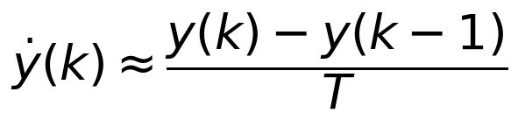
For this relative-degree-three plant, a raw second backward difference amplifies sampling noise so severely that the loop becomes unstable. A robust and standard remedy is the filtered (dirty) derivative: a first-order low-pass applied to each difference, with pole 1/τ_d. This is exactly what practical digital controllers use:
The discretized adaptation law uses the same regressor-normalized update evaluated at the sampling instants:
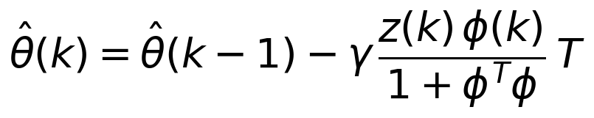

5.2 Zero-order hold
Between sampling instants the controller cannot issue new commands, so the last computed value is held:
The ZOH converts the discrete command sequence into the piecewise-constant analog signal actually applied to the actuator. Its staircase shape is clearly visible in the control signal.
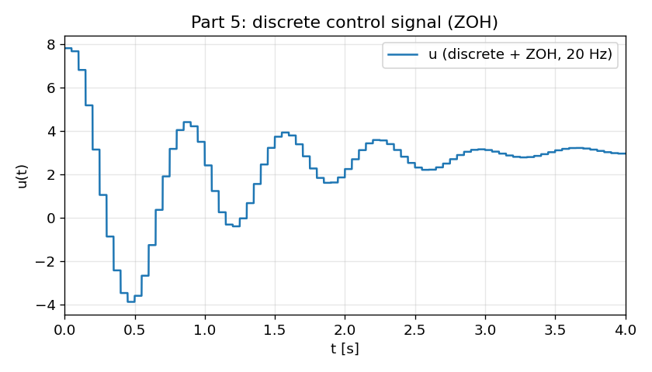
Figure 5.1 — Discrete control signal with ZOH at 20 Hz. The piecewise-constant staircase is the signal applied to the continuous plant.

5.3 Closed-loop results
Combining the discrete controller (with ZOH) and the continuous plant, the closed loop tracks the reference model well at 20 Hz, with only a small loss of accuracy relative to the continuous design. The discrete response shows slightly more overshoot and a small phase lag introduced by the hold, but remains stable and accurate.
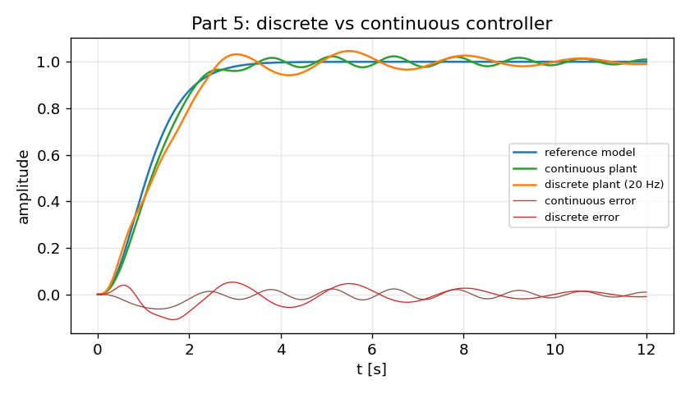
Figure 5.2 — Discrete (20 Hz) vs. continuous controller. The discrete loop tracks well; the hold adds a small phase lag and overshoot.
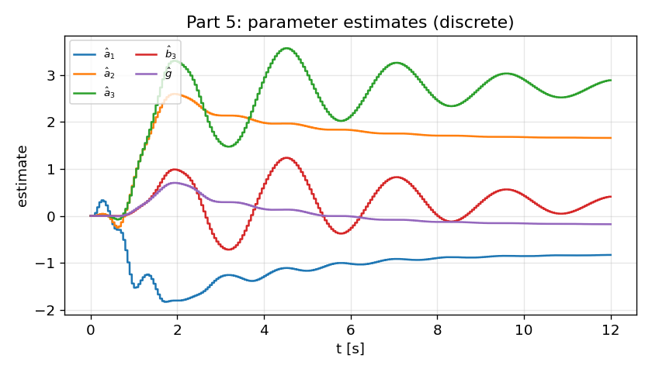
Figure 5.3 — On-line parameter estimates with the discrete controller; convergence is slower and slightly noisier than the continuous case due to sampling.
Summary (Part 5). The continuous tracking RMSE is about 0.021; the 20 Hz discrete controller reaches about 0.037. The degradation is modest at this rate and comes from the hold delay and the discrete derivative approximation. The next section studies what happens as the sampling period grows.

6. Sampling-Time Effects and a PID Remedy

6.1 Performance degradation with larger sampling time
As the sampling period T increases, two effects worsen the closed loop. First, the ZOH holds each command longer, which is equivalent to an average transport delay of T/2 and therefore adds phase lag. Second, the difference-based derivative estimates become coarser. Both effects erode the stability margin of the (relative-degree-three) loop. The simulations confirm a graceful degradation followed by a sharp stability cliff.
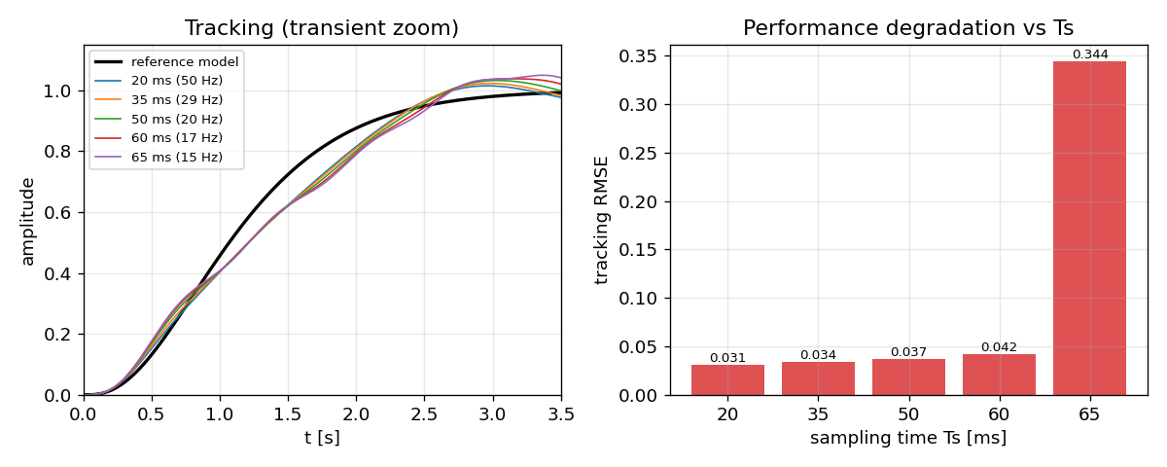
Figure 6.1 — Effect of increasing sampling time. Left: transient tracking degrades (more overshoot/oscillation) as T grows. Right: tracking RMSE rises gently to 60 ms, then jumps sharply at 65 ms as the loop approaches instability.
The RMSE rises gently from 0.031 (20 ms) to 0.042 (60 ms), then jumps to 0.34 at 65 ms — the loop is approaching its stability boundary. The dominant cause is the ZOH delay, which produces phase lag and an amplitude deficit precisely when the reference model is changing fastest (the first ~2 seconds of the step).

6.2 Reducing the degradation: PID phase-lead augmentation
To recover the lost performance without raising the sampling rate, a PID compensator is added in parallel with the adaptive controller. The derivative action supplies phase lead that counteracts the ZOH phase lag, and the proportional/integral actions restore the amplitude and remove residual error. The total command is the sum of the two laws:

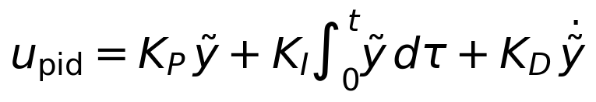
After calibration the gains were:
At a coarse 50 ms (20 Hz-class) update, the PID-augmented controller tracks the reference noticeably better than the plain discrete MRAC: overshoot is reduced, the response is faster, and the steady error is smaller. The tracking RMSE drops from 0.037 to 0.025 — about a 32% improvement — while the loop remains stable.
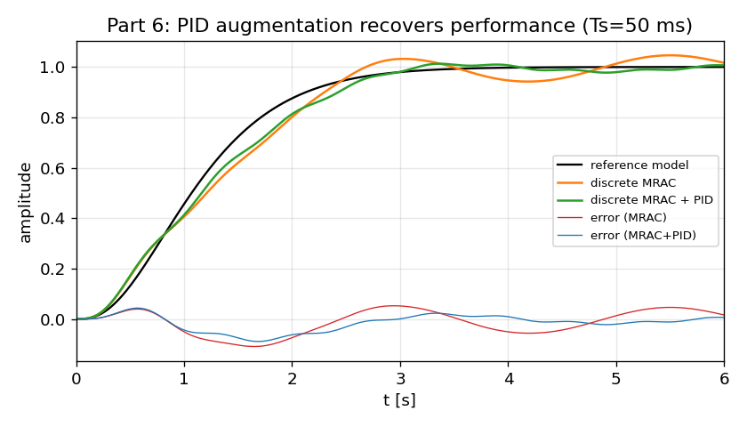
Figure 6.2 — PID augmentation at T = 50 ms. The MRAC+PID response (green) hugs the reference model; plain discrete MRAC (orange) shows more overshoot and slower settling.
The PID control component is most active during the initial transient, where it injects the aggressive correction needed to compensate the phase lag; thereafter it contributes only mild trims on top of the adaptive command.
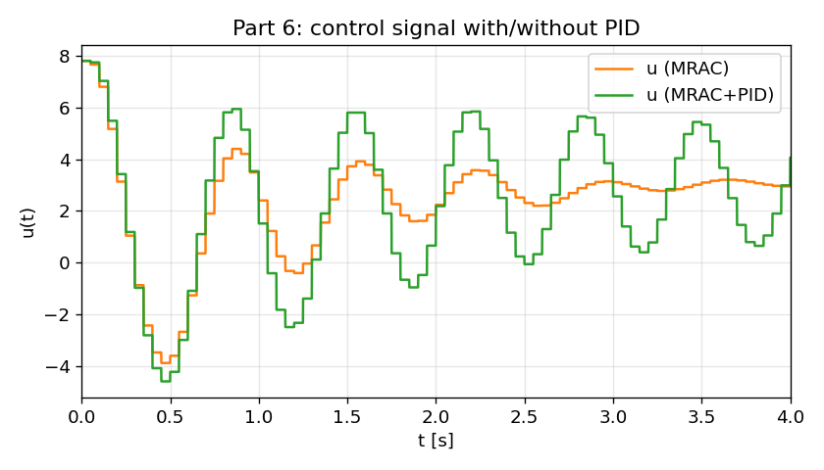
Figure 6.3 — Control signals with and without PID. The PID adds an early, aggressive correction, then settles to gentle trimming.
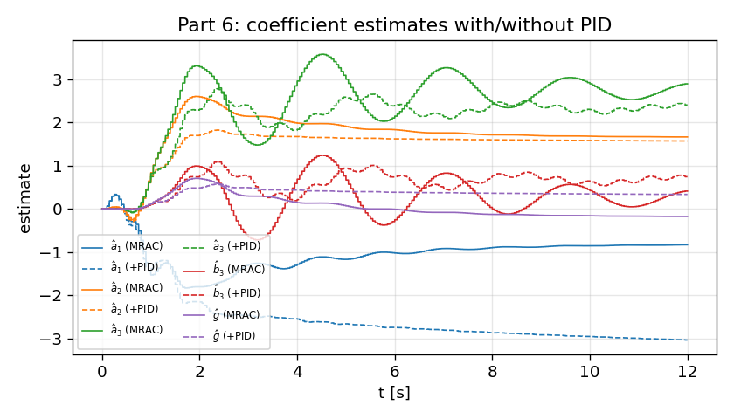
Figure 6.4 — Coefficient estimates with and without PID. The added loop changes the converged estimates because the adaptive law now sees a different error signal.

6.3 Discussion
The experiments confirm the expected digital-control phenomenology: phase lag, overshoot, and amplitude deficit all worsen as the sampling period grows, with the ZOH delay as the principal culprit. The degradation is gradual until the loop nears its stability margin, beyond which it deteriorates abruptly. Augmenting the discrete adaptive law with a PID compensator restores most of the lost performance at a coarse sampling rate by supplying compensating phase lead and amplitude, at the modest cost of a more aggressive initial control effort. More advanced tuning (e.g. systematic optimization of the PID gains, or redesigning the discrete controller directly in the z-domain) is expected to improve the result further.
Reference
J.-J. E. Slotine and W. Li, *Applied Nonlinear Control*, Prentice Hall, Englewood Cliffs, NJ, 1991 (mass–spring–damper with nonlinear spring, p. 71).

