**Programming DSP processors (31561) Final project**

Objective: heartbeat detection and processing

From:

Omri Pony I.D. number: 316352210

barak Shinfeld I.D. number: 207478546

To: MR Itzhak Kroin, EE Faculty

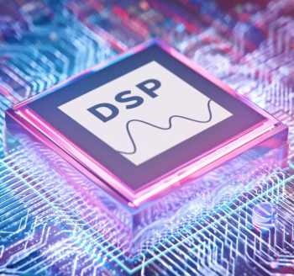

Introduction to the project: heartbeat – biological and engineering aspect

The heart is a hollow organ made of muscle. The heart and the blood vessels that surround it are part of man's cardiovascular system.

The main objective of the heart is to pump blood through the [blood vessels](https://www.msdmanuals.com/home/quick-facts-heart-and-blood-vessel-disorders/biology-of-the-heart-and-blood-vessels/biology-of-the-blood-vessels).

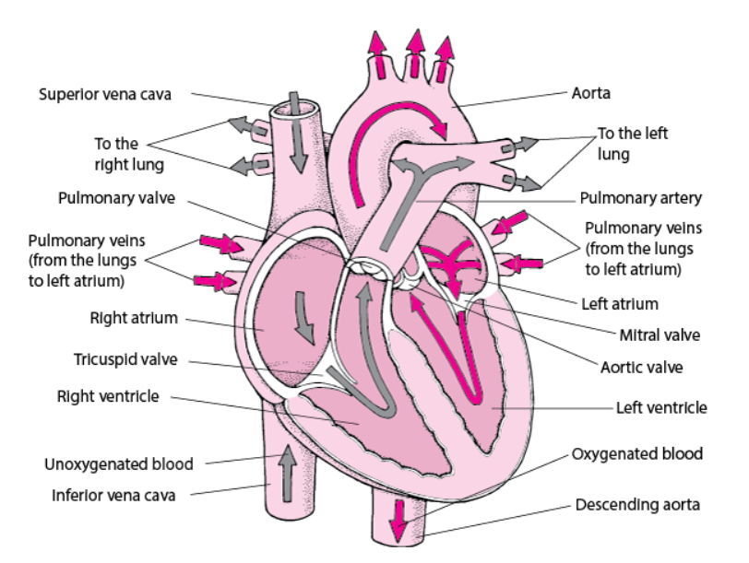The blood carries oxygen and nutrients to all parts of the body – therefore , the heart is one of the key organs in our body and it's functionality is critical to our existence and health.

Each time the heart beats-blood is pumped out of the heart and into the body to supply oxygen to working muscles or to the lungs for re-oxygenation.

**Heart rate refers to the number of times the heart beats per minute** , and is directly related to the workload being placed on the heart. When the body is in a resting state (i.e. lying down in a quiet area for at least five minutes), resting heart rate is measured. **A normal resting heart rate ranges from 60-100 beats per minute (bpm)**. Resting rates higher than 100 bpm suggest that the heart is working too hard to circulate blood, and thus may indicate a serious problem that should be monitored by a physician. Resting rates lower than 60 bpm occur more often with endurance-trained athletes whose bodies are more efficient at utilizing oxygen from the blood.

The heart rate is controlled by the two branches of the autonomic nervous system: The **sympathetic nervous system** (SNS) and the **parasympathetic nervous system** (PNS). The sympathetic nervous system (SNS) releases the hormones (catecholamines - epinephrine and norepinephrine) to accelerate the heart rate parasympathetic nervous system (PNS) releases the hormone acetylcholine to slow the heart rate.

System definitions:

Matlab simulation:

Before starting to apply the given project in the CCS environment , we first and foremost tried to simulate the whole project in a Matlab environment.

We will not present here the full code we used in order to simulate , albeit we will present the results both in time domain and in frequency domain – which can help the reader of that document to understand our thinking and working processes.

The process will be numbered – as our project's process in Matlab to understand the project we were given:

1. 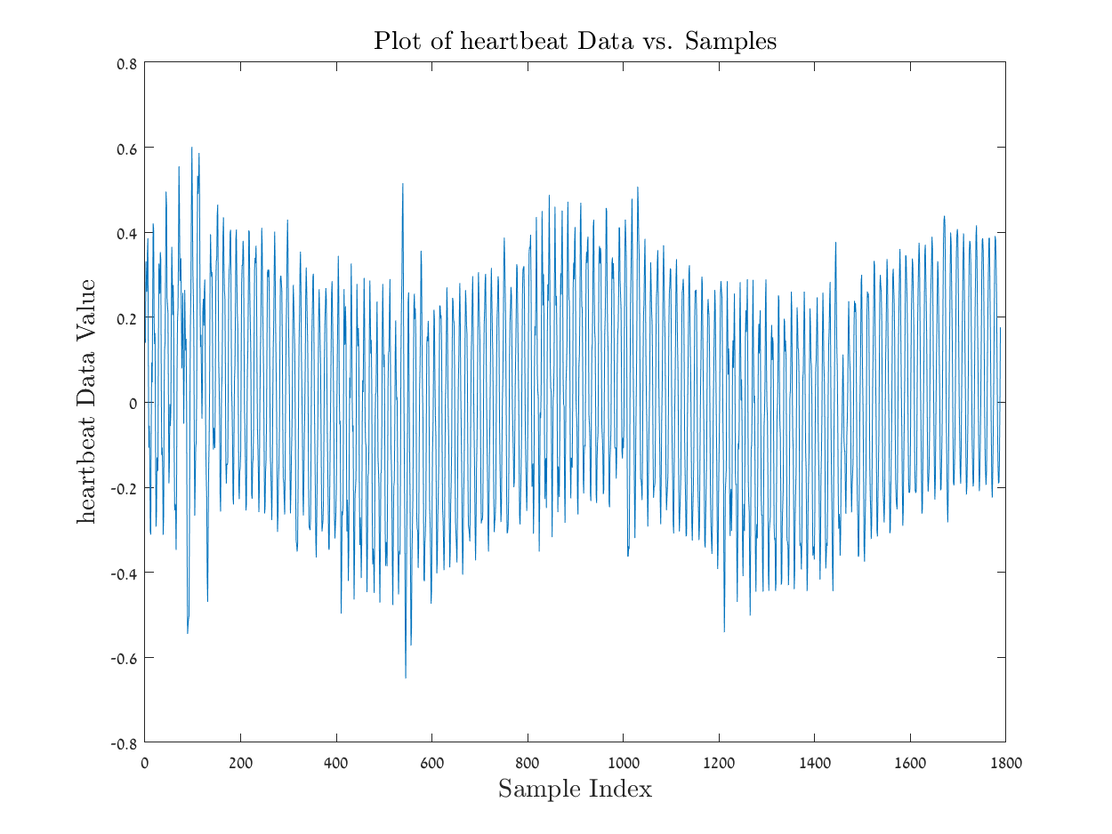
2. A graph of a person's body

   Description automatically generated with medium confidence
3. 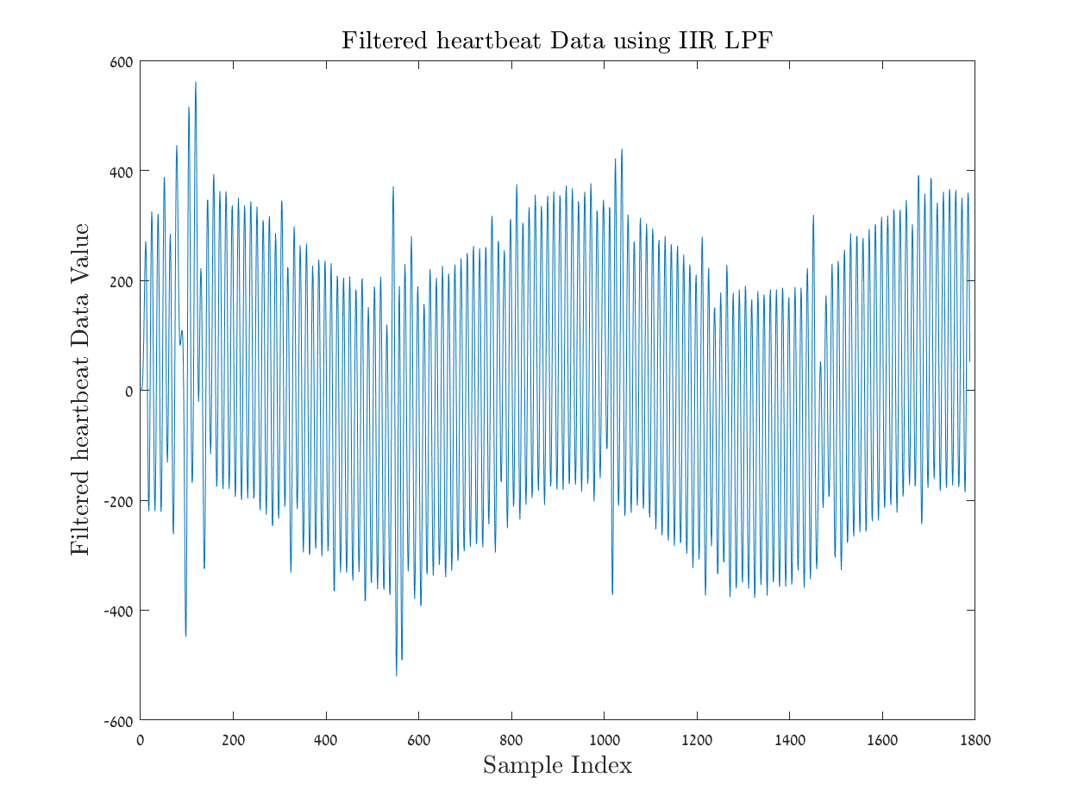

1. A graph of a graph

   Description automatically generated with medium confidence

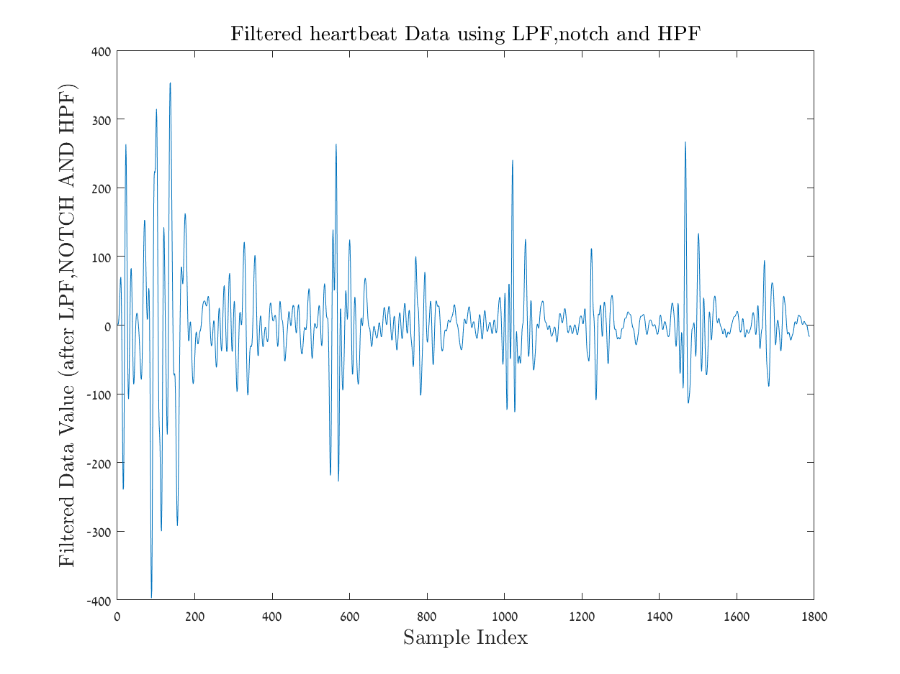

1. 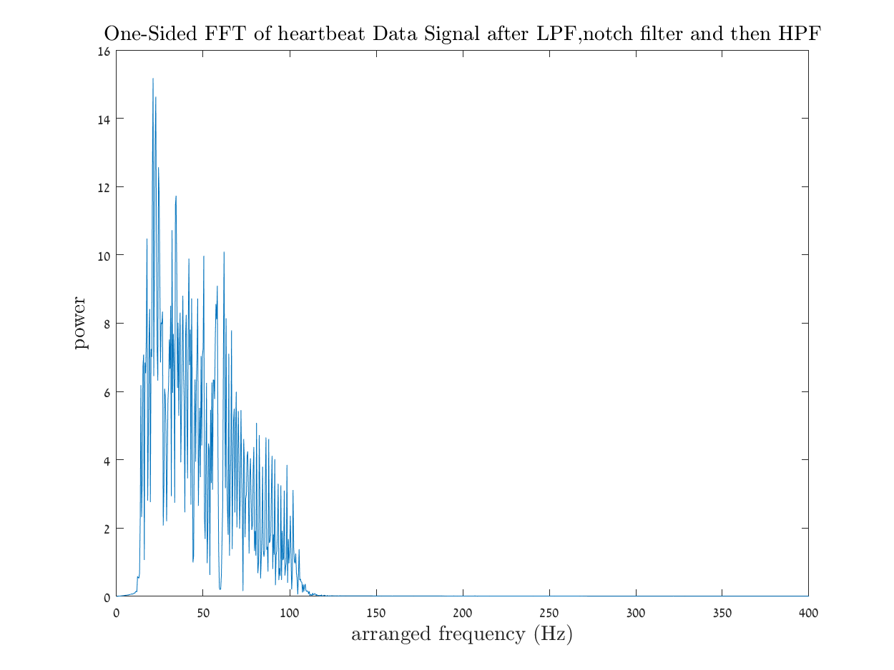

1. 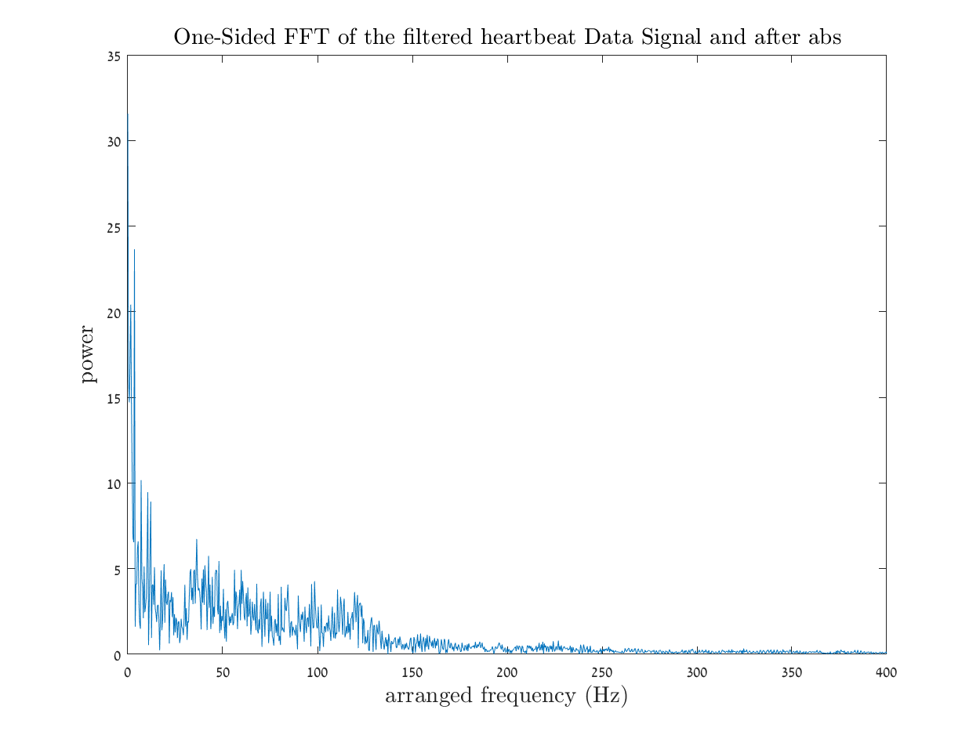
2. 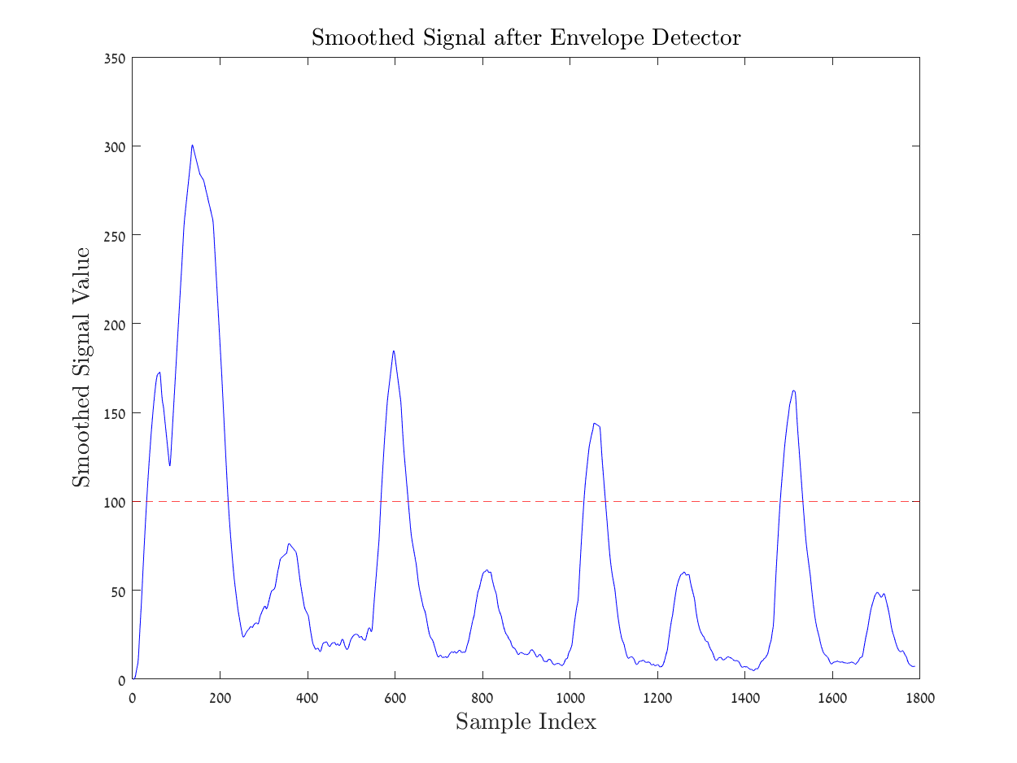
3. A graph of a signal

   Description automatically generated

**Sources used in that report:**

**https://health.ucdavis.edu/sports-medicine/resources/heart-rate**