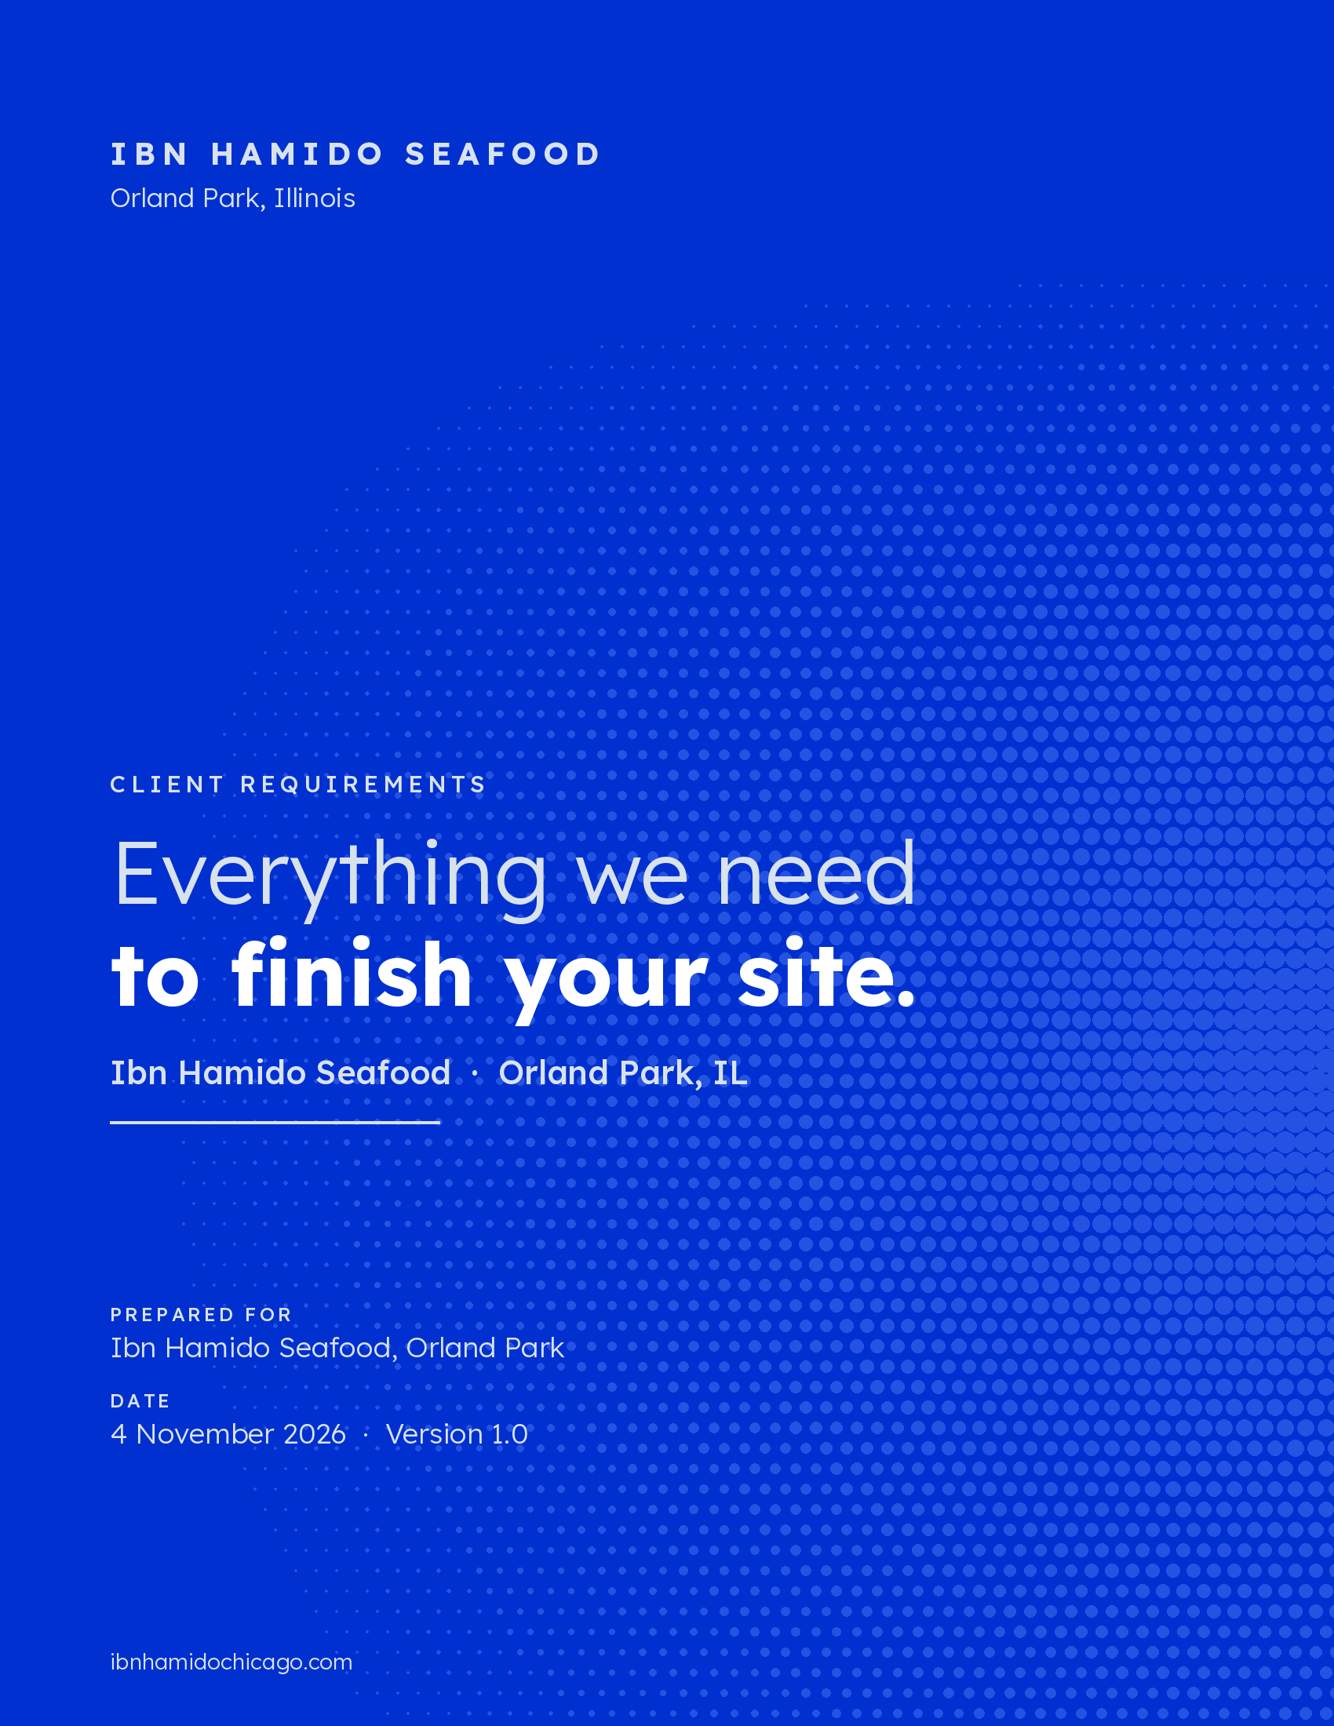

SUMMARY

10 items open the Coming Soon page.

You chose design A · Corniche, and both sites are built: the Coming Soon page for ibnhamidochicago.com, and the full site with online pickup ordering. What is left is information only you have. Part 1 is all we need to put the Coming Soon page live; Parts 2 to 8 finish the full site.
Part | What we need | Items | Needed for
1 | Needed to open the Coming Soon page | 10 | Launch
2 | Business facts | 11 | Full site
3 | Menu prices | 55 | Full site
4 | Online ordering setup | 11 | Full site
5 | In your own words | 22 | Full site
6 | Please confirm | 13 | Full site
7 | Arabic lines to check | 25 | Full site
8 | Photos and logo | 66 | Photos 7–8 of Part 1 for launch; the rest for the full site

How to reply
Type your answers into the white "Your answer" column and send the file back. Short notes, voice notes or WhatsApp messages are fine too; we tidy the English and keep your meaning.
Name each photo by its ID (for example SG-03.jpg) and send them as files through Google Drive or WhatsApp "Document", so they aren't compressed.
Part 1 first. As soon as it comes back, the Coming Soon page goes live.

Already decided for you
- The opening date shows as "Opening SOON" until you give us a date.
- The address links to Google Maps for 14035 LaGrange Rd, and the pages show a live map.
- The waitlist asks for email only. A phone/SMS field stays off until there are SMS terms.
- The Halal badge and customer reviews stay hidden until you confirm them (Parts 5 and 6).
- All photos on the design today are AI concept pictures or stand-ins. None can go on the public site, so each needs a real photo (Part 8).

PART 1

Needed to open the Coming Soon page

These 10 items are the only thing stopping the Coming Soon page from going live. The site will not publish while any of them is missing.
# | What we need | Where it shows | Your answer
1 | Restaurant phone number (or "none yet") | Google search listing
2 | Instagram @handle and link | Instagram button
3 | Jobs email (or tell us to remove the "Now hiring" card) | "Now hiring" card
4 | Contact email for privacy questions | Privacy Policy
5 | Privacy Policy start date | Privacy Policy
6 | Privacy Policy legal wording, 2 short sections (best from your lawyer or accountant) | Privacy Policy
7 | Main photo CS-01: upright 4:5, at least 1024 × 1280 px | Big photo at the top
8 | Share photo OG-01: wide 1200 × 630 px (we can crop it from CS-01) | Preview when the link is shared
9 | Access to ibnhamidochicago.com: the registrar login, or someone who can add 2 DNS records we send | Points the domain at the site
10 | The business email that should own the waitlist (a free Mailchimp account) | Waitlist sign-ups

Optional, when you have them
- Opening date. The site says "Opening SOON" until then.
- Grand opening offer, if you plan one. It goes in the waitlist line.

PART 2

Business facts for the full site

These appear on Home, Visit, Parties & Catering and in every page footer. The phone, Instagram and jobs email from Part 1 are used here too.
What we need | Where it shows | Your answer
Opening hours, Monday–Thursday | Home, Visit, footer
Opening hours, Friday–Sunday | Home, Visit, footer
Hamido Combo hours: Mon–Fri lunch only, or all day? | Menu, Order, Visit
Holiday hours note (e.g. "Closed Thanksgiving") | Visit
General contact email | Visit
Facebook page link | Footer
Google Business Profile for Orland Park. It isn't on Google Maps yet: please create and verify it, or give us manager access to set it up | Map link, footer, Google search
Private parties: maximum number of guests | Parties & Catering
Private parties and catering: how much notice you need | Parties & Catering
Catering trays: how many people one tray serves (e.g. 8–10) | Parties & Catering
How quickly you reply to a party request (e.g. 24 hours) | Party request form

PART 3

Menu prices

Every price shows as [PRICE] until you fill it in. The Astoria column is Astoria's online price on 22 October 2026, for reference only; it never appears on the Orland Park site.

Fresh catch, sold by the pound
The customer pays an estimate online and the final price is set by weight at the counter. Astoria today: market price + $4/lb cooking charge.
ID | Fish | Market price per lb | Cooking charge per lb
F-01 | Branzino
F-02 | Salmon
F-03 | Red Snapper
F-04 | Tiger Shrimp
F-05 | Scallops
F-06 | Lobster

Cooking-style extras
Grilled, Fried and Baked are included. These four cost extra (Astoria charges extra; the amount isn't listed).
ID | Style | Extra charge
K-04 | Singari
K-05 | Rada
K-06 | Butterfly
K-07 | Deboned

Dishes, sandwiches and sides
Combos come with two small sides. If every combo is one price, as at Astoria, fill in CB-01 and write "same" for the rest.
ID | Item | Astoria price | Orland Park price
CB-01 | Grilled Salmon | $21.99
CB-02 | Mixed Grilled Calamari & Shrimp | $21.99
CB-03 | Mixed Fried Calamari & Shrimp | $21.99
CB-04 | Tiger Shrimp, Grilled or Fried | $21.99
CB-05 | Calamari, Grilled or Fried | $21.99
CB-06 | Whole Branzino, Grilled or Fried | $21.99
SG-01 | Branzino Stuffed Singari | $31.99
SG-02 | Whole Wild Red Snapper | $26.99
SG-03 | Seafood Tajin | $29.99
SG-04 | Head-on Shrimp Butterfly | $40.99
SG-05 | Jumbo Shrimp Grilled | $24.99
SG-06 | King Crab Legs | $99.99
SG-07 | Lobster Tail (9 oz) | $29.99
SG-08 | Baked Clams | $21.99
SG-09 | Scallops & Shrimp Linguine | $23.99
SG-10 | White Sauce Pasta with Shrimp | $16.99
SG-11 | Fish & Chips | $19.99
SG-12 | White Fried Shrimp | $15.99
SG-13 | Hamido Seafood Pizza | $26.99
SW-01 | Fried Fish Fillet Sandwich | $12.99
SW-02 | Grilled Fish Fillet Sandwich | $12.99
SW-03 | Fried Shrimp Sandwich | $12.99
SW-04 | Grilled Shrimp Sandwich | $12.99
SW-05 | Salmon Burger | $12.99
SD-01 | Rice, Small | $5.00
SD-01 | Rice, Medium | $6.00
SD-01 | Rice, Large | $7.00
SD-02 | Tahini | $6.00
SD-03 | Babaghanoush | $6.00
SD-04 | Hamido (House) Salad | $7.49
SD-05 | Beet Salad | $6.00
SD-06 | Lemon Potatoes | $6.00
SD-07 | Garlic Eggplant | $6.00
SD-08 | Moussaka | $6.00
SD-09 | French Fries | $7.49
SD-10 | Greek Salad | $10.49
SD-11 | Herring Salad | $9.00
SD-12 | Mezza Platter | $16.00

Question | Your answer
Extra sides with a fresh-catch order: what does one extra side cost? Same as above, or a set add-on price?

PART 4

Online ordering setup

The ordering pages are built but take no real payments yet. The most important answer is which register or payment system you'll use, because it decides how fish sold by the pound is charged.
Question | Why we ask | Your answer
Which register / payment system? (Square, Toast, Clover, other) | Real checkout connects to it
Can it charge the final price after the fish is weighed? | Fish is paid as an estimate, then adjusted at the counter
How much extra to hold on the card for by-the-lb orders (e.g. 15%) | Covers a fish that weighs a little more
Largest fresh-catch order online, in lb | Bigger orders call the restaurant
Is "about 1 lb of whole fish per person" right? | Shown when choosing a weight
Sales tax rate | Checkout total
Offer tipping online? Yes / No | Checkout total
Usual wait for an ASAP order (e.g. 20 min) | "Ready in about …"
Last online order time each day | Ordering closes at this time
Pickup slots: first slot, last slot, orders per 15-minute slot | Scheduled pickup times
Who updates daily fish prices and sold-out items, and when? | Keeps prices and stock right

PART 5

In your own words

This is the writing only you can give us. Short and plain is perfect; we tidy the English and keep your meaning.

Cooking styles
One or two sentences each: what it is, how you make it, and the best fish for it. Please also correct the "Offered on" list, which is our guess.
ID | Style | Offered on (our guess) | What it is, in your words
K-01 | Grilled | Branzino, Salmon, Red Snapper, Tiger Shrimp, Scallops, Lobster
K-02 | Fried | Branzino, Salmon, Red Snapper, Tiger Shrimp, Scallops
K-03 | Baked | Branzino, Salmon, Red Snapper, Lobster
K-04 | Singari | Branzino, Salmon, Red Snapper, Tiger Shrimp, Scallops
K-05 | Rada | Branzino, Red Snapper
K-06 | Butterfly | Branzino, Red Snapper
K-07 | Deboned | Branzino, Red Snapper

Fresh fish
One line each, the way a waiter would say it.
ID | Fish | Description
F-01 | Branzino | Mediterranean sea bass. (ours: keep or change)
F-02 | Salmon
F-03 | Red Snapper
F-04 | Tiger Shrimp
F-05 | Scallops
F-06 | Lobster

Our Story page
Five short chapters, 2 to 4 sentences each, with a year where there is one.
# | Chapter | What to tell | Year | Your text
1 | Alexandria, Egypt: where it started | The family's history in Alexandria
2 | The Hamido name | Who Hamido is; where "Ibn Hamido" comes from
3 | Astoria, New York | Opening the first restaurant on Ditmars Blvd
4 | The Astoria original | Already written from the press (see Part 6)
5 | Orland Park, Illinois | Why Orland Park

Customer reviews (3)
Three real reviews you're proud of, copied exactly as written.
# | Review text | Name (first + last initial) | Source | Stars
1
2
3

Allergy note
What customers should see | Your answer
Allergy and dietary warning for the menu: e.g. shellfish, gluten in fried items, halal sourcing if it applies

PART 6

Please confirm

The site already says these things, mostly taken from the Astoria restaurant. A "yes" or a correction is enough.
# | Question | What the site says now | Yes / correction
1 | Is the food halal? | "Halal" badge, hidden until you confirm
2 | Walk-in only, reservations for private parties only? | "Walk-in only. No reservations needed."
3 | Online orders are pickup only, no delivery? | "Pickup only · pay online"
4 | Combos: can a customer pick the same side twice? | Yes, the same side can count as both
5 | Will you serve drinks, desserts, kids' items, hummus, grilled vegetables or pita? | Not on the menu yet
6 | Spelling: "Branzino" or "Bronzini" (Astoria's menu)? | Branzino
7 | Dish and side descriptions are reworded from Astoria's menu. OK to use? | Menu and Order pages
8 | The New York Times Top 100: which list and which year? | "Named to The New York Times Top 100"
9 | Where does the 4.7★ diner rating come from (Google, Yelp…)? | "4.7★ diner rating · Astoria"
10 | Is The Infatuation's 7.7/10 still right? | "7.7/10 The Infatuation"
11 | Astoria address: 31-29 or 33-08 Ditmars Blvd? | 31-29 Ditmars Blvd, Astoria, Queens
12 | Astoria's name is "Hamido Seafood"? | "From the family behind Hamido Seafood"
13 | Keep the tagline "Your fish, cooked your way." (سمكك على مزاجك)? | Every page

PART 7

Arabic lines to check

The design uses short Egyptian Arabic lines next to the English. Please mark anything that sounds wrong, or that you would say differently in Alexandria.
Arabic | Meaning | Where | OK / correction
سمكك على مزاجك | Your fish, cooked your way (tagline) | Every page
قريباً في أورلاند بارك | Coming soon to Orland Park | Coming Soon
قريباً | Opening soon | Coming Soon
زي إسكندرية بالظبط | Just like in Alexandria (how-it-works steps) | Coming Soon, Home
من إسكندرية لنيويورك لشيكاغو | From Alexandria to New York to Chicago | Coming Soon, Home
بالوزن | By weight / by the pound | Home, Menu, Order
سمك طازج بالرطل | Fresh fish by the pound | Order
على الفحم ولا مقلي؟ | Charcoal-grilled or fried? | Home, Menu
لوحة الطبخ | The cooking board (styles section) | Home
مشوي · مقلي · في الفرن | Grilled · Fried · Baked | Home, Menu
سنجاري · بالردة · بترفلاي · فيليه | Singari · Rada · Butterfly · Deboned (fillet) | Home, Menu
كومبو ابن حميدو | Hamido Combo | Home, Menu, Order
على الترابيزة | On the table (sides section) | Home
رز · طحينة · بابا غنوج · سلطة حميدو · سلطة بنجر · بطاطس بالليمون | Rice · Tahini · Babaghanoush · Hamido Salad · Beet Salad · Lemon Potatoes | Home, Menu, Order
باذنجان بالتوم · مسقعة · بطاطس محمرة · سلطة يوناني · سلطة رنجة · طبق مزة | Garlic Eggplant · Moussaka · French Fries · Greek Salad · Herring Salad · Mezza Platter | Home, Menu, Order
قاروص · سلمون · جمبري · استاكوزا | Branzino · Salmon · Tiger Shrimp · Lobster | Menu, Order
— | Red Snapper and Scallops: what do you call them? | Menu, Order
المنيو | The menu | Menu
أطباق ابن حميدو · سندوتشات · سلطات | Ibn Hamido dishes · Sandwiches · Salads | Menu, Order
اطلب من ابن حميدو | Order from Ibn Hamido | Order
شكراً | Thank you | Order confirmation
حكاية ابن حميدو | The story of Ibn Hamido | Our Story
إسكندرية · ابن حميدو · أستوريا · نيويورك · أورلاند بارك | Alexandria · Ibn Hamido · Astoria · New York · Orland Park (chapter titles) | Our Story
نورتونا | Welcome, you've brightened our place | Visit
سفرة من إسكندرية | An Alexandrian spread | Parties & Catering

PART 8

Photos and logo

The design uses 65 photos. Every one is an AI concept picture or a stand-in, and each must be replaced with a real photo before the full site opens.
- Phone photos are fine: daylight or bright even light, no flash, at least 2000 px on the long side.
- Leave space around the food: most photos are cropped to an arch or a square.
- Tick the last column as you send each one.

First: for the Coming Soon page
ID | What to shoot | Shape | Page | Sent
CS-01 | Hero spread: grilled branzino, shrimp, rice, salads | Upright 4:5 | Coming Soon
OG-01 | Share image; can be cropped from CS-01 | Wide 1200 × 630 | Link previews

Only you have these: family and restaurant photos
ID | What to shoot | Shape | Page | Sent
ST-02 | Family archive photo | Wide 16:9 | Our Story
ST-03 | Astoria storefront | Wide 16:9 | Our Story
ST-04 | Astoria dining room | Wide 16:9 | Our Story
ST-05 | Orland Park build / dining room | Wide 16:9 | Our Story
V-01 | Orland Park storefront exterior | Landscape 3:2 | Visit

Home, Our Story and Parties & Catering
ID | What to shoot | Shape | Page | Sent
H-01 | Whole grilled branzino on the table | Upright 3:4 | Home
H-03 | Sides spread | Landscape 3:2 | Home
H-08 | Story teaser: Alexandria harbor / family | Upright 4:5 | Home
H-09 | Catering trays on a long table | Wide 16:10 | Home
K-01 | Fish on the charcoal grill | Wide 16:9 | Home, Menu
ST-01 | Alexandria harbor / Qaitbay Citadel (a licensed stock photo is fine) | Wide 16:9 | Our Story
C-01 | Long table of seafood platters | Upright 4:5 | Parties & Catering
C-02 | Room set for a party | Landscape 3:2 | Parties & Catering
C-03 | Catering trays | Landscape 3:2 | Parties & Catering

Menu and Order: one photo per item
ID | What to shoot | Shape | Page | Sent
M-01 | Counter on ice | Upright 4:5 | Menu
F-01 | Branzino, raw on ice | Square | Menu, Order
F-02 | Salmon, raw on ice | Square | Menu, Order
F-03 | Red Snapper, raw on ice | Square | Menu, Order
F-04 | Tiger Shrimp, raw on ice | Square | Menu, Order
F-05 | Scallops, raw on ice | Square | Menu, Order
F-06 | Lobster, raw on ice | Square | Menu, Order
K-02 | Fried, plated | Wide 16:9 | Menu
K-03 | Baked, plated | Wide 16:9 | Menu
K-04 | Singari, plated | Wide 16:9 | Menu
K-05 | Rada, plated | Wide 16:9 | Menu
K-06 | Butterfly, plated | Wide 16:9 | Menu
K-07 | Deboned, plated | Wide 16:9 | Menu
CB-01 | Grilled Salmon, plated with two side bowls | Square | Menu, Order
CB-02 | Mixed Grilled Calamari & Shrimp, plated with two side bowls | Square | Menu, Order
CB-03 | Mixed Fried Calamari & Shrimp, plated with two side bowls | Square | Menu, Order
CB-04 | Tiger Shrimp, Grilled or Fried, plated with two side bowls | Square | Menu, Order
CB-05 | Calamari, Grilled or Fried, plated with two side bowls | Square | Menu, Order
CB-06 | Whole Branzino, Grilled or Fried, plated with two side bowls | Square | Menu, Order
SG-01 | Branzino Stuffed Singari, plated | Square | Menu, Order
SG-02 | Whole Wild Red Snapper, plated | Square | Menu, Order
SG-03 | Seafood Tajin, plated | Square | Menu, Order
SG-04 | Head-on Shrimp Butterfly, plated | Square | Menu, Order
SG-05 | Jumbo Shrimp Grilled, plated | Square | Menu, Order
SG-06 | King Crab Legs, plated | Square | Menu, Order
SG-07 | Lobster Tail (9 oz), plated | Square | Menu, Order
SG-08 | Baked Clams, plated | Square | Menu, Order
SG-09 | Scallops & Shrimp Linguine, plated | Square | Menu, Order
SG-10 | White Sauce Pasta with Shrimp, plated | Square | Menu, Order
SG-11 | Fish & Chips, plated | Square | Menu, Order
SG-12 | White Fried Shrimp, plated | Square | Menu, Order
SG-13 | Hamido Seafood Pizza, plated | Square | Menu, Order
SW-01 | Fried Fish Fillet Sandwich with fries | Square | Menu, Order
SW-02 | Grilled Fish Fillet Sandwich with fries | Square | Menu, Order
SW-03 | Fried Shrimp Sandwich with fries | Square | Menu, Order
SW-04 | Grilled Shrimp Sandwich with fries | Square | Menu, Order
SW-05 | Salmon Burger with fries | Square | Menu, Order
SD-01 | Rice | Square | Menu, Order
SD-02 | Tahini | Square | Menu, Order
SD-03 | Babaghanoush | Square | Menu, Order
SD-04 | Hamido (House) Salad | Square | Menu, Order
SD-05 | Beet Salad | Square | Menu, Order
SD-06 | Lemon Potatoes | Square | Menu, Order
SD-07 | Garlic Eggplant | Square | Menu, Order
SD-08 | Moussaka | Square | Menu, Order
SD-09 | French Fries | Square | Menu, Order
SD-10 | Greek Salad | Square | Menu, Order
SD-11 | Herring Salad | Square | Menu, Order
SD-12 | Mezza Platter | Square | Menu, Order

Logo
Question | Your answer
Is the current logo final? If you have the original file (SVG, AI or PDF), please send it.

NEXT STEPS

What happens when you reply

When you send | We do
Part 1 | Connect the domain, set up the waitlist and publish the Coming Soon page at ibnhamidochicago.com.
Parts 2 to 7 | Fill every page of the full site, set prices and connect real payments for pickup ordering.
Part 8 photos | Replace every concept picture, then test the full site on phones and computers before it opens.

Questions on any line? Reply by email or WhatsApp, or leave a comment in this file.

