# 1Outline

The Sample Code is used to evaluate the main functions of the OMRON built-in Color Sensor Module B5WC(hereafter referred to as the “Device”) on an Arduino in combination with your PC.

# 2Operating Environment

The Sample Code was tested in the environment described below.

|  |  |
| --- | --- |
| Arduino board | Arduino Mega 2560 R3  Arduino Uno R3 |
| Arduino IDE | 1.8.7 |
| OS | Windows 10 Professional 64-bit |

# 3Connection

Connect the Device to Arduino and Arduino to PC.

Connect the Arduino to the PC after connecting the Device to the Arduino.

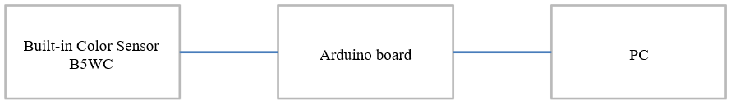

Example of connection between the Device and Arduino UNO

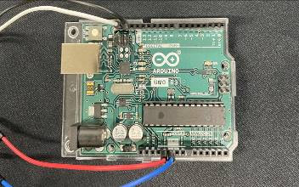

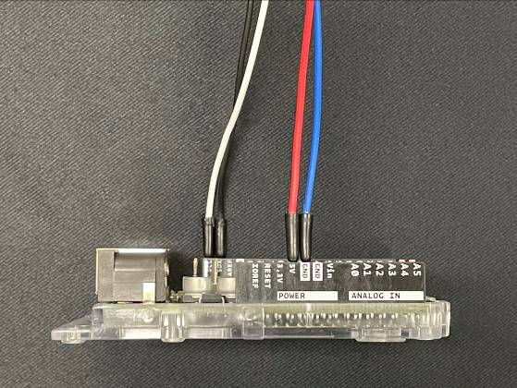 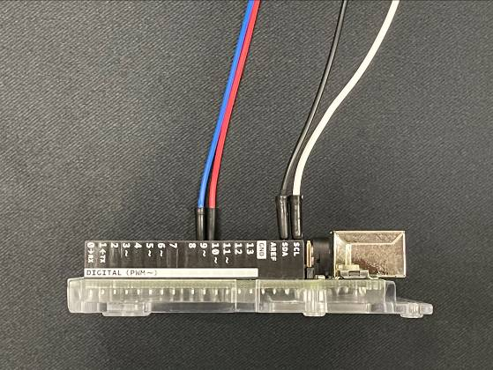

# 4 Download the Arduino IDE

Download the Arduino IDE from the following URL.

<https://www.arduino.cc/en/Main/Software>

# Open Sample Code

Start the Arduino IDE and open the Sample Code.

[File]-[Open]-[B5WC_SampleProject.ino] 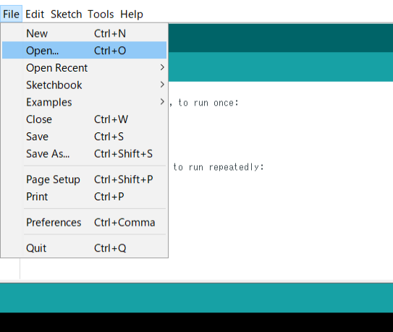

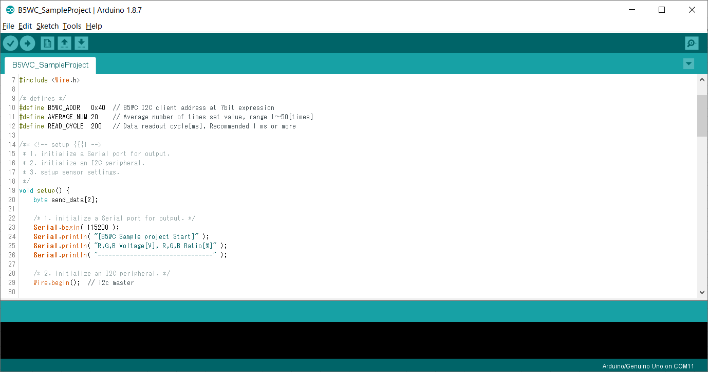

# Upload to Arudino

Configure connection settings.

[Tools]-[Board]-[Select the Arduino board you are using]

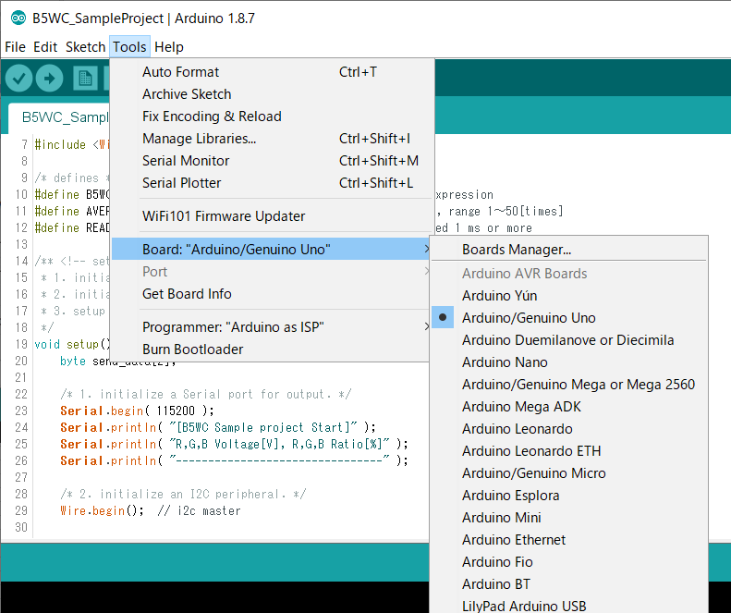

[Tools]-[Port]-[Select the USB port to which the Arduino is connected]

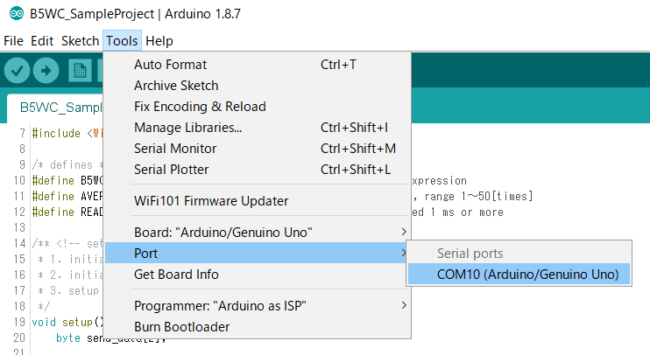

Click on "Verify" to make sure there are no errors.

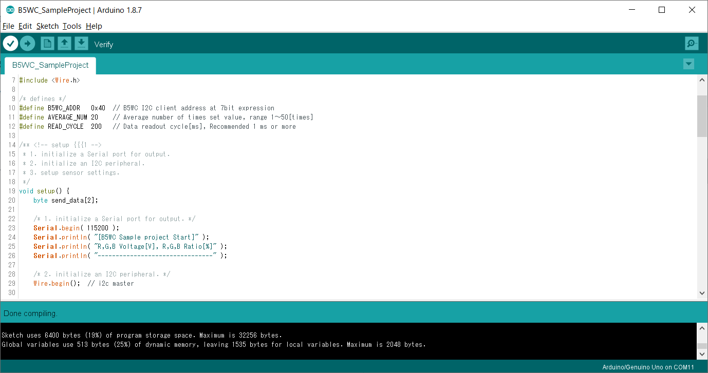

Click "Upload" and confirm that the message "Done uploading" is displayed on the screen.

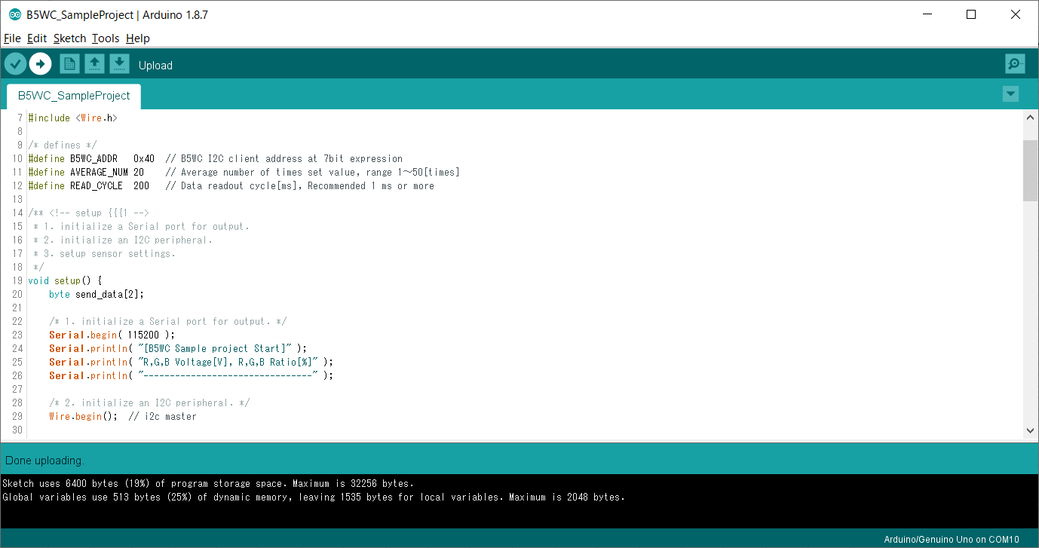

# Data acquisition

Open the Serial Monitor window.

[Tools]-[Serial Monitor]

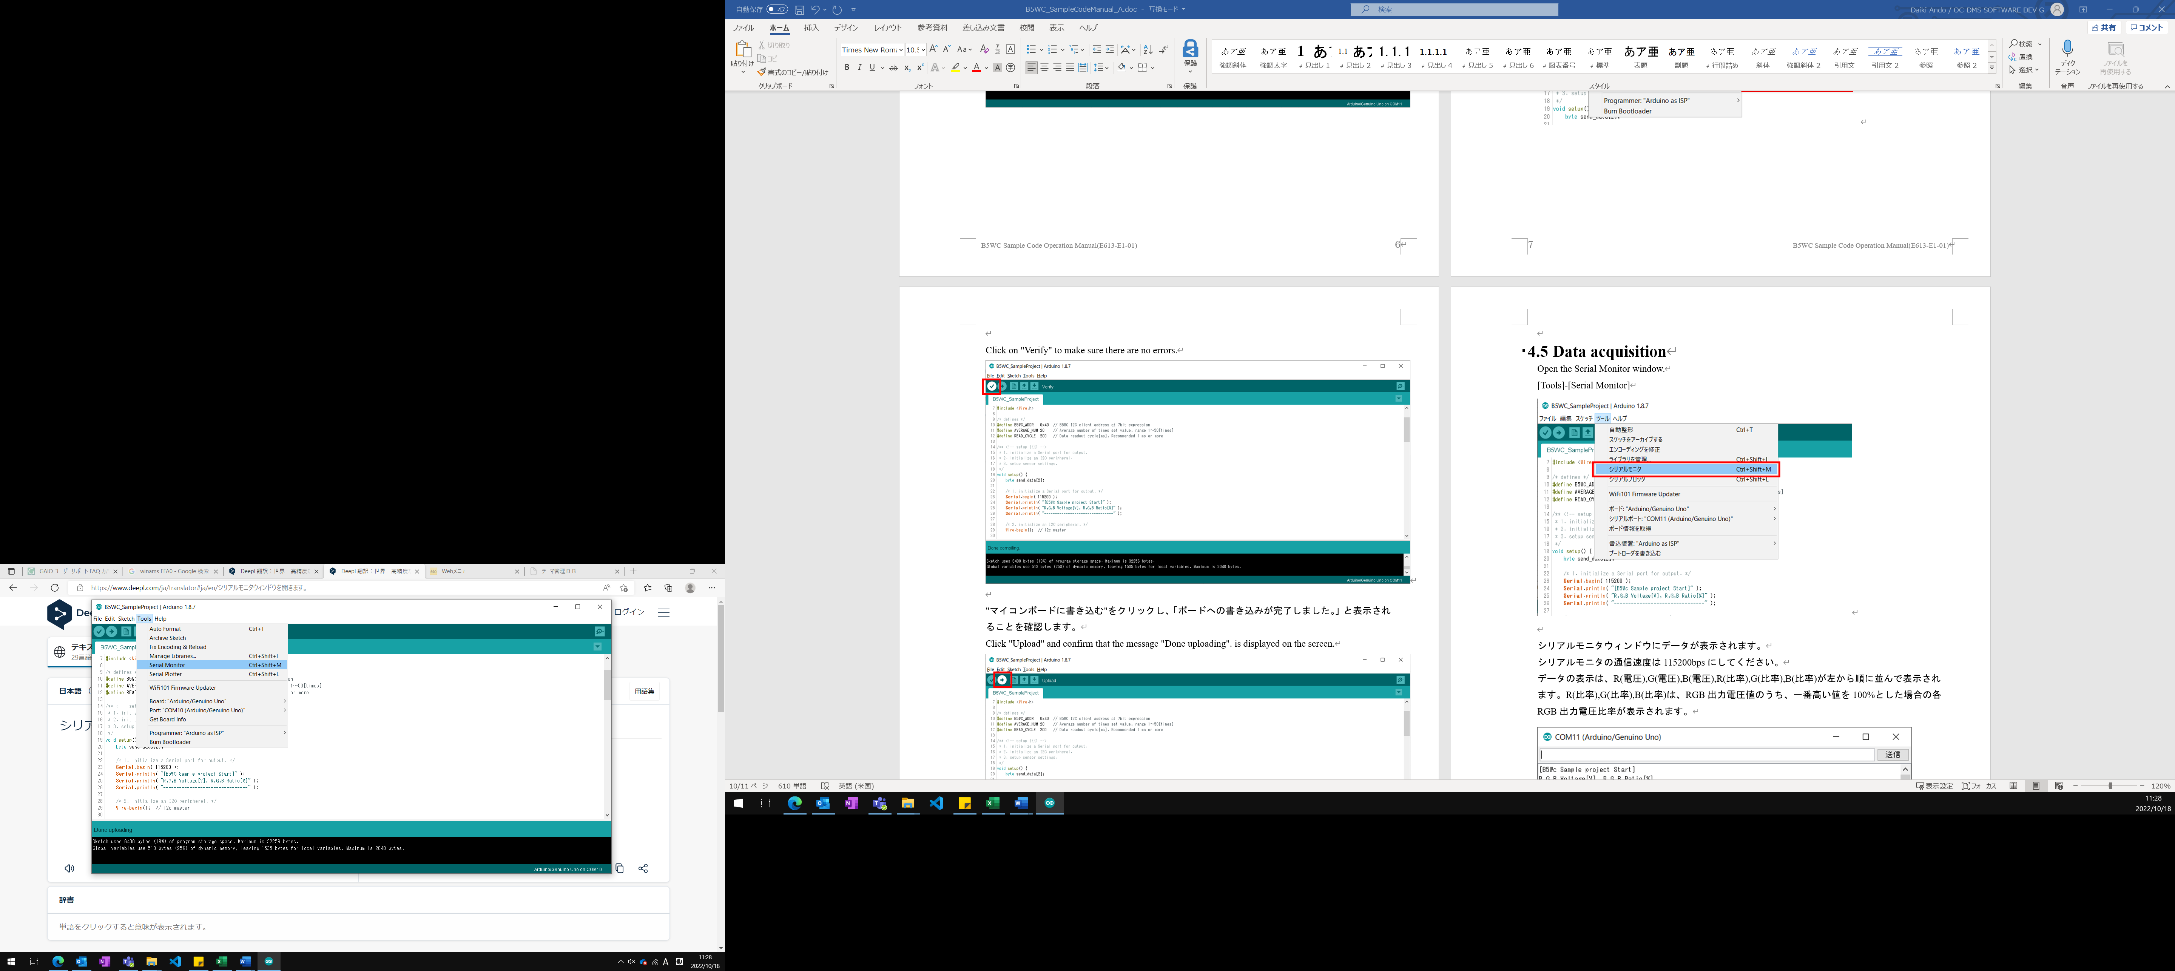

Data is displayed in the Serial Monitor window.

The communication speed of the Serial Monitor should be 115200 baud.

The data display shows R(voltage), G(voltage), B(voltage), R(ratio), G(ratio), and B(ratio) in order from left to right. R(ratio), G(ratio), and B(ratio) show the ratio of each RGB output voltage when the highest value among the RGB output voltage values is 100%.

