WEEK 6 FINAL ASSIGNMENT — ARTIFICIAL INTELLIGENCE
Student Performance Prediction Using Machine Learning
Assignment Type: Final Project | Duration: 1 Week (7 Days) | Total Marks: 100

1. Introduction
This project demonstrates a complete supervised machine-learning workflow to estimate student final scores from study habits, attendance, previous achievement, and selected background indicators.

2. Problem Statement and Objectives
Problem: estimate final_score from available features. Objectives: inspect and clean data, perform EDA, preprocess mixed data types, train a Random Forest regressor, generate predictions, and evaluate with regression metrics. ML is suitable because the target is numeric and predictors may interact nonlinearly.

3. Dataset
The CSV contains 1012 rows and 9 columns before cleaning. It is synthetic, generated reproducibly for education, and contains no real student records. Features: hours_studied, attendance_pct, previous_score, sleep_hours, tutoring, parental_education, extracurricular, internet_access. Target: final_score.

4. Data Preprocessing
Before cleaning: 1012 rows, 60 missing cells, 12 duplicate rows. After cleaning: 1000 rows, 0 missing cells, 0 duplicate rows. Numeric missing values were median-imputed; categorical missing values were mode-imputed. Categorical variables are one-hot encoded and numeric variables standardized in the model pipeline.

5. Exploratory Data Analysis
The project includes a score histogram, average score by study-hour band, attendance-versus-score scatter plot, numerical correlation heatmap, and tutoring-group box plot. These charts describe associations in synthetic data and do not establish causation.

6. Model Development
A RandomForestRegressor with 250 trees and min_samples_leaf=2 was used. The data was split into 80% training and 20% testing with random_state=42. The model is a useful nonlinear baseline for tabular data.

7. Training and Prediction
The preprocessing and regression model are combined in a scikit-learn Pipeline. The pipeline is fitted on training data, then generates predicted scores for held-out test records. Test predictions are saved to outputs/test_predictions.csv.

8. Model Evaluation
MAE = 6.206; MSE = 61.778; RMSE = 7.860; R² = 0.548. MAE and RMSE are in score points; lower is better. R² compares fit against a mean-prediction baseline. These are single-split results on synthetic data.

9. Conclusion
The project implements the end-to-end workflow from data inspection and cleaning through visualization, training, prediction, and regression evaluation.

10. Future Scope
Use an ethically collected real dataset, compare multiple models, perform cross-validation and hyperparameter tuning, inspect residuals, assess subgroup fairness, and keep educators in control of any consequential decisions.

Visualizations
01 Score Distribution
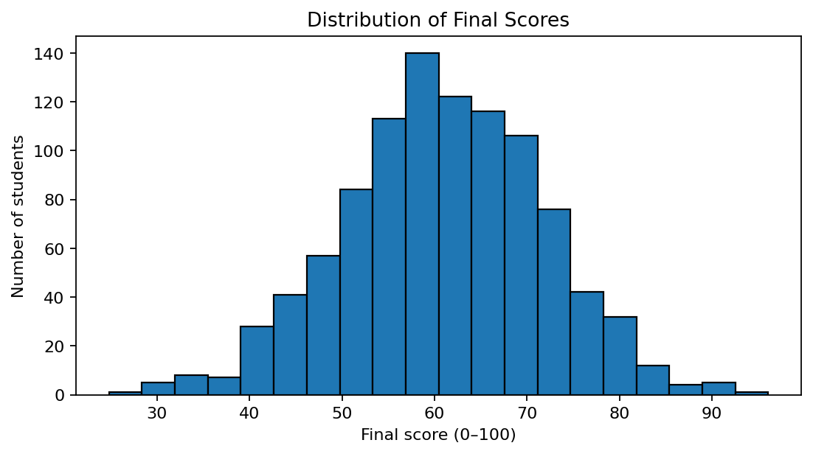
02 Score By Study Hours
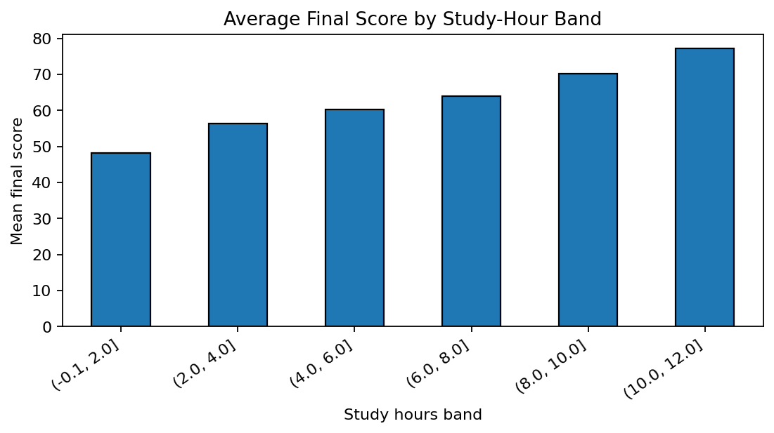
03 Attendance Vs Score
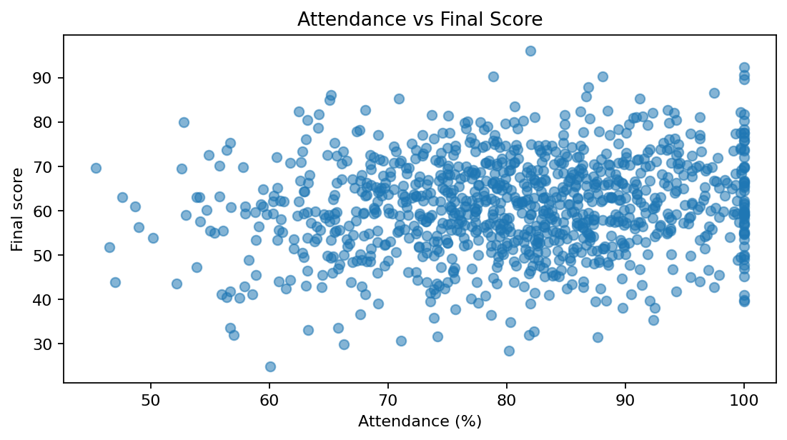
04 Correlation Heatmap
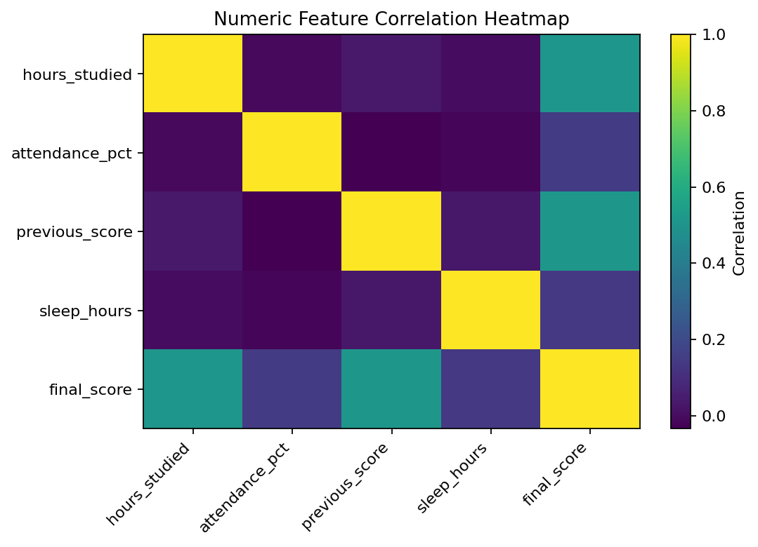
05 Tutoring Score Boxplot
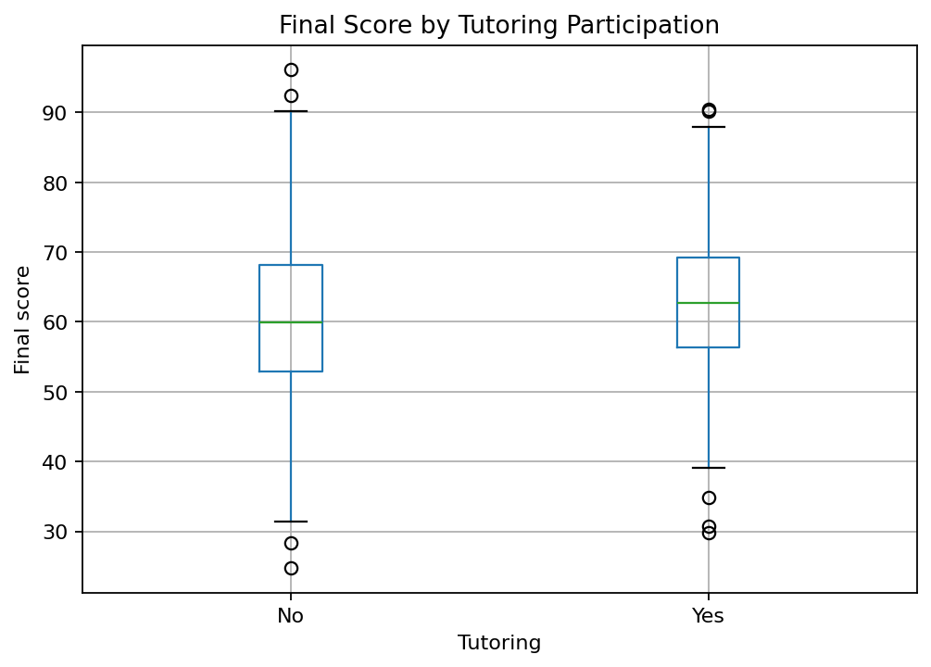
06 Actual Vs Predicted
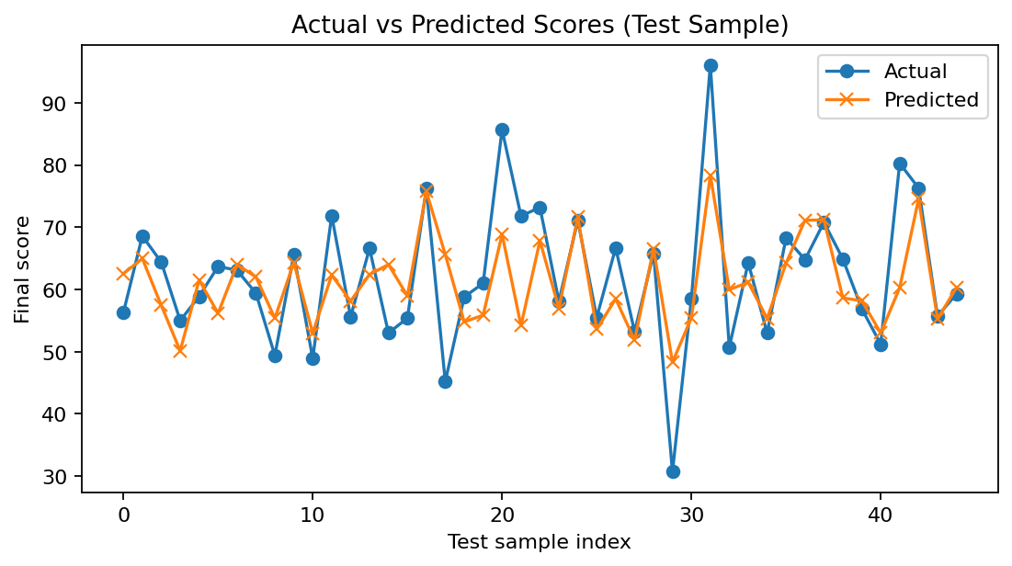
07 Feature Importance
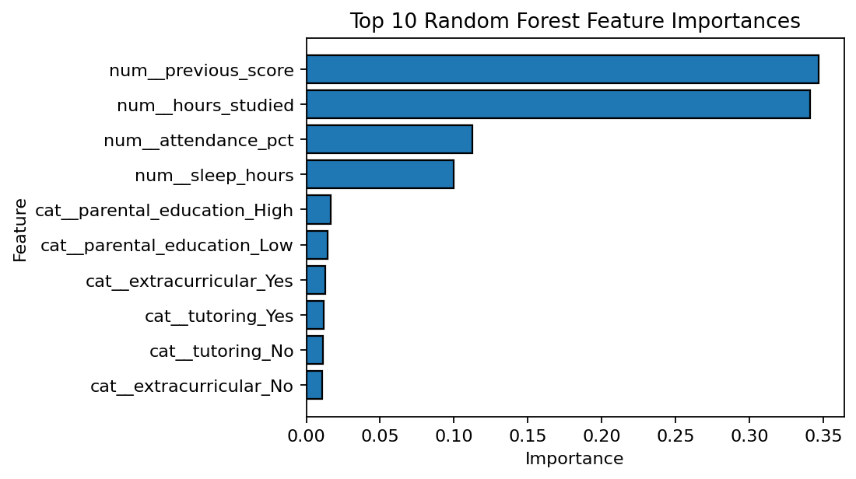

Important Dataset Notice
The included dataset is synthetic and intended only for educational demonstration. It must not be represented as real student data or used for actual grading or other consequential decisions.

