ECGenius: AI-Powered ECG Analysis and Smart Elderly Care System

1. Executive Summary
ECGenius is an integrated AI-driven healthcare platform designed to enable real-time cardiac monitoring, automated arrhythmia detection, and intelligent elderly care management. The system leverages deep learning and machine learning models to analyze ECG signals, predict heart disease risks, and provide continuous health insights.
The solution addresses a critical gap in modern healthcare by transforming raw physiological data into actionable intelligence. It combines signal processing, predictive analytics, and user-centric design to create a scalable and accessible healthcare support system.

2. Problem Statement
Cardiovascular diseases remain a leading cause of mortality worldwide. Despite advancements in medical technology, several challenges persist:
- ECG interpretation requires specialized expertise and is not easily accessible in remote or resource-constrained settings.
- Elderly individuals lack continuous health monitoring and timely medical intervention.
- Emergency response systems are often delayed due to lack of real-time alerts.
- Existing systems are reactive rather than preventive, leading to late diagnosis.
These challenges highlight the need for an intelligent system capable of continuous monitoring, early detection, and rapid response.

3. Proposed Solution
The proposed system integrates AI-based ECG analysis with a smart elderly care framework to deliver a comprehensive healthcare solution.
The platform enables users to upload ECG signals or connect real-time data streams, which are processed through advanced deep learning models to detect abnormalities. Simultaneously, the system monitors vital health parameters and generates alerts in case of anomalies.
Caregivers and family members can access a centralized dashboard to track patient health, receive notifications, and respond to emergencies efficiently.

4. Objectives
- To automate the detection and classification of cardiac arrhythmias using deep learning techniques.
- To provide continuous health monitoring for elderly individuals through an intelligent system.
- To enable early prediction of heart disease risks using machine learning models.
- To design a responsive emergency alert mechanism for critical situations.
- To create a scalable and user-friendly healthcare platform.

5. System Architecture
The system follows a modular architecture consisting of frontend, backend, AI models, and database components.
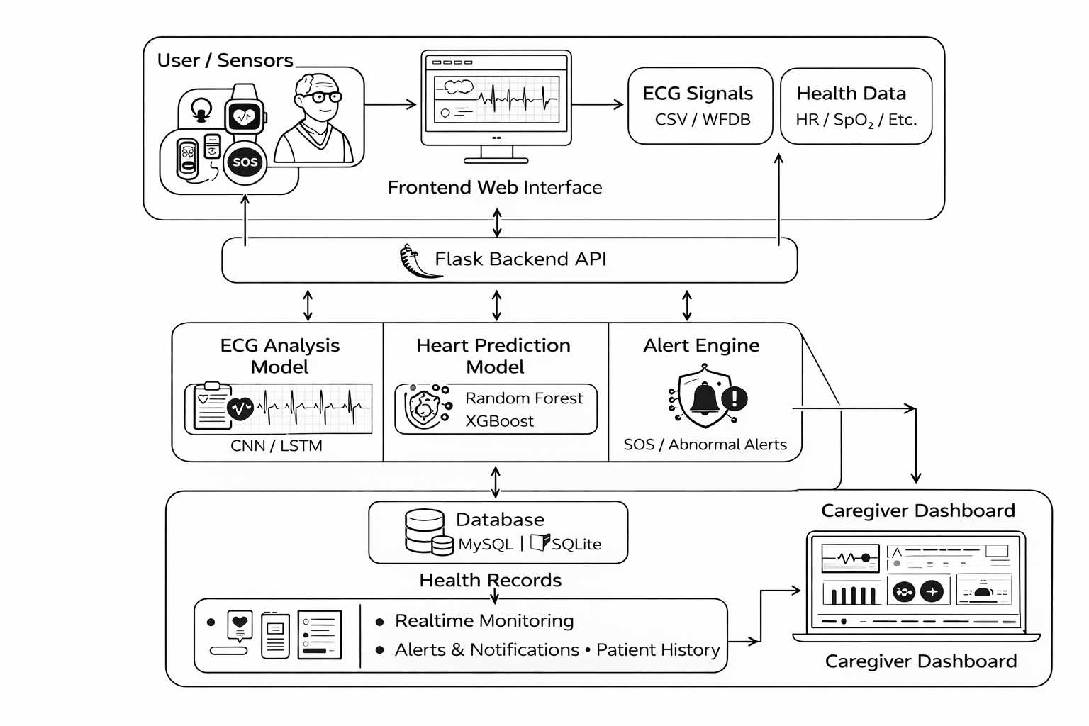
The architecture ensures efficient data flow, real-time processing, and scalability for future enhancements.
Reference architecture and module breakdown are aligned with the system design provided in the project documentation.

6. Methodology
6.1 ECG Signal Processing
The system processes ECG data through multiple stages:
- Signal acquisition from files or sensors
- Noise filtering and baseline correction
- R-peak detection for heartbeat segmentation
- Feature extraction for model input
6.2 Deep Learning Model
A hybrid model architecture is employed:
- Convolutional Neural Networks (CNN) for spatial feature extraction
- Long Short-Term Memory (LSTM) networks for temporal pattern recognition
This combination enables accurate classification of ECG signals into categories such as normal rhythm, arrhythmia, and high-risk conditions.
6.3 Heart Disease Prediction
Structured health data is processed using machine learning algorithms including:
- Random Forest
- XGBoost
- Logistic Regression
These models predict the probability of heart disease based on clinical parameters.

7. Key Modules
7.1 ECG Analysis Module
- Accepts ECG data in multiple formats (CSV, image, WFDB)
- Performs preprocessing and classification
- Displays waveform visualizations and results
7.2 Health Monitoring Module
- Tracks heart rate, oxygen levels, and blood pressure
- Maintains historical health records
- Provides periodic health insights
7.3 Elderly Care Assistant
- Medication reminders
- Daily activity and health tracking
- Voice-enabled interaction support
7.4 Emergency Alert System
- SOS trigger functionality
- Automated alerts for abnormal conditions
- Location-based notifications to caregivers
7.5 Caregiver Dashboard
- Real-time monitoring interface
- Alert management system
- Patient health analytics

8. Technology Stack
Layer | Technologies
Deep Learning | PyTorch
Machine Learning | Scikit-learn, XGBoost
Signal Processing | NeuroKit2, BioSPPy
Backend | Flask
Frontend | HTML, CSS, JavaScript
Visualization | Plotly
Database | MySQL / SQLite
Deployment | Vercel

9. Innovation and Novelty
The proposed system introduces several key innovations:
- Integration of ECG analysis with elderly care monitoring in a unified platform
- Hybrid deep learning architecture combining CNN and LSTM for improved accuracy
- Real-time health monitoring with predictive analytics
- Multi-format ECG input support, including raw signals and images
- Scalable architecture adaptable to IoT-based healthcare systems
This approach moves beyond traditional diagnostic tools and introduces a proactive healthcare paradigm.

10. Expected Impact
The system is designed to deliver measurable benefits:
- Early detection of cardiac abnormalities
- Reduction in dependency on manual ECG interpretation
- Improved safety and independence for elderly individuals
- Faster emergency response and reduced critical incidents
- Increased accessibility to healthcare in underserved regions

11. Feasibility and Implementation
The solution is highly feasible within a hackathon environment:
- Utilizes publicly available datasets such as MIT-BIH and UCI Heart Disease datasets
- Employs lightweight frameworks suitable for rapid development
- Modular architecture allows parallel development of components
- Cloud deployment ensures accessibility and scalability

12. Future Enhancements
- Integration with wearable devices for continuous monitoring
- Multilingual voice assistant for elderly users
- Telemedicine and doctor consultation features
- Advanced AI-based lifestyle and diet recommendations
- Cloud-based real-time analytics and reporting

13. Conclusion
ECGenius represents a comprehensive and forward-looking healthcare solution that combines artificial intelligence, real-time monitoring, and user-centric design. By enabling early diagnosis, continuous tracking, and rapid response, the system has the potential to significantly improve patient outcomes and redefine healthcare accessibility.

