**Figure: User Login Interface**

This page represents the login interface of the application developed using Vite and React. It allows users to enter their credentials and access the system based on their role (Employee, Manager, or Admin).

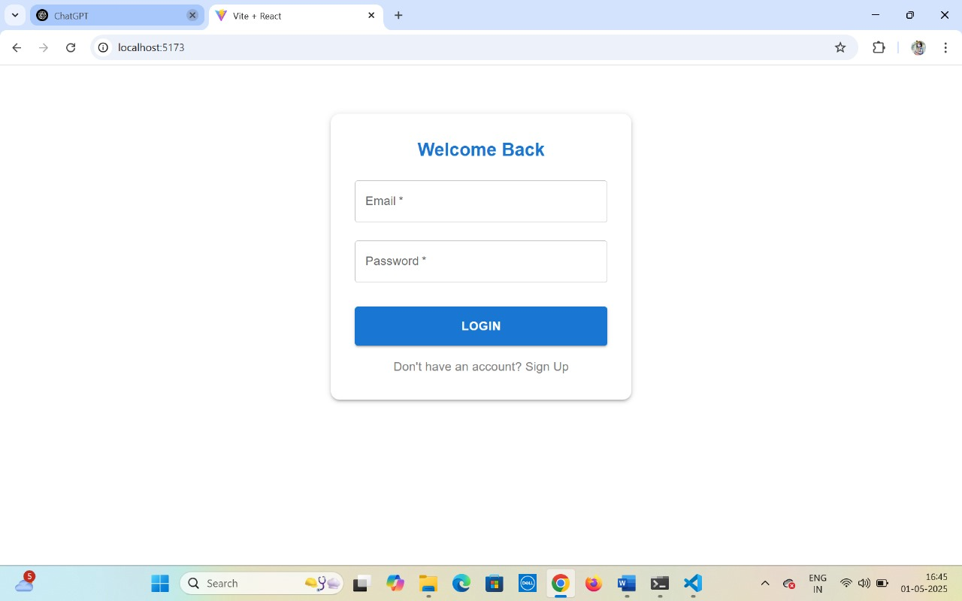

**Fields and Components:**

|  |  |  |
| --- | --- | --- |
| **Field/Component** | **Type** | **Description** |
| Email | Input Field | Accepts the user's email address for authentication. |
| Password | Input Field | Accepts the user's password for authentication. |
| Login | Button | Submits the entered credentials to the system for verification. |
| "Don't have an account? Sign Up" | Link | Redirects the user to the registration page if they do not have an existing account. |

**Functionality Overview:**

* The login form is displayed in the center of the page for clarity and accessibility.
* The system validates the credentials upon clicking the **Login** button.
* If the user does not have an account, they can navigate to the sign-up page using the **Sign Up** link.
* After successful login, the user is redirected to the appropriate dashboard based on their assigned role:
  + **Employee**: Access to apply for budgets and view their status.
  + **Manager**: Access to review and act on pending budget requests.
  + **Admin**: Access to view and manage all budget requests in the system.

**Submit a Budget Request Interface (Employee Dashboard)**

This page allows an authenticated **Employee** user to submit a new budget request within the budget management system built using **Vite + React**.

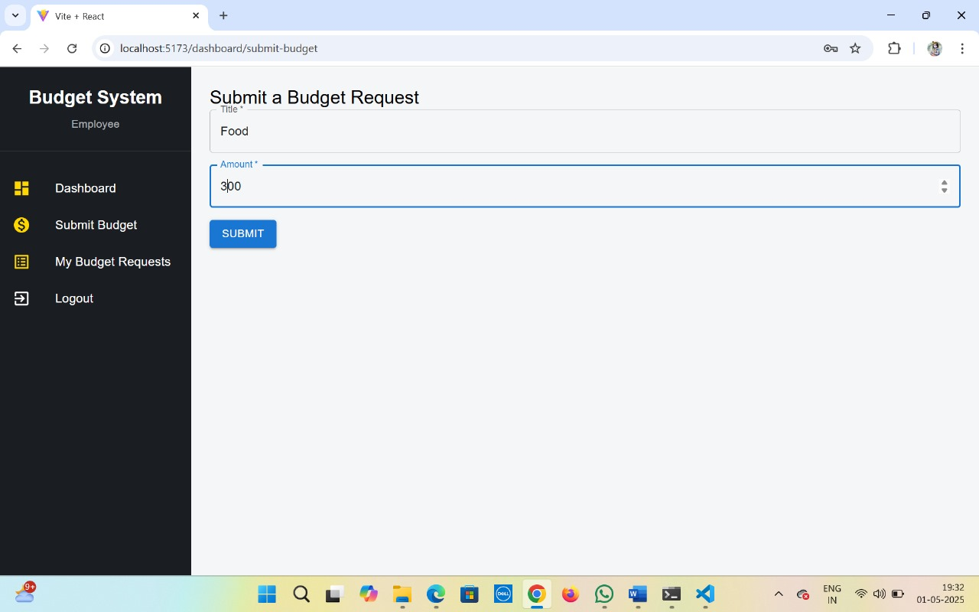

**Fields and Components:**

|  |  |  |
| --- | --- | --- |
| **Field/Component** | **Type** | **Description** |
| **Title** | Input Field | Allows the user to specify the purpose of the budget (e.g., Food, Travel). |
| **Amount** | Input Field (number) | Allows the user to enter the amount requested for the specified purpose. |
| **Submit** | Button | Sends the budget request to the system for processing and saving. |

**Functionality Overview:**

* This form is part of the **Employee Dashboard** layout.
* Users can enter a **budget title** and a **requested amount**.
* Upon clicking the **Submit** button:
  + The data is validated (e.g., amount is a positive number).
  + The request is submitted to the backend.
  + Feedback (success/failure) is shown to the user.
* The sidebar allows navigation to:
  + **Dashboard** (Home view for employees)
  + **Submit Budget** (Current page)
  + **My Budget Requests** (History of submitted requests)
  + **Logout** (To end the session)

**My Budget Requests Interface (Employee View)**

This screen allows **Employee** users to view the status of their submitted budget requests.

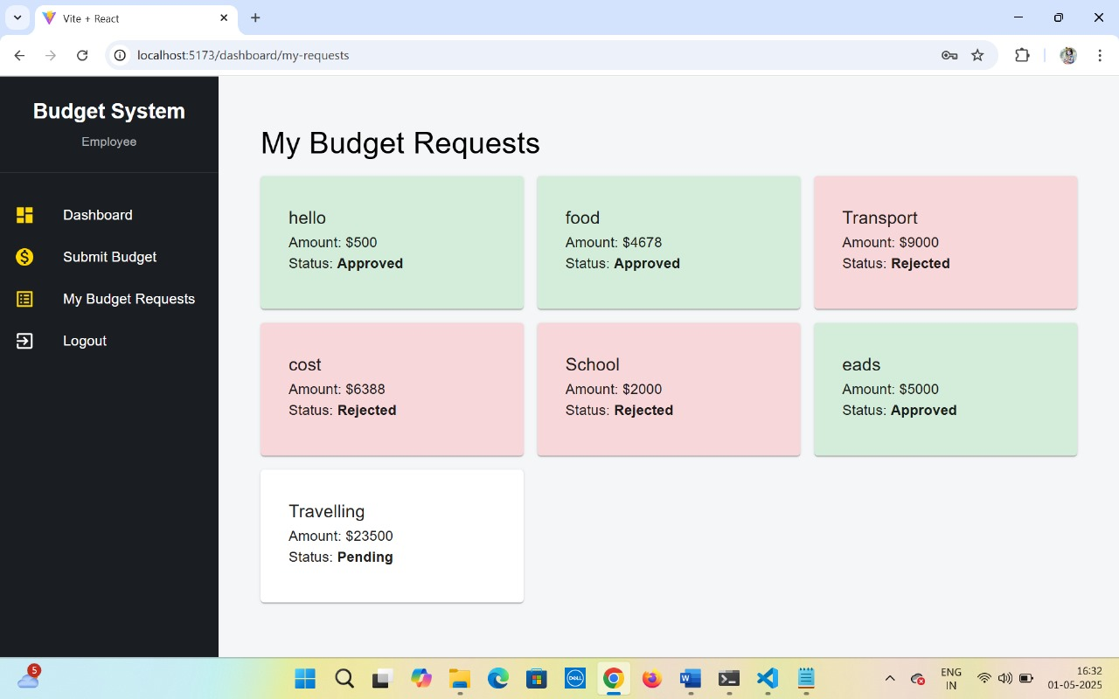

**Fields and Components:**

|  |  |  |
| --- | --- | --- |
| **Field/Component** | **Type** | **Description** |
| Request Cards | Display Box | Each card represents a submitted request with details like title, amount, and status. |
| Status Indicator | Text + Color | Status is displayed in color-coded format:  ✅ Green = Approved, ❌ Red = Rejected, ⏳ White = Pending. |
| Sidebar Menu | Navigation | Provides navigation to **Dashboard**, **Submit Budget**, **My Budget Requests**, and **Logout**. |

**Functionality Overview:**

* Lists all budget requests made by the logged-in employee.
* Each request card contains:
  + **Title** of the request.
  + **Amount** submitted.
  + **Status** (Approved, Rejected, or Pending) with color cues:
    - **Green** for Approved
    - **Red** for Rejected
    - **Neutral (White/Gray)** for Pending
* Cards are dynamically styled based on status for easy visual identification.

**Manage Budget Requests Interface (Admin View)**

This interface enables **Admin** users to review and take action on all submitted budget requests.

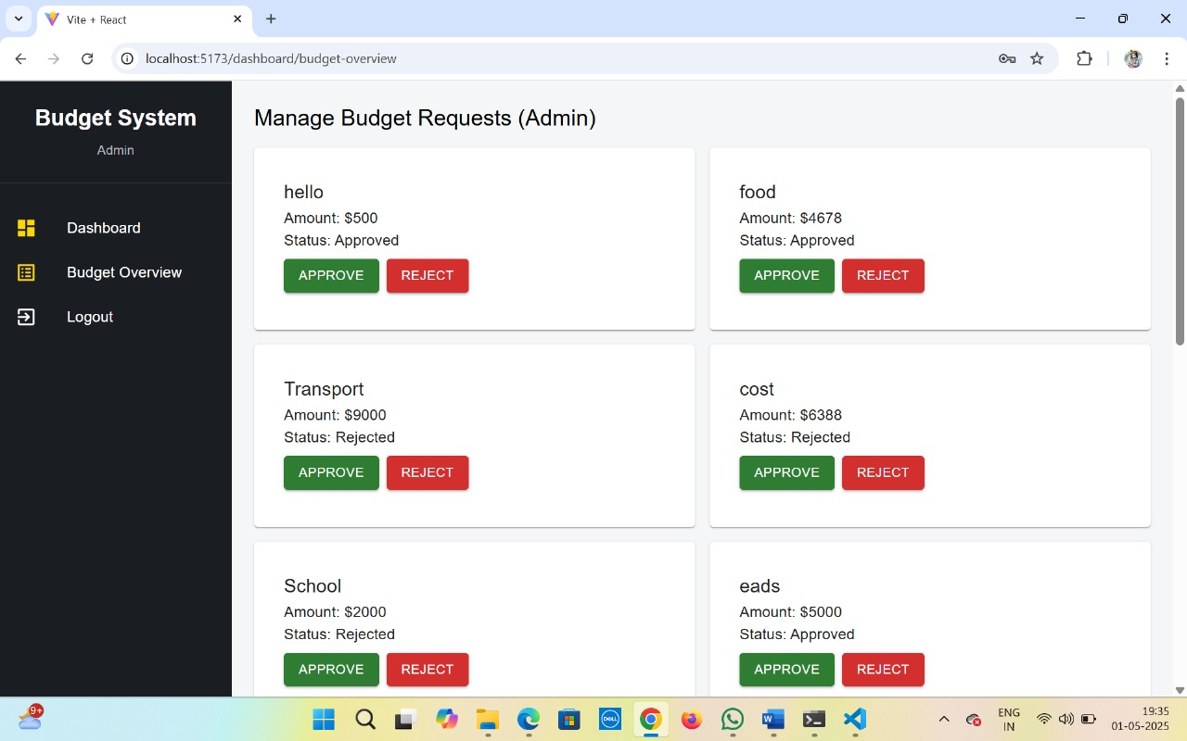

**Fields and Components:**

|  |  |  |
| --- | --- | --- |
| **Field/Component** | **Type** | **Description** |
| Request Cards | Display Box | Displays each request’s title, amount, and current status. |
| Approve Button | Action Button (Green) | Marks a request as **Approved**. |
| Reject Button | Action Button (Red) | Marks a request as **Rejected**. |
| Sidebar Menu | Navigation | Allows navigation to **Dashboard**, **Budget Overview**, and **Logout**. |

**Functionality Overview:**

* Admins can **approve** or **reject** budget requests.
* Each card includes:
  + Request **Title**
  + **Amount**
  + **Current Status**
  + **Action Buttons** for **APPROVE** (green) and **REJECT** (red)
* Changes are typically reflected in real-time and update the respective employee’s view.

**Manage Budget Requests Interface (Manager View)**

This screen is designed for **Manager** users to view and take action on employee budget requests.

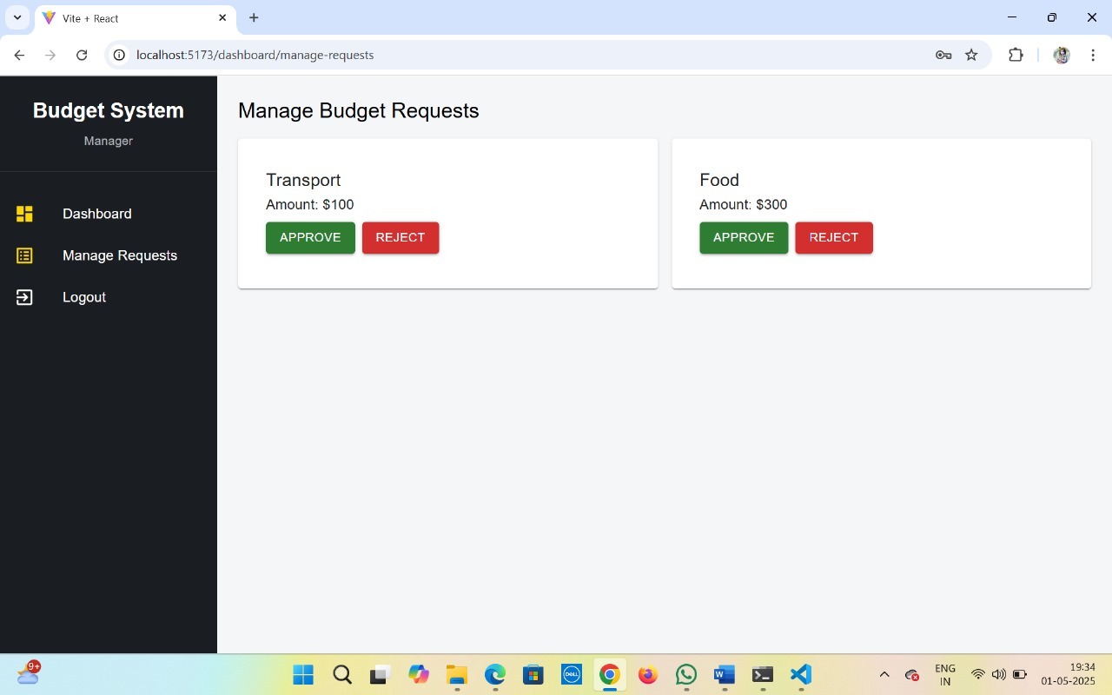

**Fields and Components:**

|  |  |  |
| --- | --- | --- |
| **Field/Component** | **Type** | **Description** |
| Request Cards | Display Box | Displays individual budget requests with relevant details. |
| Approve Button | Action Button (Green) | Used to approve the budget request. |
| Reject Button | Action Button (Red) | Used to reject the budget request. |
| Sidebar Menu | Navigation | Contains links to **Dashboard**, **Manage Requests**, and **Logout**. |

**Functionality Overview:**

* Shows a list of budget requests submitted by employees that are pending managerial approval.
* Each request card displays:
  + **Title/Label** (e.g., "Transport", "Food")
  + **Amount Requested**
  + **Approve/Reject** buttons to take action
* Once actioned, the status of the request will be updated accordingly in the system (typically reflected in both the employee and admin views).