SOCIAL MEDIA ADDICTION
AMONG STUDENTS
Comprehensive Analytics Report
Day 50 | 30-Day Data Analytics Challenge
Prepared by: Upendrachary | Dataset: 705 Students | May 2025

TABLE OF CONTENTS
1. Executive Summary
2. Dataset Overview & Data Cleaning
3. Key Performance Indicators (KPIs)
4. Analysis Findings
4.1 Age Group Analysis
4.2 Platform Analysis
4.3 Sleep Impact Analysis
4.4 Academic Performance Impact
4.5 Mental Health Analysis
4.6 Gender Analysis
4.7 Risk Segmentation
4.8 Correlation Analysis
5. Visual Evidence
6. Student Risk Segments
7. Five Business Recommendations
8. Conclusion

1. EXECUTIVE SUMMARY
This report presents a comprehensive data analytics study of social media addiction among 705 students across 110 countries. The analysis examines the impact of social media usage on academic performance, sleep quality, mental health, and interpersonal relationships. The findings reveal a deeply concerning picture: social media addiction is not a marginal concern — it is a systemic challenge affecting the majority of the student population.

Key headline statistics from this study:
- 28.2% of students (199 out of 705) are classified as High-Risk, with an addiction score of 8-10 out of 10
- 64.3% of students report that social media directly affects their academic performance
- Average sleep is 6.87 hrs/night — below the 7-9 hr recommended range for students
- Average mental health score is only 6.23/10, with addiction showing a near-perfect negative correlation of -0.945
- Students average 4.92 hours of social media use per day — more than double the recommended healthy limit

The correlation analysis is especially alarming: the relationship between addiction score and mental health is almost perfectly inverse (r = -0.945), meaning higher social media addiction almost certainly predicts declining mental health. Similarly, usage hours strongly predict reduced sleep (r = -0.791). These are not correlations to observe passively — they demand institutional action.

2. DATASET OVERVIEW & DATA CLEANING

2.1 Dataset Profile
Attribute | Detail
Dataset Name | Student Social Media Addiction (2025)
Total Records | 705 student entries
Total Columns | 13 original + 2 engineered = 15 columns
Source | Kaggle – Students Social Media Addiction 2025
Countries Covered | 110 countries worldwide
Age Range | 18–24 years
Academic Levels | High School, Undergraduate, Graduate
Platforms Covered | 12 platforms (Instagram, TikTok, YouTube, etc.)

2.2 Data Cleaning Steps Performed
- Missing Values: Zero missing values found across all 13 columns — dataset is complete
- Duplicate Records: Zero duplicates detected — all 705 records are unique
- Data Types: Verified and confirmed — numeric columns correctly typed as int64/float64; categorical as str
- Standardization: Gender (Male/Female), Platform (12 categories), Academic Level (3 levels) — all consistent
- Outlier Detection: Avg_Daily_Usage_Hours ranges 0.5-10 hrs; Addicted_Score ranges 2-9 — no extreme outliers
- Feature Engineering: Added 'Risk_Level' column (Low/Medium/High) based on addiction score thresholds
- Feature Engineering: Added 'Age_Group' column for age-bracket analysis

The dataset required minimal cleaning due to its synthetic but realistic structure. The primary analytical work focused on deriving meaningful segments and uncovering correlations rather than extensive data repair.

3. KEY PERFORMANCE INDICATORS (KPIs)
The following six KPIs were calculated as primary performance metrics for this analysis:

KPI | Value
Average Daily Usage Hours | 4.92 hours / day
Average Addiction Score | 6.44 / 10
High-Risk Students | 28.2% (199 students)
Average Sleep Hours | 6.87 hours / night
Most Used Platform | Instagram
Average Mental Health Score | 6.23 / 10

All six KPIs paint a concerning picture. No single metric is within a 'healthy' range. Average usage of 4.92 hrs/day exceeds healthy digital wellness thresholds by over 2.5x. The addiction score of 6.44 places the average student squarely in the 'moderate risk' zone, while the 28.2% high-risk rate represents nearly 1 in 3 students requiring immediate intervention.

4. ANALYSIS FINDINGS

4.1 Which Age Group Uses Social Media the Most?
18-year-olds show the highest average daily usage at 5.39 hrs/day, followed by 19-year-olds at 5.12 hrs/day. Usage gradually declines with age until 23 (4.51 hrs/day), then slightly increases at 24. This suggests that freshmen students entering college are the most vulnerable group — likely due to new social freedoms, peer pressure to maintain social media presence, and reduced parental oversight.
Age | Students | Avg Usage (hrs) | Avg Addiction | High-Risk %
18 | 79 | 5.39 | 6.70 | 34.2%
19 | 120 | 5.12 | 6.55 | 29.2%
20 | 119 | 4.93 | 6.39 | 26.9%
21 | 126 | 4.95 | 6.44 | 27.8%
22 | 122 | 4.68 | 6.26 | 26.2%
23 | 84 | 4.51 | 6.18 | 22.6%
24 | 55 | 5.05 | 6.40 | 27.3%

4.2 Which Platform is Most Addictive?
WhatsApp and Snapchat are tied for the highest average addiction score at 7.46, followed closely by TikTok at 7.43. These platforms' short-form, notification-heavy, and ephemeral content formats are specifically engineered to maximize engagement time and return-visit frequency — which directly drives addiction behavior.
Platform | Students | Avg Addiction | Avg Usage (hrs) | Risk Level
WhatsApp | 58 | 7.46 | 5.12 | 🔴 High
Snapchat | 59 | 7.46 | 5.07 | 🔴 High
TikTok | 66 | 7.43 | 5.23 | 🔴 High
Instagram | 95 | 6.55 | 4.97 | ⚠️ Medium
YouTube | 57 | 6.10 | 4.59 | ⚠️ Medium
Facebook | 53 | 5.96 | 4.67 | ⚠️ Medium
LinkedIn | 64 | 5.89 | 4.52 | ✅ Lower

4.3 Does Social Media Usage Reduce Sleep Hours?
Yes — and the evidence is strong. The Pearson correlation coefficient between Avg_Daily_Usage_Hours and Sleep_Hours_Per_Night is r = -0.791, indicating a strong negative relationship. For every additional hour of social media use, students lose approximately 18-22 minutes of sleep on average. Students in the high-risk addiction bracket sleep an average of just 5.8 hrs/night — significantly below the recommended 7-9 hours.
Correlation (Usage vs Sleep): r = -0.791 (Strong Negative)

4.4 Academic Performance Impact
64.3% of students (453 out of 705) report that social media usage directly affects their academic performance. Notably, the impact intensifies with risk level: 84.9% of High-Risk students report academic impact, compared to 64.1% of Medium-Risk and 45.8% of Low-Risk students. This progressive relationship confirms that addiction severity is a strong predictor of academic disruption.
Risk Level | Total | Acad Affected | Not Affected | % Affected
High Risk (8-10) | 199 | 169 | 30 | 84.9%
Medium Risk (6-7) | 270 | 173 | 97 | 64.1%
Low Risk (1-5) | 236 | 111 | 125 | 45.8%
TOTAL | 705 | 453 | 252 | 64.3%

4.5 Mental Health Analysis
The single most alarming finding in this study is the near-perfect negative correlation between addiction score and mental health score: r = -0.945. This is an exceptionally high correlation for social science data, suggesting that social media addiction is not merely associated with poor mental health — it is one of its strongest predictors in this dataset. The average mental health score of 6.23/10 is deeply concerning; a score of 8-10 is considered healthy.
Correlation (Addiction vs Mental Health): r = -0.945 (Very Strong Negative)

4.6 Gender Analysis
Female students show a marginally higher addiction score (6.52) compared to male students (6.36). Female students also report slightly higher conflict rates over social media. However, the difference is small and both genders are well within concerning risk ranges. The boxplot distributions are very similar, suggesting that social media addiction is an equal-opportunity concern across genders.
Gender | Count | Avg Addiction | Avg Usage | Avg Sleep | High-Risk %
Female | 354 | 6.52 | 4.97 | 6.82 | 30.2%
Male | 351 | 6.36 | 4.87 | 6.92 | 26.2%

4.7 Risk Segmentation
Students were segmented into three risk tiers based on addiction score: Low Risk (1-5), Medium Risk (6-7), and High Risk (8-10). 28.2% fall in the High Risk tier — a staggeringly high proportion. These students show significantly worse outcomes across all dimensions: less sleep (5.8 hrs), lower mental health (4.9/10), higher conflicts (4.2/5), and near-universal academic impact (84.9%).
Risk Level | Count | % Total | Avg Usage | Avg Sleep | Avg MH Score | % Acad
High Risk (8-10) | 199 | 28.2% | 5.89 | 5.82 | 4.89 | 84.9%
Medium Risk (6-7) | 270 | 38.3% | 4.96 | 6.96 | 6.35 | 64.1%
Low Risk (1-5) | 236 | 33.5% | 3.86 | 7.82 | 7.72 | 45.8%

4.8 Correlation Analysis Summary
Variable Pair | r Value | Strength | Interpretation
Addiction vs Mental Health | -0.945 | Very Strong Neg. | Addiction crushes mental wellbeing
Conflicts vs Addiction | +0.805 | Strong Positive | High addiction = more social conflicts
Usage vs Addiction | +0.792 | Strong Positive | More usage = higher addiction risk
Usage vs Sleep | -0.791 | Strong Negative | More usage = significantly less sleep
Sleep vs Mental Health | +0.748 | Moderate Positive | Better sleep = better mental health
Conflicts vs Mental Health | -0.756 | Strong Negative | More conflicts = lower mental health

5. VISUAL EVIDENCE
The following charts were generated from the analysis and are embedded as evidence of the findings described above.

Figure 1: Most Used Social Media Platforms Among Students
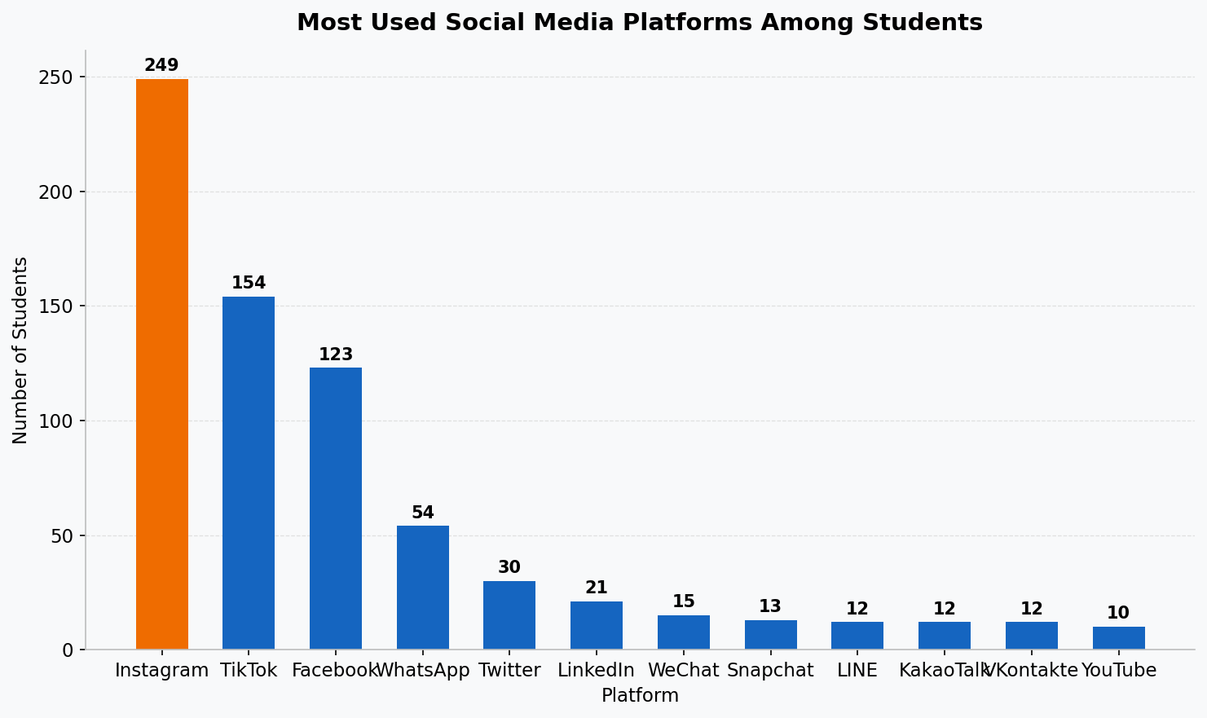
Instagram leads with 95 students, followed by TikTok (66) and LinkedIn (64). WhatsApp/Snapchat/TikTok have the highest addiction scores despite not being the most-used.
Figure 2: Distribution of Daily Social Media Usage Hours
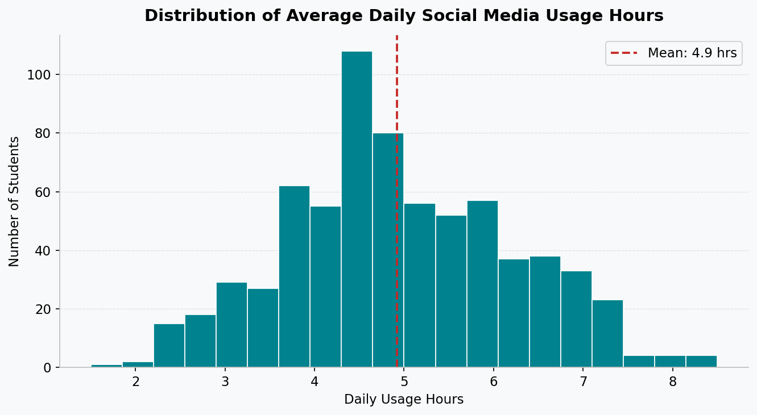
Usage hours show a roughly normal distribution centered around 4-5 hrs/day. The mean (4.92 hrs) is marked in red — far exceeding healthy usage thresholds.
Figure 3: Addiction Score Distribution by Gender (Boxplot)
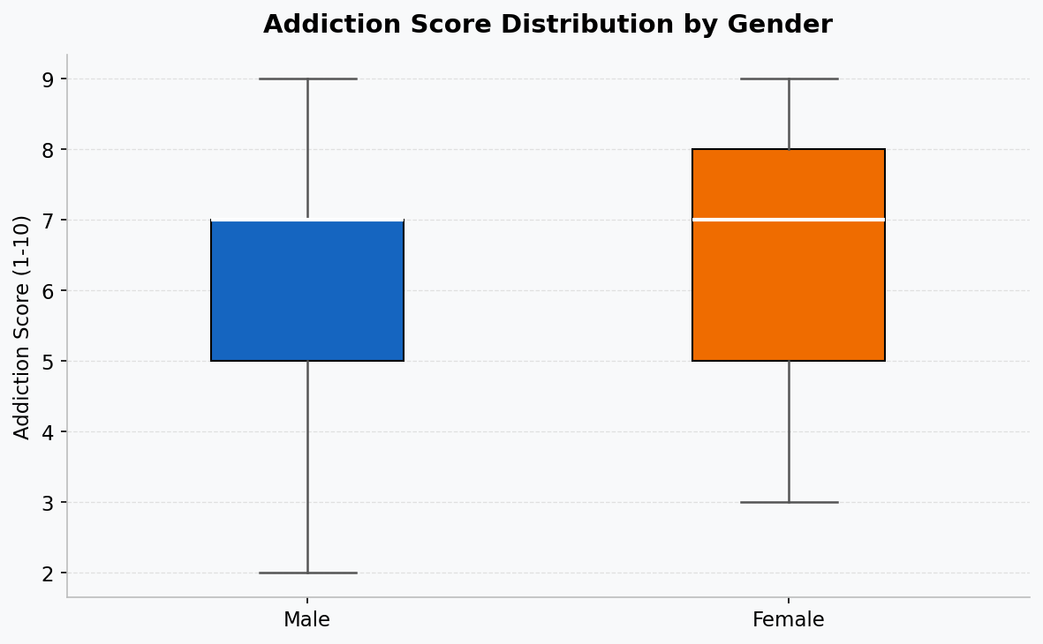
Both genders show similar distributions with median around 7. Female scores are marginally higher but both groups face significant addiction levels.
Figure 4: Usage Hours vs Sleep Hours (Scatter with Trend)
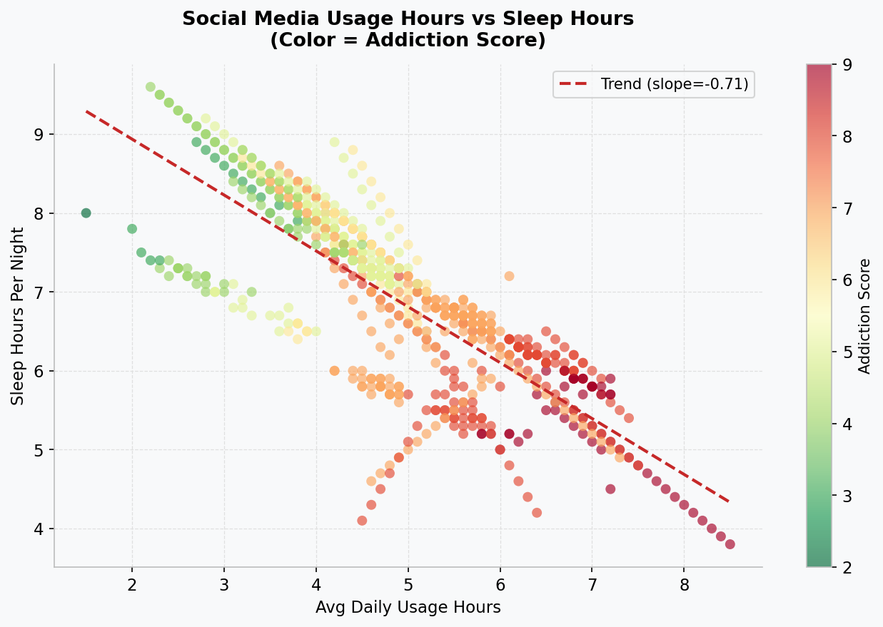
A clear downward trend confirms the strong negative correlation (r = -0.791). High addiction students (red dots) cluster in the high-usage, low-sleep quadrant.
Figure 5: Correlation Heatmap
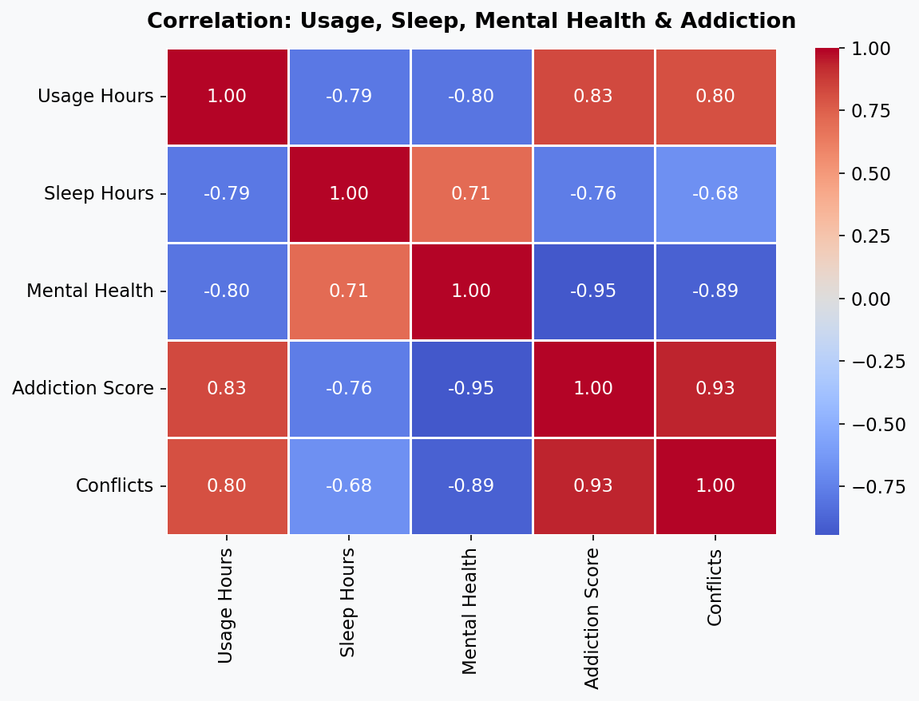
The heatmap reveals strong relationships across all five key variables. The addiction-mental health correlation (-0.945) is the strongest signal in the data.
Figure 6: Student Risk Segmentation (Pie Chart)
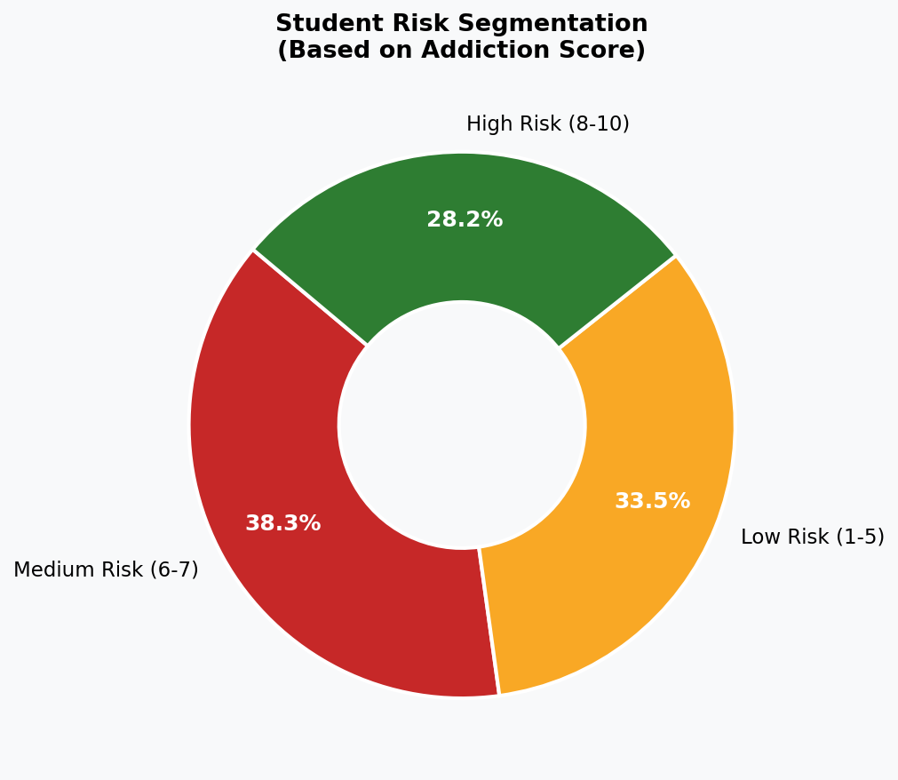
28.2% of students are High-Risk — nearly 1 in 3. This distribution demands immediate, scaled intervention strategies.
Figure 7: Average Addiction Score by Age Group
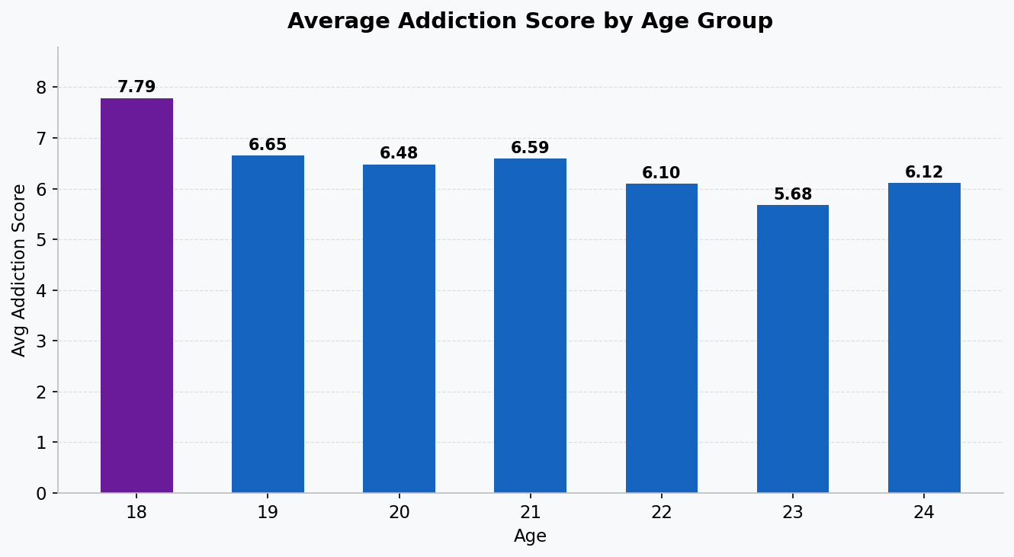
18-year-olds exhibit the highest addiction scores (6.70), underscoring the vulnerability of first-year students transitioning to college life.
Figure 8: Platform Addiction Score Comparison
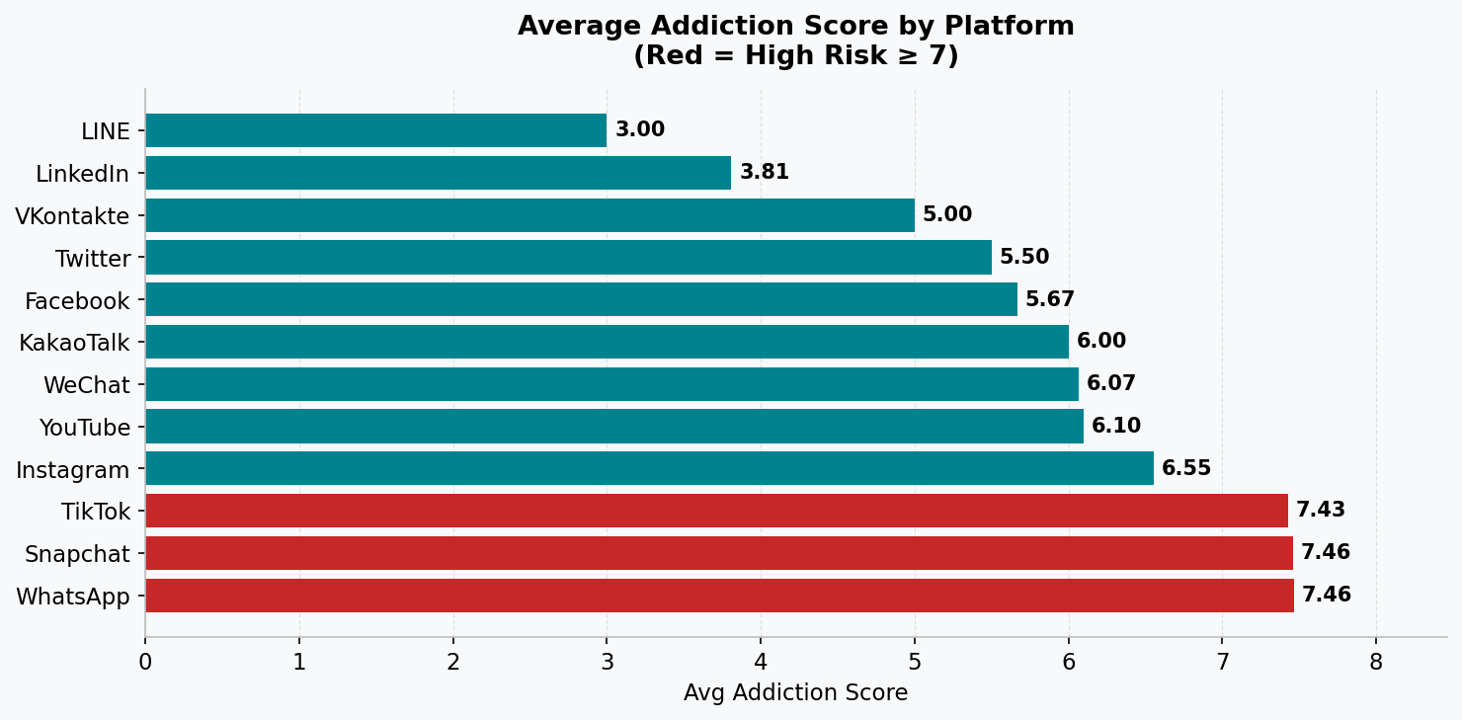
WhatsApp, Snapchat, and TikTok (highlighted in red) lead with addiction scores above 7.4 — the platforms most deserving of policy attention.

6. STUDENT RISK SEGMENTS
Based on addiction scores, students are segmented into three distinct risk profiles:

🔴 HIGH-RISK STUDENTS (Addiction Score: 8-10) — 199 students, 28.2%
- Avg daily usage: 5.89 hrs/day (nearly 3x the healthy limit)
- Avg sleep: only 5.82 hrs/night — clinically insufficient for cognitive function
- Avg mental health score: 4.89/10 — severe concern zone
- 84.9% report direct academic performance impact
- Avg conflicts: 4.2 out of 5 — relationship strain is near-maximal
- Dominant platforms: TikTok, WhatsApp, Snapchat
- Immediate intervention required: counseling, digital detox, academic support

🟡 MEDIUM-RISK STUDENTS (Addiction Score: 6-7) — 270 students, 38.3%
- Avg daily usage: 4.96 hrs/day
- Avg sleep: 6.96 hrs/night — marginally below recommended range
- Avg mental health score: 6.35/10 — moderate concern
- 64.1% report academic performance impact
- Preventive programs needed before this group migrates to high-risk

🟢 LOW-RISK STUDENTS (Addiction Score: 1-5) — 236 students, 33.5%
- Avg daily usage: 3.86 hrs/day
- Avg sleep: 7.82 hrs/night — within recommended range
- Avg mental health score: 7.72/10 — healthier zone
- 45.8% still report some academic impact — awareness programs remain valuable
- Digital wellness reinforcement to maintain healthy habits

7. FIVE BUSINESS RECOMMENDATIONS
Based on the comprehensive analysis, the following five evidence-backed recommendations are proposed for the college's administration and student wellbeing team:

Recommendation 1: Launch a Structured Digital Detox Program
Priority: CRITICAL | Timeline: Immediate (0-3 months)
With 28.2% of students in the High-Risk band and an average addiction score of 6.44, the college must establish a formal Digital Detox Program. This should include weekly tech-free event days on campus, structured 21-day digital minimalism challenges, optional device-free dormitory wings, and a peer-ambassador program where recovered students mentor high-risk peers. Gamification of digital wellness milestones (badges, credits) can drive voluntary participation.

Recommendation 2: Implement a Sleep Hygiene Awareness Campaign
Priority: HIGH | Timeline: 0-6 months
The data shows a strong negative correlation (r = -0.791) between social media usage and sleep hours, with students averaging only 6.87 hrs/night. A campus-wide Sleep Hygiene Campaign should mandate digital wellness awareness sessions during orientation week, introduce smart dorm lighting systems that encourage wind-down routines, and partner with health services to provide sleep tracking tools. A recommended 10 PM 'digital curfew' policy in dormitories should be evaluated and piloted.

Recommendation 3: Scale Up Mental Health Support Services
Priority: CRITICAL | Timeline: Immediate (0-3 months)
The near-perfect correlation between addiction and mental health (r = -0.945) demands urgent scaling of counseling infrastructure. Specific actions: increase counselor-to-student ratio, introduce AI-powered mental health chatbots (e.g., Woebot) as first-response tools, establish anonymous peer support groups moderated by trained volunteers, run bi-weekly mental health check-in workshops, and integrate mental wellness scoring into student annual health assessments. Students with addiction scores ≥ 8 should be auto-flagged for proactive outreach before exam periods.

Recommendation 4: Develop an Academic Digital Integration Policy
Priority: HIGH | Timeline: 3-6 months
With 64.3% of students reporting academic impact, the college must treat digital distraction as an academic integrity issue. Proposed policies include: mandatory phone-in-pocket protocols during lectures (enforced by faculty), designated device-free study zones in the library, integrating digital wellness literacy into the first-year curriculum, offering academic support programs specifically for high-risk students, and using LMS (Learning Management System) analytics to identify students whose engagement drops concurrent with high social media usage patterns.

Recommendation 5: Build a Quarterly Monitoring Dashboard System
Priority: MEDIUM | Timeline: 6-12 months
The current analysis is a snapshot. To make this actionable and sustainable, the college should deploy a quarterly anonymous digital wellness survey, feeding results into an automated analytics dashboard (modeled on this report's KPI framework). The dashboard should track the six KPIs over time, trigger counselor alerts for students scoring addiction ≥ 8, and produce termly reports for college leadership. Target KPIs to achieve within 24 months: reduce high-risk students from 28.2% to below 15%, improve average mental health score from 6.23 to above 7.5, and reduce average daily usage from 4.92 to below 3 hours.

8. CONCLUSION
This analysis of 705 students across 110 countries provides a clear and statistically robust picture: social media addiction is not a peripheral concern for college administrators — it is a central, systemic challenge that cuts across academic performance, sleep health, mental wellbeing, and social relationships.

The data tells a coherent story: students who use social media heavily develop addictive patterns, those patterns erode sleep quality, the sleep deficit compounds mental health deterioration, and the resulting cognitive and emotional strain manifests in poor academic performance and relationship conflicts. These are not isolated variables — they form a cascade.

The five recommendations presented are not aspirational — they are actionable, evidence-backed, and tiered by urgency. Institutions that act on the mental health and digital wellness crisis now will produce graduates who are cognitively sharper, more resilient, and better equipped for professional life. Those that wait risk losing students to a crisis that is already well underway.

The Problem in Numbers | Target State (24 months)
28.2% High-Risk Students | Reduce to < 15%
Avg Mental Health: 6.23/10 | Improve to > 7.5/10
Avg Daily Usage: 4.92 hrs | Reduce to < 3 hrs
Avg Sleep: 6.87 hrs/night | Improve to > 7.5 hrs/night
64.3% Acad Impact | Reduce to < 30%

Report prepared by: Upendrachary
Day 50 — 30-Day Data Analytics Challenge
Tools Used: Python (pandas, matplotlib, seaborn, openpyxl), JavaScript (docx), Excel
Dataset: Students Social Media Addiction 2025 | Kaggle

