Assignment 1:-

**Q:- What is SDLC:-**

**A:-** The Software Development Life Cycle (SDLC) is a structured process that enables the production of high-quality, low-cost software, in the shortest possible production time. The goal of the SDLC is to produce superior software that meets and exceeds all customer expectations and demands. The SDLC defines and outlines a detailed plan with stages, or phases, that each encompass their own process and deliverables. Adherence to the SDLC enhances development speed and minimizes project risks and costs associated with alternative methods of production.

**Q:- What is agile methodology?**

**A:-** The Agile methodology is a way to manage a project by breaking it up into several phases. It involves constant collaboration with stakeholders and continuous improvement at every stage. Once the work begins, teams cycle through a process of planning, executing, and evaluating. Continuous collaboration is vital, both with team members and project stakeholders.

**Q:- What is SRS**

**A:-** A software requirements specification (SRS) is a document that describes what the software will do and how it will be expected to perform. It also describes the functionality the product needs to fulfil all stakeholders (business, users) needs.

A software requirements specification (SRS) is a document that captures complete description about how the system is expected to perform. It is usually signed off at the end of requirements engineering phase.

**Q:- What is oops**

**A:-** Object-oriented programming (OOP) is a style of programming characterized by the identification of classes of objects closely linked with the methods (functions) with which they are associated. It also includes ideas of inheritance of attributes and methods.

**Q:- Write Basic Concepts of oops**

**A:-** Object oriented programming is a type of programming which uses objects and classes its functioning. The object oriented programming is based on real world entities like inheritance, polymorphism, data hiding, etc. It aims at binding together data and function work on these data sets into a single entity to restrict their usage.

Some basic concepts of object oriented programming are:-

* CLASS
* OBJECTS
* ENCAPSULATION
* POLYMORPHISM
* INHERITANCE
* ABSTRACTION

**Q:- What is object**

**A:-** An object is an instance of a class. It is an entity with characteristics and behaviour that are used in the object oriented programming. An object is the entity that is created to allocate memory. A class when defined does not have memory chunk itself which will be allocated as soon as objects are created.

**Q:- What is class**

**A:-** A class is a data-type that has its own members i.e. data members and member functions. It is the blueprint for an object in object oriented programming language. It is the basic building block of object oriented programming. The members of a class are accessed in programming language by creating an instance of the class.

**Q:- What is encapsulation**

**A:-** **Encapsulation** In object oriented programming, encapsulation is the concept of wrapping together of data and information in a single unit. A formal definition of encapsulation would be: encapsulation is binding together the data and related function that can manipulate the data.

Due to the concept of encapsulation in object oriented programming another very important concept is possible, it is data abstraction or Data Hiding. it is possible as encapsulating hides the data at show only the information that is required to be displayed.

**Q:- What is inheritance**

**A:-** it is the capability of a class to inherit or derive properties or characteristics other class. it is very important and object oriented program as it allows reusability i.e. using a method defined in another class by using inheritance. The class that derives properties from other class is known as child class or subclass and the class from which the properties are inherited is base class or parent class.

**Q:- What is polymorphism**

**A:-** The name defines polymorphism is multiple forms. which means polymorphism is the ability of object oriented programming to do some work using multiple forms. The behaviour of the method is dependent on the type or the situation in which the method is called.

**Q:- What is RDBMS**

**A:-** The software used to store, manage, query, and retrieve data stored in a relational database is called a relational database management system (RDBMS). The RDBMS provides an interface between users and applications and the database, as well as administrative functions for managing data storage, access, and performance.

**Q:- What is SQL**

**A:-** SQL is Structured Query Language, which is a computer language for storing, manipulating and retrieving data stored in a relational database.

SQL is the standard language for Relational Database System. All the Relational Database Management Systems (RDMS) like MySQL, MS Access, Oracle, Sybase, Informix, Postgres and SQL Server use SQL as their standard database language.

**Q:- Write SQL Commands**

**A:-** The standard SQL commands to interact with relational databases are CREATE, SELECT, INSERT, UPDATE, DELETE and DROP. These commands can be classified into the following groups based on their nature –

### 1) DDL - Data Definition Language

**CREATE:-**Creates a new table, a view of a table, or other object in the database.

**ALTER:-** Modifies an existing database object, such as a table.

**DROP:-** Deletes an entire table, a view of a table or other objects in the database.

### 2) DML - Data Manipulation Language

**SELECT:-** Retrieves certain records from one or more tables.

**INSERT:-** Creates a record.

**UPDATE:-** Modifies records.

**DELETE:-** Deletes records.

### 3) DCL - Data Control Language

**GRANT:-** Gives a privilege to user.

**REVOKE:-** Takes back privileges granted from user.

**Q:- Draw Use case on Online book shopping**

**A:-**

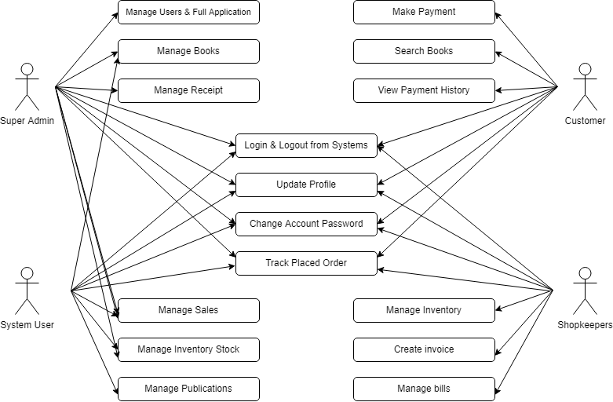

**Q:- Draw Use case on online bill payment system (paytm)**

**A:-**

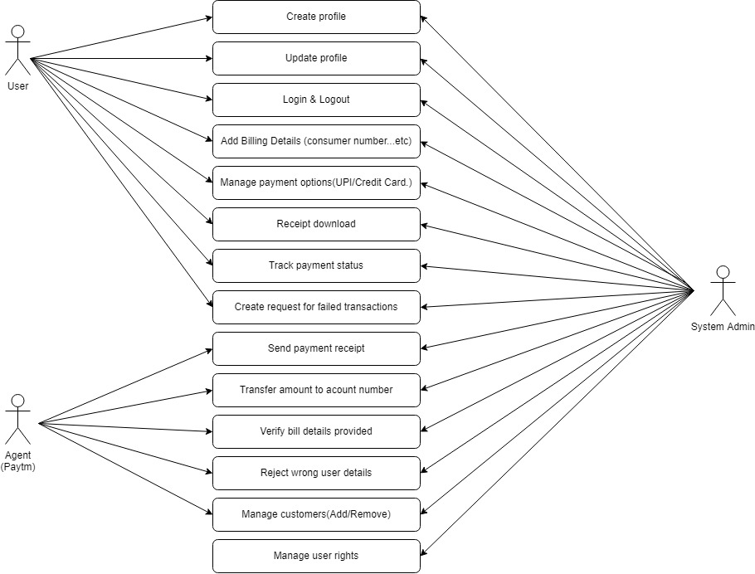

**Q:- Write SDLC phases with basic introduction**

**A:-**

1. **Planning :-**

It helps to define the problem and scope of any existing systems, as well as determine the objectives for their new systems.

By developing an effective outline for the upcoming development cycle, they'll theoretically catch problems before they affect development.

1. **Requirement Analysis (Feasibility Analysis)**

The analysis stage includes gathering all the specific details required for a new system as well as determining the first ideas for prototypes. SRS will be created in this stage.

1. **Designing (Prototyping)**

Developers will first outline the details for the overall application, alongside specific aspects, such as its:

* User interfaces
* System interfaces
* Network and network requirements
* Databases

1. **Build (Development)**

The development stage is the part where developers actually write code and build the application according to the earlier design documents and outlined specifications.

Programming languages can include staples such as C++, PHP, and more. Developers will choose the right programming code to use based on the project specifications and requirements.

1. **Testing (QA)**

It’s important that the software overall ends up meeting the quality standards that were previously defined in the SRS document.

1. **Deploy (Implementation & Integration)**

After testing, the overall design for the software will come together. Different modules or designs will be integrated into the primary source code through developer efforts, usually by leveraging training environments to detect further errors or defects.

The information system will be integrated into its environment and eventually installed. After passing this stage, the software is theoretically ready for market and may be provided to any end-users.

1. **Maintenance**

Furthermore, developers are responsible for implementing any changes that the software might need after deployment.

This can include handling residual bugs that were not able to be patched before launch or resolving new issues that crop up due to user reports. Larger systems may require longer maintenance stages compared to smaller systems.

**Q:- Explain Phases of the waterfall model**

**A:-**

* **Requirement Gathering and analysis** − All possible requirements of the system to be developed are captured in this phase and documented in a requirement specification document.
* **System Design** − The requirement specifications from first phase are studied in this phase and the system design is prepared. This system design helps in specifying hardware and system requirements and helps in defining the overall system architecture.
* **Implementation** − With inputs from the system design, the system is first developed in small programs called units, which are integrated in the next phase. Each unit is developed and tested for its functionality, which is referred to as Unit Testing.
* **Integration and Testing** − All the units developed in the implementation phase are integrated into a system after testing of each unit. Post integration the entire system is tested for any faults and failures.
* **Deployment of system** − Once the functional and non-functional testing is done; the product is deployed in the customer environment or released into the market.
* **Maintenance** − There are some issues which come up in the client environment. To fix those issues, patches are released. Also to enhance the product some better versions are released. Maintenance is done to deliver these changes in the customer environment.

**Q:-Write phases of spiral model**

**A:-** Each phase of the Spiral Model is divided into four quadrants as shown in the above figure. The functions of these four quadrants are discussed below-

* **Objectives determination and identify alternative solutions:-** Requirements are gathered from the customers and the objectives are identified, elaborated, and analysed at the start of every phase. Then alternative solutions possible for the phase are proposed in this quadrant.
* **Identify and resolve Risks:-** During the second quadrant, all the possible solutions are evaluated to select the best possible solution. Then the risks associated with that solution are identified and the risks are resolved using the best possible strategy. At the end of this quadrant, the Prototype is built for the best possible solution.
* **Develop next version of the Product:-** During the third quadrant, the identified features are developed and verified through testing. At the end of the third quadrant, the next version of the software is available.
* **Review and plan for the next Phase:-** In the fourth quadrant, the Customers evaluate the so far developed version of the software. In the end, planning for the next phase is started.

**Q:-Write agile manifesto principles**

**A:-TOPIC LEFT FOR THE CLASS DISCUSSION.**

**Q:-What is join?**

**A:-** an SQL operation performed to establish a connection between two or more database tables based on matching columns, thereby creating a relationship between the tables.

**Q:-Write type of joins.**

**A:-**

Here are the different types of the JOINs in SQL:

* **(INNER) JOIN:-** Returns records that have matching values in both tables
* **LEFT (OUTER) JOIN:-** Returns all records from the left table, and the matched records from the right table
* **RIGHT (OUTER) JOIN:-** Returns all records from the right table, and the matched records from the left table
* **FULL (OUTER) JOIN:-** Returns all records when there is a match in either left or right table

**Q:-Explain working methodology of agile model and also write pros and cons.**

**A:-** The Agile methodology is a way to manage a project by breaking it up into several phases. It involves constant collaboration with stakeholders and continuous improvement at every stage. Once the work begins, teams cycle through a process of planning, executing, and evaluating. Continuous collaboration is vital, both with team members and project stakeholders.

**Q:-Draw use case on Online shopping product using COD.**

**A:-**

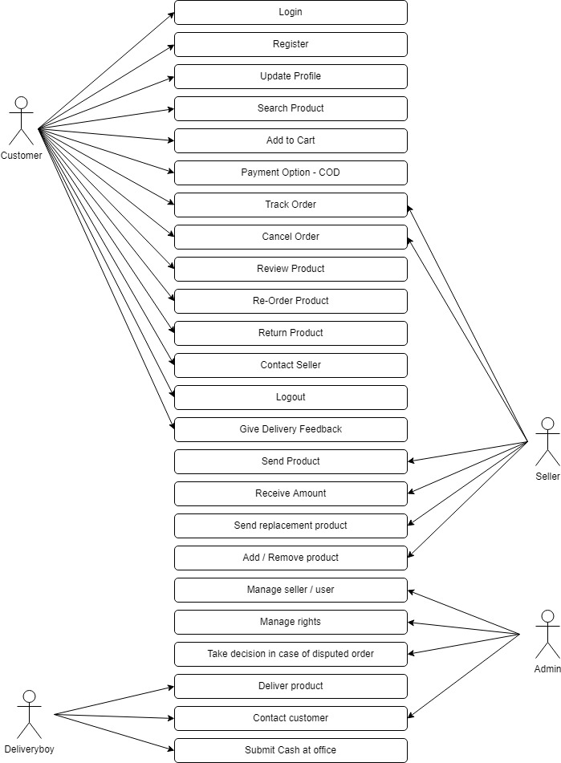

**Q:-Draw use case on Online shopping product using payment gateway.**

**A:-**  
