
LOVELY PROFESSIONAL UNIVERSITY
School of Computer Science and Engineering

PROJECT REPORT
ROUTEXAI
AI-POWERED SMART LOGISTICS & ROUTE INTELLIGENCE PLATFORM

CSE494 – Intelligent NoSQL Databases (CA-2)

Submitted by: Putluru Om Sai Nandan Reddy
Registration Number: 12304471
Section: K4E2343
Submitted to: Sandeep Kaur
Lovely Professional University, Punjab
Date: 16-10-2026

CERTIFICATE
This is to certify that the project report entitled “RouteXAI — AI-Powered Smart Logistics & Route Intelligence Platform” is submitted by Putluru Om Sai Nandan Reddy as part of the CA-2 component of CSE494 – Intelligent NoSQL Databases.
The project demonstrates the application of MongoDB database management, full-stack web development, route intelligence, shipment tracking, and logistics analytics.
To the best of my knowledge, this report represents the work completed by the students during the project period.

Signature:
Name: Putluru Om Sai Nandan Reddy
Date: 20-10-2026

DECLARATION
I hereby declare that the project report entitled “RouteXAI — AI-Powered Smart Logistics & Route Intelligence Platform” is prepared by me as part of my academic project work at Lovely Professional University.
The report describes the design, implementation, and testing of a logistics management platform developed using MongoDB, Express.js, React.js, Node.js, and supporting route intelligence and machine learning services.
I declare that the information presented in this report is based on the project implementation, development activities, and testing performed during the project. Wherever external technologies, documentation, or research materials have been used, they have been acknowledged in references.
I understand that any false declaration may result in academic consequences as per university regulations.

ACKNOWLEDGEMENT
I would like to express my sincere gratitude to Lovely Professional University for providing the academic environment and resources required to complete this project.
I am thankful to my faculty guide, Sandeep Kaur, for providing guidance, suggestions, and valuable feedback throughout the development of the RouteXAI project.
I also acknowledge the support of my department and the resources provided by the university that helped me understand the practical application of database management systems, web development, and logistics intelligence.
I would like to thank the developers and documentation teams of MongoDB, React, Node.js, Express.js, OpenRouteService, Open-Meteo, and other technologies used in the project.
Finally, I am grateful to everyone who supported me during the planning, implementation, testing, and documentation of this project

ABSTRACT
The logistics industry requires efficient shipment management, accurate delivery estimation, vehicle tracking, and timely decision-making to support reliable transportation operations. Traditional logistics management systems often depend on static route information and manual monitoring, which may result in delayed responses to changing operational conditions.
RouteXAI — AI-Powered Smart Logistics & Route Intelligence Platform is a web-based logistics management system developed to improve shipment visibility, route planning, fleet monitoring, and delivery estimation for a private logistics company operating across India.
The project follows the MERN stack architecture, using MongoDB as the primary database, Express.js and Node.js for backend services, and React.js for the frontend interface. The platform supports three major user roles: Owner, Driver, and Customer.
The Owner manages shipments, drivers, vehicles, routes, and logistics operations. Customers can create shipments, view their shipment status, and monitor delivery information. Drivers can access assigned shipments and update their operational progress.
The platform integrates several intelligence components, including route selection using OpenRouteService, weather information using Open-Meteo, machine learning-based estimated time of arrival prediction, delay-risk prediction, accessibility evaluation, and AI-assisted route recommendation.
The system also implements vehicle GPS telemetry, shipment lifecycle synchronization, live ETA recalculation, and route deviation monitoring. MongoDB stores shipment information, vehicle records, tracking data, route references, lifecycle history, and ETA snapshots.
The project was developed and tested in multiple phases. The completed lifecycle and ETA monitoring modules were verified using automated test suites and manual testing. The ETA prediction and delay-risk models were trained using synthetic logistics data, so their reported performance represents experimental results on that dataset rather than validated real-world delivery accuracy.
The project demonstrates how MongoDB and full-stack development can be combined with route intelligence and machine learning to create a centralized logistics management platform.
Keywords: MongoDB, MERN Stack, Logistics Management, Route Optimization, Shipment Tracking, ETA Prediction, Machine Learning, Fleet Management.

TABLE OF CONTENTS
Certificate 2
Declaration 3
Acknowledgement 3
Abstract 4
CHAPTER 1: INTRODUCTION 8
CHAPTER 2: PROBLEM STATEMENT 8
2.1 Existing Problems 8
2.2 Proposed Solution 9
CHAPTER 3: OBJECTIVES OF THE PROJECT 9
CHAPTER 4: SCOPE OF THE PROJECT 9
4.1 Functional Scope 9
4.2 User Roles 10
4.3 Limitations 10
CHAPTER 5: LITERATURE REVIEW 10
5.1 Database Management in Logistics 10
5.2 MongoDB and Document-Oriented Databases 10
5.3 Route Planning and Geographic Information 10
5.4 Machine Learning in Logistics 11
5.5 Research Gap and Project Contribution 11
CHAPTER 6: SYSTEM REQUIREMENTS 11
CHAPTER 7: SYSTEM DESIGN AND ARCHITECTURE 12
7.1 System Architecture 12
7.2 Architecture Diagram 12
7.3 Shipment Workflow 13
7.4 Route Selection Workflow 13
CHAPTER 8: DATABASE DESIGN 14
8.1 MongoDB Database Overview 14
8.2 Main Collections 14
8.3 Relationships Between Collections 18
CHAPTER 9: IMPLEMENTATION AND METHODOLOGY 19
9.1 Development Methodology 19
9.2 Phase 1: Foundation 20
9.3 Phase 2: Logistics and Route Intelligence 20
9.4 Phase 3A: Weather Intelligence 20
9.5 Phase 3B: Synthetic Logistics Dataset 20
9.6 Phase 3C: ETA Prediction 21
9.7 Phase 3D: Delay Risk Prediction 21
9.8 Phase 3E: Accessibility Intelligence 21
9.9 Phase 3F: AI Route Recommendation 21
9.10 Phase 3G: Owner AI Dashboard 22
9.11 Phase 4A: Live Vehicle Tracking 22
9.12 Phase 4B: Shipment Lifecycle Management 22
9.13 Phase 4C: Live ETA Recalculation and Deviation Monitoring 23
9.14 API Integration 23
CHAPTER 10: MONGODB QUERIES AND OPERATIONS 24
10.1 Insert a Shipment 24
10.2 Retrieve All Shipments 24
10.3 Find a Shipment by Tracking ID 24
10.4 Find Active Shipments 24
10.5 Update Shipment Status 25
10.6 Find Shipments Assigned to a Driver 25
10.7 Find Available Vehicles 25
10.8 Find Latest Tracking Record 25
10.9 Aggregate Shipment Status Counts 25
10.10 Search Shipments by Customer 26
10.11 Create an Index 26
10.12 MongoDB Operations Used in Project 26
CHAPTER 11: RESULTS AND OUTPUT SCREENSHOTS 27
11.1 Overview 27
11.2 Owner Dashboard 27
11.3 Route Intelligence 27
11.4 Live Vehicle Tracking 28
11.5 Shipment Lifecycle 28
11.6 Live ETA Monitoring 29
11.7 Customer Shipment Tracking 29
11.8 Driver Dashboard 30
CHAPTER 12: TESTING AND VALIDATION 31
12.1 Testing Objectives 31
12.2 Shipment Lifecycle Testing 31
12.3 ETA Monitoring Testing 31
12.4 Route Selection and ETA Synchronization 32
12.5 Machine Learning Results 32
CHAPTER 13: CHALLENGES FACED 33
13.1 Geographic Coordinate Handling 33
13.2 Route Geometry Resolution 33
13.3 Shipment Status Synchronization 33
13.4 GPS Telemetry Freshness 33
13.5 External API Dependencies 33
13.6 Synthetic Data Limitations 33
CHAPTER 14: CONCLUSION 34
CHAPTER 15: FUTURE SCOPE 34
15.1 Physical GPS Integration 34
15.2 Proof of Delivery 34
15.3 Real-World Machine Learning Validation 35
15.4 Automated Alerts 35
15.5 Improved Traffic Intelligence 35
15.6 Mobile Application 35
15.7 Scalability and Production Deployment 35
CHAPTER 16: REFERENCES / BIBLIOGRAPHY 35
APPENDIX A: ADDITIONAL DATABASE OPERATIONS 36
APPENDIX B: PHASE COMPLETION SUMMARY 37
LIST OF FIGURES
Figure 1: RouteXAI System Architecture 12
Figure 2: Shipment Creation and Assignment Workflow 13
Figure 3: Route Selection and Route Intelligence Workflow 14
Figure 4: RouteXAI Entity Relationship Overview 19
Figure 5: Owner Dashboard 27
Figure 6: Route Intelligence 28
Figure 7: Shipment Lifecycle 29
Figure 8: Customer Shipment Tracking 30
Figure 9: Driver Dashboard 30
LIST OF TABLES
Table 1: User Roles and Responsibilities 10
Table 2: Software and Hardware Requirements 11
Table 3: MongoDB Collections 14
Table 4: Shipment Lifecycle States 22
Table 5A: Machine Learning Model Results (ETA Prediction) 32
Table 5B: Delay-Risk Model Performance Metrics 32
Table 6: Phase Completion Summary 37
CHAPTER 1: INTRODUCTION
RouteXAI — AI-Powered Smart Logistics & Route Intelligence Platform is a web-based logistics management system developed to improve shipment management, route planning, vehicle tracking, and delivery estimation for a private logistics company operating across India. The system follows the MERN stack architecture, using MongoDB as the primary database, Express.js and Node.js for backend services, and React.js for the frontend. It supports three user roles: Owner, Driver, and Customer, providing a centralized platform for managing logistics operations from shipment creation to delivery.
The platform integrates several intelligence components, including route selection using OpenRouteService, weather information using Open-Meteo, machine learning-based ETA prediction, delay-risk analysis, accessibility evaluation, and AI-assisted route recommendations. It also supports vehicle GPS telemetry, shipment lifecycle synchronization, live ETA recalculation, and route deviation monitoring. MongoDB stores shipment details, vehicle and driver records, route references, tracking information, lifecycle history, and ETA snapshots to maintain consistent operational data across the application.
RouteXAI was developed in multiple phases, covering the MERN foundation, logistics management, route intelligence, machine learning modules, live tracking, and ETA monitoring. The implemented modules were evaluated through automated tests and manual testing. The ETA and delay-risk models were trained using synthetic logistics data, so their reported performance represents experimental results rather than validated real-world delivery accuracy. The project demonstrates how MongoDB, full-stack development, and machine learning can be integrated to support centralized logistics management and intelligent transportation analysis.
CHAPTER 2: PROBLEM STATEMENT
2.1 Existing Problems
Logistics operations face several challenges:
- Limited Shipment Visibility: Shipment information is scattered across systems, making tracking difficult.
- Static Delivery Estimates: Initial ETAs become inaccurate due to changing locations and route conditions.
- Route Deviation: Vehicles may deviate from planned routes without timely detection.
- Delay Management: Potential delivery delays are often identified too late.
- Fleet Assignment Issues: Incorrect synchronization of vehicle and driver statuses causes operational inconsistencies.
- Data Management Complexity: Managing shipment records, GPS updates, routes, and prediction results requires a reliable database.

2.2 Proposed Solution
RouteXAI provides a centralized logistics platform using MongoDB, route intelligence, and real-time monitoring. Key features include:
- Role-based dashboards for Owners, Drivers, and Customers.
- Route planning and live GPS tracking.
- Weather-based risk analysis and ML-based ETA prediction.
- Delay and route deviation detection.
- Dynamic ETA updates and centralized shipment status management.
The system aims to improve shipment visibility, operational efficiency, and data consistency.
CHAPTER 3: OBJECTIVES OF THE PROJECT
The main objective of RouteXAI is to develop a centralized logistics platform using MongoDB and intelligent route analysis to improve shipment management and tracking.
The specific objectives are:
- To design a MongoDB database for logistics data management.
- To develop a full-stack application using the MERN stack.
- To implement authentication and role-based access control.
- To enable customers to create and track shipments.
- To provide shipment assignment and fleet management for the Owner.
- To integrate road routing and weather services.
- To implement route evaluation and recommendation.
- To develop ML models for ETA and delay-risk prediction.
- To enable GPS-based vehicle tracking and route deviation detection.
- To dynamically update ETAs using vehicle location.
- To maintain synchronized shipment statuses across dashboards.
- To store historical shipment data for operational analysis.
CHAPTER 4: SCOPE OF THE PROJECT
4.1 Functional Scope
The project covers the development of a logistics management platform with the following functions:
- Shipment Management: Customers create shipments, while the Owner assigns drivers and vehicles.
- Route Intelligence: Retrieves road routes and supports route evaluation and selection.
- Fleet Management: Maintains vehicle records, driver assignments, and availability.
- Shipment Tracking: Displays shipment progress and current vehicle location to authorized users.
- ETA Prediction: Provides delivery estimates using route data and machine learning.
- Route Deviation Monitoring: Detects vehicle deviations from the selected route.
- Lifecycle Management: Maintains shipment statuses and prevents invalid status transitions.
4.2 User Roles
The platform provides distinct interfaces tailored to operational responsibilities:
Table 1: User Roles and Responsibilities
User Role | Responsibilities
Owner | Manage shipments, drivers, vehicles, route selection, monitoring, and operations.
Driver | View assigned shipments, update permitted shipment stages, and report delivery progress.
Customer | Create shipments and monitor their own shipment status.
4.3 Limitations
The following limitations apply to the current prototype:
- GPS updates depend on available telemetry. Test telemetry does not represent continuous physical GPS tracking.
- Weather information depends on the external weather service.
- Road routing depends on external routing services and their availability.
- The system does not guarantee real-world delivery accuracy.
- The current project is a prototype and is not a fully deployed commercial logistics service.
CHAPTER 5: LITERATURE REVIEW
5.1 Database Management in Logistics
Logistics systems use databases to manage shipment, fleet, customer, route, and tracking information. MongoDB supports structured and geographic data through its flexible document model.
5.2 MongoDB and Document-Oriented Databases
MongoDB stores data in collections of BSON documents containing fields, nested objects, and arrays. RouteXAI uses separate collections for shipments, vehicles, routes, and tracking history to manage logistics information efficiently.
5.3 Route Planning and Geographic Information
Route planning uses geographic coordinates and road networks to determine suitable routes. RouteXAI integrates OpenRouteService to retrieve road routes and travel estimates, supporting route selection and deviation monitoring.
5.4 Machine Learning in Logistics
Machine learning supports delivery-time estimation and delay-risk prediction. RouteXAI uses synthetic logistics data to develop ETA regression and delay-risk prediction models. These predictions assist operational decisions but do not guarantee actual delivery times.
5.5 Research Gap and Project Contribution
Existing logistics systems provide tracking, route planning, and fleet management. RouteXAI integrates these capabilities into a centralized MERN application with MongoDB, role-based dashboards, machine learning predictions, shipment lifecycle management, and route deviation monitoring.The project demonstrates how these components can work together to improve shipment visibility and operational management.
CHAPTER 6: SYSTEM REQUIREMENTS
Table 2: Software and Hardware Requirements
Category | Component / Technology | Requirement / Purpose
Hardware | Processor | Intel Core i5 or equivalent
Hardware | RAM | 8 GB minimum; 16 GB recommended
Hardware | Storage | 10 GB or more free space
Hardware | Display | 1366 × 768 or higher
Hardware | Network | Internet connection for external APIs
Software | Windows / Linux | Operating system
Software | Visual Studio Code | Source code editor
Software | React.js, Vite, Tailwind CSS | Frontend development
Software | Node.js, Express.js | Backend development and REST APIs
Software | MongoDB Atlas, Mongoose | Database storage and management
Software | Python 3.10, FastAPI | Machine learning services and prediction APIs
Software | Scikit-learn, Joblib | ETA and delay-risk model development and execution
Software | OpenRouteService | Road route calculation
Software | Open-Meteo | Weather information
Software | Leaflet, OpenStreetMap | Geographic visualization and vehicle tracking
Software | Git, GitHub | Source code version control
CHAPTER 7: SYSTEM DESIGN AND ARCHITECTURE
7.1 System Architecture
RouteXAI uses a layered architecture comprising four distinct operational tiers:
- Presentation Layer: React provides role-based dashboards for Owners, Drivers, and Customers, including maps, tracking tables, and operational workflows.
- Application Layer: Node.js and Express.js handle authentication, shipment operations, fleet management, tracking, and ETA updates.
- Database Layer: MongoDB Atlas stores logistics records, geospatial data, and tracking history.
- Intelligence Layer: OpenRouteService and Open-Meteo provide routing and weather data, while Python FastAPI services generate ETA and delay-risk predictions.
7.2 Architecture Diagram
The multi-tier architecture is structured as shown in Figure.
+-------------------------------------------------------------------------+
| PRESENTATION LAYER (REACT.JS) |
| +--------------------+ +--------------------+ +------------------+ |
| | OWNER DASHBOARD | | DRIVER DASHBOARD | | CUSTOMER PORTAL | |
| | Intelligence & Ops | | Assigned Deliveries| | Tracking & Orders| |
| +--------------------+ +--------------------+ +------------------+ |
+-------------------------------------------------------------------------+
| REST APIs / JWT
v
+-------------------------------------------------------------------------+
| APPLICATION LAYER (NODE.JS / EXPRESS) |
| +--------------------+ +--------------------+ +------------------+ |
| | Shipment & Fleet | | Lifecycle Engine | | Live Telemetry | |
| | Controller Service | | State Machine | | & ETA Monitoring | |
| +--------------------+ +--------------------+ +------------------+ |
+-------------------------------------------------------------------------+
| |
v Mongoose ODM v HTTP / JSON
+----------------------------+ +-------------------------------------+
| DATABASE LAYER | | INTELLIGENCE LAYER |
| (MONGODB ATLAS) | | +-----------------------------+ |
| - Users - Tracking | | | OpenRouteService (GeoJSON) | |
| - Shipments - Lifecycle | | | Open-Meteo (Live Weather) | |
| - Vehicles - ShipmentETA | | | Python FastAPI (ETA / Risk) | |
| - Routes - ETAHistory | | +-----------------------------+ |
+----------------------------+ +-------------------------------------+
Figure 1: RouteXAI System Architecture
7.3 Shipment Workflow
The main shipment workflow is:
1. Customer creates a shipment.
2. Shipment details are stored in MongoDB.
3. Owner reviews and confirms the shipment.
4. Owner assigns a vehicle and driver.
5. Route intelligence calculates candidate routes.
6. Owner selects a route.
7. The selected route is saved and linked to the shipment.
8. Driver receives shipment information.
9. Vehicle telemetry is recorded.
10. ETA monitoring recalculates arrival estimates when valid telemetry is available.
11. Driver completes permitted delivery actions.
12. Shipment is marked DELIVERED through the lifecycle service.
[Customer Creates Shipment] --> [Stored in MongoDB: CREATED]
|
v
[Owner Assigns Fleet & Driver] --> [State: VEHICLE_ASSIGNED]
|
v
[Route Intelligence Generates Candidates] --> [Owner Selects Route A/B/C]
|
v
[Driver Confirms Pickup] --> [State: PICKED_UP] --> [State: IN_TRANSIT]
|
v
[Telemetry Stream Ingestion] --> [Live Deviation & ETA Monitoring]
|
v
[At Destination] --> [OUT_FOR_DELIVERY] --> [Driver Completes: DELIVERED]
Figure 2: Shipment Creation and Assignment Workflow
7.4 Route Selection Workflow
The routing workflow follows these steps:
1. Retrieve pickup and delivery coordinates from the shipment.
2. Request road routes from the routing service.
3. Retrieve route geometry, distance, and duration.
4. Evaluate candidate routes using route intelligence.
5. Display candidate routes to the Owner.
6. Owner selects a route.
7. Store the selected route in MongoDB.
8. Associate the route with the shipment.
9. Use the selected geometry for monitoring and deviation detection.
The pickup and delivery coordinates are the authoritative shipment endpoints. Hubs may support logistics operations but are not mandatory shipment endpoints.
[Shipment Pickup & Delivery Coordinates]
|
v
[OpenRouteService Road Routing API Query]
|
v
[Extract Geometry Coordinates, Distance (km) & Duration (min)]
|
v
[Multi-Signal Evaluation Engine: Weather, AI ETA, Risk, Accessibility]
|
v
[Interactive Visual Comparison Cards Presented on Owner Dashboard]
|
v
[Owner Selection Action] --> [Persist Selected Route in MongoDB] --> [Attach to Shipment]
Figure 3: Route Selection and Route Intelligence Workflow
CHAPTER 8: DATABASE DESIGN
8.1 MongoDB Database Overview
MongoDB is used as the primary database for RouteXAI.
The database contains collections representing users, shipments, vehicles, drivers, routes, tracking records, lifecycle history, and ETA monitoring. The database design uses document references where entities are independently managed and may be updated separately. For example, a shipment references a vehicle and driver rather than maintaining a separate copy of all their details.
8.2 Main Collections
The following collections represent the principal database entities used by the project. Exact collection names are confirmed against the Mongoose model definitions.
Table 3: MongoDB Collections
Collection Name | Primary Purpose | Key Fields / References
Users | User authentication, profiles, and role management | _id, name, email, passwordHash, role, createdAt, updatedAt
Shipments | Authoritative shipment operational records | _id, trackingId, customer, pickupLocation, deliveryLocation, vehicle, driver, route, status, plannedETA
Vehicles | Fleet inventory, capacity, and current assignment | _id, registrationNumber, vehicleType, capacity, status, assignedDriver, currentLocation
Drivers | Driver records, license info, and status | _id, user, name, licenseNumber, status, assignedVehicle
Routes | Candidate road routes calculated via ORS | _id, shipment, distanceKm, durationMin, geometry, waypoints, routeScore, selected
VehicleTracking | Live GPS telemetry time-series stream | _id, vehicle, driver, shipment, location (2dsphere Point), speed, status, lastUpdated
ShipmentLifecycle | Immutable audit trail of status transitions | _id, shipment, previousStatus, newStatus, updatedBy, timestamp, remarks
ShipmentETA | Authoritative live ETA & deviation snapshot | _id, shipment, plannedETA, currentETA, remainingDistanceKm, deviationStatus, delayMinutes, trackingVitality
ShipmentETAHistory | Historical logs of ETA variances and deviations | _id, shipment, previousETA, currentETA, previousDeviationStatus, newDeviationStatus, timestamp, reason

1. Users
Stores authentication and user information.
Typical fields:
- _id: ObjectId (Primary Key)
- name: String
- email: String (Unique Index)
- passwordHash: String (Bcrypt encrypted)
- role: String (Enum: 'owner', 'driver', 'customer')
- createdAt: Date
- updatedAt: Date
The password is stored as a secure hash, not as plain text.
2. Shipments
Stores shipment information and authoritative operational state.
Typical fields:
- _id: ObjectId (Primary Key)
- trackingId: String (Unique Tracking Identifier, e.g., 'RXAI-2026-000001')
- customer: ObjectId (Ref: Users)
- pickupLocation: Object { address, city, coordinates: { type: 'Point', coordinates: [lng, lat] } }
- deliveryLocation: Object { address, city, coordinates: { type: 'Point', coordinates: [lng, lat] } }
- vehicle: ObjectId (Ref: Vehicles, optional)
- driver: ObjectId (Ref: Drivers, optional)
- route: ObjectId (Ref: Routes, optional)
- selectedRouteGeometry: Object (GeoJSON LineString)
- status: String (Enum: CREATED, PICKUP_PENDING, VEHICLE_ASSIGNED, PICKED_UP, IN_TRANSIT, AT_DESTINATION, OUT_FOR_DELIVERY, DELIVERED, DELAYED, CANCELLED, FAILED)
- plannedETA: Date
- createdAt: Date
- updatedAt: Date
Pickup and delivery locations contain geographic coordinates.
3. Vehicles
Stores fleet information, capacity, and current assignment.
Typical fields:
- _id: ObjectId (Primary Key)
- registrationNumber: String (Unique, e.g., 'DL-01-RT-1001')
- vehicleType: String (Enum: 'Small Truck', 'Medium Truck', 'Heavy Trailer')
- capacity: Number (Payload in metric tons)
- status: String (Enum: 'AVAILABLE', 'ASSIGNED', 'IN_TRANSIT', 'MAINTENANCE')
- assignedDriver: ObjectId (Ref: Drivers)
- currentLocation: Object (GeoJSON Point [lng, lat])
- createdAt: Date
- updatedAt: Date
Vehicle status is synchronized with shipment lifecycle transitions.
4. Drivers
Stores driver personnel details, license verification, and assignment.
Typical fields:
- _id: ObjectId (Primary Key)
- user: ObjectId (Ref: Users)
- name: String
- licenseNumber: String
- status: String (Enum: 'AVAILABLE', 'ON_DUTY', 'OFF_DUTY')
- assignedVehicle: ObjectId (Ref: Vehicles)
The exact fields depend on the current Driver model and authentication references.
5. Routes
Stores candidate route alternatives and selected road geometries.
Typical fields:
- _id: ObjectId (Primary Key)
- shipment: ObjectId (Ref: Shipments)
- distanceKm: Number
- durationMin: Number
- geometry: Object (GeoJSON LineString containing list of [lng, lat] vertices)
- waypoints: Array of [lng, lat] pairs
- routeScore: Number (Calculated multi-signal recommendation score)
- selected: Boolean
- createdAt: Date
Route geometry is stored in GeoJSON-compatible form.
6. VehicleTracking
Stores vehicle GPS telemetry stream.
Typical fields:
- _id: ObjectId (Primary Key)
- vehicle: ObjectId (Ref: Vehicles)
- driver: ObjectId (Ref: Drivers)
- shipment: ObjectId (Ref: Shipments)
- location: Object { type: 'Point', coordinates: [longitude, latitude] }
- speed: Number (km/h)
- status: String (Enum: 'MOVING', 'IDLE', 'OFFLINE')
- lastUpdated: Date
Geographic coordinates are stored in the order required by GeoJSON: longitude followed by latitude.
7. ShipmentLifecycle
Stores shipment lifecycle events.
Typical fields:
- _id: ObjectId (Primary Key)
- shipment: ObjectId (Ref: Shipments)
- previousStatus: String
- newStatus: String
- updatedBy: ObjectId (Ref: Users)
- timestamp: Date
- remarks: String
This collection provides an audit trail of shipment status changes.
8. ShipmentETA
Stores the latest ETA monitoring snapshot.
Typical fields:
- _id: ObjectId (Primary Key)
- shipment: ObjectId (Ref: Shipments)
- plannedETA: Date
- currentETA: Date
- previousETA: Date
- remainingDistanceKm: Number
- deviationDistanceKm: Number
- deviationStatus: String (Enum: 'ON_ROUTE', 'DEVIATED', 'PAUSED')
- consecutiveDeviations: Number
- delayMinutes: Number
- etaStatus: String (Enum: 'ON_TIME', 'DELAYED', 'EARLY')
- trackingVitality: String (Enum: 'HEALTHY', 'STALE', 'EXPIRED')
- dataSource: String
- hasRouteGeometry: Boolean
- updatedAt: Date
The latest ETA is stored separately from the history so that the current state can be retrieved efficiently.
9. ShipmentETAHistory
Stores significant ETA changes and route deviation transitions.
Typical fields:
- _id: ObjectId (Primary Key)
- shipment: ObjectId (Ref: Shipments)
- previousETA: Date
- currentETA: Date
- previousDeviationStatus: String
- newDeviationStatus: String
- timestamp: Date
- reason: String
Provides time-series audit trail of ETA changes and corridor breaches over time.
8.3 Relationships Between Collections
The logical relationships are:
- One customer can create multiple shipments.
- A shipment belongs to one customer.
- A shipment may be assigned to one vehicle.
- A shipment may be assigned to one driver.
- A shipment may have multiple candidate routes.
- A shipment has one selected route at a time.
- A vehicle can have multiple tracking records over time.
- A shipment can have multiple lifecycle history records.
- A shipment can have multiple ETA history records.
These relationships are maintained through MongoDB document references.
+--------------+ 1:N +------------------+
| USERS |---------------------->| SHIPMENTS |
| (Customers) | | |
+--------------+ +------------------+
| | | | |
| 1:1 | | | | 1:N
v | | | v
+--------------+ 1:1 Assigned | | | +-------------------+
| DRIVERS |<-------------------------+ | | | ROUTES |
+--------------+ | | | (Candidate/Sel.) |
| | | +-------------------+
| 1:1 Assigned | |
v | | 1:N
+--------------+ | v
| VEHICLES |<-----------------------------+ +-------------------+
+--------------+ | SHIPMENTLIFECYCLE |
| | (Audit Trail) |
| 1:N Telemetry +-------------------+
v |
+------------------+ | 1:1 Snapshot
| VEHICLETRACKING | v
| (GeoJSON GPS) | +-------------------+
+------------------+ | SHIPMENTETA |
| (Live Recalc/Dev) |
+-------------------+
Figure 4: RouteXAI Entity Relationship Overview
CHAPTER 9: IMPLEMENTATION AND METHODOLOGY
9.1 Development Methodology
The project was developed incrementally using a phase-based methodology. Each phase introduced a set of related features, followed by integration and testing. The implementation approach included:
- Requirement analysis.
- System architecture design.
- Database schema development.
- Backend API development.
- Frontend integration.
- External service integration.
- Machine learning implementation.
- Testing and debugging.
- Regression testing.
9.2 Phase 1: Foundation
The first phase established the application foundation. It included:
- MERN stack setup
- User authentication (JWT tokens and bcrypt password hashing)
- Role-based dashboards for Owner, Driver, and Customer
- Core MongoDB Mongoose database models
- Backend REST API route structure
- Frontend responsive navigation and theme
The application supports Owner, Driver, and Customer roles with strict authorization guards.
9.3 Phase 2: Logistics and Route Intelligence
Phase 2 implemented the principal logistics management features. The platform supports shipment creation, vehicle and driver management, hub management, route calculation, and route selection.
OpenRouteService is used to retrieve road routing information. The selected route is stored in MongoDB and associated with the shipment. The route is calculated between the customer's actual pickup and delivery locations. Hubs are not automatically inserted as mandatory shipment endpoints.
9.4 Phase 3A: Weather Intelligence
Phase 3A integrated Open-Meteo weather information into the platform. The weather module retrieves relevant weather conditions along candidate route segments and maps weather observations to operational risk categories (e.g., clear, rain, heavy storm).
The system uses weather data as a decision-support signal for route and shipment analysis. Weather risk classification is rule-based and provides operational advisory rather than an absolute guarantee of road safety or delivery conditions.
9.5 Phase 3B: Synthetic Logistics Dataset
Phase 3B involved generating a synthetic logistics dataset for machine learning model development. The project generated approximately 10,000 synthetic logistics records with multiple transportation and shipment attributes.
The dataset development process included:
- Synthetic dataset generation incorporating distance, road type, weather, vehicle category, and traffic factors.
- Dataset validation and statistical distribution analysis.
- Data dictionary creation defining features and value ranges.
- Feature preparation, categorical one-hot encoding, and numerical scaling.
- Target selection (transit duration in minutes, binary delay occurrence).
- Data leakage prevention ensuring test partition independence.
The dataset serves as an experimental research dataset rather than a collection of verified real-world commercial records.
9.6 Phase 3C: ETA Prediction
Phase 3C implemented machine learning-based ETA prediction. A Gradient Boosting Regressor was trained and selected for the reported implementation. The model predicts delivery duration using the prepared logistics features.
The prediction service is implemented using Python and FastAPI. The Node.js backend communicates with the prediction service via HTTP and provides ETA information to the frontend. The system compares the machine learning estimate with the routing service's baseline estimate to identify variance.
9.7 Phase 3D: Delay Risk Prediction
Phase 3D implemented a machine learning classification model for delay-risk prediction. A Gradient Boosting Classifier was trained to estimate the likelihood of a shipment experiencing a delivery delay based on transit conditions.
The prediction is displayed across dashboards as a decision-support indicator. This model estimates risk probabilities and does not directly alter shipment lifecycle status.
9.8 Phase 3E: Accessibility Intelligence
Phase 3E introduced a rule-based accessibility scoring engine. The engine evaluates shipment suitability using factors such as:
- Vehicle and cargo compatibility
- Route suitability and terrain constraints
- Weather risk along the road network
- Delay risk probability
- ETA impact and schedule tight-fit
- Driver experience and tenure
- Vehicle age and maintenance condition
The system identifies operational bottlenecks and generates a normalized accessibility score (0–100).
9.9 Phase 3F: AI Route Recommendation
Phase 3F implemented route recommendation using multiple intelligence signals. Candidate routes generated by OpenRouteService are evaluated using route quality, ETA, delay risk, accessibility, distance, and weather.
The recommendation score provides an objective ranking to support route comparison. However, the final route selection remains strictly under Owner control.
9.10 Phase 3G: Owner AI Dashboard
Phase 3G integrated the intelligence modules into the Owner dashboard, presenting route recommendations, ETA predictions, delay-risk estimates, accessibility scores, weather insights, and fleet summaries in a unified control interface.
The dashboard directly connects to the underlying intelligence microservices, ensuring synchronized real-time decision support.
9.11 Phase 4A: Live Vehicle Tracking
Phase 4A implemented vehicle tracking functionality. The system ingests vehicle location updates and renders them on an interactive Leaflet map. The tracking module stores vehicle coordinates (GeoJSON [longitude, latitude]), speed, status, last update timestamp, and assigned vehicle information.
Telemetry freshness is classified into HEALTHY (< 5 minutes), STALE (5–15 minutes), and EXPIRED/OFFLINE (> 15 minutes). The prototype supports simulated or manual telemetry updates, and the presence of a tracking record does not imply continuous physical vehicle motion.
9.12 Phase 4B: Shipment Lifecycle Management
Phase 4B implemented a strict shipment lifecycle state machine. All status updates are routed through the central lifecycle service to guarantee synchronization across Owner, Driver, and Customer dashboards.
The principal normal shipment lifecycle follows:
Authoritative Shipment Lifecycle Progression
CREATED → PICKUP_PENDING → VEHICLE_ASSIGNED → PICKED_UP → IN_TRANSIT → AT_DESTINATION → OUT_FOR_DELIVERY → DELIVERED

Exception states include DELAYED, CANCELLED, and FAILED according to configured transition guards:
Table 4: Shipment Lifecycle States
Lifecycle State | Operational Meaning | Permitted Next State(s) | Authorized Roles
CREATED | Shipment created by customer or owner | PICKUP_PENDING, CANCELLED | Customer, Owner
PICKUP_PENDING | Awaiting vehicle and driver assignment | VEHICLE_ASSIGNED, CANCELLED | Owner
VEHICLE_ASSIGNED | Fleet vehicle and driver assigned | PICKED_UP, CANCELLED | Owner
PICKED_UP | Driver confirmed physical package pickup | IN_TRANSIT, DELAYED | Driver, Owner
IN_TRANSIT | Vehicle is moving along selected route | AT_DESTINATION, DELAYED | Driver, Owner
AT_DESTINATION | Vehicle has arrived at destination city/hub | OUT_FOR_DELIVERY, DELAYED | Driver, Owner
OUT_FOR_DELIVERY | Driver dispatched for final drop-off | DELIVERED, FAILED, DELAYED | Driver, Owner
DELIVERED | Shipment successfully handed to recipient | None (Terminal State) | Driver, Owner
DELAYED | Shipment delayed due to weather/traffic/telemetry | Resumes previous state / IN_TRANSIT | System, Owner
FAILED | Delivery attempt failed (recipient unreachable) | PICKUP_PENDING (Re-attempt), CANCELLED | Driver, Owner
CANCELLED | Shipment aborted before transit | None (Terminal State) | Customer, Owner

9.13 Phase 4C: Live ETA Recalculation and Deviation Monitoring
Phase 4C implemented live ETA monitoring by combining selected route geometry, current vehicle location, routing service duration, machine learning predictions, telemetry freshness, and route deviation calculations.
The monitoring service stores the planned ETA upon route selection and recalculates the current ETA whenever fresh vehicle telemetry is received. The original planned ETA is permanently preserved to compute delay variances.
Route deviation is determined by calculating the minimum perpendicular distance between the vehicle's coordinates and the selected route geometry. A configurable corridor threshold (e.g., 500 meters) and consecutive-update filtering are applied to prevent false alarms. Crucially, ETA recalculation is strictly decoupled from lifecycle states; ETA changes never automatically mark a shipment as delivered.
9.14 API Integration
The frontend communicates with the backend using RESTful APIs over HTTP/JSON. The backend validates requests, checks JWT role authorization, performs MongoDB queries through Mongoose ODM, and returns standardized responses. External routing and weather APIs are accessed exclusively through secure backend proxies. Sensitive credentials are stored in environment variables (.env) and never exposed to client-side code.
CHAPTER 10: MONGODB QUERIES AND OPERATIONS
This chapter demonstrates MongoDB operations relevant to the RouteXAI database.
Important: The following are representative MongoDB queries. They are suitable for explaining the database concepts used in the project, but the exact field names and collection names must be adjusted to match the final MongoDB schemas.
10.1 Insert a Shipment
db.shipments.insertOne({
trackingId: "RXAI-2026-000001",
customer: ObjectId("CUSTOMER_OBJECT_ID"),
pickupLocation: {
city: "Hyderabad",
coordinates: { type: "Point", coordinates: [78.4867, 17.3850] }
},
deliveryLocation: {
city: "Tirupati",
coordinates: { type: "Point", coordinates: [79.4192, 13.6288] }
},
status: "CREATED",
createdAt: new Date()
});
Explanation: The query inserts a new shipment document containing a tracking identifier, customer reference, pickup information, delivery information, and initial status.
10.2 Retrieve All Shipments
db.shipments.find({});
Explanation: Retrieves shipment documents from the shipments collection.
10.3 Find a Shipment by Tracking ID
db.shipments.findOne({ trackingId: "RXAI-2026-000001" });
Explanation: Retrieves the shipment associated with a particular tracking identifier.
10.4 Find Active Shipments
db.shipments.find({
status: {
$in: [
"PICKUP_PENDING",
"VEHICLE_ASSIGNED",
"PICKED_UP",
"IN_TRANSIT",
"AT_DESTINATION",
"OUT_FOR_DELIVERY"
]
}
});
Explanation: The $in operator matches shipments whose status is one of the specified lifecycle stages.
10.5 Update Shipment Status
db.shipments.updateOne(
{ trackingId: "RXAI-2026-000001", status: "CREATED" },
{ $set: { status: "PICKUP_PENDING", updatedAt: new Date() } }
);
Explanation: The $set operator updates selected fields without replacing the entire document. In the actual application, shipment lifecycle changes must go through the backend lifecycle service rather than being performed directly from an unrestricted database query.
10.6 Find Shipments Assigned to a Driver
db.shipments.find({ driver: ObjectId("DRIVER_OBJECT_ID") });
Explanation: Retrieves shipments associated with a particular driver reference. The backend must additionally verify that the authenticated user is authorized to access these shipments.
10.7 Find Available Vehicles
db.vehicles.find({ status: "AVAILABLE" });
Explanation: Retrieves vehicles whose stored status is AVAILABLE. Vehicle availability should be determined from the authoritative assignment and fleet-management logic.
10.8 Find Latest Tracking Record
db.vehicletrackings.find({ vehicle: ObjectId("VEHICLE_OBJECT_ID") })
.sort({ lastUpdated: -1 })
.limit(1);
Explanation: Sorts tracking records in descending order of update time and retrieves the latest record. The exact collection name may differ depending on Mongoose collection naming.
10.9 Aggregate Shipment Status Counts
db.shipments.aggregate([
{ $group: { _id: "$status", totalShipments: { $sum: 1 } } }
]);
Explanation: The aggregation pipeline groups shipment documents by status and counts the number of shipments in each group.
10.10 Search Shipments by Customer
db.shipments.find({ customer: ObjectId("CUSTOMER_OBJECT_ID") });
Explanation: Retrieves shipment documents belonging to a particular customer. This query supports customer-specific shipment views.
10.11 Create an Index
db.shipments.createIndex({ trackingId: 1 });
Explanation: Creates an ascending index on the tracking identifier to support efficient tracking-ID searches. A unique index may be appropriate if the application requires tracking IDs to be unique and the existing data satisfies that constraint.
10.12 MongoDB Operations Used in the Project
The project demonstrates the following MongoDB concepts:
Table: MongoDB Operations Used in RouteXAI
Operation / Operator | Purpose in RouteXAI
insertOne() | Insert a new shipment, user, vehicle, or tracking document
insertMany() | Insert synthetic dataset records or bulk telemetry points
find() | Retrieve documents matching criteria (e.g., active shipments)
findOne() | Retrieve a single document by unique trackingId or _id
updateOne() | Update specific shipment fields or vehicle status atomically
updateMany() | Update multiple documents simultaneously
deleteOne() | Delete a single document when permitted
$set | Update selected document fields without overwriting document
$in | Match documents whose field values match an array of options
$group | Group documents by state in aggregation pipelines
$sum | Calculate aggregate totals and counts in aggregation stages
sort() | Sort query results (e.g., latest telemetry by lastUpdated desc)
limit() | Restrict the number of returned documents (e.g., limit(1))
createIndex() | Create standard ascending or 2dsphere geospatial indexes

CHAPTER 11: RESULTS AND OUTPUT SCREENSHOTS
11.1 Overview
The RouteXAI platform was implemented with separate dashboards for Owner, Driver, and Customer. The following screenshots demonstrate the actual system output across the operational modules. Each screenshot is accompanied by a figure number and an explanation of the displayed functionality.
11.2 Owner Dashboard
The Owner dashboard provides a centralized view of logistics operations. It displays shipment information, fleet-related summaries, and access to route intelligence, vehicle tracking, shipment lifecycle, and ETA monitoring. The dashboard supports operational decision-making by bringing logistics information together in a single interface.
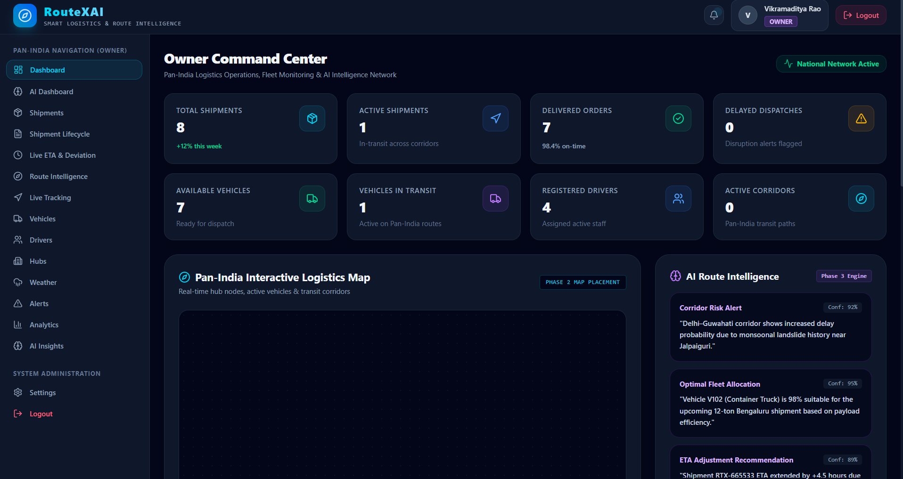
Figure 5: Owner Dashboard
11.3 Route Intelligence
The Route Intelligence dashboard displays candidate road routes between shipment pickup and delivery locations. The Owner can compare route information, review quality scores and distance metrics, and select the optimal route for the shipment. The selected route is stored in MongoDB and associated with shipment.
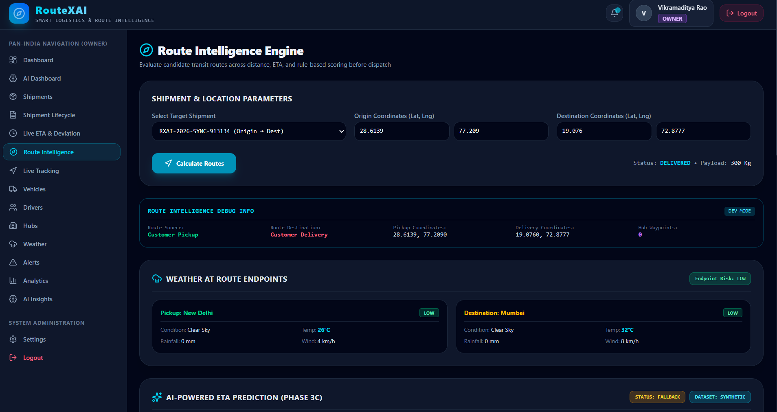
Figure 6: Route Intelligence
11.4 Live Vehicle Tracking
The Live Tracking dashboard displays vehicle telemetry on an interactive Leaflet map. The dashboard presents available vehicle information, tracking freshness, and the latest reported coordinates. The screenshot demonstrates telemetry ingestion and fleet status monitoring.
11.5 Shipment Lifecycle
The Shipment Lifecycle dashboard displays the shipment's current state and its recorded transitions. The lifecycle service maintains consistent status information across the Owner, Driver, and Customer interfaces. The dashboard provides full operational visibility and an immutable audit trail of each milestone.
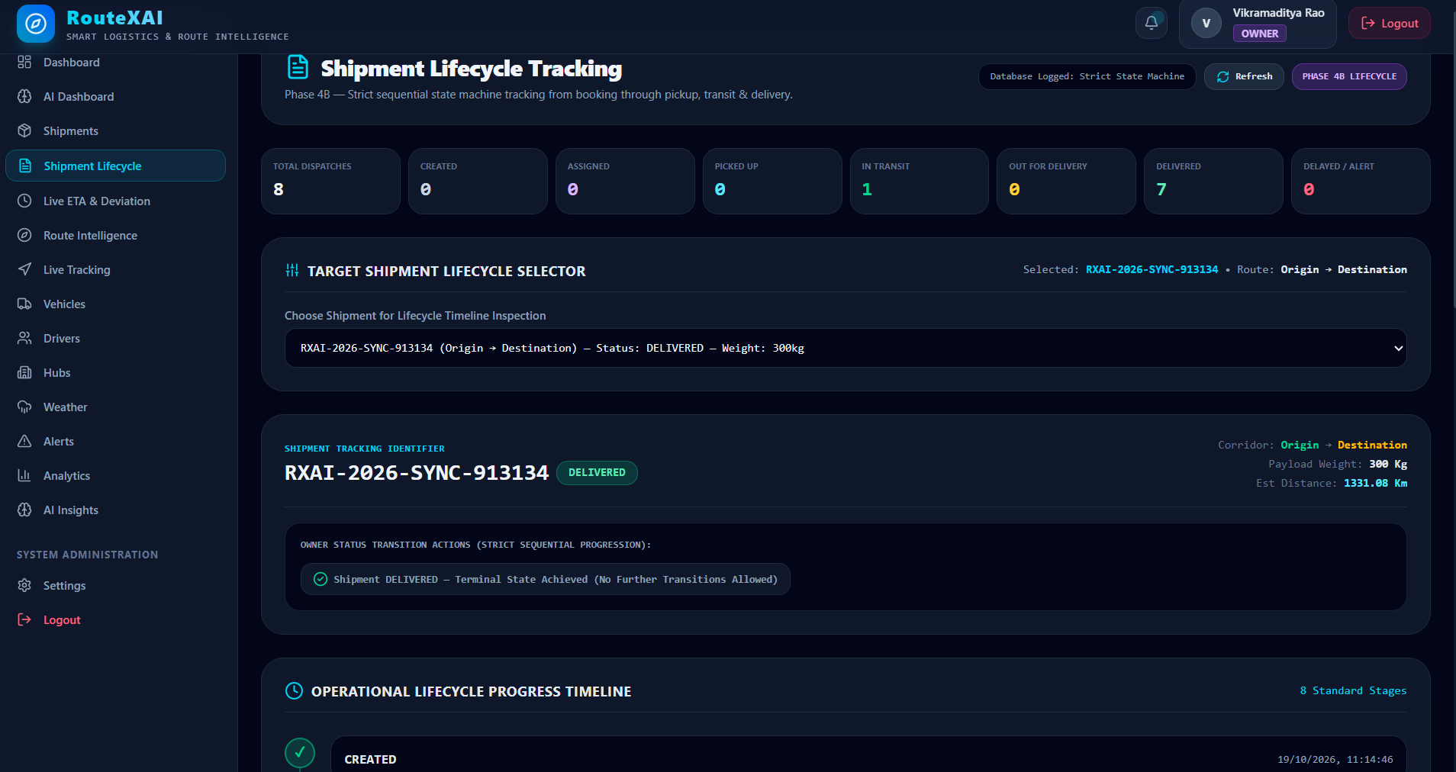
Figure 7: Shipment Lifecycle
11.6 Live ETA Monitoring
The Live ETA Monitoring dashboard displays the shipment's planned ETA, current ETA, delay variance, remaining distance, route deviation status, and telemetry freshness. When GPS telemetry is offline, the dashboard pauses live recalculation and displays the last available information or an offline warning state. This clearly distinguishes fresh live estimates from stale or unavailable data.
11.7 Customer Shipment Tracking
The Customer dashboard provides shipment status and delivery-related information. Customers can monitor their own shipments, verify package pickup and delivery milestones, and view the latest available delivery estimates in an intuitive, consumer-friendly layout.
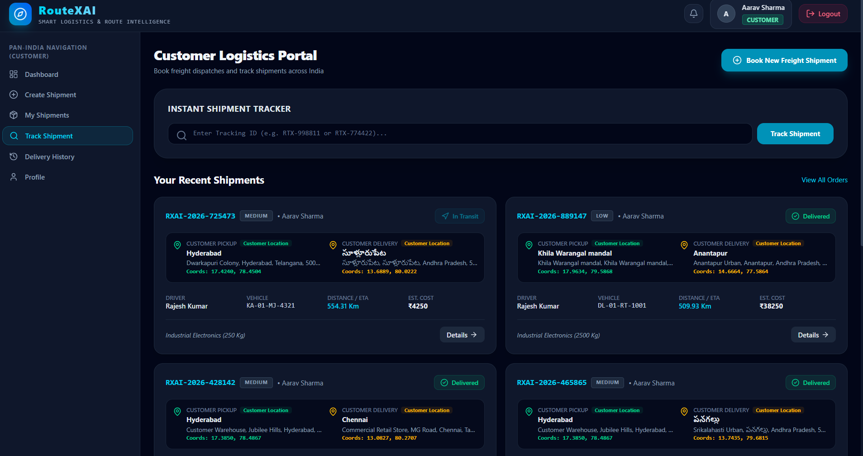
Figure 8: Customer Shipment Tracking
11.8 Driver Dashboard
The Driver dashboard provides access to assigned shipments and permitted lifecycle actions. It displays relevant shipment details, pickup/drop-off destinations, and operational progress. Driver actions are validated by the backend and integrated with the central shipment lifecycle service.
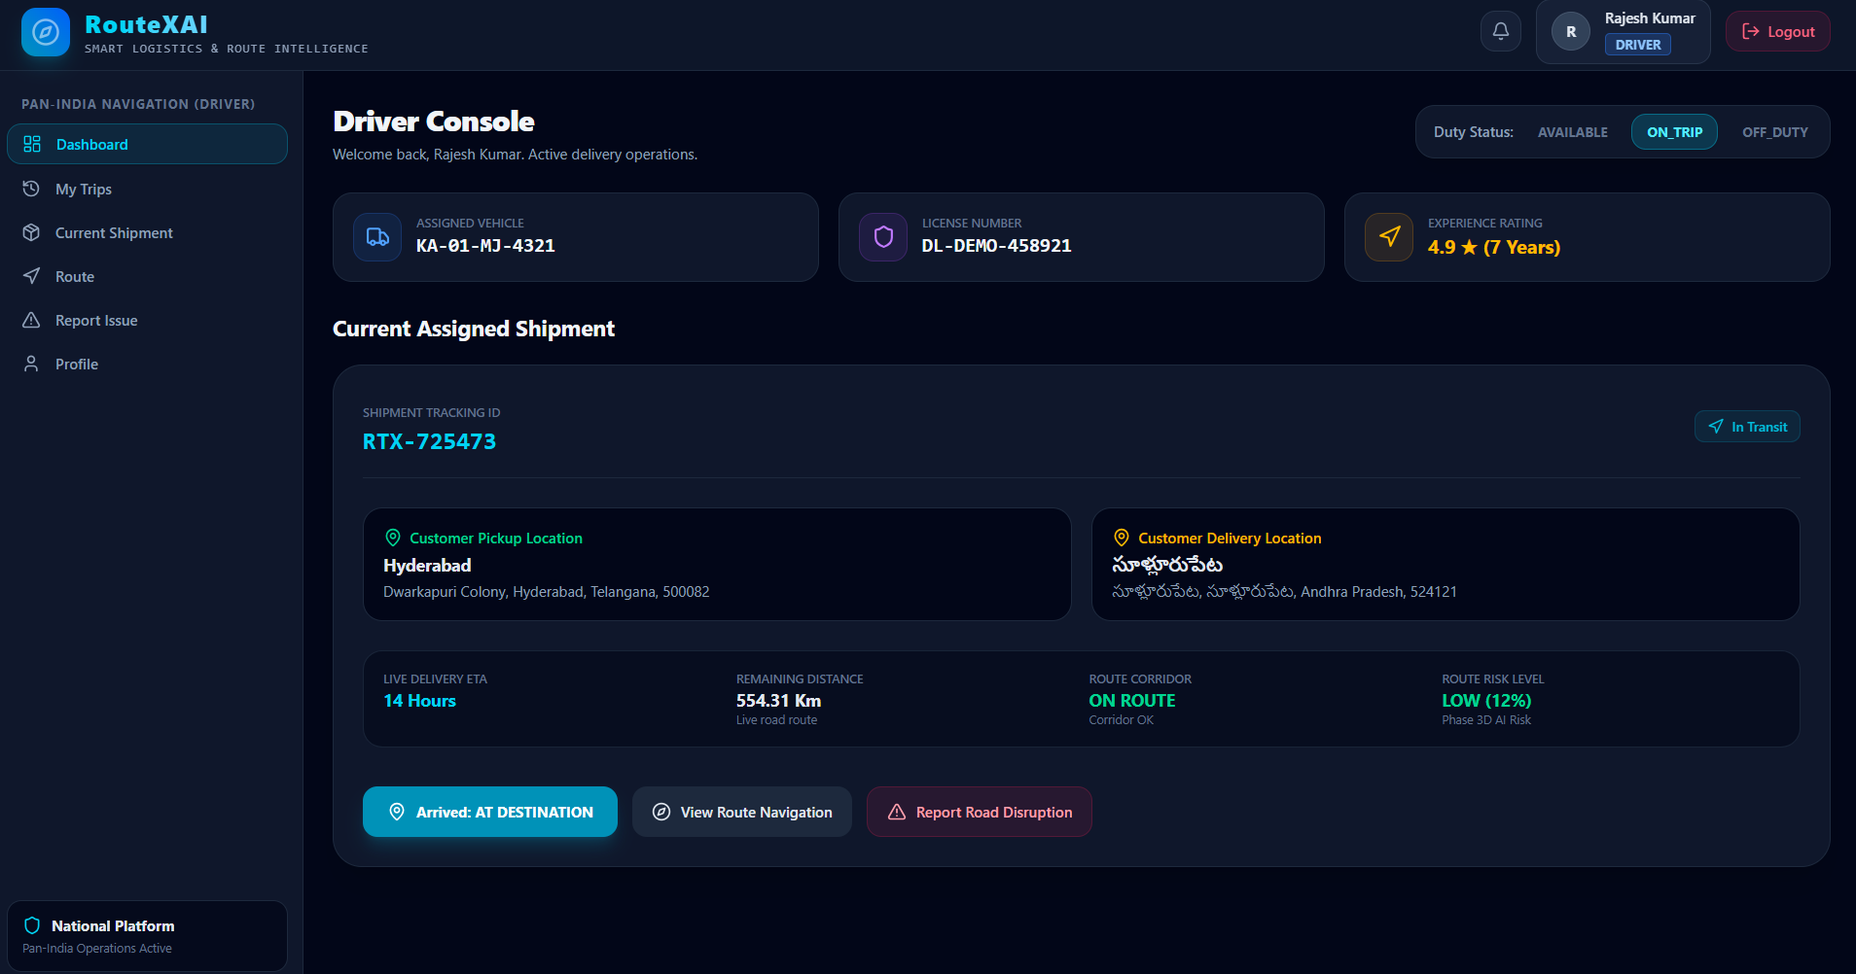
Figure 9: Driver Dashboard
CHAPTER 12: TESTING AND VALIDATION
12.1 Testing Objectives
The purpose of testing was to verify:
- Correct application behavior
- Database consistency and integrity
- Role-based authorization and security
- Shipment lifecycle synchronization across all dashboards
- Vehicle tracking functionality and telemetry vitality
- Live ETA recalculation logic and planned ETA preservation
- Route deviation detection and corridor threshold filtering
- Seamless integration between project phases
Testing included automated backend unit tests, end-to-end integration tests, regression suites, frontend production build verification, and manual UI testing.
12.2 Shipment Lifecycle Testing
Phase 4B implemented a strict shipment lifecycle state machine. Testing covered valid forward transitions, rejection of invalid or backward transitions, prevention of duplicate transitions, role authorization, and multi-dashboard synchronization.
The lifecycle test suite reported 22 successful automated tests. The global status synchronization suite also passed completely. Manual end-to-end testing confirmed that a test shipment transitioned from CREATED through to DELIVERED and immediately displayed the authoritative updated status across Owner, Driver, Customer, and audit interfaces without cache latency.
12.3 ETA Monitoring Testing
Phase 4C was tested using an automated test suite. The initial suite reported 27 successful tests. Subsequent enhancements to route geometry resolution and ETA snapshot refresh expanded the suite to 32 comprehensive tests.
The automated tests covered:
- Current ETA calculation from live vehicle position
- Planned ETA preservation and delay variance computation
- GPS freshness and telemetry vitality state transitions
- Graceful pausing of live recalculation during offline telemetry
- Route geometry attachment and corridor distance computation
- Route deviation detection and consecutive-count filtering
- Delay classification (ON_TIME, DELAYED, EARLY)
- API authorization guards for Customer and Driver views
- External routing service fallback handling
- Strict lifecycle separation preventing unwanted status mutations
Result: The final reported Phase 4C test result was 32 out of 32 tests passed (100% pass rate).
12.4 Route Selection and ETA Synchronization
During integration testing, a problem was identified in which selecting a route in the Route Intelligence module did not immediately refresh the existing ETA monitoring snapshot. The implementation was corrected so that route selection automatically triggers ETA recalculation and persists the selected geometry to the shipment.
The service was also updated to resolve selected route geometry before checking telemetry availability, allowing the system to accurately differentiate between a shipment lacking route geometry and a shipment with valid geometry whose vehicle GPS is temporarily offline.
12.5 Machine Learning Results
ETA Prediction
The ETA model was trained and evaluated using the synthetic logistics dataset. The reported comparison between the routing service baseline and the trained Gradient Boosting Regressor is shown in Table 7:
Table 5A: Machine Learning Model Results (ETA Prediction)
Model | Test MAE | Test R²
Routing Service Baseline | 49.20 minutes | 0.9961
Gradient Boosting ETA Model | 19.96 minutes | 0.9994

The Gradient Boosting model reported lower mean absolute error on the synthetic test data. However, the high reported R² values should be interpreted cautiously because the model was trained and evaluated on synthetic data generated by the project. These results do not establish equivalent performance on real logistics operations.
Delay-Risk Prediction
The reported synthetic test results for the Gradient Boosting Classifier were:
Table 5B: Delay-Risk Model Performance Metrics
Metric | Reported Result
Accuracy | 90.65%
Precision | 91.81%
Recall | 87.53%
F1 Score | 89.62%
ROC AUC | 0.9704

CHAPTER 13: CHALLENGES FACED
13.1 Geographic Coordinate Handling
Different mapping and routing tools use different coordinate orders. Some expect [latitude, longitude], while GeoJSON and MongoDB require [longitude, latitude]. Converting between these formats required careful verification to avoid inverted locations.
13.2 Route Geometry Resolution
The routing service provides route geometry as a list of coordinates. During route selection and monitoring, the system needed to associate the geometry with the shipment so that distance calculations could be performed. Correcting how the geometry was stored and resolved was necessary for accurate deviation detection.
13.3 Shipment Status Synchronization
During early testing, shipment status updates could become inconsistent across dashboards. The implementation was revised to make Shipment.status the authoritative source and route all status changes through a central lifecycle service.
13.4 GPS Telemetry Freshness
GPS telemetry may become stale or unavailable. The project introduced telemetry freshness classifications and pauses live ETA recalculation when the latest vehicle location is no longer sufficiently recent. This prevents the interface from presenting historical location information as if it were a current physical location.
13.5 External API Dependencies
Route and weather intelligence depend on external services. API rate limits, connectivity problems, or unavailable services may affect the application. The project introduced controlled fallback behavior and unavailable states to reduce the risk of misleading output.
13.6 Synthetic Data Limitations
The project required logistics data for training ETA and delay-risk models. Because verified real-world logistics data was not available for the prototype, a synthetic dataset was generated. This made it possible to implement and test the machine learning pipeline, but it also limited the conclusions that could be drawn about real-world prediction accuracy.

CHAPTER 14: CONCLUSION
RouteXAI was developed as a centralized logistics management and route intelligence platform using MongoDB and the MERN stack.
The project demonstrates how a document-oriented database can support logistics records, including shipments, vehicles, drivers, route information, GPS telemetry, lifecycle history, and ETA monitoring snapshots.
The platform integrates shipment management, route planning, weather intelligence, ETA prediction, delay-risk analysis, accessibility evaluation, route recommendation, live vehicle tracking, shipment lifecycle management, and route deviation monitoring.
The implementation follows a phase-based development approach and includes backend APIs, role-specific dashboards, database operations, external service integration, and machine learning services.
Testing and validation were performed on the implemented modules. The shipment lifecycle and ETA monitoring modules were tested for status synchronization, authorization, route geometry handling, telemetry freshness, and controlled fallback behavior.
The project also demonstrates the importance of maintaining a single source of truth for shipment status and distinguishing real-time information from historical or unavailable telemetry.
Although the platform provides a functional academic prototype, its machine learning performance remains based on synthetic data, and its tracking capability depends on available telemetry.
Overall, RouteXAI demonstrates the practical application of MongoDB and full-stack development to a logistics management problem while providing a foundation for further development and real-world validation.
CHAPTER 15: FUTURE SCOPE
The following improvements can be considered in future versions of RouteXAI:
15.1 Physical GPS Integration
The system can be connected to vehicle-mounted GPS hardware or a driver mobile application that provides authorized, continuous location telemetry. This would allow the tracking module to operate on physical telemetry streams.
15.2 Proof of Delivery
A driver-facing proof-of-delivery workflow can be expanded to support recipient confirmation codes, exact delivery timestamps, photographic proof of handover, and digital customer signatures stored securely in cloud object storage.
15.3 Real-World Machine Learning Validation
The ETA and delay-risk models can be re-trained and benchmarked using verified historical commercial shipment data across Indian transport corridors, enabling realistic evaluation of prediction accuracy.
15.4 Automated Alerts
The system can generate automated notifications for:
- Significant ETA variances and delivery delays
- Corridor breaches and route deviations
- Prolonged telemetry loss or vehicle stoppage
- Delayed deliveries and SLA violations
- Shipment lifecycle milestone transitions
Alert delivery may be implemented through WebSocket push notifications, automated SMS, or email gateways.
15.5 Improved Traffic Intelligence
Future versions could incorporate a live commercial traffic data provider to enhance ETA recalculation with real-time congestion data, carefully distinguishing live observations from static road travel duration.
15.6 Mobile Application
A dedicated native mobile application for drivers (built with React Native or Flutter) would improve usability by providing offline-first turn-by-turn navigation, background GPS reporting, and streamlined delivery workflows.
15.7 Scalability and Production Deployment
Future production hardening should include containerized Docker deployments, Kubernetes orchestration, database replication and automated backup policies, centralized log monitoring, distributed Redis caching, and automated CI/CD deployment pipelines.
CHAPTER 16: REFERENCES / BIBLIOGRAPHY
- MongoDB Inc. (n.d.). MongoDB Manual. Available at: https://www.mongodb.com/docs/manual/
- MongoDB Inc. (n.d.). Mongoose Documentation. Available at: https://mongoosejs.com/docs/
- OpenJS Foundation. (n.d.). Node.js Documentation. Available at: https://nodejs.org/docs/
- Express.js. (n.d.). Express Documentation. Available at: https://expressjs.com/
- React. (n.d.). React Documentation. Available at: https://react.dev/
- OpenRouteService. (n.d.). OpenRouteService Documentation. Available at: https://openrouteservice.org/dev/
- Open-Meteo. (n.d.). Weather API Documentation. Available at: https://open-meteo.com/en/docs
- FastAPI. (n.d.). FastAPI Documentation. Available at: https://fastapi.tiangolo.com/
- Scikit-learn. (n.d.). Scikit-learn User Guide. Available at: https://scikit-learn.org/stable/user_guide.html
- Leaflet. (n.d.). Leaflet Documentation. Available at: https://leafletjs.com/reference.html
- OpenStreetMap Contributors. (n.d.). OpenStreetMap. Available at: https://www.openstreetmap.org/
- RouteXAI Project Source Code and Development Documentation. Lovely Professional University Repository.
APPENDIX A: ADDITIONAL DATABASE OPERATIONS
This appendix provides additional illustrative MongoDB database operations used for administrative reporting and fleet inspection.
A.1 Count Documents
db.shipments.countDocuments({});
Explanation: Returns the total number of shipment documents in the collection.
A.2 Count Active Shipments
db.shipments.countDocuments({ status: "IN_TRANSIT" });
Explanation: Returns the number of shipments currently stored with IN_TRANSIT status.
A.3 Update Vehicle Location
db.vehicles.updateOne(
{ _id: ObjectId("VEHICLE_OBJECT_ID") },
{ $set: {
currentLocation: { type: "Point", coordinates: [78.4867, 17.3850] },
updatedAt: new Date()
}
}
);
Explanation: This is an illustrative database operation for updating vehicle location. In the actual application, location updates should go through the tracking API and tracking service so that the authoritative telemetry record is maintained.
A.4 Aggregation for Shipment Status Summary
db.shipments.aggregate([
{ $group: { _id: "$status", count: { $sum: 1 } } },
{ $sort: { count: -1 } }
]);
Explanation: This aggregation produces a shipment status summary sorted by shipment count in descending order.
APPENDIX B: PHASE COMPLETION SUMMARY
The development progress across all project implementation phases is summarized in Table 9:
Table 6: Phase Completion Summary
Phase | Description | Status
Phase 1 | Foundation and Authentication | Completed
Phase 2 | Logistics and Route Intelligence | Completed
Phase 3A | Weather Intelligence | Completed
Phase 3B | Synthetic Logistics Dataset | Completed
Phase 3C | ETA Prediction | Completed
Phase 3D | Delay-Risk Prediction | Completed
Phase 3E | Accessibility Intelligence | Completed
Phase 3F | AI Route Recommendation | Completed
Phase 3G | Owner AI Dashboard | Completed
Phase 4A | Live Vehicle Tracking | Completed
Phase 4B | Shipment Lifecycle Management | Completed
Phase 4C | Live ETA Recalculation and Deviation Monitoring | Implemented and tested

