SIT723 Detailed Progress Report
AI-based credit scoring benchmark with PaddleOCR extension status update
Prepared on 23 April 2026
Student: Rudraksh Dhamija
Supervisor: Dr. Shamsul Huda

1. Project Context and Current Scope
The current project scope remains aligned with the approved SIT723 research direction: benchmarking explainable AI and deep learning models for credit scoring using German Credit and Lending Club data.
The broader loan-origination relevance is retained through a document-intelligence extension. In the current pilot, PaddleOCR is treated as a supporting module for borrower-document intake rather than a replacement for the core credit-scoring study.
This report is written as a truthful progress update. All numerical claims below are derived from saved pilot experiment artifacts already produced in the workspace.

2. Research Aim, Gaps, and Questions
The main aim is to determine how well strong machine learning and neural models perform on public credit-risk datasets while preserving robustness and explainability for lending-oriented use.
The work addresses three recurring literature gaps: limited cross-dataset comparison, weak attention to minority-class detection under class imbalance, and insufficient connection between predictive performance and explainable lending practice.
Research Question | Purpose
RQ1 | Compare deep learning models with strong machine-learning baselines for credit-risk prediction.
RQ2 | Evaluate preprocessing and imbalance strategies that improve risky-borrower detection.
RQ3 | Retain practical explainability through feature-importance analysis without losing predictive quality.

3. Finalised Methodology
The methodology is fully designed and implemented as a reproducible experiment pipeline. Each run follows the same flow from data ingestion to metrics export.
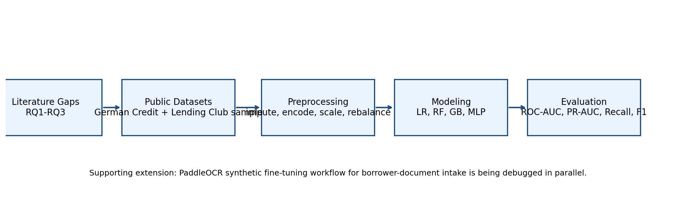
The experimental workflow uses public datasets, train/validation/test separation, explicit imbalance-handling variants, and consistent saved outputs including metrics JSON, confusion matrix, ROC curve, PR curve, and feature-importance artifacts.
Model families used in the pilot are Logistic Regression, Random Forest, HistGradientBoosting, and MLP. This provides a balanced comparison between interpretable linear baselines, strong ensemble methods, and a neural baseline.

4. Finished Experimental Design
Design Element | Current Pilot Design
Datasets | German Credit full public dataset; public cleaned Lending Club sample with pilot subset size 4,000
Preprocessing | Median or mode imputation, one-hot encoding, scaling for linear and neural models
Imbalance strategies | None, class weighting, random oversampling
Evaluation metrics | ROC-AUC, PR-AUC, precision, recall, F1, accuracy, confusion matrix, training time
Explainability | Feature-importance CSV and figure for each run
Outputs | Per-run JSON summaries, plots, and benchmark summary CSV

5. Dataset Profile
Dataset | Records used | Positive-class rate | Notes
German Credit | 1000 | 0.300 | Positive class is bad credit risk.
Lending Club sample | 4000 | 0.183 | Pilot run uses a stratified subset from a public cleaned Lending Club CSV.
The German Credit data remains useful as a compact benchmark with a known 70:30 class structure. The Lending Club pilot uses a larger public sample and therefore gives a more realistic tabular-lending setting, while still remaining computationally manageable for this stage.
The positive rate in the Lending Club pilot subset is lower than in German Credit, which makes minority-class recall especially important for model comparison.

6. Preliminary Experiments Conducted
Eight pilot benchmark runs have been completed across two datasets. The table below summarizes the current test-set results saved in the benchmark summary file.
Run ID | Dataset | Model | Imbalance | ROC-AUC | PR-AUC | Recall | F1
german_gb_none | german_credit | gradient_boosting | none | 0.790 | 0.667 | 0.444 | 0.556
german_logreg_class_weight | german_credit | logistic_regression | class_weight | 0.831 | 0.713 | 0.778 | 0.673
german_mlp_oversample | german_credit | mlp | oversample | 0.823 | 0.686 | 0.578 | 0.612
german_rf_oversample | german_credit | random_forest | oversample | 0.803 | 0.654 | 0.511 | 0.590
lending_gb_none | lending_club_sample | gradient_boosting | none | 0.690 | 0.334 | 0.127 | 0.203
lending_logreg_class_weight | lending_club_sample | logistic_regression | class_weight | 0.722 | 0.360 | 0.682 | 0.430
lending_mlp_oversample | lending_club_sample | mlp | oversample | 0.591 | 0.260 | 0.245 | 0.244
lending_rf_oversample | lending_club_sample | random_forest | oversample | 0.719 | 0.383 | 0.273 | 0.335
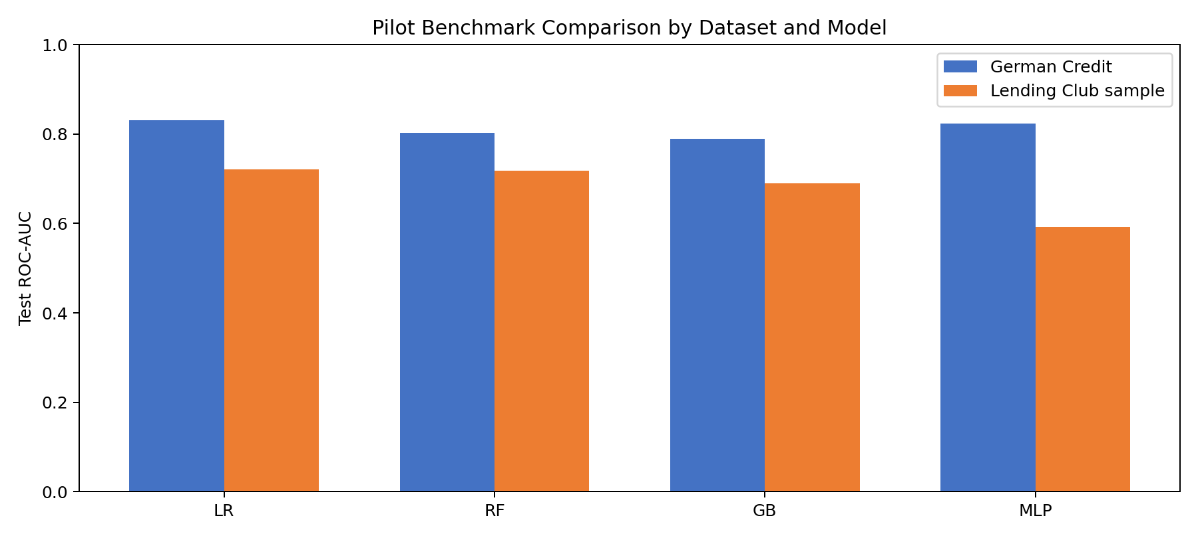

7. Early Findings and Interpretation
For German Credit, the current strongest pilot run is `german_logreg_class_weight`, which achieved test ROC-AUC 0.831, PR-AUC 0.713, recall 0.778, and F1 0.673. This result suggests that class-weighted Logistic Regression remains a strong, transparent baseline on this benchmark.
For the Lending Club sample, the current strongest ROC-AUC run is `lending_logreg_class_weight` with test ROC-AUC 0.722. However, the best ROC-AUC run does not automatically imply the strongest risky-class recall. In this pilot, the class-weighted Logistic Regression run produced comparatively higher recall 0.682, which is important when the research emphasis includes minority-risk detection.
These early results already support the value of the designed benchmark: different models optimize different objectives, and imbalance handling materially affects recall and F1. This gives the report a concrete empirical basis rather than a methodology-only description.

8. Explainability Outputs
Feature-importance artifacts were saved for every pilot run. This means the report can already demonstrate the explainability workflow required by RQ3, even before adding SHAP-style analysis in a later phase.
The strongest currently interpretable baseline is the class-weighted Logistic Regression model, which combines competitive predictive performance with straightforward coefficient-based importance ranking.
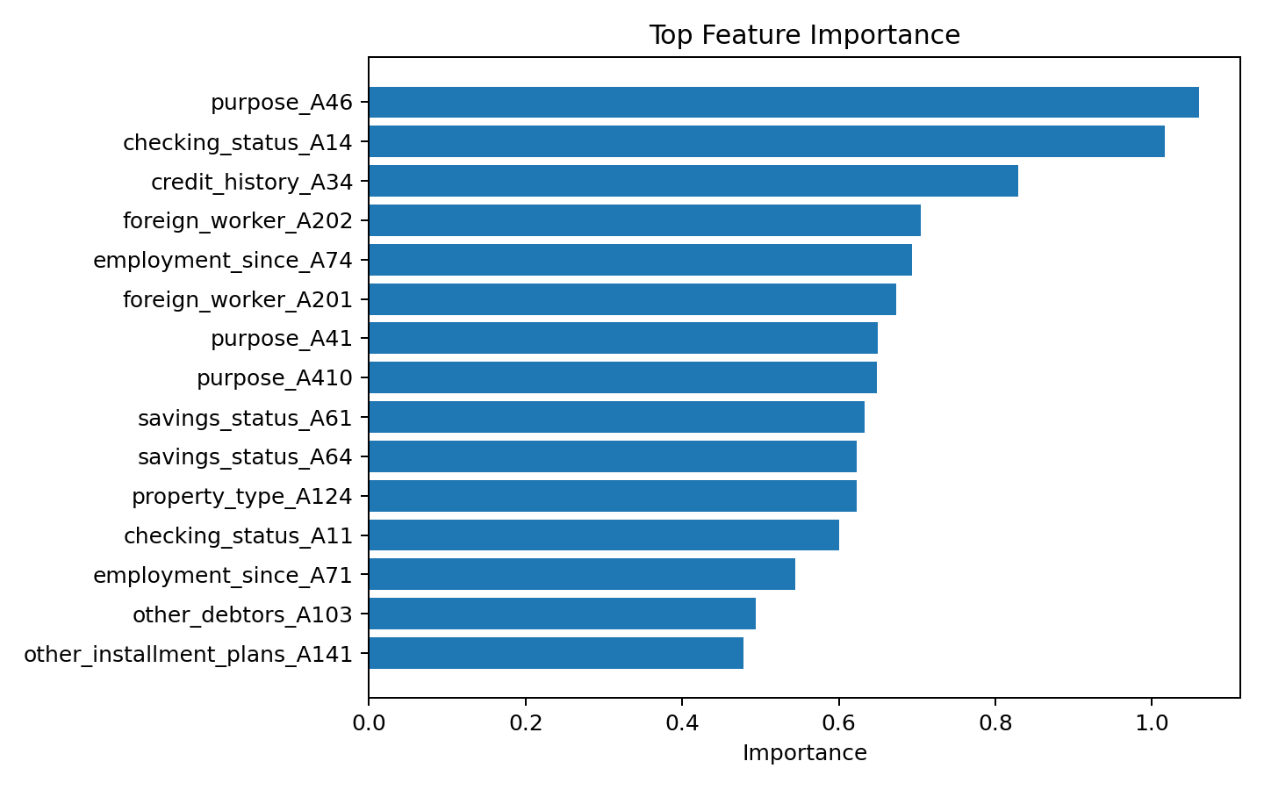
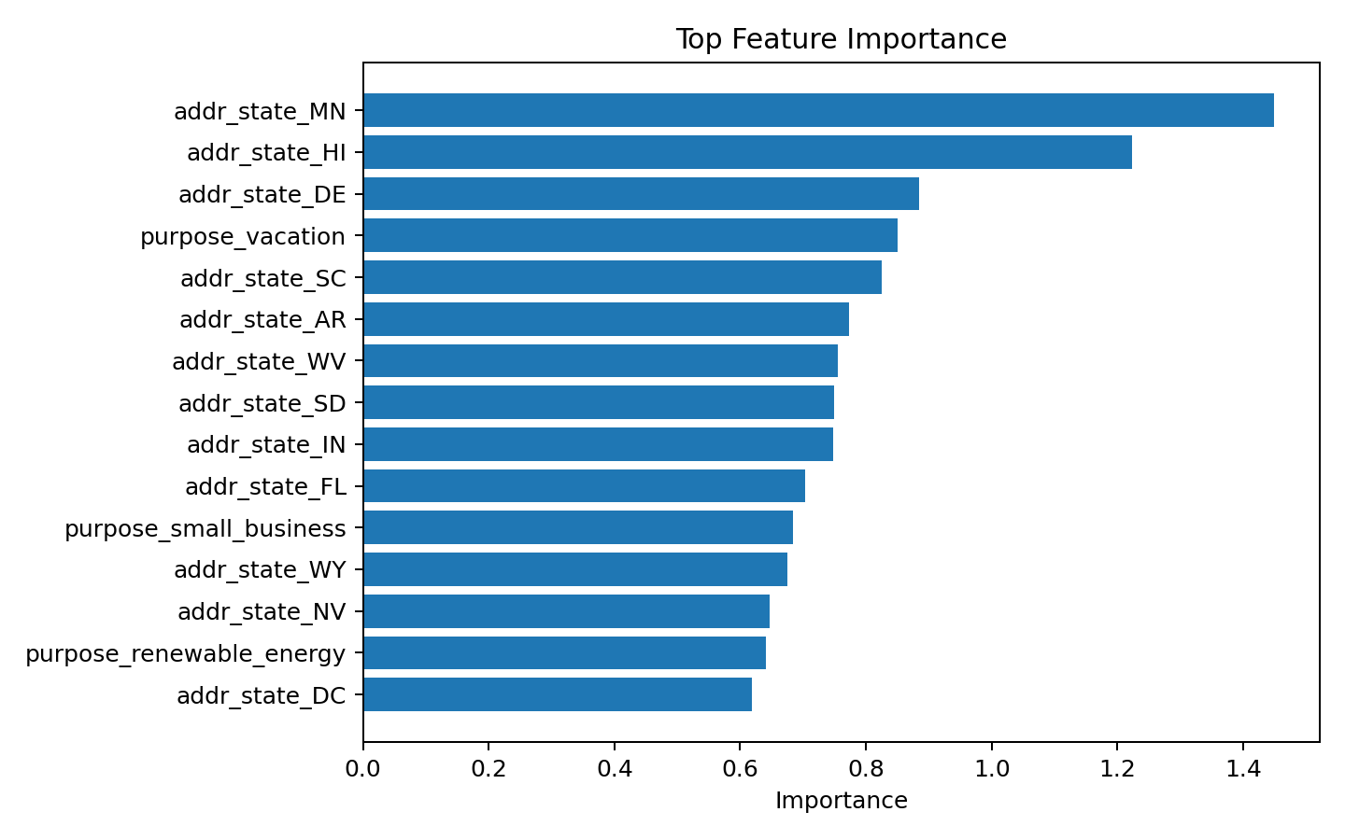

9. PaddleOCR Extension: Current Status
The PaddleOCR workstream was intentionally scoped as a supporting module to show how borrower-document ingestion can be integrated into a broader loan-origination pipeline.
OCR pilot environment setup is partially complete but the fine-tuning run has not completed yet.
Current debugging focus: the PaddleOCR bootstrap sequence progressed through package installation, repository clone, synthetic dataset generation, and pretrained archive download, but the run did not yet reach a stable saved fine-tuned checkpoint.
OCR Setup Checkpoint | Current State
Synthetic OCR data prepared | True
PaddleOCR repository cloned | True
Pretrained recognition archive downloaded | True
Pretrained model extracted | False
Training config written | False
Fine-tuned model output available | False
What is already done: synthetic OCR label files were generated, the PaddleOCR repository was cloned successfully, and the pretrained recognition archive was downloaded.
What is currently stuck: the fine-tuning bootstrap has not yet produced a stable extracted pretrained checkpoint and saved training output. This is the exact issue being debugged at the moment.
Why this is still worth reporting: the OCR pipeline is clearly documented as work in progress, and it demonstrates concrete engineering progress rather than only a future idea.

10. Current Debugging Notes
Observed State | Interpretation / Debugging Direction
`paddlepaddle` and `paddleocr` installed | Core OCR runtime is available locally.
Synthetic OCR dataset generated | Tiny pilot data is ready for a reduced recognition fine-tuning run.
Official PaddleOCR repo cloned | Training scripts are available in the workspace.
Pretrained recognition tar downloaded | Bootstrap assets are partially available.
No final OCR summary or model checkpoint yet | The run is not complete and needs further debugging before claiming OCR results.
The honest status is therefore: credit-scoring experiments are complete for the pilot stage, while PaddleOCR fine-tuning is partially set up and actively being debugged.
This separation is important because it allows the current report to present real experimental evidence without overstating the maturity of the OCR extension.

11. Limitations
The Lending Club component currently uses a manageable public sample rather than the full raw dataset used in some published studies.
The neural benchmark is still a pilot MLP rather than a more specialized tabular deep architecture.
The OCR component should be treated as engineering progress and experimental setup rather than a completed result section.

12. Next Steps
Priority | Next Action
1 | Complete the PaddleOCR bootstrap and obtain the first saved fine-tuned recognition checkpoint.
2 | Add held-out OCR evaluation metrics once the fine-tuned model runs successfully.
3 | Extend explainability with SHAP-style analysis if dependency/runtime costs remain acceptable.
4 | Run a larger Lending Club subset or the full public dataset if time and compute permit.

13. Meeting Note
To avoid confusion in supervisor communication, this report uses absolute dates. The earlier email thread referred to a meeting on Thursday 22 April 2026, but 22 April 2026 was a Wednesday. If the intended Thursday schedule is preserved, the matching date is Thursday 23 April 2026.

