Advancing Radioactive Source Detection with Machine Learning using Plastic Scintillator Detector

Gaurav Choudhary¹, Nandini Thakur¹, Om Sharma¹, Saloni Sinha¹, Aparajita Dutta¹ and Raman Sehgal ²

¹ Department of Computer Science and Engineering, Indian Institute of Information Technology, guwahati

² Nuclear Physics Division, Bhabha Atomic Research Centre, Mumbai - 400085, INDIA

. * Email: gaurav.choudhary@iiitg.ac.in

Introduction

Plastic scintillator detectors play a pivotal role in the field of radiation detection. These detectors primarily serve to identify particles, such as gamma, neutrons, muons etc. Upon interaction with these particles, the detectors produce scintillation light. By measuring the energy and flux of these particles, one can also ascertain the presence and intensity of a radioactive source. The precise detection and localization of radioactive sources are of paramount importance. Within the atomic energy sector, this accuracy is crucial. During nuclear incidents, rapid and accurate localization facilitates containment, thus protecting both personnel and the environment. In this study, we introduce a machine learning-based method to enhance the precision of radioactive source detection using plastic scintillators.

Detector Setup

The detector setup includes a plastic scintillator shaped like a cuboid with dimensions of 6 cm x 6 cm x 100 cm. Photomultiplier tubes (PMTs) are attached to both sides of the scintillator to capture light when particles interact with it. Connected to the detector is a Data Acquisition System that records the timing and integrated charge. This information is processed from the voltage pulses from the PMTs. The radioactive source is not collimated and emit particles isotopically .Using this pattern of the data as whole, we can trace back the particle's source.

Conventional technique of Position Detection

Conventionally the position of Source is detected by placing the known radioactive source like ¹³⁷Cs on different known physical position of detector. The data collected at different position is used to obtain a parameterization that will map the measured quantities to the physical position of the Radioactive source. In the present work the ¹³⁷Cs source is placed at 11 different locations along the length of the scintillator, and a parameterization is obtained between the mean of histogram of timing difference (fdelt) and physical position of source, the peak of the histogram will then be used to estimate the position of Radioactive Source from the measured time difference (fdelt) by assuming a linear relationship.

Position Detection via Machine Learning

The model in this study evaluates positional values by analyzing both the mean and the standard deviation of the 'fdelt' values for each position. Using ML library reference [1], the initial step involves fine-tuning the mean of fdelt to establish a strong linear relationship with position. In the following phase, the skewness seen in Gaussian distributions, evident when comparing expansive positions (Fig. 1) to near ones (Fig. 2), is addressed. The model transforms the standard deviation data points into second-degree polynomial features. This transformation ensures capturing the data's complexities without overfitting. By doing so, it successfully bridges the gap between the linear curve, shaped using 'fdelt' and the actual data points. During the iterative training process, the model relentlessly hones this curve. The overarching objective is twofold: to ensure the curve aptly represents the nuances of the data and, concurrently, to minimize the Mean Squared Error, which serves as the primary metric to gauge the model's proficiency. By optimizing in this manner, the algorithm ensures that its predictions are both precise and reflective of the inherent patterns in the data.

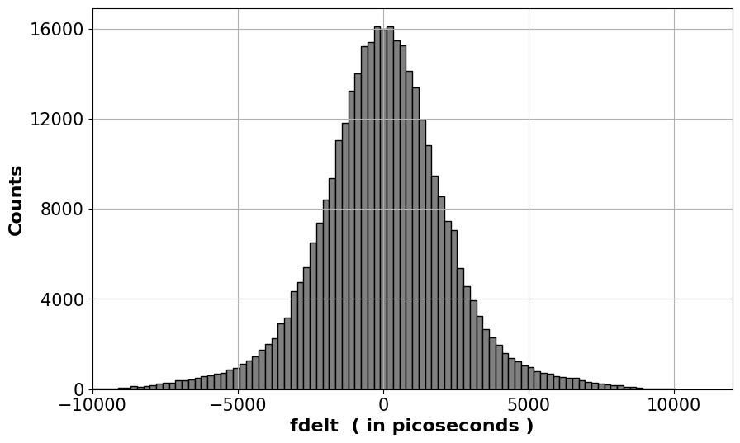
Fig. 1: Histogram Plot of fdelt (Time Difference) for 0 cm position with y-axis as frequency and x-axis as fdelt in picoseconds.

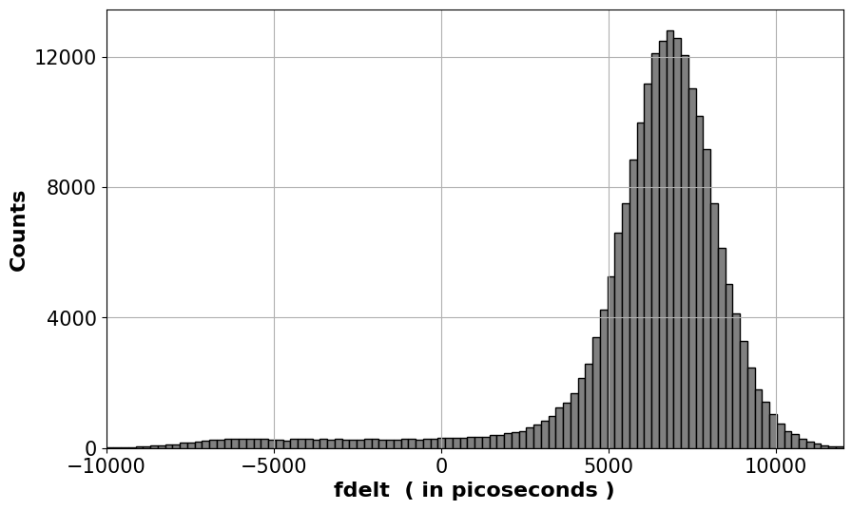
Fig. 2: Histogram Plot of fdelt (Time Difference) for +45 cm position with y-axis as frequency and x-axis as fdelt in picoseconds.

Data Sets

For the Conventional method and ML model, primary data [2] was derived by adjusting an initial error at the 0 position and utilizing the "2n+1" sequence to achieve a balanced representation. Training encompassed positions from -40 cm to 40 cm, in increments like -40, -30, and so forth. Specifically, the test data included positions +45 and -45, intentionally chosen due to their deviation from regular training increments. This ensured the model was evaluated on less familiar data points and in no case resulted in overfitting.

Results

Both methods were tasked with predicting values for +45 cm and -45 cm positions. ML model is divided into training and testing phase.

Conventional Model:
Prediction For +45 cm position: 41.38 cm
Prediction For -45 cm position: -41.18cm
Mean Absolute Percentage Error: 8.265%
Accuracy: 91.735%

ML Model:
Training Phase:
Mean squared error: 0.0039 cm²
Testing Phase:
Prediction For +45 cm position: 45.04 cm
Prediction For -45 cm position: -44.21 cm
Mean Absolute Percentage Error: 0.922%
Accuracy: 99.0778%

The ML model's low MSE during training and high accuracy during testing highlight an optimal bias-variance tradeoff.

Conclusion

The machine learning model demonstrates enhanced accuracy in comparison to conventional methods. As the number of detectors increases, this accuracy difference will further manifest.
This advancement underscores the potential to leverage the machine learning model for optimizing radioactive source detection.

References

[1] Scikit-learn Developers. (2021). Scikit-learn (Poly – Multi Regression model used).
[2] Uproot: A Pure-Python ROOT file reader (Software library).

